Vanguard X Software & System Architecture
Version 0.2 (Working Draft)
Purpose
This document is the living design reference for the Vanguard X radar. It records architectural decisions before implementation so the software can evolve from a simulation into a multifunction radar.

1. Vision
Build a modular multifunction X-band radar capable of:
• Continuous search
• Track-while-scan
• Multiple waveform families (Barker, Frank, LFM, Golay, future custom)
• Timed Ettus SDR transmission/reception
• PTZ and future electronically-steered pointing
• Operation on fixed and moving platforms
• Future adaptive/cognitive radar.

2. Design Principles
• Scheduler decides WHAT the radar does.
• Pointing Manager decides WHERE the antenna points.
• Waveform Manager decides WHAT is transmitted.
• Radar Processor processes IQ only.
• Tracker requests revisits but does not control hardware.
• STM32 performs only slow TRM serial control.
• Ettus ATR performs fast transmit/receive switching.

3. High-Level Architecture
Radar Scheduler
↓
Dwell Planner
↓
Pointing Manager
↓
TRM + Ettus Hardware Manager
↓
Radar Source
↓
Radar Processor
↓
Detector
↓
Tracker
↺ (requests future tasks)

4. Coordinate Frames
Platform-relative antenna angle
Platform heading (true)
True beam bearing
Future: full roll/pitch/yaw transformation.

5. Search Concept
Search uses continuous scanning.
The antenna moves continuously while encoder angle is measured.
Each dwell is tagged with the measured beam direction.
Support TRUE-fixed and PLATFORM-fixed search sectors.

6. Track Concept
Tracker requests revisit tasks.
Scheduler interrupts search when required.
Pointing Manager slews to predicted target position.
Execute dedicated track dwell.
Resume interrupted search.

7. Pulse Architecture
PulsePlan
ProcessingPlan
DwellPlan
Allows future Golay pairs, PRI agility, frequency agility and adaptive waveforms while remaining compatible with current fixed-PRI operation.

8. Current Status
Completed:
✓ PulsePlan architecture
✓ TRM interface
✓ STM32 serial controller
✓ PTZ simulation
Next:
□ RadarScheduler
□ PointingManager
□ Ettus timed execution
□ Search/Track tasking
□ Advanced waveform processing

9. Open Questions
• Scheduler priority policy
• Search resumption after interruption
• Moving-platform timing model
• Golay processing strategy
• Adaptive waveform policy
• Mechanical limits vs true sectors

Architecture Decision Log
Date | Decision | Reason | Status
2026-07-16 | Introduce PulsePlan/DwellPlan architecture. | Support future waveform agility and multifunction radar. | Accepted

Revision History
Version | Date | Change | Status
0.1 | 2026-07-16 | Initial architecture working draft | Superseded
0.2 | 2026-07-17 | Added UML-style component, sequence, scheduler-state and coordinate-frame diagrams | Current

10. UML-Style Architecture Diagrams
The diagrams below capture the current intended responsibilities and operational flows. They are design aids rather than final implementation constraints and should be updated as interfaces are refined.

10.1 High-Level Component Diagram
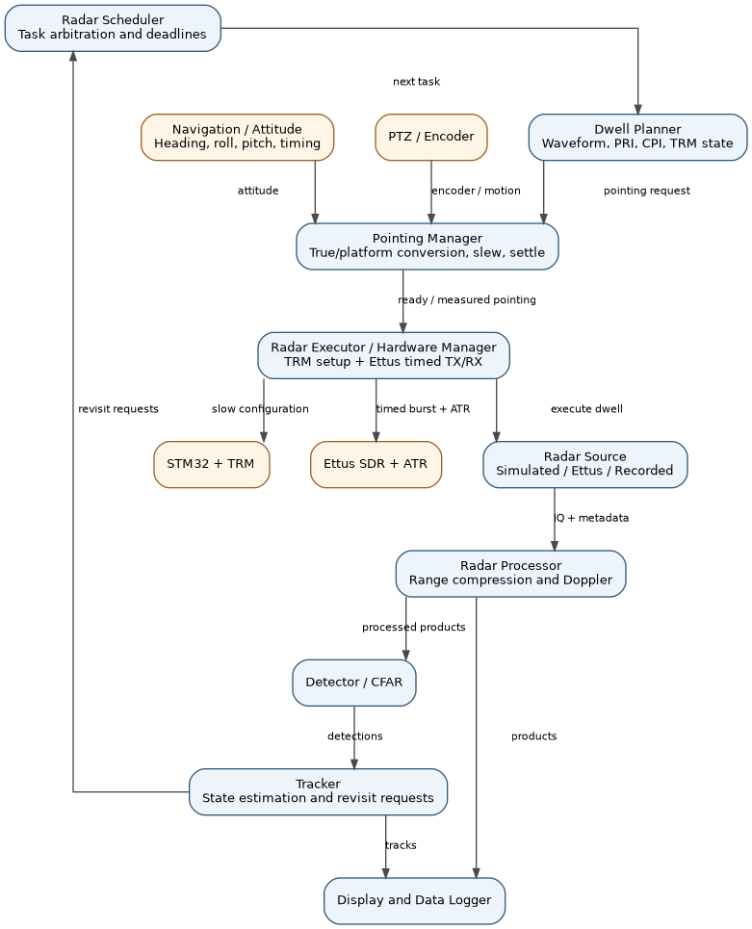
Figure 1. Vanguard X high-level software and hardware component relationships.

10.2 Search-to-Track Sequence
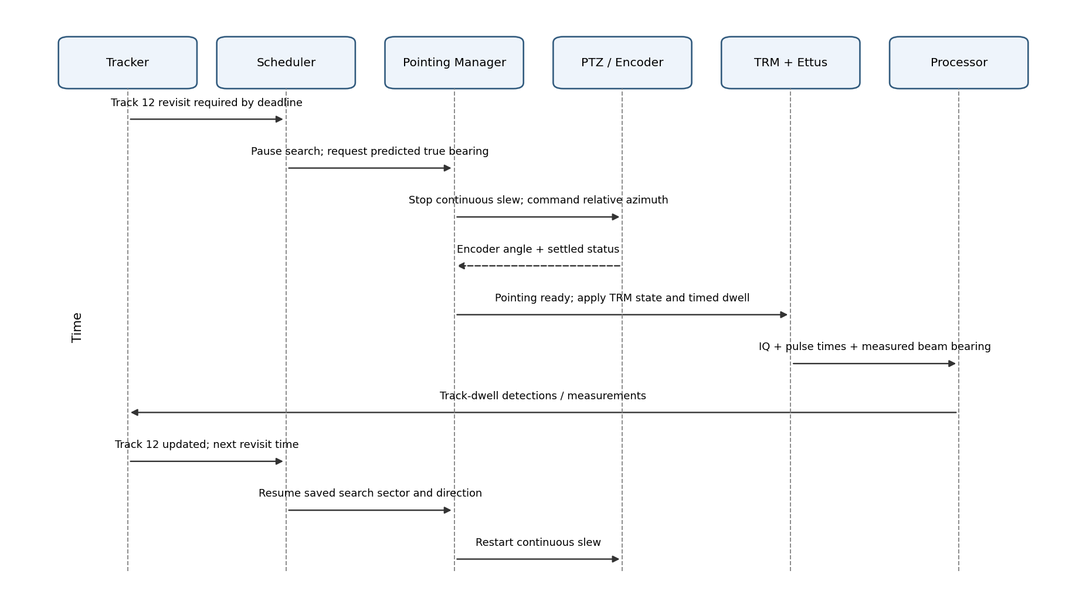
Figure 2. Track revisit pre-empts continuous search, executes a dedicated dwell, then resumes the saved search state.

10.3 Radar Scheduler State Machine
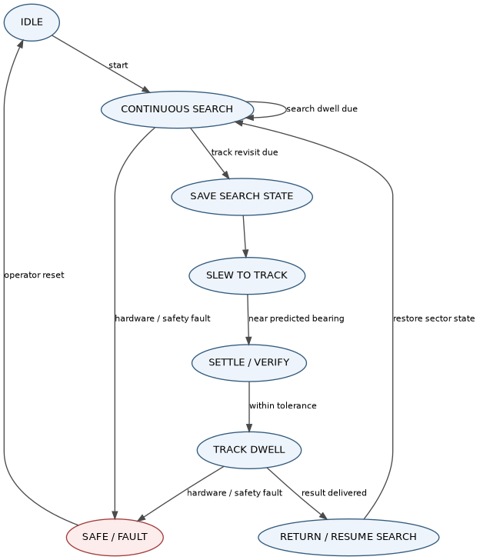
Figure 3. Initial scheduler state machine for continuous search and track-task interruption.

10.4 Coordinate Frames and Pointing
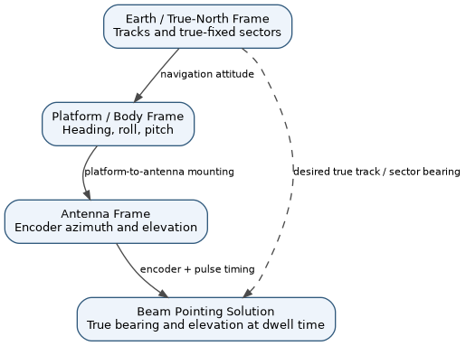
Figure 4. Separation between true-North, platform/body, antenna and beam-pointing frames.

11. New Architecture Decisions Captured in v0.2
- Search is a continuous-scan activity driven by commanded slew rate and measured encoder angle, not a sequence of discrete motor positions.
- Track tasks can pre-empt search, request a predicted true bearing, slew and settle, execute a dedicated dwell, and then resume saved search state.
- Tracks and true-fixed sectors live in Earth/true-North coordinates; PTZ commands live in platform-relative coordinates.
- True-fixed sector endpoints are recalculated as platform heading changes; platform-fixed sectors remain fixed relative to the body frame.
- The Radar Processor processes the supplied DwellPlan and IQ metadata; it does not command the antenna or decide whether a dwell is search or track.

