VANGUARD X
Software & System Architecture Specification
Version 0.7c - Timed TX/RX Hardware Validation Baseline

Document No. | VX-SSA-001
Version | 0.7c
Status | Engineering Draft
Date | 18 July 2026
Project | Vanguard X X-band Radar Prototype
Document owner | ASR Defence / Len Sciacca
Baseline | Fixed 40 MS/s waveform/timing implementation with bounded timed TX/RX hardware validation; ATR and TRM integration deferred
Repository | ~/Projects/Software/docs/architecture

Authoritative design reference for Vanguard X mission-computer, pointing, scheduling, SDR execution, signal-processing, tracking and hardware-control development.

Document Control
Version | Date | Change | Status
0.1 | 16 Jul 2026 | Initial architecture working draft | Superseded
0.2 | 17 Jul 2026 | Added operational and coordinate diagrams | Superseded
0.3 | 17 Jul 2026 | Scheduler, navigation and pointing baseline | Superseded
0.4 | 17 Jul 2026 | Formalised RadarExecutor boundary | Superseded
0.5 | 17 Jul 2026 | Integrated scheduler task selection | Superseded
0.6 | 18 Jul 2026 | PointingManager operational ownership | Superseded
0.7 | 17 Jul 2026 | Hardware-timed Ettus receive baseline and SDR execution architecture | Superseded
0.7b | 18 Jul 2026 | Fixed 40 MS/s waveform sampling, operator PRF/CPI controls and range-derived receive timing decisions | Superseded
0.7c | 18 Jul 2026 | Implemented waveform/timing controls and recorded bounded timed TX/RX B200mini validation through 4 kHz and 128 pulses | Current

Approval and configuration status
This document is an engineering baseline under Git configuration control. Changes to accepted architecture decisions shall be recorded through an Architecture Decision Record (ADR) and reflected in the version history.

Architecture decision summary
- ADR-0001: Introduce PulsePlan, DwellPlan and ProcessingPlan.
- ADR-0002: Separate RadarScheduler from PointingManager.
- ADR-0003: Use TRUE-fixed track coordinates and platform-relative motor commands.
- ADR-0004: Validate architectural behaviour against simulation before hardware integration.
- ADR-0005: STM32 is slow control; Ettus ATR owns fast T/R switching.
- ADR-0006: RadarExecutor owns execution semantics and source execution.
- ADR-0007: PointingManager is the sole motor-command owner.
- ADR-0008: SDR hardware time owns pulse and receive-window timing.
- ADR-0009: Command lead time is applied once per dwell.
- ADR-0010: Use a fixed 40 MS/s SDR sample rate for the initial hardware path.
- ADR-0011: Use one authoritative sampled waveform for transmit, simulation and matched filtering.
- ADR-0012: Make PRF and pulses per CPI operator-selectable within validated limits.
- ADR-0013: Derive receive timing and sample count from waveform duration and instrumented range.

- ADR-0014: Use bounded finite per-PRI TX/RX command pipelines.
- ADR-0015: Keep CPI processing outside the timing-critical acquisition loop.

Table of Contents
1. Introduction
2. Operational Concept
3. System Context and Hardware
4. Software Architecture
5. Coordinate Frames
6. Radar Task Model
7. Radar Scheduler
8. Pointing Architecture
9. Execution Architecture
10. Pulse and Waveform Architecture
11. Signal Processing and Tracking
12. Deployment and Hardware Control
13. SDR Execution Architecture
14. Timing Architecture
15. Interfaces and Data Contracts
16. Diagnostics and Fault Handling
17. Verification Strategy
18. Requirements Traceability
19. Development Roadmap
Appendix A. Architecture Decision Records
Appendix B. Acronyms and Glossary
Appendix C. Design Philosophy

1. Introduction

1.1 Purpose
This specification defines the software and system architecture for Vanguard X, a Python-first X-band radar prototype evolving from simulation into a hardware-executed multifunction radar. It is the authoritative design reference for mission tasking, scheduling, pointing, waveform planning, SDR execution, processing, tracking, diagnostics and hardware control.

1.2 Scope
- Continuous sector search using measured encoder angle.
- Track-while-scan tasking with search interruption and resumption.
- Fixed and moving-platform coordinate frames.
- Pulse-by-pulse waveform and timing plans.
- Simulation and Ettus B200mini hardware sources behind a common interface.
- Timed constant-PRI receive execution using SDR hardware timestamps.
- Fixed 40 MS/s SDR sampling with waveform-defined chip rates and integer samples per chip.
- Operator-selectable uniform PRF and coherent processing interval pulse count.
- Future timed transmit, ATR gating, waveform agility and adaptive operation.

1.3 Baseline statement
Version 0.7 remains the first hardware execution baseline. Version 0.7b recorded the accepted waveform-sampling and operator timing decisions. Version 0.7c records their implementation and protected B200mini timed TX/RX validation. The operational application remains transmitter-inhibited until ATR non-overlap is verified on the oscilloscope; the TRM and PA remain disconnected.

1.4 Design principles
- Scheduler decides what the radar does next.
- PointingManager decides where the antenna points and is the only motor-command owner.
- RadarExecutor translates tasks into executable dwells.
- EttusRadarSource owns deterministic SDR command execution.
- RadarProcessor processes IQ and never commands hardware.
- Tracker requests revisits but does not directly control pointing or waveform timing.
- Hardware-specific implementations conform to stable controller and source interfaces.

2. Operational Concept

2.1 Search
Search is persistent. The antenna slews continuously through a configured sector while measured encoder angle and navigation state are associated with each dwell. Search is not represented as a list of discrete motor positions.

2.2 Track
A confirmed track may request a revisit. The scheduler converts the request into a TrackTask, temporarily interrupts search, commands PointingManager to slew to the predicted true bearing, waits for readiness, executes a dedicated track dwell and resumes the saved search state.

2.3 Track-while-scan
Track-while-scan is time-sharing of the same pointing, waveform and processing resources. Track tasks pre-empt search based on priority and deadline. Future scheduling cost functions may include slew time, dwell duration, deadline slack, sector coverage debt and track quality.

2.4 Future operational modes
- Calibration and built-in test.
- Passive listen and interference assessment.
- Jammer characterisation.
- Adaptive waveform, PRI, frequency and attenuation selection.

3. System Context and Hardware
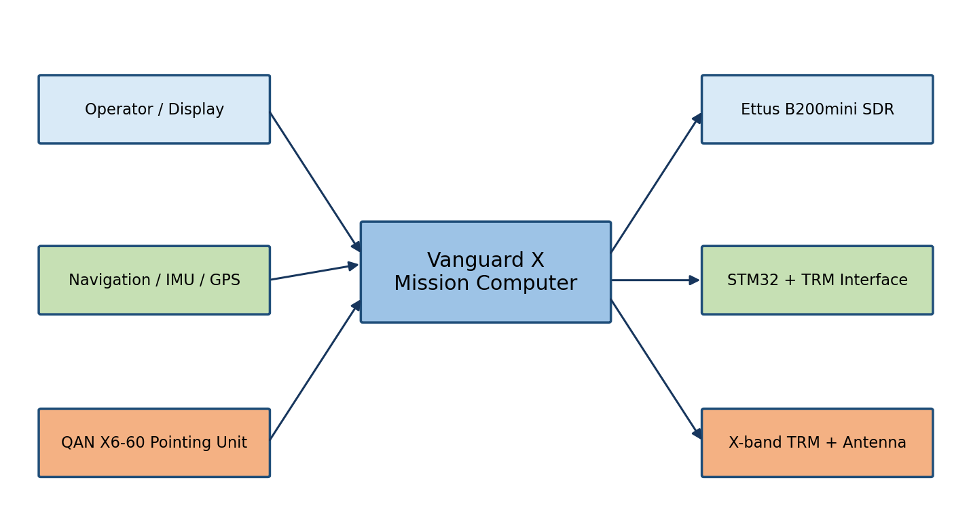
Figure 1. Vanguard X system context.

3.1 Hardware elements
- Linux MiniPC hosting the Vanguard mission-computer application.
- Ettus B200mini SDR providing timed receive acquisition and future timed waveform transmission and ATR GPIO.
- STM32 Nucleo and level-shifter HAT providing the 28-bit TRM serial configuration interface.
- X-band TRM, up/down conversion chain and antenna/radome assembly.
- QAN X6-60 motorised pointing unit with position feedback.
- IMU/GPS/INS or simulated navigation source.

3.2 Control ownership
Slow TRM configuration is written before operation or when settings change. Fast pulse-by-pulse transmit/receive switching belongs to Ettus ATR. Pointing commands belong exclusively to PointingManager through the X6-60 controller interface. RadarExecutor consumes measured PointingState and never commands the motor directly.

4. Software Architecture
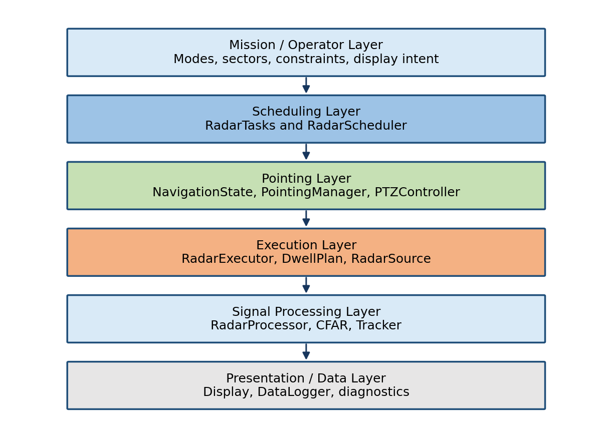
Figure 2. Vanguard X layered software architecture.

4.1 Current implemented modules
Module | Primary responsibility
RadarTasks.py | SearchTask, TrackTask, SearchSector, PointingRequest and RevisitRequest.
NavigationState.py | Timestamped platform heading, pitch and roll; simulation and future hardware adapters.
PointingManager.py | Coordinate conversion, continuous search, goto-and-hold tracking and motor ownership.
RadarScheduler.py | Persistent search, track queue, deadlines, task prioritisation and resumption.
RadarExecutor.py | Execution profile selection, DwellPlan construction, source execution and metadata.
EttusRadarSource.py | Bounded finite per-PRI timed SDR execution, TX/RX streamer ownership, receive-path warm-up and hardware diagnostics.
SimulatedSource.py | Architecture-compatible synthetic IQ source.
RadarProcessor.py | Pulse compression, Doppler processing and processed-dwell production.
CfarDetector.py | Detection thresholding and peak extraction.
RadarTracker.py | Blob formation, track initiation, maintenance and revisit requests.
RadarDisplayQt5.py | Operator presentation and status display.
DataLogger.py | Configuration-controlled data and diagnostic logging.

4.2 Dependency rule
Dependencies flow downwards through stable interfaces. Lower layers shall not make mission decisions. Hardware drivers shall not call the scheduler, detector or tracker. Presentation shall not own operational state.

5. Coordinate Frames
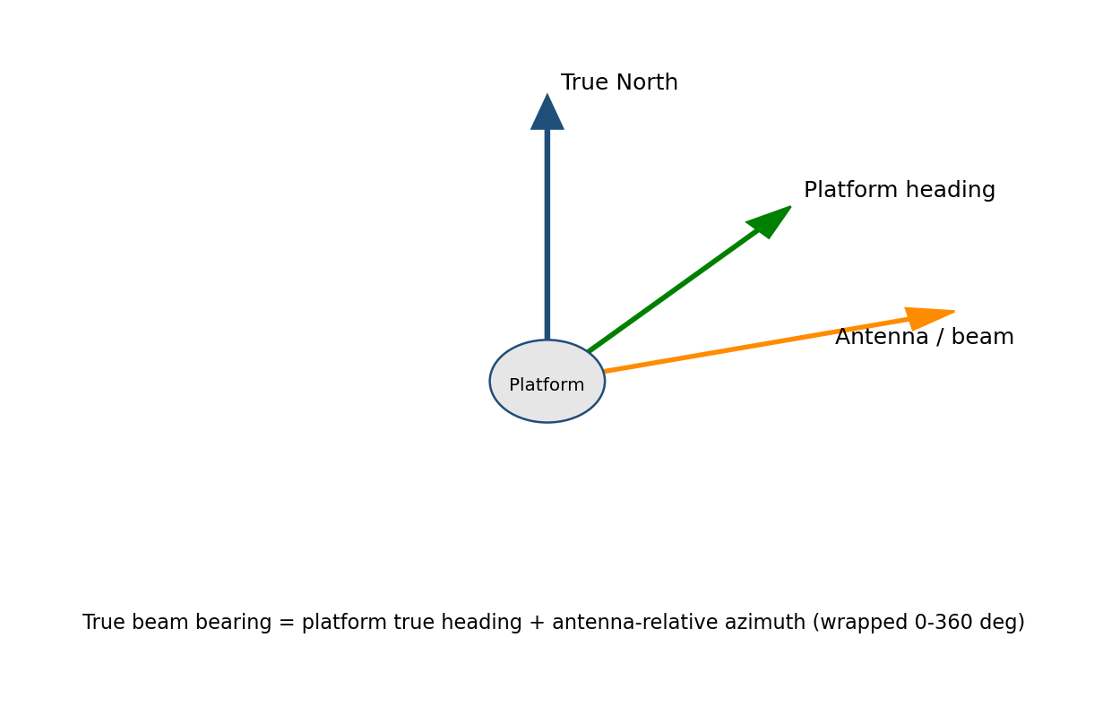
Figure 3. Relationship between true North, platform heading and antenna-relative azimuth.

5.1 Frames
- TRUE frame: bearings referenced to true North.
- PLATFORM frame: angles referenced to the platform body or bow.
- PTZ/antenna frame: encoder pan and tilt angles.
- BEAM frame: instantaneous illuminated line of sight.

5.2 Azimuth conversion
For the initial azimuth-only implementation, true beam bearing equals platform true heading plus antenna-relative azimuth, wrapped into 0-360 degrees. The inverse transformation subtracts platform heading from the requested true bearing. Full roll, pitch and tilt compensation will use a future three-dimensional rotation model.

5.3 Sector policies
- PLATFORM-fixed sectors remain fixed relative to the body and rotate in true coordinates as the platform turns.
- TRUE-fixed sectors remain geographically fixed and are continuously transformed into platform-relative motor coordinates.

6. Radar Task Model

6.1 RadarTask
RadarTask is the scheduler-domain representation of a radar action. It includes identity, task type, priority, pointing request, waveform profile, earliest start, deadline, status and metadata.

6.2 SearchTask
SearchTask owns a SearchSector and is persistent. Completion of one search dwell returns control to the scheduler without terminating the search mission.

6.3 TrackTask and RevisitRequest
Tracker emits RevisitRequest objects containing predicted range, true bearing, priority and deadline. RadarScheduler converts each request into a one-shot TrackTask. Duplicate queued requests for the same track update the existing task instead of causing uncontrolled queue growth.

6.4 Task invariants
- Tasks express intent, not hardware commands.
- Pointing requests use explicit coordinate frames.
- Waveform profiles select reusable waveform and processing recipes.
- A task may be selected only when its earliest-start constraint is satisfied.

7. Radar Scheduler

7.1 Scheduling policy
- An active task retains ownership until completed, failed or explicitly pre-empted.
- Ready track tasks outrank persistent search.
- Track selection uses base priority plus deadline urgency.
- Overdue track tasks receive a large urgency boost.
- When no track task is ready, persistent search is selected or resumed.

7.2 Search interruption and resumption
The active endpoint, direction, scan cycle and interrupted encoder angle are preserved when search is interrupted. After track completion, PointingManager resumes the same SearchTask and restores the valid search state.

7.3 Future cost model
- Estimated slew and settling time.
- Dwell duration and processing load.
- Track quality, manoeuvre and threat priority.
- Sector coverage debt and unsearched gaps.
- Calibration, passive-listen and interference-analysis obligations.

8. Pointing Architecture

8.1 Search pointing
PointingManager commands continuous slew toward the active endpoint and reverses when measured beam angle reaches or crosses that endpoint. Reversal uses measured motion and endpoint crossing to avoid repeated reversals at descending-sector boundaries.

8.2 Track pointing
Track tasks use GOTO_AND_HOLD. Requested true bearing is transformed into a platform-relative motor command. Readiness requires reachability, angular tolerance, low pan rate and any configured settling interval.

8.3 Mechanical limits
PointingManager validates converted relative azimuth against the configured mechanical window. Unreachable commands are identified and may be clipped for safe behaviour. Future scheduling policy may defer, reverse, flag incomplete coverage or request platform manoeuvre.

8.4 Measured pointing metadata
Every dwell shall carry measured encoder angle and navigation state corresponding as closely as practicable to illumination time. The initial implementation may use before-and-after position samples with dwell-centre interpolation. Future hardware shall use timestamped encoder and attitude streams.

9. Execution Architecture
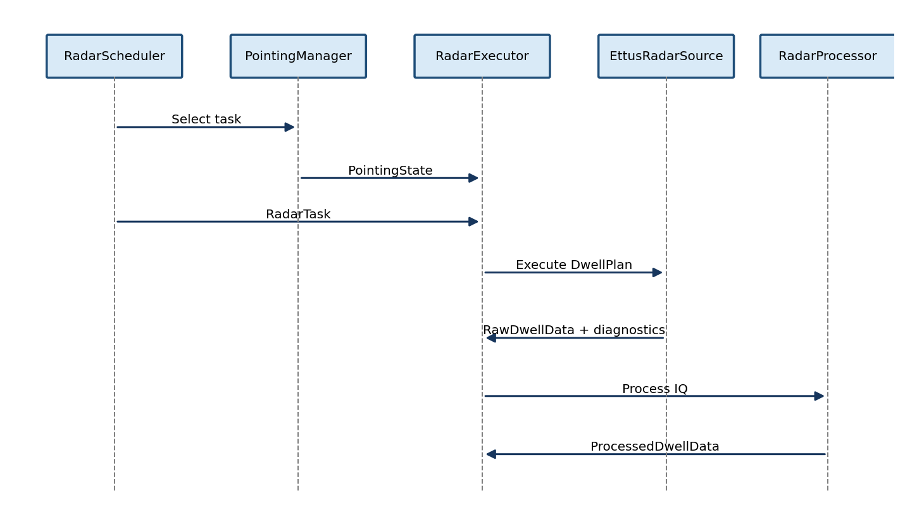
Figure 4. Scheduler-selected task execution through RadarExecutor.

9.1 RadarExecutor responsibilities
- Select an ExecutionProfile for the task.
- Construct the DwellPlan and associated processing intent.
- Verify pointing readiness and collect pointing provenance.
- Invoke the selected RadarSource implementation.
- Return ExecutionResult containing RawDwellData, DwellPlan, PointingState and diagnostics.

9.2 Excluded responsibilities
- Task selection.
- Motor-command generation.
- IQ processing or detection.
- Track-state maintenance.
- Display updates.

9.3 Source selection
SimulatedSource and EttusRadarSource implement the same operational source boundary. Runtime configuration selects the source. Hardware integration therefore remains localised to the execution layer and does not reshape Scheduler, PointingManager or RadarProcessor.

10. Pulse and Waveform Architecture

10.1 Waveform definitions
Waveforms are reusable immutable signal definitions stored by WaveformLibrary. Each definition contains WaveformId, code-family identity, chip sequence, chip count, nominal chip rate, fixed SDR sample rate, integer samples per chip, sampled waveform length and pulse duration. WaveformId explicitly includes nominal chip rate, for example Frank10_10MHz or Frank10_20MHz. Search or track purpose is not embedded in waveform samples; an execution profile associates a waveform with task and processing intent.
The initial hardware path uses a fixed 40 MS/s complex sample rate. Waveform bandwidth and pulse duration are changed through chip rate and samples per chip, not by changing the SDR sample rate.
The initial search waveform is Frank10_20MHz and the initial track waveform is Barker13_20MHz. At 20 Mchip/s these use two samples per chip: Barker13_20MHz contains 26 transmit samples and lasts 0.65 microseconds; Frank10_20MHz contains 200 transmit samples and lasts 5.00 microseconds.
Waveform chip rates shall divide 40 MS/s by an integer until fractional resampling is deliberately implemented. The initial catalogue supports 10 Mchip/s at four samples per chip and 20 Mchip/s at two samples per chip. Ambiguous rate-free identifiers such as Frank10 and Barker13 shall not be used in new plans or configuration.

10.1.1 Initial waveform identifiers
WaveformId | Chips | Chip rate | Samples/chip | TX samples | Pulse duration
Barker13_10MHz | 13 | 10 Mchip/s | 4 | 52 | 1.30 µs
Barker13_20MHz | 13 | 20 Mchip/s | 2 | 26 | 0.65 µs
Frank10_10MHz | 100 | 10 Mchip/s | 4 | 400 | 10.00 µs
Frank10_20MHz | 100 | 20 Mchip/s | 2 | 200 | 5.00 µs
The spelling and capitalisation of each WaveformId are part of the software interface. The suffix records nominal chip rate; it does not change the fixed 40 MS/s SDR sample rate.

10.2 PulsePlan
PulsePlan supports per-pulse waveform identity, PRI, transmit enable, amplitude, phase, frequency offset, receive delay, receive sample count and grouping metadata. PRI is derived from the selected PRF for the initial uniform-PRI path. This supports future complementary codes, PRI agility and frequency agility without changing the source interface.

10.3 DwellPlan and ProcessingPlan
DwellPlan describes one complete radar action, linking task identity, pointing, pulse sequence, attenuation and metadata. ProcessingPlan states how returned pulses are interpreted. The implemented hardware baseline uses uniform-PRI receive and standard Doppler FFT processing.

10.4 Advanced waveform constraints
- Golay A/B matched-filter outputs require complementary combination.
- Target Doppler between complementary pulses may degrade sidelobe cancellation.
- Nonuniform PRI requires actual pulse timestamps and a compatible slow-time algorithm.
- Waveform grouping metadata shall identify complementary or burst roles.
- The sampled transmit waveform is authoritative and shall be used unchanged by timed transmission, SimulatedSource and RadarProcessor matched filtering.
- Ideal phase-code processing gain is calculated from chip count, not from the expanded transmit sample count.

11. Signal Processing and Tracking

11.1 Processing chain
Raw IQ is pulse-compressed, windowed in slow time and transformed by Doppler FFT for uniform-PRI dwells. The detector operates on the range-Doppler power map. The tracker forms blobs, initiates tentative tracks, confirms tracks and maintains state estimates using an alpha-beta model.

11.2 Separation of concerns
- RadarProcessor does not choose search or track.
- Detector does not command waveform, TRM or pointing.
- Tracker outputs state estimates and RevisitRequest objects.
- Scheduler determines resource allocation.

11.3 Track coordinates
Tracks should ultimately be maintained in Earth-referenced coordinates. Existing azimuth-only measurements can migrate by attaching true beam bearing and platform attitude to detections while preserving platform-relative values as provenance.

12. Deployment and Hardware Control

12.1 STM32/TRM interface
The Linux host builds the complete 28-bit TRM word. The STM32 accepts PING, STATUS and WORD commands, shifts D0 first on DATA, presents falling CLOCK edges for sampling and pulses LOAD to latch configuration. This path is slow control and shall not be used for pulse-by-pulse T/R switching.

12.2 Ettus role
The Ettus B200mini executes finite hardware-timed transmit bursts and receive windows on one SDR clock. Version 0.7c has validated TX and RX independently and as bounded matched pairs under protected cable-loopback conditions. ATR GPIO timing remains disabled and shall be oscilloscope-verified before the TRM or PA is connected.

12.3 Pointing and navigation
The controller interface provides simulated and Pelco-D implementations for the X6-60. NavigationState currently supplies simulated attitude and can later be replaced by an IMU/GPS/INS adapter without changing scheduler or pointing interfaces.

13. SDR Execution Architecture

13.1 Purpose and boundary
This chapter defines deterministic SDR execution. RadarExecutor owns task-to-dwell translation; EttusRadarSource owns conversion of that DwellPlan into timed UHD receive commands and return of RawDwellData. The scheduler is intentionally unaware of UHD streamers, hardware timestamps and USB transport details.
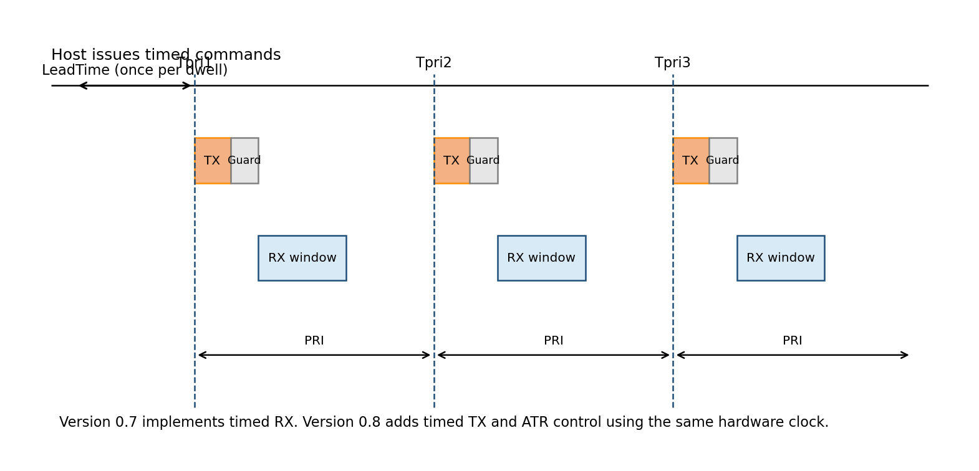
Figure 5. Hardware-timed PRI, transmit, guard and receive-window model.
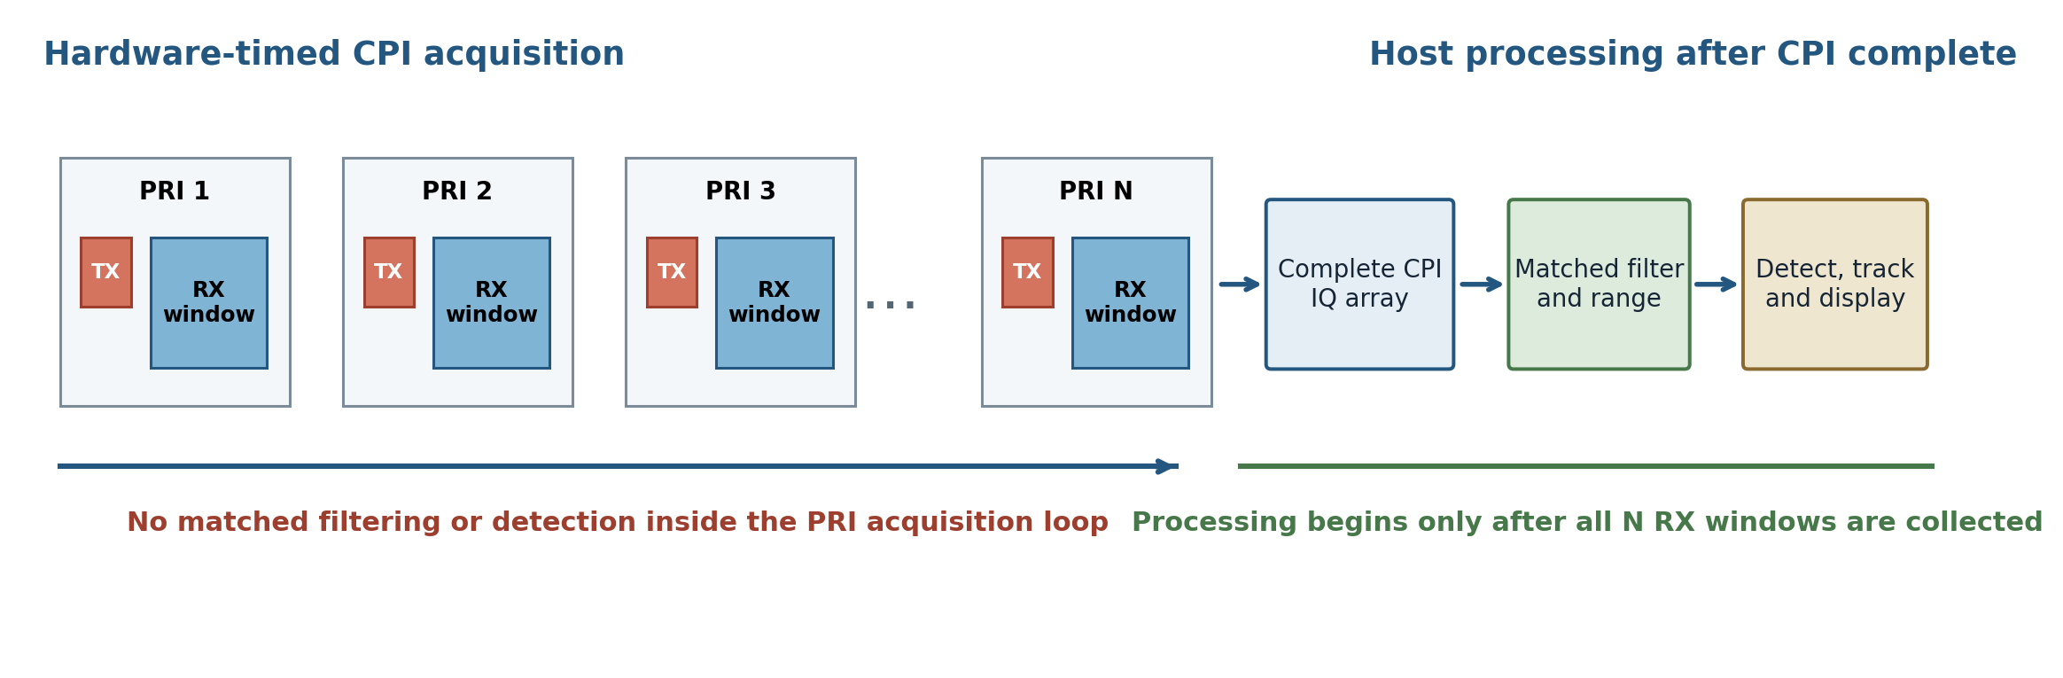
Figure 6. Complete-CPI acquisition followed by post-CPI signal processing.

13.2 Time domains
Time domain | Owner | Use
Wall time | Linux host | Logging, scheduler cadence and operator status.
Python monotonic time | Application | Performance measurement and host-side timeout control.
SDR hardware time | Ettus FPGA/driver | Deterministic timed command execution.
PRI-relative time | DwellPlan | Pulse and receive-window offsets from Tpri1.
CPI time | Radar execution | Interval covering the pulse train and associated receive windows.
Dwell time | RadarExecutor | Pointing readiness, SDR execution and return of execution metadata.

13.3 Hardware start time
For each dwell, EttusRadarSource reads the current SDR hardware time and establishes Tpri1 by adding EttusCommandLeadTimeSec. The lead time is a host-to-SDR scheduling margin. It is not a PRI, receiver delay or radar guard interval.

13.4 Bounded finite per-PRI execution
- Warm the receive path once, then determine one future hardware start time for the dwell.
- Calculate every TX and RX time from Tpri1 plus fixed PulsePlan offsets; do not query hardware time inside the PRI loop.
- Prime a bounded queue of finite individual PRI operations and replenish one pair immediately after the oldest RX window is collected.
- Check every TX send count and asynchronous event, and collect RX samples into an array shaped (NumPulses, NumSamples).
- Record TX acknowledgements, late/time events, underflows, RX metadata errors, timestamps, received-sample counts and validity diagnostics.
- Complete the CPI before matched filtering or other signal processing, then return RawDwellData through RadarExecutor.

13.5 Command lead time rule
Command lead time shall be applied once per dwell. Subsequent pulse or receive-window times are calculated from Tpri1 + n x PRI or from explicit PulsePlan offsets. Applying lead time separately to each PRI would incorrectly stretch the CPI and couple radar timing to host command latency.

13.6 Observed hardware validation
Receive-only hardware tests used 40 MS/s, Frank10_20MHz, 4 kHz PRF, 128 pulses and 4,043 RX samples per pulse. A fixed depth-20 RX pipeline returned all 517,504 samples without timeout, overflow or late command. Protected combined TX/RX loopback used a depth-8 paired pipeline at 4 kHz and 128 pulses; all 128 TX sends, burst acknowledgements and RX windows completed with zero transport errors and a repeatable +175 ns RX timestamp offset.
Metric | Observed baseline | Interpretation
Scheduler wall interval | 100-102 ms | Approximately 10 dwells per second.
Ettus collection | 11.76-11.93 ms | 5 ms lead plus CPI and transport overhead.
Processing | 8-13 ms | Pulse compression and Doppler processing.
Detect + Track | ~3 ms | Current zero-detection baseline.
Display | ~4 ms | Qt display update.
Total active dwell | 27-31 ms | Approximately 70 ms scheduling margin.

13.7 State machine
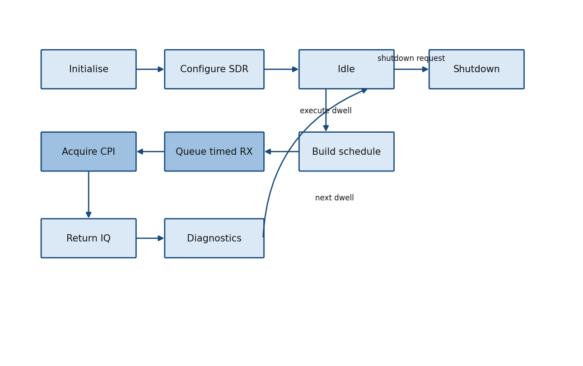
Figure 7. EttusRadarSource execution state machine.

13.8 Timed transmit and receive pairing
Timed transmit reuses Tpri1 and the fixed 40 MS/s hardware clock. Each pulse uses the authoritative sampled waveform from WaveformLibrary and explicit start/end-of-burst metadata. The host maintains a bounded horizon of finite pulse-specific operations rather than queuing an unbounded dwell or using continuous receive. Queue replenishment occurs before copying, diagnostic formatting or processing can consume the scheduling horizon. Operationally, TX occurs at Ttx[n] and RX begins only after TX is inactive and the configured guard has elapsed.

13.9 Protected loopback evidence
The non-operational cable-loopback test connected TX/RX through 30 dB attenuation to RX2, with TX gain 50 dB and RX gain 30 dB. RX opened at T and the 5 microsecond Frank10_20MHz pulse was scheduled at T + 10 microseconds so it could be observed directly. At 4 kHz and 128 pulses, the matched-filter peak was 31.56-47.69 dB above the estimated floor and locked on every pulse. The measured diagnostic-path delay was 166 samples (4.15 microseconds), with the physical response at sample 566. This value is test-path calibration evidence, not yet an operational range correction.

13.10 SDR design rules
- Never use Python sleep timing for individual radar pulses.
- Hardware timestamps own PRI execution.
- Maintain a bounded future command horizon and replenish immediately after collection of the oldest RX window.
- Perform pulse compression and all other CPI processing only after the complete dwell has been captured.
- Preserve actual hardware timestamps and receive validity metadata.
- Keep receive-only mode available until timed TX and ATR verification are complete.
- Treat late commands, overflows and timeouts as explicit execution faults.
- Derive PRI from the validated operator-selected PRF; do not expose independent PRF and PRI settings.
- Reject a PRF when its derived PRI is shorter than the timing-derived minimum PRI.

14. Timing Architecture

14.1 Dwell timing
A dwell consists of pointing-state acquisition, optional TRM state verification, SDR timed execution, raw-data return and downstream processing. Pointing and SDR time shall be recorded for provenance. Host scheduler cadence is distinct from PRI and CPI timing. For the initial uniform-PRI path, CPI duration equals the number of pulses per CPI multiplied by PRI.

14.2 Receive timing
Receive start time is derived from the pulse plan. In the timed-TX path, Trx[n] = Ttx[n] + TxPulseWidth[n] + ReceiverRecoveryTime[n]. ATR receive enable shall assert only after transmit enable is low and the configured switching and receiver-recovery interval has elapsed. Receiver recovery and guard values remain provisional until measured on the oscilloscope.
To capture the complete coded return from maximum range, receive end time equals maximum-range round-trip delay plus transmit pulse duration plus end margin. The receive sample count is the ceiling of receive capture duration multiplied by 40 MS/s.
When capture starts after transmission, received sample zero represents a non-zero range. RawDwellData shall carry the receive-window start delay, and RadarProcessor shall include the corresponding range offset in the range axis.

14.3 PRI agility
Uniform PRI remains the initial hardware path. The operator selects PRF from 1.0 to 4.0 kHz, with 2.0 kHz as the default; software derives PRI as the reciprocal of PRF. The operator also selects pulses per CPI, with 32 as the default. Staggered and jittered PRI require actual pulse timestamps and a compatible nonuniform slow-time processor.
The UI shall display derived PRI, CPI duration, unambiguous radial velocity, velocity-bin spacing and estimated antenna movement during the CPI.
The execution layer shall validate every selection independently of the UI. The accepted PRF shall remain within 1-4 kHz and its derived PRI shall not be shorter than maximum-range echo completion plus configured margins and the next-transmit guard.

14.4 Timing budget
Function | Typical budget | Owner
Command lead time | 5 ms | EttusRadarSource
Default CPI | 16 ms (32 pulses at 2 kHz PRF) | Operator selection + SDR hardware
Signal processing | 8-13 ms | RadarProcessor
Detection and tracking | ~3 ms | Detector / Tracker
Display update | ~4 ms | RadarDisplayQt5
Scheduler interval | 100 ms | Main scheduler loop
SDR sample rate | 40 MS/s fixed | WaveformLibrary / EttusRadarSource
Operator PRF range | 1-4 kHz; 2 kHz default | Operator UI / RadarExecutor
Receiver recovery and guards | Provisional until scope measurement | RF hardware verification

15. Interfaces and Data Contracts
Interface / object | Producer | Consumer | Responsibility
RadarTask | RadarScheduler | PointingManager, RadarExecutor | High-level radar action and constraints.
PointingState | PointingManager | RadarExecutor, logger, display | Measured and commanded pointing, readiness and reachability.
PulsePlan | Execution profile / RadarExecutor | RadarSource, RadarProcessor | Per-pulse timing, waveform and receive intent.
DwellPlan | RadarExecutor | RadarSource, RadarProcessor | Complete executable radar action.
ExecutionResult | RadarExecutor | Main loop | DwellPlan, RawDwellData, pointing and diagnostics.
RawDwellData | RadarSource | RadarProcessor | Pulse-by-sample complex IQ with validity metadata.
ProcessedDwellData | RadarProcessor | Detector, Tracker, Display | Range-Doppler products and processing metadata.
RevisitRequest | Tracker | RadarScheduler | Requested future observation of a track.

15.1 Required execution metadata
- DwellId, TaskId, TaskType and optional TrackId.
- Requested and measured pointing.
- Platform attitude and true beam bearing.
- Pulse waveform identifiers and requested/actual pulse times.
- Waveform chip count, chip rate, samples per chip, sampled waveform length and pulse duration.
- Selected PRF, derived PRI, pulses per CPI and calculated CPI duration.
- Receive-window start delay, receive sample count, maximum instrumented range and range-axis offset.
- Requested and validated timing margins, including provisional or measured status.
- TRM settings and source configuration.
- Dropped-sample, overflow, timeout and late-command flags.
- Processing mode and adaptation reason.

15.2 Compatibility rule
Hardware and simulation sources shall return compatible RawDwellData. Downstream code shall not branch on source type except for source-specific diagnostics and operator display.

16. Diagnostics and Fault Handling

16.1 SDR diagnostics
- LateCommandCount.
- TimeoutCount.
- OverflowCount.
- ReceivedSamples per pulse and dwell.
- ValidPulseMask.
- Scheduled first and last hardware times.
- Actual collection duration.
- Configured and maximum outstanding finite TX/RX command depth.
- TX send count, burst acknowledgement count and asynchronous underflow/time/sequence events.
- CommandLeadTimeAppliedOncePerDwell flag.

16.2 Fault policy
A single invalid pulse may be marked invalid while preserving the dwell for diagnostic processing. Repeated late commands, overflows or timeouts shall cause the dwell to fail and be reported to RadarExecutor. The scheduler may retry, defer the task or enter a safe mode according to future policy.

16.3 Shutdown
Shutdown shall stop active streaming, release the UHD streamer and device references, close pointing and TRM interfaces and permit the Qt application to terminate cleanly. Exceptions during shutdown shall be logged without preventing remaining resources from being released.

17. Verification Strategy
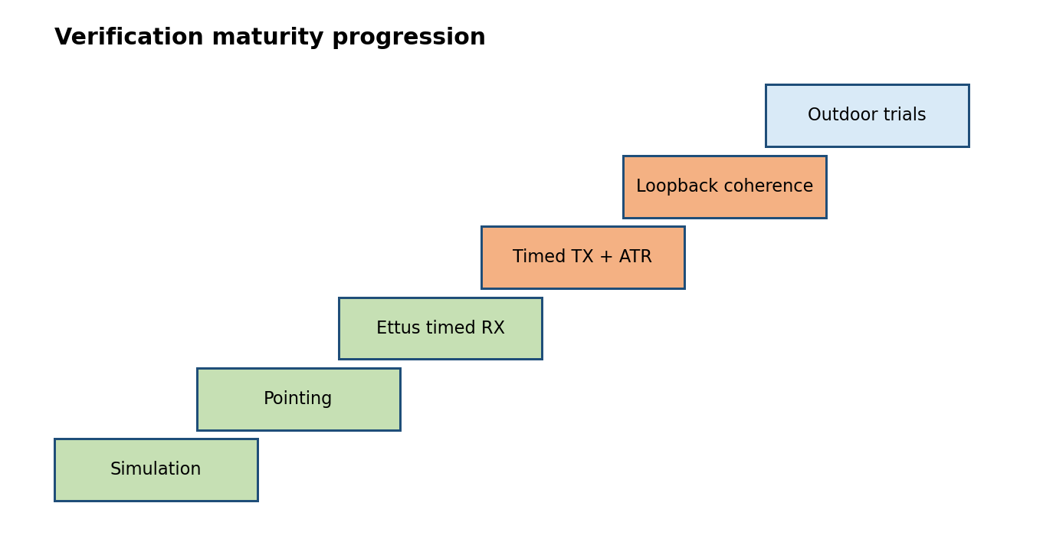
Figure 8. Verification maturity progression.

17.1 Simulation-first rule
Major architectural behaviour is validated with SimulatedSource, SimulatedPTZController and SimulatedNavigationSource before hardware changes. Hardware implementations replace interfaces rather than reshape the architecture.

17.2 Version 0.7c completed verification
- UHD Python bindings load under the selected non-Snap Python environment.
- Ettus B200mini is detected over USB3.
- Receive tuning and bounded finite per-PRI RX execution complete successfully through 4 kHz and 128 pulses.
- Timed Frank10_20MHz transmission produces the expected 200-sample, 5 microsecond RF pulse.
- Protected combined loopback passes at 4 kHz, 128 pulses and paired depth 8 with 128/128 sends, acknowledgements and RX windows.
- Matched filtering occurs after CPI collection and locks to the calibrated response on every pulse.
- Scheduler cadence, simulated PTZ angle step, processing, display and clean shutdown remain stable.

17.3 Outstanding ATR and operational-path verification
- Oscilloscope measurement of PRI and pulse count.
- Measurement of TX-to-RX guard interval.
- Confirmation that the first pulse of each dwell follows the scheduler cadence without accumulated drift.
- ATR non-overlap and receiver-recovery verification before connection to the 50 W path.
- Verification of range-axis offset when the receive window begins after transmit and receiver recovery.

18. Requirements Traceability
Requirement | Statement | Architecture | Implementation | Verification
VX-SYS-001 | Simulation and hardware sources shall use a common operational interface. | Sections 4, 9, 15 | SimulatedSource.py; EttusRadarSource.py | Source regression tests
VX-SYS-002 | Only one component shall command antenna movement. | Section 8 | PointingManager.py | Pointing regression
VX-EXEC-001 | RadarExecutor shall own task-to-dwell translation and source execution. | Section 9 | RadarExecutor.py | Execution-path regression
VX-SDR-001 | Pulse and receive timing shall use SDR hardware timestamps. | Sections 13, 14 | EttusRadarSource.py | Timed receive test
VX-SDR-002 | Command lead time shall be applied once per dwell. | Section 13.5 | EttusRadarSource.py | Collection-time evidence
VX-SDR-003 | Finite per-PRI TX/RX operations shall use a bounded future command horizon. | Sections 13.4, 13.8 | EttusRadarSource.py | 4 kHz / 128-pulse hardware test
VX-PTZ-001 | Measured pointing shall be associated with every dwell. | Sections 8, 15 | PointingManager.py; RadarExecutor.py | Metadata inspection
VX-PROC-001 | RadarProcessor shall not command hardware. | Sections 4, 11 | RadarProcessor.py | Architecture review
VX-TRM-001 | STM32 shall provide slow 28-bit TRM control only. | Section 12.1 | TRMInterface.py; TRMController.py | Scope and protocol test
VX-VER-001 | Timed TX and ATR non-overlap shall be scope-verified before connection to the high-power path. | Section 17.3 | Version 0.7c TX; Version 0.8 ATR | TX scope evidence complete; ATR CRO procedure outstanding
VX-WFM-001 | The initial SDR sample rate shall remain fixed at 40 MS/s. | Sections 10, 13 | WaveformLibrary.py; EttusRadarSource.py | Waveform metadata and rate test
VX-WFM-002 | Transmit, simulation and matched filtering shall use the same sampled waveform. | Section 10 | WaveformLibrary.py; SimulatedSource.py; RadarProcessor.py | Waveform identity regression
VX-WFM-003 | WaveformId shall include nominal chip rate and resolve to complete sampled-waveform metadata. | Section 10.1 | WaveformLibrary.py; RadarExecutor.py | Waveform catalogue and invalid-identifier tests
VX-TIM-001 | The operator shall select PRF from 1-4 kHz and pulses per CPI; PRI and CPI duration shall be derived. | Section 14 | RadarDisplayQt5.py; RadarExecutor.py | UI and plan validation test
VX-TIM-002 | Receive timing and sample count shall be derived from waveform duration, recovery, margins and maximum range. | Sections 14, 15 | RadarPlans.py; RadarExecutor.py; EttusRadarSource.py | Timing-model unit test and scope verification
VX-SDR-004 | Timed TX/RX execution shall check every TX send/acknowledgement and every finite RX window. | Sections 13.8, 16.1 | EttusRadarSource.py | Protected paired-loopback test
VX-PROC-002 | CPI processing shall begin only after acquisition of the complete dwell. | Sections 11, 13.10 | RadarProcessor.py; acquisition harness | Post-CPI processing regression

19. Development Roadmap
Baseline | Content | Hardware impact | Status
0.3 | Tasks, navigation, pointing and scheduler modules | None | Complete
0.4 | RadarExecutor profiles, plans and execution metadata | None | Complete
0.6 | PointingManager sole motor ownership | Motor simulator and PTZ | Complete
0.7 | Ettus hardware-timed receive execution | B200mini receive | Implemented baseline
0.7b | Fixed 40 MS/s waveform and operator timing decisions | No transmit enable; software contract and implementation preparation | Superseded
0.7c | Bounded timed TX/RX protected hardware validation | B200mini low-power TX and attenuated RX2 loopback; TRM disconnected | Current hardware-validation baseline
0.8 | Operational TX/RX timing, ATR GPIO and guard verification | B200mini ATR outputs observed on CRO; TRM initially disconnected | Next
1.0 | Operational multifunction radar engineering baseline | Integrated platform | Planned

19.1 Immediate next steps
- Commit the Version 0.7c bounded timed TX/RX hardware-validation baseline and supporting test evidence.
- Configure TX and RX ATR GPIO with the TRM disconnected and verify pulse width, non-overlap and guard timing on the oscilloscope.
- Integrate the validated bounded paired pipeline into the operational EttusRadarSource while retaining receive-only mode.
- Measure receiver recovery and replace provisional guard values with controlled hardware evidence.
- Calibrate operational range offset separately from the 166-sample diagnostic cable-loopback delay.
- Run operational non-overlapping TX-at-T and RX-at-T+6 microsecond timing tests across 1-4 kHz.
- Connect the TRM only after ATR polarity, idle state and non-overlap are verified.
- Profile acquisition and post-CPI processing; consider CPU affinity only if measured scheduling margin requires it.

Appendix A. Architecture Decision Records

ADR-0001: PulsePlan/DwellPlan architecture
Status: Accepted
Decision and rationale: Represent pulse-by-pulse waveform, timing and processing intent without changing source or processor APIs.

ADR-0002: Separate scheduling and pointing
Status: Accepted
Decision and rationale: Scheduler chooses tasks; PointingManager owns coordinate transformation and antenna control.

ADR-0003: Explicit TRUE and PLATFORM frames
Status: Accepted
Decision and rationale: Moving-platform search and track pointing require unambiguous coordinate ownership.

ADR-0004: Simulation-first validation
Status: Accepted
Decision and rationale: Reduce risk and prevent hardware timing concerns from distorting software boundaries.

ADR-0005: STM32 slow control; Ettus fast T/R
Status: Accepted
Decision and rationale: Keep pulse timing deterministic while retaining the STM32 as a stable configuration engine.

ADR-0006: RadarExecutor owns execution semantics
Status: Accepted
Decision and rationale: Localise task-to-dwell translation, profile selection, source execution and metadata.

ADR-0007: Single motor command owner
Status: Accepted
Decision and rationale: Prevent conflicting commands, endpoint oscillation and split scan state.

ADR-0008: SDR hardware time owns radar timing
Status: Accepted
Decision and rationale: Host scheduling is nondeterministic at PRI scale; FPGA hardware time provides deterministic execution.

ADR-0009: One lead time per dwell
Status: Accepted
Decision and rationale: Lead time exists only to allow commands to reach the SDR before Tpri1 and shall not stretch the pulse train.

ADR-0010: Fixed 40 MS/s SDR sample rate
Status: Accepted
Decision and rationale: Use a fixed 40 MS/s complex sample rate for the initial hardware path. Represent waveform bandwidth through chip rate and integer samples per chip so SDR configuration remains stable. The initial catalogue uses the explicit identifiers Barker13_10MHz, Barker13_20MHz, Frank10_10MHz and Frank10_20MHz; rate-free identifiers are not permitted in new plans.

ADR-0011: Authoritative sampled waveform
Status: Accepted
Decision and rationale: Expand the phase-code chips once in WaveformLibrary and use the same sampled complex waveform for timed transmission, simulation and matched filtering. Preserve chip count separately for code identity and ideal processing-gain calculation.

ADR-0012: Operator-selectable PRF and CPI pulse count
Status: Accepted
Decision and rationale: Expose PRF from 1.0 to 4.0 kHz and pulses per CPI through the front UI, with defaults of 2.0 kHz and 32 pulses. Derive PRI and CPI duration so contradictory timing inputs cannot be entered independently. Validate the selection below the UI boundary.

ADR-0013: Range-derived receive timing
Status: Accepted
Decision and rationale: Derive receive start, receive end, sample count, buffer size, range-axis offset and maximum safe PRF from sampled waveform duration, receiver recovery, maximum instrumented range and configured timing margins. Recovery and guard values remain provisional until measured.

ADR-0014: Bounded finite per-PRI command pipeline
Status: Accepted
Decision and rationale: Use finite pulse-specific timed TX bursts and RX windows within a bounded future horizon. Replenish immediately after collecting the oldest RX window. This avoids unbounded command queues, continuous-RX semantics and host-latency collapse while preserving pulse-level ATR intent.

ADR-0015: Post-CPI signal processing
Status: Accepted
Decision and rationale: The timing-critical acquisition loop performs only queue replenishment, streamer I/O and minimal validity accounting. Matched filtering, Doppler processing, plotting and diagnostic formatting occur after the complete CPI is captured.

Appendix B. Acronyms and Glossary
Term | Definition
ATR | Automatic transmit/receive control provided by SDR GPIO.
CPI | Coherent Processing Interval.
Dwell | One radar action containing one or more pulses and associated processing.
PRI | Pulse Repetition Interval.
Tpri1 | Hardware timestamp of the first PRI in a dwell.
LeadTime | Host-to-SDR scheduling margin added once to establish Tpri1.
RawDwellData | Pulse-by-sample complex IQ and source validity metadata.
PointingState | Measured and commanded pointing solution produced by PointingManager.
TRUE frame | Bearing referenced to true North.
PLATFORM frame | Angle referenced to the platform body or bow.
TRM | Transmit/Receive Module.
X6-60 | QAN X6-60 motorised pan/tilt pointing unit.
UHD | USRP Hardware Driver.
USRP | Universal Software Radio Peripheral.
PRF | Pulse Repetition Frequency; the reciprocal of PRI.
WaveformId | Stable waveform identifier containing code family/order and nominal chip rate, for example Frank10_20MHz.

Appendix C. Design Philosophy

C.1 Architecture before hardware
The architecture defines stable responsibilities first. Hardware drivers are inserted behind established boundaries so the scheduler, pointing and processor remain testable and replaceable.

C.2 Deterministic timing at the correct layer
Linux and Python are appropriate for mission logic and dwell scheduling but not individual pulse timing. Hardware timestamps and FPGA-controlled I/O own PRI, transmit and receive timing.

C.3 Single ownership of stateful resources
A motor, SDR stream or TRM configuration path shall have one operational owner. Other components consume state or request actions through interfaces.

C.4 Provenance is part of the data
IQ without pulse timing, pointing, navigation and hardware status is incomplete. Metadata is required for calibration, debugging, replay and later adaptive behaviour.

C.5 Simulation and hardware equivalence
Simulation is not a separate application. It uses the same task, pointing, execution and processing contracts so architectural behaviour can be verified before hardware risk is introduced.

C.6 Incremental verification
Receive-only operation remains available while timed transmit is added. Low-power scope and loopback verification precede connection to the high-power RF path.

END OF DOCUMENT

