Go to “Manage Jenkins”

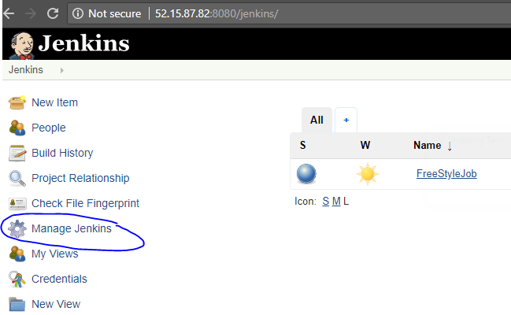

Click on manage nodes:

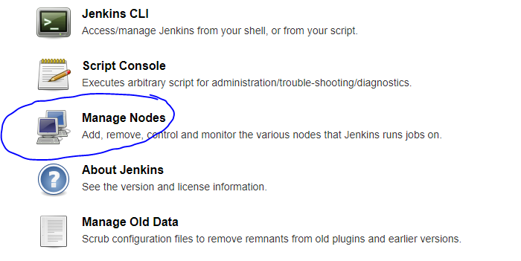

Click on new node:

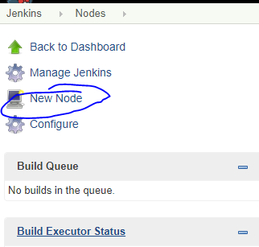

Give the node name: ex: “slave1”

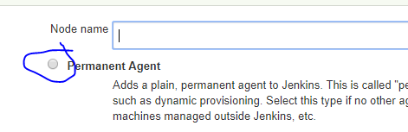

**Remote root directory**: Give the path where Jenkins job should execute: for that you can give the existing path OR you can create one folder in slave machines then give that path.

In this example, created a folder “Jenkins” under the default user “ec2-user” in AWS EC2 REDHAT instance.

**Give IP Address for “HOST”**: Run the command “ip addr” or “ip a” or “ifconfig” or you can find the private IP address over the AWS console.

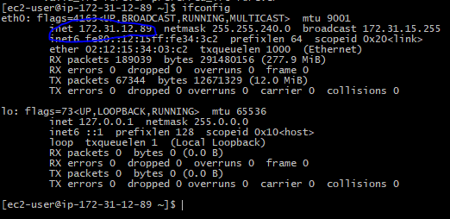

Choose the launch method as shown below. Or you can choose your own method if you aware.

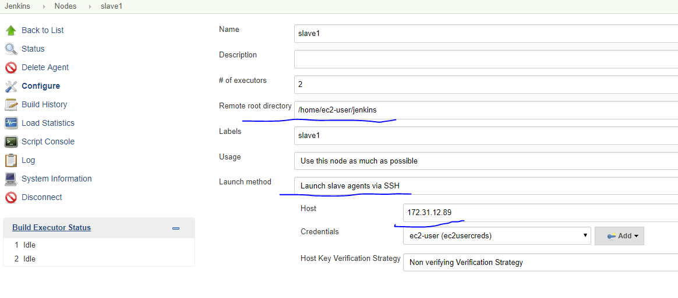

Master Jenkins machine need to connect with slave Linux machine. For this we have to configure credentials.

Click on Add🡪Jenkins.

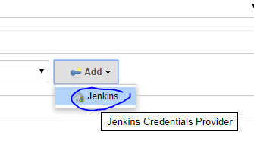

**Username and password**: You can enter directly the **Username and password** of the slave machine.

But, Here I am selecting, SSG Username with privatekey.

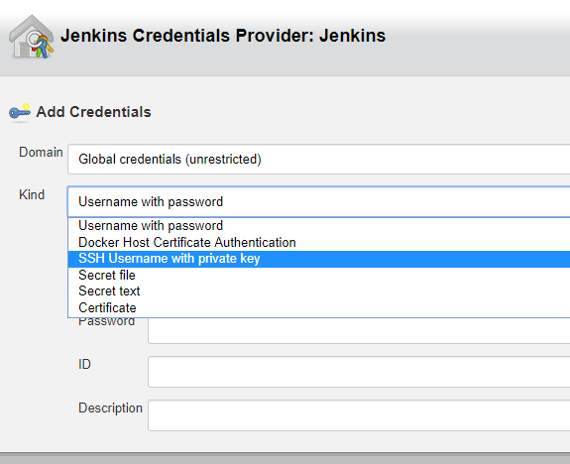

Username: ec2-user

Private Key: Enter directly

When you are working with AWS instance, you should have “*.pem” file to connect the linux instance (which is created for slave).

Copy the RSA private key from “*.pem” file and paste it here.

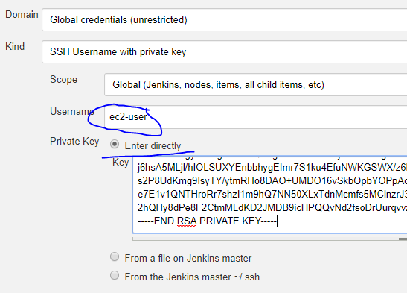

Enter any specific value for “ID” & “Description”. Don’t leave those are empty.

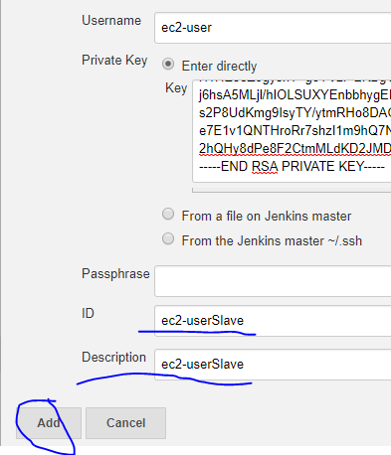

Choose the cred id which is added for this.

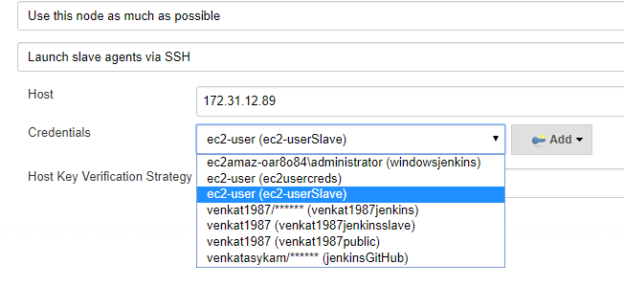

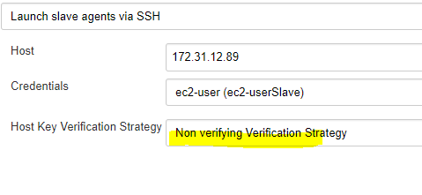

Click on SAVE. You will be prompted to the below window. Click on **relaunch agent**. Make sure java installed on the slave machine.

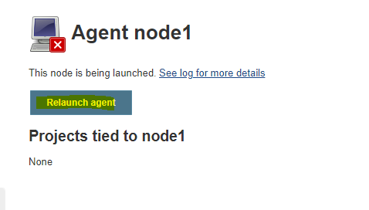

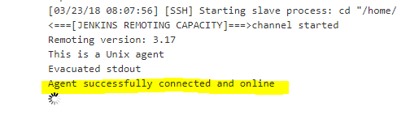

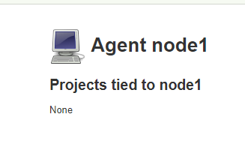

List of Online nodes:

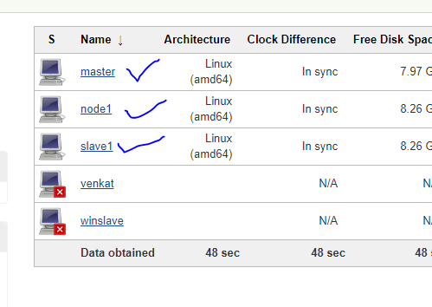

Go to slave1 configuration and add the paths of the node. To work with Jenkins builds we need to install the required tools on the slave machine.

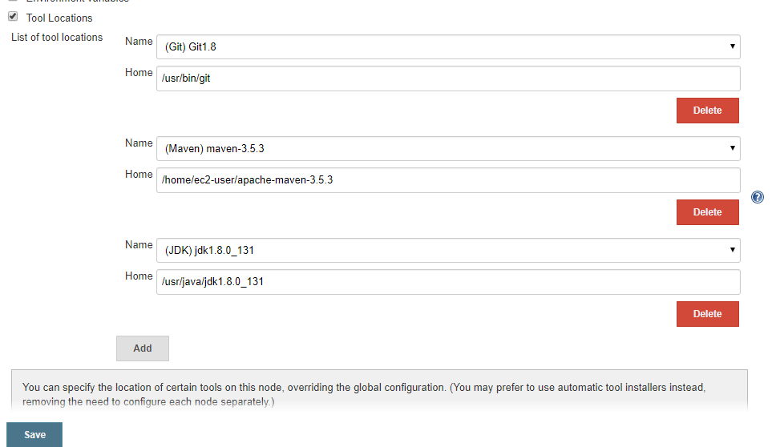

Sample example job which is configured & running on the **slave1** machine.

Go to Jenkins job configuration🡪 select restrict where this project can be run🡪 choose **slave1 🡪** save the job config & triger the job.

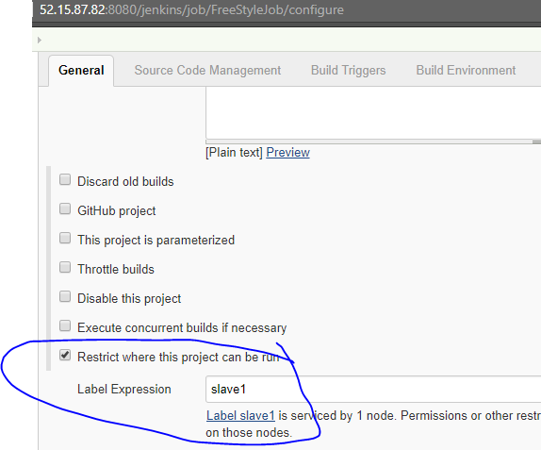

See the build console, its running “slave1” machine.

