|  |  |  |
| --- | --- | --- |
| **Section** | **Topic** | **Pages** |
| A | Launch the EC2 redhat instance in AWS & connect to the instance. | 1-6 |
| **B** | **Tomcat Start-up.** | 7-11 |
| **C** | **Jenkins Start-up** & sample job configuration. | 12-25 |

1. Launch the EC2 redhat instance in AWS & connect to the instance.
2. Login to AWS 🡪Services (top left side) 🡪 EC2.

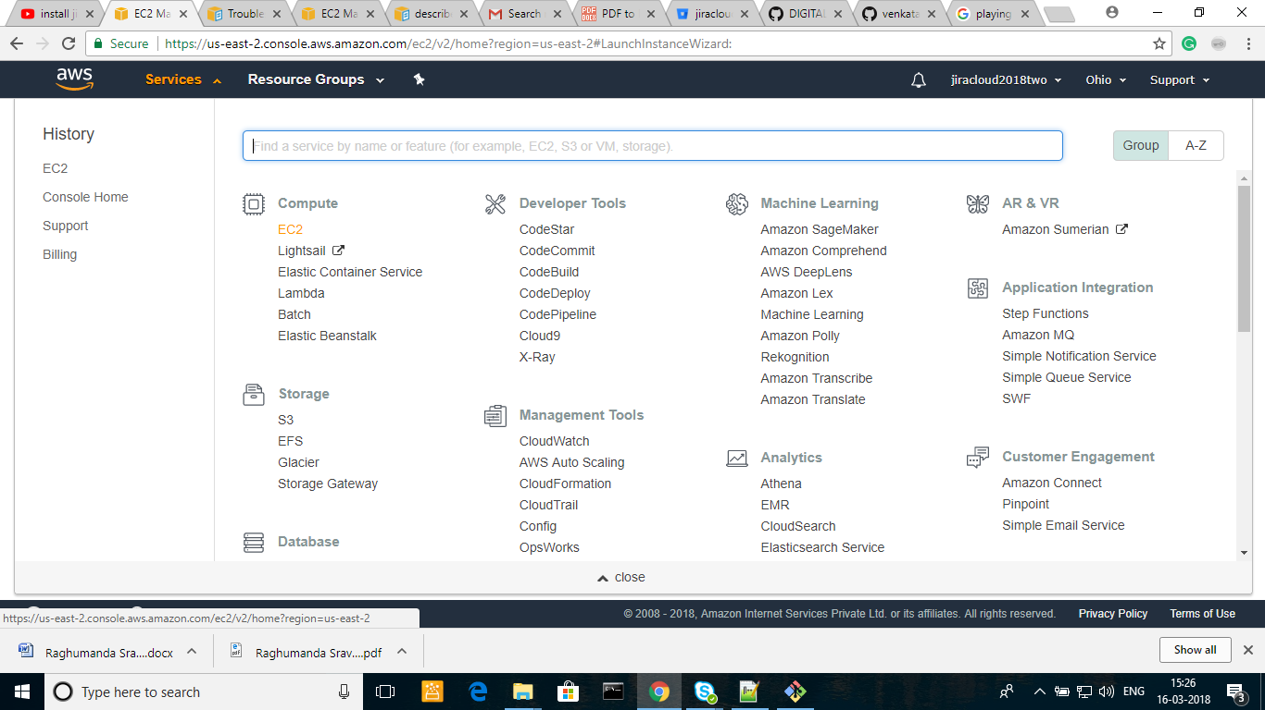

1. Click on “Launch Instance”.

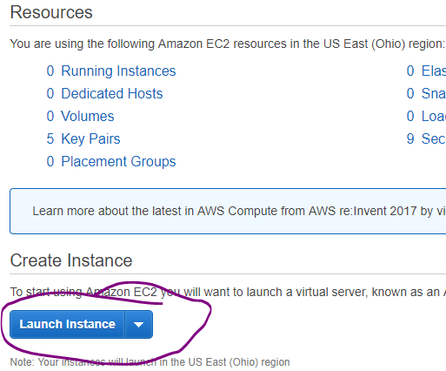

Choose “Free Tier Only”🡪Choose RHEL machine.

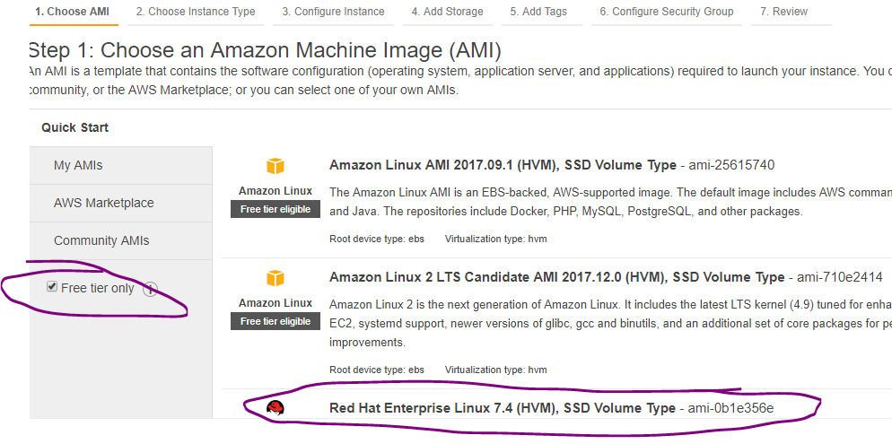

Default size is 10GB (its more enough for us) 🡪 click on “Review and Launch”.

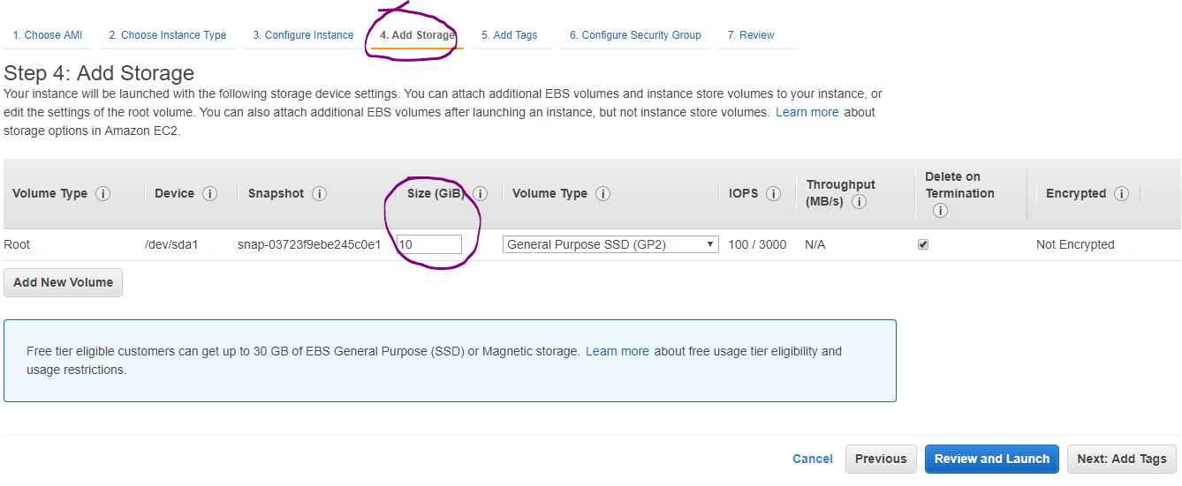

Click on Launch.

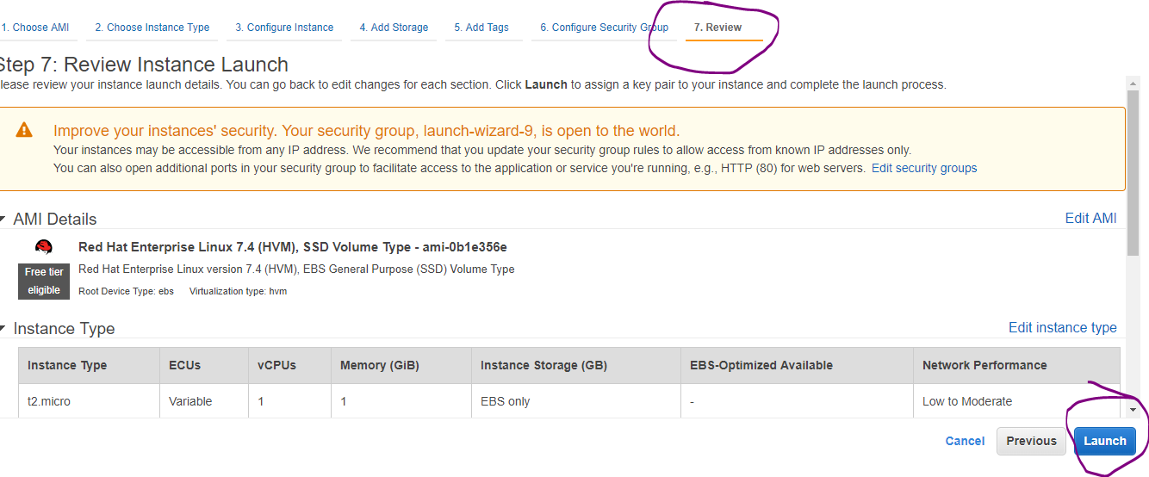

Select “Create a new key pair” 🡪 give the file name🡪 download🡪 file will be downloaded to your local machine. 🡪 click on Launch Instances.

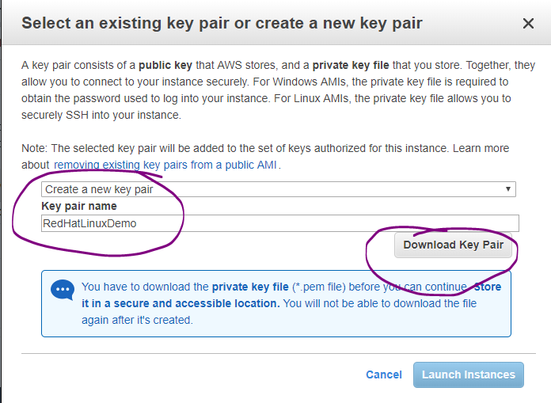

Scroll down in this page and click on view launch

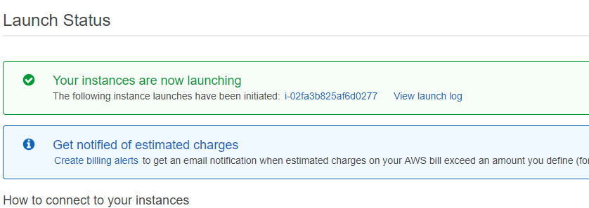

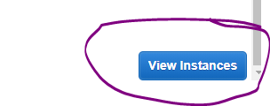

You can give the instance name which is showing empty below. Choose the instance & click on connect if you want to connect.

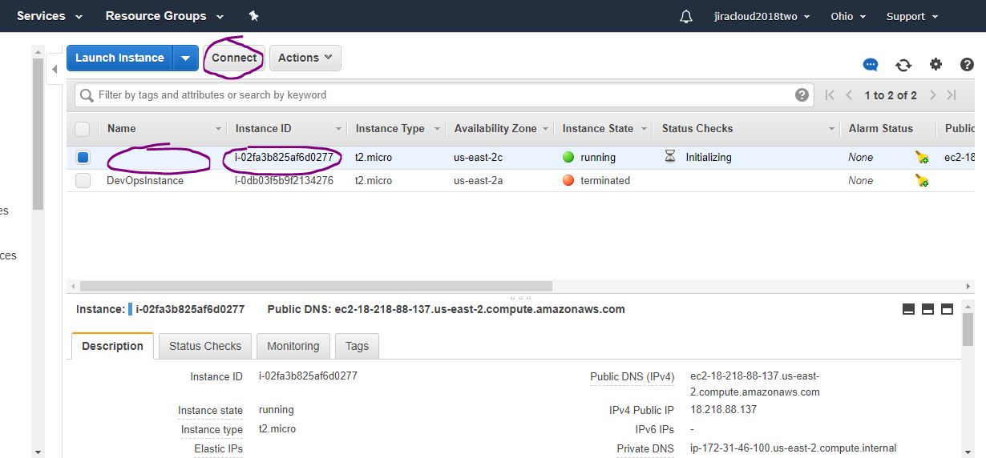

You can give the instance name as showing below.

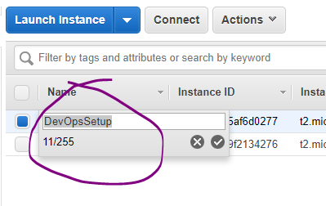

Choose the instance & click on connect. Copy the ssh command & paste it on “git bash” to connect to the instance.

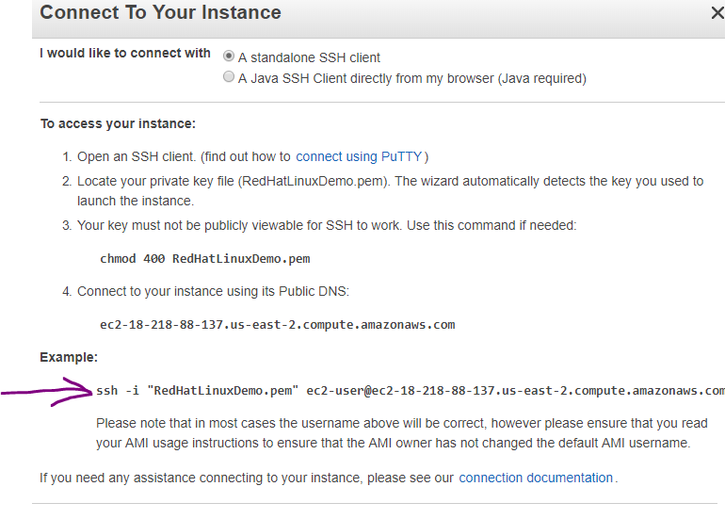

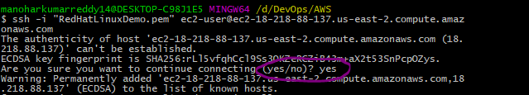

Now Go to “Java-Tomcat-maven-git-Jenkins.sh” file and go through the section Note & Installation Procedure at the end of the file.

1. **Tomcat Start-up**

Update tomcat-users.xml file: vi tomcat7/conf/tomcat-users.xml

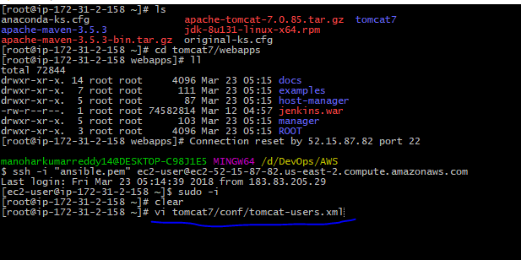

|  |
| --- |
| Update tomcat-users.xml file with below content.<role rolename="manager-gui"/>  <user username="tomcat" password="s3cret" roles="manager-gui"/> |

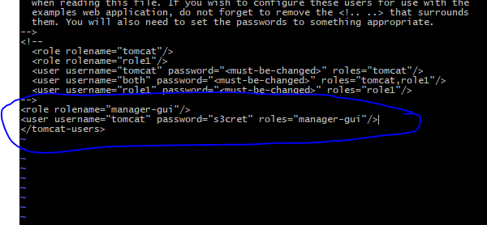

Startup the tomcat server: ./tomcat7/bin/startup.sh

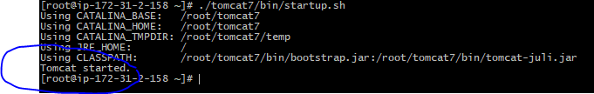

To launch the tomcat url on web browser, we have to free all the security restrictions.

For that go to AWS, choose the instance where tomcat installed. Clock on the security group as shown below.

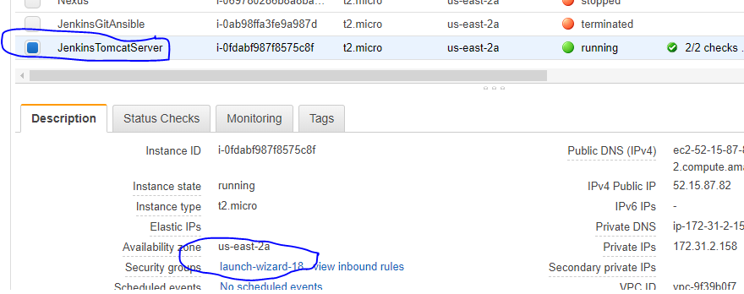

Clock on Actions🡪Edit Inbound Rules.

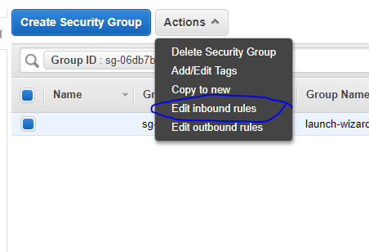

Change the “Type” from the default value “ssh” to “All traffic” and then click on save.

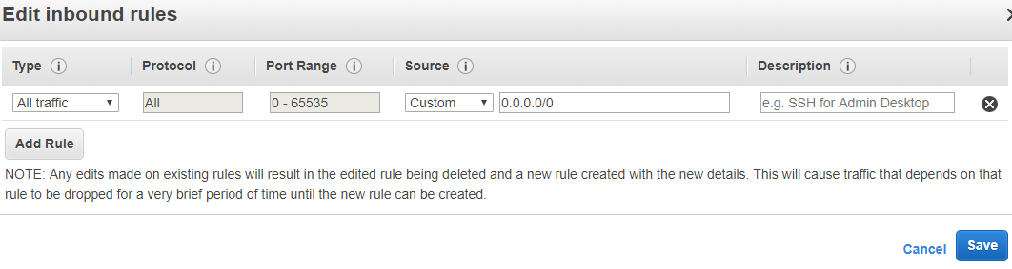

Go o instances 🡪 choose your instance🡪 copy the public IP.

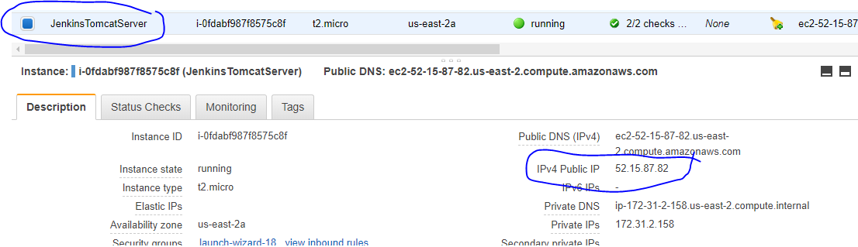

http://<publicIp>:8080 ex: <http://52.15.87.82:8080> 🡪 it will navigate to tomcat server home page.

And click on “manager webapp”.

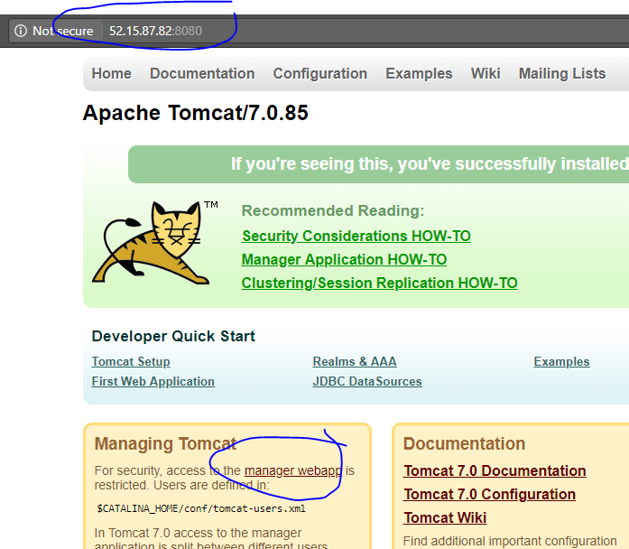

Enter the username & pwd which were configured in tomcat-users.xml file 🡪 click on Log in.

<role rolename="manager-gui"/>

<user username="tomcat" password="s3cret" roles="manager-gui"/>

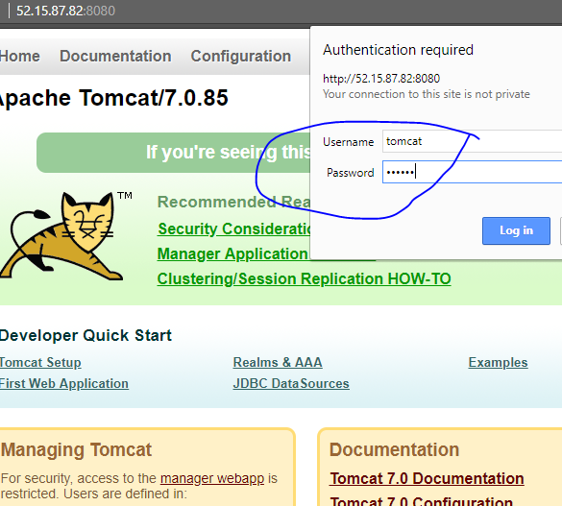

Here you will find the Jenkins🡪 click on it.

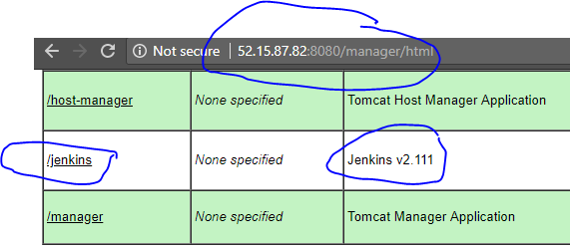

1. **Jenkins Start-up** & sample job configuration:

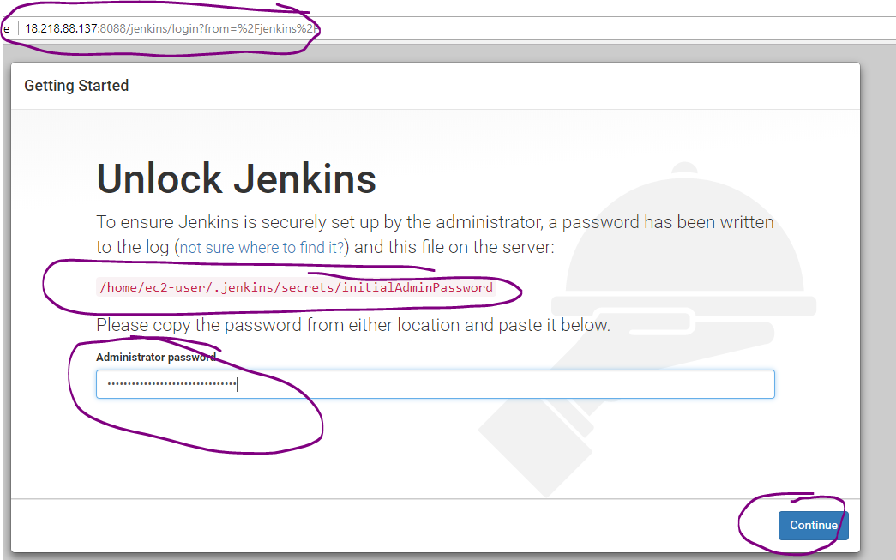

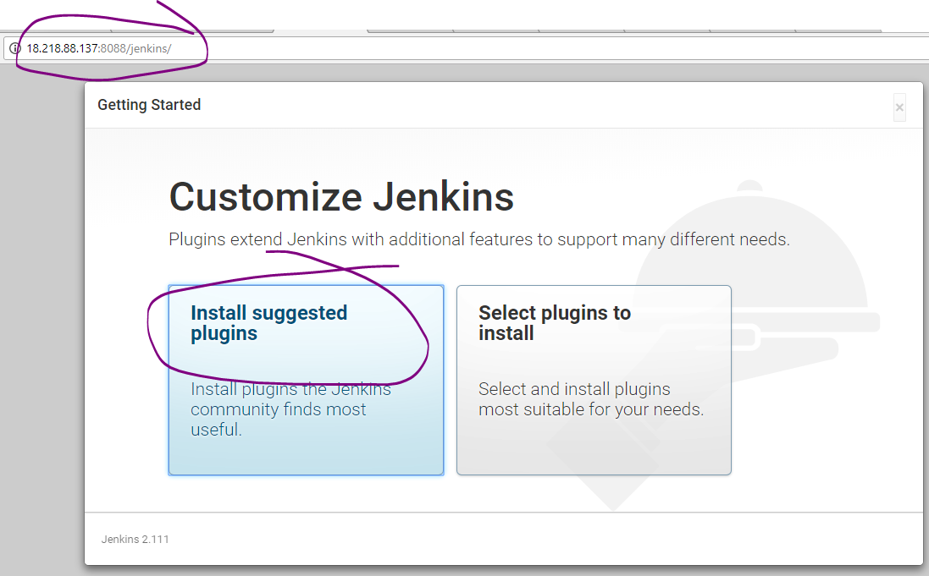

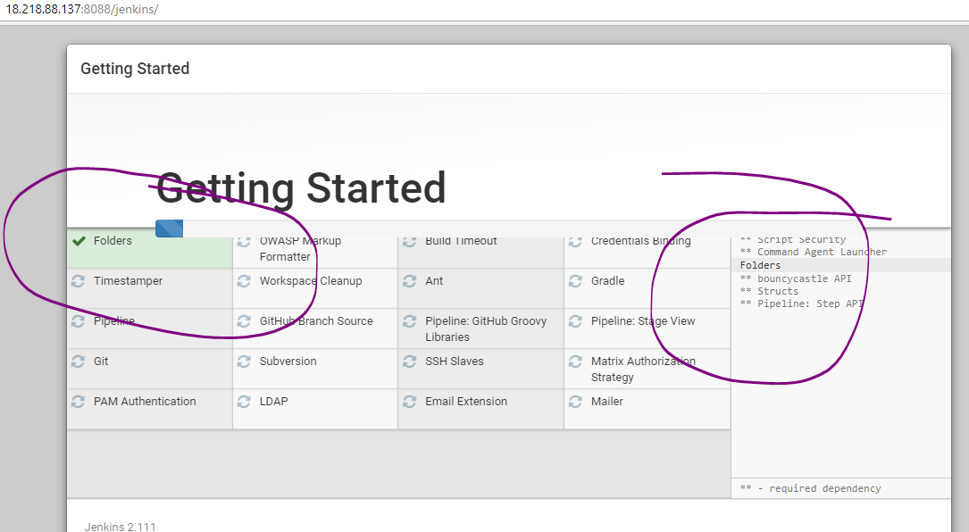

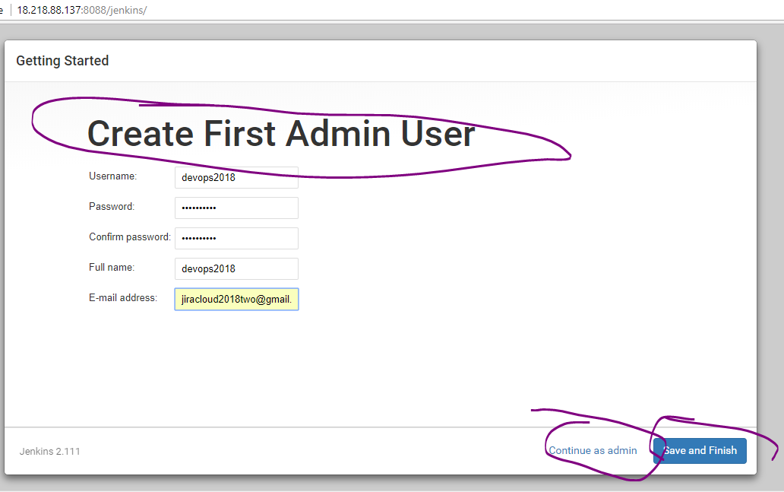

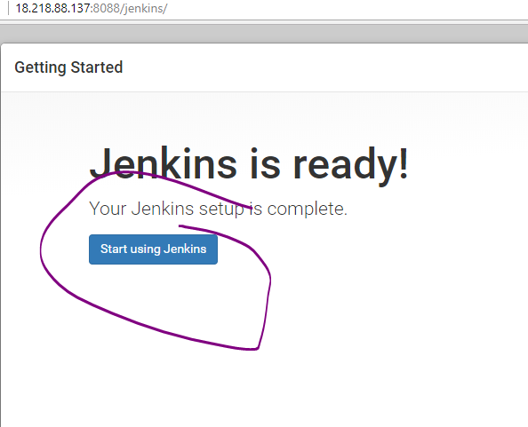

Global Tools configuration:

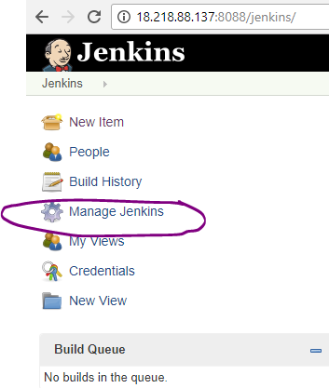

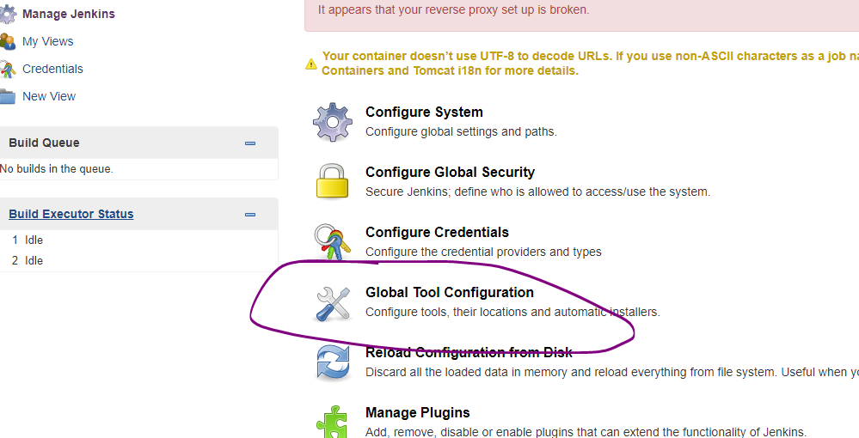

Add maven, java, git home paths

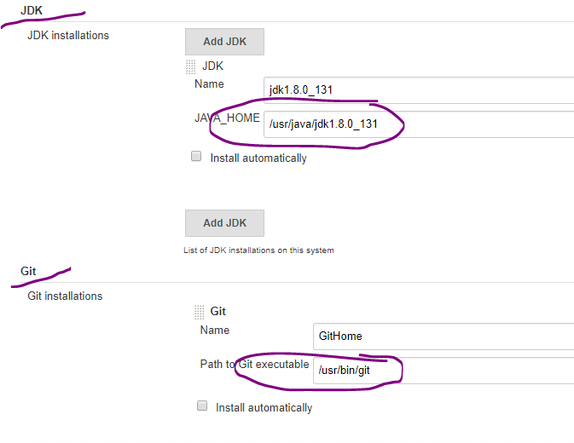

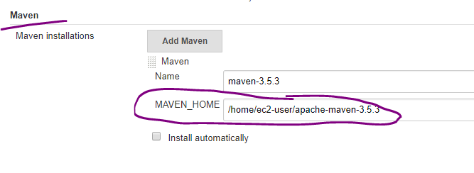

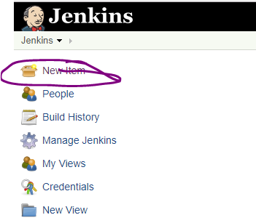

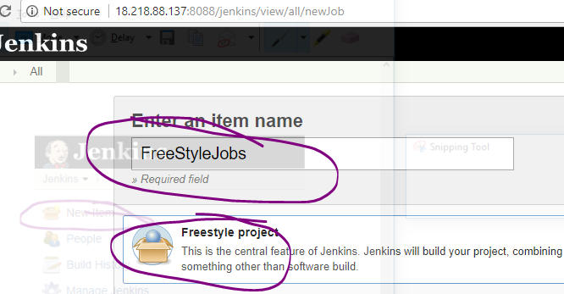

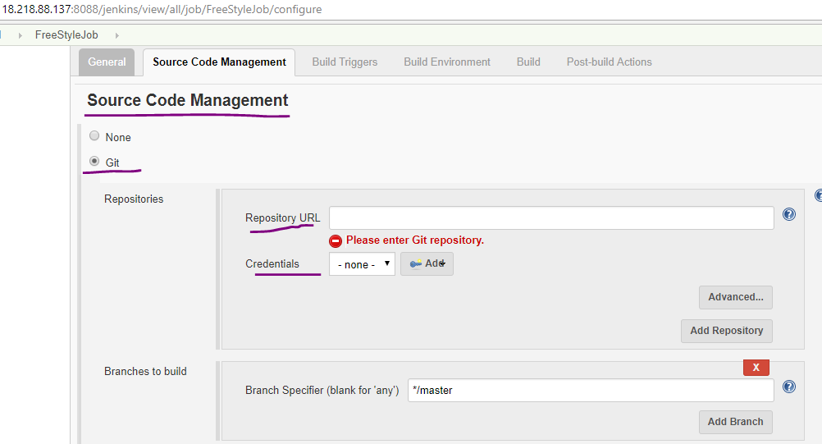

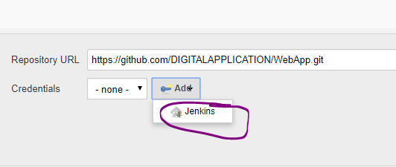

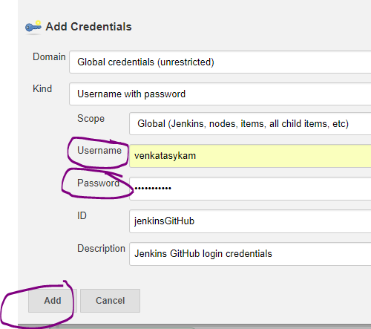

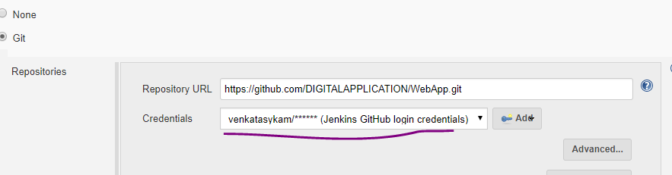

Check whether the code is being cloned / checkout or not.

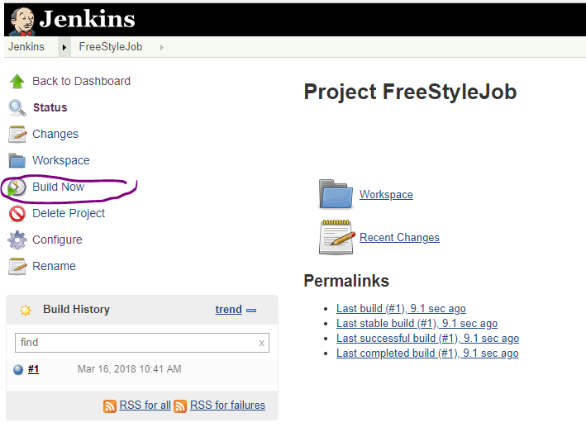

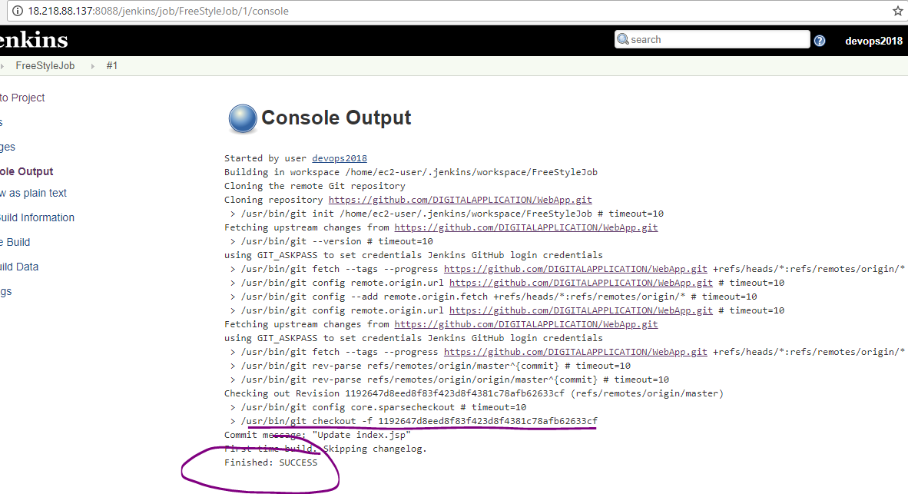

**Build (i.e., compile the source code & package):**

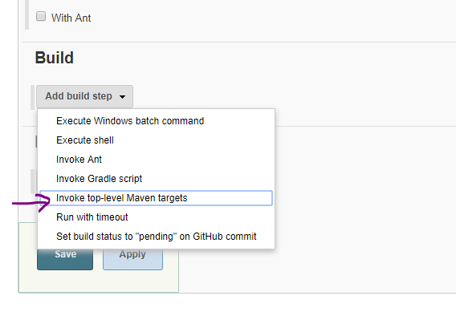

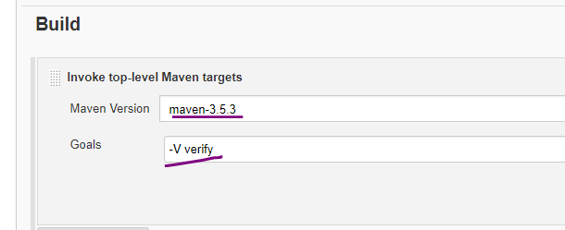

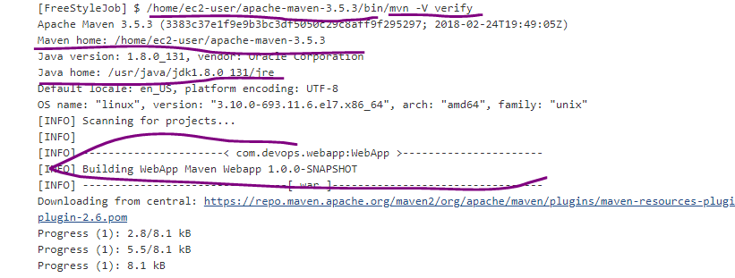

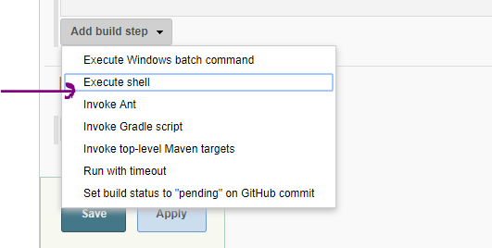

**Deployment**:

#Deploy the war to tomcat server.

#**Step-1**: Removing the existing package

rm -rf /root/tomcat7/webapps/WebApp-*.war

rm -rf /root/tomcat7/webapps/WebApp-*

#**Step-2**: Staging the new package to tomcat server.

cp ${WORKSPACE}/target/*.war /root/tomcat7/webapps

You can find the above same script in “DeploymentScript.sh”.

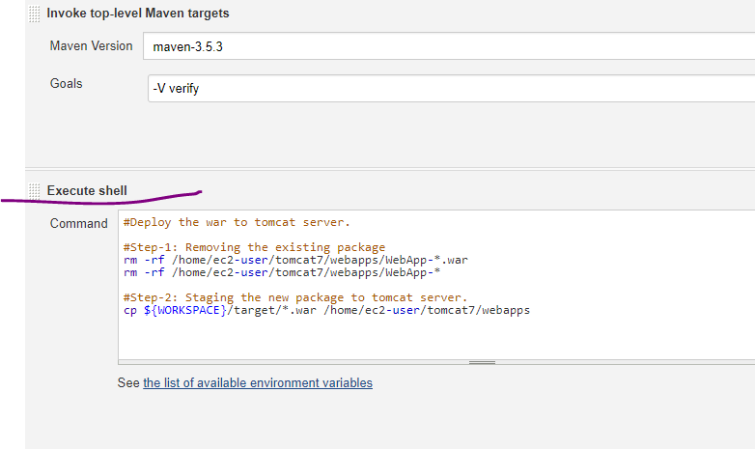

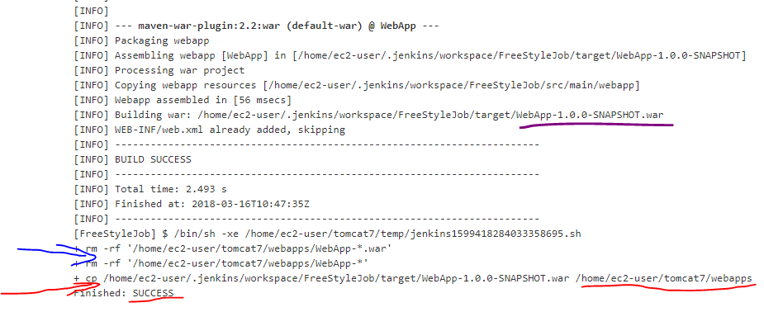

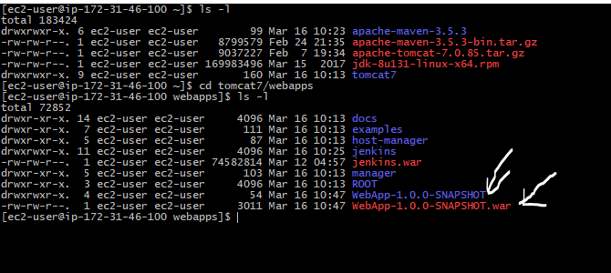

<http://18.218.88.137:8088/manager/html>

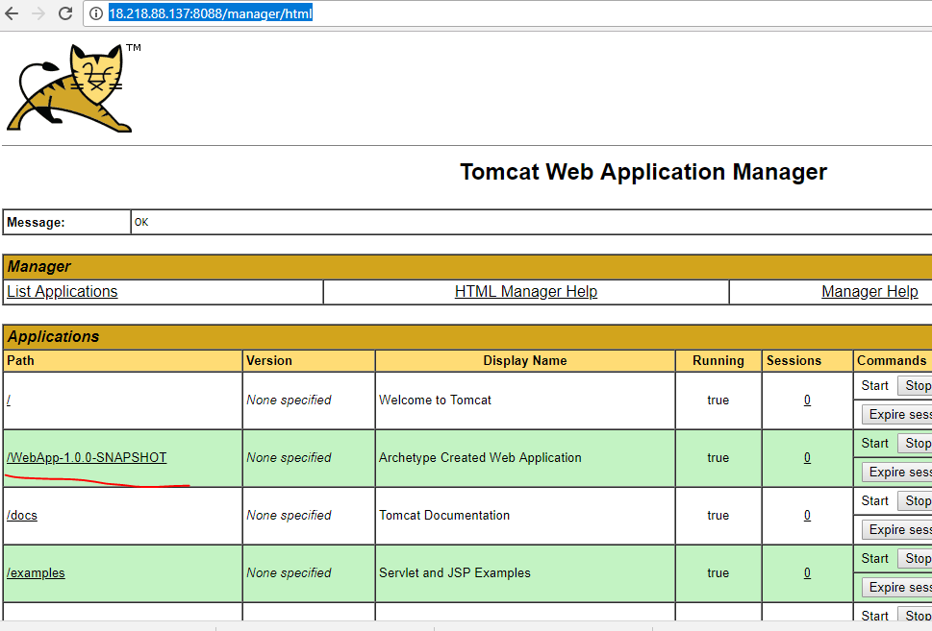

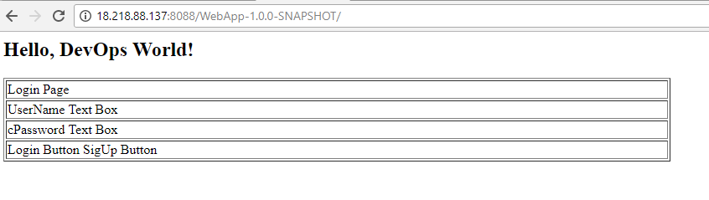

Now Go to “NexusSetup.sh” file and go through the section Note & Installation Procedure at the end of the file.