Launch an AWS EC2 instance:

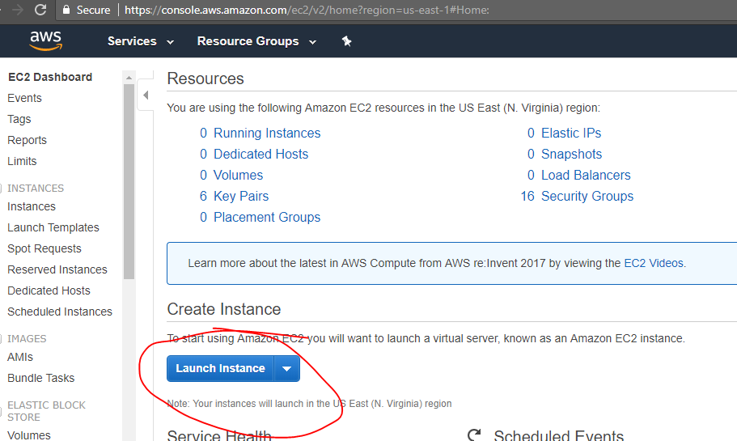

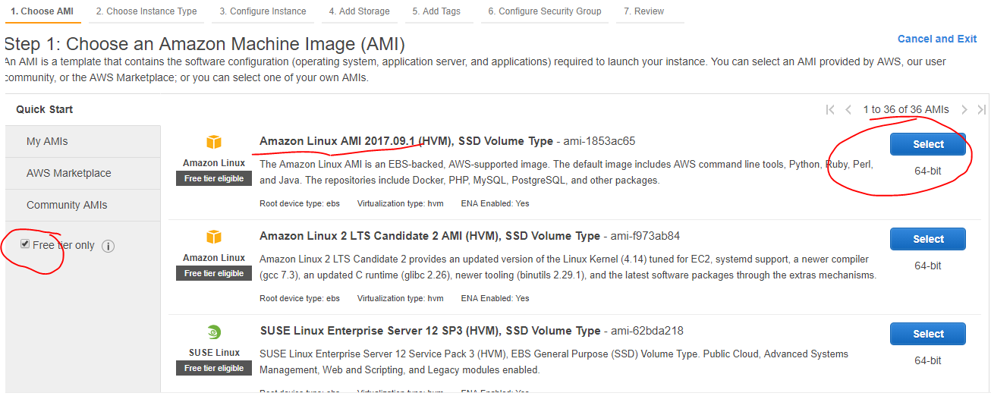

Choose t2.medium machine, with 4GB RAM (This JIRA need minimum 2GB machines). Click on review and launch or go to next step, I am skipping to “Add Tags”.

Note: This is not free tier, AWS will charge minimum Rs.15 to Rs.20 per hour, so practice and terminate the instances.

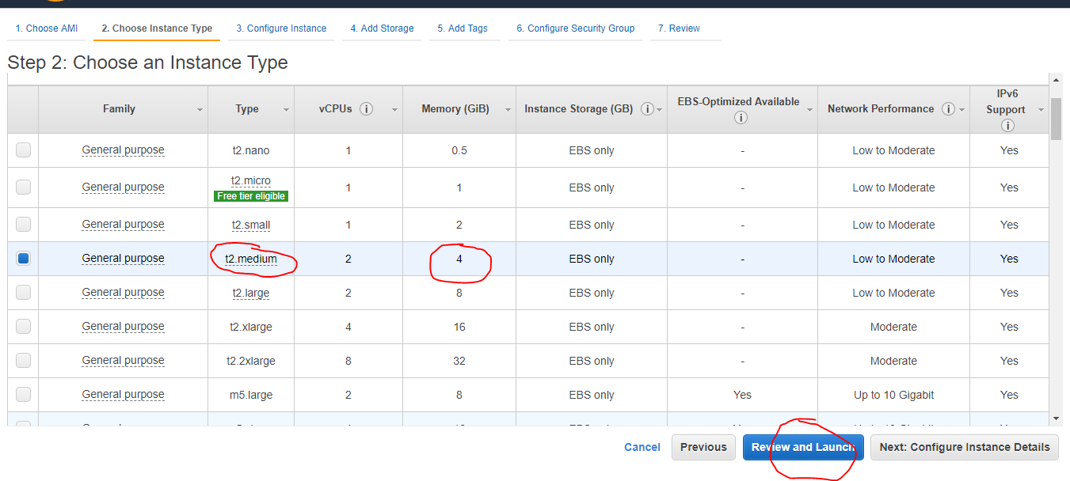

Click on “Add Tag”🡪 Enter “Name” as Key & “JIRA Server” as “Value.”🡪next.

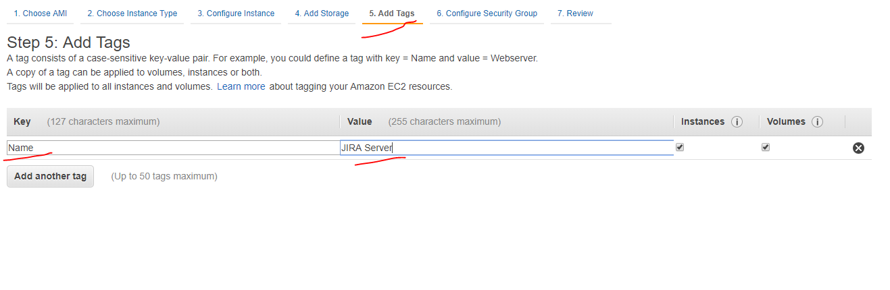

Since it is just for practice, I am allowing all the traffic without any restrictions. 🡪 next

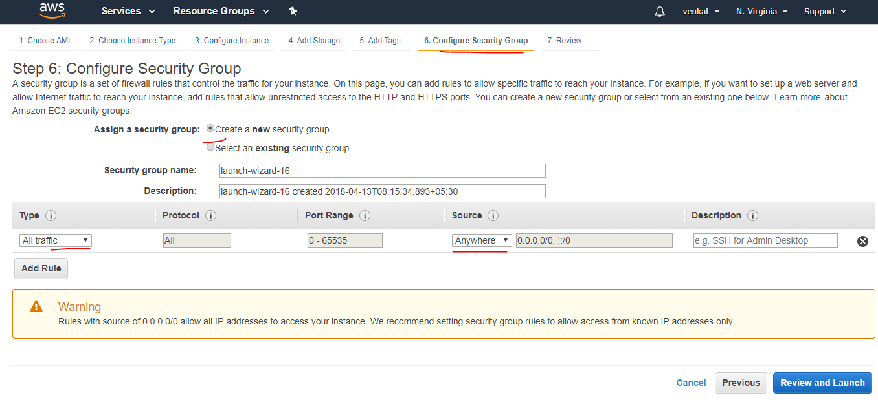

In Revoew screen, AWS is WARNING us as this is not free tier and it’s not secured. 🡪 Launch

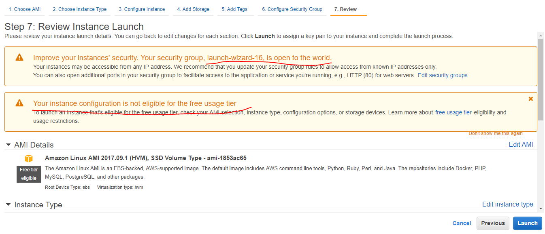

If this is first time,

1. choose “Create a new key par”
2. Give anyname to your key.
3. Click on “Download Key Pair”.
4. Its successfully downloaded to my local machine.
5. Now, the button enabled “Launch Instances”🡪 click on it. 🡪Click on “View Instances” in the next screen.

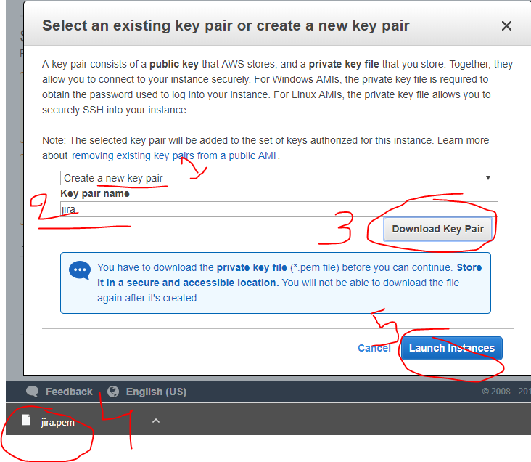

Click on “connet”

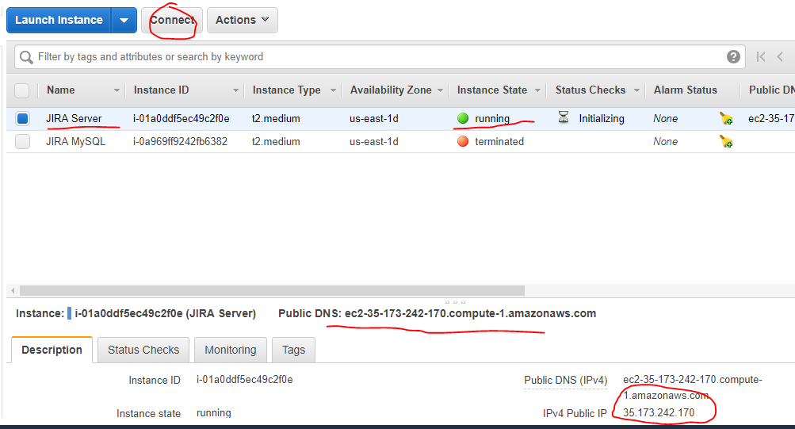

Copy the entire command.

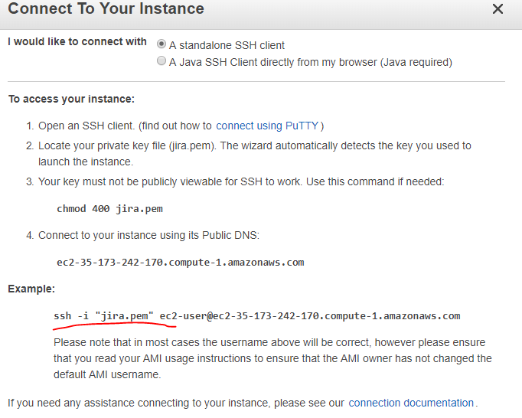

Open the GitBash and connect to instance. (I am opening Git Bash terminal where my jira.pem key pair downloaded)

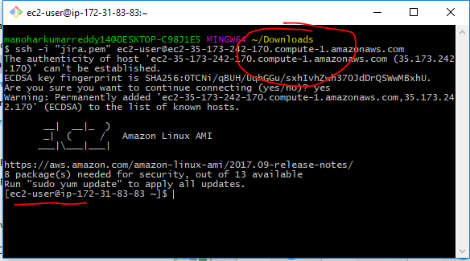

Now, please refer “AWS-JIRA-PostgreSQL.sh” to find the installation commands.

Or you can find here the same in the form of images.

Logged into root user and updated system with latest packages.

|  |
| --- |
| sudo -i  sudo yum update -y |

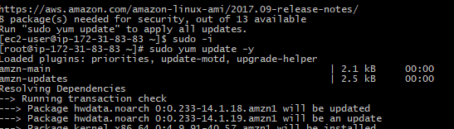

POSTGRESQL INSTALLATION: From the list you can choose any version you want to install. Here, I am choosing 94.

|  |
| --- |
| sudo yum list postgre* |

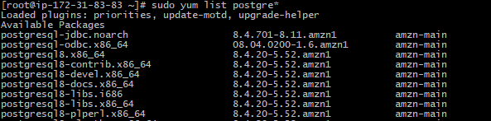

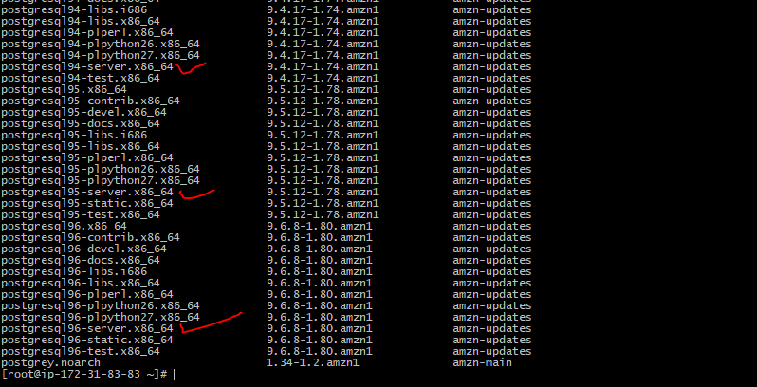

|  |
| --- |
| sudo yum install -y postgresql94-server.x86_64 |

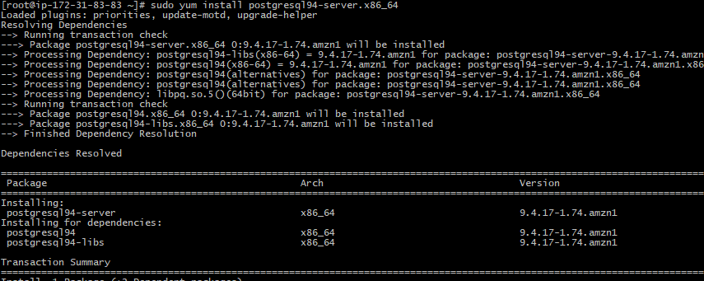

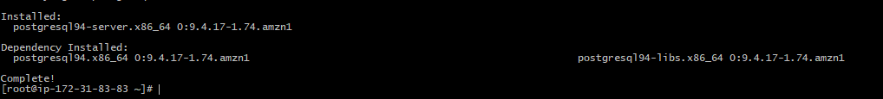

1. Login to the default user ‘postgres’. (Password is the same as user name) : sudo su - postgres
2. List the file to check the postgre file after the installation.
3. Initialize the data base. : initdb data
4. Successfully initialized, now, start the database: pg_ctl -D data -l logfile start
5. Server started, now create the DB for JIRA: cretedb jiradb
6. Exit from the postgres. And install JIRA.

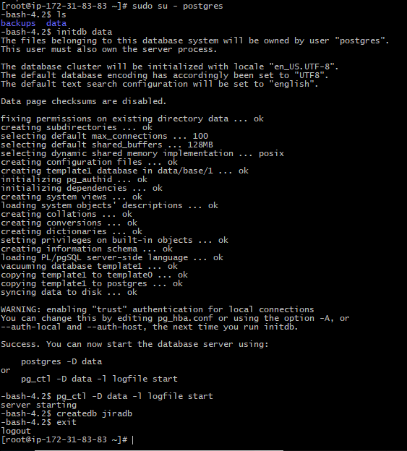

Download and install JIRA on this AWS Linux machine:

1. Install “wget” if it does not exists. 🡪 sudo yum install wget -y.
2. Download the JIRA bin package: sudo wget <https://www.atlassian.com/software/jira/downloads/binary/atlassian-jira-software-7.8.0-x64.bin>
3. List the files in the current directory make suer its downloaded. : ls or ll

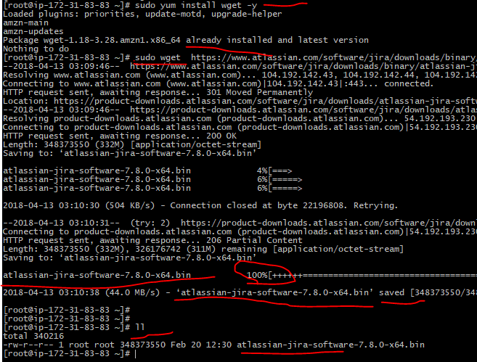

1. If you are running from ec2-user, then give the permissions on the jira bin file.: chmod a+x atlassian-jira-software-7.8.0-x64.bin
2. Now, Install the JIRA & start the jira as server.: sudo ./atlassian-jira-software-7.8.0-x64.bin.

You have to provide your inputs for below

* 1. Install OK or Cancel: enter “o”
  2. Express Install with default settings and others options. Choose “1”.
  3. Install as service or exit: Enter ‘i’ to proceed with install as a service. (IF you exit, you have to manually start the jira.)
  4. Start JIRA Software 7.8.0 now? : Choose “y”.
  5. Just observe that, jira installation directory & home directory in the linux machine.
  6. See the default post rumber whether the JIRA running by default.
  7. Launch the URL with your publicIP: http://<publicIP>:8080

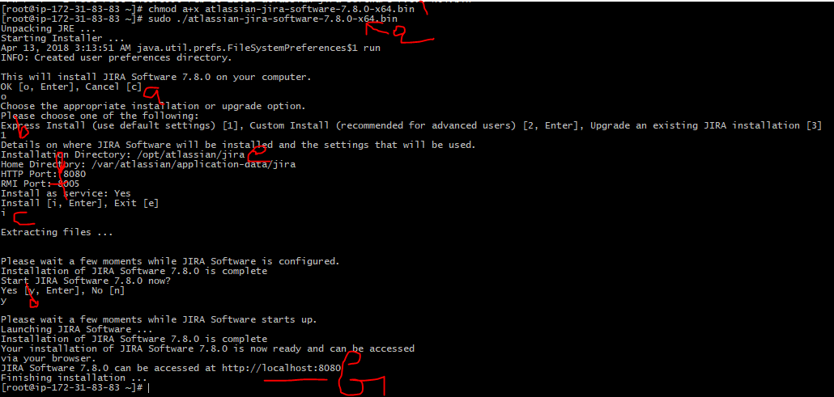

Copy the publicIP fro9m AWS console.

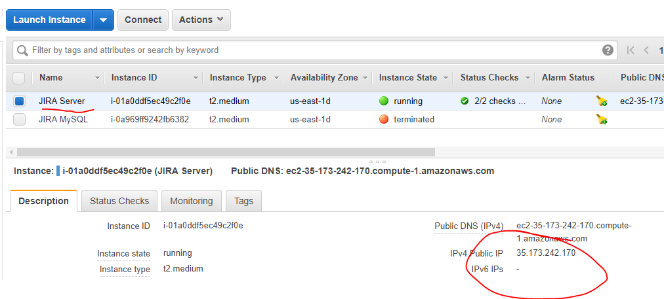

Launch the URL in browser.

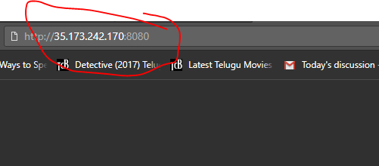

Choose “I'll set it up myself” 🡪 Next

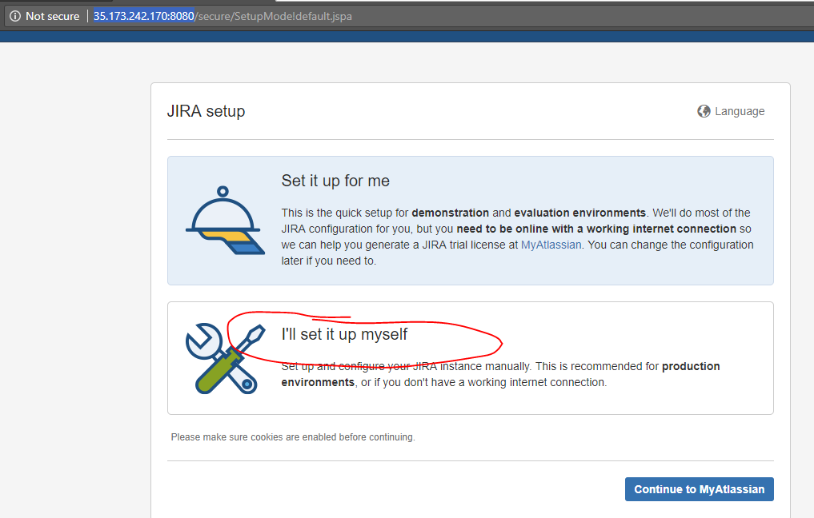

Choose “My Own Databse” ( or you can proceed with the option ‘Built In’ with the default DB providing by JIRA)

We have a database ready for this JIRA.

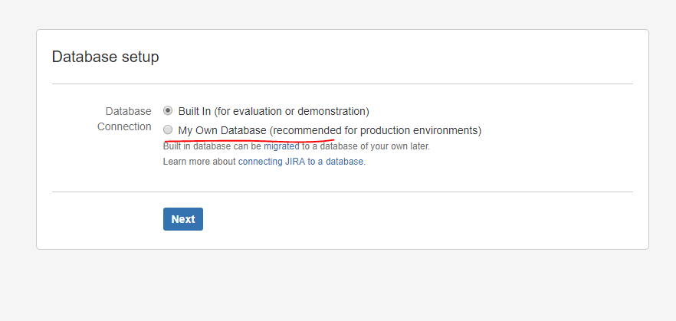

1. Choose the databsse type as “PostgreSQL”, this will automatically populate default Post number & default schema name of postgre database.
2. Choose localhost OR give the IP address incase you installed the DB on another instance.
3. Give the DB name that we created for JIRA as “jiradb”.
4. Default username and password are “postgres”.
5. Click on “Test Connection” whether it is connection or not. You will get acknowledged on top of the same screen(see the below image with number 5). And then click on the button NEXT.

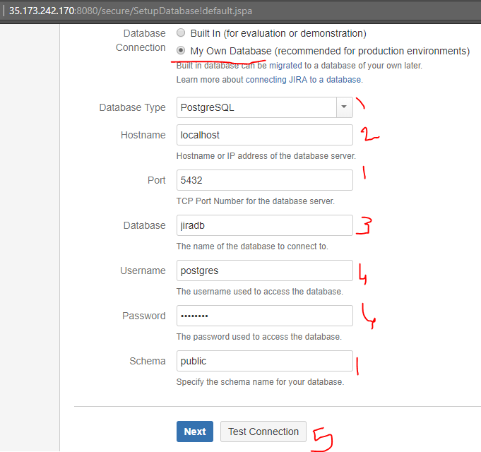

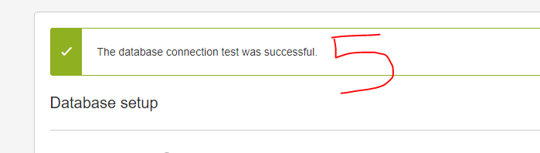

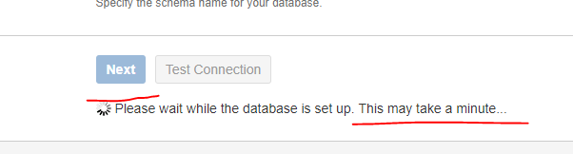

Database connected and default tables are created in background. You can give your company name or any name for Application Title.

If you choose any option public/private. I am proceeding with default values by just changing the Application title. 🡪 Next

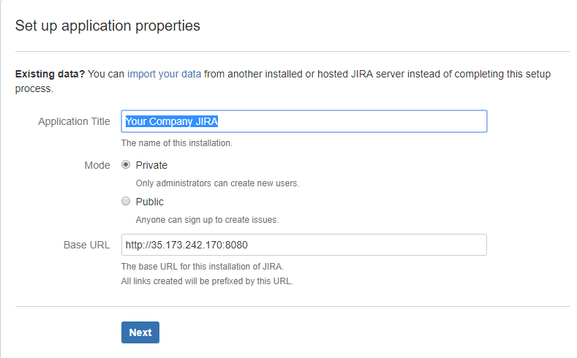

In realtime, you may need to enter the licence key generated by Atlassian JIRA team. In ousr case, it just a trail one. Click on generate JIRA trail licence. It will navigate to atlassian site.

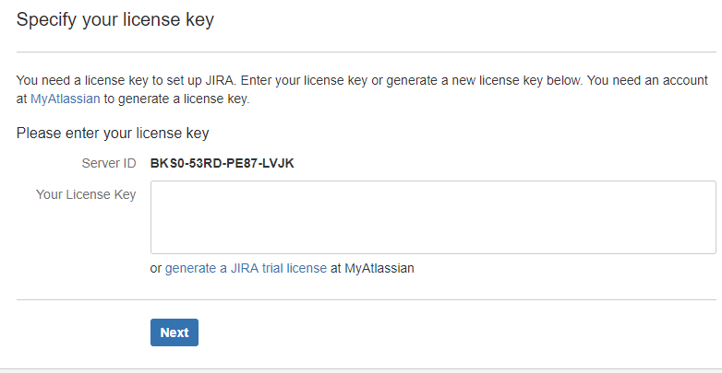

This is the default screen loading when we clicked on “generate JIRA trail licence” fdrom the previous screen.

Choose JIRA Software Server.

Give you organization name (any name)

Click on generate licence button.

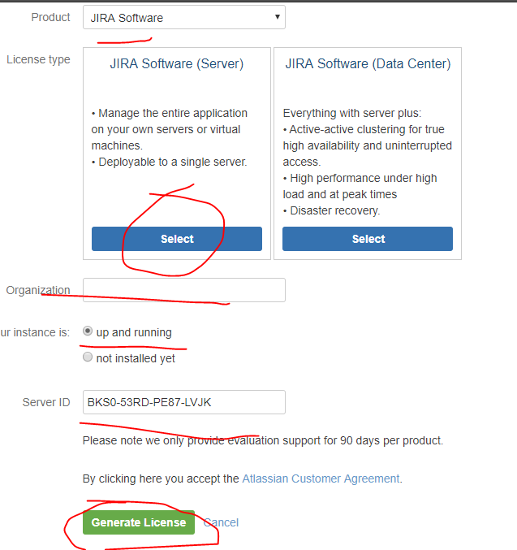

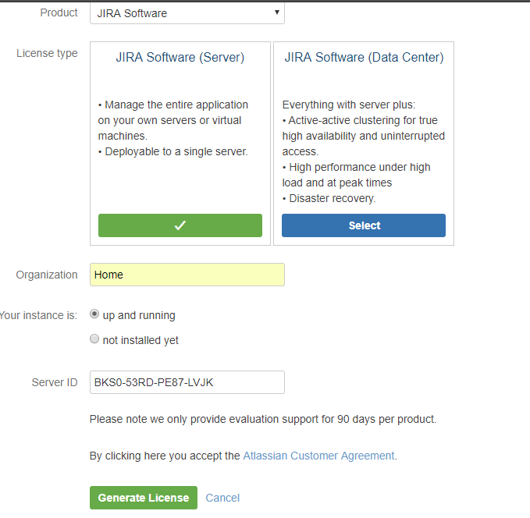

If you have an existing account on atlassin login with those creeds , otherwise login with google id.

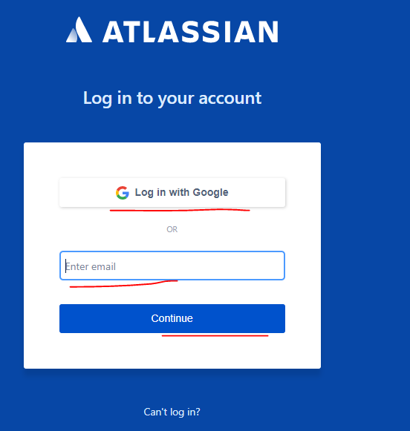

Once you logged into the account with googleId, It will ask you for confirmation as below.

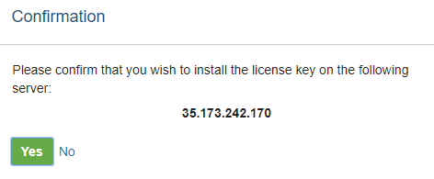

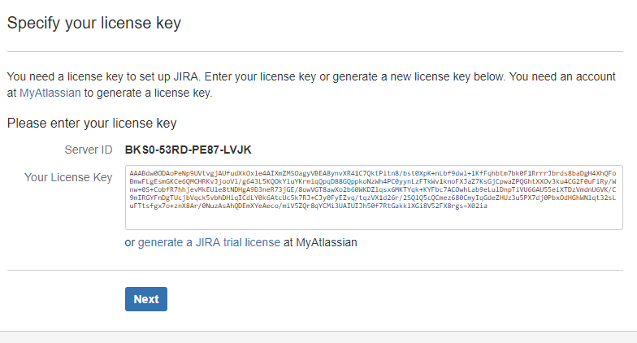

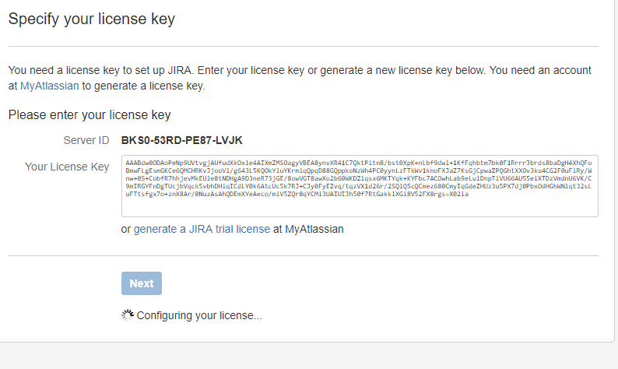

Setup an admin account as it is required initially to login to the JIRA application. Enter the details and click on NEXT.

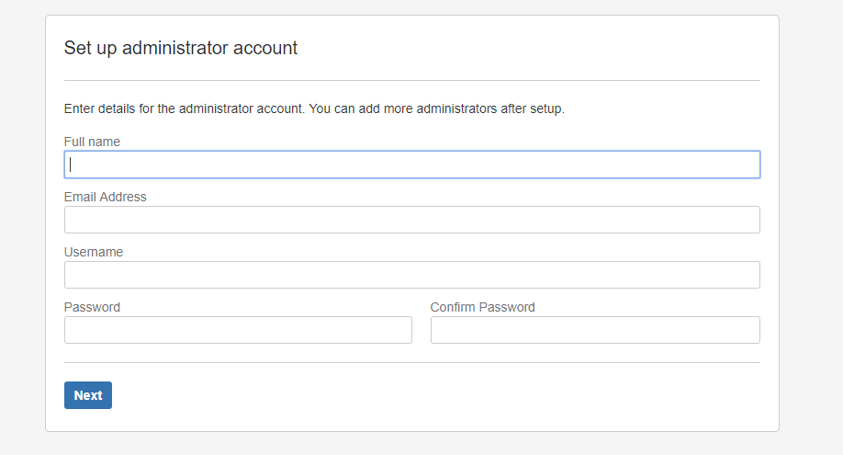

As I don’t have any SMTP or any other email server details, I am proceeding with the option “Later”.

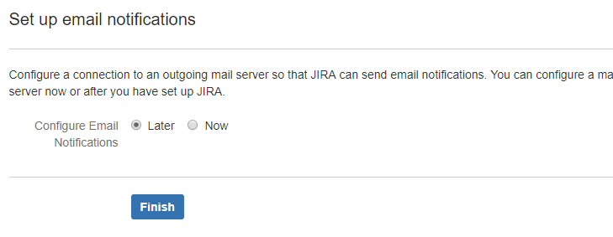

Choose the language you are confirtable with and continue.

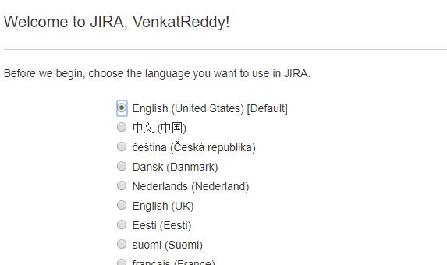

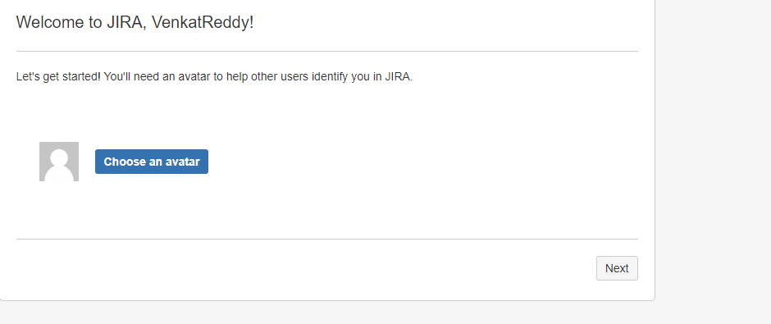

1. See the existing project.
2. Create a new project. 🡪 Proceeding with this option.
3. Import the projects/issues form csv file or another format(ZIP) it is expecting.

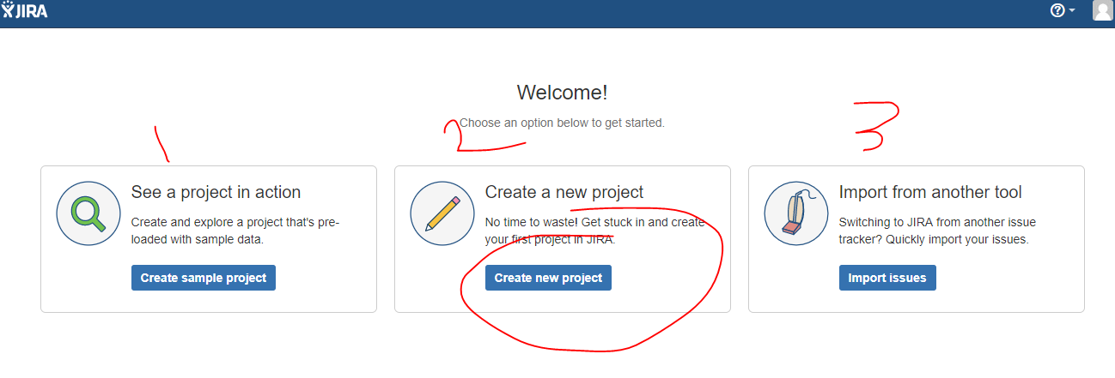

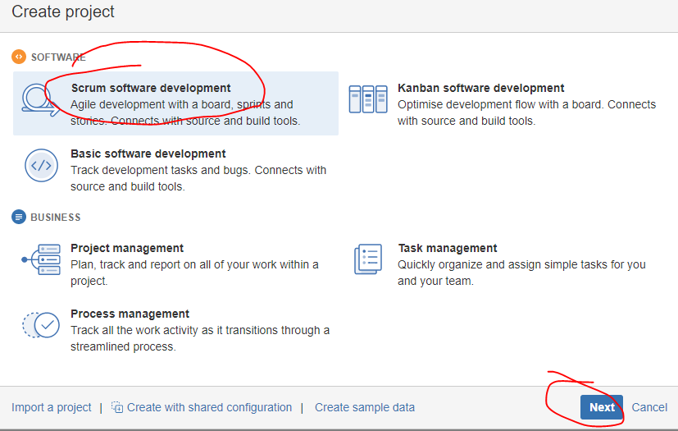

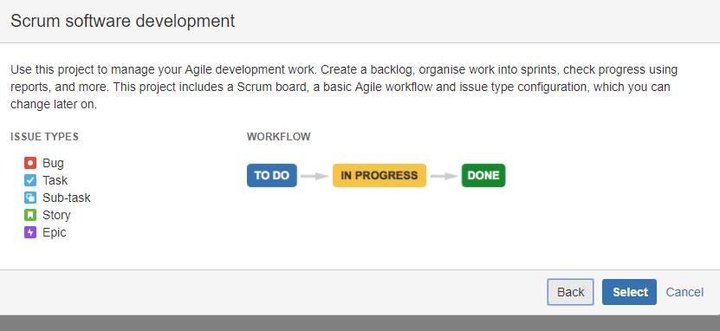

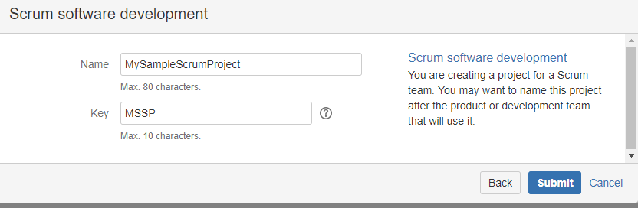

**Here is the home page of the JIRA project “MSSP” as you created above: and then Click on the project ICON(top left corner) it will navigate to project summary. See the following image below.**

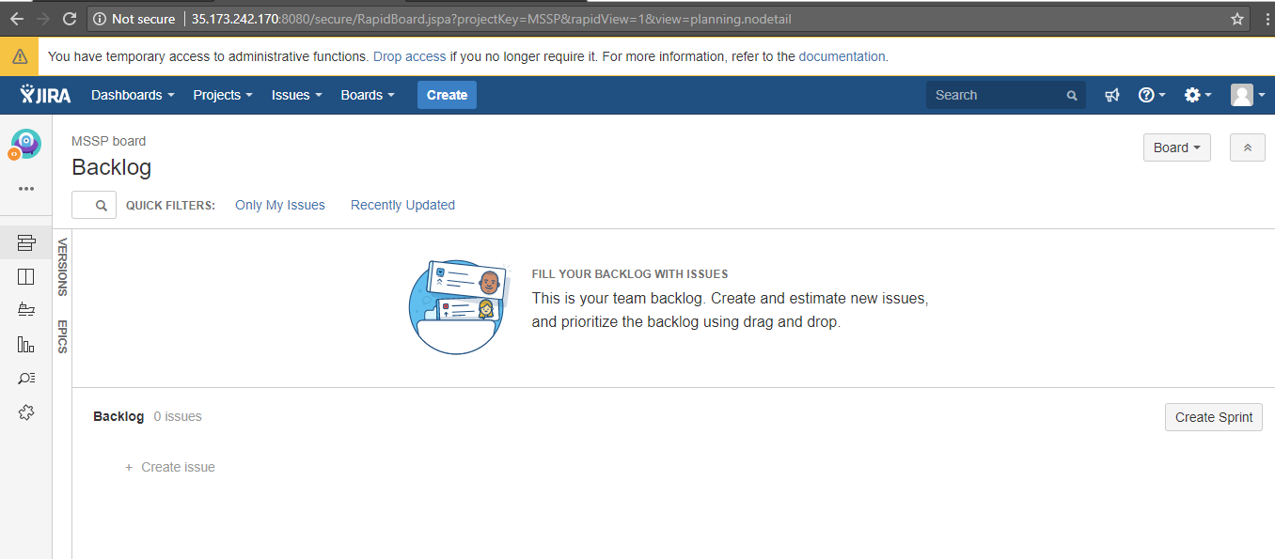

**Click on the project ICON(top left corner) it will navigate to project summary.**

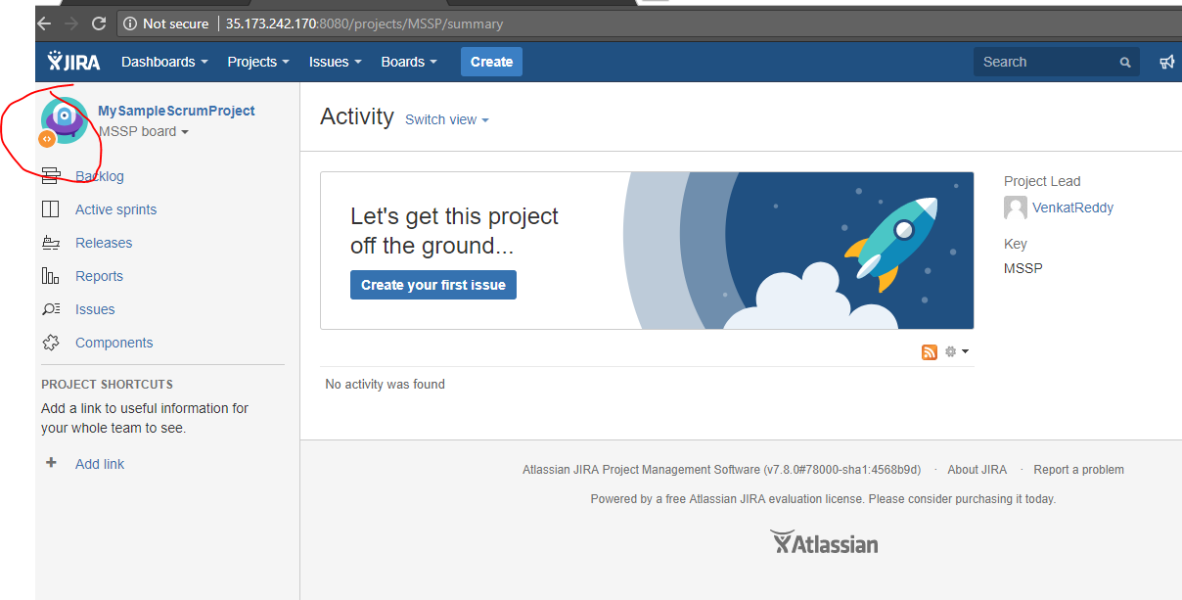

**Here is the default system default dashboard of JIRA: (Click on dashboard🡪system dashboard.**

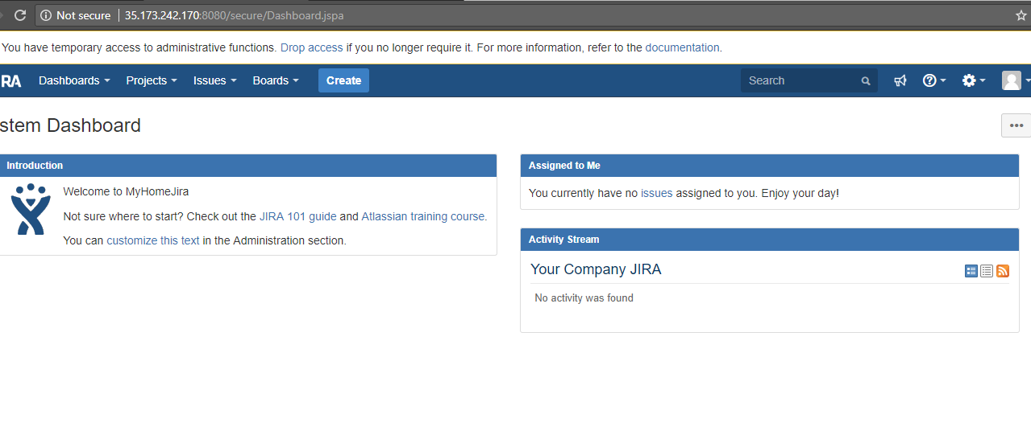

**Click on projects and go to your projects:**

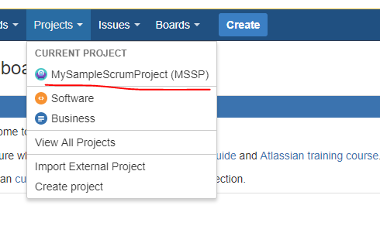

Let’s check the data base, how many default tables created by JIRA for the first time. There are totally 251 tables created automatically.

su - postgres

psql

\connect jiradb

\dt

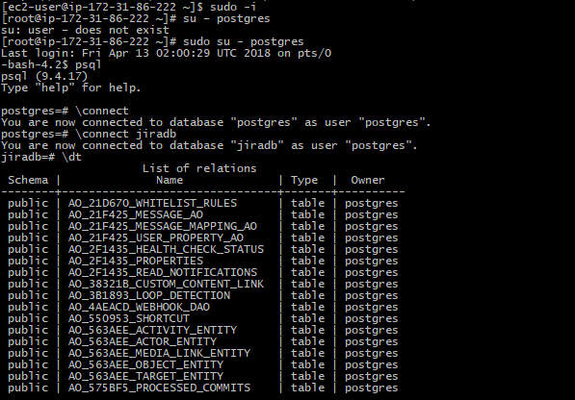

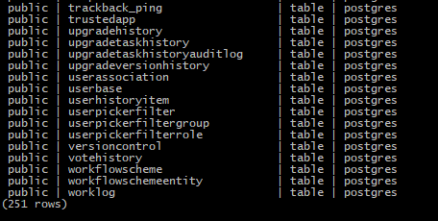

jiradb=# \dt

List of relations

Schema | Name | Type | Owner

--------+--------------------------------+-------+----------

public | AO_21D670_WHITELIST_RULES | table | postgres

public | AO_21F425_MESSAGE_AO | table | postgres

public | AO_21F425_MESSAGE_MAPPING_AO | table | postgres

public | AO_21F425_USER_PROPERTY_AO | table | postgres

public | AO_2F1435_HEALTH_CHECK_STATUS | table | postgres

public | AO_2F1435_PROPERTIES | table | postgres

public | AO_2F1435_READ_NOTIFICATIONS | table | postgres

public | AO_38321B_CUSTOM_CONTENT_LINK | table | postgres

public | AO_3B1893_LOOP_DETECTION | table | postgres

public | AO_4AEACD_WEBHOOK_DAO | table | postgres

public | AO_550953_SHORTCUT | table | postgres

public | AO_563AEE_ACTIVITY_ENTITY | table | postgres

public | AO_563AEE_ACTOR_ENTITY | table | postgres

public | AO_563AEE_MEDIA_LINK_ENTITY | table | postgres

public | AO_563AEE_OBJECT_ENTITY | table | postgres

public | AO_563AEE_TARGET_ENTITY | table | postgres

public | AO_575BF5_PROCESSED_COMMITS | table | postgres

public | AO_575BF5_PROVIDER_ISSUE | table | postgres

public | AO_575BF5_PROVIDER_SEQ_NO | table | postgres

public | AO_587B34_GLANCE_CONFIG | table | postgres

public | AO_587B34_PROJECT_CONFIG | table | postgres

public | AO_5FB9D7_AOHIP_CHAT_LINK | table | postgres

public | AO_5FB9D7_AOHIP_CHAT_USER | table | postgres

public | AO_60DB71_AUDITENTRY | table | postgres

public | AO_60DB71_BOARDADMINS | table | postgres

public | AO_60DB71_CARDCOLOR | table | postgres

public | AO_60DB71_CARDLAYOUT | table | postgres

public | AO_60DB71_COLUMN | table | postgres

public | AO_60DB71_COLUMNSTATUS | table | postgres

public | AO_60DB71_DETAILVIEWFIELD | table | postgres

public | AO_60DB71_ESTIMATESTATISTIC | table | postgres

public | AO_60DB71_ISSUERANKING | table | postgres

public | AO_60DB71_ISSUERANKINGLOG | table | postgres

public | AO_60DB71_LEXORANK | table | postgres

public | AO_60DB71_LEXORANKBALANCER | table | postgres

public | AO_60DB71_NONWORKINGDAY | table | postgres

public | AO_60DB71_QUICKFILTER | table | postgres

public | AO_60DB71_RANKABLEOBJECT | table | postgres

public | AO_60DB71_RAPIDVIEW | table | postgres

public | AO_60DB71_SPRINT | table | postgres

public | AO_60DB71_STATSFIELD | table | postgres

public | AO_60DB71_SUBQUERY | table | postgres

public | AO_60DB71_SWIMLANE | table | postgres

public | AO_60DB71_TRACKINGSTATISTIC | table | postgres

public | AO_60DB71_VERSION | table | postgres

public | AO_60DB71_WORKINGDAYS | table | postgres

public | AO_97EDAB_USERINVITATION | table | postgres

public | AO_A0B856_WEB_HOOK_LISTENER_AO | table | postgres

public | AO_B9A0F0_APPLIED_TEMPLATE | table | postgres

public | AO_CFF990_AOTRANSITION_FAILURE | table | postgres

public | AO_E8B6CC_BRANCH | table | postgres

public | AO_E8B6CC_BRANCH_HEAD_MAPPING | table | postgres

public | AO_E8B6CC_CHANGESET_MAPPING | table | postgres

public | AO_E8B6CC_COMMIT | table | postgres

public | AO_E8B6CC_GIT_HUB_EVENT | table | postgres

public | AO_E8B6CC_ISSUE_MAPPING | table | postgres

public | AO_E8B6CC_ISSUE_MAPPING_V2 | table | postgres

public | AO_E8B6CC_ISSUE_TO_BRANCH | table | postgres

public | AO_E8B6CC_ISSUE_TO_CHANGESET | table | postgres

public | AO_E8B6CC_MESSAGE | table | postgres

public | AO_E8B6CC_MESSAGE_QUEUE_ITEM | table | postgres

public | AO_E8B6CC_MESSAGE_TAG | table | postgres

public | AO_E8B6CC_ORGANIZATION_MAPPING | table | postgres

public | AO_E8B6CC_ORG_TO_PROJECT | table | postgres

public | AO_E8B6CC_PROJECT_MAPPING | table | postgres

public | AO_E8B6CC_PROJECT_MAPPING_V2 | table | postgres

public | AO_E8B6CC_PR_ISSUE_KEY | table | postgres

public | AO_E8B6CC_PR_PARTICIPANT | table | postgres

public | AO_E8B6CC_PR_TO_COMMIT | table | postgres

public | AO_E8B6CC_PULL_REQUEST | table | postgres

public | AO_E8B6CC_REPOSITORY_MAPPING | table | postgres

public | AO_E8B6CC_REPO_TO_CHANGESET | table | postgres

public | AO_E8B6CC_REPO_TO_PROJECT | table | postgres

public | AO_E8B6CC_SYNC_AUDIT_LOG | table | postgres

public | AO_E8B6CC_SYNC_EVENT | table | postgres

public | AO_ED669C_SEEN_ASSERTIONS | table | postgres

public | app_user | table | postgres

public | audit_changed_value | table | postgres

public | audit_item | table | postgres

public | audit_log | table | postgres

public | avatar | table | postgres

public | board | table | postgres

public | boardproject | table | postgres

public | changegroup | table | postgres

public | changeitem | table | postgres

public | clusteredjob | table | postgres

public | clusterlockstatus | table | postgres

public | clustermessage | table | postgres

public | clusternode | table | postgres

public | clusternodeheartbeat | table | postgres

public | clusterupgradestate | table | postgres

public | columnlayout | table | postgres

public | columnlayoutitem | table | postgres

public | component | table | postgres

public | configurationcontext | table | postgres

public | customfield | table | postgres

public | customfieldoption | table | postgres

public | customfieldvalue | table | postgres

public | cwd_application | table | postgres

public | cwd_application_address | table | postgres

public | cwd_directory | table | postgres

public | cwd_directory_attribute | table | postgres

public | cwd_directory_operation | table | postgres

public | cwd_group | table | postgres

public | cwd_group_attributes | table | postgres

public | cwd_membership | table | postgres

public | cwd_user | table | postgres

public | cwd_user_attributes | table | postgres

public | deadletter | table | postgres

public | draftworkflowscheme | table | postgres

public | draftworkflowschemeentity | table | postgres

public | entity_property | table | postgres

public | entity_property_index_document | table | postgres

public | entity_translation | table | postgres

public | external_entities | table | postgres

public | externalgadget | table | postgres

public | favouriteassociations | table | postgres

public | feature | table | postgres

public | fieldconfigscheme | table | postgres

public | fieldconfigschemeissuetype | table | postgres

public | fieldconfiguration | table | postgres

public | fieldlayout | table | postgres

public | fieldlayoutitem | table | postgres

public | fieldlayoutscheme | table | postgres

public | fieldlayoutschemeassociation | table | postgres

public | fieldlayoutschemeentity | table | postgres

public | fieldscreen | table | postgres

public | fieldscreenlayoutitem | table | postgres

public | fieldscreenscheme | table | postgres

public | fieldscreenschemeitem | table | postgres

public | fieldscreentab | table | postgres

public | fileattachment | table | postgres

public | filtersubscription | table | postgres

public | gadgetuserpreference | table | postgres

public | genericconfiguration | table | postgres

public | globalpermissionentry | table | postgres

public | groupbase | table | postgres

public | issue_field_option | table | postgres

public | issue_field_option_scope | table | postgres

public | issuelink | table | postgres

public | issuelinktype | table | postgres

public | issuesecurityscheme | table | postgres

public | issuestatus | table | postgres

public | issuetype | table | postgres

public | issuetypescreenscheme | table | postgres

public | issuetypescreenschemeentity | table | postgres

public | jiraaction | table | postgres

public | jiradraftworkflows | table | postgres

public | jiraeventtype | table | postgres

public | jiraissue | table | postgres

public | jiraperms | table | postgres

public | jiraworkflows | table | postgres

public | jiraworkflowstatuses | table | postgres

public | jquartz_blob_triggers | table | postgres

public | jquartz_calendars | table | postgres

public | jquartz_cron_triggers | table | postgres

public | jquartz_fired_triggers | table | postgres

public | jquartz_job_details | table | postgres

public | jquartz_job_listeners | table | postgres

public | jquartz_locks | table | postgres

public | jquartz_paused_trigger_grps | table | postgres

public | jquartz_scheduler_state | table | postgres

public | jquartz_simple_triggers | table | postgres

public | jquartz_simprop_triggers | table | postgres

public | jquartz_trigger_listeners | table | postgres

public | jquartz_triggers | table | postgres

public | label | table | postgres

public | licenserolesdefault | table | postgres

public | licenserolesgroup | table | postgres

public | listenerconfig | table | postgres

public | mailserver | table | postgres

public | managedconfigurationitem | table | postgres

public | membershipbase | table | postgres

public | moved_issue_key | table | postgres

public | nodeassociation | table | postgres

public | nodeindexcounter | table | postgres

public | notification | table | postgres

public | notificationinstance | table | postgres

public | notificationscheme | table | postgres

public | oauthconsumer | table | postgres

public | oauthconsumertoken | table | postgres

public | oauthspconsumer | table | postgres

public | oauthsptoken | table | postgres

public | optionconfiguration | table | postgres

public | os_currentstep | table | postgres

public | os_currentstep_prev | table | postgres

public | os_historystep | table | postgres

public | os_historystep_prev | table | postgres

public | os_wfentry | table | postgres

public | permissionscheme | table | postgres

public | permissionschemeattribute | table | postgres

public | pluginstate | table | postgres

public | pluginversion | table | postgres

public | portalpage | table | postgres

public | portletconfiguration | table | postgres

public | priority | table | postgres

public | productlicense | table | postgres

public | project | table | postgres

public | project_key | table | postgres

public | projectcategory | table | postgres

public | projectchangedtime | table | postgres

public | projectrole | table | postgres

public | projectroleactor | table | postgres

public | projectversion | table | postgres

public | propertydata | table | postgres

public | propertydate | table | postgres

public | propertydecimal | table | postgres

public | propertyentry | table | postgres

public | propertynumber | table | postgres

public | propertystring | table | postgres

public | propertytext | table | postgres

public | qrtz_calendars | table | postgres

public | qrtz_cron_triggers | table | postgres

public | qrtz_fired_triggers | table | postgres

public | qrtz_job_details | table | postgres

public | qrtz_job_listeners | table | postgres

public | qrtz_simple_triggers | table | postgres

public | qrtz_trigger_listeners | table | postgres

public | qrtz_triggers | table | postgres

public | reindex_component | table | postgres

public | reindex_request | table | postgres

public | remembermetoken | table | postgres

public | remotelink | table | postgres

public | replicatedindexoperation | table | postgres

public | resolution | table | postgres

public | rundetails | table | postgres

public | schemeissuesecurities | table | postgres

public | schemeissuesecuritylevels | table | postgres

public | schemepermissions | table | postgres

public | searchrequest | table | postgres

public | sequence_value_item | table | postgres

public | serviceconfig | table | postgres

public | sharepermissions | table | postgres

public | tempattachmentsmonitor | table | postgres

public | trackback_ping | table | postgres

public | trustedapp | table | postgres

public | upgradehistory | table | postgres

public | upgradetaskhistory | table | postgres

public | upgradetaskhistoryauditlog | table | postgres

public | upgradeversionhistory | table | postgres

public | userassociation | table | postgres

public | userbase | table | postgres

public | userhistoryitem | table | postgres

public | userpickerfilter | table | postgres

public | userpickerfiltergroup | table | postgres

public | userpickerfilterrole | table | postgres

public | versioncontrol | table | postgres

public | votehistory | table | postgres

public | workflowscheme | table | postgres

public | workflowschemeentity | table | postgres

public | worklog | table | postgres

Selected one and printing it.



Creating one more project and print the same table. So that, table should populate with two rows.

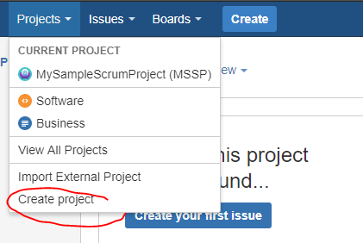

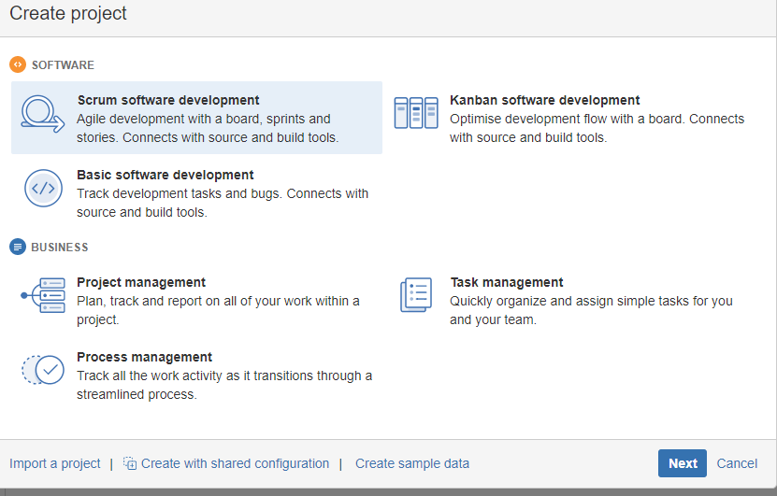

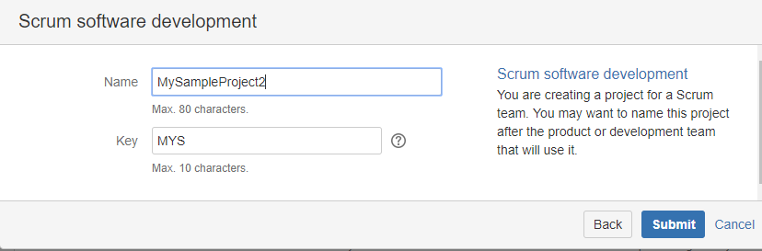

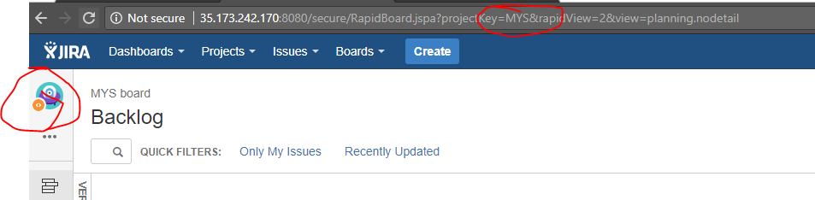

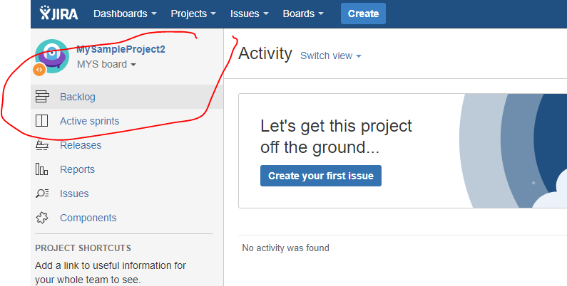

Now let’s check the table in the database.

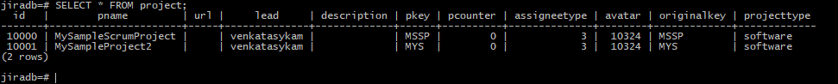



This will prove that out DB connected to JIRA app & running successfully.