Another example,

<https://github.com/DIGITALAPPLICATION/Calculator/blob/master/pom.xml>

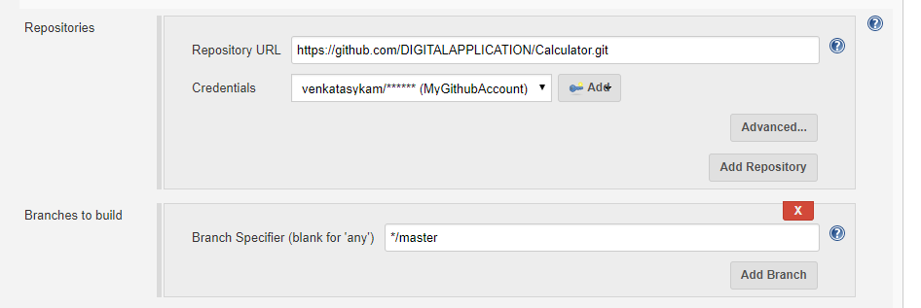

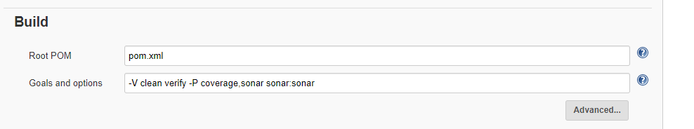

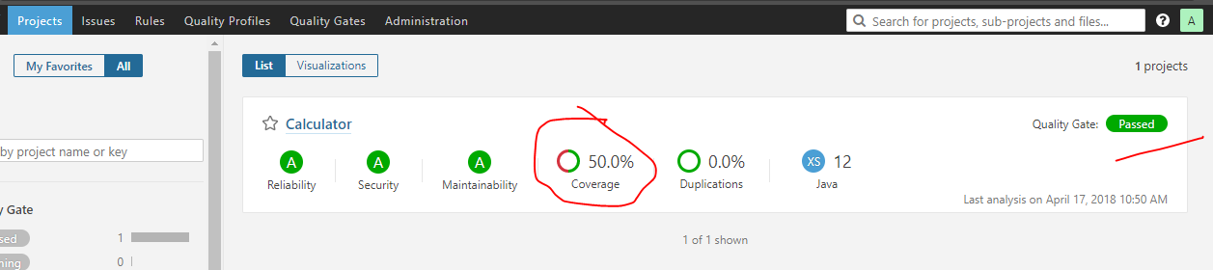

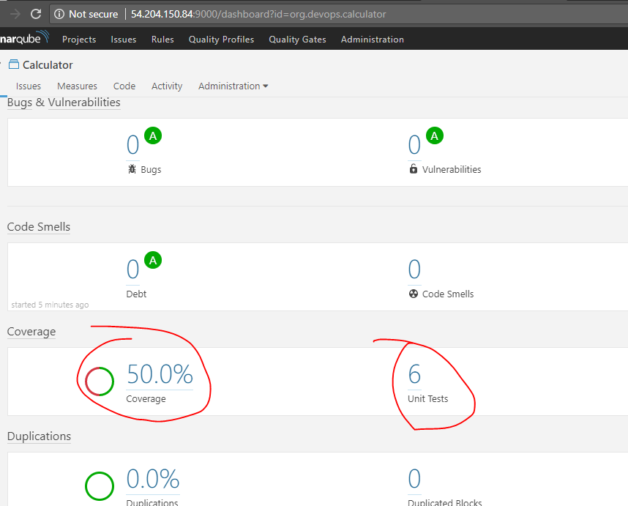

There are only two original source files

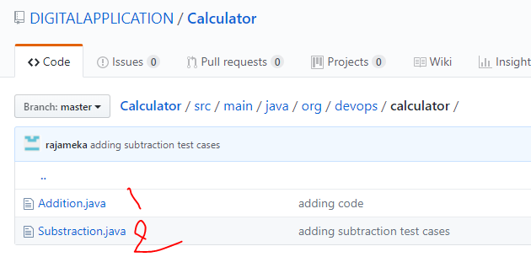

But only one junit test file is there for original code.

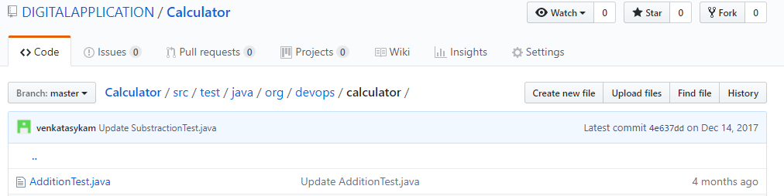

Writing another test file for Substation:

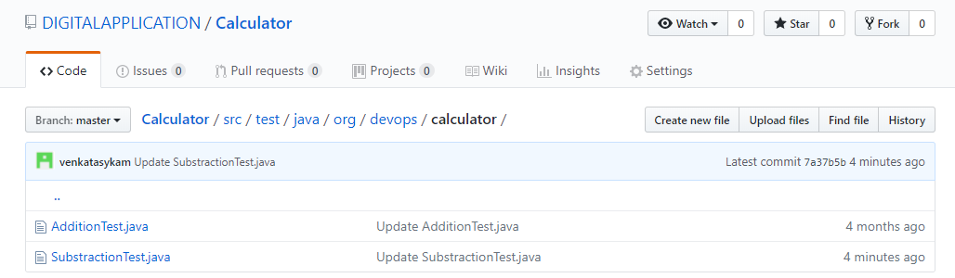

Now the coverage showing 100%. i.e., how many original source files are there those many number of test file also covered.

