SONAR installation

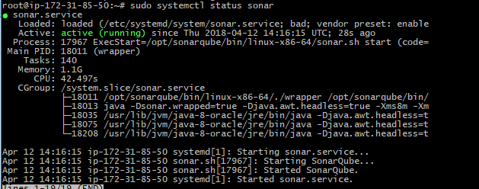

Sonar is running and click on login.

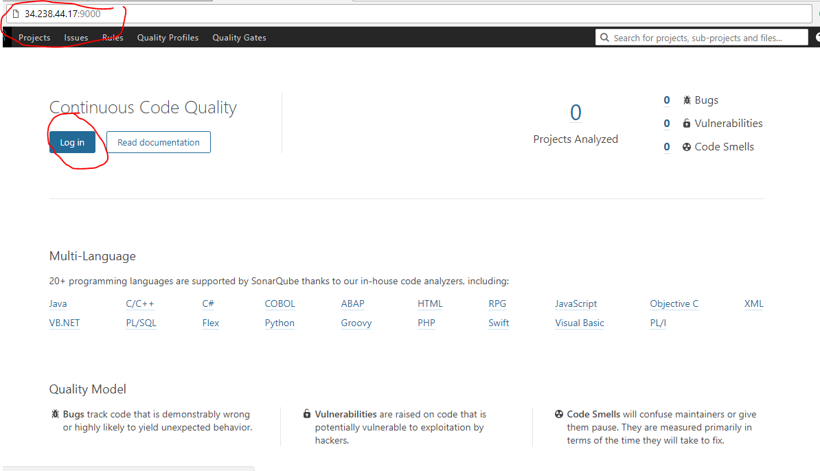

default username & passwd are

uname: admin

paswd: admin

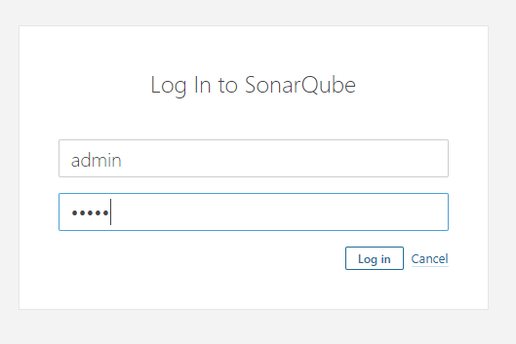

After login, it will navigate to sonar projects. As of now, there are no projects analysis report uploaded to sonar.

