**AWS-Bitbucket-PostgreSQL-Installation**

|  |
| --- |
| Note: Please view this image in “Web Layout” to see the complete image,  right side bottom of the word doc. |

Select External to provide the database details Or you can proceed with internal as of now, and give the data base details later. Here, I am choosing external.

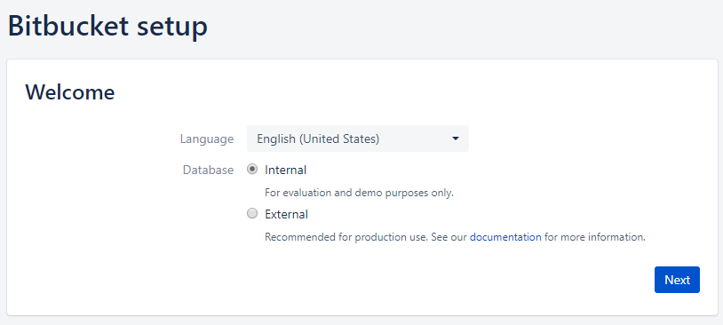

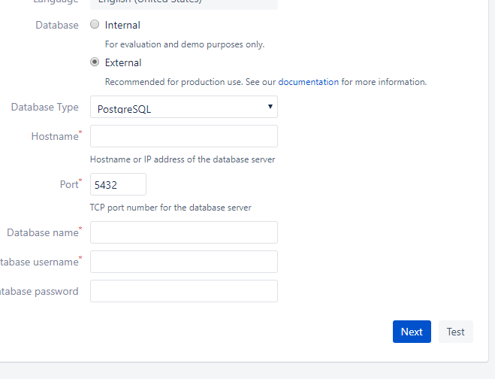

Choose the DatabaseType as PostgreSQL, if he postgre SQL is installed on the same server then give the host name as localhost, if the database is available on another machine give the IP address of the host. Click on ‘Test’ to check the database connection with bitbucket.

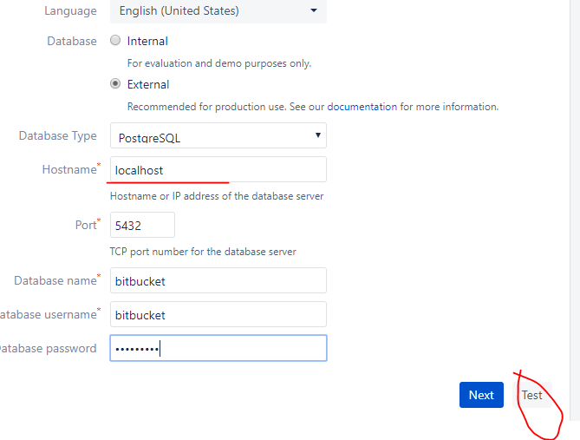

Click on ‘Test’ to check the database connection with bitbucket. Connection succesfull. Then click on NEXT.

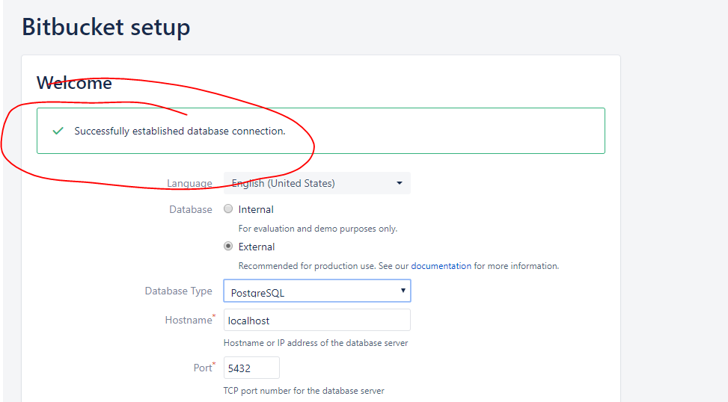

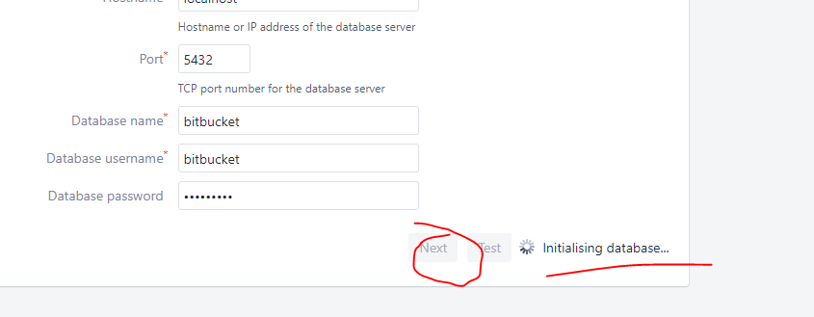

Choose “I need an evaluation licence” since this is for practice. Or else you can procide the key which is provided by Atlassian team.

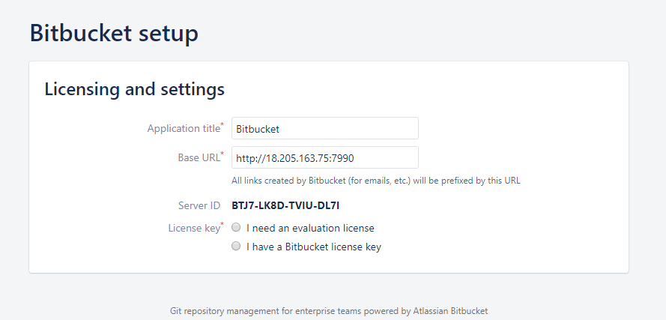

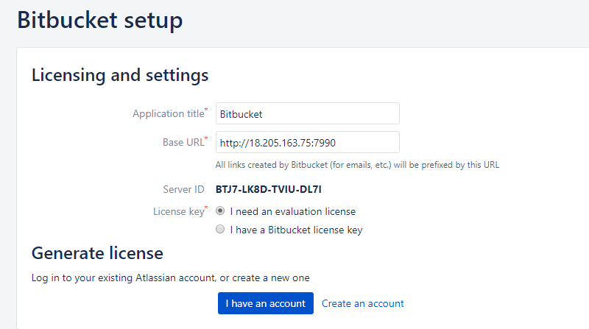

If you already have an account with Atlassian, then click on “I have an account” or if you are new to Atlassian choose “Create an account”. I am choosing “I have an account” since I am already a member of Atlassian site. (If you are new to Atalassian, click on Create an account, this would take much time).

Choose ‘bitbukcet’ server. Click on ‘Generate Licence’.

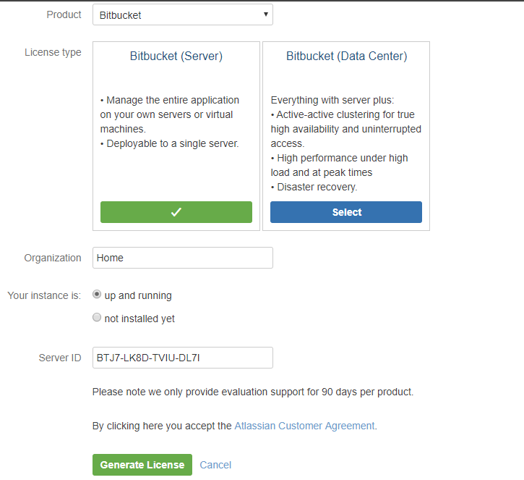

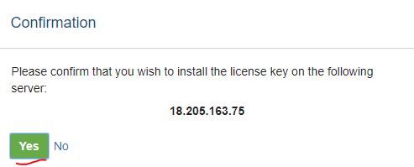

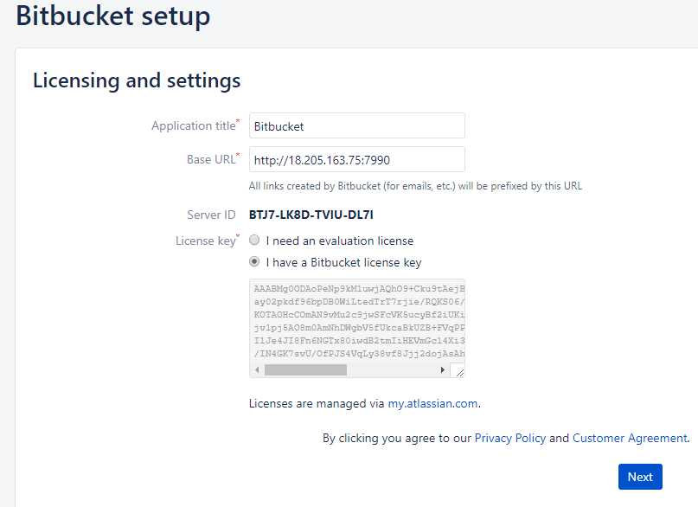

If you already have a plan to integrate JIRA, you can integrate it now, otherwise signup & “Go to Bitbucket”.

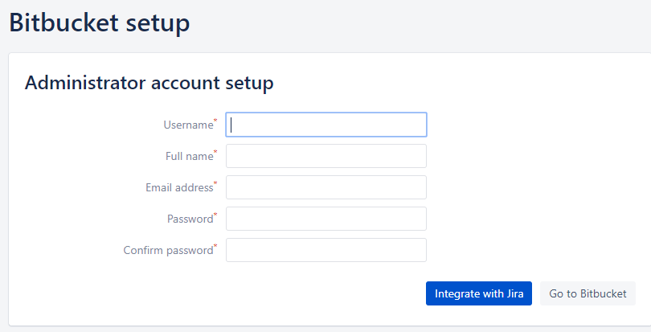

Once signup success, then login to bitbucket with new creds.

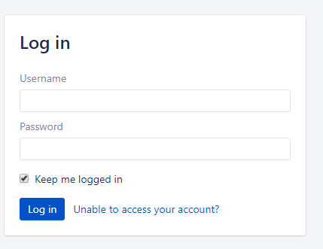

Home page once you firsttime logged into bitbucket.

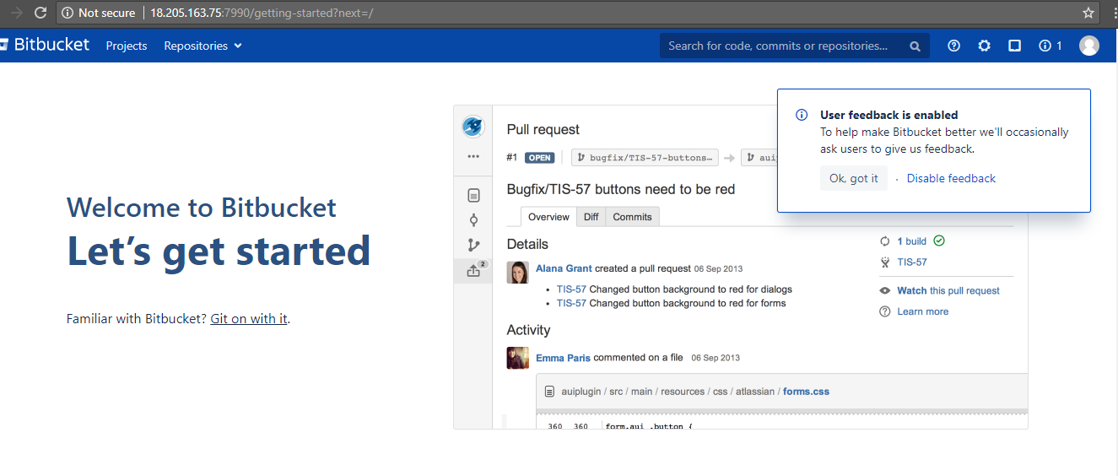

Scroll down



Click on create new project.

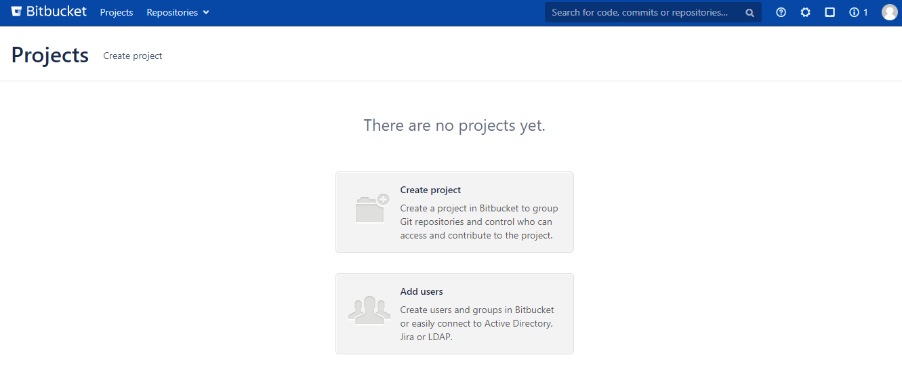

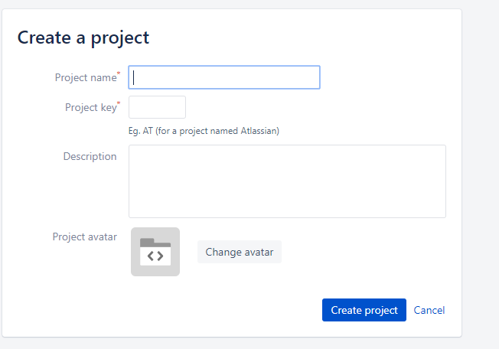

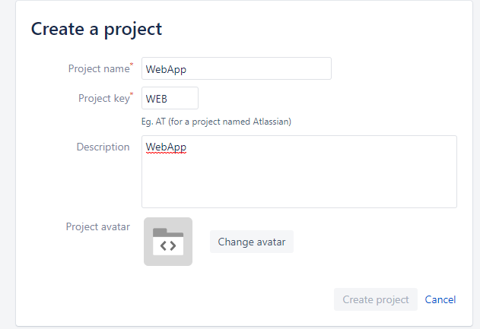

Create a repo for your project:

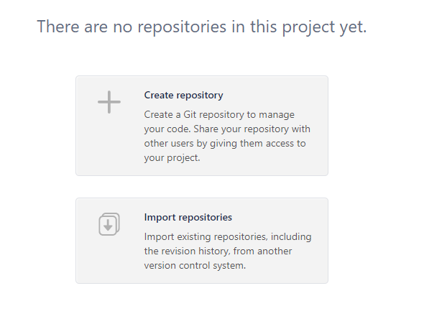

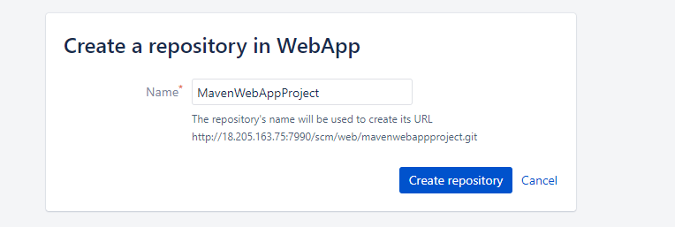

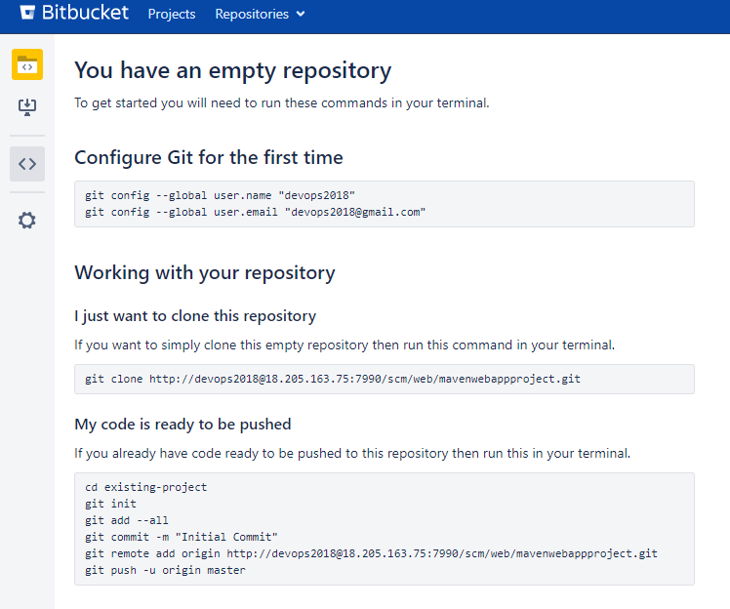

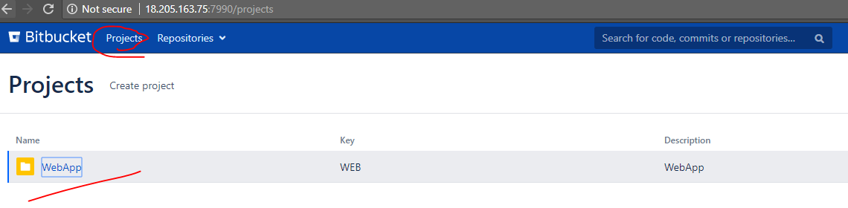

Add the code from local to Bitbucket:

Open GitBash or TortoiseGit or any client which can interact with bitbucket.

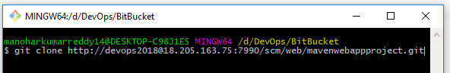

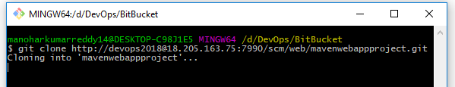

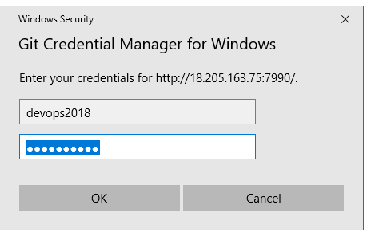

1. Adding the local code to local git repo ‘mavenwebappproject’ for the branch ‘master’.
2. Committing the code to local git repo ‘mavenwebappproject’ for the branch ‘master’.
3. Pushing the local commit from local branch ‘master’ to remote branch ‘master’.

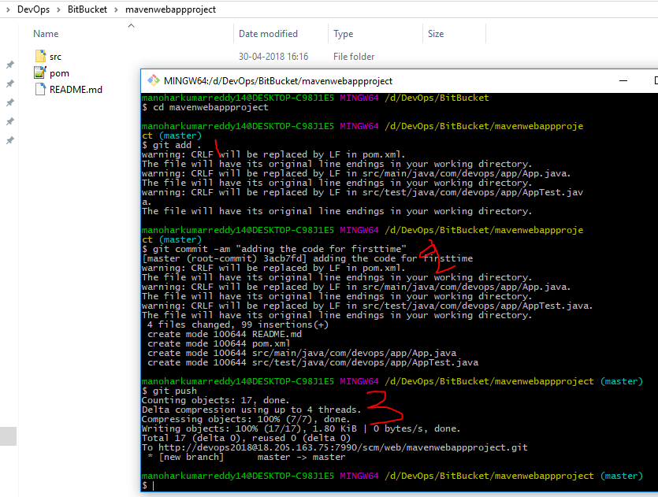

Verify the code in server whether its uploaded or not.

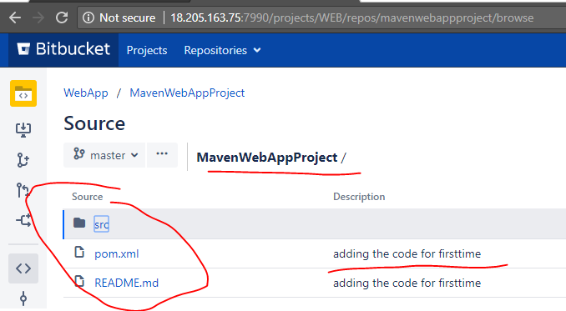

Verify the list of list of bitbucket projects & repos in databse:

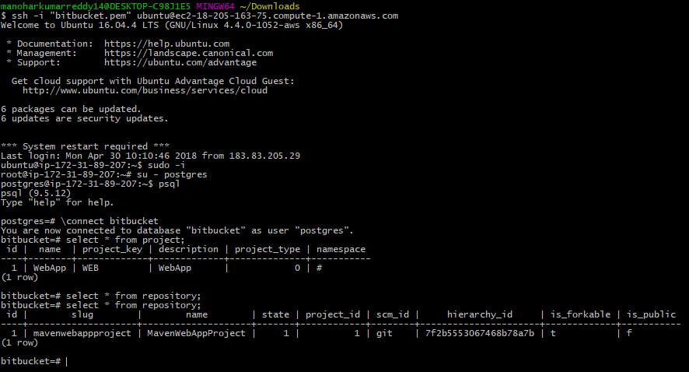

Create a new project & repo in bicket and check the DB again:

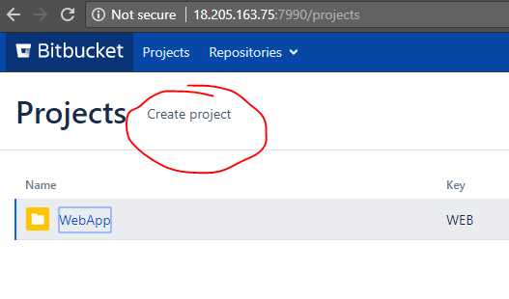

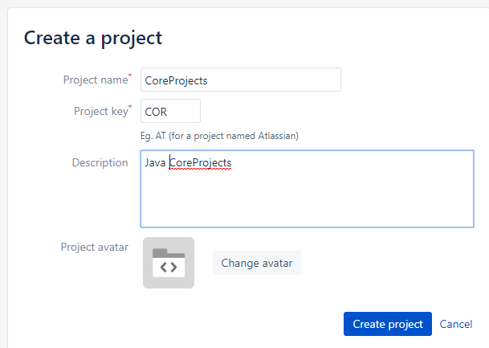

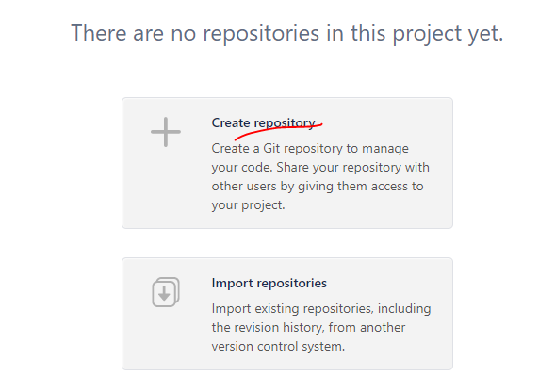

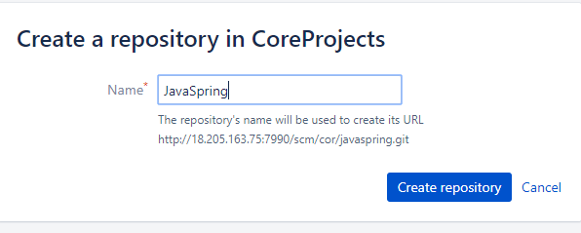

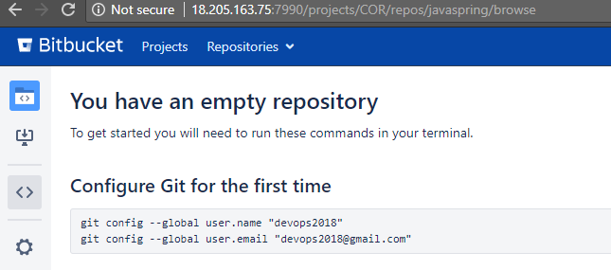

Now, you can see the list of projects and repos in DB:

