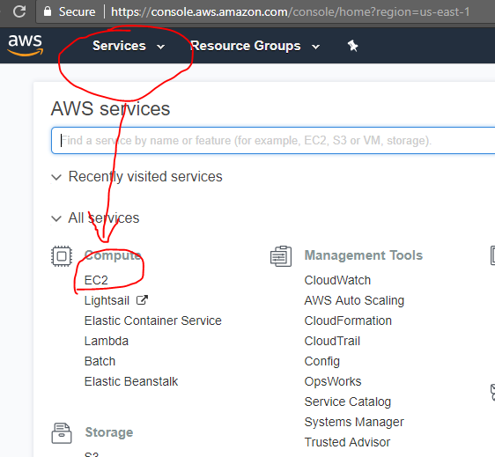

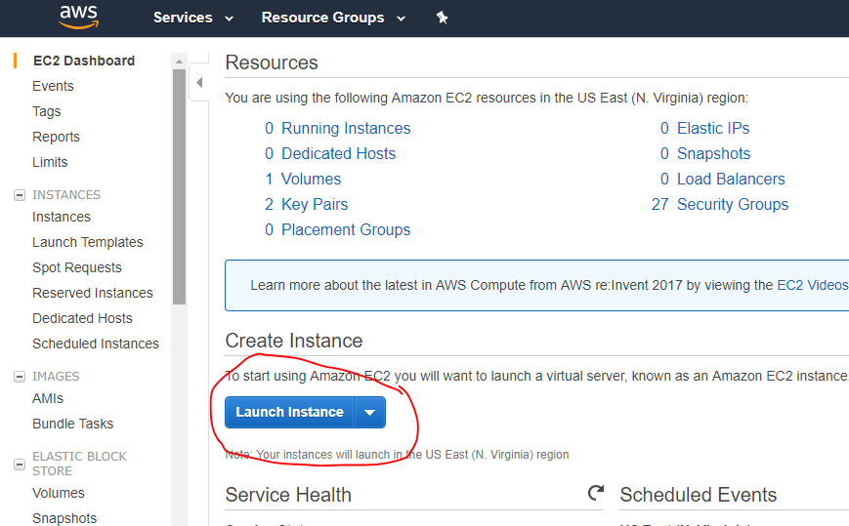

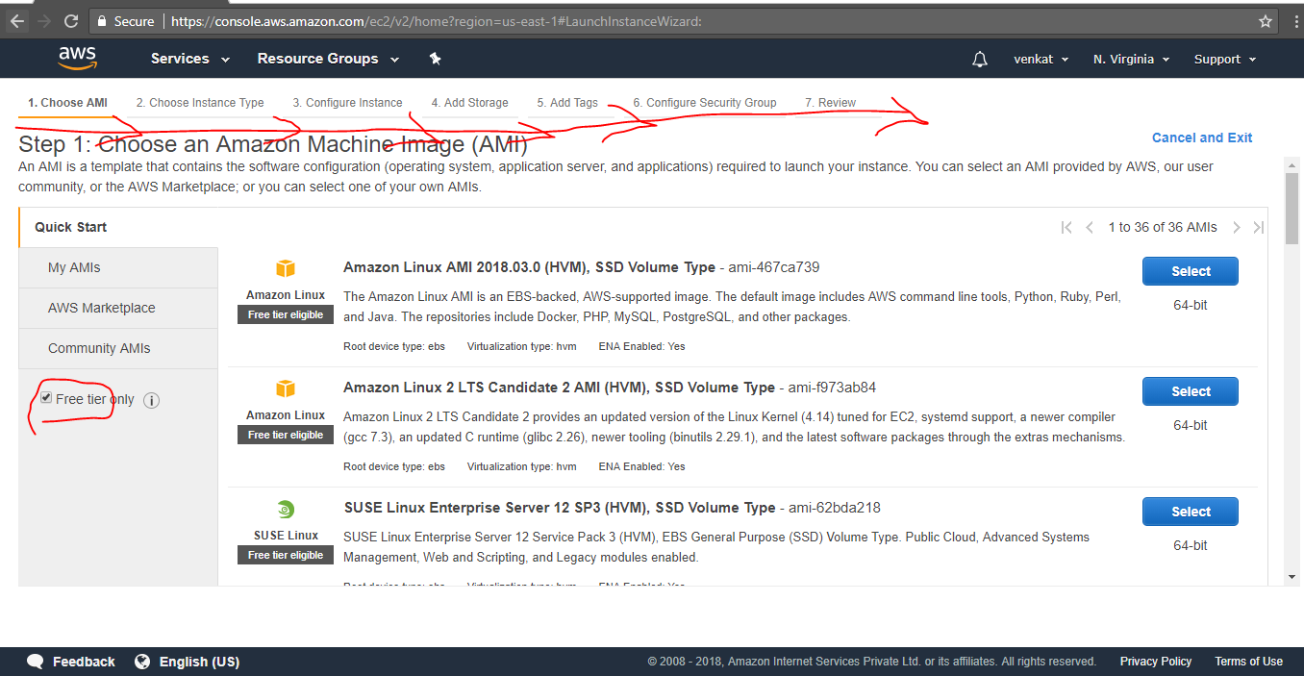

Scroll down & choose windows machine:

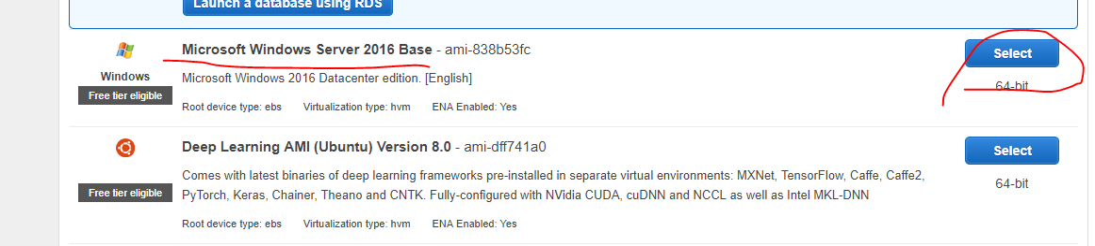

Proceed with default values:

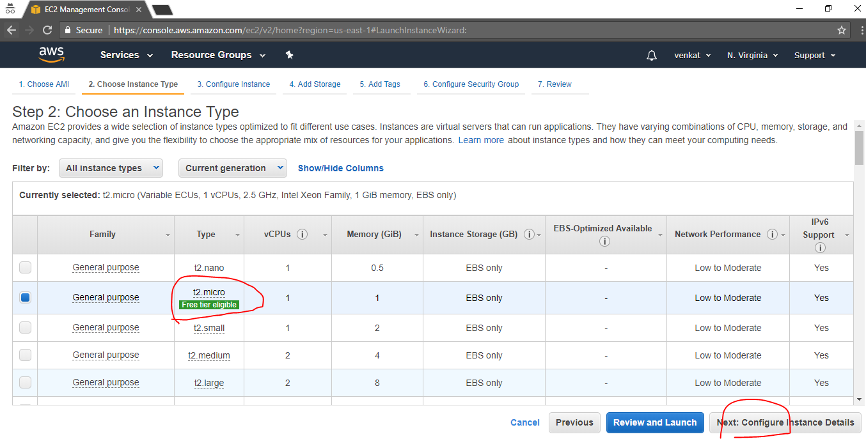

Proceed with default values:

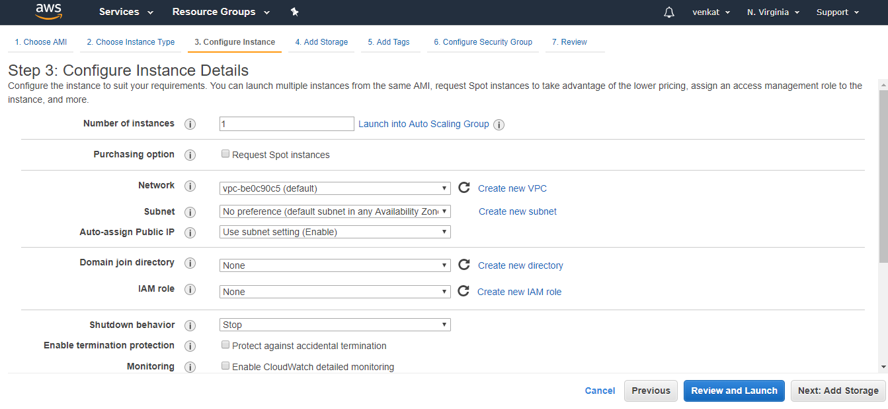

Proceed with default values:

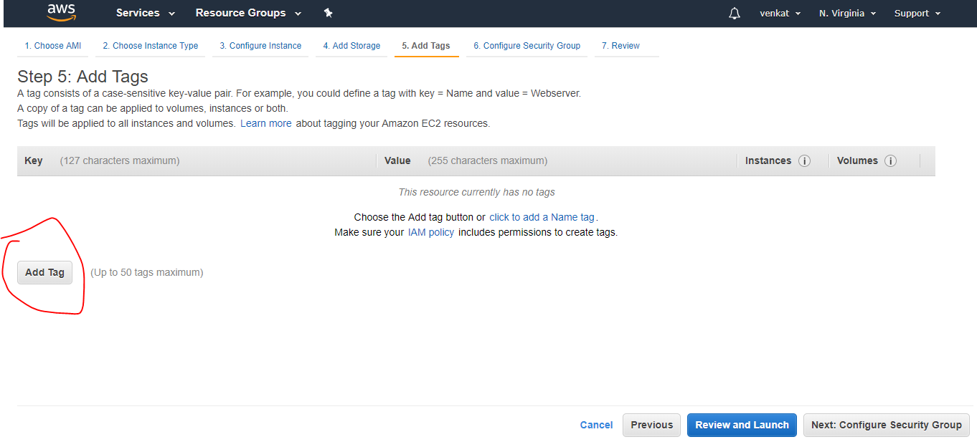

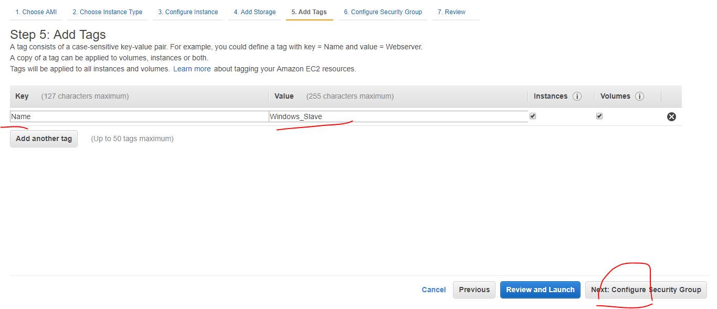

As this practice is not for production allowing this instance to all the ports.

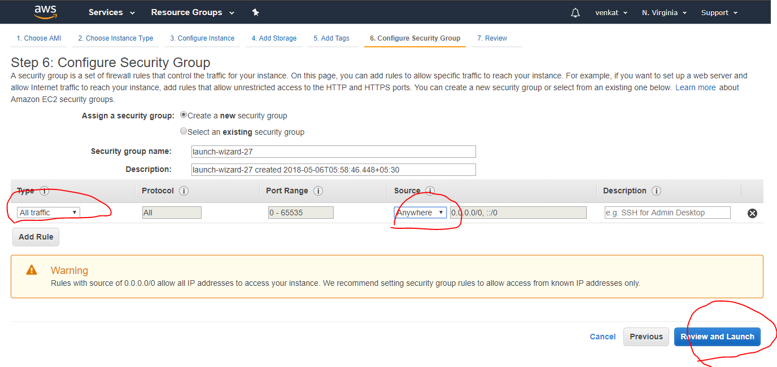

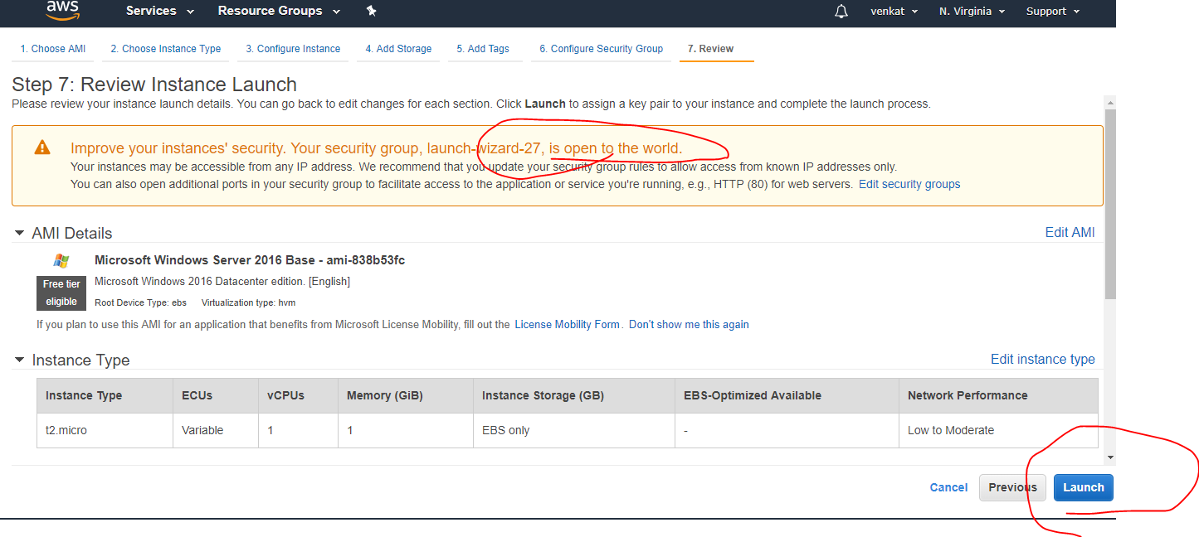

Proceed with the exiting key pair if you already have the key in your local machine OR proceed with below steps.

1. Choose “Create a new pair”.
2. Give any name to the key.
3. Click on “Download Key Pair”.
4. See the downloaded Key pem file (on chrome browser).
5. Once the key .pem file downloaded, the button “Launch Instances” is enabled.

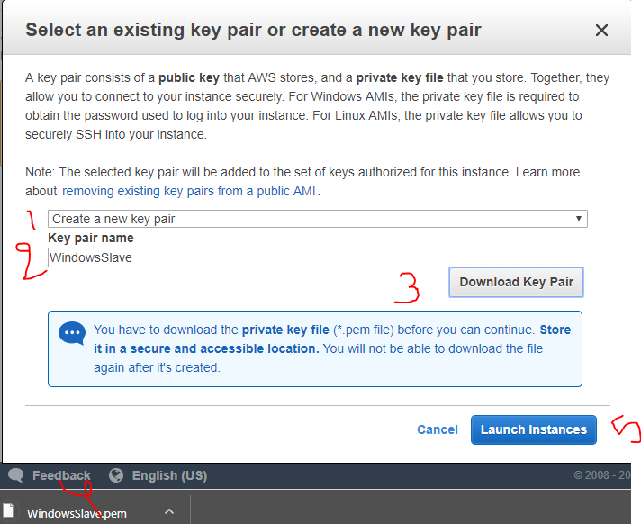

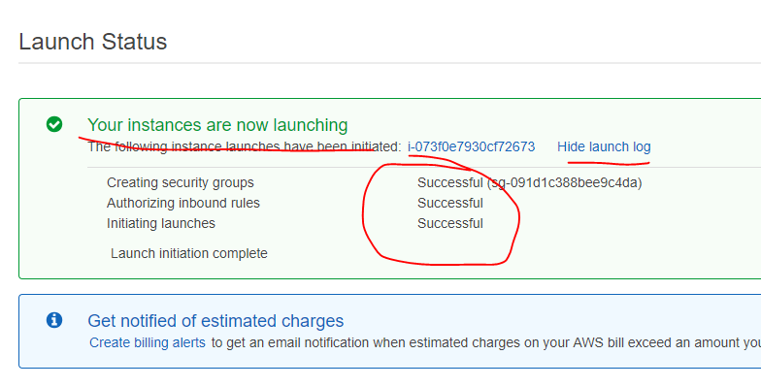

Scroll down and click on View Instances. See the below image and green status as “running”. Now click on “Connect” button.

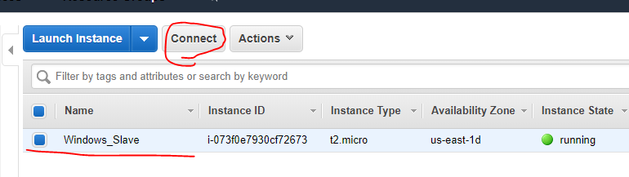

Click on “Download Remote Desktop File” (Don’t click on Get Password now).

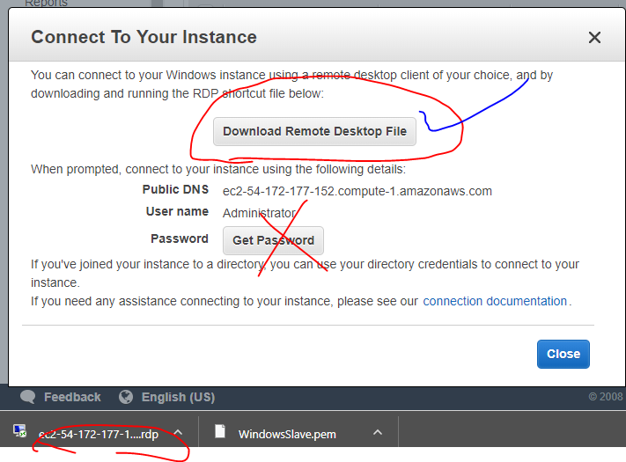

Open the downloaded Remote Desktop File (rdp). It will ask you to connect or cancel.

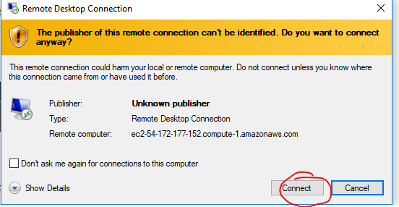

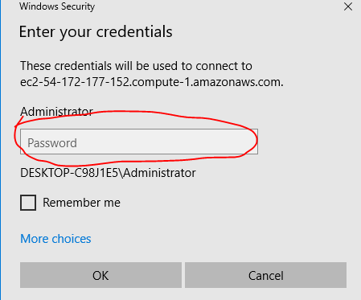

Now click on “Get Password”.

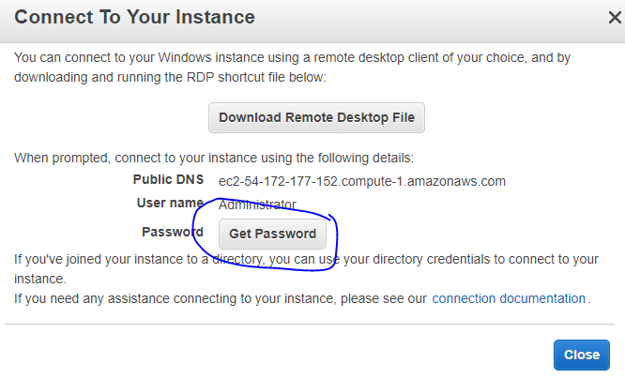

It will ask you to load the key pem file. You can copy the content from pem file or you can load the key file using “Choose File” option.

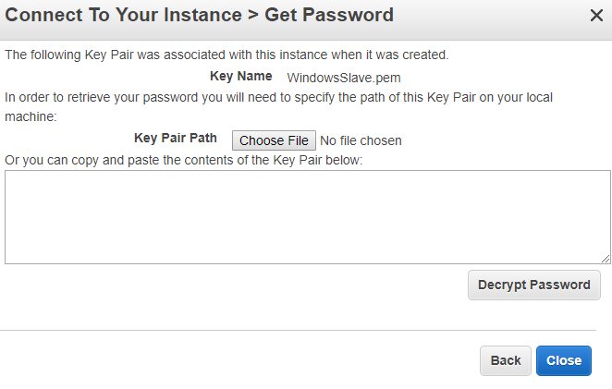

Click on Choose File” button and load the pem file.

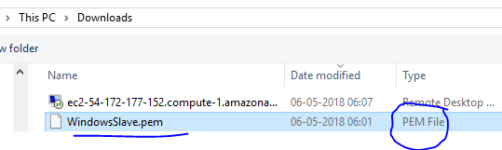

Key loaded, now click on “Decrypt Password”.

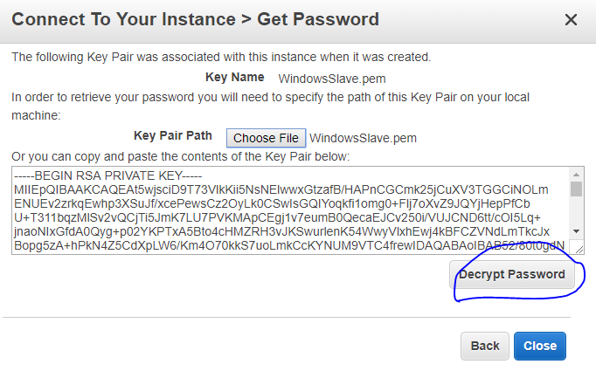

Copy the password & paste it on the below window.

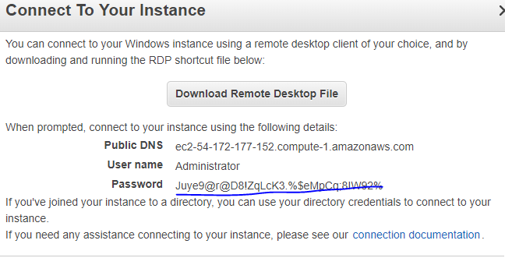

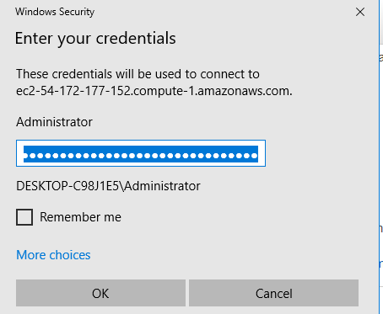

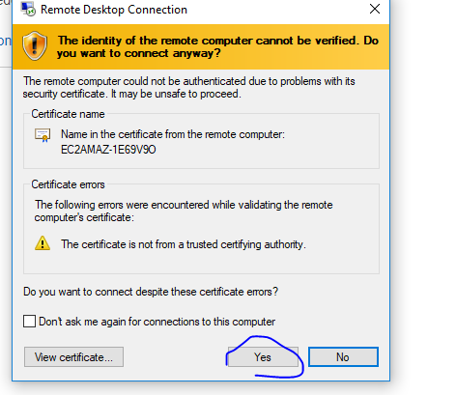

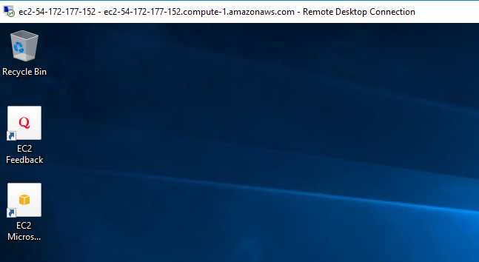

Successfully connected to windows.