**LDAP-Installation-Configuration-Groups-and-Users-creation**

Step-1: Update the packages:

sudo apt-get update

Step-2: Install the LDAP:

sudo apt-get install slapd ldap-utils

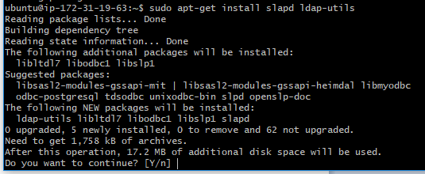

Continue with the option Y and enter the admin password:

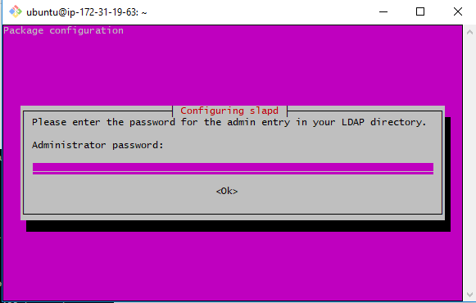

Enter he password & press the tab, so that the cursor will move to “Ok” option. Press the button enter.

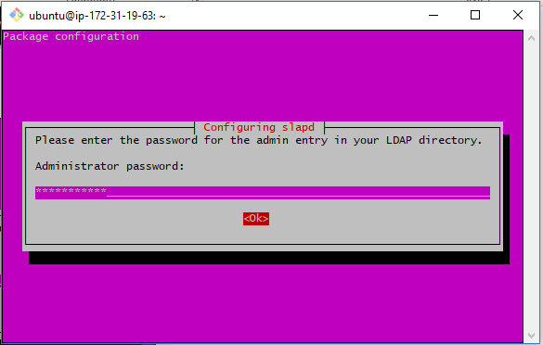

Re-enter the password:

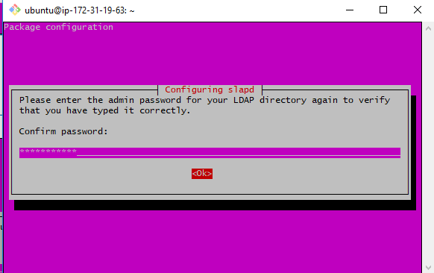

Step-3: LDAP Configuration

sudo dpkg-reconfigure slapd

Choose “No”. 🡪 Press Enter.

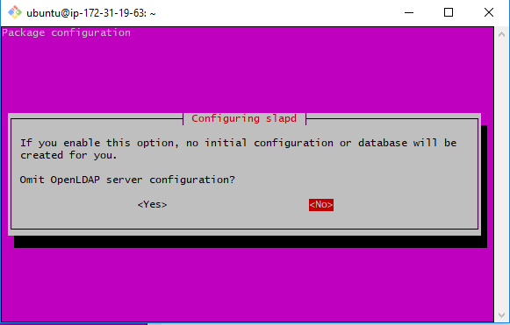

Please note down this: You can give any domain name you want (for this practice), but remember it. (Note it down somewhere in the notepad or doc).

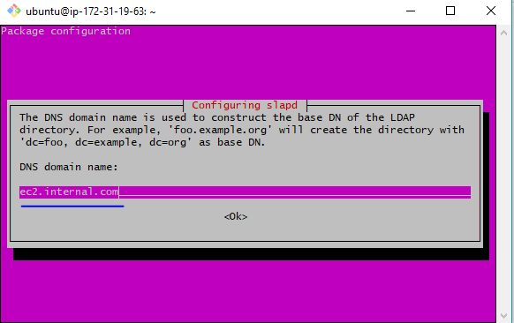

Proceed with the default value.

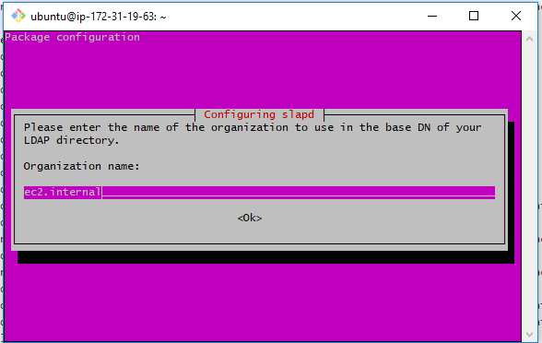

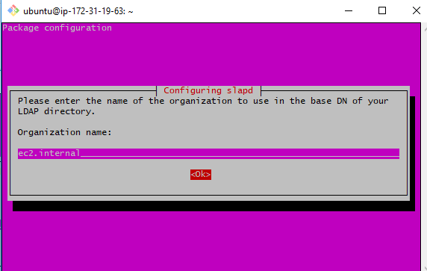

Enter the Admin pwd which you already created in Step-2 or give a new one (but note it down). (I am giving the same one.)

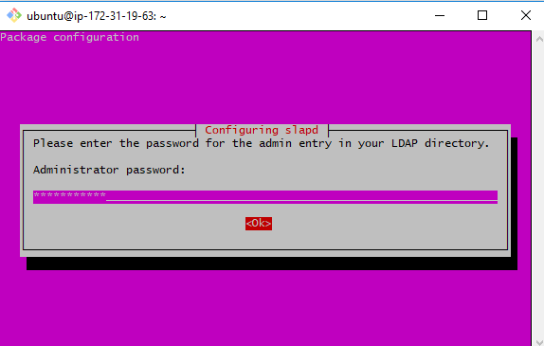

Re-enter the password:

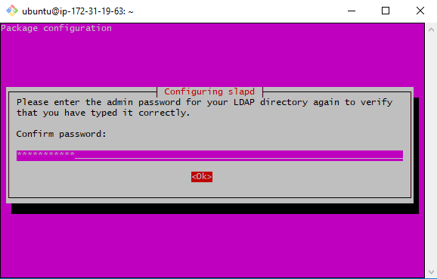

Choose ‘HBD’ and press tab.

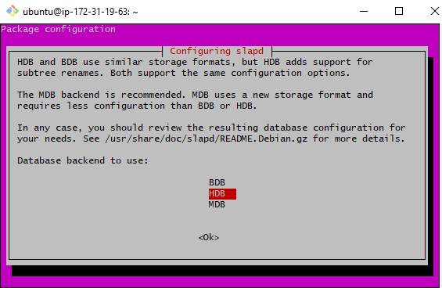

‘Ok’ selected after the tab pressed, now click on “Enter”.

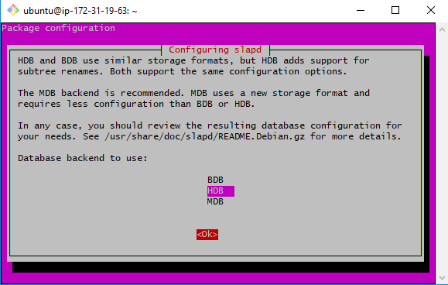

Proceed with Default option:

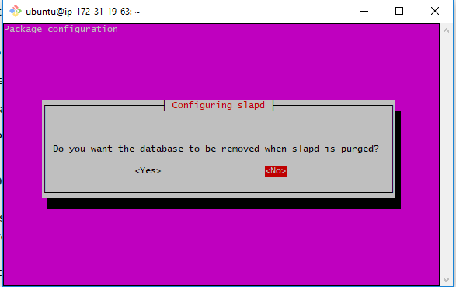

Proceed with Default option:

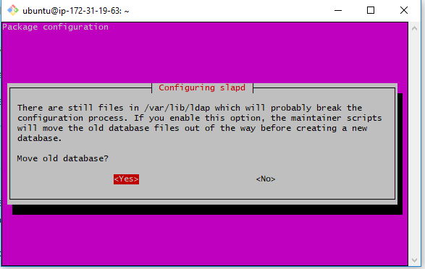

Proceed with Default option:

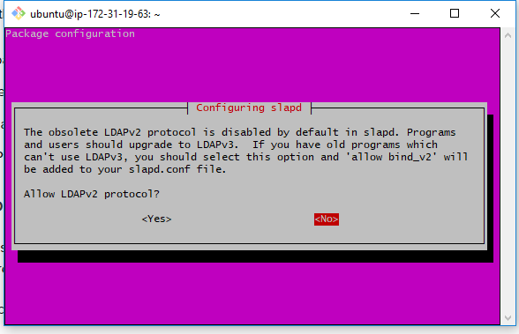

Step-4: Install PHPldapadmin

sudo apt-get install phpldapadmin -y

Step-5: Configure PHPldapadmin: Update the ldap config file with IP address & root DN details.

sudo vi /etc/phpldapadmin/config.php

We need to update the the config file with these three line. First search for each file & update the line as

|  |
| --- |
| $servers->setValue('server','host','54.86.91.105');  $servers->setValue('server','base',array('dc=ec2,dc=internal,dc=com'));  $servers->setValue('login','bind_id','cn=admin,dc=ec2,dc=internal,dc=com'); |

See the below steps how to update it in the file. (If you are sure, you can directly search for the above three lines and update them).

5.1. Update the LDAP server IP address details.

Open the file in VI editor.

sudo vi /etc/phpldapadmin/config.php

Search for $servers->setValue('server','host'

As showing in below image. Just press the slash “/” it will go in search mode. And then enter the string you want to search, then press enter, it will go to that line once the matching found. Or manually search for it and update the line.

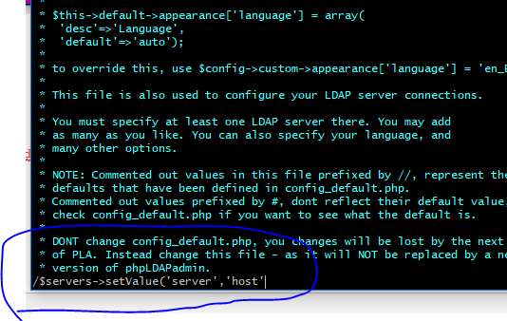

Update the IP address (either public or private). Here, I have updated with public IP.

|  |
| --- |
| $servers->setValue('server','host','54.86.91.105'); |

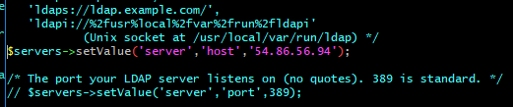

(Save the file to avoid any loss of data in the next update, or proceed with the update)

5.2. Update the root DN details:

Search for, $servers->setValue('server','base',array('dc=example,dc=com'));

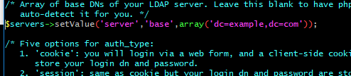

Update the line with domain name (root DN) which we have entered earlier as ec2.internal.com while installing LDAP.

$servers->setValue('server','base',array('dc=ec2,dc=internal,dc=com'));



5.3. Update the config file with admin details.

Search for, $servers->setValue('login','bind_id',

Update the value to : $servers->setValue('login','bind_id','cn=admin,dc=ec2,dc=internal,dc=com');

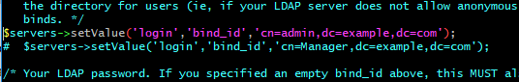

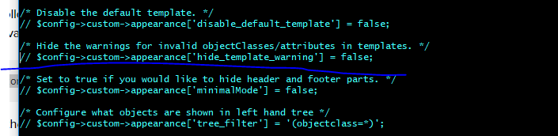

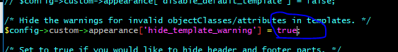

Step-6: Launch the URL in browser http://<publicIP>/phpldapadmin/

Home page of LDAP.

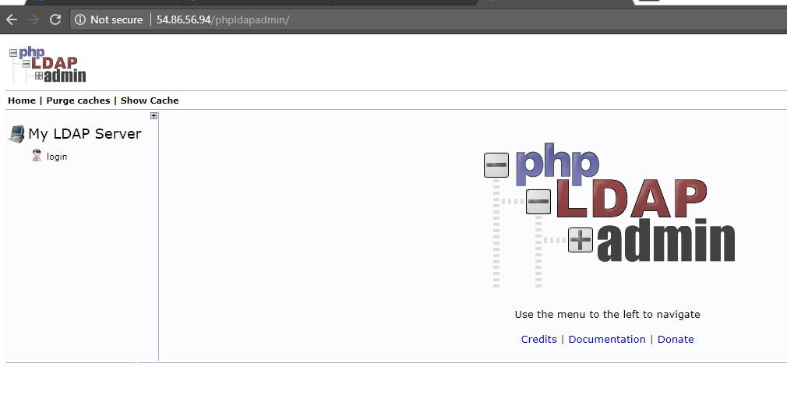

Login as admin: (By default it displays the admin username, ignore the warning)

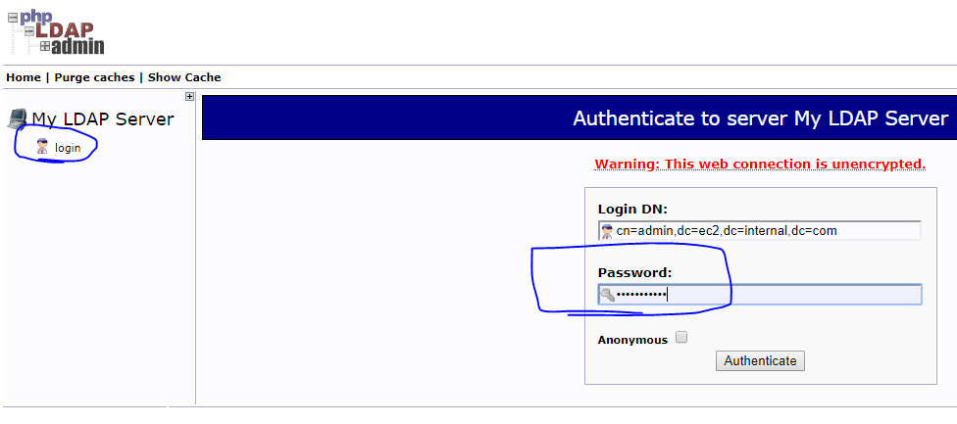

Authentication Success:

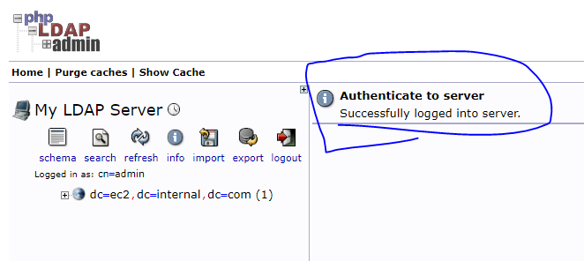

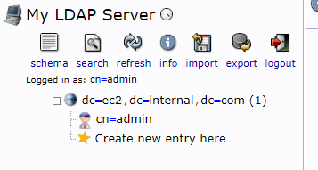

Click on cn=admin you will navigate to admin profile, if you want, you can update the password in admin profile.

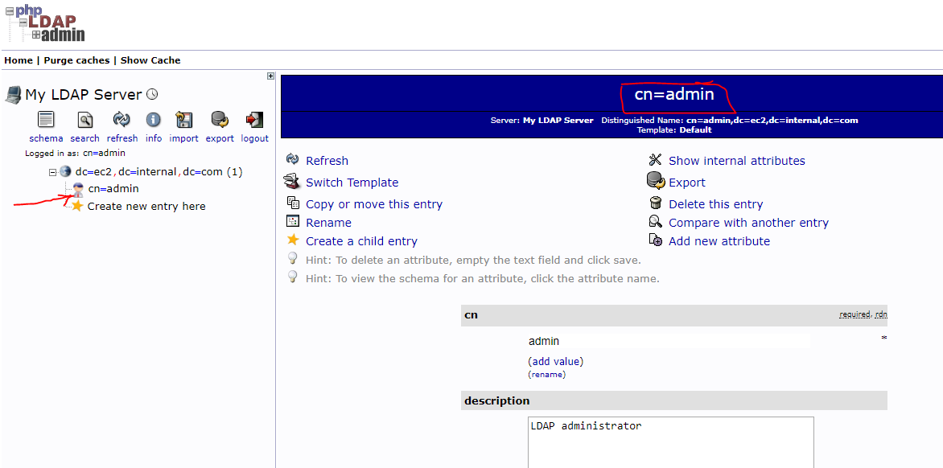

Now, let’s create Users & Groups in LDAP:

Click on new entry & choose “Organizational Unit” as shown in below image.

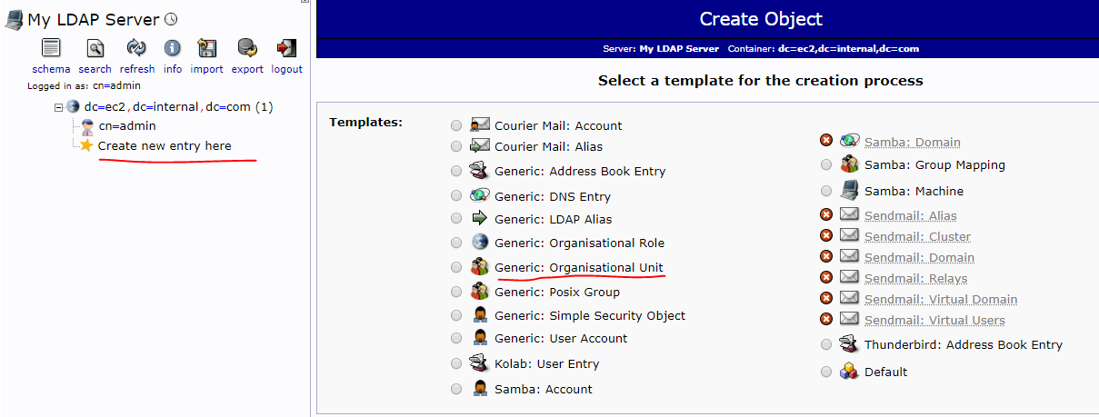

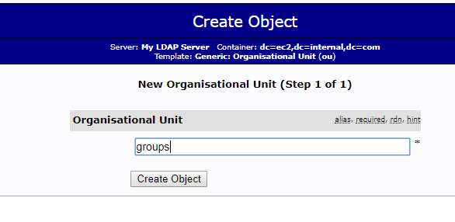

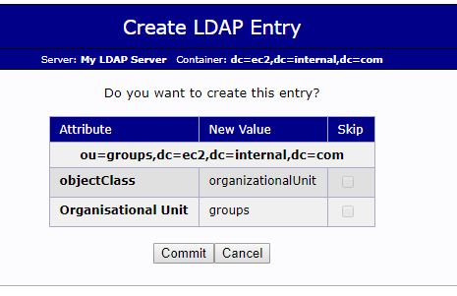

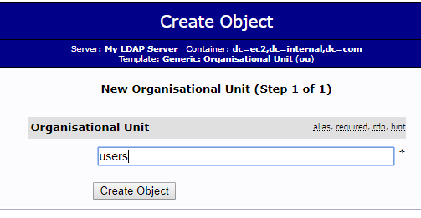

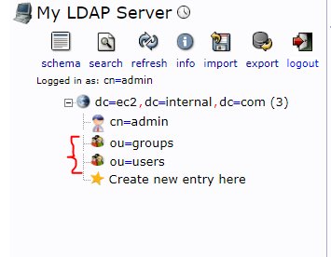

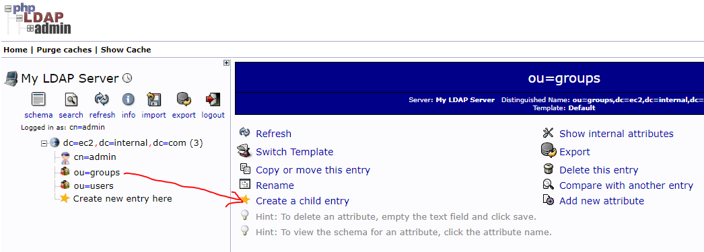

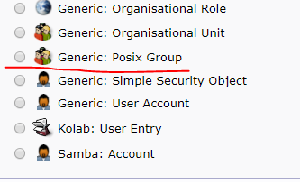

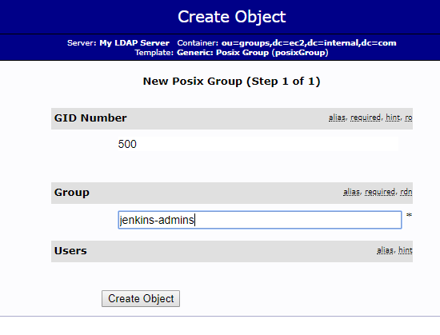c

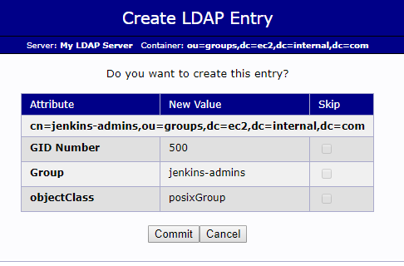

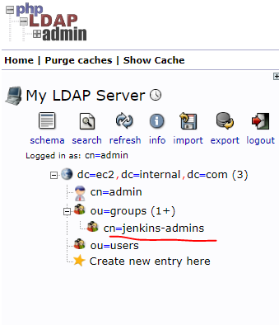

Create for Jenkins-developers, Jenkins-buildEngineers, Jenkins-read.

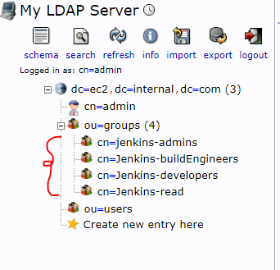

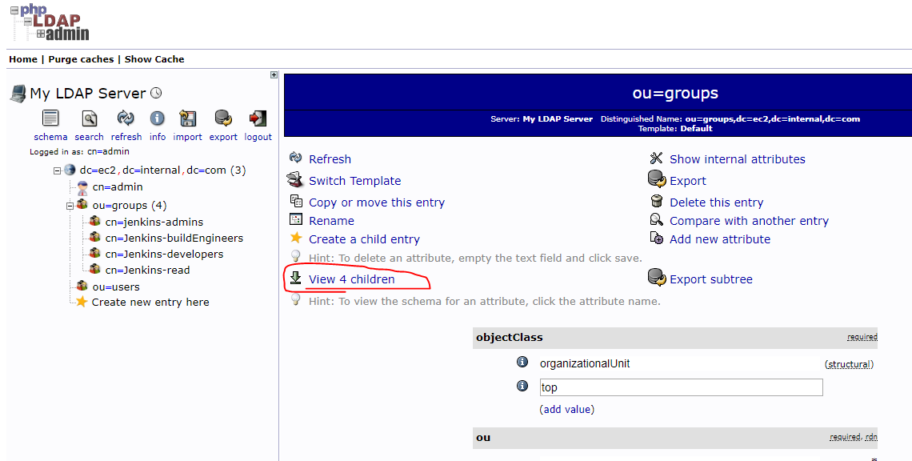

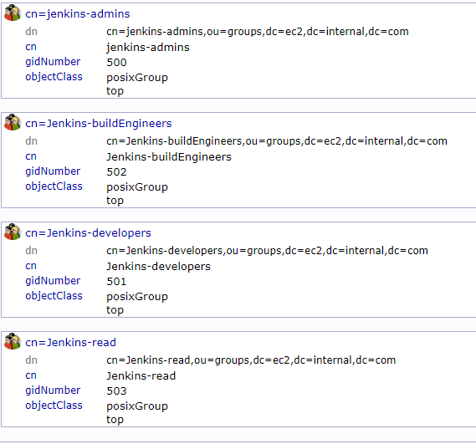

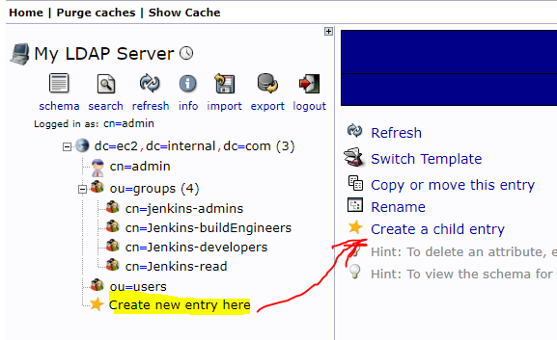

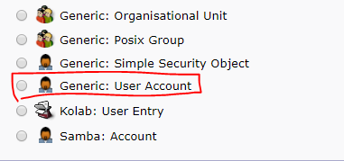

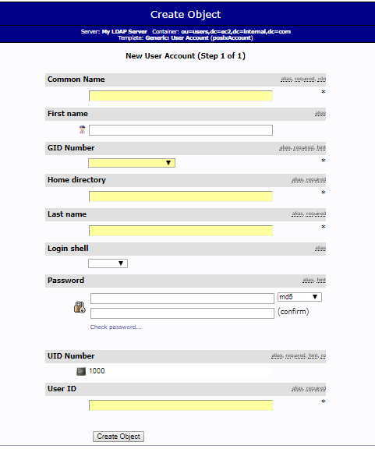

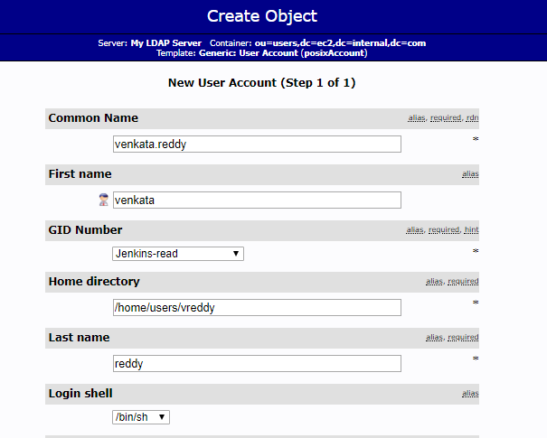

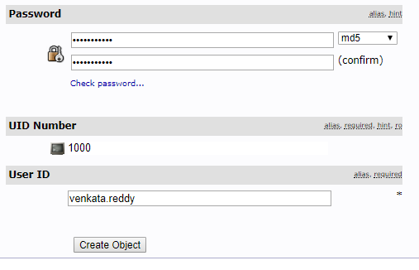

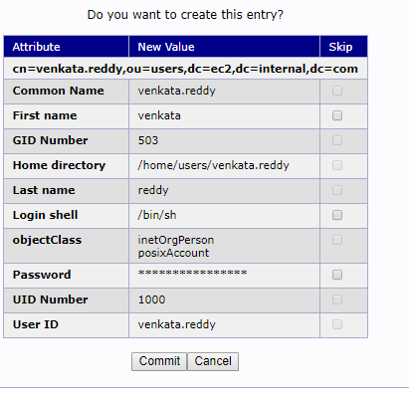

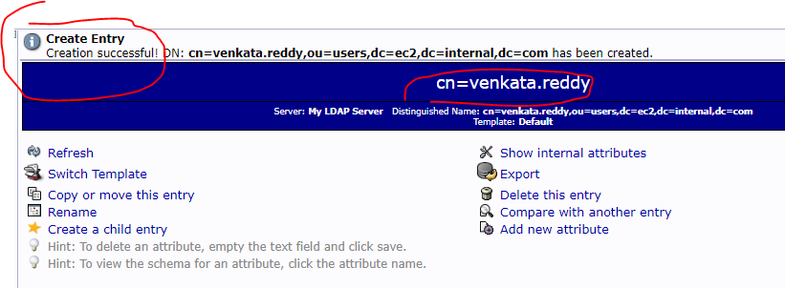

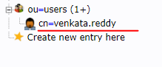

Create 5 users by copying the existing one. Click on the existing user 🡪 Copy or move this entry

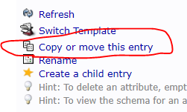

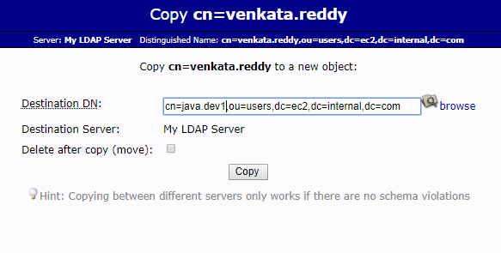

Give the userdetails CN, first name, last name & make sure change the uidNumber to 10001. If you are going to create the thrird user again by copying the existing one make sure you update the uidNumber in sequence i.e. 1002.

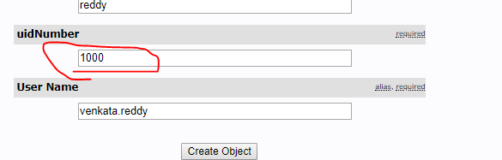

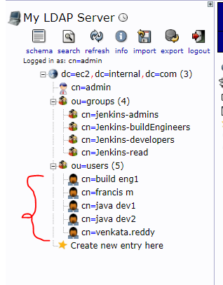

User Login to LDAP:

Signout as Admin & try to login as user. Before signout copy the DN by selecting any user.

**cn=venkata.reddy,ou=users,dc=ec2,dc=internal,dc=com**

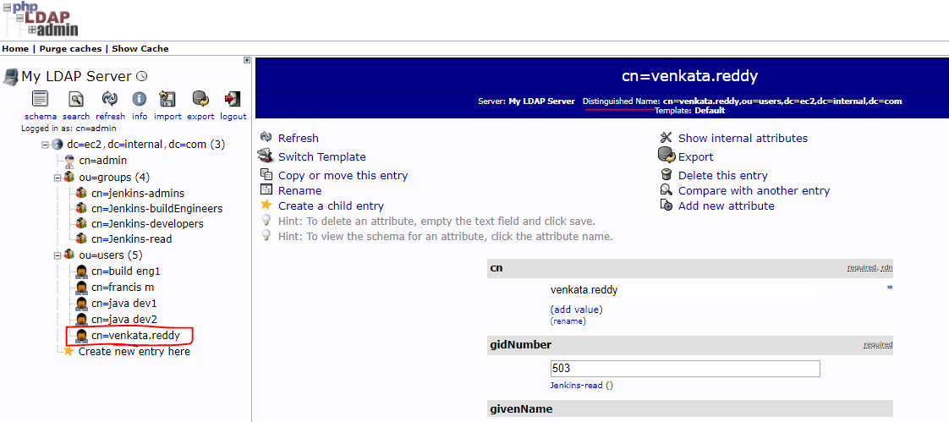

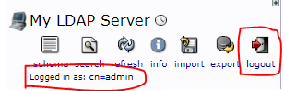

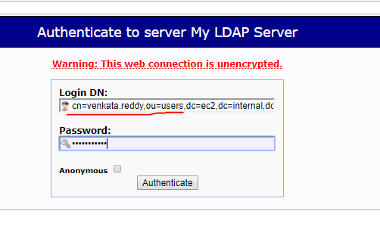

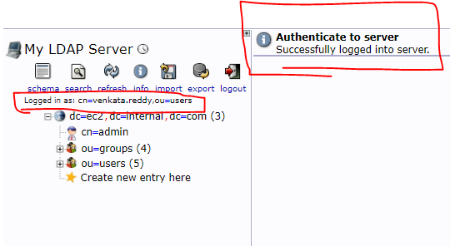

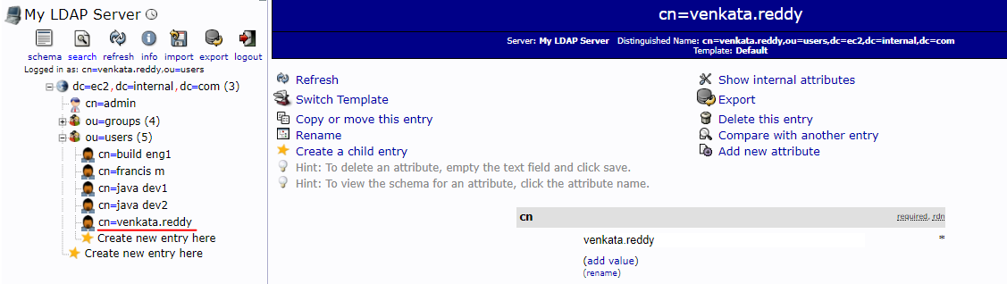

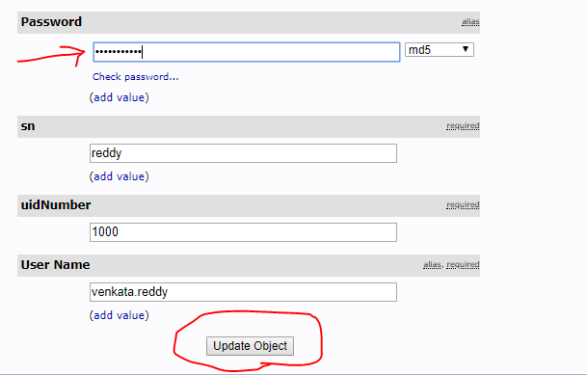

Now, users & groups are ready. Go to Jenkins & configure LDAP. **Refer the file: Jenkins-User-management-with-LDAP.doc**