There are Many ways to provide access to URERS, among them we are going to see “Role-Based Strategy”.

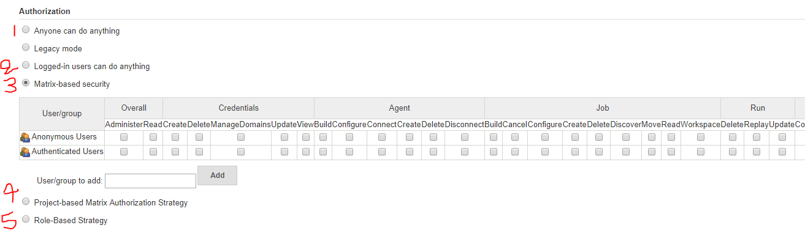

To configure this role based strategy, we need to install a plugin “Role-based Authorization Strategy” as shown in below image.

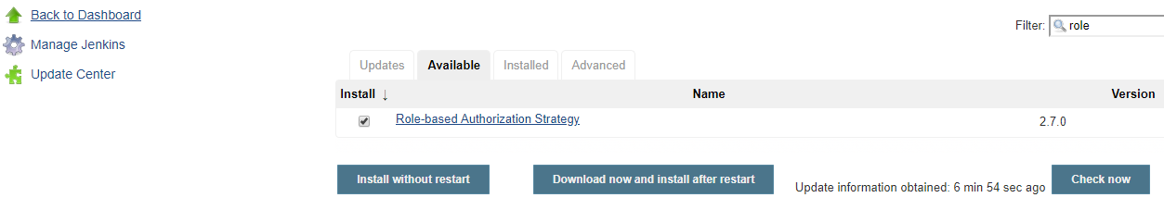

Once the plugin installed you will be able to see two features in two locations.

1. Manage Jenkins 🡪 Configure Global Security 🡪 Authorization. Activate the Role-Based Strategy by selecting this radio button here. And save the configuration.

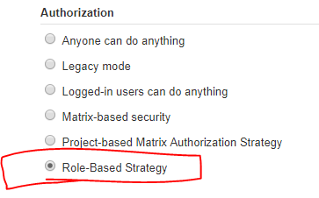

1. Manage Jenkins 🡪 Manage and Assign roles.

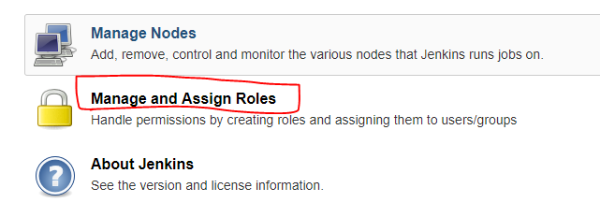

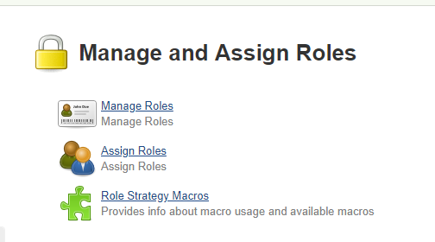

Now, define the role. Click on Manage Roles 🡪 Add all the group names which we created in LDAP and give the appropriate permissions.

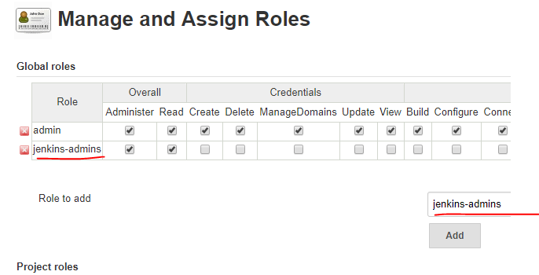

We have given different permissions sets to different groups. That means we are defining roles on Jenkins. Few of the employees might need admin rights, few of the employees might need build trigger & configure access to take care of build & deployment activities, few of them need only read only access etc. (You can give the permissions on your own way per project requirement).

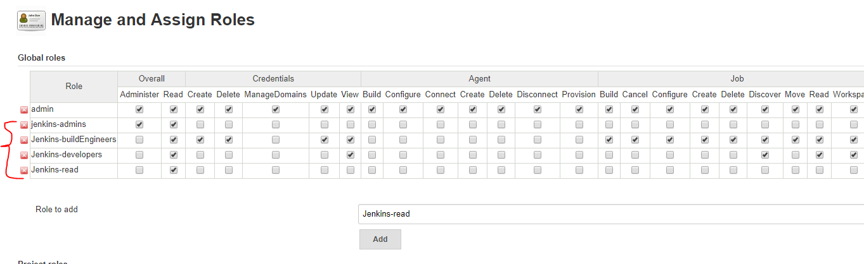

Go to “Assign Roles”: Once we have done with above configuration, here we can see all the roles. Add the users to different roles. (devops2018 is the user from Jenkins own database, after we connected to LDAP, Jenkins is unable to find the user ‘devops2018’ from LDAP server). See the below the red cross X mark pointing the user which is not there in LDAP. here it is showing as “User or group found”. This proves that LDAP users & groups are loaded to Jenkins. (Remove this user by clicking on red cross X button).

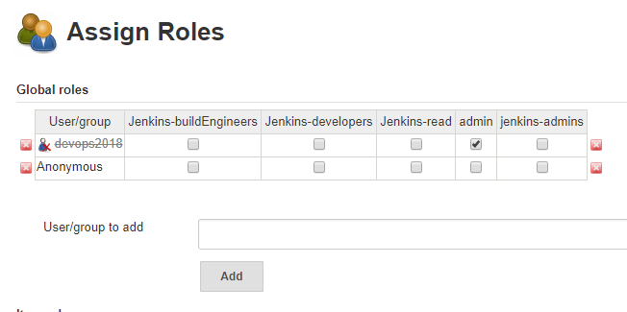

Add the users to appropriate roles:

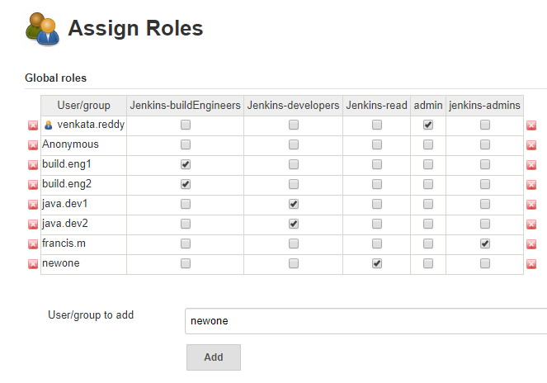

Save and navigate this same page (Manage Jenkins 🡪 Manage and Assign roles 🡪 Assign Roles). Asssume by mistake I have added a wrong user as “build.eng2”. See the below the red cross X mark pointing the user which is not there in LDAP. here it is showing as “User or group found”. This proves that LDAP users & groups are loaded to Jenkins. (Remove this user by clicking on red cross X button).

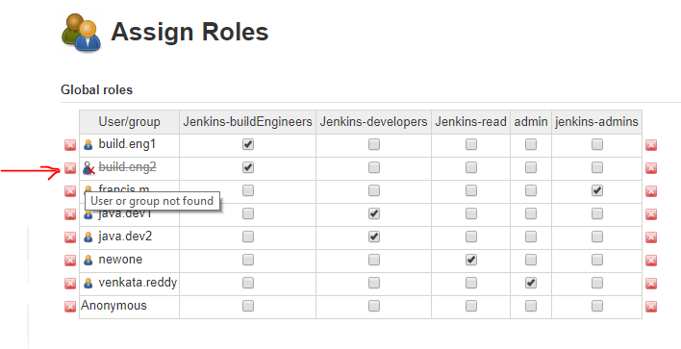

Now, logout from Jenkins check everyone’s login access.

First with admin: venkata.reddy

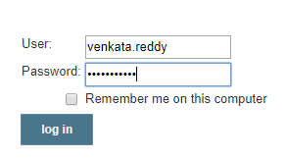

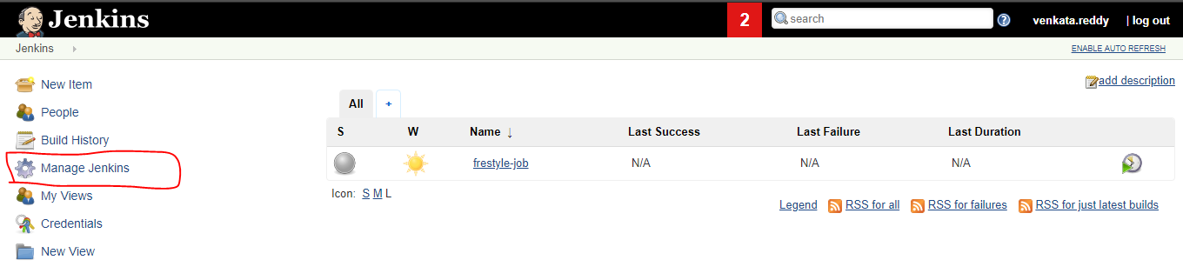

Second one build eng: Unable to see the Manage Jenkins.

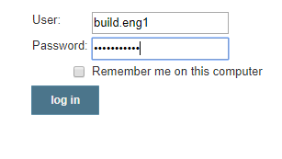

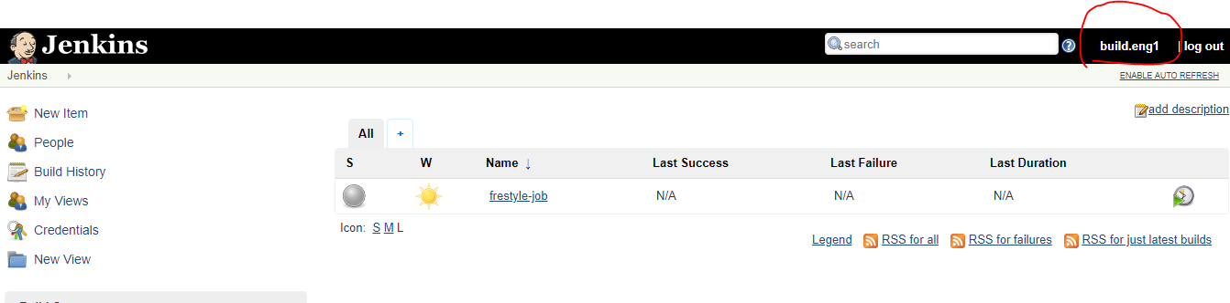

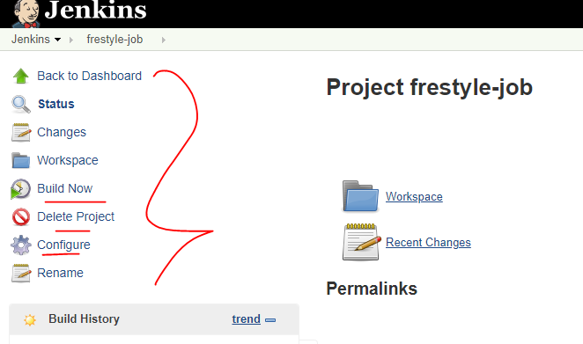

Third one java dev user: Able to see the Jenkins jobs & its workspace. But can’t able to trigger the jobs (Build now option is not there for dev user).

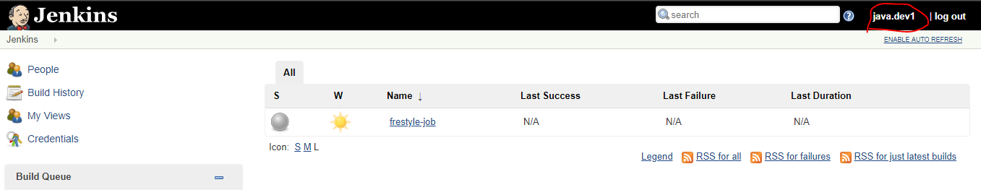

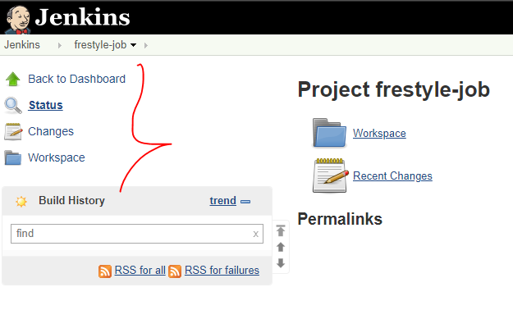

User who have read only access: Even this user can’t able to see the Jenkins jobs.

