TNSDC – IBM AGENTIC AI INTERNSHIP
PROJECT REPORT
CAMPUSAI
An Agentic AI Student Support Assistant
using RAG, Tools and Memory

Student Name | ______________________________
Register Number | ______________________________
Degree / Branch | B.Tech Information Technology
Institution | University College of Engineering, Villupuram

Academic / Internship Demonstration Report

DECLARATION
I hereby declare that the project titled “CampusAI – An Agentic AI Student Support Assistant using RAG, Tools and Memory” has been prepared as an academic and internship demonstration project under the TNSDC–IBM Agentic AI Internship. The implementation, documentation and screenshots included in this report describe the supplied prototype and its demonstrated capabilities.
Student Signature: ____________________ Date: ____________________

ACKNOWLEDGEMENT
I express my sincere gratitude to the TNSDC–IBM Agentic AI Internship program and to my institution, University College of Engineering, Villupuram, for providing an opportunity to study and demonstrate Agentic AI concepts. I also acknowledge the Streamlit and Scikit-learn ecosystems used to implement the prototype.

TABLE OF CONTENTS
- 1. Abstract
- 2. Introduction and Project Overview
- 3. Problem Statement
- 4. Objectives
- 5. Proposed Solution
- 6. System Architecture
- 7. Agentic Workflow
- 8. RAG-Style Knowledge Retrieval
- 9. Tool Calling
- 10. Conversation Memory
- 11. Technology Stack
- 12. Implementation Details
- 13. User Interface and Screenshots
- 14. Testing and Results
- 15. Advantages and Limitations
- 16. Future Enhancements
- 17. GitHub Repository Preparation
- 18. Conclusion
- 19. References
- 20. Appendix – Demo Script and Viva Questions

1. ABSTRACT
CampusAI is a lightweight Agentic AI Student Support Assistant developed as a practical demonstration of retrieval-augmented concepts, tool calling and conversation memory. It provides a conversational Streamlit interface for college-related questions covering regulations, examinations, certificates, syllabus, fees, leave, placement and project activities. Knowledge-oriented questions are handled through a local knowledge base, while attendance and timetable requests are routed to dedicated tools. Conversation history is retained during the active application session.
The supplied implementation is intentionally simple and reproducible. It uses Python, Streamlit and Scikit-learn. The retrieval layer converts knowledge-base chunks into TF-IDF vectors and ranks them using cosine similarity. The agent layer uses lightweight intent rules to select between knowledge retrieval and tools. This makes the project suitable for demonstrating the fundamental workflow of an agentic application without requiring an external API key.
Keywords: Agentic AI, RAG, TF-IDF, cosine similarity, tool calling, conversation memory, Streamlit, student support.

2. INTRODUCTION AND PROJECT OVERVIEW
Students frequently need quick access to regulations, syllabus information, certificate procedures, examination guidance, fees, leave procedures and placement information. When these details are distributed across different documents or notices, searching for the correct information can be time-consuming. CampusAI addresses this interaction problem through a single conversational interface.
The project combines three major capabilities: (1) RAG-style retrieval from a local college knowledge base, (2) tool selection for structured requests such as attendance and timetable, and (3) session-based conversation memory. The report source describes these as the core capabilities of the prototype. fileciteturn0file0L12-L20

2.1 Project Scope
- Provide a student-friendly conversational interface.
- Retrieve grounded information from a prepared local knowledge base.
- Demonstrate capability selection and tool execution.
- Maintain the current conversation within the Streamlit session.
- Provide an easily reproducible local demo without an external API key.

3. PROBLEM STATEMENT
Students often need information from regulations, syllabus, FAQs and college notices. Searching multiple sources can be time-consuming. A conversational assistant can provide faster access to known information and use tools for structured requests. This problem framing is directly reflected in the supplied project report. fileciteturn0file0L21-L32

4. OBJECTIVES
- Answer student questions through a conversational interface.
- Retrieve relevant information from a college knowledge base.
- Demonstrate agent-style capability/tool selection.
- Maintain conversation memory during the current session.
- Provide grounded answers based on the supplied knowledge base.
- Create a reproducible academic project suitable for GitHub review and demonstration.

5. PROPOSED SOLUTION
The proposed solution follows a simple decision-and-execution pipeline. A student enters a natural-language query. The agent analyzes the query and selects either the RAG-style knowledge search path or one of the available tools. The selected capability produces the answer, which is shown in the chat interface and stored in session memory.
The source report describes the same three-part solution: a retrieval component using TF-IDF similarity, a lightweight agent that detects tool-oriented requests, and Streamlit session state for conversation history. fileciteturn0file0L42-L45

6. SYSTEM ARCHITECTURE
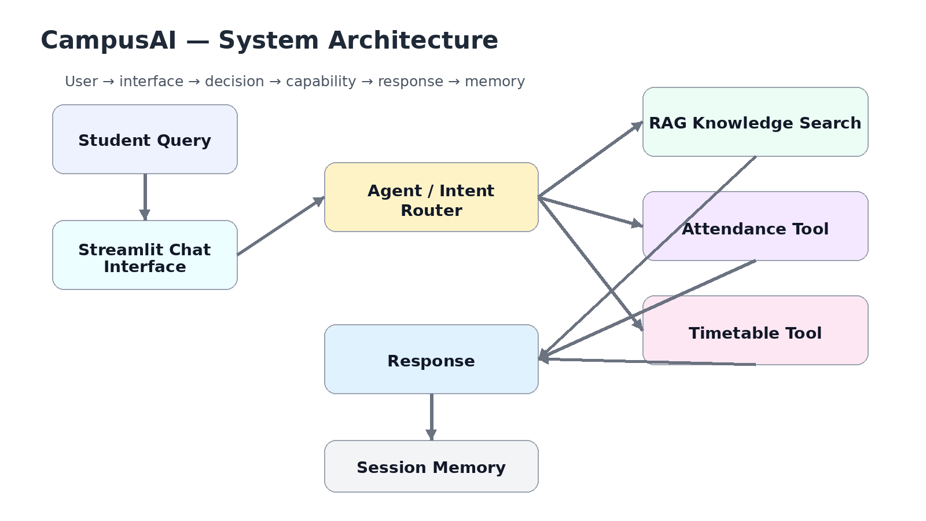
Figure 1. CampusAI system architecture.
The architecture separates the user interface, decision layer, retrieval/tool capabilities, response generation and session memory. This separation makes the prototype easy to explain and extend.
The original project report represents the flow as Student → Streamlit Chat Interface → Agent/Intent Decision → RAG Knowledge Search or Attendance/Timetable Tools → Response → Conversation Memory. fileciteturn0file0L46-L57

7. AGENTIC WORKFLOW
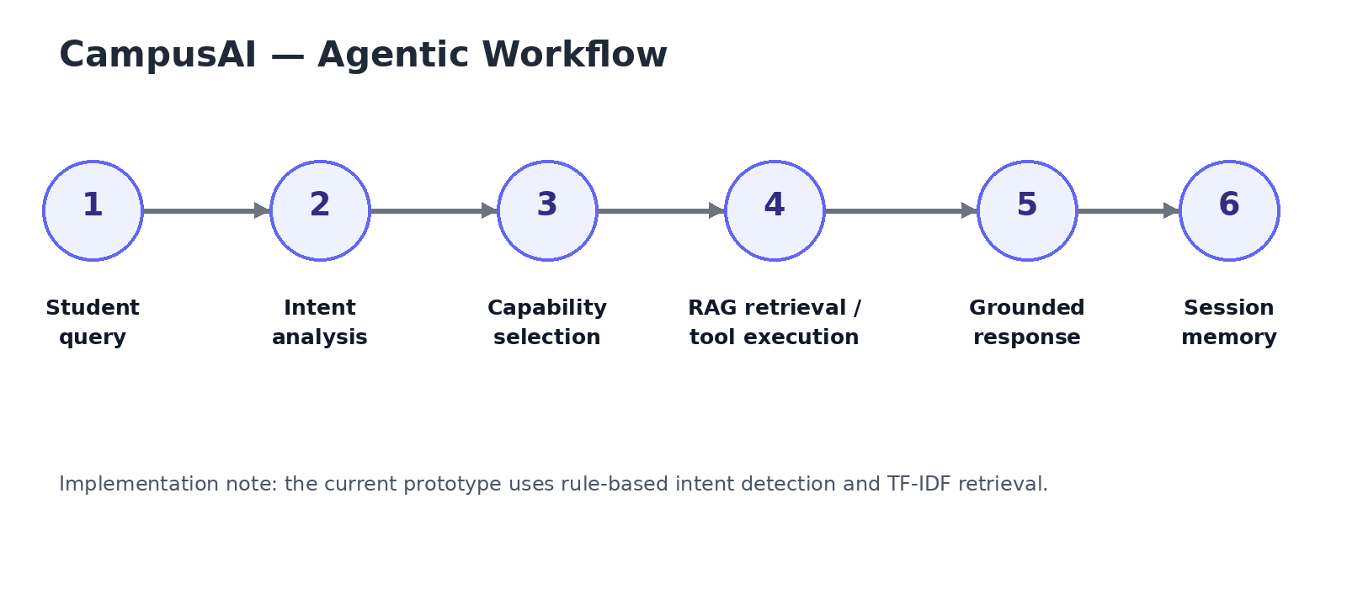
Figure 2. Agentic workflow implemented by the prototype.
- 1. Query intake
- 2. Intent analysis
- 3. Capability selection
- 4. Retrieval or tool execution
- 5. Response presentation
- 6. Conversation storage
The implementation uses keyword-based routing. Attendance-related terms trigger the Attendance Tool; timetable-related terms trigger the Timetable Tool; other queries use the retrieval path. This is a lightweight demonstration of agent-style decision making rather than a full autonomous LLM planner.

8. RAG-STYLE KNOWLEDGE RETRIEVAL
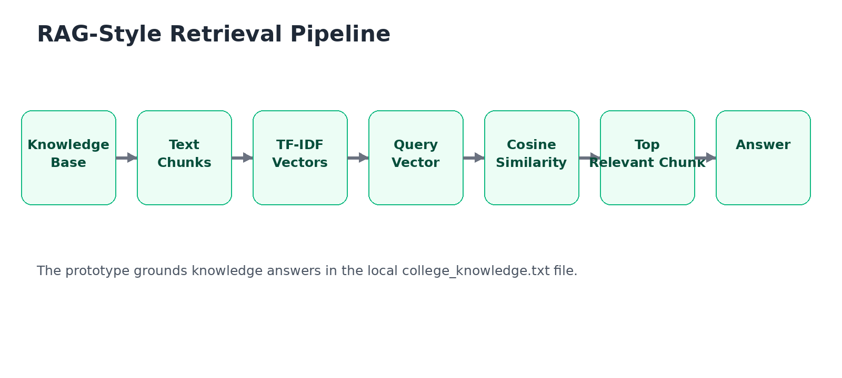
Figure 3. TF-IDF and cosine-similarity retrieval pipeline.

8.1 Knowledge Base
The knowledge base is stored in data/college_knowledge.txt. It contains sections covering college regulations, examinations, bonafide certificates, transfer certificates, syllabus, fees, leave, placement, project guidance and FAQ guidance. The source report identifies the local text knowledge base as the grounding source. fileciteturn0file0L65-L73

8.2 Retrieval Process
- The knowledge file is read as UTF-8 text.
- Sections are split into chunks using a separator.
- Scikit-learn TfidfVectorizer converts chunks into numerical vectors.
- The user query is converted into a TF-IDF vector.
- Cosine similarity scores the query against all chunks.
- The highest-scoring relevant chunks are returned.
- The prototype uses the top retrieved chunk as the displayed knowledge answer.
The report explicitly states that the knowledge base is searched using TF-IDF similarity and that the retrieval path is intended to ground responses. fileciteturn0file0L42-L45

9. TOOL CALLING
Tool calling is demonstrated through two dedicated functions: Attendance Tool and Timetable Tool. The agent detects attendance-related requests and calls the attendance function. It detects timetable-related requests and calls the timetable function, including recognition of weekday names.
Tool | Trigger examples | Purpose
Attendance Tool | attendance, present percentage, percentage | Returns demonstration attendance status and minimum requirement.
Timetable Tool | timetable, class today, schedule | Returns day-wise demonstration timetable.
RAG Knowledge Search | Other college-information queries | Retrieves relevant content from the local knowledge base.

10. CONVERSATION MEMORY
Conversation memory is implemented with Streamlit session state. User and assistant messages are stored in st.session_state.messages and rendered again on subsequent interactions within the active session. A Clear Memory button resets this list.
The supplied report identifies session state as the mechanism for maintaining conversation memory during the current application session. fileciteturn0file0L58-L64

11. TECHNOLOGY STACK
Technology | Role | Reason for use
Python | Core application and agent logic | Simple, readable implementation.
Streamlit | Web UI and session state | Rapid development of a conversational interface.
Scikit-learn | TF-IDF and cosine similarity | Provides lightweight local retrieval.
TF-IDF | Document/query vectorization | Ranks relevant knowledge chunks.
Local text KB | Grounding source | Keeps the demonstration reproducible and offline.
Session State | Conversation memory | Maintains messages during the active session.
These technologies match the implementation listed in the supplied report. fileciteturn0file0L65-L73

12. IMPLEMENTATION DETAILS

12.1 Application Initialization
The application configures a Streamlit page titled “CampusAI – Student Support Agent”, reads the knowledge-base file, builds the TF-IDF retriever and initializes the message history.

12.2 Retrieval Function
The retrieve() function transforms the query, computes cosine similarity against the document matrix, ranks the scores and returns relevant chunks whose similarity is greater than zero.

12.3 Agent Function
The agent() function first normalizes the query. It checks attendance-related keywords, then timetable-related keywords, and otherwise follows the RAG path. It returns three values: an execution plan, an answer, and the capability used.

12.4 User Interface
The sidebar displays the three capabilities and a demo-mode message. The main page shows the CampusAI title, subtitle, previous conversation messages, an agent-execution expander and the chat input.
The supplied report lists these features as RAG Knowledge Search, Tool Calling, Conversation Memory, Agent Execution Trace, Simple Web UI and Demo Mode. fileciteturn0file0L58-L64

13. USER INTERFACE AND SCREENSHOTS
The following visuals are derived from the supplied working application screenshot. The cropped views are included to make the report easier to inspect; they do not represent separate application runs.
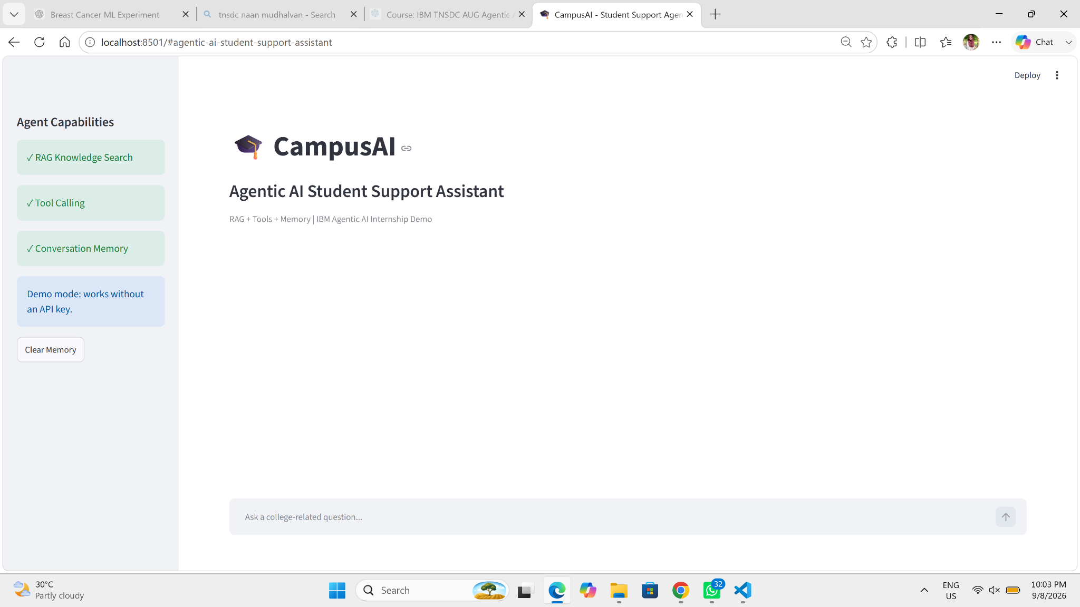
Figure 4. Working CampusAI application interface.
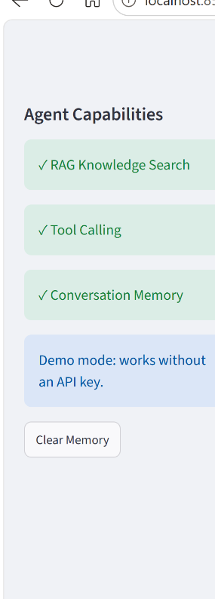
Figure 5. Cropped view of the Agent Capabilities sidebar.
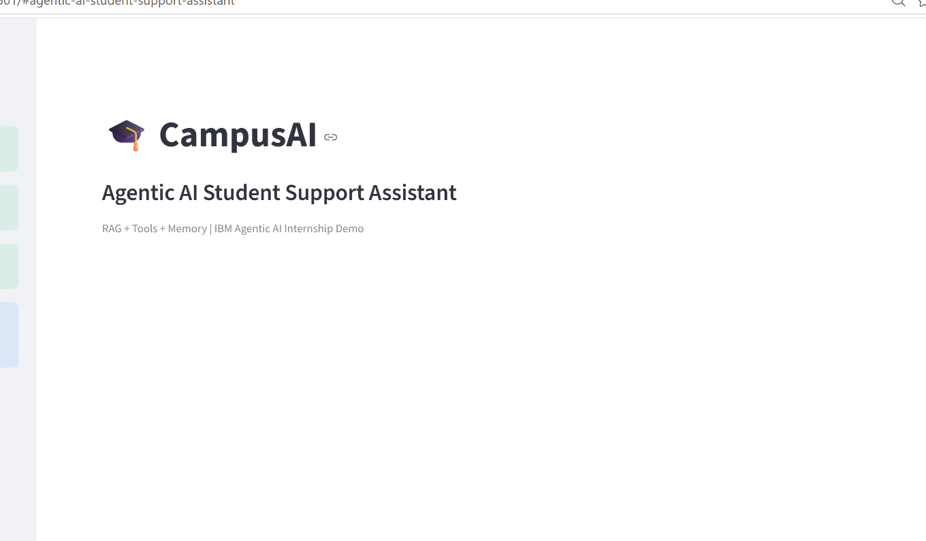
Figure 6. Cropped view of the main CampusAI chat interface.
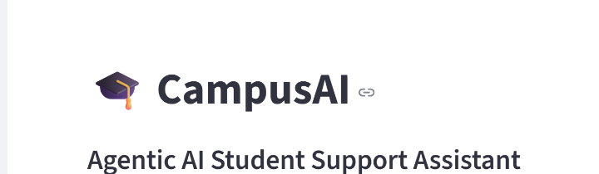
Figure 7. Cropped view of the CampusAI application header and branding.
The supplied project report records that the application runs successfully as a local Streamlit web application and that the screenshot represents the working CampusAI interface. fileciteturn0file0L81-L92

14. TESTING AND RESULTS
The project should be demonstrated using three representative request classes: knowledge retrieval, attendance tool calling and timetable tool calling. The source report states that knowledge questions retrieve prepared information, attendance requests demonstrate one tool, timetable requests demonstrate a second tool, and conversation history is maintained during the active session. fileciteturn0file0L86-L92
ID | Input | Expected capability | Expected result
TC01 | Minimum attendance | RAG Knowledge Search | Relevant knowledge-base section about 75% attendance.
TC02 | Attendance percentage | Attendance Tool | Attendance result and minimum requirement.
TC03 | Monday timetable | Timetable Tool | Monday timetable is returned.
TC04 | Bonafide certificate procedure | RAG Knowledge Search | Relevant certificate procedure is retrieved.
TC05 | Syllabus contents | RAG Knowledge Search | Relevant syllabus section is retrieved.
TC06 | Clear Memory | Session State | Conversation history is reset.

14.1 Result Summary
- Local Streamlit interface is available for demonstration.
- Knowledge questions can be grounded in the prepared knowledge base.
- Attendance requests demonstrate dedicated tool execution.
- Timetable requests demonstrate a second dedicated tool.
- Conversation history remains visible during the active session.
- The execution trace identifies the capability selected.

15. ADVANTAGES AND LIMITATIONS

15.1 Advantages
- Simple architecture that is easy to explain in a viva.
- Runs locally without an external API key.
- Grounded knowledge path reduces reliance on unsupported free-form answers.
- Clear separation between retrieval and tool functions.
- Conversation state makes multi-turn demonstration possible.
- Easy to extend with institutional documents and APIs.

15.2 Limitations
- Attendance and timetable values are static demonstration data.
- The knowledge base is manually maintained.
- Intent selection is keyword/rule based.
- The current prototype does not call an external generative model.
- Memory is session-based and is not persistent.
- There is no authentication or role-based access control.
- The prototype should not be treated as the authoritative source for official academic decisions.

16. FUTURE ENHANCEMENTS
- Integrate IBM watsonx.ai / Granite models.
- Use embeddings and a production vector database.
- Connect real college APIs for attendance, timetable and notices.
- Add authentication and role-based access.
- Add Tamil-English multilingual support.
- Support document upload and automatic knowledge-base updates.
- Add persistent memory and database-backed conversation history.
- Deploy the application online.
- Introduce automated unit tests, CI/CD and application monitoring.
These future directions align with the supplied report, which specifically mentions watsonx.ai/Granite, a production vector database, real college APIs, authentication, Tamil-English support, online deployment and document upload. fileciteturn0file0L100-L112

17. GITHUB REPOSITORY PREPARATION
A professional GitHub repository should make the project easy for an evaluator to understand, run and inspect. The recommended repository name in the supplied report is campusai-agentic-ai-student-support. fileciteturn0file0L113-L123

17.1 Recommended Repository Structure
CampusAI/
├── app.py
├── requirements.txt
├── data/
│ └── college_knowledge.txt
├── docs/
│ ├── diagrams/
│ └── screenshots/
├── README.md
├── LICENSE
├── CONTRIBUTING.md
└── .gitignore

17.2 GitHub README Contents
- Project overview and purpose
- Feature list
- Architecture diagram
- Installation and run instructions
- Demo questions
- Project structure
- Screenshots
- Technology stack
- Limitations
- Future scope
- Academic/internship context
- License and author placeholders

17.3 Recommended Git Commands
git init
git add .
git commit -m "Initial CampusAI agentic AI project"
git branch -M main
git remote add origin <YOUR_GITHUB_REPOSITORY_URL>
git push -u origin main
After publishing, paste the final repository URL into the report's GitHub URL field. The source report specifically recommends uploading app.py, the knowledge-base file, requirements.txt and README.md. fileciteturn0file0L113-L123

18. CONCLUSION
CampusAI demonstrates a compact and understandable Agentic AI workflow for student support by combining knowledge retrieval, tool usage and conversation memory. The prototype shows how one conversational interface can route different types of requests to different capabilities. The implementation is intentionally lightweight, making it suitable for an internship demonstration while leaving clear paths for integration with stronger language models, production retrieval systems and real institutional APIs.
The supplied project report reaches the same conclusion: the prototype combines knowledge retrieval, tools and memory and shows how an assistant can select different capabilities based on a student's request. fileciteturn0file0L93-L98

19. REFERENCES
- TNSDC – IBM Agentic AI Internship project template/materials supplied for the project.
- Official college/university regulations, syllabus, FAQs and notices used as knowledge sources.
- Streamlit documentation.
- Scikit-learn documentation.
The supplied report lists the same reference categories. fileciteturn0file0L124-L130

20. APPENDIX – DEMO SCRIPT AND VIVA QUESTIONS

20.1 Demo Script
“This is CampusAI, an Agentic AI Student Support Assistant. The left panel shows RAG Knowledge Search, Tool Calling and Conversation Memory. I will first ask a knowledge question to demonstrate retrieval. Next, I will ask for attendance to demonstrate tool calling. Then I will ask for a timetable. The conversation remains visible because memory is maintained in the current session.”

20.2 Viva Questions and Answers
Q: What is Agentic AI?
A: An AI system that can understand a task, decide which capability or tool to use, execute it and return a result.
Q: What is RAG?
A: Retrieval-Augmented Generation retrieves relevant external knowledge and uses it to ground an AI response.
Q: Why use RAG?
A: To ground answers in a specific knowledge base and reduce unsupported responses.
Q: What is tool calling?
A: The agent selects a function or external capability to perform a task.
Q: What is memory?
A: Memory stores conversation information so the assistant can maintain context across turns.
Q: What retrieval method is used here?
A: TF-IDF vectorization with cosine similarity.
Q: Is the current prototype using an external LLM?
A: No. The supplied implementation is a lightweight local demonstration; future scope includes IBM watsonx.ai/Granite integration.
Q: Where is the knowledge stored?
A: In data/college_knowledge.txt.
---
End of Report

