- Tentang Pet
Pet adalah bot chat yang diberi nama “Asri cat” yang dimainkan dengan mengirim keyword aksi, bot chat ini dibuat dengan memanfaatkan fitur API bot dari sebuah aplikasi pengirim pesan yaitu LINE messager yang dihubungkan dengan code PHP untuk proses input dan output aksi dan statenya serta menggunakan database mySQL untuk menyimpan update State terakhir. Pemilik pet dideteksi berdasarkan userid pemilik akun LINE.
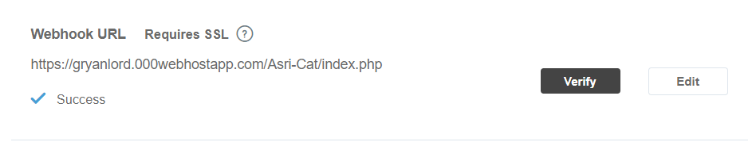
Gambar 1 url webhook yg diaplikasikan di LINE Developer
- a. Daftar State
- Senang : Kondisi pet dalam keadaan senang
- Bosan : Kondisi pet dalam keadaan bosan
- Tidur : Kondisi pet sedang tidur
- Lapar : Kondisi pet saat lapar
- Marah : Kondisi pet sedang marah
- Sakit : Kondisi pet dalam kondisi sakit
b. Daftar Aksi
- Bermain : Aksi bermain dengan pet
- Abaikan : Aksi mengabaikan pet
- Beri makan : Aksi memberi makan pet
- Elus : Aksi mengelus pet

- a. Diagram Transisi

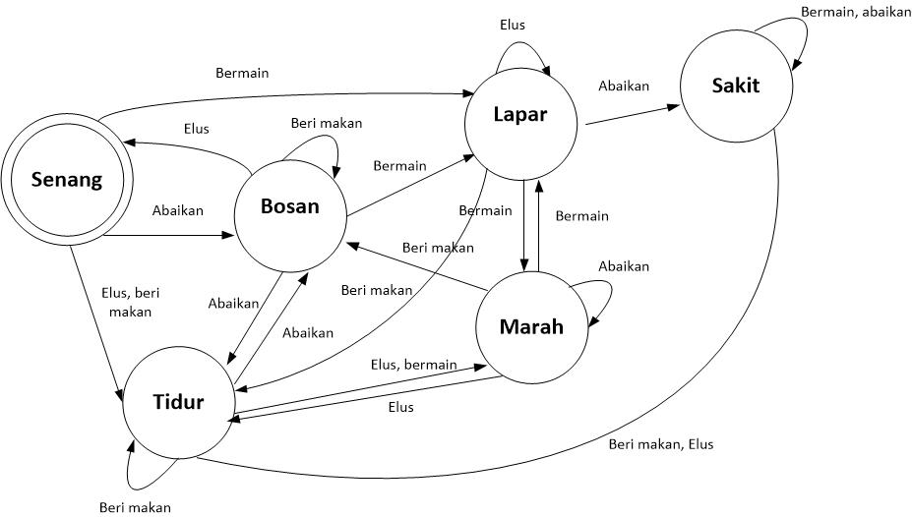
b. Definisi Formal
∑ = {Bermain, Beri makan, Elus, Abaikan}
Q = {Senang, Bosan, Tidur, Lapar, Marah, Sakit}
S = Lapar
F = Senang

Transisi | Bermain | Beri makan | Elus | Abaikan
Senang | Lapar | Tidur | Tidur | Bosan
Bosan | Lapar | Bosan | Senang | Tidur
Tidur | Marah | Tidur | Marah | Bosan
Lapar | Marah | Tidur | Lapar | Sakit
Marah | Lapar | Bosan | Tidur | Marah
Sakit | Sakit | Tidur | Tidur | Sakit

- Source Code
- Index.php
<?php
require_once __DIR__ . '/koneksi.php';
require_once __DIR__ . '/lineBot.php';

$bot = new Linebot();

$text = $bot->getMessageText();

$userid = $bot->getUserId();

$glog = mysqli_query($conn, "SELECT kondisi FROM State WHERE id=1");
if (mysqli_num_rows($glog)>0){
while($row=mysqli_fetch_row($glog))
{
$kondisi=$row[0];
}}

if($userid=='Ufe9a81dd472229dec8ebb01abb934520'){
if (strtolower($text) == 'cek'){
$balas='Meow meow';
$bot->replya($balas,$kondisi);

}
if (strtolower($text) == 'userid'){
$balas=$userid;
$bot->reply2($balas);

}
if (strtolower($text) == 'main'){
if($kondisi=='senang'){
mysqli_query($conn,"UPDATE State SET kondisi='lapar' WHERE id=1");

$balas='Meow senang bermain, meow lapar setelah bermain';
$kondisi='lapar';
}else
if($kondisi=='bosan'){
mysqli_query($conn,"UPDATE State SET kondisi='lapar' WHERE id=1");

$balas='Meow sedang bosan, meow merasa lapar';
$kondisi='lapar';
}else
if($kondisi=='tidur'){
mysqli_query($conn,"UPDATE State SET kondisi='marah' WHERE id=1");

$balas='Meow sedang tidur, meow marah diajak main';
$kondisi='marah';
}
else
if($kondisi=='lapar'){
mysqli_query($conn,"UPDATE State SET kondisi='sakit' WHERE id=1");

$balas='Meow lapar, meow sakit jika diajak main';
$kondisi='sakit';
}
else
if($kondisi=='marah'){
mysqli_query($conn,"UPDATE State SET kondisi='tidur' WHERE id=1");

$balas='Meow sedang marah, meow tidur setelah main';
$kondisi='tidur';
}
else
if($kondisi=='sakit'){
mysqli_query($conn,"UPDATE State SET kondisi='sakit' WHERE id=1");

$balas='Meow sedang sakit, meow tambah sakit jika bermain';
$kondisi='sakit';
}

$bot->replya($balas,$kondisi);

}
else if (strtolower($text) == 'makan'){
if($kondisi=='senang'){
mysqli_query($conn,"UPDATE State SET kondisi='tidur' WHERE id=1");

$balas='Meow senang makan, meow ngantuk lalu tidur';
$kondisi='tidur';
}else
if($kondisi=='bosan'){
mysqli_query($conn,"UPDATE State SET kondisi='bosan' WHERE id=1");

$balas='Meow sedang bosan, gak mau makan';
$kondisi='bosan';
}else
if($kondisi=='tidur'){
mysqli_query($conn,"UPDATE State SET kondisi='tidur' WHERE id=1");

$balas='Meow habis makan tidur lagi';
$kondisi='tidur';
}
else
if($kondisi=='lapar'){
mysqli_query($conn,"UPDATE State SET kondisi='tidur' WHERE id=1");

$balas='Habis makan meow tidur';
$kondisi='tidur';
}
else
if($kondisi=='marah'){
mysqli_query($conn,"UPDATE State SET kondisi='bosan' WHERE id=1");

$balas='Meow bosan gak mau makan';
$kondisi='bosan';
}
else
if($kondisi=='sakit'){
mysqli_query($conn,"UPDATE State SET kondisi='tidur' WHERE id=1");

$balas='Meow tidur semoga cepat sembuh';
$kondisi='tidur';
}

$bot->replya($balas,$kondisi);

}
else if (strtolower($text) == 'elus'){
if($kondisi=='senang'){
mysqli_query($conn,"UPDATE State SET kondisi='tidur' WHERE id=1");

$balas='Meow senang dielus, meow ngantuk lalu tidur';
$kondisi='tidur';
}else
if($kondisi=='bosan'){
mysqli_query($conn,"UPDATE State SET kondisi='senang' WHERE id=1");

$balas='Meow senang dielus';
$kondisi='senang';
}else
if($kondisi=='tidur'){
mysqli_query($conn,"UPDATE State SET kondisi='marah' WHERE id=1");

$balas='Meow sedang tidur, marah karna dielus';
$kondisi='marah';
}
else
if($kondisi=='lapar'){
mysqli_query($conn,"UPDATE State SET kondisi='lapar' WHERE id=1");

$balas='Meow lapar';
$kondisi='lapar';
}
else
if($kondisi=='marah'){
mysqli_query($conn,"UPDATE State SET kondisi='tidur' WHERE id=1");

$balas='Meow tidur karna dielus';
$kondisi='tidur';
}
else
if($kondisi=='sakit'){
mysqli_query($conn,"UPDATE State SET kondisi='tidur' WHERE id=1");

$balas='Meow tidur karna dielus';
$kondisi='tidur';
}

$bot->replya($balas,$kondisi);

}
else if (strtolower($text) == 'elus'){
if($kondisi=='senang'){
mysqli_query($conn,"UPDATE State SET kondisi='tidur' WHERE id=1");

$balas='Meow senang dielus, meow ngantuk lalu tidur';
$kondisi='tidur';
}else
if($kondisi=='bosan'){
mysqli_query($conn,"UPDATE State SET kondisi='senang' WHERE id=1");

$balas='Meow senang dielus';
$kondisi='senang';
}else
if($kondisi=='tidur'){
mysqli_query($conn,"UPDATE State SET kondisi='marah' WHERE id=1");

$balas='Meow sedang tidur, marah karna dielus';
$kondisi='marah';
}
else
if($kondisi=='lapar'){
mysqli_query($conn,"UPDATE State SET kondisi='lapar' WHERE id=1");

$balas='Meow lapar';
$kondisi='lapar';
}
else
if($kondisi=='marah'){
mysqli_query($conn,"UPDATE State SET kondisi='tidur' WHERE id=1");

$balas='Meow tidur karna dielus';
$kondisi='tidur';
}
else
if($kondisi=='sakit'){
mysqli_query($conn,"UPDATE State SET kondisi='tidur' WHERE id=1");

$balas='Meow tidur karna dielus';
$kondisi='tidur';
}

$bot->replya($balas,$kondisi);

}
else if (strtolower($text) == 'abaikan'){
if($kondisi=='senang'){
mysqli_query($conn,"UPDATE State SET kondisi='bosan' WHERE id=1");

$balas='Meow bosan karna diabaikan';
$kondisi='bosan';
}else
if($kondisi=='bosan'){
mysqli_query($conn,"UPDATE State SET kondisi='tidur' WHERE id=1");

$balas='Meow tidur karna diabaikan';
$kondisi='tidur';
}else
if($kondisi=='tidur'){
mysqli_query($conn,"UPDATE State SET kondisi='bosan' WHERE id=1");

$balas='Meow bosan karna diabaikan';
$kondisi='bosan';
}
else
if($kondisi=='lapar'){
mysqli_query($conn,"UPDATE State SET kondisi='sakit' WHERE id=1");

$balas='Meow sakit karna diabaikan';
$kondisi='sakit';
}
else
if($kondisi=='marah'){
mysqli_query($conn,"UPDATE State SET kondisi='marah' WHERE id=1");

$balas='Meow marah karna diabaikan';
$kondisi='marah';
}
else
if($kondisi=='sakit'){
mysqli_query($conn,"UPDATE State SET kondisi='sakit' WHERE id=1");

$balas='Meow sakit karna diabaikan';
$kondisi='sakit';
}

$bot->replya($balas,$kondisi);

}}else{$bot->reply2('Anda bukan pemilik pet');}

?>

- lineBot.php
<?php

require_once __DIR__ . '/setting.php';
class Linebot {
private $channelAccessToken;
private $channelSecret;
private $webhookResponse;
private $webhookEventObject;
private $apiReply;
private $apiPush;

public function __construct(){
$this->channelAccessToken = Setting::getChannelAccessToken();
$this->channelSecret = Setting::getChannelSecret();
$this->apiReply = Setting::getApiReply();
$this->apiPush = Setting::getApiPush();
$this->webhookResponse = file_get_contents('php://input');
$this->webhookEventObject = json_decode($this->webhookResponse);
}

private function httpPost($api,$body){
$ch = curl_init($api);
curl_setopt($ch, CURLOPT_POST, true);
curl_setopt($ch, CURLOPT_CUSTOMREQUEST, 'POST');
curl_setopt($ch, CURLOPT_RETURNTRANSFER, true);
curl_setopt($ch, CURLOPT_POSTFIELDS, json_encode($body));
curl_setopt($ch, CURLOPT_HTTPHEADER, array(
'Content-Type: application/json; charser=UTF-8',
'Authorization: Bearer '.$this->channelAccessToken));
$result = curl_exec($ch);
curl_close($ch);
return $result;
}

public function keluar($groupid){
$ch = curl_init('https://api.line.me/v2/bot/group/'.$groupid.'/leave');
curl_setopt($ch, CURLOPT_POST, true);
curl_setopt($ch, CURLOPT_CUSTOMREQUEST, 'POST');
curl_setopt($ch, CURLOPT_RETURNTRANSFER, true);
curl_setopt($ch, CURLOPT_POSTFIELDS, json_encode($body));
curl_setopt($ch, CURLOPT_HTTPHEADER, array(
'Content-Type: application/json; charser=UTF-8',
'Authorization: Bearer '.$this->channelAccessToken));
$result = curl_exec($ch);
curl_close($ch);
return $result;
}

public function masuk($groupid){
$ch = curl_init('https://api.line.me/v2/bot/group/'.$groupid.'/join');
curl_setopt($ch, CURLOPT_POST, true);
curl_setopt($ch, CURLOPT_CUSTOMREQUEST, 'POST');
curl_setopt($ch, CURLOPT_RETURNTRANSFER, true);
curl_setopt($ch, CURLOPT_POSTFIELDS, json_encode($body));
curl_setopt($ch, CURLOPT_HTTPHEADER, array(
'Content-Type: application/json; charser=UTF-8',
'Authorization: Bearer '.$this->channelAccessToken));
$result = curl_exec($ch);
curl_close($ch);
return $result;
}

public function reply2($text){
$api = $this->apiReply;
$webhook = $this->webhookEventObject;
$replyToken = $webhook->{"events"}[0]->{"replyToken"};
$body["replyToken"] = $replyToken;
$body["messages"][0] = array(
"type" => "text",
"text"=>$text
);

$result = $this->httpPost($api,$body);
return $result;
}

public function replya($text,$kondisi){
$api = $this->apiReply;
$webhook = $this->webhookEventObject;
$replyToken = $webhook->{"events"}[0]->{"replyToken"};
$body["replyToken"] = $replyToken;
$body["messages"][0] = array(

'type'=> 'template',
'altText'=> 'this is a buttons template',
'template'=> array(
'type'=> 'buttons',
'actions'=> array(
array(
'type'=> 'postback',
'label'=> 'Bermain',
'data'=> 'main',
'text'=> 'main'
),
array(
'type'=> 'postback',
'label'=> 'Beri makan',
'data'=> 'makan',
'text'=> 'makan'
),
array(
'type'=> 'postback',
'label'=> 'Elus',
'data'=> 'elus',
'text'=> 'elus'
),
array(
'type'=> 'postback',
'label'=> 'Abaikan',
'data'=> 'abaikan',
'text'=> 'abaikan'
)
),
'text'=> $text,
'title'=> 'Kondisi : '.$kondisi

)

);

$result = $this->httpPost($api,$body);
return $result;
}

public function getMessageText(){
$webhook = $this->webhookEventObject;
$messageText = $webhook->{"events"}[0]->{"message"}->{"text"};
return $messageText;
}

public function postbackEvent(){
$webhook = $this->webhookEventObject;
$postback = $webhook->{"events"}[0]->{"postback"}->{"data"};
return $postback;
}

public function getUserId(){
$webhook = $this->webhookEventObject;
$userId = $webhook->{"events"}[0]->{"source"}->{"userId"};
return $userId;
}
public function getGroupId(){
$webhook = $this->webhookEventObject;
$userId = $webhook->{"events"}[0]->{"source"}->{"groupId"};
return $userId;
}
public function getMessageId(){
$webhook = $this->webhookEventObject;
$userId = $webhook->{"events"}[0]->{"message"}->{"id"};
return $userId;
}

}

- koneksi.php
<?php
$server = "localhost";
$username = "id5489118_asricat";
$password = "123ASRIANOR123";
$db_name = "id5489118_asricatdb";

$conn = mysqli_connect($server, $username, $password, $db_name);

if(mysqli_connect_errno())
{
echo "Failed to connect to Mysql : " . mysqli_connect_error();

}
?>

- setting.php
<?php

class Setting {
public function getChannelAccessToken(){
$channelAccessToken = "ArePRNR96q1yfBZTCyX70Jdl4ph0PcPw8iL+4XVFuPfh84hri87kApDS0oDWjchmey/HkPMrrTtgU0bjVqRGwbfAr3qga2iqUiLhWF6SzNyswpnUu92DfixsI4jdX/S2ETstdxkN9yne0nj5nlt8dwdB04t89/1O/w1cDnyilFU=";
return $channelAccessToken;
}
public function getChannelSecret(){
$channelSecret = "96b14b086f746cb5d7183aff30cb07f5";
return $channelSecret;
}
public function getApiReply(){
$api = "https://api.line.me/v2/bot/message/reply";
return $api;
}
public function getApiPush(){
$api = "https://api.line.me/v2/bot/message/push";
return $api;
}
}
?>

- Screenshot
