Cloud Computing Project
Application: CloudDash Integrity

Cloud Computing - Dashcam Encoder / Transmitter and Decoder
Student: Ashriel Nhembo

Complete Project Documentation
Hybrid Dashcam Evidence Acquisition, Transmission, and Integrity Verification

Introduction
This document is the complete technical documentation for the CloudDash Integrity project. It covers the Encoder/Transmitter, Decoder/Insurer, development environment, installation, Supabase configuration, architecture, implementation choices, integrity protocol, offline behavior, retention, deployment, automated tests, runtime evidence, demonstration plan, limitations, and final deliverables.

Table of Contents
- Project Overview
- Requirements and Deliverables
- Technology Stack and Repository Structure
- System Architecture
- Development Environment and Installation
- Supabase Backend Configuration
- Encoder / Transmitter Implementation
- Offline Transmission and Retention
- Incident Evidence Workflow
- Decoder / Insurer Implementation
- Integrity Verification Mechanism
- Security and Access Control
- Deployment Architecture
- Testing and Validation
- Runtime Demonstration Evidence
- Segment Fingerprinting Rationale
- Legacy TXT Compatibility
- Requirement Traceability
- Known Limitations and Production Hardening
Conclusion
Appendix A. Repository File Map

Appendix B. Reproducibility Commands
Appendix C. Open Source Attribution and References

Project Overview
CloudDash Integrity is a hybrid dashcam evidence system designed for a driver smartphone and an insurer-side verification workflow. The system deliberately separates continuous video storage from integrity metadata. During normal driving, video remains local on the driver's device while cryptographic fingerprints are transmitted to the cloud. When the driver locks an incident, a bounded incident window is preserved, and the corresponding video is additionally uploaded to private cloud storage.
The insurer-side Decoder verifies that a supplied or retrieved video is identical to the originally fingerprinted evidence. Verification combines exact-byte SHA-256 hashing, ECDSA P-256 signatures, capture-session identity, ordered hash-chain continuity and the trusted Supabase record.
Core design principle
Normal driving video is local-first. The cloud receives trusted signed fingerprints and session metadata. Only protected incident video is stored in the private evidence bucket.

Requirements and Deliverables

Component | Required deliverable | Project response
Encoder / Transmitter | Complete application and source code | React/Vite application, local storage,  cryptographic modules, Supabase repositories and migrations
Encoder / Transmitter | Installation and environment report | Documented in README, SUPABASE.md, DEPLOYMENT.md  and this report
Encoder / Transmitter | Implementation and technical choices | Camera/simulation capture, MediaRecorder segments, SHA-256, ECDSA signatures, hash chain,  IndexedDB outbox, retention
Encoder / Transmitter | Video demonstration | Procedure documented; final  recording must be submitted
Decoder / Insurer | Complete application and source code | Decoder, cloud reference stream, local file verification and private incident  retrieval are implemented
Decoder / Insurer | Installation and environment report | Same reproducible  application/backend environment
Decoder / Insurer | Integrity mechanism explanation | Exact-byte hashing + signature  verification + session hash-chain verification + trusted cloud record
Decoder / Insurer | Video demonstration | Procedure documented; final  recording must be submitted

Technology Stack and Repository Structure

Layer | Technology / implementation
Frontend | React 18, React Router, Vite 6
Video capture | Browser MediaRecorder and Media APIs
Cryptography | Web Crypto API: SHA-256 and ECDSA P-256 with SHA-  256
Local persistence | IndexedDB for video blobs, device key pair and offline  fingerprint outbox
Cloud backend | Supabase Auth, PostgreSQL, Realtime and Storage
Authorization | Supabase Row Level Security with workspace/device  access rules
Deployment | Vercel SPA deployment; optional Node/Express Docker

Layer | Technology / implementation
 | deployment
Validation | Node test runner under tests/ and GitHub Actions CI

Key repository locations:
- src/App.jsx - application UI and end-to-end Encoder/Decoder workflows
- src/security/chain.js - evidence canonicalization, SHA-256 and chain verification
- src/security/deviceKeys.js - device signing key generation and ECDSA signing/verification
- src/security/verification.js - file hash comparison and trusted fingerprint verification
- src/storage/localEvidenceStore.js - local video persistence and retention
- src/storage/offlineQueue.js - persistent retry queue
- src/fingerprintRepository.js - fingerprint, session and incident cloud operations
- supabase/migrations/ - database schema, RLS, capture-session hardening and modern perceptual-evidence support
- docs/ - architecture, deployment, Supabase setup and demo documentation
- tests/ - integrity, repository and evidence file tests

System Architecture
Figure 1 presents the complete hybrid evidence architecture. It separates the driver smartphone, on-device cryptographic processing and local storage, Supabase cloud services, and the insurer-side Decoder.
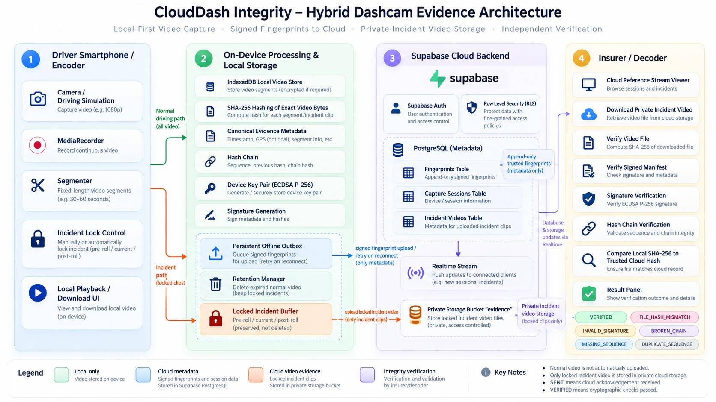
Figure 1. CloudDash Integrity hybrid dashcam evidence architecture. Normal video remains local; signed fingerprints persisted in Supabase; only locked incident video is uploaded to private evidence storage; the Decoder independently validates the file hash, device signature and capture-session chain.

Development Environment and Installation
  - Prerequisites
    - Node.js 22 or a compatible modern Node release and npm.
    - Git for source retrieval and version control.
    - A modern Chromium-based browser for camera/media APIs, Web Crypto and IndexedDB.
    - Docker Desktop and Supabase CLI if reproducing the full local Supabase environment.
    - A Supabase hosted project for cloud deployment.
    - A Vercel account for the documented frontend deployment path.

Clone and install
git clone https://github.com/asrieldev/clouddash-integrity.git cd clouddash-integrity
npm install

Environment variables
Create a .env file in the repository root:
VITE_SUPABASE_URL=<your Supabase project URL> VITE_SUPABASE_ANON_KEY=<your public browser/anon key>
These are browser configuration values used by the Supabase client. Service-role or other privileged server secrets must not be embedded in the frontend.

Start the application
npm run dev For the optional combined local frontend/server workflow:
npm start

Supabase Backend Configuration
  - Local Supabase
- Install the Supabase CLI and Docker Desktop.
- Run supabase start from the repository root.
- Run supabase db reset to apply the migration history.
- Copy the local project URL and anon key into .env.
- Start the frontend with npm run dev.

Hosted Supabase
- Create the hosted Supabase project.
- Link the repository using supabase link --project-ref <project-ref>.
- Apply the schema using supabase db push.
- Configure VITE_SUPABASE_URL and VITE_SUPABASE_ANON_KEY in the deployment environment.
- Configure the deployed application origin in Supabase Authentication Site URL and Redirect URLs.

Core cloud tables and services

Object | Role in CloudDash
devices | Stores device identity, ownership, public signing key and  device metadata
capture_sessions | Separates independent recording sessions and their lifetime
fingerprints | Append-only trusted evidence references: hash, sequence,  signature, chain fields
incidents | Represents driver-locked events
incident_videos | Links a private Storage object to its trusted  fingerprint/session/segment
Storage bucket: evidence | Private object storage for locked incident video only
Supabase Realtime | Delivers cloud reference updates to connected interfaces

Encoder / Transmitter Implementation
  - Capture and segmentation
Each Start Dashcam action creates a new capture session. MediaRecorder captures from the selected camera or driving simulation source and divides the recording into fixed-length evidence segments. The UI supports configurable segment length, incident pre-roll/post-roll and local retention.

Local persistence
Before cloud transmission, original video blobs and evidence metadata are persisted in IndexedDB. The local store supports playback, download, per-device listing, size accounting and deletion. Normal video can therefore remain available through page refreshes while the cloud only stores its trusted reference.

Exact-byte hashing
SHA-256 is computed using Web Crypto over the exact video segment bytes. Any changed byte produces a different digest. This means re-encoding, blur, crop, overlays, frame edits, compression changes, audio edits, resolution changes or file replacement will cause an exact-byte mismatch.

Canonical metadata and hash chain
Modern CloudDash evidence uses the version-3 signed fingerprint format. The canonical chain payload binds workspaceId, deviceId, sessionId, segmentId, sequence, normalized capturedAt, bytes, SHA-256 and previousHash; version 3 also binds the perceptual profile through its signed digest. The chainHash is the SHA-256 digest of the canonical representation. The first segment of every capture session starts at sequence 0 with previousHash = null.

ECDSA device signature
A P-256 ECDSA key pair is generated with Web Crypto. The private key remains in the device-side IndexedDB key store. The canonical fingerprint payload, including the chain hash, is signed using ECDSA with SHA-256. The public key is registered with the device for Decoder verification.

Offline Transmission and Retention
  - Persistent outbox
The offline queue is stored in IndexedDB. Fingerprints move through queue states such as QUEUED, SENDING and FAILED; successful transmission removes the queue entry and the UI reflects the segment as SENT. A browser refresh or temporary connection loss does not discard pending evidence.

Idempotency and conflict handling
Each modern segment uses an immutable segment UUID. Capture-session/sequence uniqueness prevents accidental cross-session collision. If an insert encounters an existing identical record, repository code can treat it as idempotent; conflicting evidence identity fails rather than overwriting the trusted record.

Retention
The retention manager deletes expired normal video while preserving locked evidence. Manual deletion is guarded so a normal recording is only deletable once its fingerprint is successfully acknowledged and the recording is not locked.
Difference between SENT and VERIFIED
SENT means that Supabase acknowledged the fingerprint insert. VERIFIED is a Decoder result and requires the cryptographic verification conditions to pass.

Incident Evidence Workflow
Lock Incident Clip protects a bounded evidence window around an event. The selected pre-roll/current/post-roll local segments are marked as locked and therefore excluded from rolling retention.
After the corresponding fingerprint has been acknowledged, the locked video is uploaded to the private evidence bucket with upsert disabled. The incident_videos row links storage_path, fingerprint_id, session_id, segment_id, sequence, hash and signature. Existing-object conflicts are validated by re-hashing the existing bytes and fail closed if they differ from the trusted fingerprint.

Decoder / Insurer Implementation
The Decoder is the insurer-side verification interface. It can verify a local .webm or .mp4 file, validate a signed JSON evidence manifest and retain support for legacy raw .txt hashes in review mode. Local video hashing occurs inside the browser; a locally supplied verification file is not uploaded merely to check its hash.

Cloud reference stream
Trusted fingerprints are loaded from Supabase and updated through Realtime. Modern records are grouped by session identity, so verification is scoped to the exact recording session rather than all sequences produced by a device.

Private incident retrieval
Authorized users can retrieve incident videos from the private evidence Storage bucket, play/download it and verify it against the linked trusted fingerprint.

Integrity Verification Mechanism
  - Verification sequence
- Compute SHA-256 of the supplied video bytes.
- Resolve the trusted fingerprint record in Supabase.
- Compare the local digest with the trusted cloud SHA-256 value.
- Load the public key associated with the trusted record.
- Verify the ECDSA P-256 signature over canonical fingerprint metadata.
- Load all applicable session records from sequence 0 through the target sequence.
- Recompute and validate the ordered hash chain, sequence continuity and previous-hash links.
- Return VERIFIED only if the applicable cryptographic and structural checks pass.

Detectable failures

Condition | Expected Decoder outcome / interpretation
Exact original bytes + valid metadata/signature/chain | VERIFIED
Video edited, blurred, cropped, re-encoded or replaced | FILE_HASH_MISMATCH / mismatch
Signature or signed metadata changed | INVALID_SIGNATURE
chain_hash or previous_hash modified | BROKEN_CHAIN
Sequence omitted | MISSING_SEQUENCE
Sequence order reversed | REORDERED_SEQUENCE
Duplicate sequence | DUPLICATE_SEQUENCE
Records from the wrong modern capture session | SESSION_MISMATCH

Condition | Expected Decoder outcome / interpretation
No trusted cloud reference | FINGERPRINT_NOT_FOUND / NOT_FOUND
Forensic scope
SHA-256 proves exact byte equality against a trusted reference. It does not identify the semantic type of edit. The report therefore claims detection of modification, not classification of the modification.

Security and Access Control

Control | Implementation
Authentication | Supabase Auth
Workspace/device authorization | RLS helper functions and membership/device ownership  checks
Fingerprint immutability | Application roles receive SELECT/INSERT;  UPDATE/DELETE is revoked
Private incident video | Storage access requires authenticated authorized  device/workspace access
Objects overwrite protection | Incident upload uses upsert: false and validates duplicate-  object bytes
Device signing identity | ECDSA public key stored with device; private key remains  on device
Session isolation | Modern fingerprints require session_id and segment_id with  uniqueness constraints

The SQL migration layer is part of the security design. This prevents the integrity model from depending only on frontend behavior. A production version should additionally use hardware-backed mobile keys/attestation rather than browser IndexedDB for the strongest device trust guarantees.

Deployment Architecture
  - Vercel
The documented production path serves the Vite single-page application through Vercel. The project uses a rewrite configuration so application routes resolve to index.html. Supabase remains the managed backend for Auth, PostgreSQL, Realtime and Storage.

Docker / Express alternative
The Dockerfile uses Node 22 Alpine, installs dependencies with npm ci, builds the Vite frontend and runs the optional Express server on port 3001. The server exposes /api/health and serves the built frontend when dist is present.
docker build --build-arg VITE_SUPABASE_URL=<url> --build-arg VITE_SUPABASE_ANON_KEY=<key> -t clouddash-integrity .

docker run -p 3001:3001 clouddash-integrity

Testing and Validation

Automated test suite and build evidence
The final documented revision uses an automated quality suite covering cryptographic integrity, signature and identity checks, chain continuity, storage/retention, matching, history/reliability and recovery behavior. The documented acceptance run reported 39 automated tests passed with 0 failures.
- SHA-256 determinism.
- Valid hash-chain construction and verification.
- Detection of modified hash/metadata and broken previous-hash links.
- Missing, reordered and duplicate sequence behavior.
- ECDSA signature validation and rejection of signature/metadata tampering.
- Session-scoped identity and sequence-zero restart behavior.

- Persistent outbox identity and per-device retry selection.
- Exact video hash comparison.
- Signed manifest validation.
- Retention of locked evidence and deletion of expired normal video.
- Guarded manual deletion.
- Incident storage conflict detection.

Video Evaluation Lab: current manual run
The uploaded Evaluation Lab export contains 385 metric/threshold reports generated from 7 test videos against 2 local reference videos. Every uploaded test was assigned the same ground-truth label, “trim-start”, so this run is a focused manual batch rather than the full 23-scenario benchmark. Each video was evaluated across 55 configurations using aHash, dHash, pHash and wHash, Hamming/normalized Hamming, pHash vector distances, and fuzzy-hash diagnostics.
Measure | Observed value | Interpretation
Reference videos | 2 | Two local benchmark references were available.
Test videos | 7 | All seven were labeled trim-start in this run.
Metric/threshold decisions | 385 | 55 configurations per test video.
TRUE_MATCH | 110 | Expected related footage accepted.
MISSED_MATCH | 275 | Expected related footage not accepted.
CONTENT_MATCH | 110 | Enough aligned fingerprints for content-level correspondence.
PARTIAL_MATCH | 16 | Some correspondence found, but coverage stayed below the acceptance rule.
NO_MATCH | 259 | Insufficient fingerprint alignment for acceptance.

Qualitative analysis of the seven-video run
The dominant pattern is threshold sensitivity rather than universal failure. The exact reference is consistently recognised, while several modified clips produce only partial alignment and fail the 70% minimum-coverage acceptance rule. This is valuable evidence because it shows where the current matcher is robust and where calibration or stronger temporal/geometric normalisation is still required.
Test file | Observed result | Qualitative interpretation
Beggining trim.mp4 | 0/55 accepted; max partial coverage 60%. | Partial correspondence is visible but remains below the 70% acceptance requirement; this is a missed trim-start match.
authenthic.webm | 53/55 TRUE_MATCH; 2/55 missed; max coverage 100%; not byte-exact. | Very strong content correspondence without exact-byte equality. Report as related footage/content match, not exact authenticity.
colouring.mp4 | 0/55 accepted; max partial coverage 30%. | Colour/appearance change substantially degrades matching. This should be documented as a robustness limitation, not hidden.
dashcam-46b7b14b-4f17-4ef5-86e0-1ab02b76c4be-3-ad949633-3f3f-475f-8799-a985f925cb60.webm | 55/55 TRUE_MATCH; exact bytes 55/55; max coverage 100%. | Strong exact-control result. Because it is byte-identical, labeling it as trim-start is a ground-truth configuration conflict, not a matcher error.
qw.mp4 | 0/55 accepted; max partial coverage 50%. | Only fragmented correspondence is observed. Permissive configurations show timing/reorder-like indicators, so this case should be routed to human review.
removed begining.mp4 | 0/55 accepted; max partial coverage 55.6%. | Some related content is found, but insufficient aligned fingerprints remain for acceptance under the current policy.
trim.mp4 | 2/55 TRUE_MATCH; 53/55 missed; max coverage 75%. | Trimmed content is detected only by a small subset of permissive configurations. Threshold and coverage calibration are needed.

Metric and threshold interpretation
The export labels its thresholds EXPERIMENTAL_UNCALIBRATED. Because every video in this run was marked as expected to match, there are no negative-control cases; specificity and false-positive rate therefore cannot be established from this export. The system’s recommendation to add both matching and non-matching labeled videos is correct. Fuzzy byte-oriented metrics were weak in this run: ssdeep recall remained about 7.7% across the tested thresholds, while TLSH reached about 30.8% recall only at a broad distance threshold of 300. They should remain auxiliary diagnostics rather than primary visual-match evidence.

Qualitative interpretation framework for all required scenarios
Scenario | Qualitative result to report | Expected class
Authentic / exact original | Exact SHA-256, signature and chain pass; perceptual alignment also strong. | VERIFIED
Trimmed beginning | Remaining frames align to a later reference position; missing prefix visible. | CONTENT/PARTIAL
Trimmed end | Early content aligns; missing suffix visible. | CONTENT/PARTIAL
Extract from longer trip | Clip maps to a bounded reference interval. | CONTENT_MATCH
Shifted timeline | Same content with temporal offset; estimated offset changes, not identity. | CONTENT_MATCH
Slower playback | Alignment slope/speed ratio changes; repeated timing may appear. | CONTENT + timing
Faster playback | Compressed timing/skipped correspondence lowers coverage. | CONTENT + timing
Different frame rate | Content remains related while sampling cadence changes. | CONTENT_MATCH
Missing frames | Unmatched gaps appear while surrounding frames align. | CONTENT + modification
Duplicated frames | Repeated/static-scene or duplicate mappings may appear. | CONTENT + indicator
Reordered frames | Temporal order is inconsistent; reorder indicator should be raised. | CONTENT + modification
H.264 to H.265 / HEVC | Exact hash changes; perceptual content should remain aligned. | CONTENT_MATCH
Different bitrate | Exact hash changes; visual similarity should stay high. | CONTENT_MATCH
Different resolution | Exact hash changes; moderate scaling should remain matchable. | CONTENT_MATCH
Compression / quality | Exact hash changes; heavy compression can reduce similarity. | CONTENT / weaker
Brightness | Global luminance change should retain enough structure. | CONTENT_MATCH
Contrast | Tone-distribution change can increase perceptual distance. | CONTENT / sensitive
Salt-and-pepper noise | Sparse noise should modestly reduce similarity. | CONTENT / weaker
Moderate image noise | High-frequency corruption can lower frame-level similarity. | CONTENT / weaker
Logo / watermark / overlay | Localized obstruction causes regional mismatch while timing may align. | CONTENT or miss
Cropped image | Geometric information loss can strongly reduce matching features. | CONTENT/PARTIAL/miss
Another trip | No reliable reference should be found. | NO_MATCH / TN
Partially replaced footage | Matching before/after with an unmatched middle interval. | CONTENT + modification

Full synthetic benchmark and qualitative results
Benchmark scope. The reproducible command-line evaluation generated 23 labelled 12-second FFmpeg cases and 1,265 method/threshold decisions. It compares aHash, dHash, pHash and wHash using Hamming and normalized Hamming distance; a standardized luminance vector using L1, L2 and cosine distance; and encoded-file fuzzy hashes using ssdeep similarity and TLSH distance. These synthetic results are useful for controlled comparison, but they do not establish real-road accuracy.
Scenario family | Observed qualitative result | Interpretation
Exact control | The authentic file aligned 24/24 sampled frames with a score of 100. | Strong positive control; exact SHA-256 remains the authenticity decision.
Trim and extraction | Beginning trim, end trim and a middle extract all aligned to the correct reference interval. | Temporal alignment handles missing prefixes and suffixes well.
Shift and frame sampling | A 3-second shift, changed FPS, missing frames and duplicated frames remained content matches. | The matcher tolerates offsets and moderate sampling gaps.
Playback speed | The 1.1x and 0.9x timing variants produced only partial matches at the default pHash threshold. | Speed changes are a documented weakness and require alignment improvements.
Codec and quality | HEVC, lower bitrate, lower resolution, heavy compression, brightness, contrast and noise remained content matches. | Low-frequency fingerprints are robust to these tested encoding and appearance changes.
Reorder, overlay and crop | Reversed order, a white overlay and cropping were missed by default pHash matching. | These cases require human review or stronger spatial/temporal features.
Different trip | The unrelated Mandelbrot reference was rejected with no accepted aligned frames. | Correct true negative, although one negative is not enough to estimate specificity.
Partial replacement | 18/24 samples aligned and the substituted middle section was marked for review. | Useful modification localisation; a content match must not be reported as exact verification.

Distance metric and threshold findings
Raw and normalized Hamming distance make identical decisions for these 64-bit hashes because normalized Hamming is the raw bit count divided by 64. Candidate thresholds maximize F1 on the same synthetic calibration set; they are provisional and must be frozen before held-out testing.
Method and metric | Candidate threshold | F1 | Qualitative conclusion
aHash / Hamming | 15 bits / 0.234375 | 1.000 | Promising on this set, but coarse brightness structure can collide.
dHash / Hamming | 6 bits / 0.09375 | 1.000 | Strictest successful Hamming threshold; still needs real-trip negatives.
pHash / Hamming | 18 bits / 0.28125 | 0.952 | Two expected matches remained missed; not reliable alone.
wHash / Hamming | 15 bits / 0.234375 | 1.000 | Not independent evidence because this low-frequency variant equals aHash here.
Vector L1 | 24 | 1.000 | Good synthetic calibration candidate.
Vector L2 | 3.75 | 1.000 | Good synthetic calibration candidate.
Cosine distance | 0.10 | 1.000 | Robust here, but similar coarse scenes can still be confused.

Fuzzy hash findings
ssdeep. Only the byte-identical file matched; every re-encoded variant scored zero. All tested similarity thresholds from 10 to 100 therefore produced F1 0.087, so no useful ssdeep visual threshold was found. TLSH. A distance threshold of 300 gave the best tested fuzzy F1 of 0.872, but transformed positives ranged as far as 453 while the unrelated trip scored 320. The overlap makes TLSH unsuitable as a stand-alone visual matcher. Both fuzzy methods compare compressed file bytes rather than decoded visual content.
Qualitative conclusion. CloudDash demonstrates useful content correspondence across trims, offsets, codec changes and several quality transformations, while honestly exposing failures for speed changes, reversal, overlays and crop. The current candidate thresholds are suitable for demonstration and further calibration only. A defensible production threshold requires independent real dashcam trips, visually similar negative controls, a trip-level calibration/validation split, and separate reporting of false matches, missed matches and modification localisation.

Network-recovery evidence
The Evaluation Lab exposes fault-injection controls for queued sends, delayed acknowledgements, retry and duplicate/idempotent delivery. The current uploaded evaluation-results.json contains no populated network rows, so this export alone must not be presented as proof of a completed network-failure run. For the demonstration, run the dedicated recovery scenarios and capture generated/received fingerprints, lost/pending count, duplicate handling, recovery state and elapsed time.

Verification history and operational reliability
The latest supplied Integrity & History screenshot reports an exact-video pass rate of 98.9%: 925 passed out of 935 completed checks, with 10 failed and 0 errors. This is an operational exact-verification pass rate, not perceptual-matching accuracy. Exact verification answers whether trusted bytes/signature/chain checks passed; the Evaluation Lab instead measures tolerance to modified or transformed footage.

Continuous integration configuration:
npm ci
npm test
npm run build

Runtime Demonstration Evidence
The following screenshots were supplied from the deployed application and are included as runtime evidence. They support the report's description of the implemented user-visible behavior.
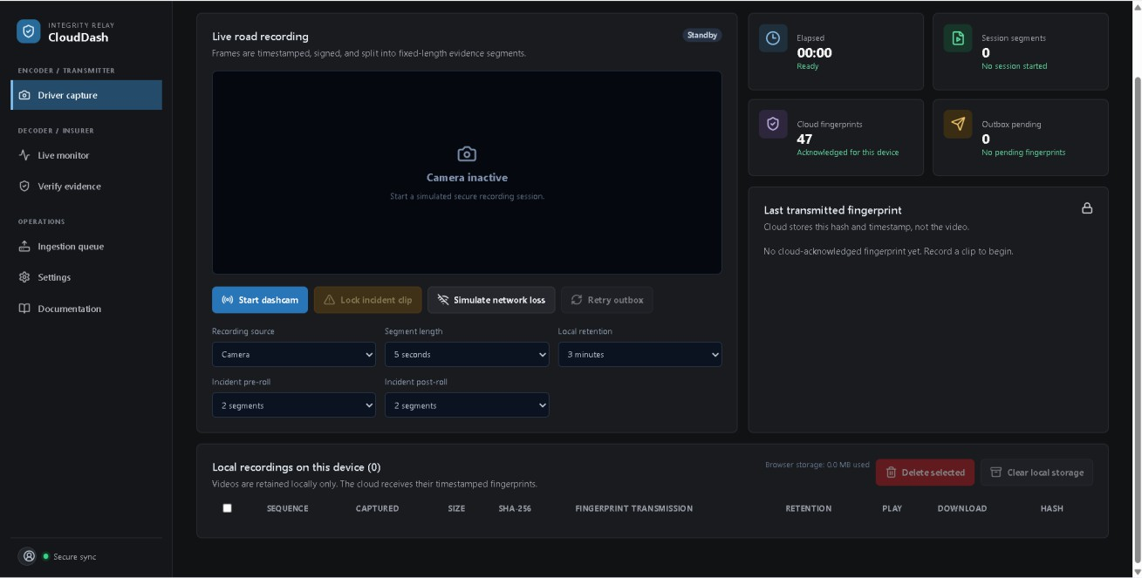
Figure 2. Encoder / Transmitter - Driver Capture interface. The deployed application exposes camera/simulation capture, segment length, retention, incident pre/post-roll, network-loss simulation, retry controls, cloud fingerprint count, and local recordings.

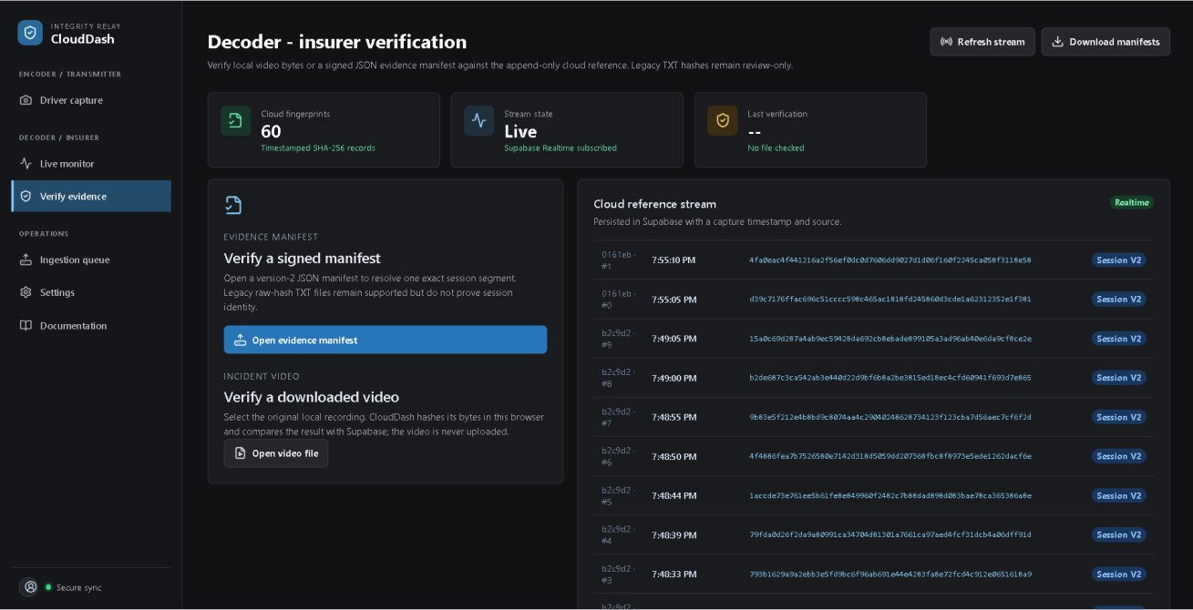
Figure 3. Decoder / Insurer verification interface. The Decoder exposes signed manifest verification, local video verification, the Supabase Realtime reference stream, and modern session-scoped signed fingerprints.
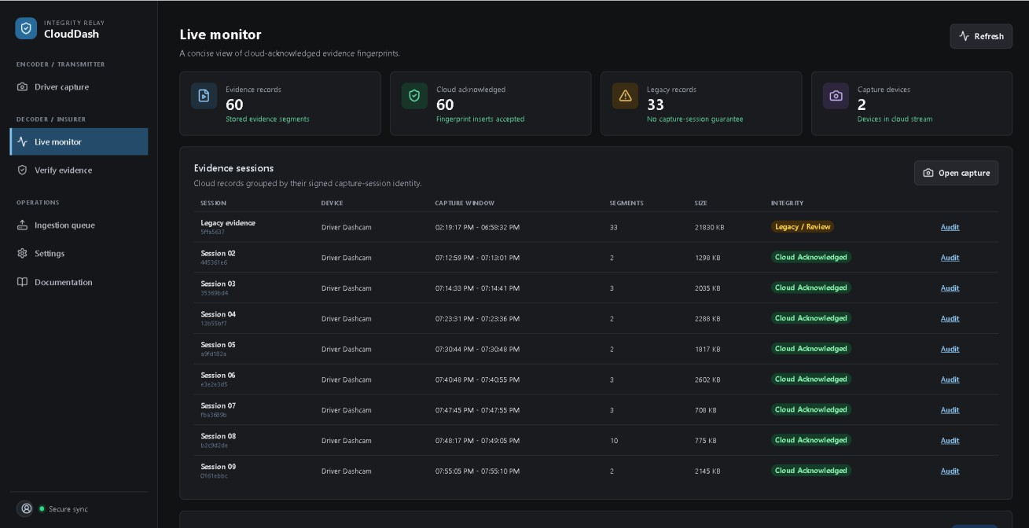
Figure 4. Live Monitor. Trusted cloud records are grouped by signed capture-session identity, distinguishing modern session-scoped evidence from legacy records.

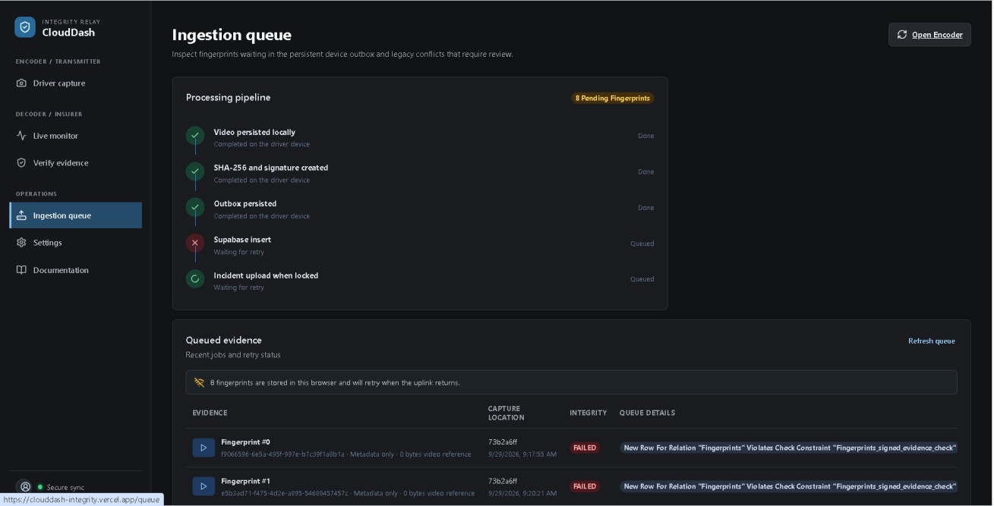
Figure 5. Persistent ingestion queue during a failed upload condition. Fingerprints remain in the browser outbox with failure information instead of silently disappearing.

Additional evaluation evidence
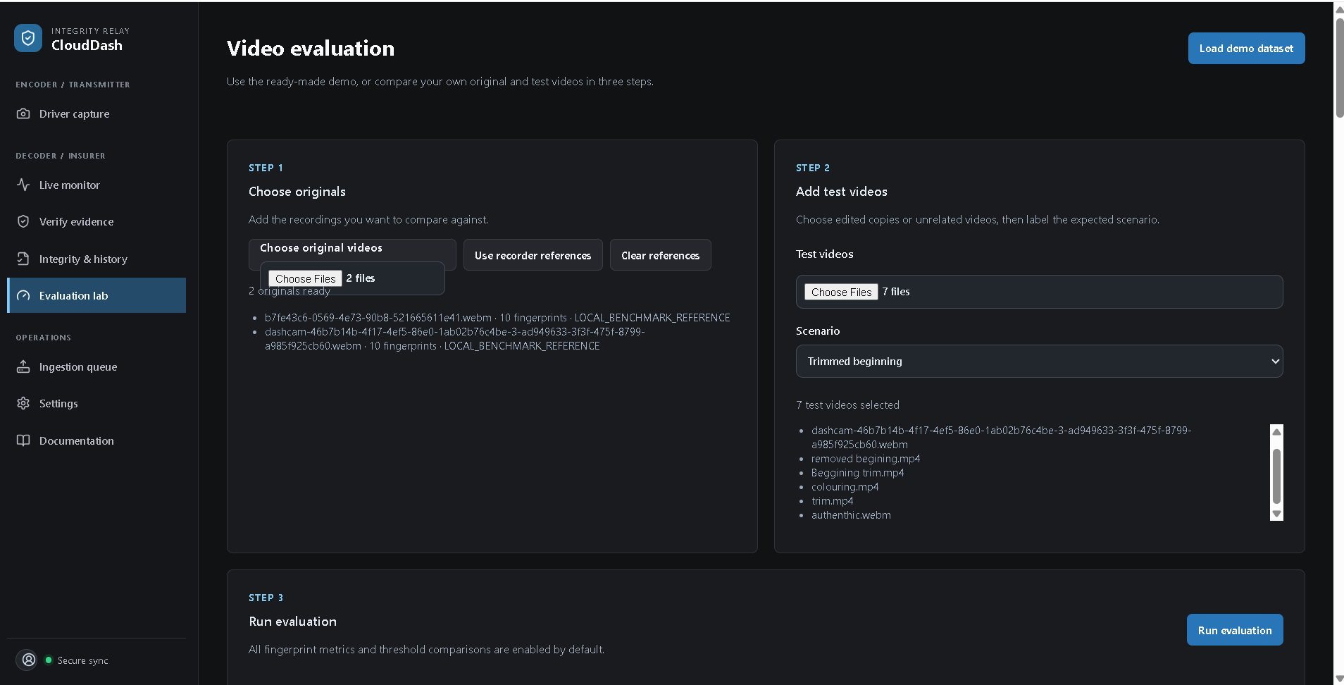
Figure 6. Video Evaluation Lab setup. Two local references and seven test videos are loaded; the displayed batch uses the “Trimmed beginning” ground-truth label.

Figure 7. Evaluation Lab recovery, fuzzy-hash and scenario-coverage panels. Recovery testing, fuzzy diagnostics and scenario limitations are separated from the main matching result.
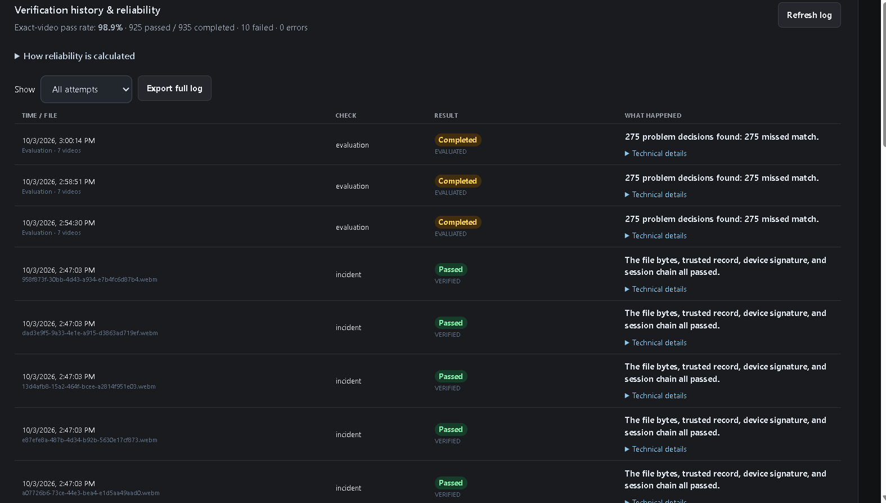
Figure 8. Verification history and reliability snapshot. Exact-video pass rate is 98.9% (925 passed / 935 completed), with 10 failed and 0 errors; evaluation findings remain visible in the audit history.

Segment Fingerprinting Rationale
CloudDash uses each fixed-duration MediaRecorder blob as the transmitted forensic evidence unit. SHA-256 is computed over the exact container bytes, which include every encoded frame and audio byte in that playable segment. Blur, crop, overlays, frame insertion or deletion, re-encoding, truncation, replacement and other byte changes therefore invalidate the trusted digest. This bounded segment design preserves exact-file integrity while reducing transmission and database overhead compared with one digest per decoded frame. SHA-256 detects that bytes differ; it does not classify the visual edit.

Legacy TXT Compatibility
For backward compatibility, the Decoder accepts a plain-text file containing one 64-character hexadecimal SHA-256 value per non-empty line. It validates line format and searches the trusted cloud stream for each value. A changed valid-looking hash returns FINGERPRINT_NOT_FOUND or a mismatch; malformed lines return an invalid-file result. TXT input remains review-only because a raw digest contains no signed session, device, sequence or chain identity. Modern evidence exchange uses a signed JSON manifest; version 3 additionally protects the perceptual profile used for similarity analysis.

Requirement Traceability

Assignment requirement | Implementation evidence | Status
Acquire frames / camera video | Media capture source and MediaRecorder workflow | Implemented
Compose/process video | Fixed-length segment generation | Implemented
Generate hashes | SHA-256 over exact video bytes | Implemented
Dynamic transmission of hashes | Persistent outbox -> Supabase fingerprints | Implemented
Network interruption handling | IndexedDB queue, retry on reconnect/manual retry | Implemented
Delete data after validity period | Configurable retention; locked evidence exempt | Implemented
Complete Encoder source | React/Vite plus storage/security/repository modules | Implemented
Encoder installation/configuration report | README/docs plus this report | Implemented
Encoder results demo | Documented demo procedure; video submission | Implemented

Assignment requirement | Implementation evidence | Status
Decoder integrity verification | Hash + ECDSA + session hash chain + trusted reference | Implemented
Algorithm/protocol explanation | Sections 11-12 and repository architecture/security code | Implemented
Detect modified/corrupt/inconsistent evidence | Mismatch, invalid signature, broken/missing/reordered chain states | Implemented
Complete Decoder source | Integrated Decoder/monitor/retrieval modules | Implemented
Decoder installation/configuration report | Same reproducible application/backend environment | Implemented
Decoder results demo | Documented demo procedure; video submission | Implemented
Legacy TXT fingerprint handling | One SHA-256 value per line; malformed and changed values fail; raw hashes remain review-only | Implemented and documented
Third-party attribution | Appendix C lists dependencies, licenses/specifications and official references | Documented
Physical camera validation | Encoder demonstration procedure requires browser permission and real camera capture | Submission demonstration required

Known Limitations and Production Hardening

Current prototype boundary | Recommended production improvement
Browser IndexedDB private key storage | Move driver implementation to native Android/iOS and  use hardware-backed Keystore/Secure Enclave
Browser/device compromise before capture | Add device attestation, signed enrollment and hardware-  backed identity
Perceptual analysis is diagnostic, not authenticity proof | Keep SHA-256/signature/chain authoritative and calibrate similarity on independent real dashcam datasets.
Operational observability is limited | Add centralized audit logs, alerts, monitoring and  verification failure telemetry
Retention policy is configurable in application | Apply SENT/unlocked/pending-incident safeguards consistently to automatic retention and define formal insurer lifecycle policy.
Academic prototype deployment | Perform load, mobile battery, network and browser  compatibility testing before production use
Current seven-video evaluation uses one global label | Assign a separate ground-truth scenario to each test file and include unrelated negatives before reporting accuracy/specificity.
Experimental similarity thresholds | Select thresholds using independent validation data and report precision, recall, F1 and false-positive rate.
2 FPS perceptual sampling | Use denser/adaptive sampling for short edits or explicitly report that sub-interval edits can be missed.
Fuzzy byte hashes are weak for visual transformations | Use ssdeep/TLSH only as auxiliary signals; do not substitute them for perceptual/temporal matching.

Conclusion
CloudDash Integrity implements the assignment as a complete hybrid system rather than an isolated hash demonstration. The Encoder captures and segments road video, persists original evidence locally, computes exact-byte SHA-256 fingerprints, binds them into signed session hash chains, transmits them through an outage-tolerant queue and applies retention rules. Locked incidents are escalated into private cloud evidence storage.
The Decoder independently computes the supplied file hash, verifies the device ECDSA signature, validates capture-session sequence/chain continuity and compares the result against the append-only trusted cloud reference. Supabase provides authenticated cloud persistence, RLS, Realtime and private incident storage. The repository also includes reproducible deployment documentation, tests and CI.
For final submission, the remaining non-code deliverables are the narrated Encoder and Decoder demonstration videos showing the behaviors documented in Section 16.

Evaluation conclusion: CloudDash correctly separates exact cryptographic integrity from perceptual similarity, but the current seven-video manual batch also exposes real limitations. Five files were missed across most or all tested configurations, the whole batch used one scenario label, and no negative-control video was included. The appropriate academic conclusion is therefore not “100% accurate”; it is that the pipeline is functional, auditable and experimentally useful, while threshold calibration, per-file ground-truth labeling and broader real-world datasets remain necessary before operational deployment.

Appendix A. Repository File Map

Path | Purpose
README.md | Project overview, local run instructions and hybrid  architecture summary
package.json | Dependencies and development/build/test scripts
src/App.jsx | Primary application and user workflows
src/security/chain.js | Versioned evidence canonicalization, SHA-256 and hash-  chain verification
src/security/deviceKeys.js | ECDSA P-256 key generation/signing/verification
src/security/fingerprintFile.js | JSON signed manifest and legacy TXT parsing
src/security/verification.js | File hash and trusted reference verification
src/storage/localEvidenceStore.js | IndexedDB local video and retention
src/storage/offlineQueue.js | Persistent offline outbox and retry
src/fingerprintRepository.js | Supabase fingerprint/session/incident operations
src/evidenceRepository.js | Evidence/device repository wrappers
supabase/migrations/ | Schema, RLS, storage, realtime and capture-session  upgrades
docs/ARCHITECTURE.md | Trust boundaries and evidence data flow
docs/SUPABASE.md | Local/hosted backend setup
docs/DEPLOYMENT.md | Vercel production deployment path
docs/DEMO.md | Encoder and Decoder demo checklist
tests/ | Automated integrity and repository tests
.github/workflows/ci.yml | Automated npm install, test and build
Dockerfile | Container deployment option
vercel.json | SPA deployment rewrites

Appendix B. Reproducibility Commands
# Install
git clone https://github.com/asrieldev/clouddash-integrity.git cd clouddash-integrity
npm ci

# Local Supabase supabase start supabase db reset

# Hosted Supabase
supabase link --project-ref <project-ref> supabase db push

# Run
npm run dev

# Validate npm test
npm run build

# Optional Docker
docker build -t clouddash-integrity .
docker run -p 3001:3001 clouddash-integrity

Appendix C. Open Source Attribution and References
CloudDash uses installed open-source packages and standard browser APIs. Exact package versions are locked in package-lock.json. No third-party source code is copied into the application outside those dependencies.

Component | Use | License or standard | Official reference
React and React DOM | User interface | MIT | https://react.dev/
React Router | Client-side routing | MIT | https://reactrouter.com/
TanStack Query | Asynchronous client state | MIT | https://tanstack.com/query/latest
Supabase JavaScript | Auth, PostgreSQL, Realtime and private Storage | MIT | https://supabase.com/docs
Vite and React plugin | Development and production build | MIT | https://vite.dev/
Lucide React | Interface icons | ISC | https://lucide.dev/
Recharts | Dashboard charts | MIT | https://recharts.org/
Three.js | Driving simulation rendering | MIT | https://threejs.org/
Express, CORS and Concurrently | Optional local and container tooling | MIT | https://www.npmjs.com/
Web Crypto API | SHA-256 and ECDSA P-256 | W3C specification | https://www.w3.org/TR/WebCryptoAPI/
IndexedDB, MediaRecorder and getUserMedia | Local persistence and camera capture | Web standards | https://developer.mozilla.org/docs/Web/API
Node.js test runner | Automated evidence tests | MIT | https://nodejs.org/api/test.html

