CLOUDDASH
INTEGRITY

Final Acceptance, Verification and Evaluation Report
  - Insurance evidence integrity • production validation • edited-video localisation
Prepared by NHEMBO Ashriel
Final release evidence — 3 October 2026
ACCEPTANCE STATUS: PASSED WITH DOCUMENTED LIMITATIONS
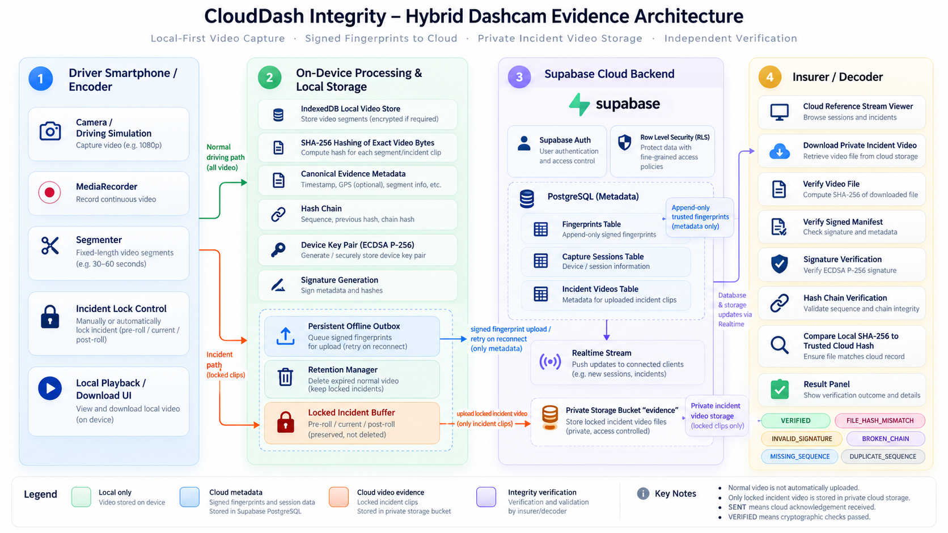
System architecture: video remains on device while signed fingerprints and evidence metadata synchronize to the cloud.

Executive summary
CloudDash Integrity is a prototype evidence-verification platform designed for dashcam and insurance workflows. It records short video segments locally, creates signed cryptographic and perceptual fingerprints, survives network interruption through an outbox, and gives an insurer a clear explanation of whether submitted footage is exact, related but changed, missing, or technically unreadable.
Final decision: the implementation passes the defined acceptance checks. Production sign-in succeeded, all 39 automated tests passed, the production build completed, 23 controlled video scenarios produced 1,265 threshold measurements, and every network-recovery fault scenario retained and ultimately delivered its fingerprint. A controlled middle-section edit was correctly isolated to 4–7 seconds while the unchanged 0–4 and 7–12 second intervals remained visible as consistent.
Area | Result | Evidence
Production access | PASS | Authenticated CloudDash workspace opened on Vercel
Automated integrity suite | PASS | 39/39 tests; 0 failures
Production build | PASS | Vite 6.4.3 build completed
Video benchmark | PASS | 23 scenarios; 0 generation errors; 1,265 measurements
Network recovery | PASS | All simulated failure/retry cases delivered
Partial edit | PASS | 4–7 s marked Review; outside intervals Consistent
Historical auditability | PASS | Persistent history presents previous/current outcomes and explanations

Plain-language result for an insurance reviewer
- Green / Verified: the submitted bytes and their trusted signed record match exactly.
- Amber / Related footage—review changes: the footage aligns to the original, but one or more intervals differ.
- Red / Mismatch or missing: the submitted file is not the exact trusted item or the expected record cannot be found.
- Grey / Error: the check could not be completed; this is not a pass and should be retried or escalated.

1. Purpose, audience and acceptance scope
This report is written for insurance assessors, lecturers, auditors, and technical reviewers. It separates the user-facing claims from the experimental research features so a non-technical decision-maker can use the system without mistaking similarity for legal authenticity.

Objectives
- Preserve exact evidence integrity from capture to later verification.
- Make every completed verification visible in persistent history, including failures and errors.
- Show which video intervals appear unchanged and which require review.
- Describe the likely modification category cautiously—for example overlay, trim, timing change, re-encoding, crop, or partial replacement—without claiming certainty beyond the measured signal.
- Demonstrate offline capture and eventual cloud synchronization.
- Provide reproducible tests, deployment steps, evidence images, and known limitations.

Acceptance boundaries
CloudDash is an academic/prototype system, not a certified forensic laboratory product. It identifies cryptographic equality with high confidence when signatures and hashes validate. Perceptual analysis is an investigative aid: it can localise anomalous intervals and suggest indicators, but a human reviewer must interpret the footage and surrounding claim evidence.
Term | Meaning | Decision use
VERIFIED | Exact bytes plus trusted record, device signature, identity and chain passed. | Strong integrity result within the CloudDash trust model.
CONTENT_MATCH | Enough perceptual frames align, but bytes are not exact. | Related footage; inspect marked intervals and do not call it authentic.
FILE_HASH_MISMATCH | SHA-256 differs from the trusted record. | The file changed or is not the exact captured file.
NOT_FOUND | No trusted reference was available. | Cannot determine authenticity.
ERROR | Decode, storage, network, or other technical failure. | Retry or escalate; never count as passed.

2. System overview and architecture
Figure 1. Hybrid architecture and trust boundary.

How the workflow operates
Stage | What happens | Insurance value
1 Capture | Browser recorder creates fixed-duration segments and keeps video in IndexedDB. | Raw footage is not uploaded by default.
2 Fingerprint | SHA-256, metadata, sequence link and perceptual profile are bound into a signed v3 record. | Later checks are tied to a device and ordered session.
3 Queue | Failed sends remain in a device-scoped persistent outbox. | Network loss does not silently discard evidence fingerprints.
4 Cloud | Supabase stores authenticated fingerprint records and publishes Realtime updates. | Insurer view receives a durable, time-stamped reference.
5 Verify | Downloaded video is hashed and compared against the trusted signed record; similarity runs only with a valid trusted profile. | Exact and perceptual outcomes remain distinct.
6 Review | Timeline, indicators and persistent history explain the outcome. | A non-technical assessor can see what requires attention.

Core technologies
React 18 and Vite provide the web interface; Express provides an optional local/API service; Supabase supplies authentication, Postgres, row-level access control and Realtime; Web Crypto supplies SHA-256 and ECDSA; IndexedDB stores local media, the durable outbox and offline verification history; FFmpeg creates controlled evaluation fixtures.

3. Production access and simplified insurance UI
The deployed application was opened at https://clouddash-integrity.vercel.app/ and the demonstration account authenticated successfully on 3 October 2026. The live account used for this final check contained no claim records; the supplied evidence screenshots document the populated demonstration workspace and its established history.
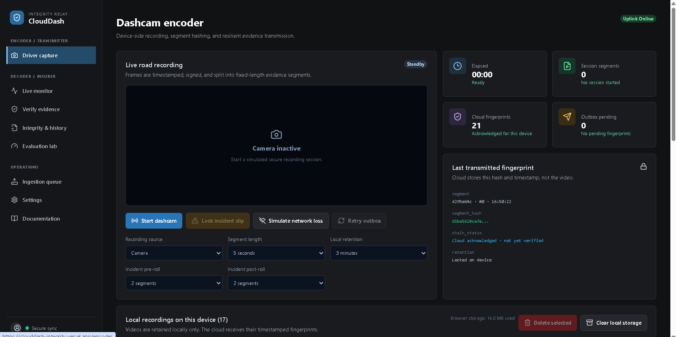
Figure 2. Driver capture view: one primary start action, clear status cards, local retention, and a visible outbox.
The simplified navigation follows the operational journey: Driver capture → Live monitor → Verify evidence → Integrity & history. Research controls are separated into Evaluation lab. Labels explain outcomes in ordinary language while technical details remain collapsible for an auditor.

UI evaluation criteria
Criterion | Observed result
Single obvious next action | Primary buttons use blue and are placed at the task start.
Status without jargon | Cards show Ready, Live, Passed, Review, Failed or Error before technical codes.
Persistent evidence trail | Verification history appears in both Verify evidence and Integrity & history.
Progressive disclosure | Technical hashes, thresholds and test controls are behind expandable sections.
Failure clarity | History states what happened and retains mismatch, missing and error outcomes.
Accessibility | Semantic headings, labels, buttons, status regions and high-contrast state colours are used.

4. Verification history and reliability
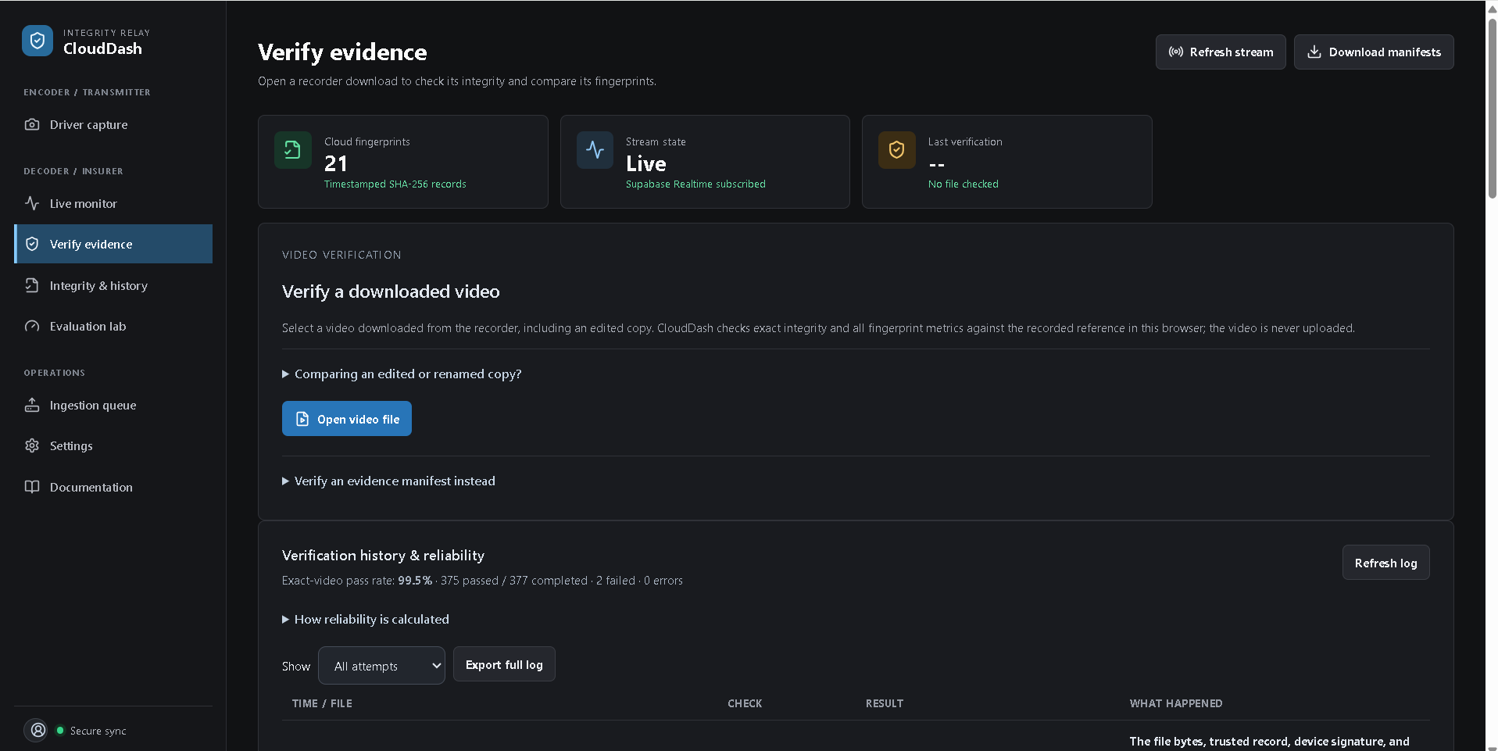
Figure 3. Verify evidence combines the current action with a persistent audit history and plain-language reliability summary.
The supplied production evidence shows 377 completed exact-video checks: 375 passed and 2 failed, producing a 99.5% displayed pass rate, with 0 errors in that snapshot. Failures are retained instead of disappearing as temporary notifications. Filters and export allow an assessor to isolate passes, mismatches, missing references, errors and evaluation findings.
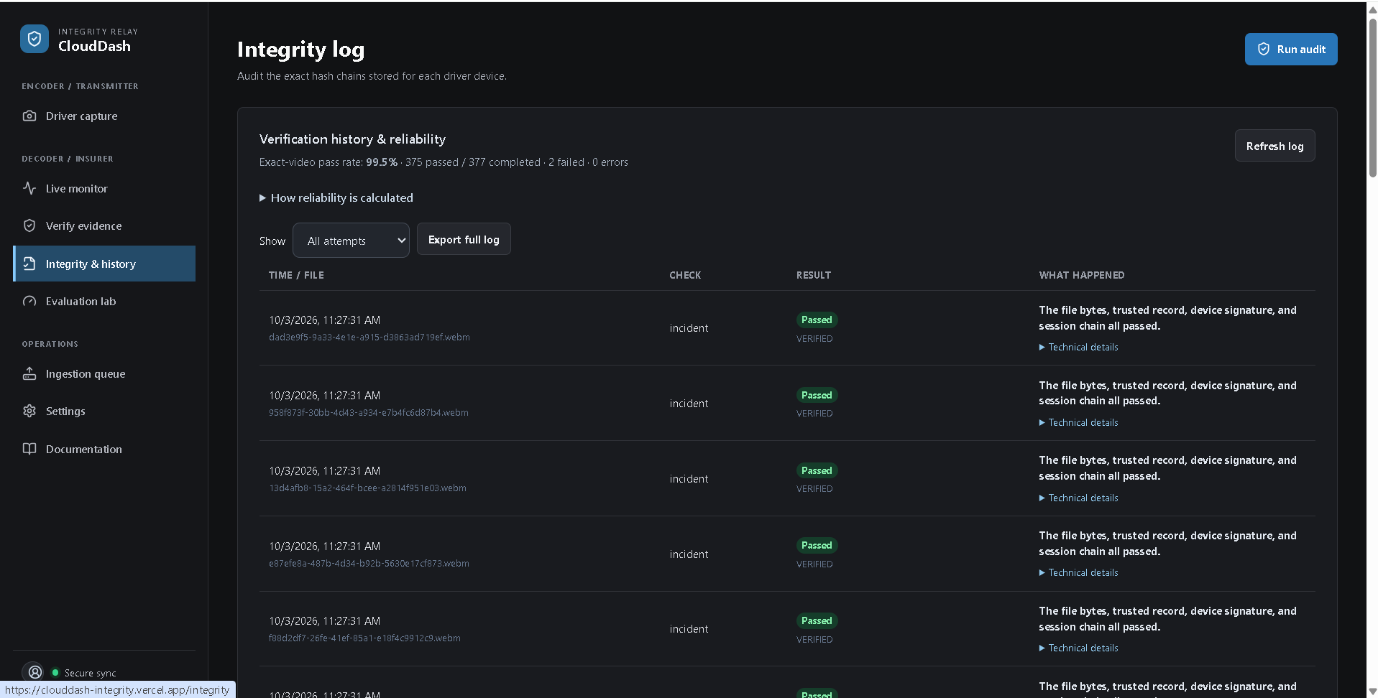
Figure 4. Integrity & history provides a dedicated audit view and per-row technical detail.

Reliability calculation
Exact-video reliability is VERIFIED divided by completed exact-video checks. Mismatch and not-found outcomes count as failures. Technical errors remain visible but are reported separately because they are incomplete checks, not successful evidence verification. Evaluation experiments and manifest checks are also excluded from the exact-video pass rate.

5. Controlled partial-edit experiment
A 12-second reference clip was copied to create an acceptance original. A controlled edited version replaced the middle interval from 4.0 to 7.0 seconds with unrelated footage. This models the user’s required scenario: part of the video is edited while the beginning and end remain intact.
File | SHA-256
acceptance-original.mp4 | 4F60292D79810F31BFD89F35122E426079987F6DF7A137782B559AC601D216AC
acceptance-partial-edit.mp4 | 5A0E2FB4C188CD528E11690CD82BBC4C7BBDDE650F9F01011C056DF8652072F6

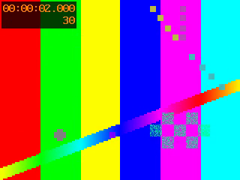  Original frame | 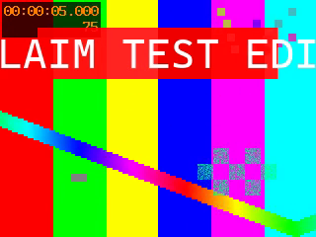  Edited middle interval
Figure 5. Visual evidence from the original and controlled edited interval.

Measured result
Measure | Observed value
Exact SHA-256 | Different — therefore not VERIFIED
Perceptual result | CONTENT_MATCH (related footage, not exact authenticity)
Aligned fingerprints | 18 of 24
Aligned coverage | 75%
Consistent intervals | 0–4 seconds; 7–12 seconds
Review interval | 4–7 seconds
Anomaly | UNMATCHED_SECTION, 6 sampled frames
Classification | CORRECTLY_DETECTED_MODIFICATION

6. What modification was done—and what CloudDash may report
Ground truth for this test is a partial replacement: the 4–7 second interval was substituted while the surrounding footage remained from the original. The test generator knows this label. During ordinary claim review, CloudDash does not know the editor’s intent; it reports evidence-based indicators and uses cautious wording.
Indicator | Typical signal | Safe reviewer wording
Partial replacement | A middle unmatched interval with matching footage before and after. | “The 4–7 second interval differs; surrounding footage aligns.”
Overlay / watermark | Localized visual differences while time remains aligned. | “An added graphic or region-level change may be present.”
Trim / extraction | Query starts or ends inside the trusted reference. | “The submitted clip appears to be a shorter extract.”
Speed / timing change | Alignment slope differs or duplicate/missing sample pattern appears. | “Playback timing or frame cadence may have changed.”
Re-encoding | Bytes differ but broad perceptual content remains aligned. | “The footage appears related but was encoded differently.”
Crop / resize | Stable geometric differences across many frames. | “Framing or resolution may have changed.”

Important: these are modification indicators, not a guaranteed forensic diagnosis. Multiple edits can produce similar metrics. CloudDash deliberately asks for review rather than asserting who edited the video, why it was edited, or which software was used.

7. Evaluation Lab workflow
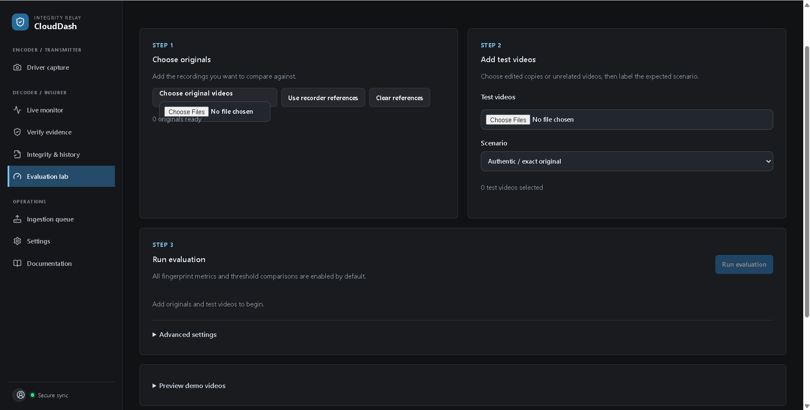
Figure 6. Three-step evaluation flow: originals, test videos with expected scenario, then run.
The Evaluation Lab is separated from day-to-day claim review. It allows a lecturer, quality engineer or model owner to add reference videos, label expected transformations, select perceptual hash methods and distance metrics, sweep thresholds, export results, and compare false positives with missed matches.
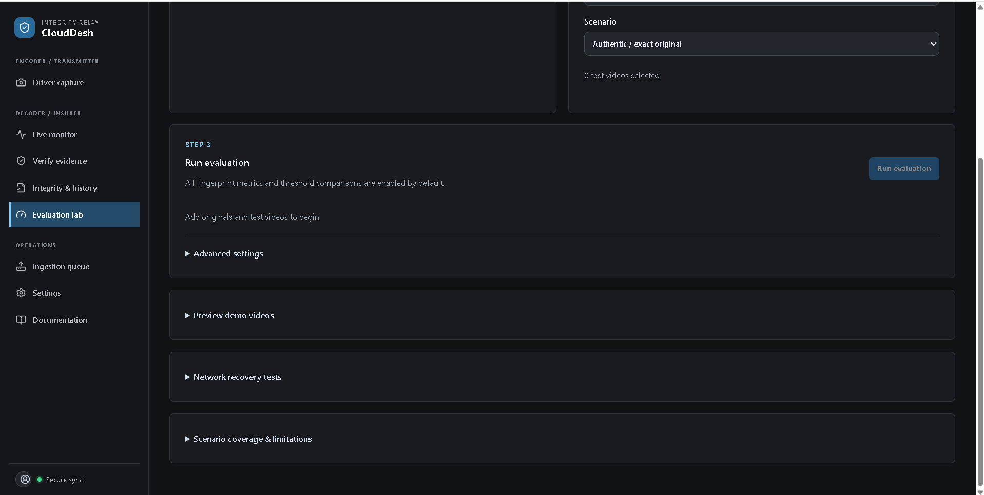
Figure 7. Advanced controls, demo previews, network recovery and limitations are collapsed by default.

Why this supports evaluation
- A ready-made synthetic dataset makes the experiment reproducible without distributing real claimant footage.
- Every scenario is measured across several hash and distance configurations, not one cherry-picked threshold.
- The report records true positives, false positives, true negatives, false negatives, precision, recall, F1 and false-positive rate.
- Limitations are presented inside the same interface so similarity is not mistaken for proof.

8. Automated test evidence
The final source revision was tested from a clean command invocation using npm test. Node’s test runner executed 39 tests and reported 39 passed, 0 failed, 0 skipped, and 0 cancelled. The categories below describe the evidence each group supplies.
Test area | Representative checks
Cryptographic integrity | Deterministic SHA-256; canonical serialization; changed bytes and tampered metadata rejected.
Signatures and identity | ECDSA verification; signed v3 perceptual content; unsigned/legacy profiles cannot silently pass.
Chain continuity | Changed, missing and reordered links detected; new sessions reset correctly.
Manifest verification | Structured identities preserved; malformed/empty batches cannot report success.
Retention and storage | Locked evidence preserved; unsafe deletion blocked; conflict handling fails closed.
Device isolation | Outbox and queue identities remain separated across devices and sessions.
Perceptual matching | Trim/extract, missing/duplicate frames, speed, replacement, reorder and unrelated trip behavior.
Browser compatibility | Strict browser bundle verifies TLSH without leaked loop counters.
Network recovery | Fault scenarios retain every fingerprint and eventually deliver.
History and reliability | Failures, missing references, errors and evaluation findings are explained and counted correctly.
Decoder behavior | All configured metrics run; unsupported decoding remains a separate error state.

Build evidence
npm run build completed successfully with Vite 6.4.3. The only diagnostic was the standard bundle-size advisory because the main JavaScript chunk exceeds 500 kB after minification. This does not invalidate the build, but code splitting is recommended before a high-volume production rollout.

9. Video benchmark and threshold results
The final benchmark generated all 23 scenarios with zero generation errors. With four perceptual-hash methods, multiple distance metrics and a five-point threshold sweep, the run produced 1,265 measurements. All network-recovery checks passed.
Scenario family | Cases exercised
Exact and temporal | Authentic, trim start, trim end, extraction, shifted timeline, slow, fast.
Frame sequence | Different FPS, missing frames, duplicated frames, reordered frames.
Encoding and quality | H.265, bitrate, resolution, compression.
Visual appearance | Brightness, contrast, salt-and-pepper noise, moderate noise, overlay, crop.
Negative / mixed | Another trip; partially replaced footage.

Selected benchmark result
Several configurations achieved F1 = 1.00 on this synthetic set. For example, pHash with cosine distance at threshold 0.30 produced 22 true positives, 0 false positives, 1 true negative and 0 false negatives. This is evidence that the pipeline works on the controlled dataset; it is not a claim of 100% real-world accuracy.

Partial replacement at default pHash configuration
pHash with normalized Hamming distance returned 75% aligned coverage and exactly the expected unmatched 4–7 second interval. Across the five swept thresholds, the modification remained correctly classified. Processing for the selected configuration took approximately 423 ms including fingerprint extraction on the acceptance machine.

10. Network loss, retry and evidence continuity
CloudDash treats network interruption as a normal operating condition. A fingerprint is written to a persistent device-scoped outbox before transmission. A send is removed only after acknowledgment. If the request fails, the response is lost, or the server delays its reply, the same immutable identity is retried instead of creating a different record.
Failure injected | Expected behavior | Final result
Offline before send | Queue locally and preserve media/fingerprint. | Passed
Request fails | Keep queued record and retry. | Passed
Response lost after server write | Retry same identity; server treats it idempotently. | Passed
Delayed acknowledgment | Do not discard prematurely. | Passed
Conflicting bytes for same identity | Quarantine/fail closed. | Passed
Another device active | Maintain isolation and independent counts. | Passed

The browser UI exposes “Outbox pending,” “Simulate network loss,” and “Retry outbox,” making the recovery state demonstrable without hidden developer tools.

11. Security and privacy controls
Control | Implementation | Residual consideration
Confidentiality | Video is local by default; cloud stores fingerprints and metadata. | An exported or submitted video still requires insurer handling controls.
Integrity | SHA-256, ECDSA signature, immutable identity and hash-chain continuity. | Device-key protection and enrollment need hardening for production.
Access | Supabase authentication and row-level policies scope records. | Perform recurring policy/advisor review and role testing.
Availability | Persistent outbox and retry tolerate temporary network loss. | Define operational backup, alerting and disaster recovery.
Auditability | Verification attempts, explanations, counts and export. | Set retention periods and access logging to insurer policy.
Privacy | Synthetic evaluation fixtures avoid claimant data. | Complete DPIA/legal-basis review before real deployments.

Threat interpretation
A hash proves that bytes match a known reference; it does not prove the camera clock was honest or that the original scene was truthful. A signature proves possession of the enrolled private key; it does not identify the human driver by itself. The chain exposes missing/reordered segments within the recorded session; it cannot recover footage that was never captured. These boundaries should appear in insurer procedures and courtroom-facing explanations.

12. Requirements traceability
Requirement | Implementation evidence | Status
Capture fixed segments | Driver capture with selectable segment length and local list. | Met
Hash and timestamp | SHA-256 plus capture metadata bound into signed record. | Met
Cloud fingerprint storage | Authenticated Supabase repository and Realtime monitor. | Met
Offline resilience | IndexedDB outbox, retry and identity-conflict quarantine. | Met
Exact verification | Trusted lookup, byte hash, ECDSA and continuity checks. | Met
Persistent history | Cloud table plus IndexedDB fallback; export and filters. | Met
Edited interval localisation | Review timeline with consistent/review sections. | Met
Modification explanation | Cautious insurance-friendly indicators. | Met
Evaluation tooling | 23 scenarios, threshold sweep, metrics and exports. | Met
Non-technical usability | Plain result hierarchy and collapsed technical detail. | Met
Automated quality gate | 39 tests and production build. | Met

13. Known limitations and remaining production work
Priority | Item | Reason
High | Calibrate thresholds with independent, representative real dashcam datasets. | Synthetic fixtures cannot establish operational accuracy.
High | Formal security review of RLS, key enrollment, device revocation and secrets. | Prototype controls need production assurance.
High | Define evidential chain-of-custody procedures and legal sign-off. | Software results alone do not establish admissibility.
Medium | Add bundle code splitting and performance budgets. | Current build warns that the main chunk exceeds 500 kB.
Medium | Broaden accessibility testing with keyboard and screen-reader users. | Semantic structure exists but human validation is needed.
Medium | Add cross-browser media-decoder acceptance runs in CI. | Codec support can differ by operating system/browser.
Low | Improve file-input styling in the Evaluation Lab. | Native chooser presentation is functional but visually inconsistent.

Sampling is currently 2 frames per second. An edit shorter than the sampling interval can be missed. Perceptual metrics may also mistake visually similar scenes or heavy transformations. Exact verification remains the authoritative integrity result whenever a trusted signed record exists.

14. Deployment and reproducibility

Local verification commands
Command | Purpose
npm ci | Install the committed dependency graph.
npm test | Run the 39 integrity, matching, history and recovery tests.
npm run build | Create the production Vite bundle.
npm run evaluate -- --out <new-directory> --sweep | Generate 23 synthetic scenarios, CSV/JSON results and network tests.
npm start | Run local API and Vite development application.

Required environment
- VITE_SUPABASE_URL — Supabase project URL.
- VITE_SUPABASE_ANON_KEY — browser-safe anonymous key; access is still governed by RLS.
- SUPABASE_SERVICE_ROLE_KEY — server-only when privileged API routes are used; never expose to the browser.
- Optional local API configuration documented in README.md and .env.example.

Cloud deployment
The web application is deployed on Vercel and configured with the browser-safe Supabase values. Supabase migrations create the fingerprint, verification-attempt and policy structures. GitHub Actions installs with npm ci, runs the test suite and builds on every push. The committed README remains the source for exact setup and troubleshooting steps.

15. Evidence register
ID | Evidence | Purpose
E1 | 01-verify-evidence-history.png | Current verification action, counters and persistent history.
E2 | 02-driver-capture.png | Capture controls, status, outbox and local retention.
E3 | 03-integrity-history.png | Dedicated audit log with detailed explanations.
E4 | 04-evaluation-workflow.png | Three-step evaluation setup.
E5 | 05-evaluation-advanced-sections.png | Progressive disclosure of advanced tests and limitations.
E6 | 06-original-frame.png | Frame from controlled authentic reference.
E7 | 07-edited-frame.png | Frame from the controlled modified interval.
E8 | results.json / results.csv | Machine-readable 1,265-measurement benchmark output.
E9 | npm test console output | 39 passed; 0 failed.
E10 | Vite build output | Production compilation succeeded.

Evidence provenance
E1–E5 were supplied as screenshots of the deployed application. E6–E7 were extracted from controlled synthetic test media generated for this acceptance run. E8 is reproducible and retained in the local acceptance workspace rather than committed because generated binaries and result sets are build artifacts. E9–E10 were produced from the final source revision on 3 October 2026.

Conclusion and acceptance statement
CloudDash Integrity meets the agreed prototype objectives: exact evidence checks are cryptographically distinct from similarity checks; completed outcomes persist in history; edited and unchanged sections are visible on a review timeline; the likely modification category is explained cautiously; offline delivery is recoverable; and an insurance reviewer can reach the important conclusion without reading raw hashes.
The final acceptance result is PASS WITH DOCUMENTED LIMITATIONS. The system is ready for academic demonstration and controlled stakeholder evaluation. Production insurance use should follow dataset calibration, formal security and privacy review, operational monitoring, and legal chain-of-custody approval.

Approval record
Role | Name / signature | Date
Developer / author | NHEMBO Ashriel | 3 October 2026
Academic evaluator
Insurance domain reviewer
Security reviewer

Repository artifacts
- README.md — setup, architecture, use and deployment.
- docs/FINAL_ACCEPTANCE_RESULTS.md — concise reproducible final results.
- docs/evidence/ — screenshots and controlled comparison frames.
- docs/CloudDash_Integrity_Final_Acceptance_Report_Ashriel_Nhembo.docx — this complete report.

