Anirudh Sriram
Collaborator – Anand Sanmukhani
Lab 7
Adding 1-Ahead & 2-Ahead forwarding

To implement 1-Ahead & 2-Ahead Forwarding, we had to implement a forwarding unit. This forwarding unit takes as input Rs & Rt from the ID/EX stage, as well as the Register Read from the Ex/Mem stage as well as the Register Read from the Mem/WB stage. It also takes the in the WB inputs from the EX/Mem and Mem/WB stages. It then outputs two signals, which acts as control units for two MUXes. The forwarding unit compares the Rs & Rt to the register reads from the two stages. If they are equal the corresponding MUX control signal is set to 10 if it's the first stage, and 01 if it's the second stage. The default values for the control signals are 00, if none of the if statements apply.

Adding $0 Write and No Write

To add $0 Write we added an extra parameter to the if statement to check if any of the register reads are 0. If they are none of the corresponding if statements are executed. To add the no write feature to the forwarding unit, we just added another parameter to the if statement, ExMemWrite and checked if that was 0 or not. If it was not 0, then the corresponding if statement is executed, or else not.

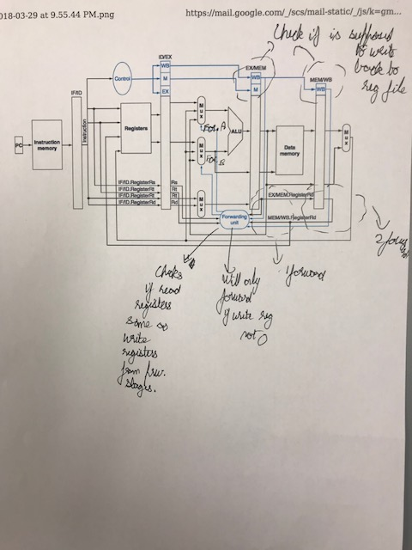
Checking Register Bypass

To check if the register bypass works, we just added another instruction so a register is read 3 stages after a register is written to. Then the waveform generated was checked, to see if the bypass worked.

