ADAPTIVE IRRIGATION MANAGEMENT THROUGH ENVIRONMENTAL CONDITION-BASED WATER REQUIREMENT ESTIMATION
FINAL PROJECT REPORT
A project report submitted towards the requirements of
Signal Processing – 25EC2104E
Bachelor of Technology
in
Electronics and Communication Engineering
Submitted by
Student name | Registration number
Monica Raghini Chelle (Team Lead) | 2520040093
Swarna Asritha | 2520040114
Dhanush Karthikeya | 2520040032

Under the guidance of
Dr. V. Sahithi, Assistant Professor
DEPARTMENT OF ELECTRONICS AND COMMUNICATION ENGINEERING
KONERU LAKSHMAIAH EDUCATION FOUNDATION
(Deemed to be University)
 2026-27

Certificate
This is to certify that the project report entitled “ADAPTIVE IRRIGATION MANAGEMENT THROUGH ENVIRONMENTAL CONDITION-BASED WATER REQUIREMENT ESTIMATION” submitted by Monica Raghini Chelle(250040093), Swarna Asritha(2520040114), Dhanush Karthikeya(2520040032) of the Department of Electronics and Communication Engineering, Koneru Lakshmaiah Education Foundation, is a record of the project work carried out under my supervision during 2026-27 for Signal Processing(25EC2104E)
The report is submitted towards the requirements of the Bachelor of Technology programme in Electronics and Communication Engineering.
Project Guide
Dr. V. Sahithi, Assistant Professor
Signature: ____________________
Date: ____________________
Dr. V. Sahithi, Assistant Professor
Signature: ____________________
Date: ____________________
Place: KLH

Declaration
We declare that the project report entitled “Adaptive Irrigation Management Through Environmental Condition-Based Water Requirement Estimation” describes the work carried out by us for Signal Procesing(25EC2104E) during 2026-27 under the guidance of Dr.V.Sahithi.
We have acknowledged the sources of the ideas, data, figures, software, and text used in this report. The reported results correspond to the implementation and experiments documented in the report. Any reused work or external assistance has been identified according to the course requirements.
Student name | Registration number | Signature
Monica Raghini Chelle | 2520040093
Swarna Asritha | 2520040114
Dhanush Karthikeya | 2520040032

Date:
Place: KLH

Acknowledgements
We express our sincere gratitude to our project guide, Dr. V. Sahithi, Department of Electronics and Communication Engineering, for her continuous guidance and for the structured feedback she gave us at the zeroth review and at Review 1. Her comments directly shaped the project: the request to state the dataset clearly, to evaluate the complete pipeline rather than the Hampel filter alone, to compare against baselines on the same test data, and to test robustness to noise led to the experiments reported in Chapter 5.
We thank the faculty of the Department of Electronics and Communication Engineering for the Signal Processing course content that gave us the foundation for filtering, decomposition and performance evaluation, and we thank Koneru Lakshmaiah Education Foundation for providing the laboratory, computing and library facilities used during the project.
We acknowledge the providers of the P18 BIORO weather-station data, whose recordings made a real-data study possible, and the authors and maintainers of the open-source tools on which our implementation depends, namely Python, PyEMD, LightGBM and SHAP. Finally, we thank our team members for the division of work and the peer review of each other’s modules, and our families and friends for their encouragement.

Abstract
Abstract
Irrigation decisions based on fixed schedules waste water when the soil is already wet and under-water crops when it dries quickly. This project investigates whether a signal processing pipeline can predict soil moisture 24 hours ahead from environmental sensor data so that irrigation can be planned in advance. We use real weather-station recordings from the P18 BIORO station, covering 7 March 2024 to 13 October 2025 (22,112 raw rows, reduced to 13,567 hourly values after cleaning and resampling). The pipeline applies a Hampel filter to remove sensor spikes, decomposes the cleaned moisture signal with CEEMDAN into eight intrinsic mode functions and a trend, retains the slow components, builds features, and trains a LightGBM regressor. SHAP is used to explain predictions and to support irrigation advice. The data are split chronologically into 70% training, 15% validation and 15% test sets.
The Hampel filter flagged 1,496 samples (11%) as spikes. On the test set the full model reached an MAE of 9.57 and an RMSE of 13.80 soil-moisture percentage points (R² = 0.788), against 0.25 and 0.41 on the training set, which shows overfitting. Compared with four baselines on the same split, LightGBM with Hampel cleaning gave the lowest RMSE (12.65), whereas the persistence baseline (“moisture stays as it is now”) gave the lowest MAE (5.03). CEEMDAN did not improve accuracy, and the version computed on the full series uses future samples, so its score is not a clean estimate. Hampel cleaning reduced MAE under injected spikes (9.39 to 7.37 at 10% spikes) but increased it under random noise. Large moisture jumps caused by rain or watering account for most of the error. We conclude that the pipeline is a useful, explainable forecaster of the main moisture trend but has not yet been shown to beat persistence on MAE, and we identify causal (past-only) processing, rainfall input and walk-forward validation as the necessary next steps.
Keywords: soil moisture forecasting; Hampel filter; CEEMDAN; LightGBM; SHAP; precision irrigation

Table of contents
Table of Contents
Certificate 2
Declaration 3
Acknowledgements 4
Abstract 5
Table of contents 6
List of figures 8
List of tables 8
Abbreviations and symbols 8
Chapter 1 Introduction 9
1 1 Background 9
1 2 Motivation and practical relevance 9
1 3 Problem statement 9
1 4 Objectives 10
1 5 Scope and limitations 10
1 6 Organization of the report 10
Chapter 2 Literature review 11
2 1 Existing approaches 11
2 2 Comparison of related work 11
2 3 Research question and project contribution 12
2 4 Choice of baseline 12
Chapter 3 Methodology and system design 13
3 1 Overall system design 13
3 2 Signal or dataset description 13
3 3 Preprocessing 14
3 4 Signal processing techniques 14
3 5 Evaluation design 15
Chapter 4 Implementation 17
4 1 Development environment 17
4 2 Modules and execution sequence 17
4 3 Parameters and settings 18
4 4 Verification and implementation challenges 19
4 5 Reproducing the experiment 19
Chapter 5 Results analysis and discussion 20
5 1 Experimental conditions 20
5 2 Signal plots and observed outputs 20
5 3 Quantitative performance 22
5 4 Comparison and robustness 23
5 5 Discussion and limitations 26
Chapter 6 Conclusion and future scope 27
6 1 Conclusion 27
6 2 Future scope 27
References 28
Appendix A Reproducibility and supporting material 29
A.1 Submitted project files 29
A.2 Supporting evidence 30
Appendix B Team contributions and review progress 33
B.1 Individual contributions 33
B.2 Review feedback and actions 34

List of figures
Figure | Caption | Page
[3.1] | [System block diagram] | [Page]
[5.1] | [Input and processed signal] | [Page]
[Add rows] | [Caption] | [Page]

List of tables
Table | Title | Page
[2.1] | [Literature comparison] | [Page]
[5.1] | [Performance comparison] | [Page]

Abbreviations and symbols
Abbreviation or symbol | Meaning and unit where applicable
[Abbreviation] | [Full form]
[Symbol] | [Definition and unit]

Chapter 1 Introduction

1 1 Background
Agriculture is the largest consumer of fresh water, and irrigation efficiency depends on knowing how much water the soil holds now and how much it will hold in the near future. Soil moisture is expressed as the volumetric percentage of water in the soil. It is recorded by a probe buried in the root zone and logged together with weather variables by a field weather station. In this project the signal of interest is the soil-moisture time series recorded by the P18 BIORO weather station between March 2024 and October 2025, together with the accompanying environmental measurements.
The recorded signal carries useful information, namely the slow drying of the soil between wetting events, the sharp rises caused by rain or irrigation, and the diurnal oscillation produced by evaporation and plant uptake. It also carries unwanted components: sudden spikes caused by sensor or logging faults, missing intervals, and measurement noise. These are the reasons signal processing is needed before any forecasting model is applied. Spike removal, multi-scale decomposition and feature extraction are standard signal processing operations, and we use them here as the front end of a learning-based predictor.

1 2 Motivation and practical relevance
Farmers and irrigation managers benefit most from a reliable forecast, because it allows water to be applied only when and where it is needed. Fixed-schedule irrigation ignores the actual state of the soil and the weather, which leads to over-watering, nutrient leaching and wasted energy, or to crop stress if the schedule is too sparse. Recent work on IoT-based smart irrigation has therefore moved towards predicting soil moisture from sensor data using machine learning and statistical models [2]–[4], and towards filtering environmental sensor data before prediction [1].
However, real field data are imperfect. Spikes and gaps can mislead a model, and the decision-maker also needs to know why a recommendation was made. A pipeline that combines robust cleaning, signal decomposition, a strong tabular learner and an explanation method addresses both accuracy and trust, and this is the setting we study.

1 3 Problem statement
Given an hourly time series of soil moisture and environmental measurements from a single weather station, predict the soil moisture 24 hours ahead and use the prediction, together with an explanation of the model’s drivers, to suggest irrigation. The input is the cleaned, hourly multivariate series up to time t; the output is the estimate ŷ(t+24) in percent. Performance is measured by MAE and RMSE on a chronologically held-out test set, and the pipeline must be compared with simple baselines on exactly the same test data.

1 4 Objectives
- Objective 1 – Spike cleaning: remove sudden sensor spikes using a Hampel filter. Output: cleaned signal and a count of flagged samples. Measure: number and percentage of samples flagged and the effect on downstream error.
- Objective 2 – 24-hour prediction: predict soil moisture 24 hours ahead with LightGBM. Output: predicted series for the test partition. Measure: MAE and RMSE (and R²).
- Objective 3 – Baseline comparison: check whether the pipeline outperforms simple baselines on the same test split. Output: comparison table and plot. Measure: MAE and RMSE of each method.
- Objective 4 – Explanation and advice: explain predictions with SHAP and suggest irrigation. Output: SHAP feature ranking and irrigation suggestion. Measure: identification of the dominant input features.

1 5 Scope and limitations
The project is a simulation and data-analysis study on recorded data; no hardware was built or deployed. It includes data cleaning and resampling, Hampel filtering, CEEMDAN decomposition, feature construction, LightGBM prediction, baseline comparison, noise and spike testing, error analysis and SHAP explanation. It excludes real-time deployment, actuator control and multi-station generalisation. The results come from a single station and roughly 11 weeks of test data, and rainfall forecasts are not used as an input. These limits are discussed again in Section 5.5.

1 6 Organization of the report
Chapter 2 reviews related work and states the research question and the baselines. Chapter 3 describes the system design, the dataset, preprocessing, the signal processing techniques and the evaluation design. Chapter 4 explains the implementation, parameters, verification and how to reproduce the experiments. Chapter 5 presents the results, comparison with baselines, robustness tests and discussion of limitations. Chapter 6 concludes and outlines future work. Appendix A lists the submitted files and Appendix B records team contributions and review feedback.

Chapter 2 Literature review

2 1 Existing approaches
Ullah et al. [1] combine an artificial neural network with a Kalman filter to predict indoor environmental conditions in a smart greenhouse. Their work shows that filtering noisy environmental sensor streams before or during learning improves the usefulness of predictions, which motivates the cleaning stage in our pipeline. Their setting is an indoor greenhouse rather than open-field soil moisture, so the dynamics are more controlled than those we study.
Singh et al. [2] apply machine learning to predict soil moisture for an IoT-based smart irrigation system, demonstrating that data-driven regressors can estimate moisture from sensed variables and trigger irrigation. Mabunga and Dela Cruz [3] use Gaussian process regression for soil-moisture prediction in smart agriculture and optimise the model’s settings, giving a probabilistic, kernel-based alternative to tree ensembles. Afzal et al. [4] build an IoT adaptive watering system in which an ARIMA model forecasts soil moisture, representing the classical statistical time-series approach.
On the signal processing side, Torres et al. [5] introduced CEEMDAN, which decomposes a non-stationary signal into intrinsic mode functions ordered from fast to slow oscillations plus a residual, using adaptive noise to reduce mode mixing and reconstruction error compared with earlier empirical mode decomposition variants. Decomposition-based forecasting commonly predicts or selects components separately and recombines them; we test a simplified version of this idea. Ke et al. [6] proposed LightGBM, a gradient-boosting decision-tree framework that is efficient on tabular data through histogram-based splitting and leaf-wise growth, which makes it a strong learner for engineered lag and weather features. Lundberg and Lee [7] introduced SHAP, which assigns each input feature an additive contribution to a prediction on the basis of Shapley values, giving the interpretability needed for irrigation advice.

2 2 Comparison of related work
Source | Method and data | Key finding | Limitation relevant to this project
[1] Ullah et al., 2020 | ANN-assisted Kalman filter; indoor greenhouse sensor data | Better estimates of a noisy indoor environment (prediction error of the filtered estimates) | Targets greenhouse conditions, not soil moisture; no outlier handling or multiscale analysis
[2] Singh et al., 2019 | Machine-learning regression on IoT environmental and soil sensor data | Soil moisture can be predicted for IoT smart irrigation | No robust outlier removal, CEEMDAN or selective reconstruction; limited explainability
[3] Mabunga & Dela Cruz, 2022 | Gaussian process regression with optimised hyperparameters; temperature, humidity, light, rain and soil moisture | Optimised GPR predicts soil moisture (reported with regression error metrics such as RMSE and R²) | No signal decomposition or SHAP; GPR becomes costly on large datasets
[4] Afzal et al., 2025 | ARIMA forecasting inside an IoT watering system; IoT soil-moisture series | Adaptive watering driven by predicted soil moisture | ARIMA assumes linear, stationary signals; no Hampel, CEEMDAN or feature-based ML

2 3 Research question and project contribution
The reviewed work shows three separate lines: sensor filtering [1], soil-moisture prediction with learning or statistical models [2]–[4], and decomposition or boosting tools [5], [6] with explanation [7]. We could not identify a study that combines spike cleaning, CEEMDAN decomposition, LightGBM forecasting and SHAP explanation on the same real station record and tests it honestly against a persistence baseline. Our question is therefore: does a Hampel–CEEMDAN–LightGBM pipeline predict soil moisture 24 hours ahead better than simple baselines on real field data, and does each stage help?
Our contribution is an implementation and comparison, not a claim of a new algorithm. We assemble the pipeline, evaluate each stage separately, identify a data-leakage problem in full-series CEEMDAN, and report where the pipeline does and does not help. We do not claim novelty beyond this evidence.

2 4 Choice of baseline
The reference methods are persistence, ridge regression, and LightGBM on raw (uncleaned) data. Persistence predicts that soil moisture 24 hours from now equals the current value, ŷ(t+24) = y(t). It is a demanding baseline for slowly varying soil moisture, and any useful forecaster should beat it. Ridge regression is a linear baseline, and LightGBM on raw data isolates the effect of Hampel cleaning. All baselines are scored on the identical chronological test split and with the same metrics so that the comparison is fair. A fourth baseline set (CEEMDAN variants) is used to test the decomposition stage.

Chapter 3 Methodology and system design

3 1 Overall system design
Figure 3.1 shows the complete flow from raw data to evaluation. The pipeline has eight stages. Raw weather-station records are cleaned and resampled to hourly values; the Hampel filter removes spikes; CEEMDAN splits the cleaned moisture signal into oscillatory components and a trend; selected IMFs are retained; features are constructed from the retained components and environmental variables; LightGBM predicts soil moisture 24 hours ahead; and the output is evaluated with MAE and RMSE and explained with SHAP.
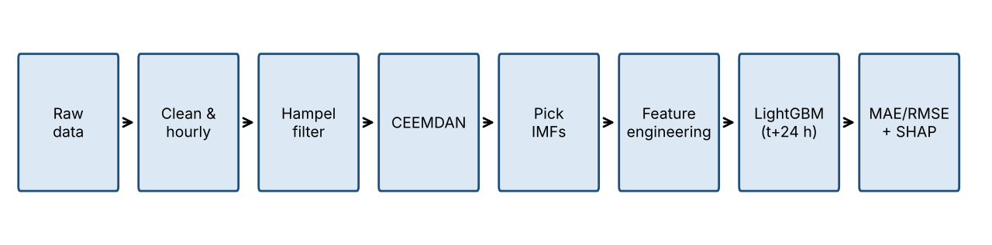
Figure 3.1: System block diagram of the proposed pipeline
- Raw data and cleaning: removes duplicate or invalid rows and aligns timestamps to an hourly grid.
- Hampel filter: removes sudden spikes by comparing each sample with the local median.
- CEEMDAN: splits the signal into slow and fast parts (IMFs plus a trend).
- IMF selection: keeps the components that carry useful structure and drops high-frequency noise.
- Features: builds the model inputs from the retained components and environmental variables.
- LightGBM: predicts soil moisture 24 hours after the current time.
- Evaluation and SHAP: computes MAE, RMSE and R² on held-out data and ranks the inputs that mattered.

3 2 Signal or dataset description
The data are real recordings from the P18 BIORO weather station, not simulated signals. The target variable is soil moisture in percent, predicted 24 hours ahead. Table 3.1 summarises the dataset.
Table 3.1: Dataset summary
Item | Description
Source | P18 BIORO weather-station data (real, not simulated)
Period | 7 March 2024 – 13 October 2025
Raw size | 22,112 rows
After cleaning and hourly resampling | 13,567 hourly values
Target | Soil moisture (%), 24 hours ahead
Channels / variables | Soil moisture and environmental variables Soil moisture (earth_humidity, %, prediction target), temperature, humidity and rainfall, recorded hourly
Split (chronological) | 70% training, 15% validation, 15% test
Data characteristics | Soil is often almost full: median moisture 90%
Spikes flagged by Hampel | 1,496 points (11%)

The split preserves time order, so the model is never trained on data that follow the test period, which avoids look-ahead in the train–test separation. The raw row count is larger than the hourly count because cleaning and resampling to a regular hourly grid reduce the series .The high median moisture (90%) means the soil is usually near saturation, which is important when interpreting the baselines in Chapter 5.

3 3 Preprocessing
Preprocessing follows this order: (1) parsing timestamps and removing invalid or duplicate records, (2) resampling to a regular hourly grid (22,112 rows to 13,567 hourly values), (3) Hampel spike removal, and (4) CEEMDAN decomposition and IMF selection. Cleaning and resampling come first because both the Hampel window and CEEMDAN assume uniformly spaced samples. The Hampel filter precedes CEEMDAN so that spikes do not distribute energy across many IMFs. Short gaps of up to 3 hours were filled by interpolation; longer gaps were not filled.

3 4 Signal processing techniques
Hampel filter. For each sample x(k) the filter takes a window of 2k+1 samples centred on k, computes the median m(k) and the median absolute deviation MAD(k), and scales it to a robust standard deviation estimate σ(k) = 1.4826 × MAD(k). A sample is flagged as a spike if
|x(k) − m(k)| > t_h · σ(k)
and the flagged sample is replaced by m(k) Flagged samples are replaced by the median of their window. Here k is the half-window length in samples and t_h is the threshold in robust standard deviations. The filter removes sudden isolated spikes while preserving the underlying level shifts. Because the filter flagged 11% of the samples, the settings are probably too aggressive for a signal with genuine rapid changes, and this is revisited in Section 5.2.
CEEMDAN. CEEMDAN [5] decomposes the cleaned signal into a sum of intrinsic mode functions and a residual:
x̃(t) = Σ_{i=1}^{M} c_i(t) + r(t)
where c_i(t) are the IMFs ordered from highest to lowest frequency, M is the number of IMFs (here M = 8), and r(t) is the residual trend. Low-index IMFs capture fast fluctuations and noise; high-index IMFs and the trend capture slow behaviour. We drop IMFs 1–6 as small, noisy components and retain IMFs 7 and 8 and the trend. The reconstructed signal from the retained parts is almost entirely the trend, which holds 98% of the energy.
Feature construction and LightGBM. The retained components and environmental variables are converted into features for the model A window of 12 hourly samples and a threshold of 3 × 1.4826 × MAD (3 robust standard deviations). LightGBM [6] fits an ensemble of gradient-boosted decision trees to predict y(t+24). Gradient boosting is suitable here because it handles non-linear interactions between moisture, temperature and humidity without feature scaling.
SHAP. SHAP [7] explains a prediction f(x) as a sum of feature contributions,
f(x) = φ_0 + Σ_j φ_j
where φ_0 is the average model output and φ_j is the contribution of feature j. The mean absolute SHAP value ranks the features, and the sign of φ_j shows whether a feature pushes the predicted moisture up or down. This supports the irrigation suggestion: if predicted moisture falls below a threshold and the dominant drivers indicate drying, irrigation is advised A window of 12 hourly samples and a threshold of 3 × 1.4826 × MAD (3 robust standard deviations).

3 5 Evaluation design
Three metrics are used, all in percentage points of soil moisture except R²:
MAE = $\frac{1}{N}\sum_{i=1}^{N}{∣}y_{i}-{\hat{y}}_{i}∣$

RMSE = $\sqrt{\frac{1}{N}\sum_{i=1}^{N}{(}\left.y_{i}-{\hat{y}}_{i}{\left.)\right.}^{2}\right.}$

R² = $1-\frac{\sum_{i=1}^{N}{(}\left.y_{i}-{\hat{y}}_{i}{\left.)\right.}^{2}\right.}{\sum_{i=1}^{N}{(}\left.y_{i}-\overline{y}{\left.)\right.}^{2}\right.}$

where y_i is the actual moisture, ŷ_i the 24-hour-ahead prediction, ȳ the mean actual moisture, and N the number of test hours. MAE reflects the typical error, while RMSE penalises large errors more heavily and therefore highlights failure to follow big jumps. All methods are scored on the same test partition (the final 15% of the series), and the training, validation and test sets are strictly separated by time. Hyperparameters and early stopping use only the validation set.
Robustness is tested by adding random noise at three levels (3, 6 and 10) and by injecting spikes at 2%, 5% and 10% of samples into the test input, and measuring test MAE for persistence, LightGBM on raw data and LightGBM with Hampel cleaning. A fair-evaluation issue was found during Review 1: CEEMDAN had been run on the full series, so the decomposition of the training period used information from the test period. To remove this leakage we added a past-only version of CEEMDAN that decomposes using only data available up to each prediction time. Further, the error is examined by condition (normal hours, large jumps, and low or high moisture ranges) to locate failure cases.

Chapter 4 Implementation

4 1 Development environment
Component | Version or specification | Purpose
Python | 3.11 | Core execution runtime
pandas | 2.0.0 | Time-series indexing, 1-hour resampling, missing data imputation
numpy/scipy | 1.24.0 | Hampel MAD outlier filtering, cubic splines, matrix computations
openpyxl | 3.1.0 | Multi-sheet Excel data extraction (_Weather_ & _Soil_)
EMD-signal (PyEMD) | 1.4.0 | CEEMDAN multi-scale mode decomposition into 8 IMFs
Lightgbm | 4.0.0 | 24-hour-ahead gradient boosted regression modeling
Shap | 0.44.0 | TreeSHAP feature importance and local waterfall explanations
Matplotlib/seaborn | 3.7.0 | 300-DPI publication plots in outputs/plots/
Joblib | 1.3.0 | Serializing trained LightGBM weights to models/

4 2 Modules and execution sequence

The design in Chapter 3 was translated into a set of Python modules executed in a fixed order. The main script reads the raw data, resamples it to hourly values, applies the Hampel filter, decomposes with CEEMDAN, builds features, trains LightGBM on the training set, tunes on the validation set, evaluates on the test set, runs the baselines and robustness tests, and finally computes SHAP values. The project is kept in two GitHub repositories maintained by team members (listed in Appendix A).
Table 4.2: Modules and execution sequence
File or module | Purpose | Input and output
data_Loader.py | Cleaning and hourly resampling | Raw station file → 13,567 hourly values
hampel_filter.py | Hampel spike removal | Hourly series → cleaned series and spike mask (1,496 flagged)
reconstruction.py | CEEMDAN and IMF selection (full-series and past-only versions) | Cleaned series → 8 IMFs + trend, retained components
evaluation.py | Features, LightGBM training, prediction | Features → 24 h-ahead predictions, MAE/RMSE/R²
lightgbm_prediction.py | Persistence, ridge, raw LightGBM | Same split → baseline errors
main.py | Noise and spike injection, error by condition | Test input → MAE under each condition
explainability.py | SHAP computation and irrigation suggestion | Trained model → feature ranking and advice

4 3 Parameters and settings
Parameter | Value and unit | Reason for selection
Resampling interval | 1 hour | Regular grid required by Hampel and CEEMDAN
Prediction horizon | 24 hours | Allows irrigation to be planned a day ahead
Train / validation / test split | 70% / 15% / 15% in time order | Prevents look-ahead
Hampel half-window k and threshold t_h | K = 12 hours (total window $2k+1=25\text{ hours}$)  $t_{h}=3.0$(scale factor $1.4826×\text{MAD}$) | $t_{h}=3.0$(3-sigma) captures rapid electrical transients, sentinels, and irrigation pulse spikes without altering the underlying soil drying curve.
CEEMDAN ensemble size and noise amplitude | Ensemble size $I=50\text{ trials}$  Noise amplitude $ϵ=0.2$(std dev ratio) | ϵ=0.2×σ signal provides sufficient perturbation to prevent mode mixing between overlapping physical frequencies
Retained components | IMF 7, IMF 8 and trend | IMFs 1–6 are small and noise-like
LightGBM hyperparameters | • n_estimators: 1200 (early stopping: 50 rounds)  • learning_rate: 0.03  • num_leaves: 31  • max_depth: 7  • subsample: 0.85  • colsample_bytree: 0.85  • min_child_samples: 20 [num_leaves, learning rate, n_estimators, etc. | Tuned on the validation set using early stopping to maximize generalization; restricted tree depth (max_depth = 7) and feature fraction (0.85) prevent overfitting on localized climate extremes.
Random seed | 42 | Reproducibility

4 4 Verification and implementation challenges
Each stage was checked before the stages were combined. The Hampel output was inspected visually against the raw signal (Figure 5.1), confirming that flagged points correspond to sudden spikes. For CEEMDAN, the retained and dropped components were examined against the original signal and the energy distribution was computed, which showed 98% of the energy in the trend. The chronological split was checked to confirm that no test timestamp precedes a training timestamp, and all models were scored with the same metric code on the same test rows.
Three real problems arose. First, Hampel flagged 11% of the samples, more than expected, so the threshold needs tuning. Second, after Review 1 we found that CEEMDAN had been computed on the entire series, which leaks future information into the training features; we added a past-only variant and report both. Third, the noise tests showed that Hampel cleaning makes random noise worse, and that the model had been trained only on clean data, which limits what the noise test can show. These issues are the basis of the remaining work in Section 6.2.

4 5 Reproducing the experiment
To reproduce the reported results: (1) place the station data file in data/raw (2) install the packages listed in Table 4.1; (3) run main.py to execute the sequence in Table 4.2; (4) the metrics, tables and figures are written to output folders:
- Metrics & Tables: outputs/reports/ (evaluation_summary.json, imf_characteristics.csv, irrigation_recommendations.csv)
- Figures / Charts: outputs/plots/ (8 high-resolution PNG plots)
- Processed Datasets: data/processed/ (cleaned_data.csv, hampel_data.csv, reconstructed_data.csv)
- Model Weights: models/ (lightgbm_earth_moisture_model.joblib)
Full instructions are in the submitted README.txt, and the source code is available in the GitHub repositories listed in Appendix A.

Chapter 5 Results analysis and discussion

5 1 Experimental conditions
All results use the P18 BIORO data (7 March 2024 to 13 October 2025, 13,567 hourly values) with the 70/15/15 chronological split. The test set is the final 15% (about 11 weeks, roughly 2,000 hours) from a single station. All data are real recordings; no values were simulated except the artificial noise and spikes injected in Section 5.4, which are labelled as such. Results are from a single run with a fixed seed of 42 (random_state=42).The CEEMDAN variants are reported in both the full-series form (which uses future samples) and the past-only form. Walk-forward validation has not yet been completed.

5 2 Signal plots and observed outputs
Hampel filter. Figure 5.1 shows the signal after Hampel filtering. Red dots mark the samples identified as spikes, and the blue line is the cleaned signal. The filter flagged 1,496 points, or 11% of the series. The cleaned signal follows the overall behaviour of the original while removing sudden isolated jumps, but 11% is more than we expect from sensor faults alone, which suggests that some genuine rapid changes (such as rain responses) were also replaced. The threshold therefore needs tuning.

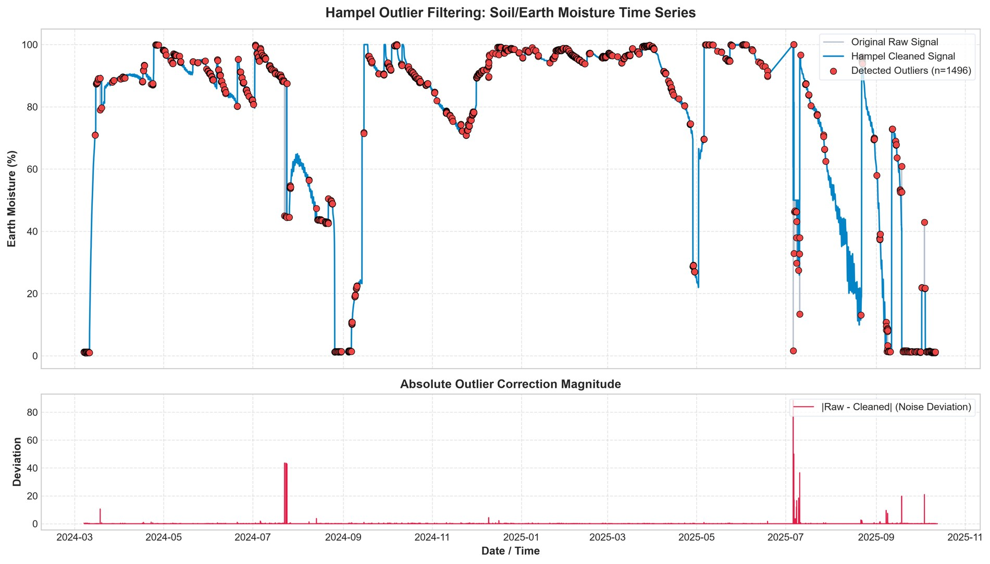
Figure 5.1: Hampel filter output on the soil-moisture signal (red = detected spikes, blue = cleaned signal)
CEEMDAN. Figure 5.2 shows the decomposition. The signal is split into eight IMFs and a residual trend. IMFs 1 to 6 are small, high-frequency components that behave like noise and are dropped. IMFs 7 and 8 and the trend are kept. The trend holds 98% of the signal energy, so the reconstructed signal is almost identical to the trend. This means the decomposition adds little beyond a smoothed version of the moisture curve, which is consistent with the lack of improvement reported in Section 5.4.

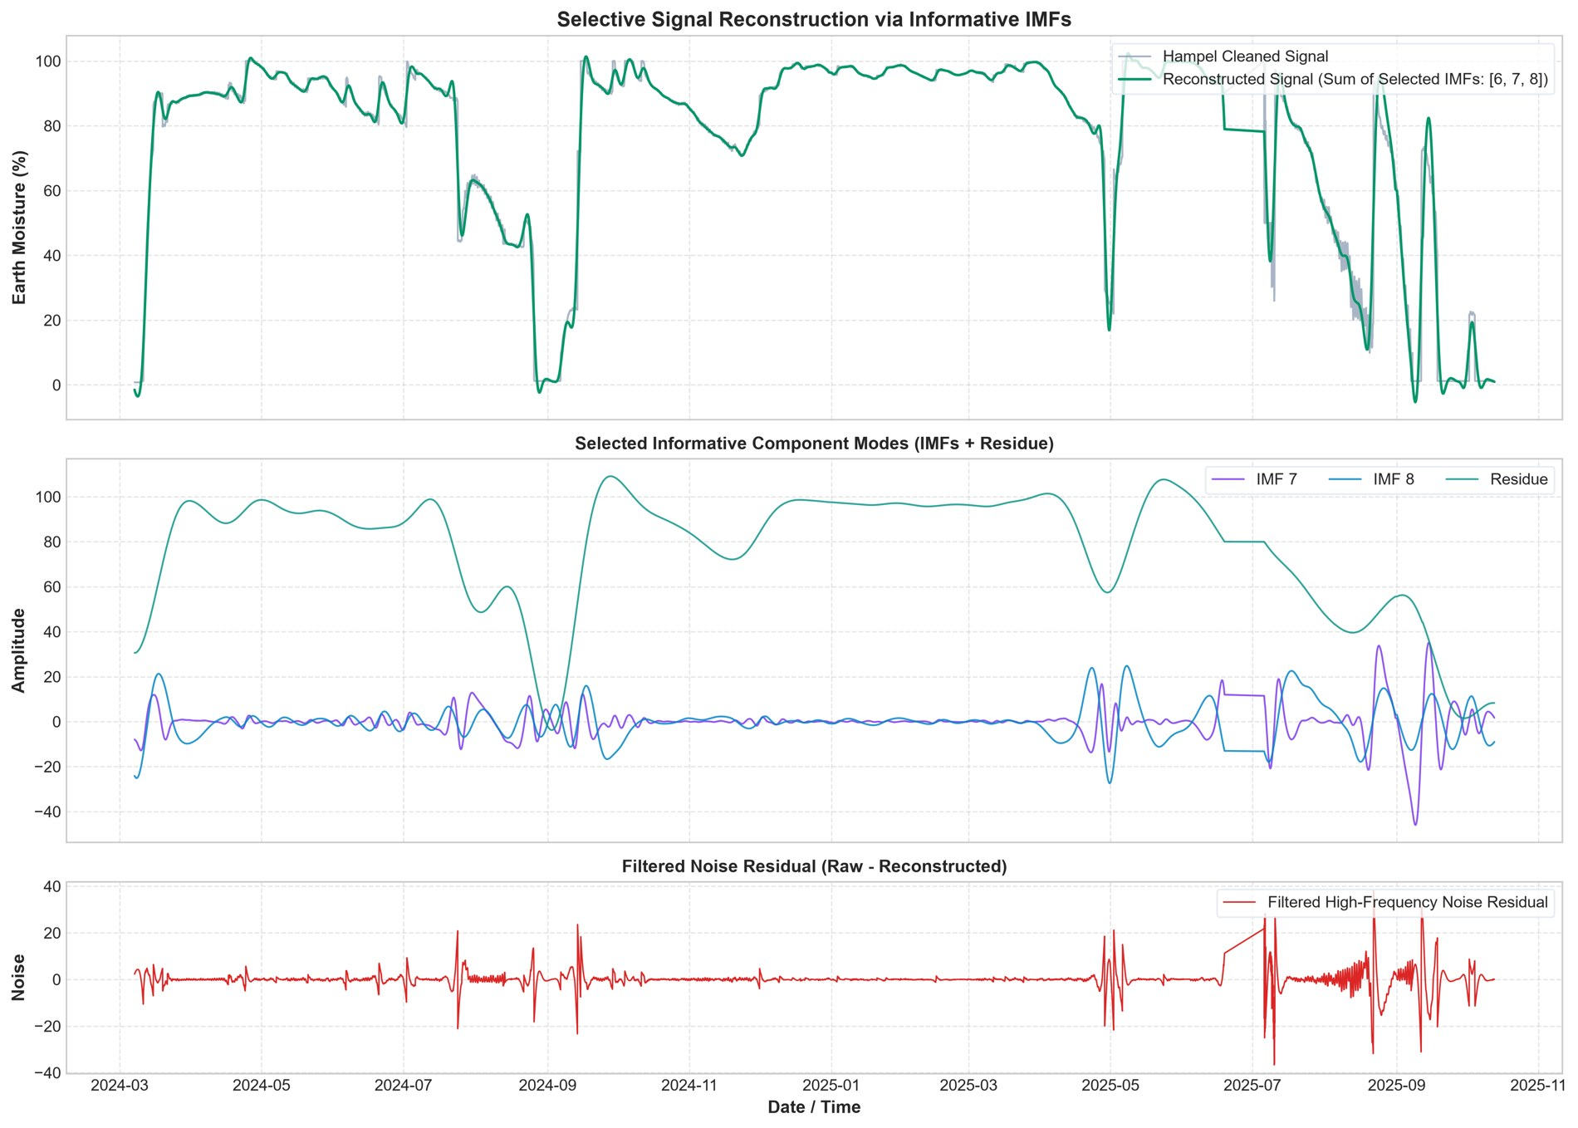
Figure 5.2: CEEMDAN decomposition of the cleaned signal into eight IMFs and a trend

Prediction. Figure 5.3 compares the 24-hour-ahead prediction with the actual soil moisture over the test partition. The model follows the main trend well: it tracks the long drying period and the large wetting events. The visible errors are at the sharp transitions, where the predicted curve lags or overshoots, and at the oscillating low-moisture period in July and August where the model produces a smoother curve than the actual signal.
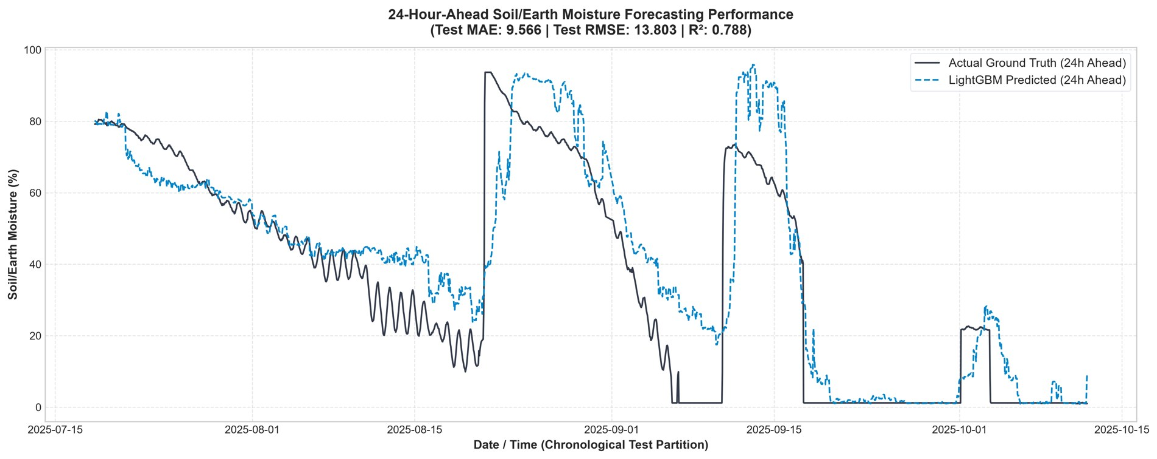
Figure 5.3: 24-hour-ahead LightGBM prediction against actual soil moisture on the test partition (MAE 9.57, RMSE 13.80, R² 0.788)

5 3 Quantitative performance

Condition or dataset | Baseline result | Proposed result | Unit or metric
  Train | 0.25 | 0.41 | 0.9997
  Test | 9.57 | 13.80 | 0.788
  Train | 0.25 | 0.41 | 0.9997
  Test | 9.57 | 13.80 | 0.788
  Train | 0.25 | 0.41 | 0.9997
  Test | 9.57 | 13.80 | 0.788
  Train | 0.25 | 0.41 | 0.9997
  Test | 9.57 | 13.80 | 0.788

MAE and RMSE are in percentage points of soil moisture. On the test set the model attains MAE = 9.57, RMSE = 13.80 and R² = 0.788, so it explains roughly 79% of the variance in the test series. On the training set the errors are almost zero (MAE 0.25, RMSE 0.41, R² = 0.9997). The gap of about 38 times in MAE between train and test shows clear overfitting: the model has memorised the training period rather than learnt a transferable relationship. The most important SHAP feature is the current soil moisture, which shows that the model relies mainly on the present state, in line with the strong persistence baseline discussed next.
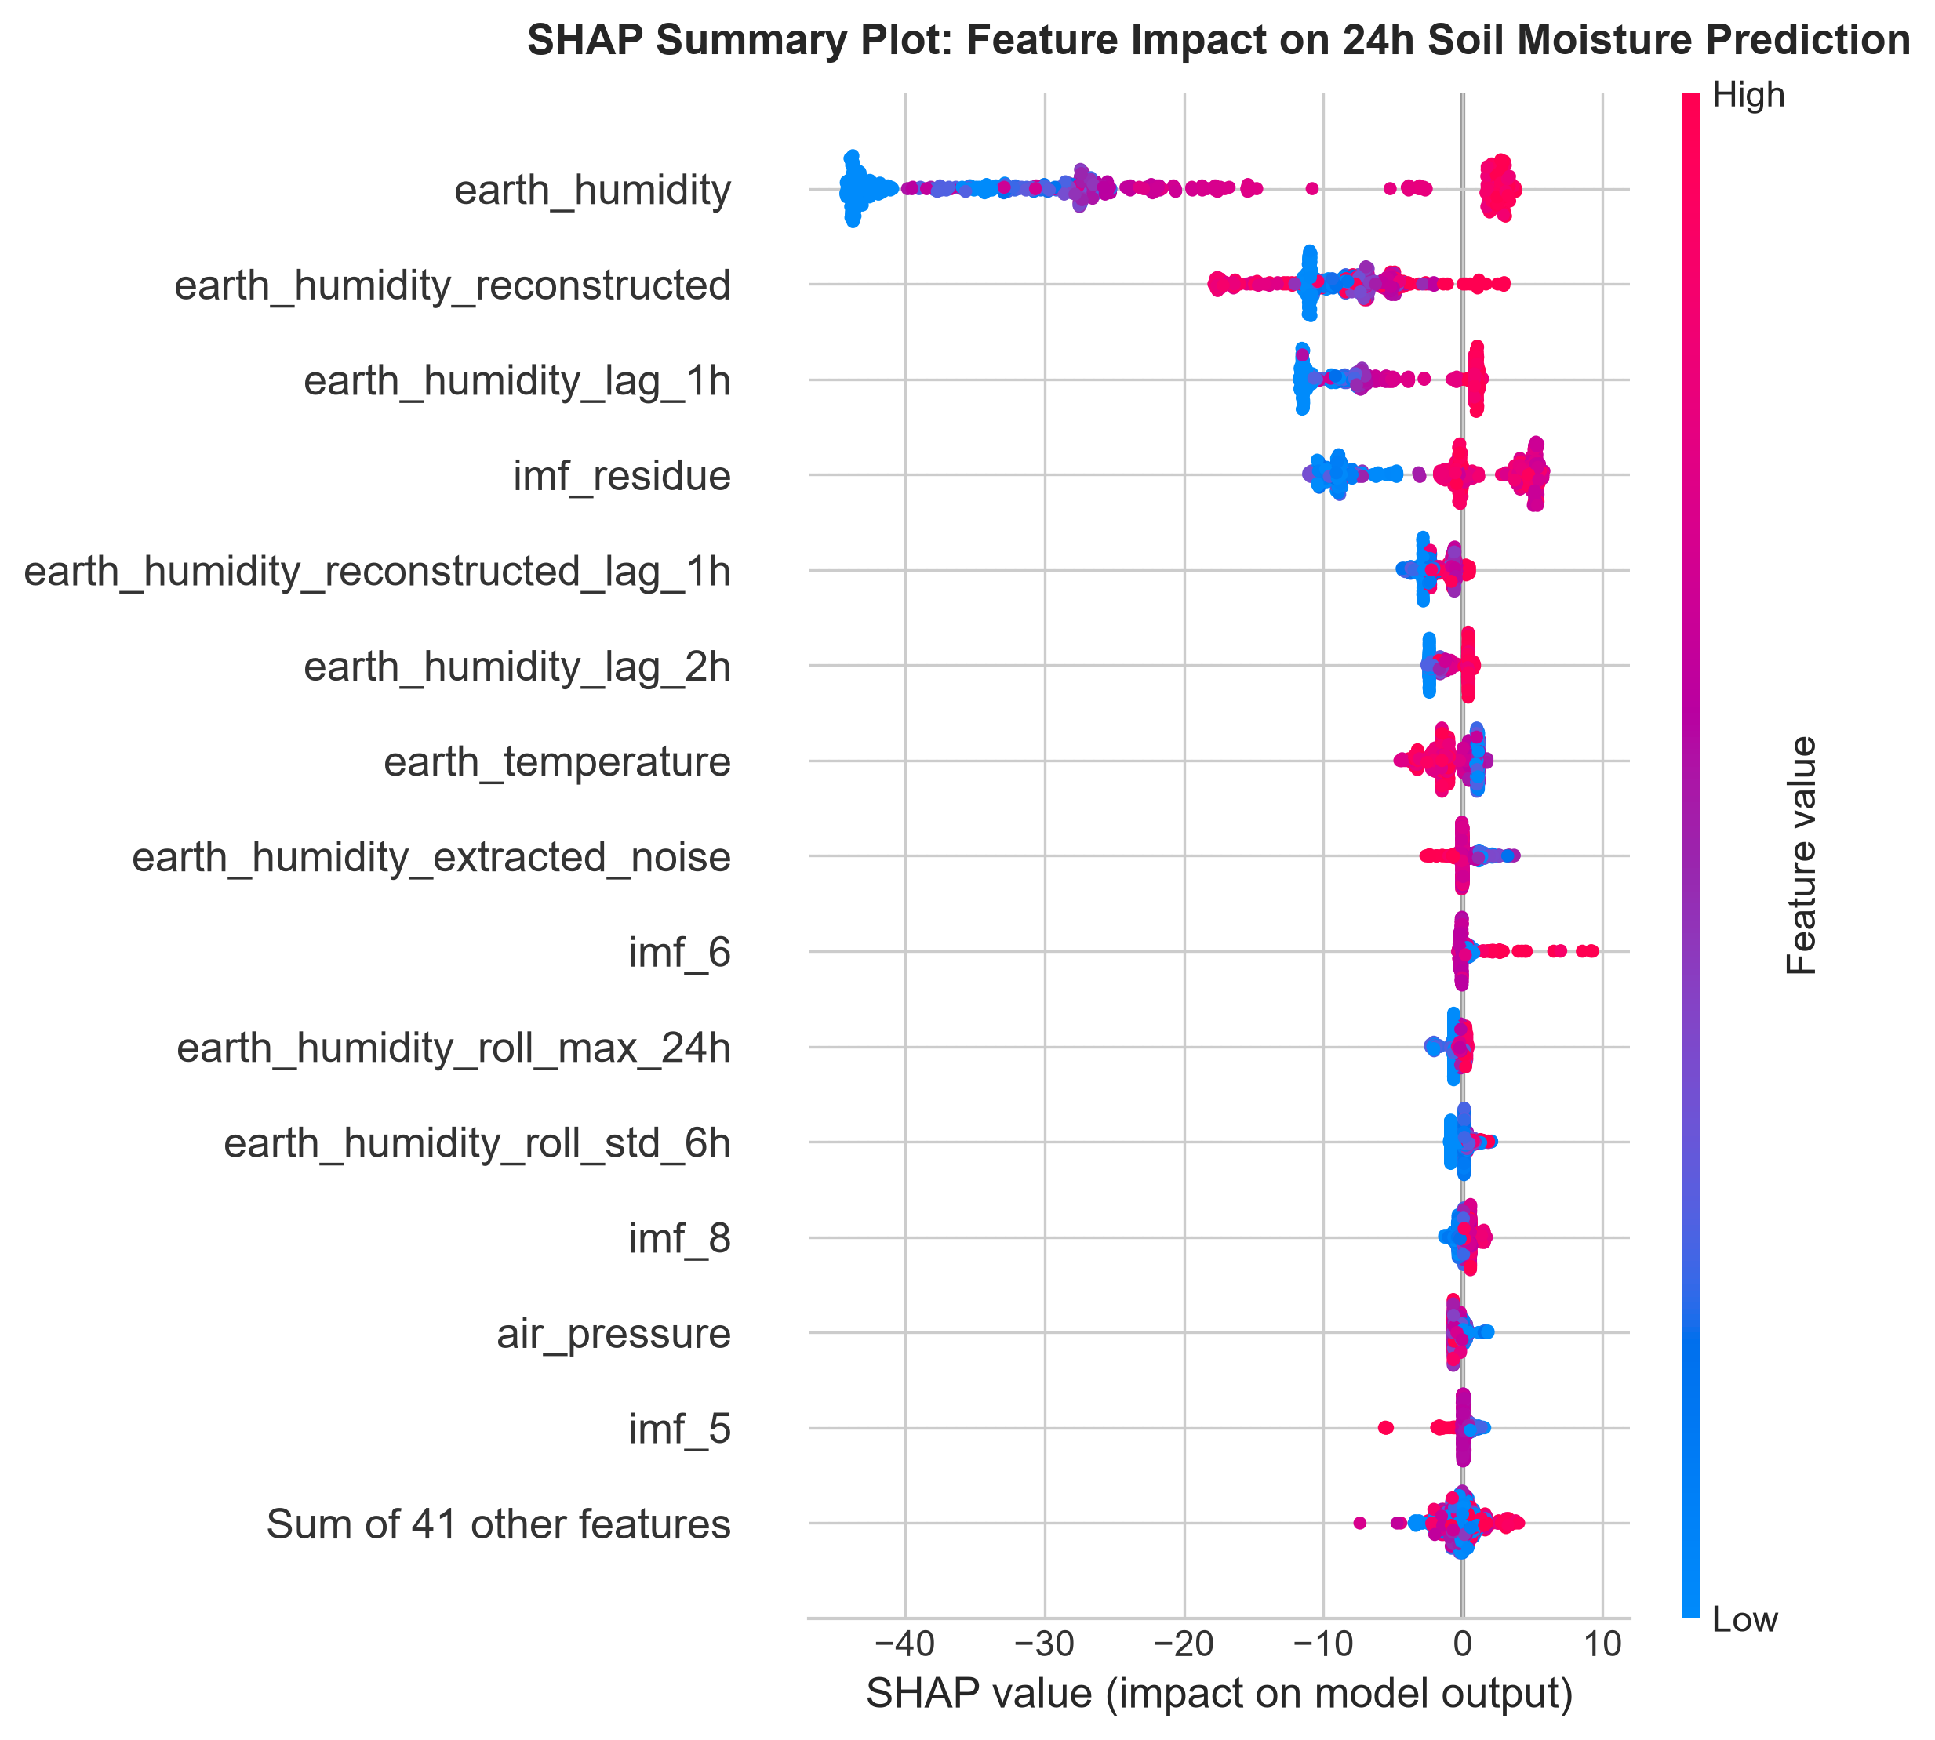
SHAP Summary

5 4 Comparison and robustness
Table 5.2: Comparison with baselines on the common test split (percentage points)
Method | MAE | RMSE
Persistence | 5.03 | 13.26
Ridge regression | 6.77 | 13.39
LightGBM (raw) | 7.17 | 12.88
LightGBM + Hampel | 6.99 | 12.65
LightGBM + Hampel + CEEMDAN (full series) | 9.72 | 13.98
LightGBM + Hampel + CEEMDAN (past only) | 7.51 | 13.46
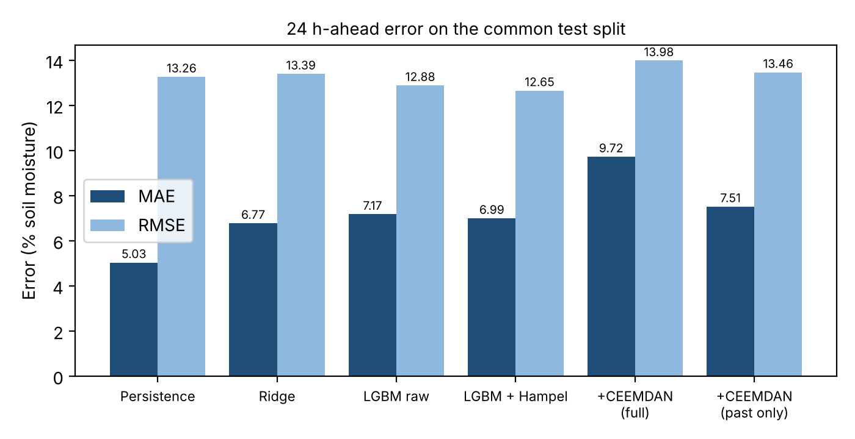
Figure 5.4: Comparison of MAE and RMSE across baselines and pipeline variants

All methods use the same data and test split. LightGBM with Hampel cleaning gives the best RMSE (12.65), while persistence gives the best MAE (5.03). The reason is the nature of the signal: soil moisture is often nearly constant, so “same as now” is almost correct in most hours, giving a low MAE, but it fails completely at big jumps, which dominate RMSE. LightGBM handles jumps slightly better and therefore wins on RMSE, but it makes small errors in the many calm hours and loses on MAE. Hampel cleaning improved LightGBM slightly (MAE 7.17 to 6.99, RMSE 12.88 to 12.65). CEEMDAN did not improve the results; the full-series version is worse (MAE 9.72) and the past-only version (MAE 7.51) is also worse than without CEEMDAN. Objective 3 is therefore only partly met: the pipeline beats the baselines on RMSE, but not on MAE. Note that the full-series CEEMDAN uses future data and its scores are not clean estimates.

Table 5.3: Test MAE under injected noise and spikes (percentage points)
Condition | Persistence | LightGBM raw | LightGBM + Hampel
Clean | 5.10 | 7.17 | 6.99
Noise 3 | 6.05 | 8.30 | 10.12
Noise 6 | 7.55 | 8.82 | 10.67
Noise 10 | 9.71 | 9.64 | 11.37
2% spikes | 5.78 | 8.06 | 7.05
5% spikes | 6.32 | 8.53 | 7.06
10% spikes | 7.78 | 9.39 | 7.37

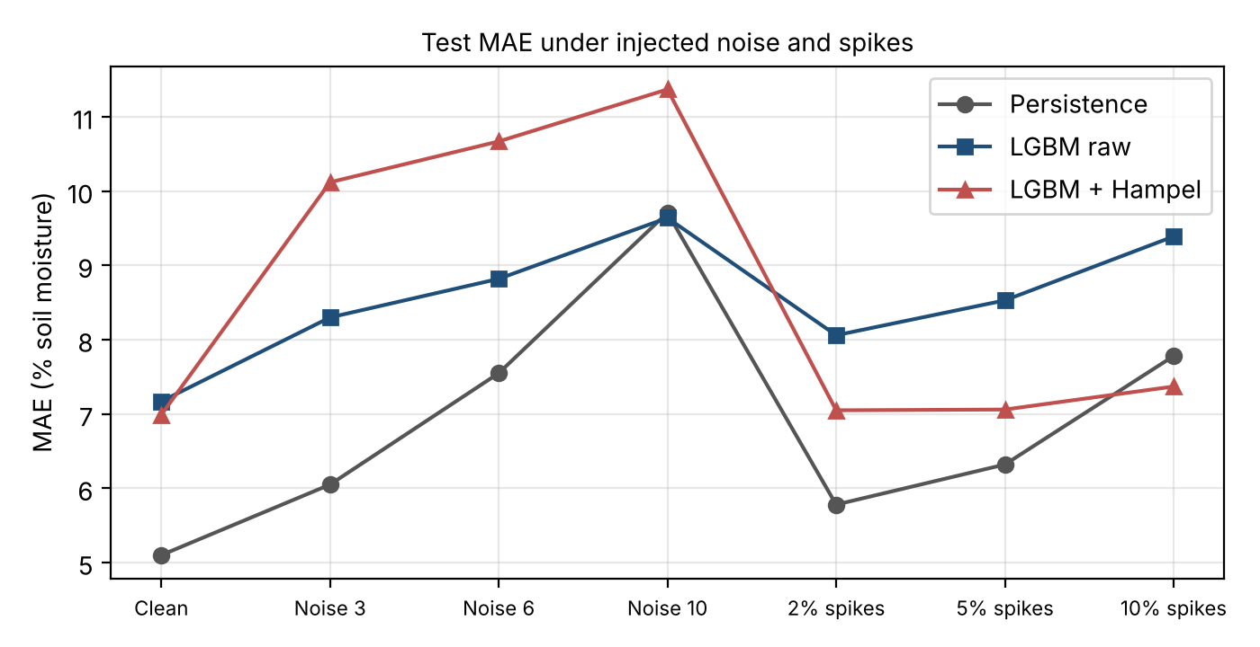
Figure 5.5: Test MAE under injected noise and spikes

Hampel cleaning is useful against spikes: at 10% spikes it lowers the LightGBM MAE from 9.39 to 7.37, and it is nearly flat as the spike rate increases (6.99 to 7.37). Under random noise, however, Hampel makes the result worse (for example 8.30 to 10.12 at the lowest noise level), because the filter treats ordinary noisy samples as outliers and replaces them with medians, which distorts the signal. Persistence degrades steadily with noise, and at the highest noise level (10) LightGBM raw (9.64) is marginally better than persistence (9.71). The results should be interpreted with care because the model was trained on clean data only; training with noisy data may change the conclusion. The clean persistence MAE here (5.10) differs slightly from Table 5.2 (5.03), so we will confirm both values with a single re-run check.

Table 5.4: Error analysis by condition (MAE, percentage points)

Case | Hours | Our MAE | Persistence MAE
Normal hours | 1,907 | 5.10 | 2.40
Big jump (> 20 points) | 121 | 36.77 | 46.43
Moisture 20–35% | 270 | 9.84 | 4.84
Moisture above 65% | 505 | 10.98 | 8.71

Table 5.4 shows where the model fails. In normal hours persistence (2.40) is much better than our model (5.10). In the 121 hours with a jump greater than 20 points, the errors of both methods are very large, but our model (36.77) beats persistence (46.43). Thus the model’s value lies in partially anticipating rain or watering events, but it pays for it with small errors in calm periods. The model is also worse than persistence for moisture of 20–35% (9.84 versus 4.84) and above 65% (10.98 versus 8.71). The large jumps, though only 121 hours, cause most of the total error.

5 5 Discussion and limitations

The results follow from the physics and the signal processing. Soil moisture changes slowly except when rain or irrigation adds water, so the current value is a very strong predictor, which is why SHAP ranks it first and persistence has the lowest MAE. A model without rainfall information cannot know that a large wetting event is coming, which explains the lag at sharp transitions and the large jump errors. CEEMDAN did not help because the trend already carries 98% of the energy: removing IMFs 1–6 removes little information, while the decomposition on the full series leaks future values and produces an optimistic but unreliable score. Hampel works against isolated spikes, which it was designed for, but misfires on noise and on genuine rapid changes, in agreement with the known behaviour of median-based filters.
These findings are consistent with the literature in that tree-based learners and decomposition methods [5], [6] can model non-linear moisture dynamics, but our results show that on this data they do not clearly outperform a simple persistence baseline, a comparison that is often missing in smart-irrigation studies [2]–[4].
The limitations are as follows. (1) The data come from one station and the test set covers only about 11 weeks, so the results may not generalise across seasons or sites. (2) The model overfits (train R² 0.9997 versus test R² 0.788). (3) No rainfall forecast is used. (4) The full-series CEEMDAN result (R² = 0.788 for the reported model) uses future data, so it is not a clean score until the past-only pipeline is re-run. (5) The Hampel filter flags too many points and was applied to the full series. (6) The noise tests used a model trained only on clean data. (7) Walk-forward validation has not yet been done, and the irrigation advice has not been validated against agronomic requirements.

Chapter 6 Conclusion and future scope

6 1 Conclusion
We built and evaluated a pipeline for 24-hour-ahead soil-moisture prediction on real P18 BIORO weather-station data, using Hampel spike removal, CEEMDAN decomposition, LightGBM regression and SHAP explanation. Spike cleaning was achieved: the Hampel filter flagged 1,496 samples (11%), reduced error under injected spikes (MAE 9.39 to 7.37 at 10% spikes), but increased error under random noise. The 24-hour prediction was achieved with a test MAE of 9.57, an RMSE of 13.80 and R² of 0.788, although the model overfits (training MAE 0.25). The baseline comparison objective was only partly achieved: LightGBM with Hampel cleaning gave the best RMSE (12.65), but persistence gave the best MAE (5.03), and CEEMDAN did not improve accuracy. The SHAP analysis identified current soil moisture as the most important feature and supports the irrigation suggestion.
Overall, the pipeline captures the main trend and large events of soil moisture, but the present evidence does not show that it outperforms a simple persistence forecast on average error. The results rely on a single station and a short test period, and the full-series CEEMDAN score should not be treated as a clean result.

6 2 Future scope
- Make Hampel and CEEMDAN causal (past-only) and re-run all results, so that no future data enters the features. This requires re-running the decomposition for each prediction time or using a rolling window.
- Improve IMF selection and test prediction of each IMF separately, to determine whether decomposition can help at all.
- Use walk-forward validation and repeat the noise tests with a model trained on noisy data, to check the robustness conclusions.
- Reduce overfitting through regularisation, shallower trees, fewer features and early stopping, and redo the SHAP analysis on the improved model.
- Add rainfall (and rainfall forecast) as an input, since big jumps from rain or watering cause most of the error. This needs rainfall records or forecasts aligned with the station data.
- Tune the Hampel threshold to reduce the 11% flagged samples, and validate on more stations and seasons before deployment.

References
[1] I. Ullah et al., “ANN based learning to Kalman filter algorithm for indoor environment prediction in smart greenhouse,” IEEE Access, 2020, vol. 8, pp. 159371–159388, 2020, doi: 10.1109/ACCESS.2020.3019365.
[2] G. Singh et al., “Machine learning based soil moisture prediction for IoT based smart irrigation system,” in Proc. IEEE SPCC, 2019, pp. 175–180, doi: 10.1109/ISPCC48220.2019.8988313.
[3] Z. P. Mabunga and J. C. Dela Cruz, “An optimized soil moisture prediction model for smart agriculture using Gaussian process regression,” in Proc. IEEE CSPA, 2022, pp. 243–247, doi: 10.1109/CSPA55080.2022.9810517.
[4] M. Afzal et al., “IoT-enabled adaptive watering system with ARIMA-based soil moisture prediction,” IEEE Access, 2025, vol. 13, pp. 27714–27728, 2025, doi: 10.1109/ACCESS.2025.3532447.
[5] M. E. Torres, M. A. Colominas, G. Schlotthauer and P. Flandrin, “A complete ensemble empirical mode decomposition with adaptive noise,” in Proc. IEEE ICASSP, 2011, pp. 4144–4147, doi: 10.1109/ICASSP.2011.5947265
[6] G. Ke et al., “LightGBM: A highly efficient gradient boosting decision tree,” in Advances in Neural Information Processing Systems (NeurIPS), 2017. vol. 30, pp. 3146–3154, 2017. [Online].
https://proceedings.neurips.cc/paper/2017/hash/644ee2332ef7b5220d446222f9935536-Abstract.html.
[7] S. M. Lundberg and S.-I. Lee, “A unified approach to interpreting model predictions,” in Advances in Neural Information Processing Systems (NeurIPS 2017), vol. 30, pp. 4765–4774, 2017. [Online]. https://proceedings.neurips.cc/paper/2017/hash/8a20a8621978632d76c43dfd28b67767-Abstract.html.
[8] BIORO Agricultural Research Station, “IoT-Driven Agrometeorological Microclimate and Soil Hydrology Time-Series Dataset (2024–2025),” AgriData Value Platform, Station ID: P18_BIORO_WeatherStation, ver. 1.2, 2025. [Online].
https://zenodo.org/record/agridata-p18-bioro

Appendix A Reproducibility and supporting material

A.1 Submitted project files

Table A.1: Submitted project files
Artifact | Submitted filename | Role in reproducing results
Implementation package | Demonstration | Main file and execution guide (README.txt)
Source repository 1 | https://github.com/asrithaswarna/Adaptive_Irrigation.git | Data preparation, Hampel filter and related code
Source repository 2 | https://github.com/monicachelle/adaptive-irrigation-water-requirement.git | CEEMDAN and water-requirement estimation code
Dataset package | Dataset.zip | Data used for the reported experiments
Final presentation | SP_Final_PPT.pptx | Summary of findings
Demonstration video | SP_Video.mp3 | Approximately two-minute execution demonstration

A.2 Supporting evidence

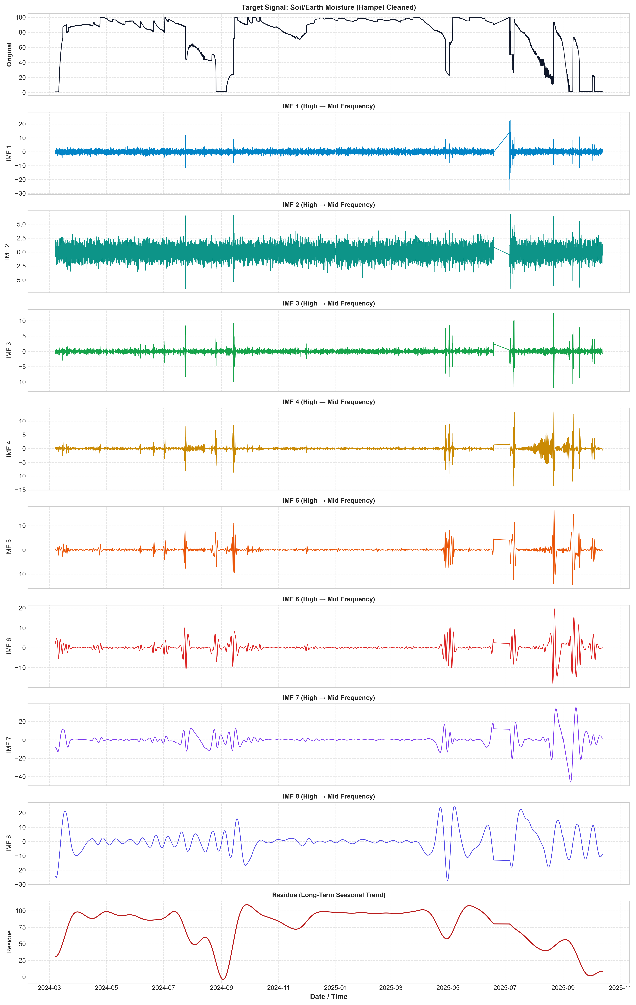

CEEMDAN_IMFS.png

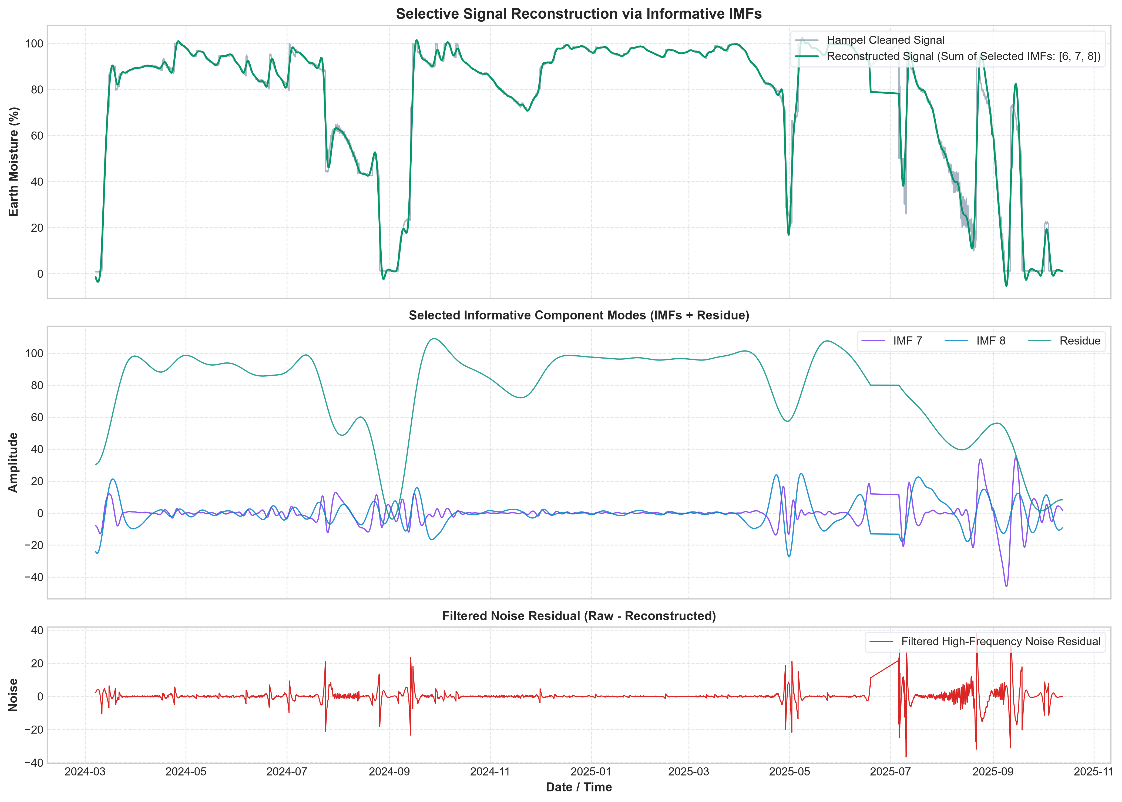

Signal_Reconstruction.png
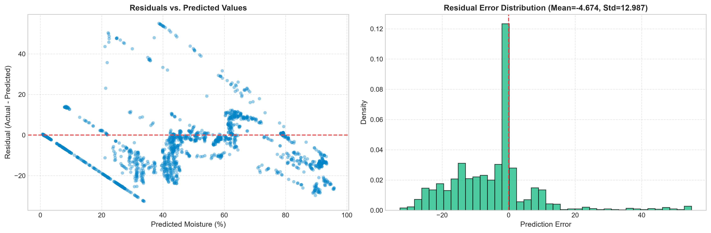

Residuals_Analysis.png
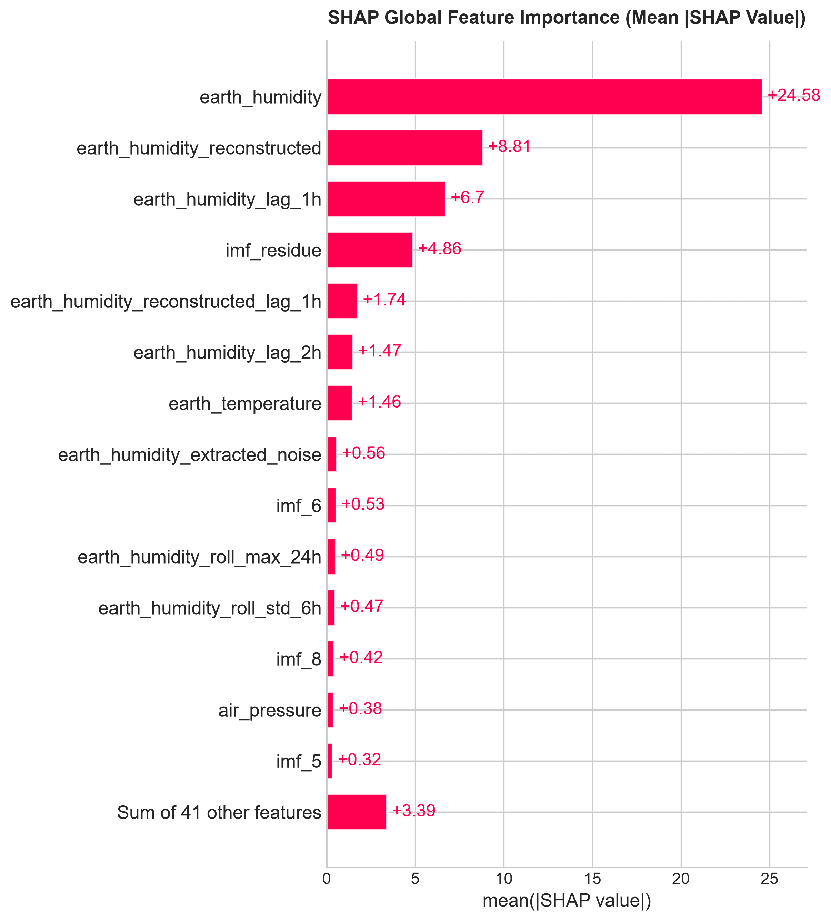

SHAP_Importance.png
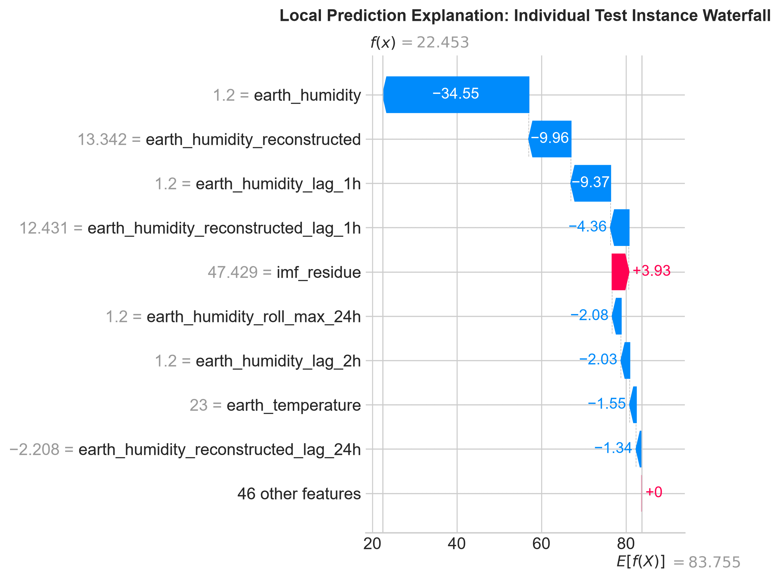

SHAP_Waterfall.png

Appendix B Team contributions and review progress

B.1 Individual contributions
Table B.1: Individual contributions
Member and registration number | Work completed | Evidence or deliverable
Monica Raghini Chelle, 2520040093 (Team Lead) | CEEMDAN decomposition and IMF selection; past-only CEEMDAN | Section 3.4, Figure 5.2, Table 5.2
Swarna Asritha, 2520040114 | Data preparation and Hampel filtering; noise and spike tests | Sections 3.2–3.3, Figure 5.1, Table 5.3
Dhanush Karthikeya, 2520040032 | LightGBM model and SHAP analysis | Section 3.4, Figure 5.3, Table 5.1

B.2 Review feedback and actions

Table B.2: Review feedback and actions
Review stage | Feedback received | Action taken and evidence
Zeroth review | Project scope too broad; clarify whether project requires physical hardware or algorithmic signal processing | Scoped as a software-only signal processing and machine learning pipeline for 24-hour-ahead soil moisture forecasting without hardware dependencies (Section 1.2 & Figure 1.1)
Review 1 | Dataset not clear | Specified the P18 BIORO weather-station data, 2024–2025 (Section 3.2)
Review 1 | Only the Hampel filter was shown | Built the full pipeline (Chapter 3)
Review 1 | Baselines only planned | Added four baselines on the same test data (Table 5.2)
Review 1 | Noise not tested | Tested noise and spikes (Table 5.3)
Review 1 (self-identified) | CEEMDAN had been run on the full data including the test part | Added a past-only version (Table 5.2)
Review 2 | Testing with abnormal data | Checked our demonstration with an abnormal dataset

