# Basics

## Retrieve the total number of orders placed.

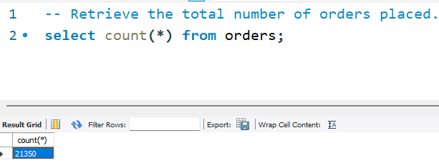

## Calculate the total revenue generated from pizza sales.

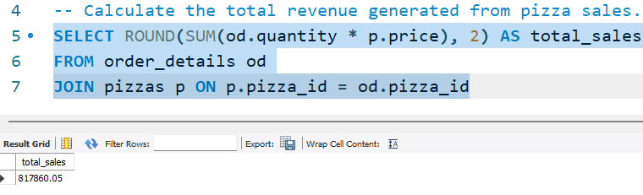

## Identify the highest-priced pizza.

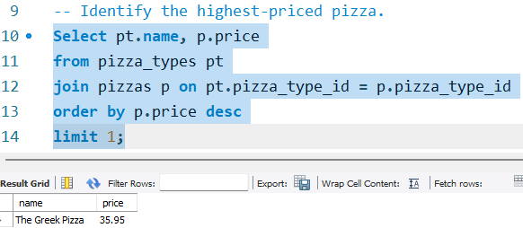

## Identify the most common pizza size ordered.

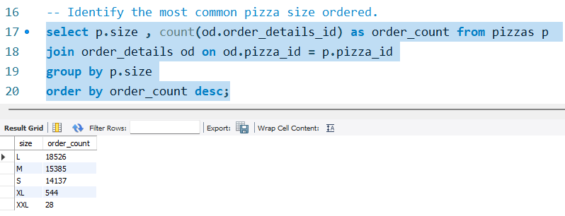

## List the top 5 most ordered pizza types along with their quantities.

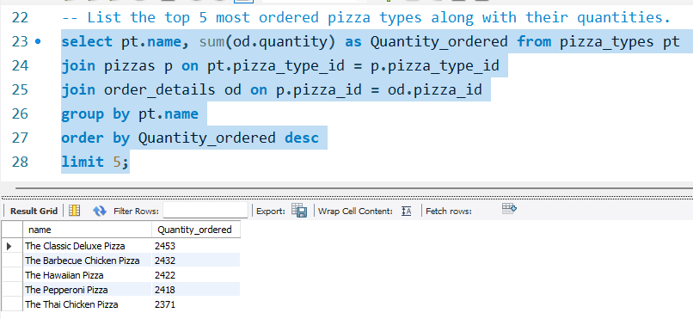

# Intermediate

## Join the necessary tables to find the total quantity of each pizza category ordered

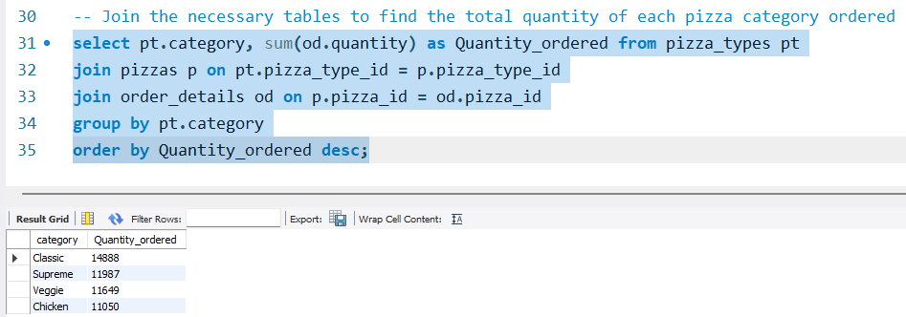

## Determine the distribution of orders by hour of the day.

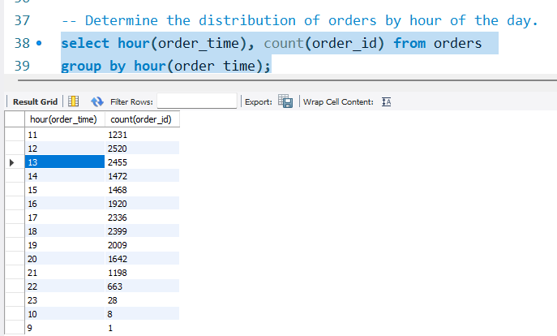

## Join relevant tables to find the category-wise distribution of pizzas

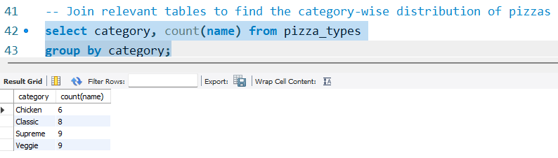

## Group the orders by date and calculate the average number of pizzas ordered per day.

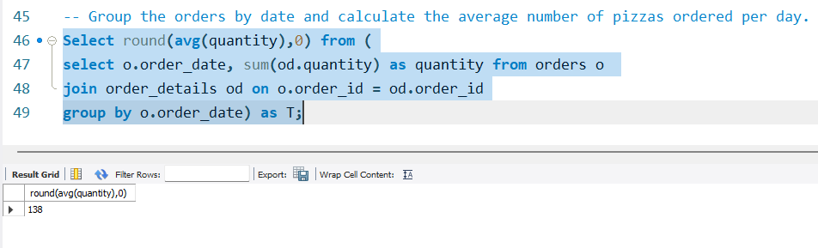

## Determine the top 3 most ordered pizza types based on revenue.

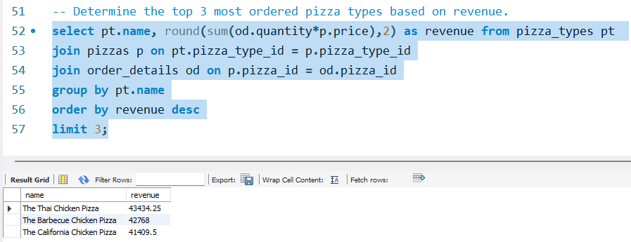

# Advanced

## Calculate the percentage contribution of each pizza type to total revenue.

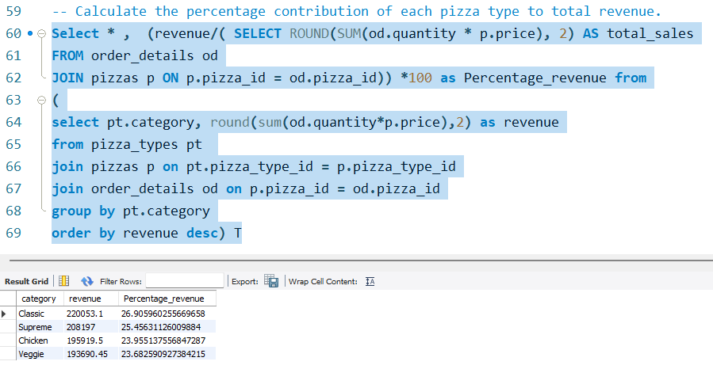

## Analyze the cumulative revenue generated over time.

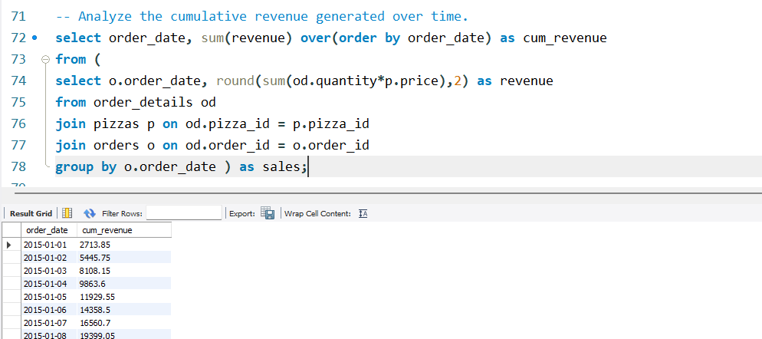

## Determine the top 3 most ordered pizza types based on revenue for each pizza category.

