Observations:

1. Of the selected drugs, Capomulin was the only one that reduced the size of the tumor  
   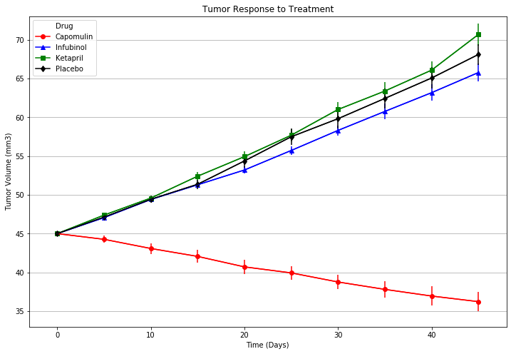
2. As you can see in the above graph and one the one below, Infubinol seems to have a better effect that doing nothing (a.k.a the Placebo)  
   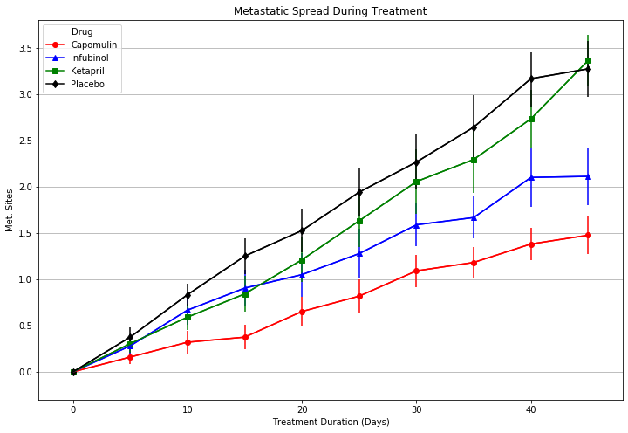
3. Although not part of the analysis, Ramicane also reduced the size of the tumor  
   