1. Max Temperature peaks around 0 Lat

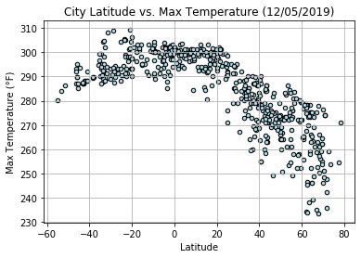

1. Not as clear as temperature, but near 0 Lat, there is a high percentage of Humidity, and it appears to drop off as you move further away  
   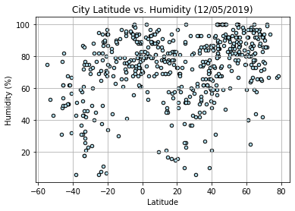
2. There doesn’t seem to be any correlation between Cloudiness or wind speed and Lat  
   