**Assignment 4 – Distributed Software Development**

- Sri Venkata Subramaniyan Arunagiri

**Question 1.1:**

Persons.xsd File: <http://webstrar5.fulton.asu.edu/page7/Persons.xsd>

**Question 1.2:**

Persons.xml File: <http://webstrar5.fulton.asu.edu/page7/Persons.xml>

**Question 1.3:**

Persons.xsl File: <http://webstrar5.fulton.asu.edu/page7/Persons.xsl>

Persons.html file: <http://webstrar5.fulton.asu.edu/page7/Persons.html>

Snapshot of the Persons.xml after the xsl :

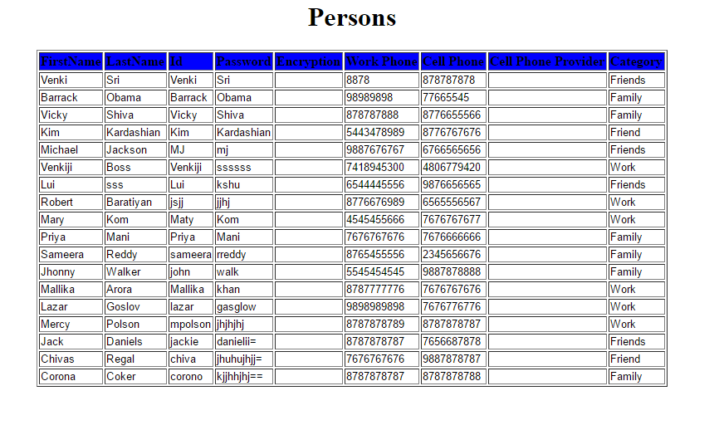

**Question 2.1 & Question 2.2:**

The web application and web services are deployed in webstar. Use the following URL to access the application and the web service.

http://webstrar5.fulton.asu.edu/page7/WebForm1.aspx - URL of Web App deployed in Webstar.

http://webstrar5.fulton.asu.edu/page8/Service.svc - URL of web service deployed in Webstar

(OR)

http://localhost:15698/Service.svc - Local Web Service URL.

http://localhost:19409/WebForm1.aspx - Local Web Application URL.

Extract the zip file Assignment4_1209374085.

The folder WebService has the webservice. Start the webservice.

The WebApp has the Web Application. Start the web Application. For ease of use both service and application are embedded in the same solution.

Please use the **localhost_15698.sln** file to run the application.

**TestCases**

2.2**XML to HTML Transformation**

**Without Error:**

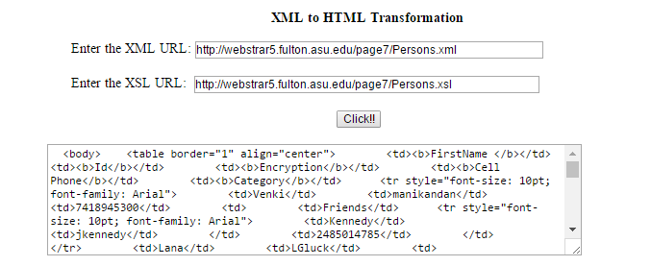

**With Error:**

The name of the xsd file is given wrong. The web service throws cannot find file exception

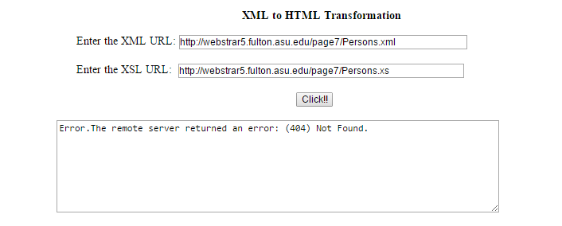

2.1 **Validate XML against XSD**

**Without Error:**

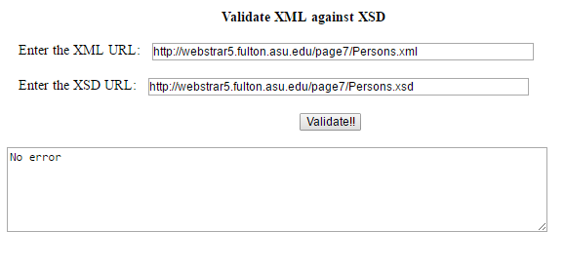

**With Error:**

When trying to validate Courses.xml against persons.xsd, the validation fails as the structure is totally different.

