* **Margin:-** Oru box ennoru boxkum ulla space
* **Border -** border
* **Padding -** text padding
* **Text -** text
* **Cursor**: https://www.w3schools.com/cssref/tryit.php?filename=trycss_cursor
* **Mouse over: -** when go the curser above text

If the mouse goes to the nearby button, it automatically comes with a hand symbol:.

input[type=”submit”]:hover

{

Cursor:pointer;

background-color:green;

}

output:



* Active- sudo class - when click the color change

a:active{

font-weight: bold;

color: chartreuse;

}

* **HTML Element**

<p> - tag in HTML

p {

text-align: center;

color: red;

}

* **HTML element with id="para1": - unique, space not come**

#para1 {

text-align: center;

color: red;

}

* **Class - we can use same class name for multiple element,**

.center {

text-align: center;

color: red;

}

* **<p> elements with class="center"**

p.center {

text-align: center;

color: red;

}

* **All HTML element**

* {

text-align: center;

color: blue;

}

* **Many elements**

h1, h2, p {

text-align: center;

color: red; }

* **Background Image**

p {

background-image: url("paper.gif");

}

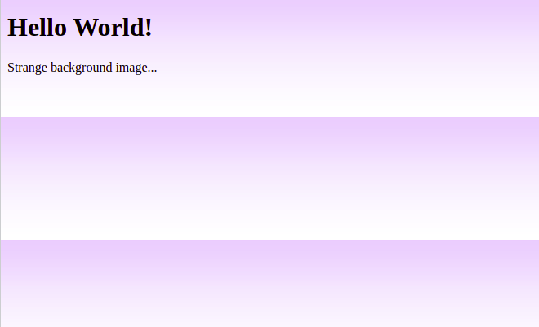

* **Repeat image:**

body {

background-image: url("gradient_bg.png");

background-repeat: repeat-x;

}

body {

background-image: url("gradient_bg.png");

background-repeat: repeat-x;

}

* **Border:**

<https://www.w3schools.com/css/css_border.asp>

* **Margin: - full div**

p {

margin-top: 100px;

margin-bottom: 100px;

margin-right: 150px;

margin-left: 80px;

}

* **Padding - contant div**

div {

border: 1px solid black;

background-color: lightblue;

padding-top: 50px;

padding-right: 30px;

padding-bottom: 50px;

padding-left: 80px;

}

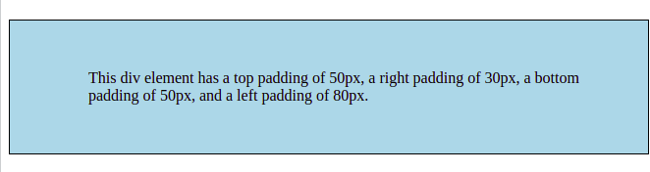

* **Text:**

<https://www.w3schools.com/css/css_text.asp>

* **border-radius: 1rem;**

Curve the box, rem - root em



* **padding: 5px 15px; -> space between button and text**
* **transition**: width 2s, height 4s;

Using mouse over width and height automatically increased

<https://www.w3schools.com/css/tryit.asp?filename=trycss3_transition2>

* #inputBox:focus {

border-color: blue;

}

If a click event happens that time that box will be increased or color changed like that.

<https://www.w3schools.com/cssref/tryit.php?filename=trycss_dim_width_inputfocus>

* **flex-direction: column;**

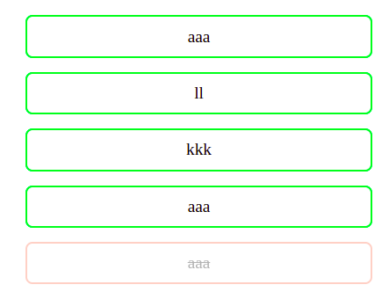

* **flex-direction: row;**

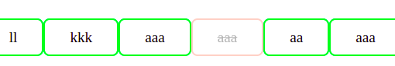

* **word-wrap: break-word;**

Break the word

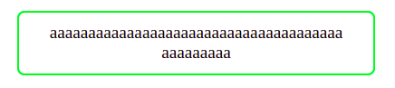

* **Opacity**

dullness

**Selectors**:

<div class="section1">

<h1 id=”h1_1”>Mithra</h1>

<h2 id=”h2_2”>Muthu</h2>

<h1 id=”h1_1”>M</h3>

<h3 id=”h3_3”>M</h3>

<div>

<h1 id=”h1_1”>Mithra</h1>

</div>

</div>

* **.section1 h1 -(desentant and child)it is selected the under the class(**class="section1"**) h1**

It is all the h1 node under the .**section1**

* **.section1 > h1 ->(child) select h1 node child of .section1**

Child h1 node only select

* **h1 + h2**  ->(first sibling) h1 first sibling, take the h1 styles in h2
* #h1_1 ~ h2 ->(all sibling) all sibling, #h1_1 - take code, h2 - apply following all h2, ~ all sibling
* **display: block;** -> column -> It take size of contant

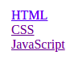

* **display: inline;** -> row



* **display: none;** ->hide the content
* Priority:

1. !important
2. Inline style
3. Id
4. Class
5. Element name

* **Tracfic light:**

.card {

height: 250px;

width: 80px;

border-radius: 20px;

background-color: black;

padding: 15px;

}

.card1 {

height: 40px;

width: 40px;

border-radius: 40px;

background-color: #4b5069;

margin-bottom: 40px;

}

* **background-color: lightblue;**
* **background-image: url("paper.gif");**
* **background-position: center;**
* **background-repeat: no-repeat;**
* **overflow-x: scroll;**
* **overflow-y: scroll;**
* **margin-top: 10px;**
* **margin-bottom: 100px;**
* **margin-right: 150px;**
* **margin-left: 10px;**
* **text-decoration: underline;**
* **text-decoration: line-through; -** delete line
* **text-decoration-**<https://www.w3schools.com/cssref/tryit.php?filename=trycss_text-decoration>
* **Text-transform**-><https://www.w3schools.com/cssref/pr_text_text-transform.php>
* **Display** ->https://www.w3schools.com/cssref/pr_class_display.php
* **H1::first-letter**