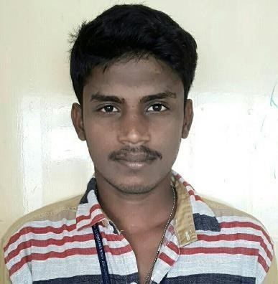

**R.MUTHU**



**PANDI**



79 SOUTH STREET



AMMAPURAM



**Email: asrmuthu57 @gmail.com**



ALAZAPURI PO



.



**Contact no: 7904688429**



THENI . 625523.



**CAREER OBJECTIVE:**

* I want to be part of the success in an environment of growth and excellence. And I want learn new things day by day.

**ACADEMIC PROFILE:**

|  |  |  |  |  |
| --- | --- | --- | --- | --- |
| **Course** | **Name of School / College** | **Board/University** | **Percentage /**  **CGPA** | **Year of**  **passing** |
| B-TECH(IT) | ANNA UNIVERSITY  (BIT CAMPUS), TRICHY. | Anna University | 61 | 2017 |
| HSC | DEVANGER HIGHER SECONDARY  SCHOOL, CHINNALA PATTI | State Board | 85 | 2013 |
| SSLC | DEVANGER HIGHER  SECONDARY SCHOOL,  CHINNALA PATTI. | State Board | 96 | 2011 |

**SKILLS:**

* LANGUAGES AND SKILS: XML, XSLT, CSL, XSL-FO, XHTML,XPP**.**
* AGILE METHODOLOGY
* I AM INTERESTED TO LEARN NEW TECHNOLOGIES.

**TOTAL WORKING EXPERIENCES:** **4 Years**

**ORGANIZATIONS**

**1 .RR DONNELY**

**Designation**  : Document Specialist

**Project name** : Xyvision

**Project** **detail** : XML to PDF conversion using XSLT and XPP.

**Skills** : XML,XSLT,HTML5,XPP.

**Industry** : Publishing, Finance.

**Duration** : Dec 2017 – June 2019

**2. SPS**

**Designation** : Senior Programmer.

**Project name** : COAST

We created a tool to support clients and sps production team. The tool is mainly working on xml to client xml, xml to pdf, Docx to pdf, Html to Pdf.

**Skills** : XML,XSLT,XSL FO,CSL,XHTML.

**Industry** : Publishing.

**Clients** : Springer, Wiley.

**Duration** : June 2019 – Present.

**PERSONAL DETAILS:**

Name : R MUTHU PANDI

Father’s name : S.RAJ

DOB :19-11-1995

Sex : Male

Mother tongue : Tamil

Nationality : Indian

Positives : Self-Motivator, never-die-attitude

Languages known : Tamil, English.

Hobbies : Bike ride, Reading Newspaper, Cricket

**DECLARATION:**

I hereby declare that the information furnished above is true to the best of my knowledge.

Date: Yours obediently,

Place: (MUTHU PANDI)