**DATABASE:**

* show databases;
* 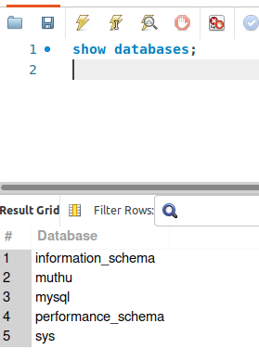
* drop database;
* create database muthu;
* create table users(ID INT NOT NULL AUTO_INCREMENT, NAME VARCHAR(50) NOT NULL, AGE INT NOT NULL, primary key(ID));
* show tables;
* 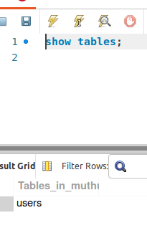
* describe users;
* 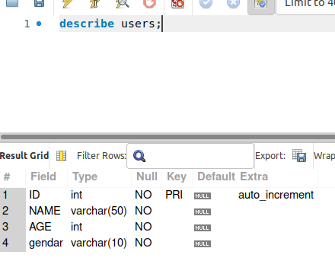
* alter table users add gendar varchar(10) NOT NULL AFTER AGE;
* describe users;
* **Add columns**
* alter table users add city varchar(100) not null, add contact varchar(50) not null;
* **Modify**
* alter table users modify contact varchar(25) not null;
* **Change the table name;**
* alter table users rename to students;
* select * from students;
* 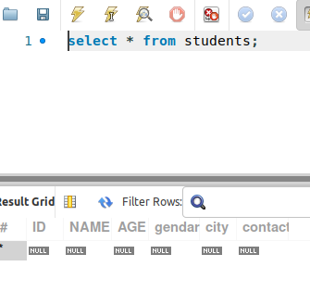
* INSERT the values
* insert into students values (null, 'muthu', 25,'male', 'salam','7904688429');
* 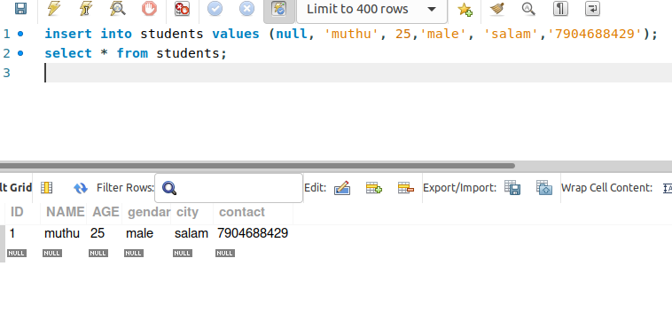
* **Delete:**
* delete from students where not(id=1);
* delete from students where id=1;