Python

Python is an interpreted high-level general-purpose programming language. It is beginner language because it was easy to learn.

Using:dropbox, google file sharing and youtube.

Complier: motha programyum eduthu check panni error irukanu sllum.

Compiler takes entire program as input intermediate object code is generated errors are displayed program is checked.

Interpreter-மொழிபெயர்ப்பாளர்

it takes single instrcution as input. 7line error na 7th line mattum vittatu matha ella lineyum execute pannum. Line by line execute pannum.

*)Add two numbers:

**Code:**

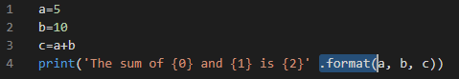

**Output:**



*)Numbers:

