**MSP430F6636 BSL Bootloader User Guide**

**Introduction**

The MSP430F6636 BSL (Bootloader) is a small piece of software that is responsible for starting up the MSP430F6636 microcontroller and loading the operating system. The BSL is stored in non-volatile memory, such as ROM or flash memory, so that it is always available even when the system is turned off.

The BSL can be used to program the MSP430F6636 microcontroller using a variety of communication interfaces, such as UART, USB, and I2C. This makes it easy to update the firmware on the microcontroller without having to remove it from the system.  
  
Here's a more detailed explanation of the process of using the TI UART bootloader on the MSP430F6636 board:

## **Creating the Firmware Binary File:**

* Open the TI Code Composer Studio (CCS) IDE.
* Compile the bootloader MSP430F6636 BSL Project and flash it through MSP- FET Debugger.

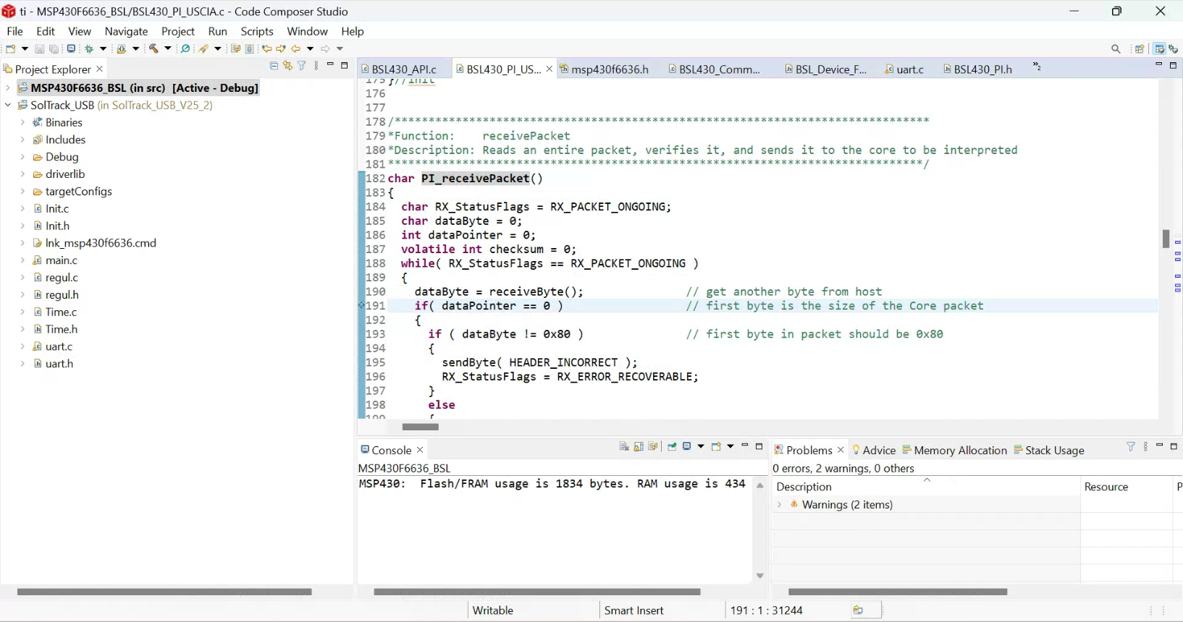

* Write or import the firmware code for your application.
* Build the project to generate the firmware binary file. This file typically has a .hex or .bin extension.

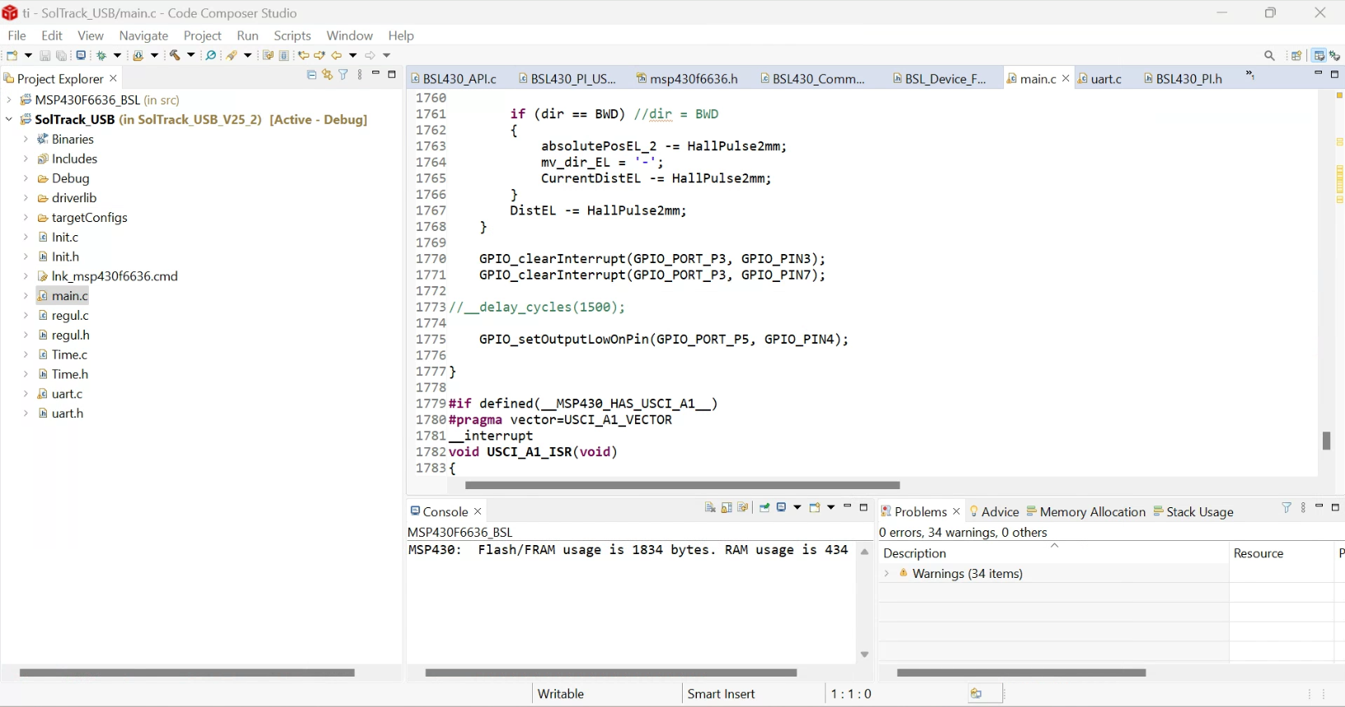

## **Sending the Firmware Binary File to the MSP430F6636 Board:**

* Connect the MSP430F6636 board to a computer using a USB-to-UART converter.
* Install a UART communication program on the computer. Several free and commercial options are available, such as Tera Term, PuTTY, or HyperTerminal.
* Open the UART communication program and configure it to communicate with the MSP430F6636 board. Set the baud rate to 9600 bps, data bits to 8, parity to none, and stop bits to 1.
* Try communicating with the already present software if the RS-485 is working fine or not.
* [BSL Scripter](https://software-dl.ti.com/msp430/msp430_public_sw/mcu/msp430/MSPBSL_Scripter/latest/index_FDS.html) from TI is used to flash the firmware file such .bin or .hex file.
* Open command prompt and run BSL scripter present in the given location:

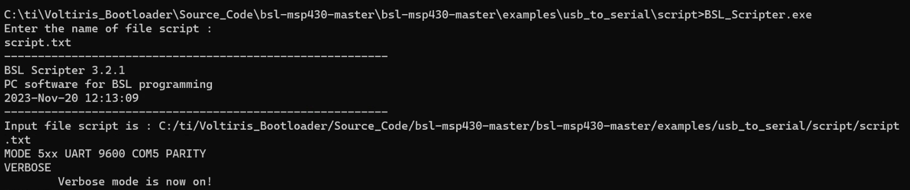

* Please provide the script.txt file after executing the BSL scripter, including the reference to our firmware file.
* In the script file, we need to substitute the firmware name wherever .txt files are referenced.  
   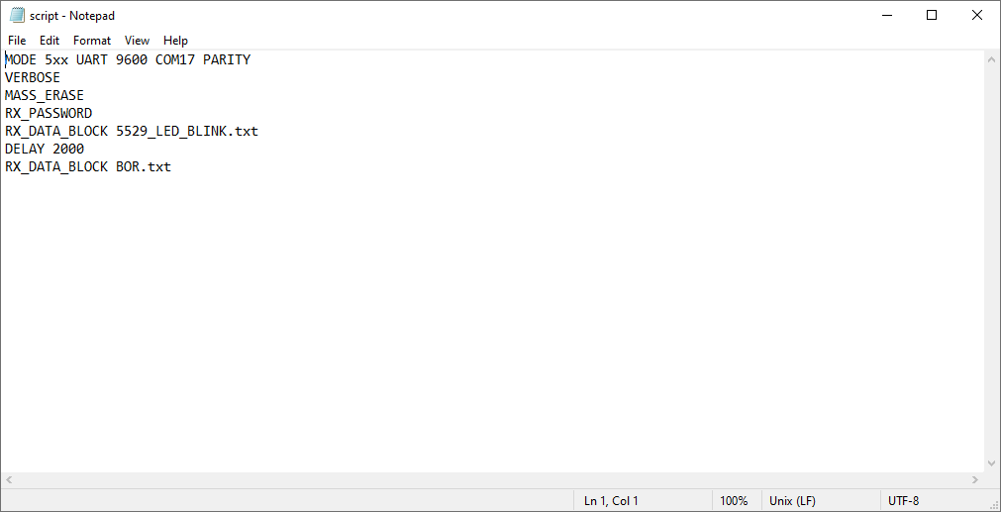

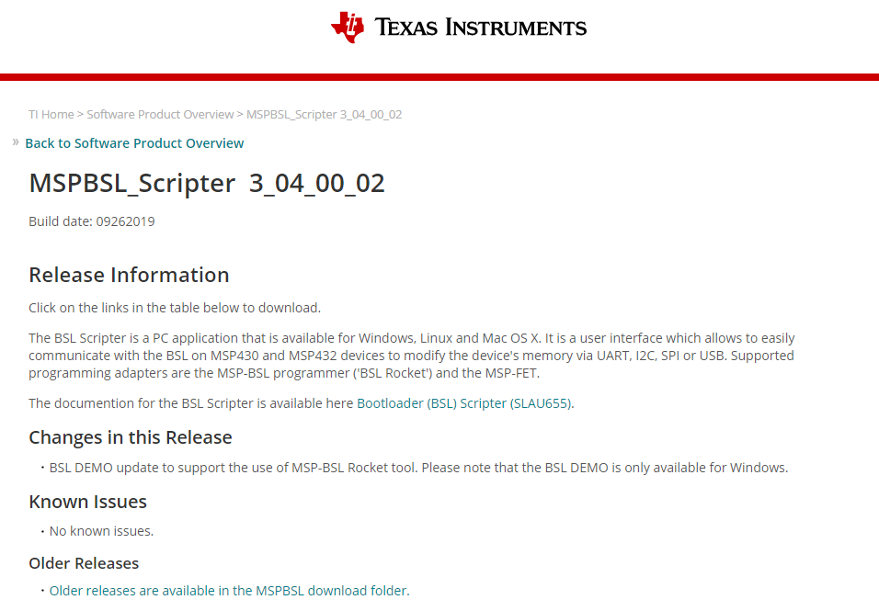

## **Verifying the Firmware Update:**

* After sending the firmware binary file, observe the output in the UART communication program. The bootloader should display messages indicating the progress of the firmware update process on the BSL Scripter.
* Once the firmware update is complete, the bootloader should display a message indicating successful completion.
* To troubleshoot an unsuccessful completion, verify the RS-485 connection and ensure proper communication is established.
* Alternatively, confirm that you've flashed the accurate BSL firmware; otherwise, the firmware won't be properly installed.
* The expected result should resemble this:   
    
  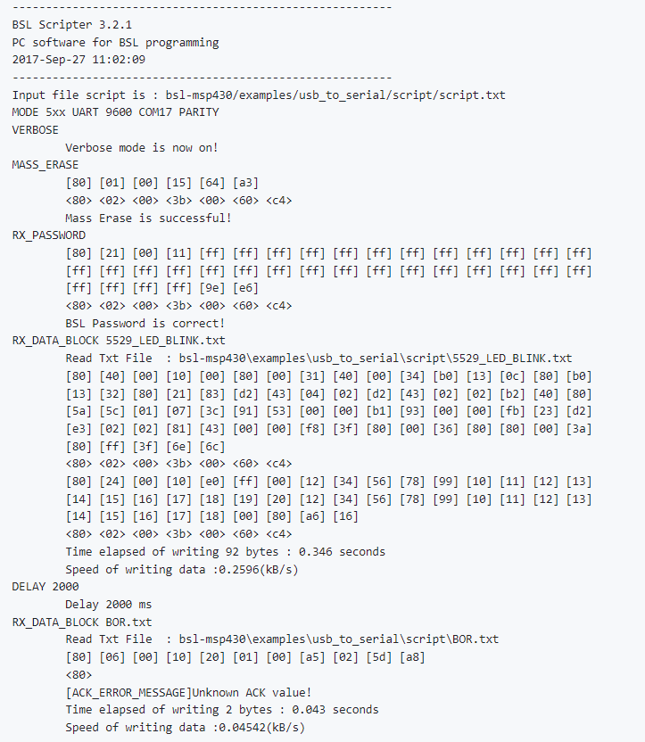

**Update Process in a Network:**

* If you have multiple devices on the RS-485 bus, you will typically need to update each device individually. The programming tool communicates with each device on the bus and updates its firmware.
* It's crucial to handle this process carefully to avoid disruptions in the network. You might implement a mechanism to ensure that devices are updated in a synchronized manner.

**How to use the BSL**

To use the BSL to program the MSP430F6636 microcontroller, you will need a bootloader utility program. There are a number of bootloader utility programs available, both commercial and open source.

Once you have a bootloader utility program, you can connect the MSP430F6636 microcontroller to your computer using the appropriate communication interface. Then, you can use the bootloader utility program to load a firmware image onto the microcontroller.

**BSL commands**

The BSL supports a number of commands that can be used to control the bootloader and load firmware. The following table lists some of the most common BSL commands:

|  |  |
| --- | --- |
| Command | Description |
| BSL_CMD_GET_VERSION | Returns the version of the BSL. |
| BSL_CMD_GET_ID | Returns the ID of the MSP430F6636 microcontroller. |
| BSL_CMD_ERASE | Erases the flash memory of the MSP430F6636 microcontroller. |
| BSL_CMD_PROGRAM | Programs the flash memory of the MSP430F6636 microcontroller with a firmware image. |
| BSL_CMD_VERIFY | Verifies that the flash memory of the MSP430F6636 microcontroller contains the correct firmware image. |

For more information on the BSL commands, please consult the MSP430F6636 BSL datasheet, which is available for download from the Texas Instruments website.

**Troubleshooting**

If you are having problems using the BSL, please consult the MSP430F6636 BSL datasheet or the documentation for your bootloader utility program. You can also contact Texas Instruments support for help.

**Conclusion**

The MSP430F6636 BSL is a powerful tool that can be used to program the MSP430F6636 microcontroller using a variety of communication interfaces. This makes it easy to update the firmware on the microcontroller without having to remove it from the system.