MyFirstRMarkdown

As Salik

5/5/2021

# My First R Markdown

## Introduction

**Markdown** is a very basic and easy-to-use syntax for styling written documents. It’s very easy to make some words **bold** and other words *italic* with Markdown. You can even [link to FCSIT](https://fsktm.um.edu.my/)!

**Here is a code chunk and it prints the code and result.**

set.seed(1)  
x <- rnorm(100)  
mean(x)

## [1] 0.1088874

*Here is a code chunk but it only print the result.*

## [1] -0.1365489

Here is a code chunk but it doesn’t print anything!!!

Inline text computation

### The current time is Wed May 05 1:06:17 PM 2021.

summary(cars)

## speed dist   
## Min. : 4.0 Min. : 2.00   
## 1st Qu.:12.0 1st Qu.: 26.00   
## Median :15.0 Median : 36.00   
## Mean :15.4 Mean : 42.98   
## 3rd Qu.:19.0 3rd Qu.: 56.00   
## Max. :25.0 Max. :120.00

You can also embed plots, for example:

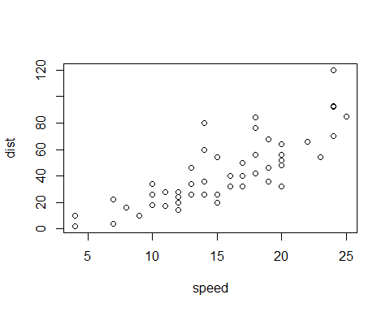 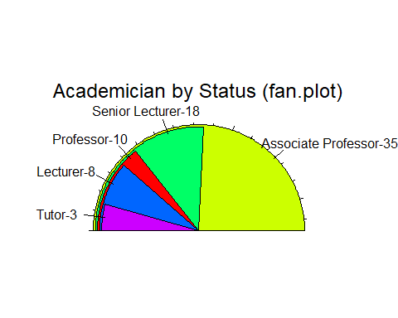

Taman_Bunga: 

|  |  |
| --- | --- |
| Subject | Credit Hour |
| Philosophy | 2 |
| Information Literacy | 2 |
| Social Engagement | 2 |
| Data Structure | 5 |
| Computer System and Architechture | 3 |
| Machine Learning | 3 |
| Intro to Data Science | 3 |

Note that the echo = FALSE parameter was added to the code chunk to prevent printing of the R code that generated the plot.