*install wamp server for windows

*After installation you can see wamp or wamp64 folder in C-Drive

*Go inside wamp64/www and paste the esign-php code.

*Restart the wamp server

Note - This is develop and tested on PHP7.4 version. So select and set php7.4 in your wamp server.

*Now, Install Imagick.dll.exe from below link

<https://fossies.org/windows/misc/ImageMagick-7.1.0-16-Q16-x64-dll.exe/>

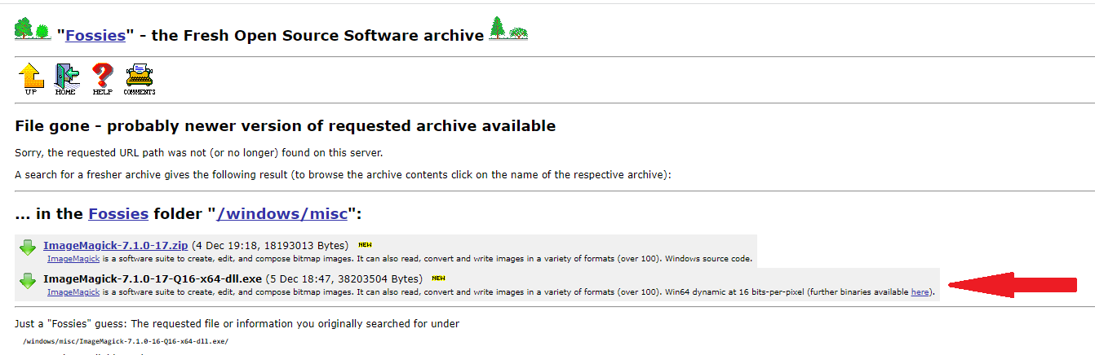

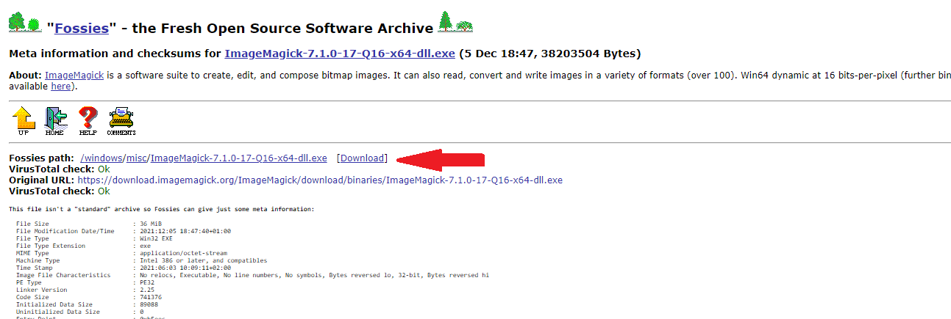

*downalod dll from this below link

https://shouts.dev/how-to-install-imagemagick-php-ext-on-windows (Follow the link and download imagic latest version accoring to your PHP version7.4)

like this - <https://pecl.php.net/package/imagick/3.6.0/windows>

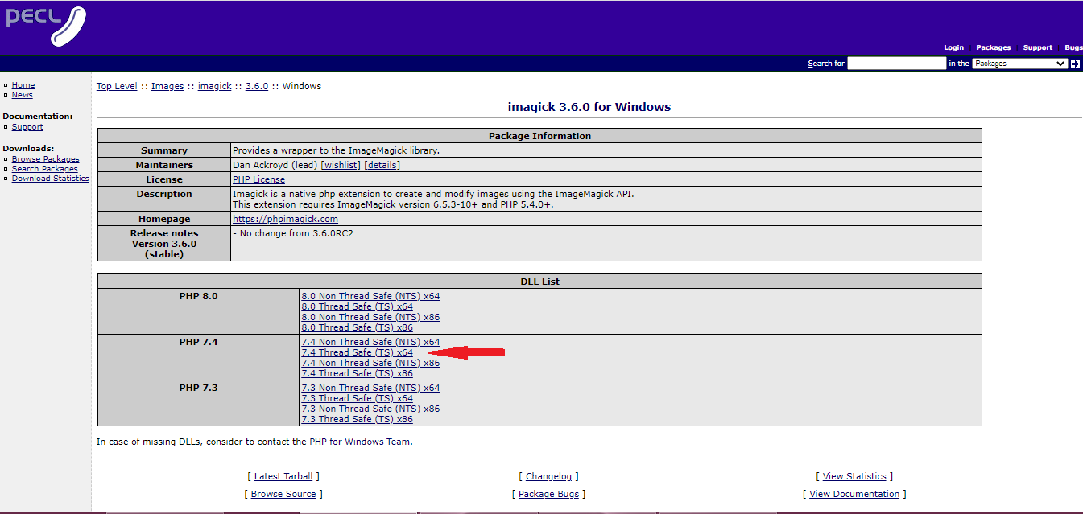

*extract the zip folder, copy extension=php_imagick.dll and paste into following path wamp/bin/php/php_7.4/ext

* Open wamp/bin/php/php_7.4/php.ini file and search for extension word and then paste this text -> extension=php_imagick.dll (i have added on line no 954)

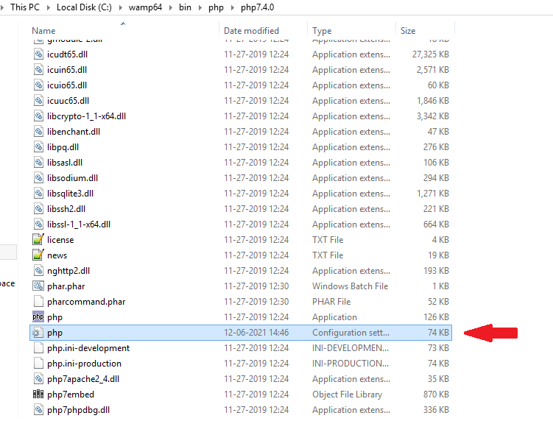

*then restart wamp server, and go to php.ini of wamp server and search for extension word and then paste this text -> extension=php_imagick.dll 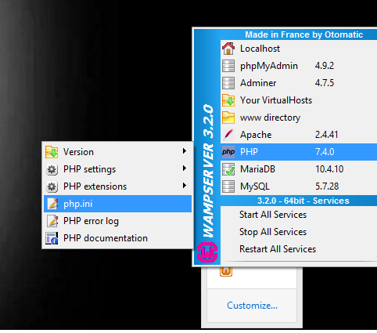

* If you are using Windows platform then you need to install GhostScript exe to work on PDF signing.
* Use following link to download the GhostScript.exe

<https://github.com/ArtifexSoftware/ghostpdl-downloads/releases/download/gs9550/gs9550w64.exe>

* After all the installations done,

Go-to chrome browser and type localhost/esign/index.php and enter – you will directly navigate to the Adhar number entry screen, it means your image/pdf file is read by the system for the signing operation.

* The path for attachment of image/pdf file is hardcoded in wamp/www/esign/config.php file.