CHAPTER 02 CABLES

II.1. Introduction

II.2. Characteristics and working mode of a cable

II.3. Cable subjected to concentrated loads

II.4. Cable subjected to a uniform horizontally distributed load

II.5. Cable under its own weight

II.6. Application to the suspended bridge

II.7. Problems

II.1. Introduction
Cables are important and efficient structural elements that primarily carry loads through tensile forces. Their high tensile strength and relatively low self-weight make them widely used in suspension and cable-stayed bridges, roofs, towers, elevators, cable cars, and lifting equipment.
From a structural point of view, an ideal cable is assumed to be perfectly flexible and inextensible. It cannot resist bending, shear, or compression ; therefore, the internal force is always tensile and tangent to the cable at every point. The shape of a cable depends on the applied loads and the support conditions.
Depending on the loading conditions, different cable configurations may be obtained. This chapter considers cables subjected to concentrated loads, uniformly distributed loads along the horizontal projection, and uniformly distributed loads along the cable itself. Although these loading conditions produce different cable geometries, their equilibrium can be established using the fundamental principles of statics. The relationships between the applied loads, support reactions, tensile forces, cable slope, and geometry are developed accordingly.
The analysis of cables is essential for determining support reactions, internal tensile forces, cable profiles, slopes, and displacements. The chapter also establishes relationships between the horizontal component of cable tension, the internal forces, the cable geometry, and its total length. Finally, the influence of cable elasticity is considered when the assumption of inextensibility is relaxed.
These concepts provide a fundamental basis for understanding and analyzing cable-supported structures in civil and structural engineering.
II.1.1. Pedagogical Objectives
Upon completion of this chapter, students will be able to :
- Define a structural cable and explain its fundamental mechanical role in a structural system.
- Identify the main applications of cables in civil engineering, including suspension and cable-stayed bridges, suspended roofs, guyed towers, and overhead transmission lines.
- Explain the mechanical behavior of an ideal cable and understand why it carries only axial tension with zero bending moment ((M=0)).
- Establish and apply the fundamental equations governing cable equilibrium and geometry under different loading conditions.
- Analyze cables subjected to concentrated vertical loads using equilibrium equations at discrete points.
- Determine the cable profile, sag, horizontal tension (H), and maximum tension (Tmax) for different types of distributed loading, including the parabolic and catenary configurations.
- Determine support reactions and analyze different cable support configurations, such as pulleys, saddles, and roller supports.
- Apply cable analysis principles to the preliminary sizing and structural assessment of practical cable-supported systems.

II.2. Characteristics and Working Behavior of a Cable
Cables have several specific characteristics that distinguish them from conventional structural members.
II.2.1 Characteristics of cables
II.2.1.1 High Strength-to-weight ratio
One of the main advantages of cables is their high tensile strength compared with their relatively low weight. This characteristic makes them particularly efficient for structures subjected mainly to tensile forces and for applications involving long spans.
II.2.1.2 High tensile strength
Cables are manufactured from high-strength steel wires. Depending on the steel grade and cable construction, high strength classes can be obtained.
The cable catalog specifies, for example, standard steel grades of approximately:
- 1770 N/mm²;
- 1960 N/mm²;
- 2160 N/mm².
These values correspond to the nominal tensile strength classes of the steel used for the cable wires.
II.2.1.3 Flexibility
A cable has a very small diameter compared with its length. Consequently, it is highly flexible and can adapt to curved configurations under loading.
The flexibility of a cable depends on several factors, including:
- The number of strands;
- The number and diameter of wires in each strand;
- The type of core;
- The arrangement of the wires;
- The lay direction ;
- The cable construction.
Different cable constructions are therefore selected according to the required degree of flexibility and the type of service.
II.2.1.4 Ductility and elongation
Steel cables are manufactured through processes such as wire drawing, which influence their mechanical behavior. Their elongation characteristics therefore differ from those of conventional structural steel members.
Cable selection must take into account the expected elongation under service loading, particularly in applications where deformation can significantly influence the structural response.
II.2.1.5 Resistance to wear and fatigue
Cables may be subjected to repeated bending, vibration, shocks, and changes in curvature during service. These effects can lead to wire wear and fatigue.
The required properties depend directly on the application and operating conditions.

II.2.2 Construction of a steel wire rope (For more details, please refer to the PDF link. : https://drive.google.com/file/d/1eQQlNRZF6_IiOx3F-8NP_myZgcpr6Dph/view?usp=sharing)
A steel wire rope is composed of three main components as shown in Fig 1 :
- a central core;
- several strands arranged around the core;
- steel wires forming each strand.
A common construction consists of a central core surrounded by six or eight outer strands. The rope construction depends on the number of strands, number and arrangement of wires, core type, direction of lay, and steel grade.
Key terminology

French | English | Meaning
Fil | Wire | Small steel element
Toron | Strand | Group of several wires
Âme | Core | Central supporting element
Câble | Wire rope | Complete assembly

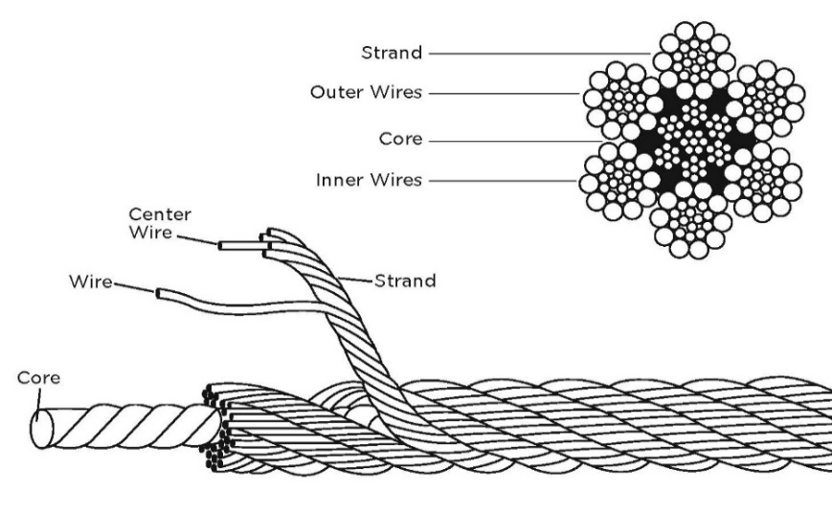

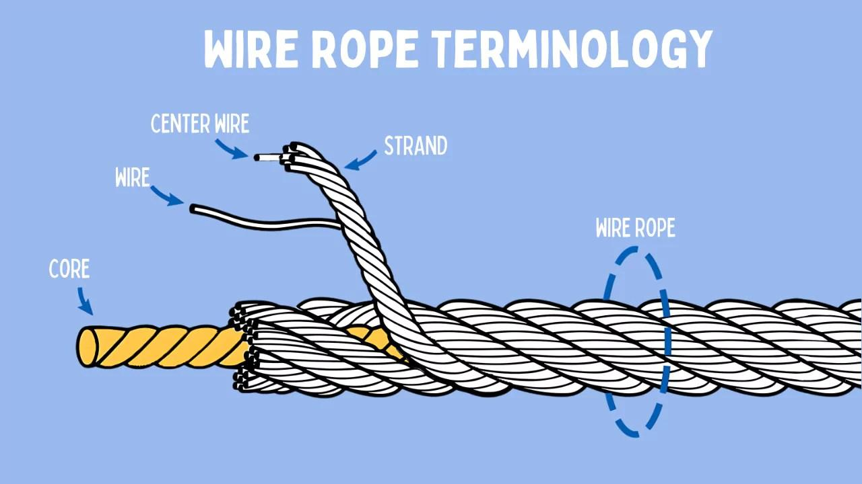

Fig 1. Wire rope terminology.
II.2.2.1 Different types of wire ropes: construction and applications
- Galvanized Aviation-Type Wire Ropes — 6×19 and 7×19
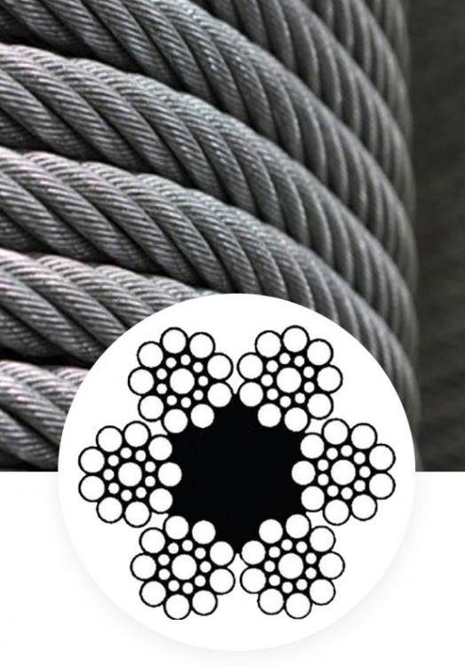
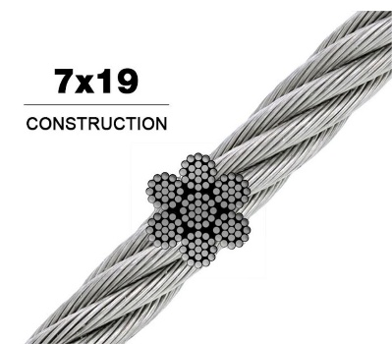
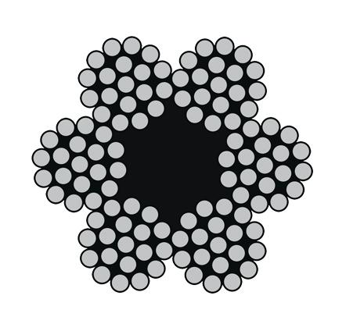
- Figure A — Construction

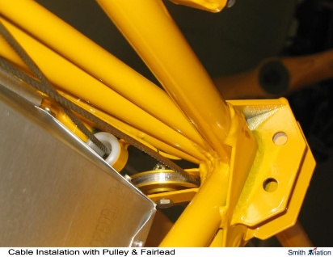
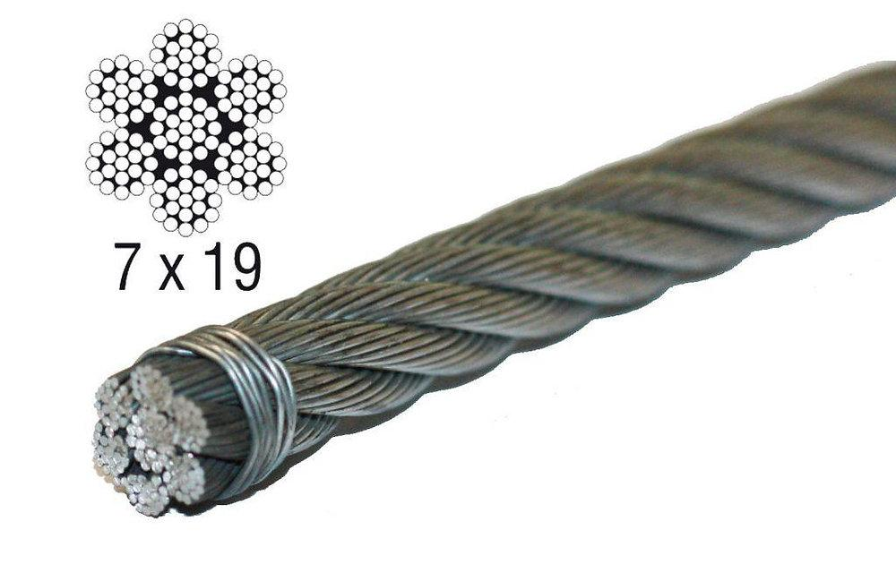
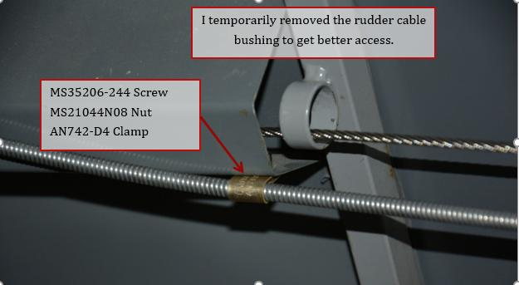
- Figure B — Main Applications

Fig.2 — Câbles galvanisés type aviation : construction 6×19 / 7×19 et exemples d’utilisation.
- Classe 6×19 — EN 12385-4
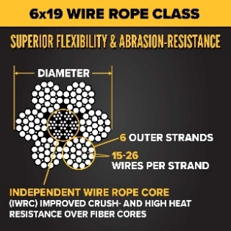
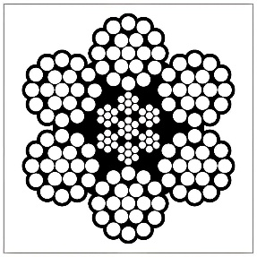
Figure A — Construction 6×19
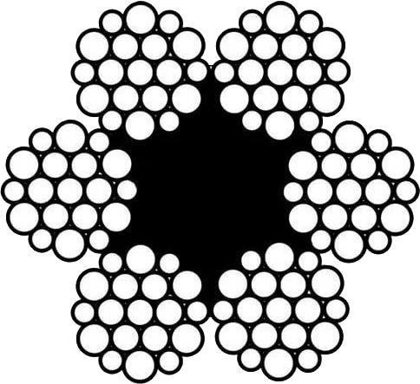

Figure B — Applications: Cranes, Winches, and Logging
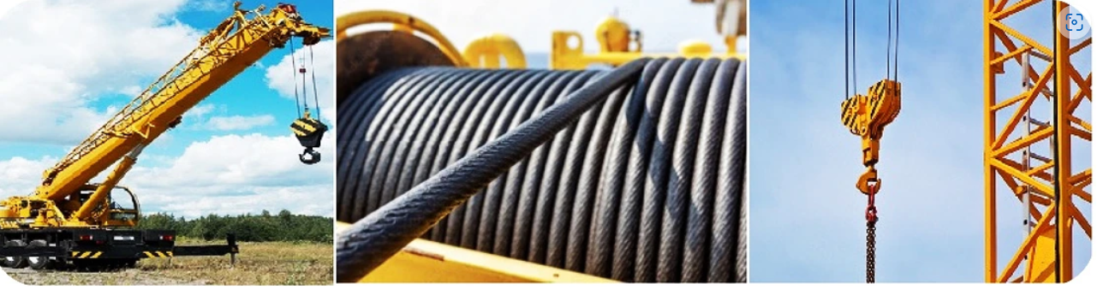

Fig.3 — 6×19 Wire Rope : Construction and Lifting/Winching Applications.
- Classe 6×36 — EN 12385-4
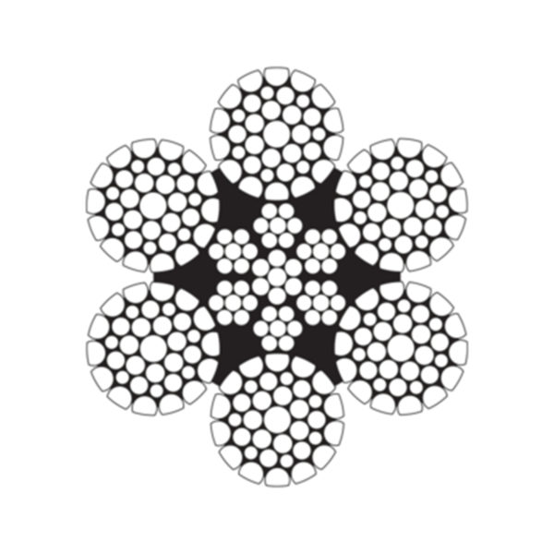

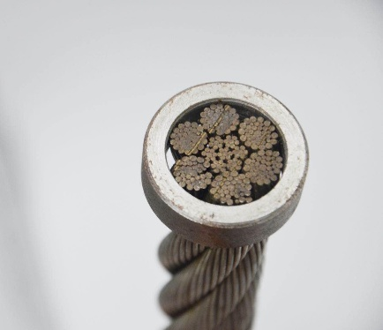
Figure A — Construction 6×36

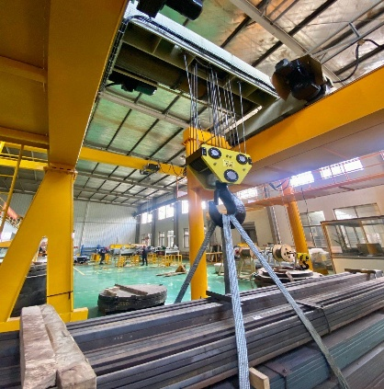
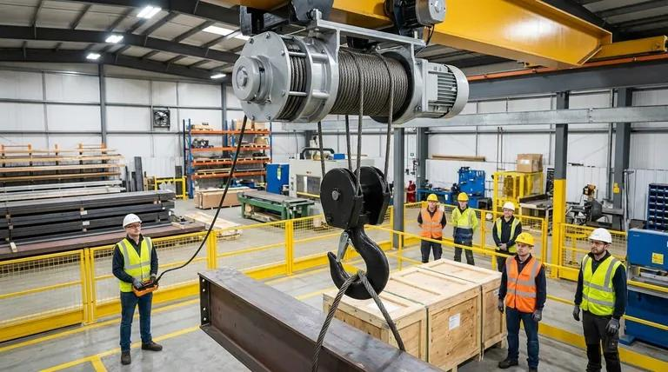
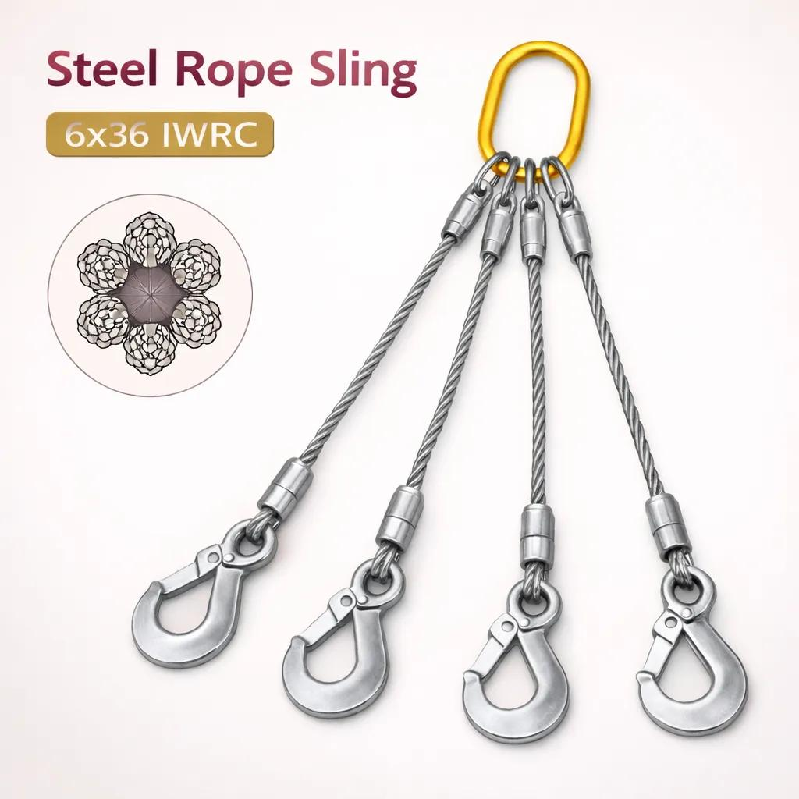
Figure B — Applications: Slings and Lifting
Fig.4 — 6×36 Wire Rope : Flexible Construction and Lifting Applications.
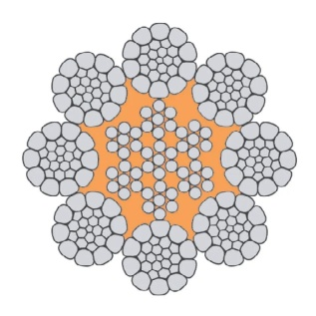
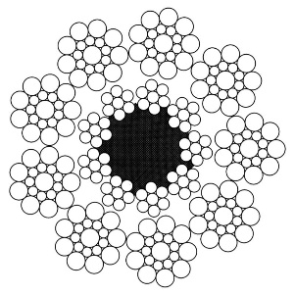
- Compacted 8×19 and 8×36 Wire Ropes
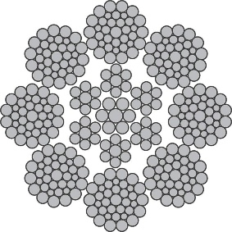

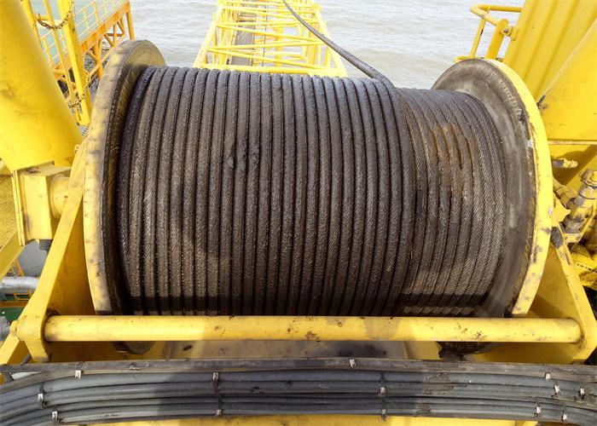
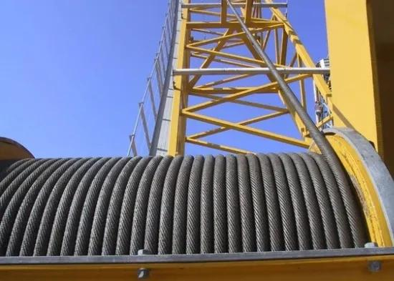
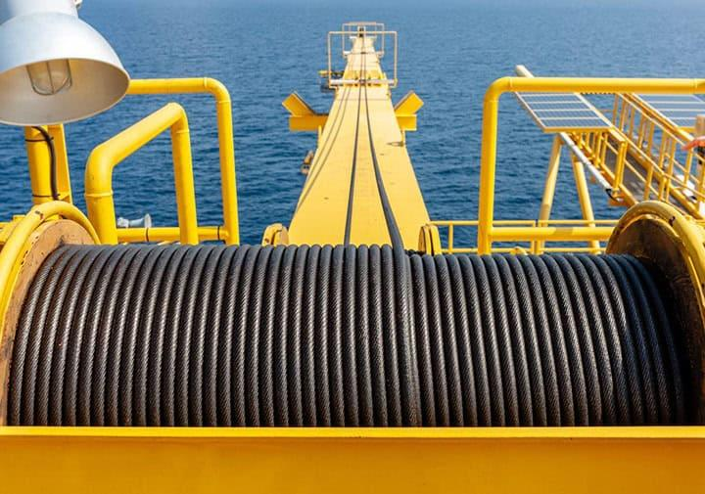
Figure B — Applications on Drums / Cranes
Fig.5 — Compacted Wire Rope: Modified Strand Geometry and Applications in Lifting Equipment.
- Rotation-Resistant Wire Ropes — 17×7, 18×7, 19×7
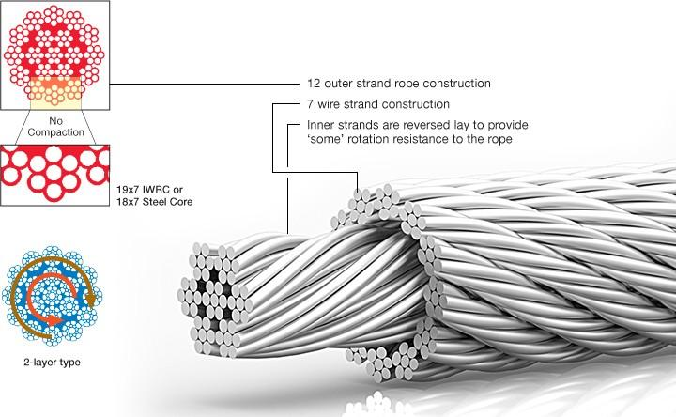
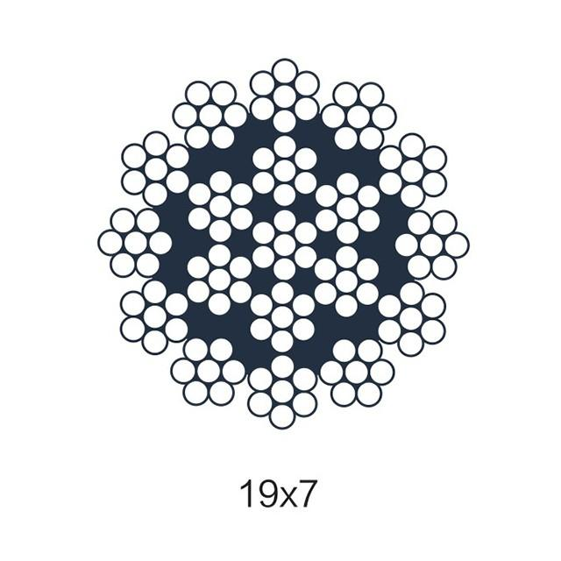
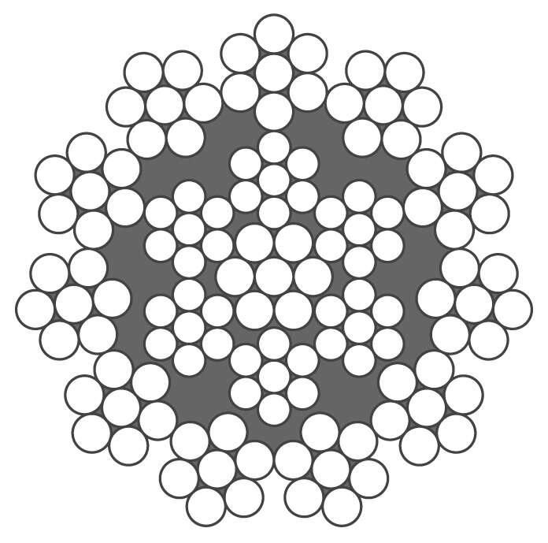
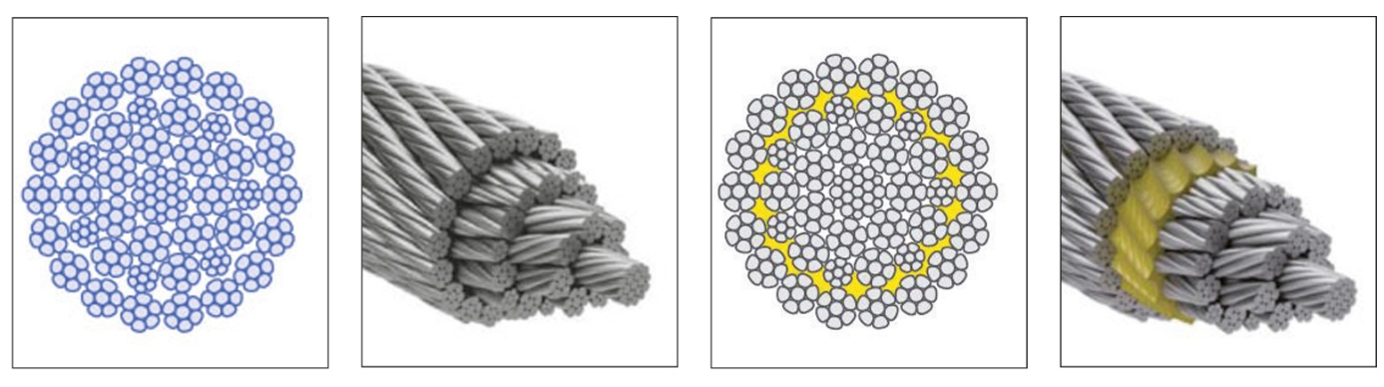
Figure A — Construction
- Locked-Coil Wire Ropes
Applications:
- Suspension bridges
- Stay cables
- Dynamic applications may be considered under certain conditions
Construction:
- One or more layers of Z-shaped wires
- Several configurations:
  - Single layer of Z-shaped wires
  - Two layers of Z-shaped wires
  - Multi-layer Z-shaped wires
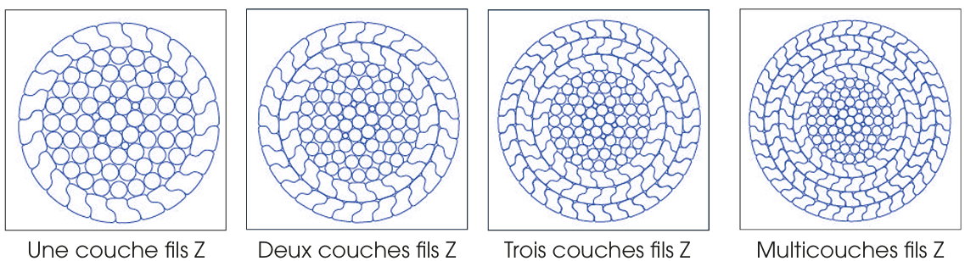
Figure A — Construction : Single-, double-, and multi-layer Z-shaped wire configurations

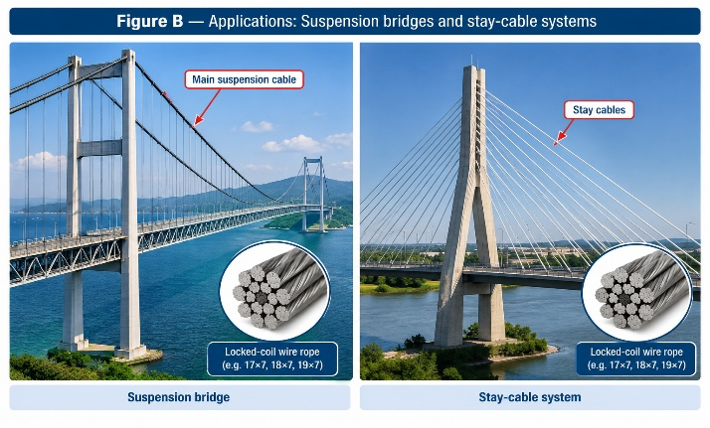
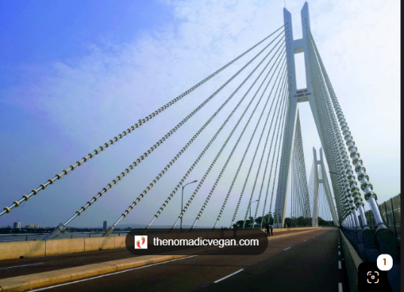
Figure B — Applications : Suspension bridges and stay-cable systems
Fig.5 — Applications : Suspension bridges and stay-cable systems
- SPECIAL-PURPOSE MONO-STRAND CABLES
Strand cables consist of a single large-diameter strand.
The configurations indicated in the source are :
- 61 wires
- 91 wires
- 127 wires
- 169 wires
Figure A — Construction : Cross-sections of strand cables: 61, 91, 127, and 169 wires.
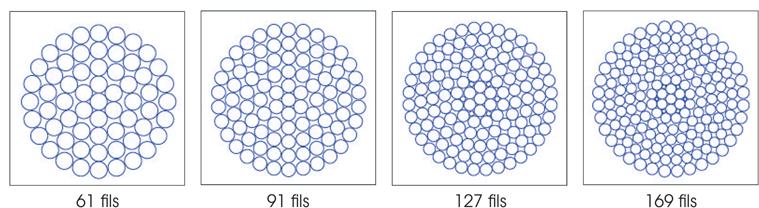
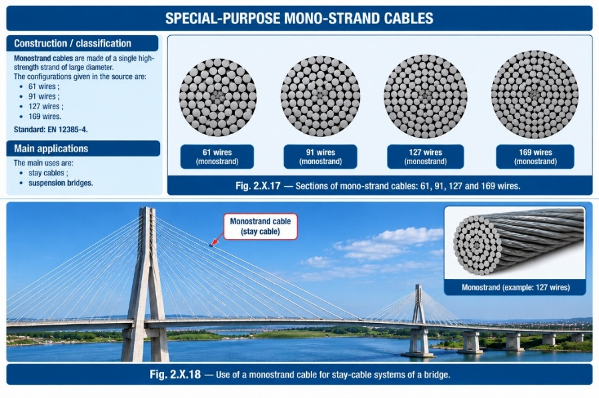
Figure B — Applications : Suspension bridges

Fig.6 — Applications : Suspension bridges
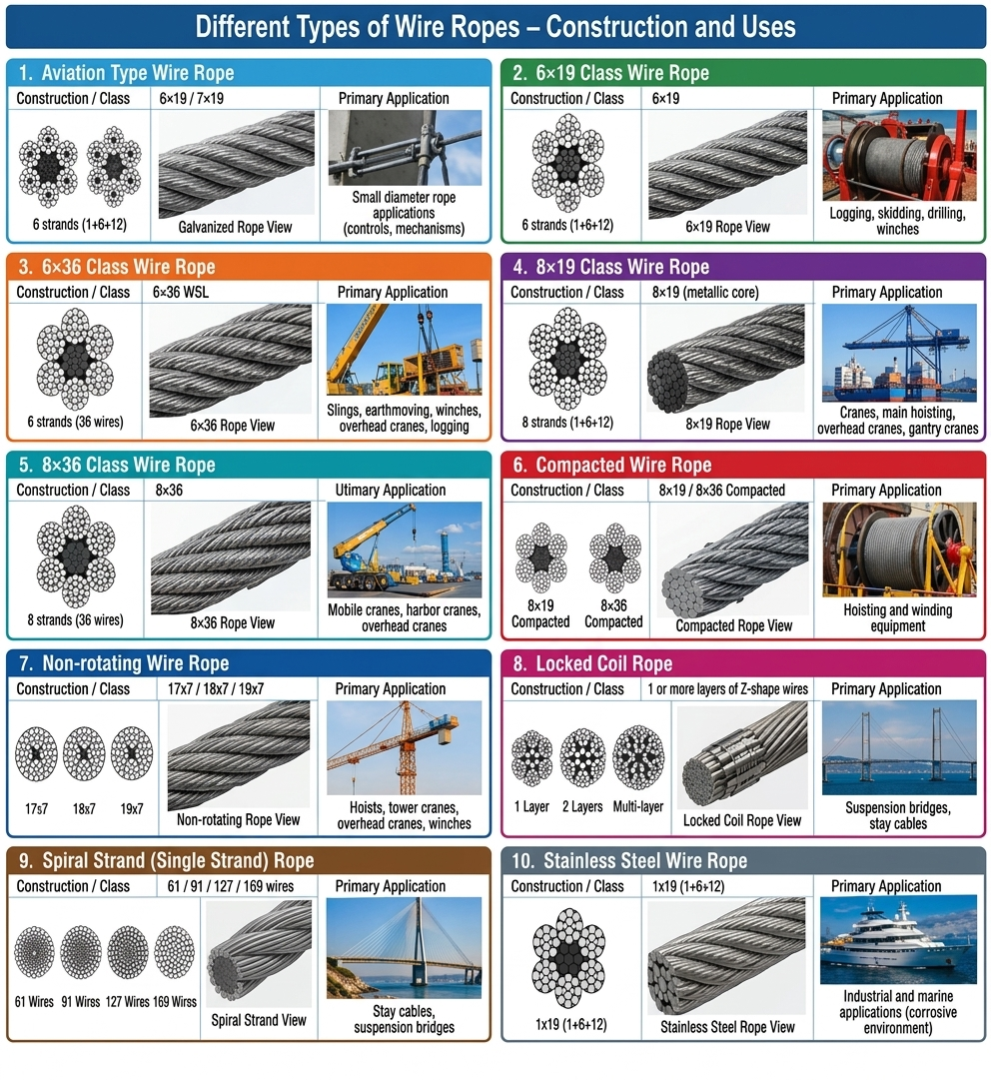
Fig.7— Different Types of Wire Ropes – Construction and Uses
II.2.3 Cables in Structural Engineering : Theory and Applications
II.2.3.1 Suspension Roofs
A suspension roof is a roof in which cables constitute the principal load-carrying elements. Typical applications include:
- stadiums;
- sports halls;
- exhibition centers;
- railway stations;
- large halls;
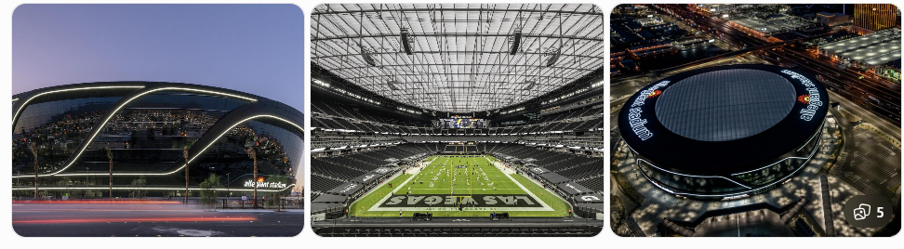
Figure 8— Cable-net suspension roof of Allegiant Stadium, Las Vegas.
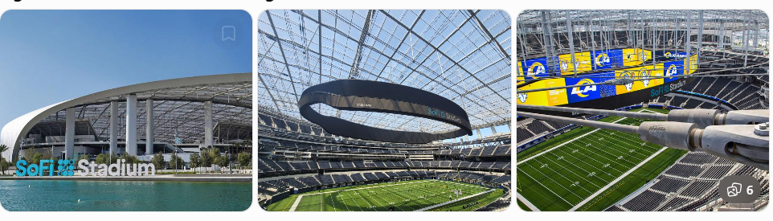
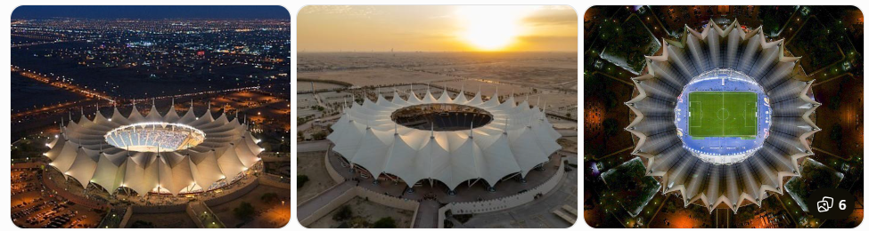
Figure 9 — Cable-net roof of SoFi Stadium, Inglewood, California.
Figure 10 — King Fahd International Stadium, Riyadh
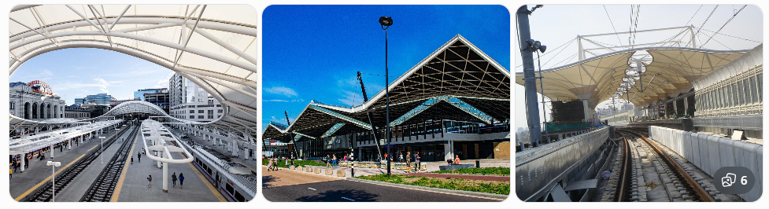
Figure 11— Railway station with tensile/cable-supported roof

II.2.3.2 Suspension Bridges :
A suspension bridge is a bridge in which the main load-carrying elements are suspension cables. The cables are anchored at both ends and pass over towers. Vertical suspenders (hangers) connect the main cables to the bridge deck and transfer the loads from the deck to the cables
- Main structural components
- Main cables — carry the principal tensile forces.
- Towers — support the main cables and transfer vertical and horizontal forces to the foundations.
- Hangers / suspenders — connect the bridge deck to the main cables.
- Bridge deck — carries vehicles, pedestrians, and other traffic loads.
- Anchorages — resist the horizontal component of the cable tension at the ends.
- Stiffening girder or truss — provides rigidity to the deck and distributes traffic loads.
- Structural principle
The load path can be summarized as:
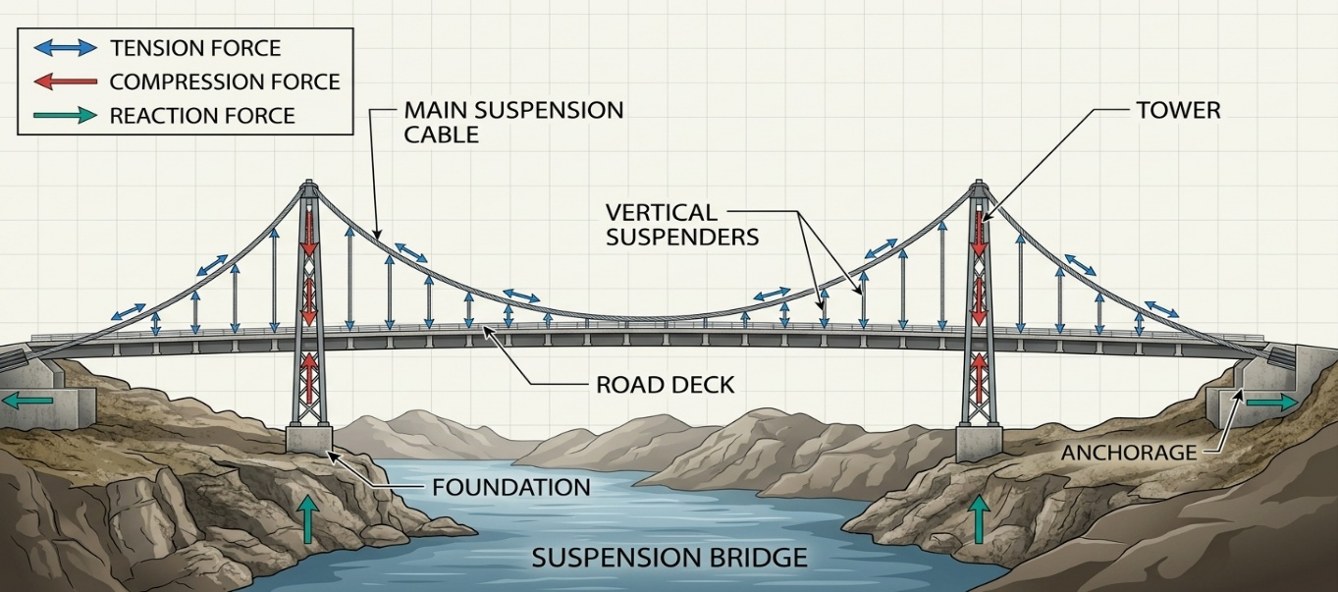
Traffic load → Deck → Hangers → Main cables → Towers + Anchorages → Foundations
Figure 12- Load Path in a Suspension Bridge (From Traffic to Foundations)

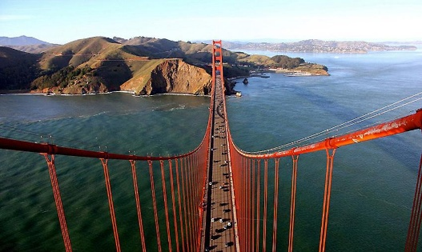
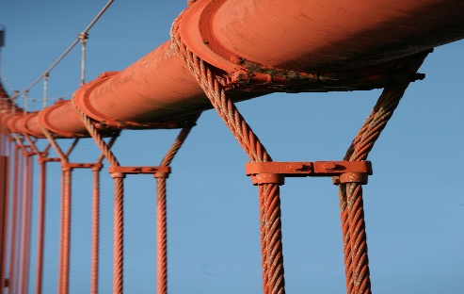
- Real Applications
Figure 13 — Golden Gate Bridge, San Francisco, USA.
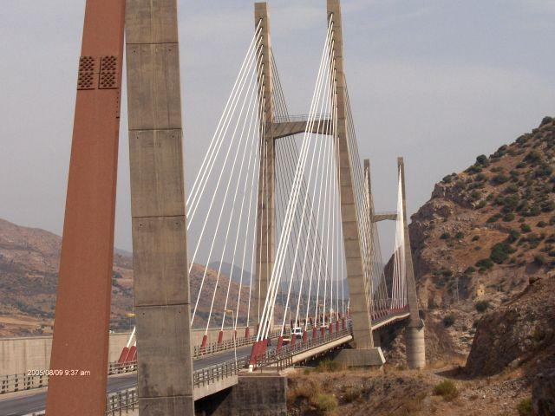
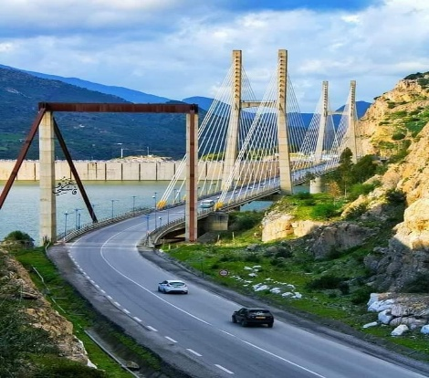
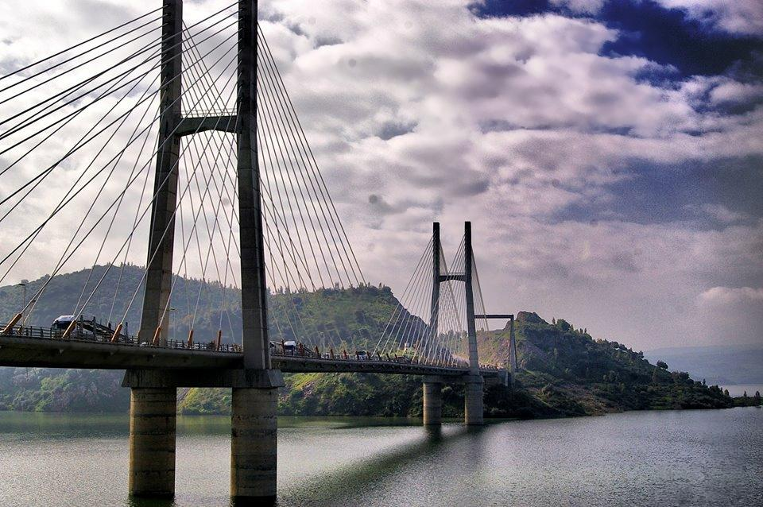
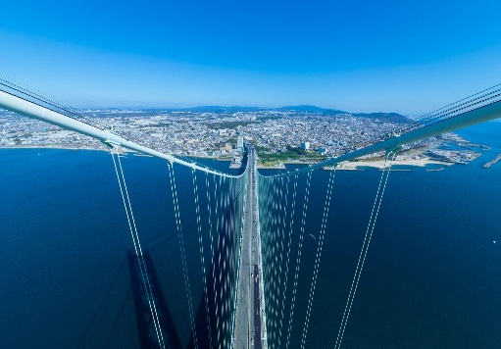
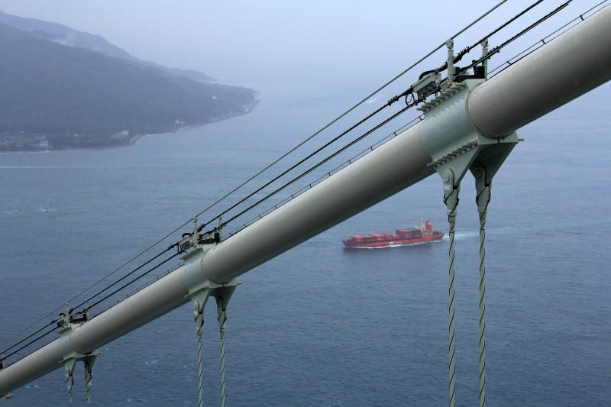
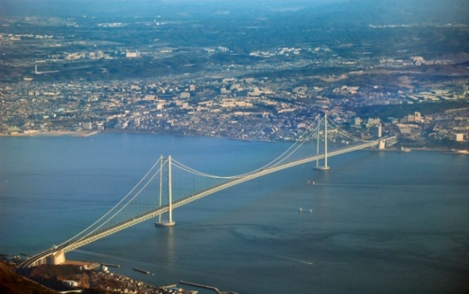
Figure 14 — Akashi Kaikyo Bridge, Japan.
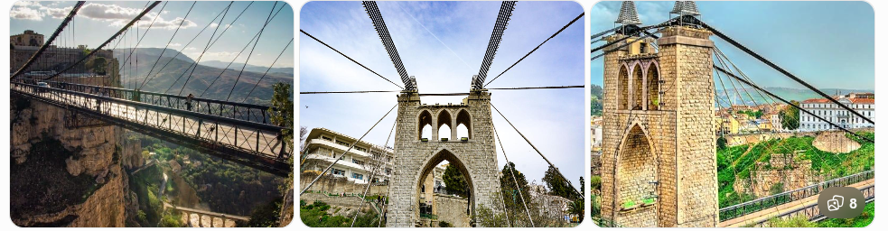
Figure 15 — Sidi Merouane Cable-Stayed Bridge —Mila- Algeria
Figure 16— Main cables and suspenders of Sidi M’Cid Bridge.
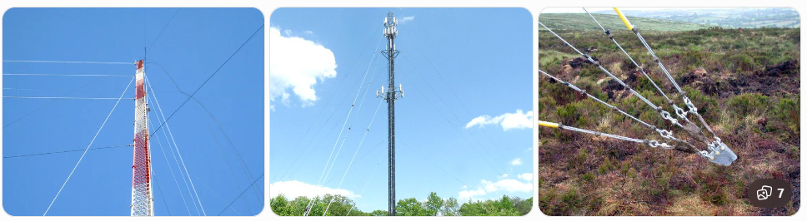
II.2.3.3 Guy Wire / Guy Cable : A guy wire is a tensioned cable used to support, stabilize, and brace a structure. It works primarily in tension.
Figure 17- Guyed antenna mast: guy wires stabilize the mast against lateral loads
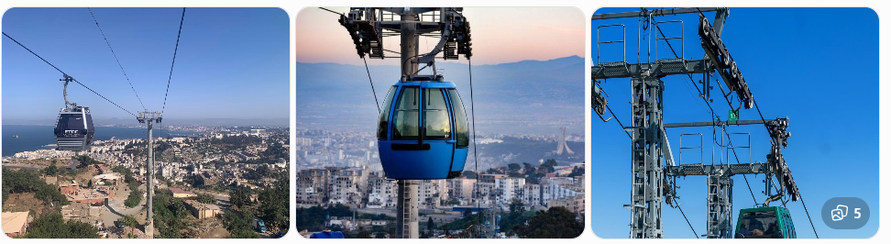
II.2.3.4 Cable Car / Aerial Cableway : An aerial cableway is a transportation system in which cables support and move cabins or vehicles between stations. The cables carry the weight of the cabins and passengers and transmit the loads to the supporting towers and anchorages.
Figure 18- An aerial cableway
II.2.4 Types of Cable Anchorages
II.2.4.1 - Conical Socket Anchorage
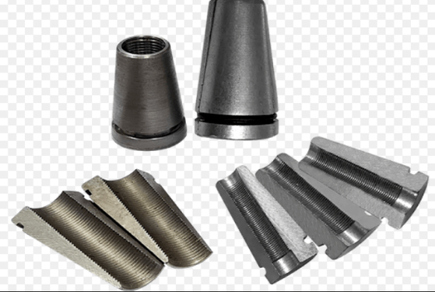
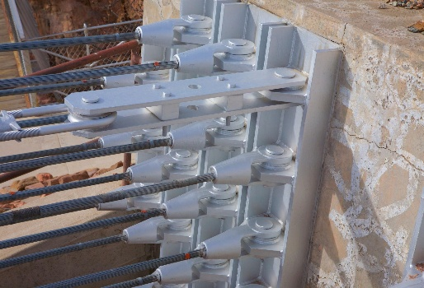
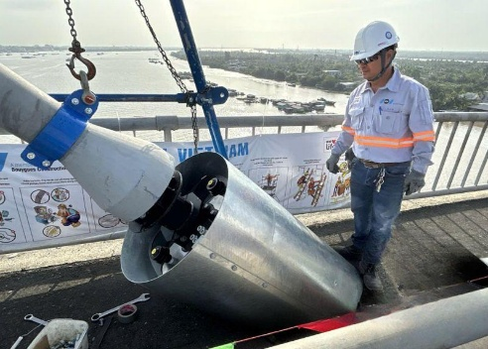
A conical socket anchorage consists of a tapered metal socket in which the cable wires are secured. It transfers the cable's tensile force to the supporting structure.
Figure 19 — Conical socket anchorage
II.2.4.2 - Wedge Anchorage :
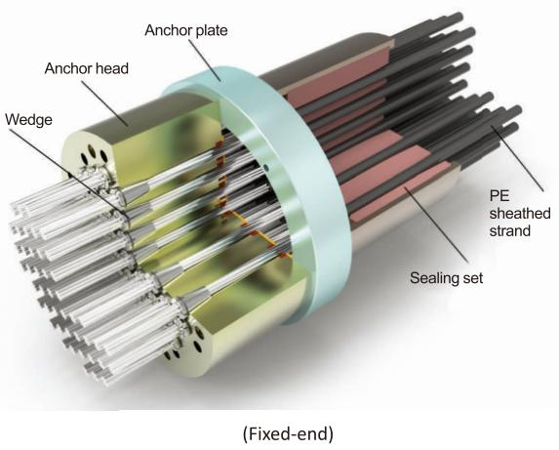
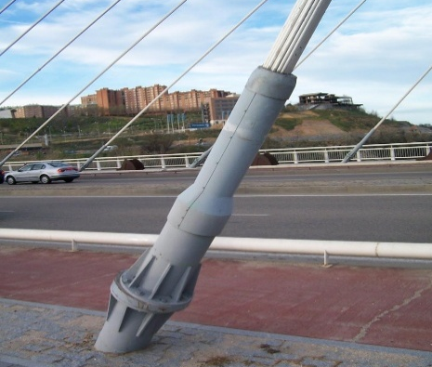
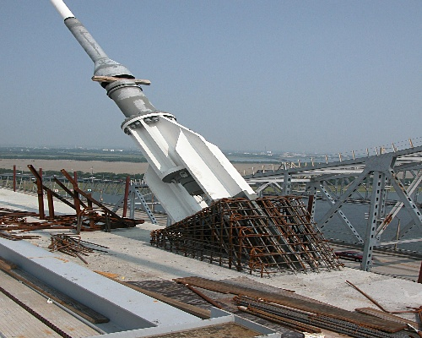
A wedge anchorage uses wedges to grip and lock the cable. The tensile force is transferred from the cable to the anchorage body through the wedges.
Figure 20— Wedge-type cable anchorage
II.2.4.3 - Clamped Anchorage
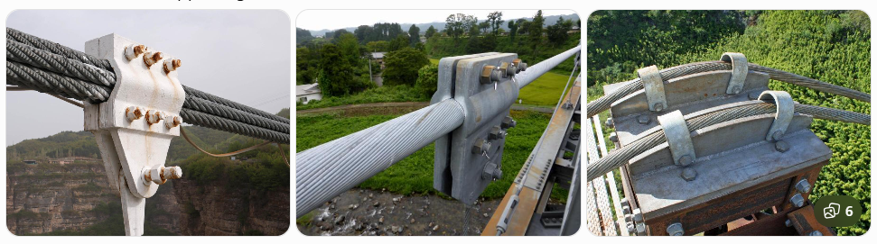
A clamped anchorage uses mechanical clamps, bolts, or clamping plates to grip the cable and transfer its tensile force to the supporting structure.
Figure 21— Clamped cable anchorage
II.2.4.4 - Ground Anchorage
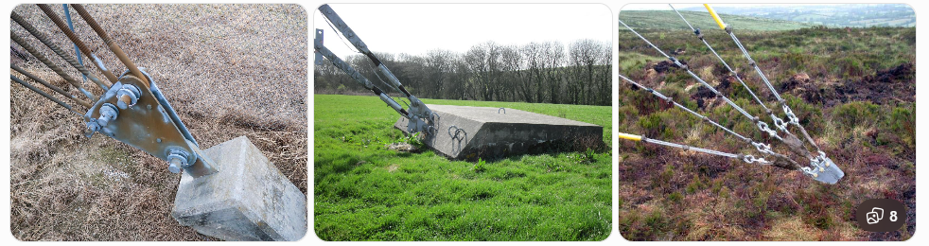
A ground anchorage transfers the tensile force of a cable into the ground through an anchorage block, foundation, or ground anchor.
Figure 22— Ground anchorage for a guy cable
II.2.4.5 - Threaded Anchorage
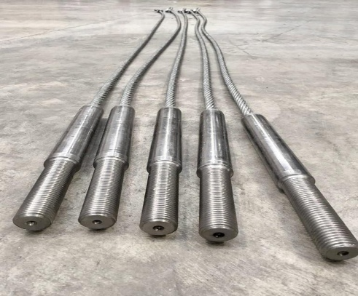
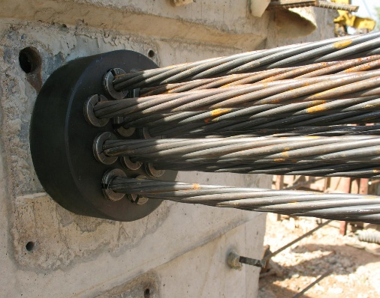
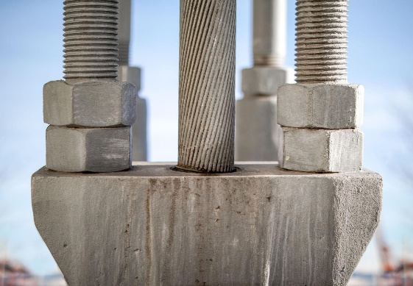
A threaded anchorage uses a threaded connection to secure the cable or its terminal component and transfer the tensile force to the supporting structure.
Figure 23 — Threaded cable anchorage
II.2.4.6 - Socket Anchorage
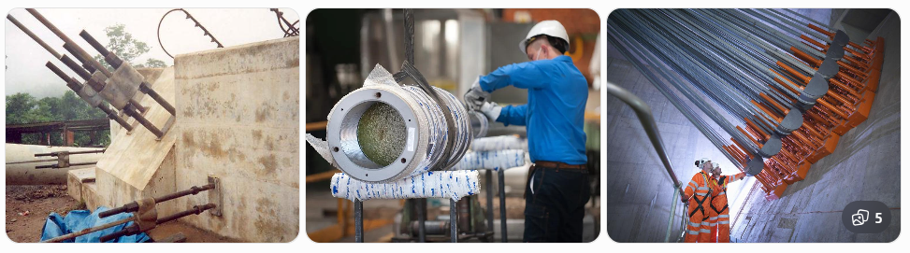
A socket anchorage is a cable termination system in which the end of a cable is inserted into a metal socket and securely fixed, usually by a socketing material such as zinc or resin.
Figure 24— Socket anchorage for a structural cable
II.2.5 Basic Assumptions for cable analysis
Cables are flexible structural elements mainly used to carry and transmit loads through tension. They are widely used in suspension bridges, cable-stayed bridges, suspension roofs, guyed towers, cableways, and other tension structures.
For the theoretical analysis of cables, an idealized mechanical model is adopted. This model is based on several simplifying assumptions that allow the equilibrium configuration and internal forces of the cable to be determined.
II.2.5.1 Perfectly Flexible Cable
An ideal cable is assumed to be perfectly flexible, meaning that its bending stiffness is negligible. Consequently, the cable can change its curvature freely under the applied loads without developing a bending moment.
Therefore, for a perfectly flexible cable:
- The cable cannot resist bending moments ;
- The cable cannot resist shear forces ;
- The cable carries only an axial tensile force ;
- The tensile force is always tangent to the cable at each point.
For an ideal cable, the bending moment and shear force are therefore zero:
$$\boxed{M=0} \\ \boxed{V=0}$$
The only internal force is the axial tensile force :
$$\boxed{N=T>0}$$
where $M$is the bending moment, $V$is the shear force, and $N=T$is the tensile axial force.
- Key idea: An ideal cable is a tension-only structural element.

II.2.5.2 Inextensible Cable
The cable is assumed to be inextensible, meaning that its elastic deformation is neglected.
Consequently, the total length of the cable remains constant before and after loading.
If $L_{0}$is the initial length and $L$is the length after loading :
Or :
$$\boxed{ΔL=0}$$
If the cable is represented by the curve
$$y=y\left(x\right),$$
The differential length of the cable is:
$$ds=\sqrt{dx^{2}+dy^{2}}$$
Since
$$dy=\frac{dy}{dx} dx,$$
we obtain:
$$\boxed{ds=\sqrt{1+{\left(\frac{dy}{dx}\right)}^{2}} dx}$$
Therefore, the total length of the cable between supports $A$and $B$is:
$$\boxed{L=\int_{x_{A}}^{x_{B}}{\sqrt{1+{\left(\frac{dy}{dx}\right)}^{2}}} dx}$$
For an inextensible cable:
$$\boxed{\int_{x_{A}}^{x_{B}}{\sqrt{1+{\left(\frac{dy}{dx}\right)}^{2}}} dx=L_{0}}$$
Thus, the cable-length compatibility condition is:
$$\boxed{L-L_{0}=0}$$
Or equivalently: ΔL=0
- Key idea: The cable may change its shape, but its total length remains constant.
II.2.5.3 Neglect of the Cable Self-Weight
In some problems, the self-weight of the cable is neglected when it is small compared with the applied loads.
The distributed load due to the cable's own weight is then considered negligible:
$$q_{c }≅0$$
where ($q_{c }≅0$) represents the distributed load intensity due to the self-weight of the cable.
Under this assumption, the analysis considers only the externally applied loads.
- Important Remark
The self-weight cannot always be neglected. In long-span cable structures, such as suspension bridges, the weight of the cable itself can represent a significant part of the total loading and can strongly influence the cable profile and tensile forces.
- Key idea: The self-weight may be neglected only when its effect is sufficiently small compared with the applied loads.
II.2.6 Types of loads applied to the cable
The loads acting on a cable can generally be divided into two main categories:
II.2.6.1 Concentrated Loads ($P_{i}$)
II.2.6.2 Distributed Loads :
- Load per unit horizontal projection q(x)
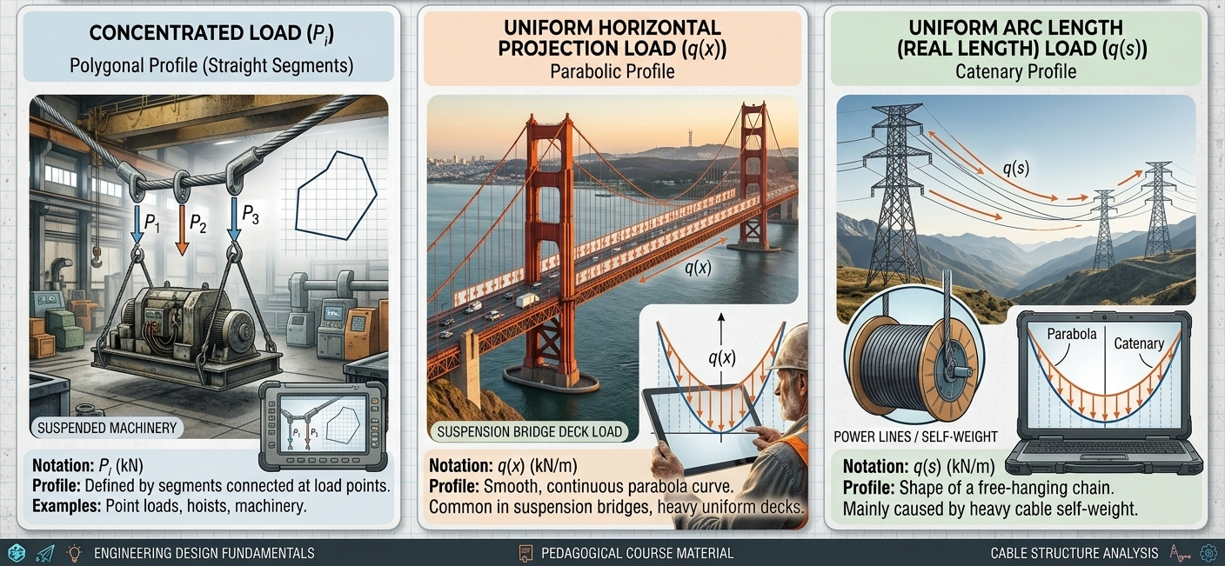
- Load per unit cable Length q(s)
Figure 25— Types of loads applied to the cable

II.3. Cable subjected to concentrated loads
A concentrated load acts at a specific point of the cable. Several concentrated loads can be represented by :
$$P_{1},P_{2},P_{3},………….$$
where each ($P_{i}$) represents a concentrated force.
When a cable is subjected only to concentrated loads, there is no distributed load between two consecutive load points.
Under the ideal cable assumptions, each unloaded portion of the cable takes a straight-line configuration.
Therefore, a cable carrying only concentrated loads consists of several straight segments connected at the points where the concentrated loads are applied.
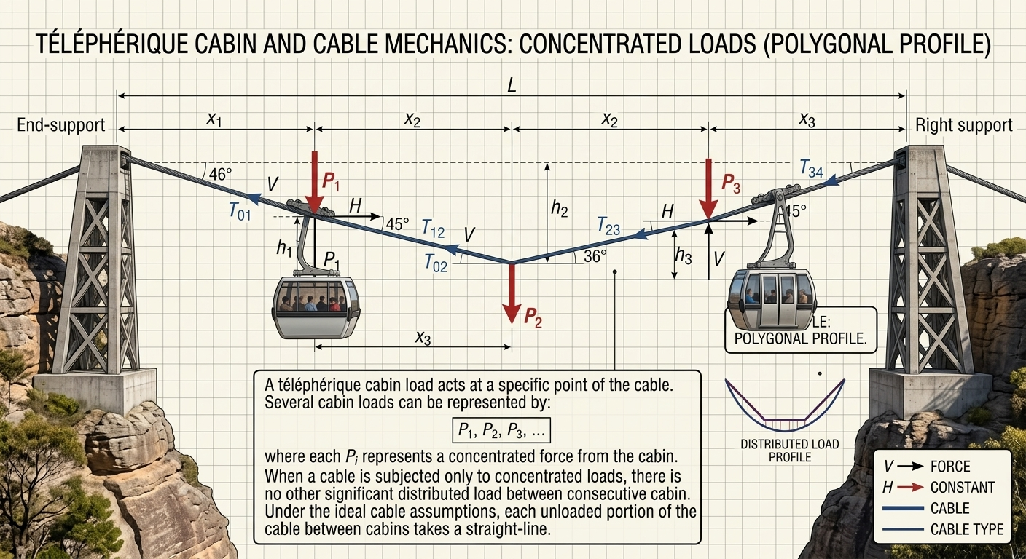
- Key idea: Concentrated loads produce a cable profile made of straight segments between the load points.
Figure 26— Concentrated loads -cable car (aerial cableway)
A cable may be subjected to several concentrated loads (P1, P2, , Pn). As a first approximation, the self-weight of the cable is assumed to be negligible compared with the applied concentrated loads. The shape of a cable depends on the loading condition: under a uniformly distributed load, the cable takes a parabolic or catenary shape, whereas under concentrated loads, it forms a polygonal line. If the coordinates of one point of application are known, the equilibrium equations can be used to determine the coordinates of the other points and the tensile forces in the successive cable segments. The total cable length can then be calculated as the sum of the lengths of all segments. The inverse problem, which consists of determining the positions of the load application points for a prescribed cable length, is more complex and requires the introduction of a corresponding comparison beam.
Two methods for analyzing cables subjected to concentrated loads will be presented
- Direct Method
Consider a cable subjected to a system of concentrated forces as shown in Figure 27 . The system is statically indeterminate.
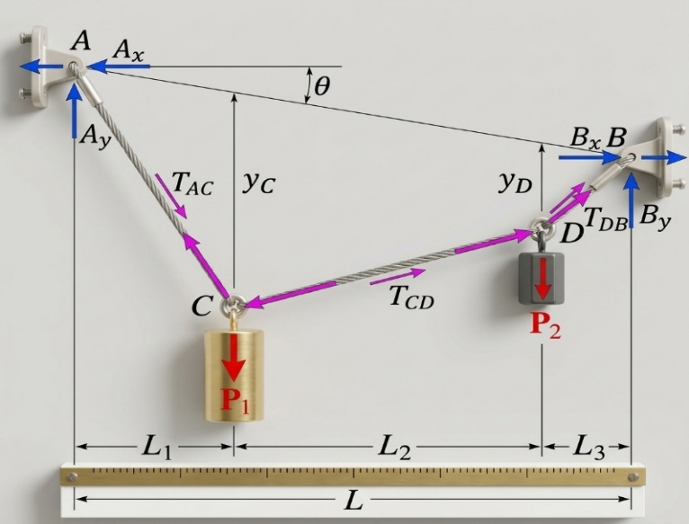

Figure 27- Free-body diagram and geometry of a suspended cable system
For the cable shown in the figure, subjected to two concentrated loads $P_{1}$and $P_{2}$, the system is statically indeterminate.
Unknowns
There are 9 unknowns:
- Four support reactions:
$$A_{x}, A_{y}, B_{x}, B_{y}$$
- Three cable tensions:
$$T_{AC}, T_{CD}, T_{DB}$$
- Two cable sags (vertical coordinates):
$$y_{C}, y_{D}$$
Therefore,
$$\boxed{\text{Number of }\text{unknowns}=4+3+2=9}$$
- Equilibrium equations
At each point $A$, $B$, $C$, and $D$, two equilibrium equations can be written:
$$\sum{F_{x}}=0, \sum{F_{y}}=0$$
Setting the vertical coordinate of support $B$ as $y_{B}=L\tan{θ}$ (where $L=L_{1}+L_{2}+L_{3}$):
- Node A:
$$\left\{\begin{matrix}\sum{F_{x}}=0⟹A_{x}-T_{AC}{\cos{θ}}_{1}=0 \\ \sum{F_{y}}=0⟹A_{y}-T_{AC}{\sin{θ}}_{1}=0\end{matrix}\right.$$
- Node C:
$$\left\{\begin{matrix}\sum{F_{x}}=0⟹T_{AC}{\cos{θ}}_{1}-T_{CD}{\cos{θ}}_{2}=0 \\ \sum{F_{y}}=0⟹T_{AC}{\sin{θ}}_{1}-T_{CD}{\sin{θ}}_{2}-P_{1}=0\end{matrix}\right.$$
- Node D:
$$\left\{\begin{matrix}\sum{F_{x}}=0⟹T_{CD}{\cos{θ}}_{2}-T_{DB}{\cos{θ}}_{3}=0 \\ \sum{F_{y}}=0⟹T_{CD}{\sin{θ}}_{2}-T_{DB}{\sin{θ}}_{3}-P_{2}=0\end{matrix}\right.$$
- Node B:
$$\left\{\begin{matrix}\sum{F_{x}}=0⟹B_{x}-T_{DB}{\cos{θ}}_{3}=0 \\ \sum{F_{y}}=0⟹B_{y}-T_{DB}{\sin{θ}}_{3}=0\end{matrix}\right.$$
- Expressing All Unknowns in Terms of Horizontal Tension $H$
From the horizontal equilibrium equations ($\sum{F_{x}}=0$), the horizontal component of tension is constant throughout the entire cable:
$$A_{x}=B_{x}=T_{AC}{\cos{θ}}_{1}=T_{CD}{\cos{θ}}_{2}=T_{DB}{\cos{θ}}_{3}=H$$
Thus,
$$\boxed{4×2=8\text{ equilibrium equations}}$$
Since there are 9 unknowns but only 8 independent equilibrium equations, one additional equation is required.
Geometrical compatibility equation
To make the system statically determinate, one additional geometric equation must be introduced.
There are two possible alternatives:
- Using the total cable length
If the total cable length $L_{c}$is known:
$$\boxed{L_{c}=\sqrt{L_{1}^{2}+y_{C}^{2}}+\sqrt{L_{2}^{2}+{\left(y_{D}-y_{C}\right)}^{2}}+\sqrt{L_{3}^{2}+y_{D}^{2}}}$$
This equation expresses the total length of the three cable segments:
$$AC+CD+DB=L_{c}$$
- Using a prescribed sag
If the sag at $C$or $D$is known, an additional equation is directly available:
$$\boxed{y_{C}=\text{known}}$$
or
$$\boxed{y_{D}=\text{known}}$$
Hence, the complete system contains:
$$\boxed{9\text{ unknowns}=8\text{ equilibrium equations}+1\text{ geometric equation}}$$
Therefore, the system can be solved.

Excercice 01 :
Determine the tensile forces in the cable shown in the figure 28 and calculate the height $h$.
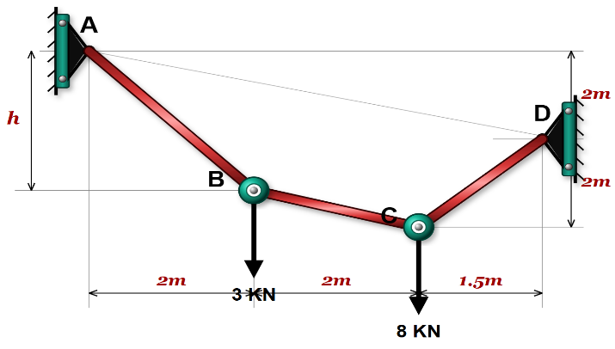
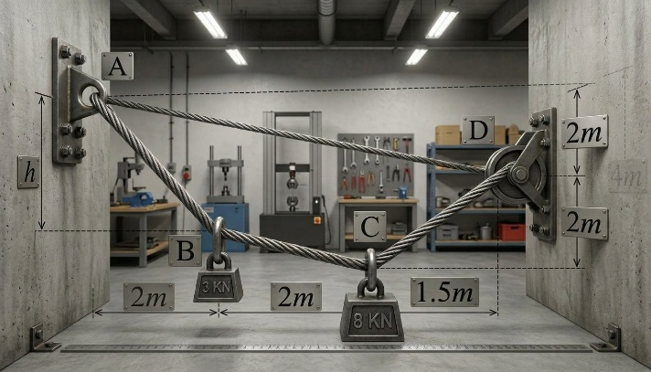
Figure 28 - Suspended cable system under concentrated point loads and realistic simulation of a steel cable in equilibrium
Solution 01 :
- Geometry and Unknowns
Setting the origin at node $A\left(0,0\right)$:
- Node A: $\left(x_{A},y_{A}\right)=\left(0,0\right)$
- Node B: $\left(x_{B},y_{B}\right)=\left(2,-h\right)$
- Node C: $\left(x_{C},y_{C}\right)=\left(4,-4\right)$ (prescribed sag from diagram: $2\text{ m}+2\text{ m}=4\text{ m}$ below level A)
- Node D: $\left(x_{D},y_{D}\right)=\left(5.5,-2\right)$
Applied Loads:
- $P_{1}=3\text{ kN}$ (at Node B)
- $P_{2}=8\text{ kN}$ (at Node C)
- Slopes of Cable Segments
The tangents of the inclination angles relative to the horizontal are expressed as:
$${\tan{θ}}_{1}=\frac{y_{A}-y_{B}}{x_{B}-x_{A}}=\frac{0-\left(-h\right)}{2}=\frac{h}{2}$$
$${\tan{θ}}_{2}=\frac{y_{B}-y_{C}}{x_{C}-x_{B}}=\frac{-h-\left(-4\right)}{2}=\frac{4-h}{2}$$
$${\tan{θ}}_{3}=\frac{y_{D}-y_{C}}{x_{D}-x_{C}}=\frac{-2-\left(-4\right)}{1.5}=\frac{2}{1.5}=\frac{4}{3}$$
- Nodal Equilibrium Equations Expressed in Terms of $H$
From horizontal equilibrium ($\sum{F_{x}}=0$), the horizontal component of tension $H$ is constant throughout the entire cable:
$$A_{x}=D_{x}=T_{AB}{\cos{θ}}_{1}=T_{BC}{\cos{θ}}_{2}=T_{CD}{\cos{θ}}_{3}=H$$
From vertical equilibrium ($\sum{F_{y}}=0$) at each node:

At Node B:
$$T_{AB}{\sin{θ}}_{1}-T_{BC}{\sin{θ}}_{2}-P_{1}=0$$
Dividing by $H$ (since $\frac{T\sin{θ}}{H}=\tan{θ}$):
$${\tan{θ}}_{1}-{\tan{θ}}_{2}=\frac{P_{1}}{H}$$
$$\frac{h}{2}-\frac{4-h}{2}=\frac{3}{H}⟹\frac{2h-4}{2}=\frac{3}{H}⟹H\left(h-2\right)=3 \text{--- (Equation 1)}$$

At Node C:
$$T_{CD}{\sin{θ}}_{3}+T_{BC}{\sin{θ}}_{2}-P_{2}=0$$
Dividing by $H$:
$${\tan{θ}}_{3}+{\tan{θ}}_{2}=\frac{P_{2}}{H}$$
$$\frac{4}{3}+\frac{4-h}{2}=\frac{8}{H}⟹\frac{8+3\left(4-h\right)}{6}=\frac{8}{H}⟹H\left(20-3h\right)=48 \text{--- (Equation 2)}$$
- Solving the System
From Equation 1, $H=\frac{3}{h-2}$. Substituting this into Equation 2:
$$\frac{3}{h-2}\left(20-3h\right)=48$$
$$3\left(20-3h\right)=48\left(h-2\right)$$
$$60-9h=48h-96$$
$$57h=156⟹h=\frac{156}{57}=\frac{52}{19}≈2.74\text{ m}$$

Calculating Horizontal Tension $H$:
$$H=\frac{3}{\frac{52}{19}-2}=\frac{3}{\frac{14}{19}}=\frac{57}{14}≈4.07\text{ kN}$$
- Cable Segment Tensions
The tension in any segment $i$ is given by $T_{i}=\frac{H}{{\cos{θ}}_{i}}=H\sqrt{1+{\tan^{2}{θ}}_{i}}$:
- Segment AB:
$${\tan{θ}}_{1}=\frac{2.7368}{2}=1.3684$$
$$T_{AB}=4.0714×\sqrt{1+{\left(1.3684\right)}^{2}}≈6.90\text{ kN}$$
- Segment BC:
$${\tan{θ}}_{2}=\frac{4-2.7368}{2}=0.6316$$
$$T_{BC}=4.0714×\sqrt{1+{\left(0.6316\right)}^{2}}≈4.82\text{ kN}$$
- Segment CD:
$${\tan{θ}}_{3}=\frac{4}{3}≈1.3333$$
$$T_{CD}=4.0714×\sqrt{1+{\left(\frac{4}{3}\right)}^{2}}=4.0714×\frac{5}{3}≈6.79\text{ kN}$$
- Support Reactions
- At Node A:
$$A_{x}=H=4.07\text{ kN}$$
$$A_{y}=H{\tan{θ}}_{1}=4.0714×1.3684≈5.57\text{ kN}$$
- At Node D:
$$D_{x}=H=4.07\text{ kN}$$
$$D_{y}=H{\tan{θ}}_{3}=4.0714×\frac{4}{3}≈5.43\text{ kN}$$
Solution 02 :
- Unknowns and System Equations
- 8 Unknowns: 4 support reactions ($X_{A},Y_{A},X_{D},Y_{D}$), 3 cable segment tensions ($T_{AB},T_{BC},T_{CD}$), and sag $h=y_{B}$.
- 8 Equilibrium Equations: 2 equations ($\sum{F_{x}}=0$ and $\sum{F_{y}}=0$) at each of the 4 nodes ($A,B,C,D$).
- Segment CD Geometry and Moment Equilibrium
For segment $CD$:
- Horizontal span: $Δx=1.5\text{ m}$
- Vertical span: $Δy=2.0\text{ m}$
- Length of segment: $L_{CD}=\sqrt{{1.5}^{2}+{2.0}^{2}}=2.5\text{ m}$
Trigonometric components:
$${\cos{θ}}_{CD}=\frac{1.5}{2.5}=0.6$$
$${\sin{θ}}_{CD}=\frac{2.0}{2.5}=0.8$$
Support reactions at node $D$ in terms of tension $T_{CD}$:
$$X_{D}=T_{CD}{\cos{θ}}_{CD}=0.6T_{CD}$$
$$Y_{D}=T_{CD}{\sin{θ}}_{CD}=0.8T_{CD}$$
Applying overall moment equilibrium about support $A$ ($\sum{M_{A}}=0$):
$$\sum{M_{A}}=X_{D}⋅\left(2\right)+Y_{D}⋅\left(5.5\right)-3⋅\left(2\right)-8⋅\left(4\right)=0$$
$$\left(0.6T_{CD}\right)⋅2+\left(0.8T_{CD}\right)⋅5.5-6-32=0$$
$$1.2T_{CD}+4.4T_{CD}=38$$
$$5.6T_{CD}=38⟹T_{CD}=\frac{38}{5.6}≈6.79\text{ kN}$$
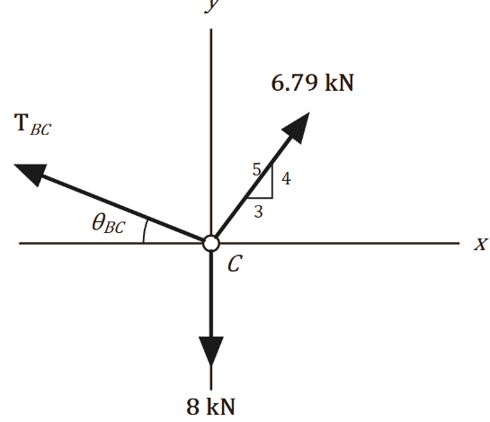
- Equilibrium of Node C
Node C
From the Free Body Diagram of Node C:
- Horizontal axis ($\sum{F_{x}}=0$):
$$T_{CD}{\cos{θ}}_{CD}-T_{BC}{\cos{θ}}_{BC}=0$$
$$6.79×0.6-T_{BC}{\cos{θ}}_{BC}=0⟹T_{BC}{\cos{θ}}_{BC}=4.07\text{ k}\text{N}$$
- Vertical axis ($\sum{F_{y}}=0$):
$$T_{CD}{\sin{θ}}_{CD}-8+T_{BC}{\sin{θ}}_{BC}=0$$
$$6.79×0.8-8+T_{BC}{\sin{θ}}_{BC}=0⟹5.43-8+T_{BC}{\sin{θ}}_{BC}=0⟹T_{BC}{\sin{θ}}_{BC}=2.57\text{ kN}$$
- Angle $θ_{BC}$ and tension $T_{BC}$:
$${\tan{θ}}_{BC}=\frac{2.57}{4.07}≈0.6316⟹θ_{BC}=\arctan\left(0.6316\right)≈{32.3}^{∘}$$
$$T_{BC}=\sqrt{{\left(4.07\right)}^{2}+{\left(2.57\right)}^{2}}≈4.82\text{ k}\text{N}$$
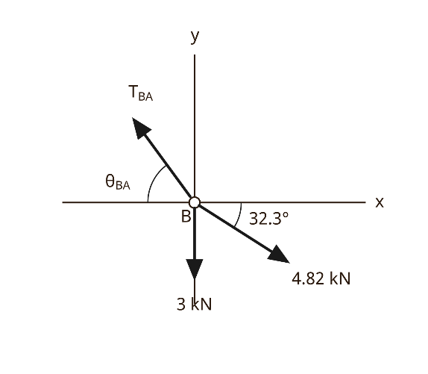
- Equilibrium of Node B
Node B
From the Free Body Diagram of Node B:
- Horizontal axis ($\sum{F_{x}}=0$):
$$-T_{BA}{\cos{θ}}_{BA}+T_{BC}{\cos{θ}}_{BC}=0$$
$$T_{BA}{\cos{θ}}_{BA}=4.82×\cos\left({32.3}^{∘}\right)=4.07\text{ kN}$$
- Vertical axis ($\sum{F_{y}}=0$):
$$T_{BA}{\sin{θ}}_{BA}-T_{BC}{\sin{θ}}_{BC}-3=0$$
$$T_{BA}{\sin{θ}}_{BA}=4.82×\sin\left({32.3}^{∘}\right)+3=2.57+3=5.57\text{ kN}$$
- Angle $θ_{BA}$ and tension $T_{BA}$:
$${\tan{θ}}_{BA}=\frac{5.57}{4.07}≈1.3686⟹θ_{BA}=\arctan\left(1.3686\right)≈{53.8}^{∘}$$
$$T_{BA}=\sqrt{{\left(4.07\right)}^{2}+{\left(5.57\right)}^{2}}≈6.90\text{ kN}$$
- Sag Height $h$ Calculation
Using triangle geometry for segment $AB$:
$${\tan{θ}}_{BA}=\frac{h}{2\text{ m}}$$
$$h=2\text{ m}×\tan\left({53.8}^{∘}\right)=2×1.3686≈2.74 \text{m}$$
- Method 02 :Analysis Method – Comparison Beam

Basic Principle: General Cable Theorem
The theorem establishes an equivalence between the behavior of a cable and that of a simply supported virtual beam:
Fundamental Rule: At any point $x$ along the cable, the product of the horizontal force (thrust $H$) and the sag/height $y\left(x\right)$ is equal to the bending moment $M_{0}\left(x\right)$ calculated on the equivalent simply supported beam:
$$H⋅y\left(x\right)=M_{0}\left(x\right) ⟺ y\left(x\right)=\frac{M_{0}\left(x\right)}{H}$$
For a cable of negligible weight subjected to vertical loads, the product of the horizontal component of tension (H) and the sag (y(x)) measured at a section (x) is equal to the bending moment (M(x)) at the same section of a simply supported beam having the same horizontal span and subjected to the same loads as the cable:
La correction LaTeX est :
$$\boxed{H y\left(x\right)=M\left(x\right)}$$
$$\boxed{y\left(x\right)=M\left(x\right)/H }$$
This fundamental relationship is known as the comparison beam principle.

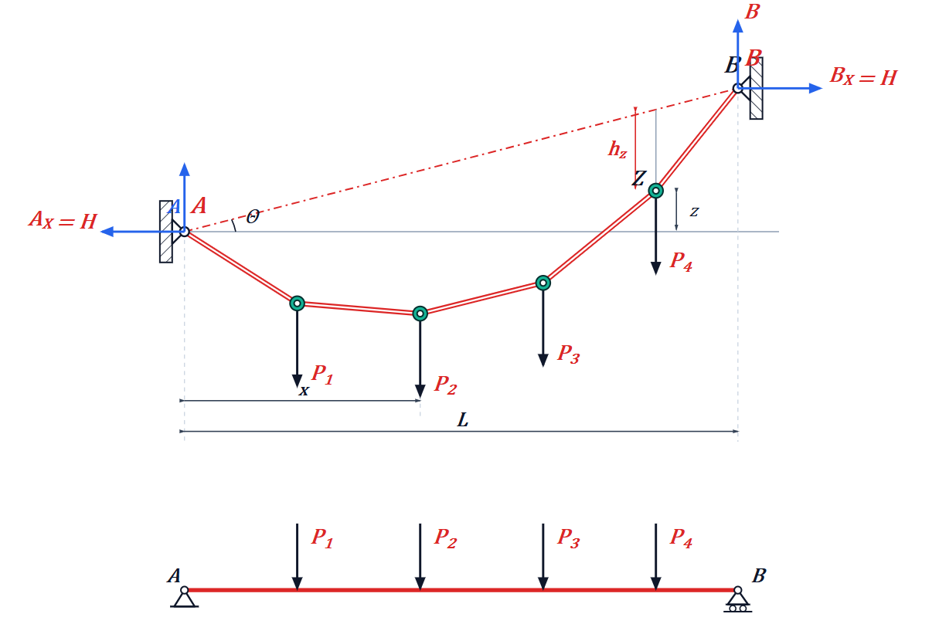
Figure 29-
Example 02
Revisit Example 1 (Figure 28) by applying the general cable theorem to determine $H$:
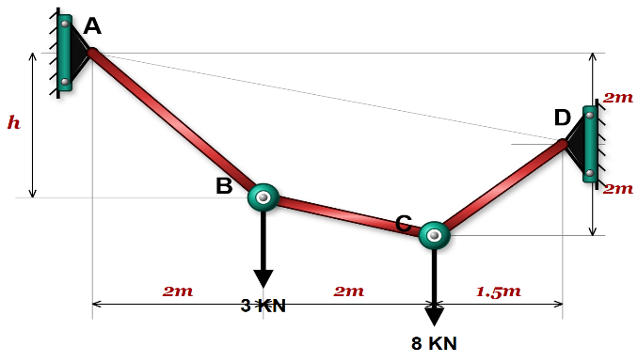
$$h_{B}$$
$$h_{C}$$

The objective is to use this theorem to find the horizontal thrust $H$ and then determine the height $h_{B}$ at point B.
Step 1: Analyze the equivalent simply supported beam (bottom-right diagram)
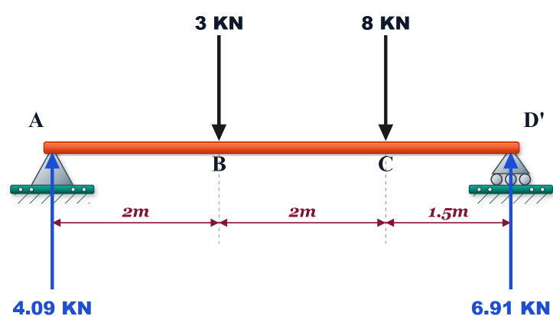
Virtually replace the cable with a straight beam resting on supports A and D with a total span $L=2+2+1.5=5.5 \text{m}$:
- Applied loads: $3\text{ kN}$ at B ($2\text{ m}$ from A) and $8\text{ kN}$ at C ($1.5\text{ m}$ from D).
- Calculated vertical support reactions: $V_{A}=4.09\text{ kN}$ and $V_{D}=6.91\text{ kN}$.
Step 2: Calculate the horizontal thrust $H$
To determine $H$, point C is used since its height geometry $h_{C}$ is defined:
- Geometric calculation of $h_{C}$:
$$h_{C}=2+1.5×\frac{2}{5.5}=2.545\text{ m}$$
- Calculate bending moment $M_{C}$ on the virtual beam at point C:
Isolating the right segment (from support D):
$$M_{C}=V_{D}×1.5=6.91×1.5=10.365\text{ kN}⋅\text{m}$$
- Deduce horizontal thrust $H$: According to the theorem, $H×h_{C}=M_{C}$:
$$H=\frac{M_{C}}{h_{C}}=\frac{10.365}{2.545}=4.072\text{ kN}$$
(The horizontal reaction components at the supports are therefore $A_{X}=D_{X}=H=4.072\text{ kN}$).
Step 3: Calculate height $h_{B}$ at point B
Now that $H$ is known, apply the same relation to point B:
- Calculate bending moment $M_{B}$ on the virtual beam at point B:
Isolating the left segment (from support A):
$$M_{B}=V_{A}×2=4.09×2=8.18\text{ kN}⋅\text{m}$$
- Calculate height $h_{B}$:
$$H×h_{B}=M_{B}⟹h_{B}=\frac{M_{B}}{H}$$
$$h_{B}=\frac{8.18}{4.072}=2.01\text{ m}$$
Example 03
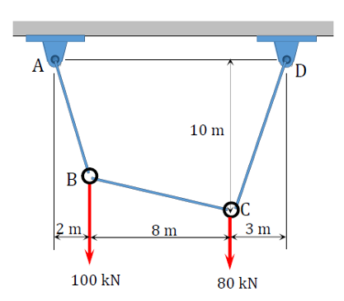
Problem Statement: A cable supports two concentrated vertical loads at points $B$ and $C$ (Figure 29).
- Vertical load at $B$: $P_{B}=100\text{ kN}$
- Vertical load at $C$: $P_{C}=80\text{ kN}$
- Horizontal distances : $x_{AB}=2\text{ m}$, $x_{BC}=8\text{ m}$, $x_{CD}=3\text{ m}$
- Vertical sag at point $C$: $y_{C}=10\text{ m}$
Determine:
- Support reactions at $A$ and $D$ ($A_{x},A_{y},D_{x},D_{y}$).
- Sag at point $B$ ($y_{B}$).
- Tensions in cable segments $AB$, $BC$, and $CD$.
- Total length of the cable ($L$)
Figure 29 -
Solution
Step 1: Support Reactions ($A_{x},A_{y},D_{x},D_{y}$)
- Total horizontal span:
$$L=x_{AB}+x_{BC}+x_{CD}=2+8+3=13\text{ m}$$
- Vertical Reactions ($A_{y},D_{y}$):
Taking moments about support $A$:
$$\sum{M_{A}}=0⟹\left(100×2\right)+\left(80×10\right)-\left(D_{y}×13\right)=0$$
$$200+800-13D_{y}=0⟹D_{y}=\frac{1000}{13}≈76.92\text{ kN}$$
Vertical equilibrium:
$$\sum{F_{y}}=0⟹A_{y}+D_{y}=100+80=180\text{ kN}$$
$$A_{y}=180-76.92=103.08\text{ kN}$$
- Horizontal Reactions ($A_{x},D_{x}$):
Isolating section $CD$ and taking moments about point $C$ (where $y_{C}=10\text{ m}$):
$$\sum{M_{C}}=0⟹\left(D_{y}×3\right)-\left(D_{x}×y_{C}\right)=0$$
$$76.923×3-10D_{x}=0⟹D_{x}=\frac{230.769}{10}≈23.08\text{ kN}$$
Horizontal equilibrium:
$$\sum{F_{x}}=0⟹A_{x}=D_{x}=H=23.08\text{ kN}$$
Step 2: Sag at Point B ($y_{B}$)
Isolating section $AB$ and taking moments about point $B$:
$$\sum{M_{B}}=0⟹\left(A_{y}×2\right)-\left(A_{x}×y_{B}\right)=0$$
$$103.077×2-23.077×y_{B}=0$$
$$y_{B}=\frac{206.154}{23.077}≈8.93\text{ m}$$
Step 3: Cable Tensions ($T_{AB},T_{BC},T_{CD}$)
- Tension in segment $AB$ ($T_{AB}$):
$$T_{AB}=\sqrt{A_{x}^{2}+A_{y}^{2}}=\sqrt{{23.08}^{2}+{103.08}^{2}}=\sqrt{532.68+10625.49}≈105.63\text{ kN}$$
- Tension in segment $BC$ ($T_{BC}$):
  - Horizontal force: $H=23.08\text{ kN}$
  - Vertical shear force: $V_{BC}=A_{y}-100=103.08-100=3.08\text{ kN}$
$$T_{BC}=\sqrt{H^{2}+V_{BC}^{2}}=\sqrt{{23.08}^{2}+{3.08}^{2}}=\sqrt{532.68+9.49}≈23.28\text{ kN}$$
- Tension in segment $CD$ ($T_{CD}$):
$$T_{CD}=\sqrt{D_{x}^{2}+D_{y}^{2}}=\sqrt{{23.08}^{2}+{76.92}^{2}}=\sqrt{532.68+5916.69}≈80.31\text{ kN}$$
Step 4: Total Cable Length ($L_{\text{total}}$)
Using Pythagorean theorem on each segment:
- Length of segment $AB$ ($L_{AB}$):
$$L_{AB}=\sqrt{Δx_{AB}^{2}+y_{B}^{2}}=\sqrt{2^{2}+{8.93}^{2}}=\sqrt{4+79.74}≈9.15\text{ m}$$
- Length of segment $BC$ ($L_{BC}$):
$$Δy_{BC}=y_{C}-y_{B}=10-8.93=1.07\text{ m}$$
$$L_{BC}=\sqrt{Δx_{BC}^{2}+Δy_{BC}^{2}}=\sqrt{8^{2}+{1.07}^{2}}=\sqrt{64+1.14}≈8.07\text{ m}$$
- Length of segment $CD$ ($L_{CD}$):
$$L_{CD}=\sqrt{Δx_{CD}^{2}+y_{C}^{2}}=\sqrt{3^{2}+{10}^{2}}=\sqrt{9+100}≈10.44\text{ m}$$
- Total Cable Length ($L_{\text{total}}$):
$$L_{\text{total}}=L_{AB}+L_{BC}+L_{CD}=9.15+8.07+10.44=27.66\text{ m}$$

II.4. Cable subjected to a uniform horizontally distributed load
Cables provide an effective means of supporting the dead weight of girders or bridge decks with very long spans. A suspension bridge is a typical example, where the deck is suspended from the main cable by a series of closely spaced, equally distributed hangers.
To analyze this problem, we first determine the shape of a cable subjected to a uniformly distributed vertical load $w_{0 }$per unit horizontal length, as shown in Fig. 30–a.
The $x$- and $y$-axes have their origin at the lowest point $O$of the cable, where the slope is zero.
The free-body diagram of a small cable segment of length ∆s $s$is shown in Fig. 30–b. Since the tensile force in the cable varies continuously in both magnitude and direction along its length, the tension is denoted by $T$. The uniformly distributed load is replaced by its resultant force $w_{0}x$, which acts at a distance $x/2$from point $O$.
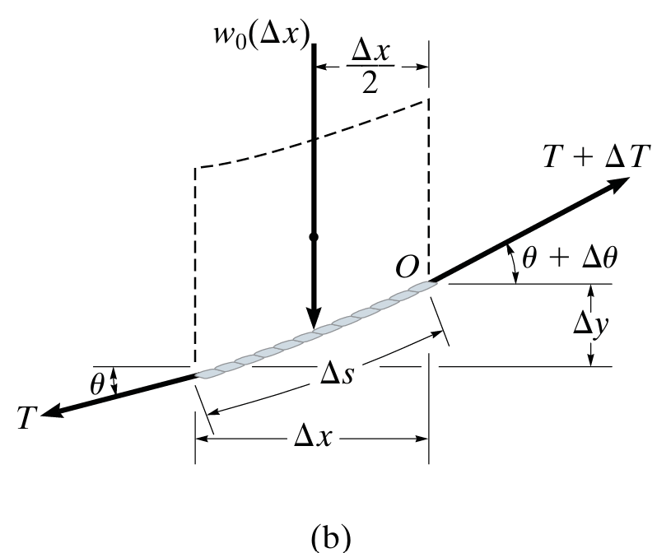
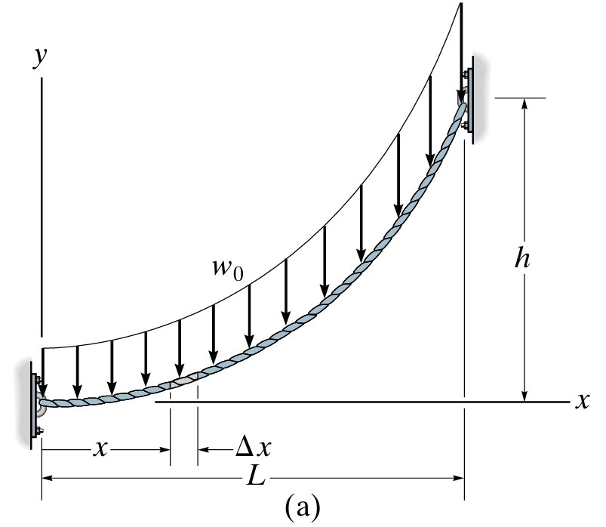

V+∆V

H+∆H

H

V

Figure 30- a) Cable subjected to a uniformly distributed vertical load $w_{0 }$ per unit horizontal length. b) Free-body diagram of a small cable segment of length ∆s.

Applying the equations of equilibrium gives:
- Horizontal Equilibrium
The horizontal equilibrium of a small cable segment $Δs$gives:
$$\boxed{\sum{F_{x}}=0}$$
Therefore,
$$-H+\left(H+dH\right)=0$$
which gives:
$$\boxed{dH=0}$$
Hence, the horizontal component of the cable tension is constant along the cable:
- Vertical Equilibrium
The vertical equilibrium of a small cable segment $ds$gives:
$$\boxed{\sum{F_{y}}=0}$$
Thus,
$$-V-w_{0 } dx+\left(V+dV\right)=0$$
which gives:
$$\boxed{dV=w_{0 } dx}$$
or
$$\begin{matrix} & \boxed{\frac{dV}{dx}=w_{0 }\left(x\right)} & & \text{(2)}\end{matrix}$$
From the geometry of the cable:
$$\begin{matrix} & \boxed{\tan{θ}=\frac{dy}{dx}=\frac{V}{H}} & & \text{(3)}\end{matrix}$$
Since $H$is constant, differentiating Equation (3) with respect to $x$gives:
$$\frac{d^{2}y}{dx^{2}}=\frac{1}{H}\frac{dV}{dx}$$
Using Equation (2):
$$\begin{matrix} & \boxed{\frac{d^{2}y}{dx^{2}}=\frac{w_{0 }\left(x\right)}{H}} & & \text{(4)}\end{matrix}$$
Therefore, the general equation governing the cable profile is:
$\boxed{\frac{d^{2}y}{dx^{2}}=\frac{w_{0 }\left(x\right)}{H}}$ $\text{(}\text{5}\text{)}$
This equation shows that the shape of the cable depends directly on the applied distributed load $w_{0 }\left(x\right)$
Solving differential Equation (4), together with the corresponding boundary conditions, gives the cable configuration (y(x)), known as the equilibrium shape of the cable.

Integrating twice yields:
$y\left(x\right)=\frac{w_{0}}{2H}x^{2}+C_{1}x+C_{2}$ $\text{(}\text{6}\text{)}$
For a cable pinned at both ends at the same elevation $\left(0,0\right)$ and $\left(L,0\right)$ with maximum sag $f$ at midspan $x=L/2$:
$y\left(x\right)=\frac{4f}{L^{2}}x\left(L-x\right)$ $\text{(}\text{7}\text{)}$
Where the horizontal tension $H$ is related to the sag by:
$H=\frac{w_{0}L^{2}}{8f}$ $\text{(} \text{8}\text{)}$
- Calculation of Total Cable Tension
The total tension $T$ at any point along the cable is the resultant of its horizontal component $H$ and vertical component $V$:
$$T^{2}=H^{2}+V^{2}$$
Factoring out $H^{2}$:
$$T^{2}=H^{2}\left(1+\frac{V^{2}}{H^{2}}\right)$$
From the geometry of the cable, the slope is defined as $y'=\frac{dy}{dx}=\tan{θ}=\frac{V}{H}$. Substituting $\frac{V}{H}=y'$ gives:
$$T^{2}=H^{2}\left(1+{\left(y'\right)}^{2}\right)$$
Taking the square root yields the expression for total cable tension $T\left(x\right)$:
$T\left(x\right)=H\sqrt{1+{\left(\frac{dy}{dx}\right)}^{2}}=H\sqrt{1+{\left(y'\right)}^{2}}$ $\text{(}\text{9}\text{)}$
- Physical Remark
- The horizontal component $H=T\cos{θ}$ remains constant along the entire length of the cable.
- The total tension $T\left(x\right)$ directly depends on the local slope $y'$.
- The steeper the cable slope (larger $|y'|$), the greater the tension $T$.
- Consequently, tension $T$ reaches its maximum at the support/anchor points (where the slope is steepest) and its minimum at the lowest point of the cable (where the slope is zero, $y'=0⟹T=H$).
The horizontal component $H$ is obtained using the boundary condition $y=h$ at $x=L$:
$$H=\frac{w_{0}L^{2}}{2h} \text{--- } \text{(}\text{10}\text{)}$$
Finally, substituting equation (10) into equation (4) gives:
$$\frac{d^{2}y}{dx^{2}}=\frac{2h}{L^{2}} donc y=h{\left(\frac{x}{L}\right)}^{2} \text{---} \text{ (}\text{11}\text{)}$$
- Maximum Cable Tension
The maximum tension in the cable occurs when the angle $θ$ is maximum, which is at the right support $x=L$. From the force triangle components, we have:
$$T_{max}=\sqrt{H^{2}+{\left(T\sin{θ}\right)}^{2}} \text{--- } \text{(}\text{1}\text{2}\text{)}$$
Since $T\sin{θ}=V\left(x\right)=w_{0}x$, at $x=L$ the vertical reaction is $V_{max}=w_{0}L$. Substituting this gives:
$$T_{max}=\sqrt{H^{2}+{\left(w_{0}L\right)}^{2}} \text{--- } \text{(}\text{14}\text{)}$$

- Arc Length of a Cable
The length $s$ of the cable between two points $x_{1}$ and $x_{2}$ is given by:
$$s=\int_{x_{1}}^{x_{2}}{d}s$$
From differential geometry:
$$ds=\sqrt{dx^{2}+dy^{2}}=\sqrt{1+{\left(\frac{dy}{dx}\right)}^{2}} dx=\sqrt{1+{\left(y'\right)}^{2}} dx$$
Substituting $ds$ into the integral gives the exact total length:
$$s=\int_{x_{1}}^{x_{2}}{\sqrt{1+{\left(y'\right)}^{2}}} dx$$
This integral can be evaluated either analytically or numerically, depending on the complexity of the cable profile $y\left(x\right)$.
Small-Sag Approximation ($f≪L$)
When the maximum sag $f$ is small compared to the span $L$ ($f≪L$), the slope $y'=\frac{dy}{dx}$ is small compared to unity ($y'^{2}≪1$). We can simplify the square root using the binomial series expansion ${\left(1+u\right)}^{n}≈1+nu$:
$$\sqrt{1+{\left(y'\right)}^{2}}={\left(1+{\left(y'\right)}^{2}\right)}^{1/2}≈1+\frac{1}{2}{\left(y^{'}\right)}^{2}$$
Substituting this approximation into the length integral yields:
$$s≈\int_{x_{1}}^{x_{2}}{\left[1+\frac{1}{2}{\left(\frac{dy}{dx}\right)}^{2}\right]}dx=\left(x_{2}-x_{1}\right)+\frac{1}{2}\int_{x_{1}}^{x_{2}}{{\left(\frac{dy}{dx}\right)}^{2}}dx$$
- Application to a Parabolic Cable
For a symmetrical parabolic cable with span $L$ over $x∈\left[0,L\right]$ and profile $y\left(x\right)=\frac{4f}{L^{2}}x\left(L-x\right)$:
- Derivative (slope):
$$\frac{dy}{dx}=\frac{4f}{L^{2}}\left(L-2x\right)$$
- Integral of ${\left(y'\right)}^{2}$:
$$\int_{0}^{L}{{\left(\frac{dy}{dx}\right)}^{2}}dx=\frac{16f^{2}}{L^{4}}\int_{0}^{L}{{\left(L-2x\right)}^{2}}dx=\frac{16f^{2}}{3L}$$
- Approximate Cable Length:
$$s≈L+\frac{8f^{2}}{3L}$$

II.4. 1 Special Case: Uniformly Distributed Load
- The most common example of this case is the main cable of a suspension bridge. The weight of the bridge is approximately uniformly distributed horizontally.
- The self-weight of the cable is neglected compared with the weight it supports.
- The load transmitted to the main cable by a large number of vertical suspenders can be modeled as a uniformly distributed load.
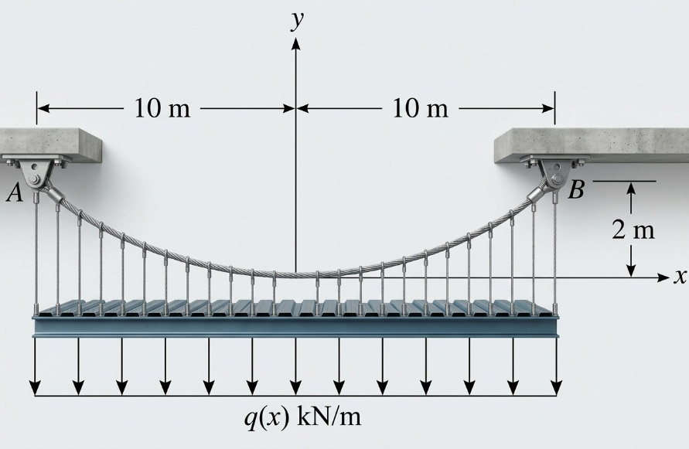

Shape of the Cable
For a uniformly distributed load $q_{0}$, the cable takes the shape of a parabola.
Starting from Equation (4):
$$q(x)=q_{0}$$
Since the horizontal component of the cable tension $H$is constant :
$$\boxed{y^{''}=\frac{q_{0}}{H}}$$
Integrating twice gives:
$$\boxed{y=\frac{q_{0}}{2H}x^{2}+C_{1}x+C_{2}}$$
Thus, the equation of the cable is a parabola.
The constants $C_{1}$and $C_{2}$are determined from the support conditions.
Here, $x$is the horizontal coordinate measured from the lowest point of the cable.
Tension in the Cable
At a section located at a horizontal distance $x$from the lowest point, the tension is:
$$\boxed{T=\sqrt{H^{2}+{\left(q_{0}x\right)}^{2}}}$$
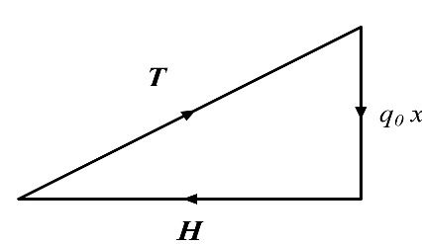

where:
- $H$= constant horizontal component of the cable tension;
- $q_{0}$= uniformly distributed load per unit horizontal length;
- $x$= horizontal distance from the lowest point;
- $T$= total tension in the cable.
Application 1: Horizontal Cable under a Uniformly Distributed Load
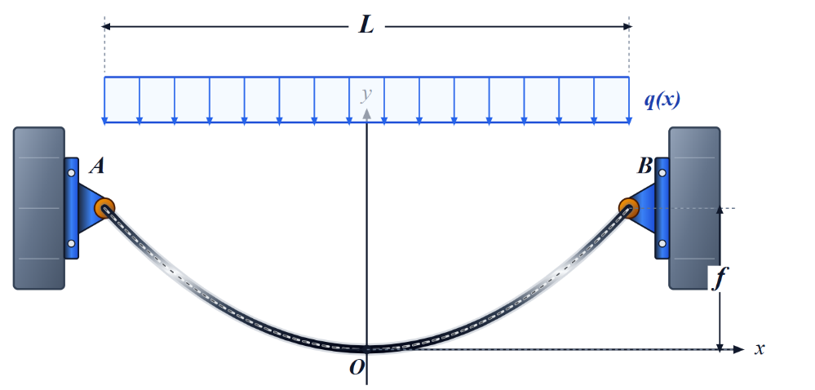

For $x=0$, we have:
$$y=y^{'}=0$$
Therefore,
$$\boxed{C_{1}=C_{2}=0}$$
and the cable equation becomes:
$$\boxed{y=\frac{q_{0}}{2H}x^{2}}$$
At the supports $A$and $B$, the sag is $f$, and the span is $L$. Thus, for $x=\frac{L}{2}$:
$$f=\frac{q_{0}}{2H}{\left(\frac{L}{2}\right)}^{2}$$
Hence,
$$\boxed{H=\frac{q_{0}L^{2}}{8f}}$$
Since
$$y=\frac{q_{0}}{2H}x^{2}$$
we obtain:
$$\boxed{y=\frac{4fx^{2}}{L^{2}}}$$
Tension in the Cable
The tension at a section located at $x$is:
$$T=\sqrt{H^{2}+q_{0}^{2}x^{2}}$$
Using
$$H=\frac{q_{0}L^{2}}{8f}$$
gives:
$$\boxed{T=\frac{q_{0}L^{2}}{8f}\sqrt{1+{\left(\frac{8fx}{L^{2}}\right)}^{2}}}$$
The maximum tension occurs at the supports $A$and $B$, where:
$$x=\frac{L}{2}$$
Therefore:
$$T_{max}=\sqrt{H^{2}+{\left(\frac{q_{0}L}{2}\right)}^{2}}$$
Introducing the parameter
$$\boxed{k=\frac{4f}{L}}$$
we obtain:
$$\boxed{T_{max}=H\sqrt{1+k^{2}}}$$
Or, equivalently,
$$\boxed{T_{max}=H\sqrt{1+{\left(\frac{4f}{L}\right)}^{2}}}$$
Cable Length
The length of the cable over the horizontal interval from $0$to $x$is:
$$\boxed{s=\int_{0}^{x}{\sqrt{1+{\left(\frac{dy}{dx}\right)}^{2}}} dx}$$
Since
$$y=\frac{4fx^{2}}{L^{2}}$$
we have:
$$\frac{dy}{dx}=\frac{8fx}{L^{2}}$$
Therefore,
$$\boxed{s=\int_{0}^{x}{\sqrt{1+{\left(\frac{8fx}{L^{2}}\right)}^{2}}} dx}$$
Using the binomial expansion and retaining the first three terms:
$$\sqrt{1+u}≈1+\frac{1}{2}u-\frac{1}{8}u^{2}$$
we obtain:
$$s≈\int_{0}^{x}{\left[1+\frac{1}{2}{\left(\frac{8fx}{L^{2}}\right)}^{2}-\frac{1}{8}{\left(\frac{8fx}{L^{2}}\right)}^{4}\right]}dx$$
For the total cable length, by symmetry:
$$L_{\text{cable}}=2\int_{0}^{L/2}{\left[1+\frac{1}{2}{\left(\frac{8fx}{L^{2}}\right)}^{2}-\frac{1}{8}{\left(\frac{8fx}{L^{2}}\right)}^{4}\right]}dx$$
After integration:
$$\boxed{L_{\text{cable}}≈L+\frac{8f^{2}}{3L}-\frac{32f^{4}}{5L^{3}}}$$
Or, in dimensionless form:
$$L_{\text{cable}}=L\left\{1+\frac{8}{3}{\left(\frac{f}{L}\right)}^{2}-\frac{32}{5}{\left(\frac{f}{L}\right)}^{4}\right\}$$
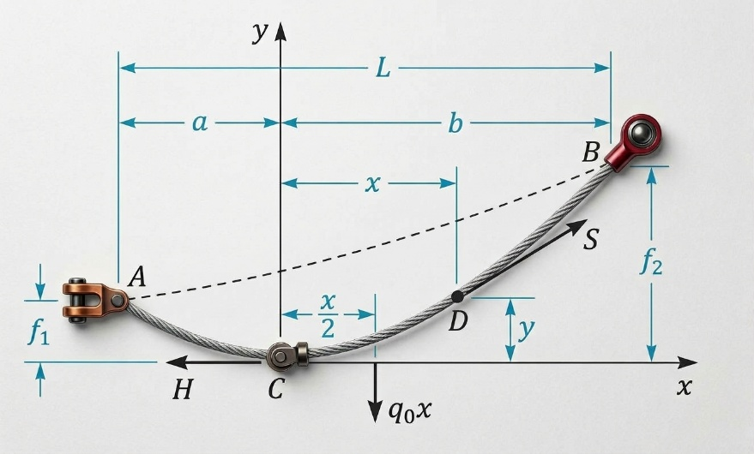
Application 2: Inclined Cable and Uniformly Distributed Load

For a cable pinned at its two ends at different levels, we obtain:
For $x=0$, we have $y=y'=0$, hence
$$C_{1}=C_{2}=0 \text{and} y=\frac{q_{0}}{2H}x^{2}$$
At A, $x=a$ and $y=f_{1}$, hence $f_{1}=\frac{q_{0}a^{2}}{2H}$
At B, $x=b$ and $y=f_{2}$, hence $f_{2}=\frac{q_{0}b^{2}}{2H}$
The equilibrium of segment $CD$ implies $T=\sqrt{H^{2}+{\left(q_{0}x\right)}^{2}}$
In particular, the tensions at A and B are:
$$T_{A}=\sqrt{H^{2}+{\left(q_{0}a\right)}^{2}} \text{and} T_{B}=\sqrt{H^{2}+{\left(q_{0}b\right)}^{2}}$$
1. Differential Length of the Cable
For an infinitesimal cable segment:
$$\boxed{ds=\sqrt{dx^{2}+dy^{2}}}$$
Dividing by $dx$:
$$ds=\sqrt{1+{\left(\frac{dy}{dx}\right)}^{2}} dx$$
Hence:
$$\boxed{ds=\sqrt{1+{\left(\frac{q_{0}x}{H}\right)}^{2}} dx}$$
2. Length of the Cable Segment $CB$
Let $b$be the horizontal distance between the lowest point $C$and support $B$.
The cable length between $C$and $B$is therefore :
$$s_{CB}=\int_{C}^{B}{d}s$$
or:
$$\boxed{s_{CB}=\int_{0}^{b}{\sqrt{1+{\left(\frac{q_{0}x}{H}\right)}^{2}}} dx}$$
To evaluate this integral, introduce the substitution :
$$\boxed{u=\frac{q_{0}x}{H}}$$
Thus:
$$x=\frac{H}{q_{0}}u$$
and:
$$dx=\frac{H}{q_{0}}du$$
The limits become:
$$x=0 ⇒ u=0 \\ x=b ⇒ u=\frac{q_{0}b}{H}$$
Therefore:
$$s_{CB}=\frac{H}{q_{0}}\int_{0}^{q_{0}b/H}{\sqrt{1+u^{2}}} du$$
3. Evaluation of the Integral
The required standard integral is:
$$\boxed{\int{\sqrt{1+u^{2}}} du=\frac{1}{2}\left[u\sqrt{1+u^{2}}+asinh⁡\left(u\right)\right]}$$
where:
$$\boxed{asinh⁡\left(u\right)=\ln\left(u+\sqrt{1+u^{2}}\right)}$$
Thus:
$$s_{CB}=\frac{H}{2q_{0}}{\left[u\sqrt{1+u^{2}}+asinh⁡\left(u\right)\right]}_{0}^{q_{0}b/H}$$
Substituting the upper limit:
$$s_{CB}=\frac{H}{2q_{0}}\left[\frac{q_{0}b}{H}\sqrt{1+{\left(\frac{q_{0}b}{H}\right)}^{2}}+\operatorname{asinh}\left(\frac{q_{0}b}{H}\right)\right]$$
Therefore:
$$\boxed{s_{CB}=\frac{b}{2}\sqrt{1+{\left(\frac{q_{0}b}{H}\right)}^{2}}+\frac{H}{2q_{0}}\operatorname{asinh}\left(\frac{q_{0}b}{H}\right)}$$

4. Length of the Cable Segment $CA$
Similarly, let $a$be the horizontal distance between the lowest point $C$and support $A$.
Following exactly the same procedure:
$$\boxed{s_{CA}=\int_{0}^{a}{\sqrt{1+{\left(\frac{q_{0}x}{H}\right)}^{2}}} dx}$$
Therefore:
$$\boxed{s_{CA}=\frac{a}{2}\sqrt{1+{\left(\frac{q_{0}a}{H}\right)}^{2}}+\frac{H}{2q_{0}}\operatorname{asinh}\left(\frac{q_{0}a}{H}\right)}$$
5. Total Length of the Cable $AB$
The total cable length is the sum of the two portions:
$$\boxed{L_{\text{cable}}=s_{CA}+s_{CB}}$$
Hence:
$$\boxed{\begin{aligned}L_{\text{cable}}=&\frac{a}{2}\sqrt{1+{\left(\frac{q_{0}a}{H}\right)}^{2}}+\frac{H}{2q_{0}}\operatorname{asinh}\left(\frac{q_{0}a}{H}\right) \\ &+\frac{b}{2}\sqrt{1+{\left(\frac{q_{0}b}{H}\right)}^{2}}+\frac{H}{2q_{0}}\operatorname{asinh}\left(\frac{q_{0}b}{H}\right)\end{aligned}}$$
This is the exact expression for the length of a parabolic cable subjected to a uniformly distributed load over its horizontal projection.
6. Alternative Logarithmic Form
Since
$$asinh⁡\left(u\right)=\ln\left(u+\sqrt{1+u^{2}}\right),$$
The segment $CB$can also be written as:
$$\boxed{s_{CB}=\frac{b}{2}\sqrt{1+{\left(\frac{q_{0}b}{H}\right)}^{2}}+\frac{H}{2q_{0}}\ln\left[\frac{q_{0}b}{H}+\sqrt{1+{\left(\frac{q_{0}b}{H}\right)}^{2}}\right]}$$
And similarly for $CA$.
7. Special case: symmetric cable
If the cable is symmetric about its lowest point $C$:
$$\boxed{a=b=\frac{L}{2}}$$
where $L$is the horizontal span.
Then:
$$\boxed{L_{\text{cable}}=2s_{CB}}$$
and therefore:
$$\boxed{L_{\text{cable}}=L\sqrt{1+{\left(\frac{q_{0}L}{2H}\right)}^{2}}+\frac{H}{q_{0}}\operatorname{asinh}\left(\frac{q_{0}L}{2H}\right)}$$
This is the exact cable length for the symmetric parabolic cable.

