CHAPTER 01 - Influence Lines of Determinate and Indeterminate Structures

I. Influence Lines of Determinate Structures

I.1. Introduction

I.2. Influence lines for beams: Static–analytical approach

I.3. Müller–Breslau principle: kinematic–qualitative approach

I.4. Influence lines for Girders with floor systems

I.5. Influence lines for Trusses

I.6. Influence lines for Frames

I.7. Applications of influence lines

I.7.1. Response at a particular location due to a single moving concentrated load

I.7.2. Response at a particular location due to a uniformly distributed live load

I.7.3. Response at a particular location due to a series of moving concentrated loads

I.8. Problems

II. Influence Lines of Indeterminate Structures

Influence Lines of determinate and Indeterminate Structures
- Introductoion
Influence lines have importante application for the design of structures that resist large live loads. In this module we will discuss how to draw the influence line for a statically determinate structure. The theory is applied to structures subjected to a distributed load or a series of concentrated forces, and specific applications to floor girders and bridge trusses are given. The determination of the absolute maximum live shear and moment in a member is discussed at the end of this module
- Learning outcomes: apply the methods of structural analysis for external and internal actions on various types of structural systems due to static and moving loads.
- Learning objectives
Student learning objectives for this module upon completion of this module, you will be able to:
• Know the meaning of influence lines.
• Determine its an important part in the design of bridges, industrial crane rails, conveyors, and other structures where loads move across their span.
- Learning activities
Activities for this module
• Do the assignments and problem sets
• Take the quiz (Quiz1)
- Influence Lines of determinate Structures
I.1. Defintion
An influence line represents the variation of the reaction, shear, moment, or deflection at a specific point in a member as a concentrated force moves over the member. Once this line is constructed, one can tell at a glance where the moving load should be placed on the structure so that it creates the greatest influence at the specified point. Furthermore, the magnitude of the associated reaction, shear, moment, or deflection at the point can then be calculated from the ordinates of the influence line diagram. For these reasons, influence lines play an important part in the design of bridges, industrial crane rails, conveyors, and other structures where loads move across their span.
The following sign conventions are used:
Table 1. sign conventions
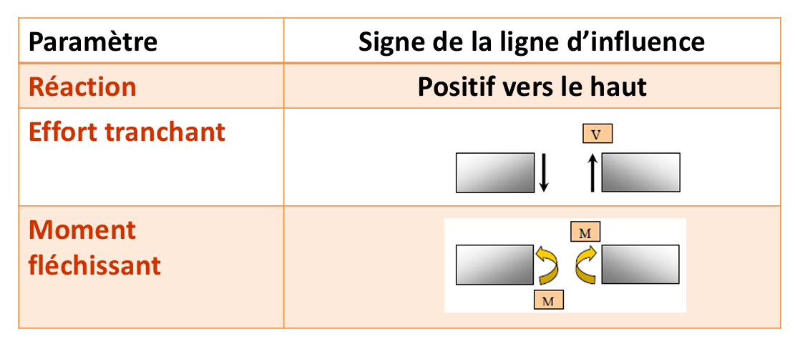
- Remark: For other sign conventions, they must be clearly defined.

I.2 Influence Lines for Beams
I.2.1Procedure for Analysis(Analytical Method)
Either of the following two procedures can be used to construct the influence line at a specific point P in a member for any function (reaction, shear, or moment). For both of these procedures we will choose the moving force to have a dimensionless magnitude of unity.
I.2.1 Tabulate Values
- Place a unit load $P=1$at different positions $x$along the member.
- For each position, use statics to calculate the required quantity: reaction $R$, shear force $V$, or bending moment $M$.
- Apply the adopted sign conventions.
- For a statically determinate beam, the influence line consists of straight-line segments.
- Prepare a table showing the unit-load position $x$and the corresponding value of $R$, $V$, or $M$.
- Plot the calculated values and connect the points to construct the influence line.
Key principle:
Example 01
Construct the influence line for the vertical reaction at $A$of the beam shown in Fig. 1 using the analytical method by tabulating the values.
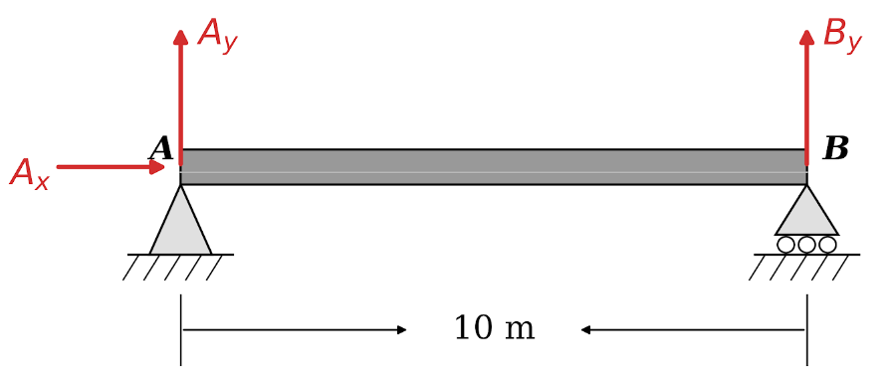
Fig 1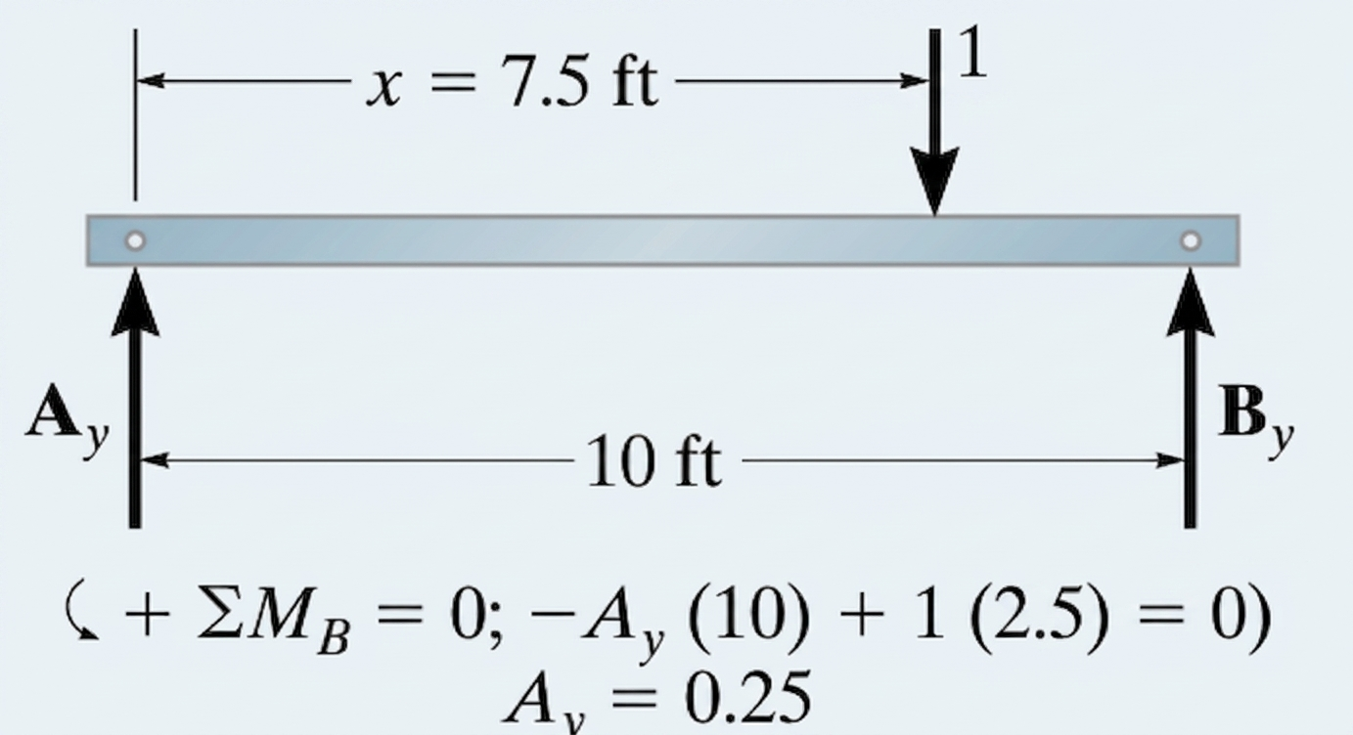

SOLUTION
Tabulate Values. A unit load is placed on the beam at each selected point x and the value of Ay is calculated by summing moments about B. For example, when x=2.5 m, x=5 m and x=7 m, see Figs. 2-3 and 4, respectively. The results for Ay are entered in the Table 2. A plot of these values yields the influence line for the reaction at A, Fig. 5. This line or diagram gives the reaction at A as the unit load moves from one position to the next along the beam.

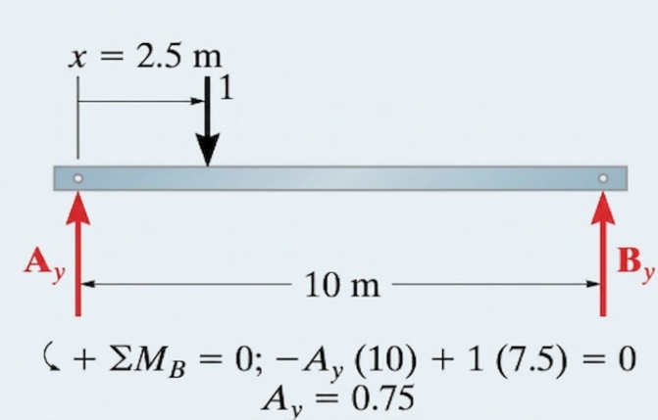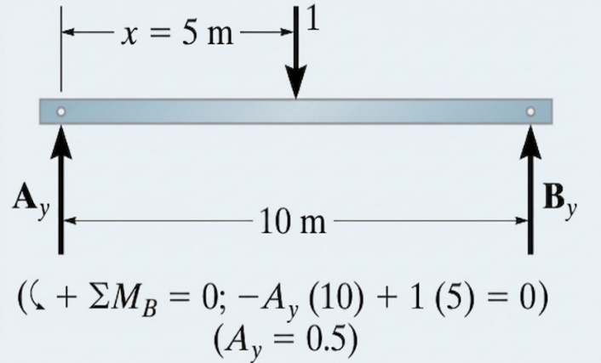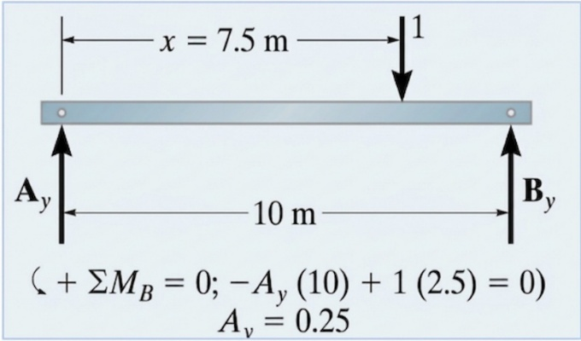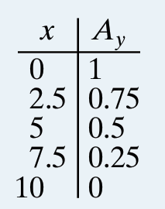
Table 2
Fig 4
Fig 3
Fig 2
Fig 4
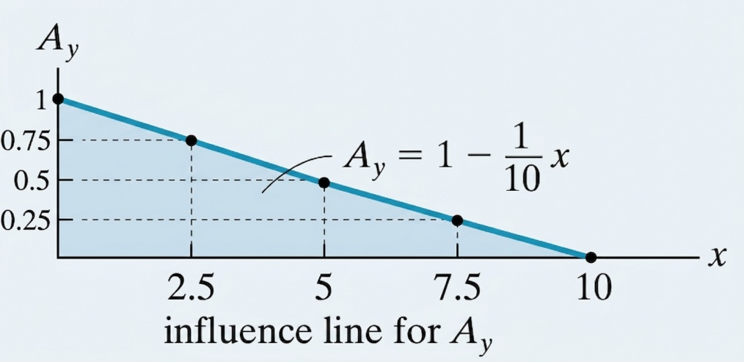
Fig 5
I.2.2 Influence-Line Equations
Rather than placing the unit load at specific points on the beam and plotting the values of Ay for each point, we can place the unit load a variable distance x from A, Fig 6. The reaction Ay as a function of x can be determined from.
Influence Line Equation
The equation expressing the reaction $A_{y}$ as a function of the position $x$ of the unit load ($P=1$) on the $10\text{ m}$ beam is:
$$A_{y}\left(x\right)=1-\frac{1}{10}x \text{for }0≤x≤10\text{ m}$$
Step-by-Step Derivation Method
- Definition of distances :
  - The total span of the beam is $L=10\text{ m}$.
  - The unit load $P=1$ is located at a distance $x$ from support $A$.
  - The lever arm of the load $P$ relative to support $B$ is $\left(10-x\right)$.
- Moment equilibrium equation about $B$ ($\sum{M_{B}}=0$):
Taking counterclockwise as positive, the reaction $A_{y}$ creates a clockwise (negative) moment and the unit load $1$ creates a counterclockwise (positive) moment about $B$:
$$-A_{y}⋅\left(10\right)+1⋅\left(10-x\right)=0$$
- Isolating $A_{y}$:
$$10⋅A_{y}=10-x$$
$$A_{y}=\frac{10-x}{10}=1-\frac{1}{10}x$$
Key Point Verification
- $x=0\text{ m}$: $A_{y}=1-\frac{0}{10}=1$
- $x=2.5\text{ m}$: $A_{y}=1-\frac{2.5}{10}=0.75$
- $x=5\text{ m}$: $A_{y}=1-\frac{5}{10}=0.5$
- $x=7.5\text{ m}$: $A_{y}=1-\frac{7.5}{10}=0.25$
- $x=10\text{ m}$: $A_{y}=1-\frac{10}{10}=0$
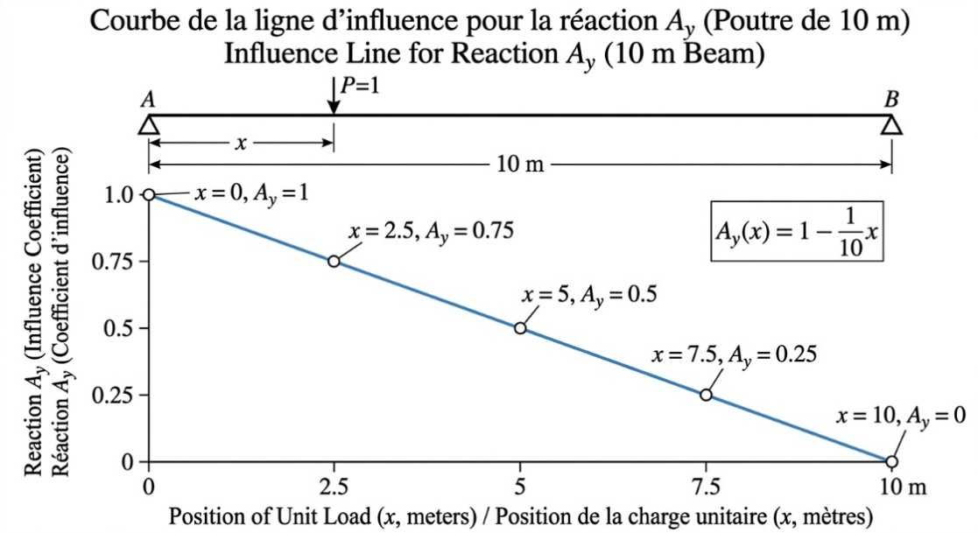
Fig 6

Example 02
Construct the influence line for the vertical reaction at B of the beam in Fig. 7.

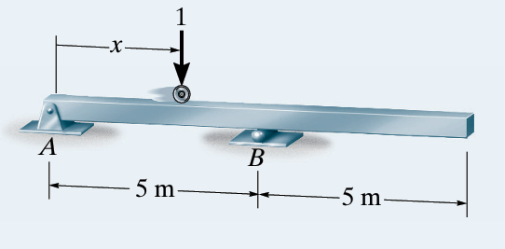
Fig 7
Soltution
Tabulate Values.
Statics verification for the reaction $B_{y}$ at each load position $x$ using moment equilibrium about support $A$ ($\sum{M_{A}}=0$, counterclockwise positive):
Step-by-Step Statics Calculations
- $x=0\text{ m}$ (Support A):
$$\sum{M_{A}}=0⟹B_{y}\left(5\right)-1\left(0\right)=0⟹B_{y}=0$$
- $x=2.5\text{ m}$ (Mid-span AB):
$$\sum{M_{A}}=0⟹B_{y}\left(5\right)-1\left(2.5\right)=0⟹B_{y}=\frac{2.5}{5}=0.5$$
- $x=5.0\text{ m}$ (Support B):
$$\sum{M_{A}}=0⟹B_{y}\left(5\right)-1\left(5\right)=0⟹B_{y}=\frac{5}{5}=1.0$$
- $x=7.5\text{ m}$ (Mid-overhang):
$$\sum{M_{A}}=0⟹B_{y}\left(5\right)-1\left(7.5\right)=0⟹B_{y}=\frac{7.5}{5}=1.5$$
- $x=10.0\text{ m}$ (Free End):
$$\sum{M_{A}}=0⟹B_{y}\left(5\right)-1\left(10\right)=0⟹B_{y}=\frac{10}{5}=2.0$$

Tabulated Values for $B_{y}$
Position x (m) | Moment Equilibrium Equation | Reaction By​
0.0 | $$B_{y}\left(5\right)-1\left(0\right)=0$$ | 0.0
2.5 | $$B_{y}\left(5\right)-1\left(2.5\right)=0$$ | 0.5
5.0 | $$B_{y}\left(5\right)-1\left(5\right)=0$$ | 1.0
7.5 | $$B_{y}\left(5\right)-1\left(7.5\right)=0$$ | 1.5
10.0 | $$B_{y}\left(5\right)-1\left(10\right)=0$$ | 2.0

Influence Line Equation for $B_{y}$
Influence-Line Equation. We must determine the reaction By when the unit load is placed a distance x from A, Fig. 7. Applying moment equilibrium about support $A$ ($\sum{M_{A}}=0$, taking counterclockwise moments as positive) yields the continuous equation for $B_{y}$ across the entire span Fig 8 : $0≤x≤10 \text{m}$:
$$\sum{M_{A}}=0⟹\left(B_{y}⋅5\right)-\left(1⋅x\right)=0$$
$$B_{y}\left(x\right)=\frac{x}{5}=0.2x \text{for }0≤x≤10\text{ m}$$
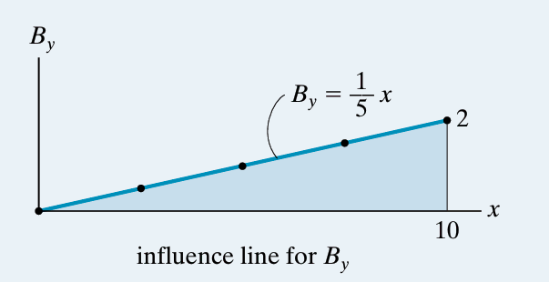
Fig 8

Example 3
Construct the influence line for the shear at point C of the beam in Fig. 9.
Fig 9
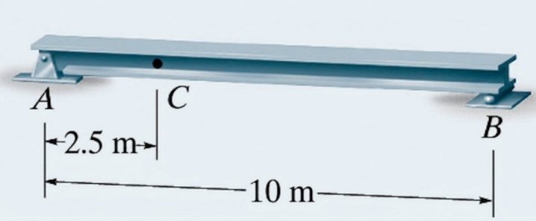
Solution
Tabulate Values. At each selected position x of the unit load, the method of sections is used to calculate the value of Vc. Note in particular that the unit load must be placed just to the left (x=2.5-) and just to the right (x=2.5+) of point C since the shear is discontinuous at C, Figs. 10 and 11. A plot of the values in Table 3 yields the influence line for the shear at C, Fig. 13. Here the diagram gives the shear at C as the unit load moves from one position to the next along the beam.
Internal shear force $V_{C}$ calculation using static equilibrium equations ($\sum{M_{A}}=0$ and $\sum{F_{y}}=0$) for each unit load position along the beam ($L=10\text{ ft}=3.048\text{ m}$) with section cut at $x_{C}=2.5\text{ ft}=0.762 \text{m}$:
1. Load at $x=0\text{ ft}$ ($0\text{ m}$)
- Support Reactions:
$$\sum{M_{A}}=0⟹B_{y}\left(10\right)-1\left(0\right)=0⟹B_{y}=0$$
$$\sum{F_{y}}=0⟹A_{y}+B_{y}-1=0⟹A_{y}=1$$
- Equilibrium of Left Segment $AC$:
$$\sum{F_{y}}=0⟹A_{y}-1-V_{C}=0⟹1-1-V_{C}=0⟹V_{C}=0$$
2. Load at $x={2.5}^{-}\text{ ft}$ (${0.762}^{-}\text{ m}$) — Just to the left of point $C$
- Support Reactions:
$$\sum{M_{A}}=0⟹B_{y}\left(10\right)-1\left(2.5\right)=0⟹B_{y}=0.25$$
$$\sum{F_{y}}=0⟹A_{y}=0.75$$
- Equilibrium of Right Segment $CB$:
$$\sum{F_{y}}=0⟹V_{C}+B_{y}=0⟹V_{C}+0.25=0⟹V_{C}=-0.25$$
3. Load at $x={2.5}^{+}\text{ ft}$ (${0.762}^{+}\text{ m}$) — Just to the right of point $C$
- Support Reactions:
$$\sum{M_{A}}=0⟹B_{y}\left(10\right)-1\left(2.5\right)=0⟹B_{y}=0.25$$
$$\sum{F_{y}}=0⟹A_{y}=0.75$$
- Equilibrium of Left Segment $AC$:
$$\sum{F_{y}}=0⟹A_{y}-V_{C}=0⟹0.75-V_{C}=0⟹V_{C}=+0.75$$
4. Load at $x=5\text{ ft}$ ($1.524\text{ m}$)
- Support Reactions:
$$\sum{M_{A}}=0⟹B_{y}\left(10\right)-1\left(5\right)=0⟹B_{y}=0.50$$
$$\sum{F_{y}}=0⟹A_{y}=0.50$$
- Equilibrium of Left Segment $AC$:
$$\sum{F_{y}}=0⟹A_{y}-V_{C}=0⟹0.50-V_{C}=0⟹V_{C}=+0.50$$
5. Load at $x=7.5\text{ ft}$ ($2.286\text{ m}$)
- Support Reactions:
$$\sum{M_{A}}=0⟹B_{y}\left(10\right)-1\left(7.5\right)=0⟹B_{y}=0.75$$
$$\sum{F_{y}}=0⟹A_{y}=0.25$$
- Equilibrium of Left Segment $AC$:
$$\sum{F_{y}}=0⟹A_{y}-V_{C}=0⟹0.25-V_{C}=0⟹V_{C}=+0.25$$
6. Load at $x=10\text{ ft}$ ($3.048\text{ m}$)
- Support Reactions:
$$\sum{M_{A}}=0⟹B_{y}\left(10\right)-1\left(10\right)=0⟹B_{y}=1.00$$
$$\sum{F_{y}}=0⟹A_{y}=0$$
- Equilibrium of Left Segment $AC$:
$$\sum{F_{y}}=0⟹A_{y}-V_{C}=0⟹0-V_{C}=0⟹V_{C}=0$$

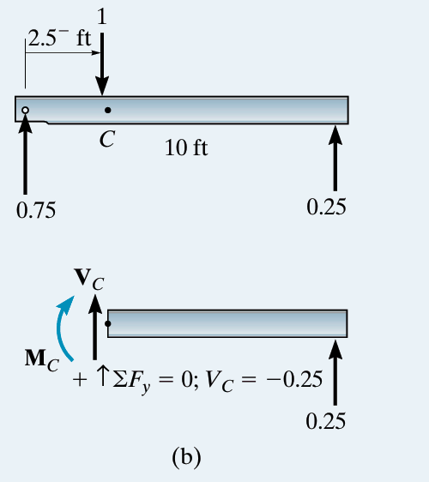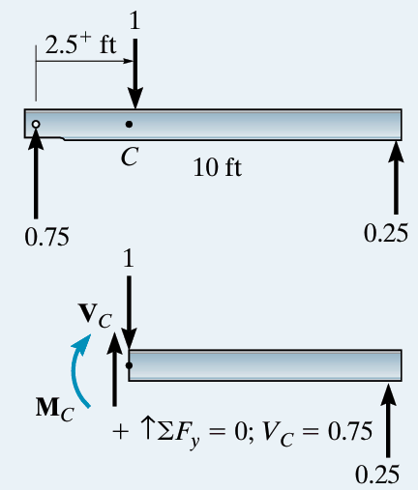
Fig 11
Fig 10
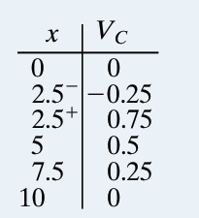
Table 3

Influence-Line Equations.
Here two equations have to be determined, since there are two segments for the influence line due to the discontinuity of shear at C. First we determine Ay, Fig 12. Using the result we then obtain the internal shear at C for each region, Fig. 13. The equations are plotted in Fig.14.
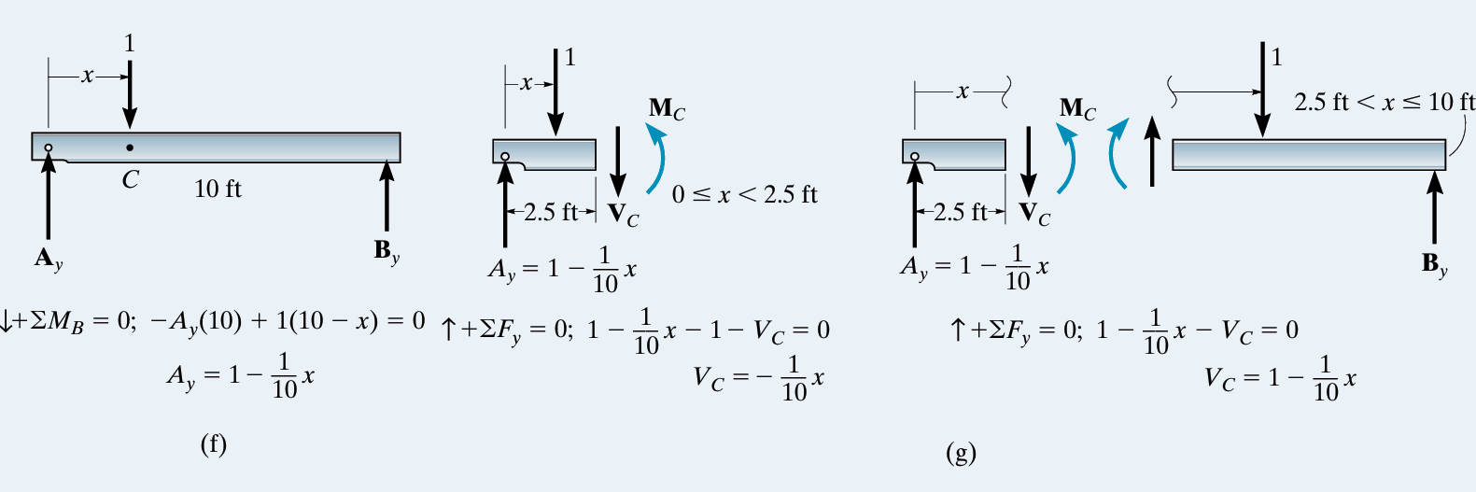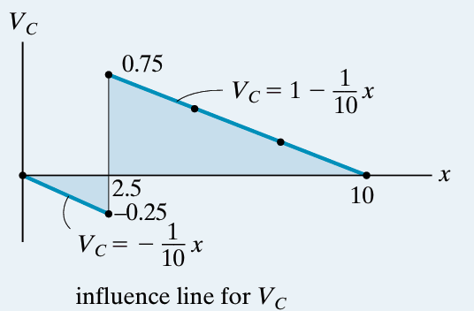
Fig 12
Fig 15
Fig 13
Example 04
Construct the influence line for the shear at point C of the beam in Fig. 14
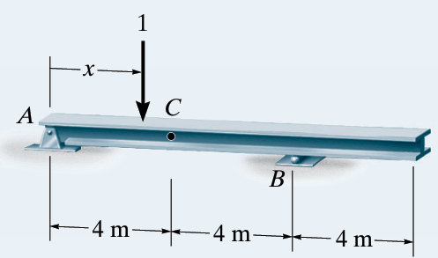
Fig 14

Tabluate values
Calculs Point par Point
- $x=0\text{ m}$ (Load at support $A$ / Charge en $A$) :
  - $\sum{M_{B}}=0⟹R_{A}⋅8-1⋅8=0⟹R_{A}=1,00$
  - $\sum{F_{y}}=0⟹R_{B}=1-1,00=0,00$
  - Shear force / Effort tranchant : $V_{C}=R_{A}-1=1,00-1=0,00$
- $x=2\text{ m}$ (Load between $A$ and $C$ / Charge entre $A$ et $C$) :
  - $\sum{M_{B}}=0⟹R_{A}⋅8-1⋅6=0⟹R_{A}=0,75$
  - $\sum{F_{y}}=0⟹R_{B}=1-0,75=0,25$
  - $V_{C}=R_{A}-1=0,75-1=-0,25$
- $x=4^{-}\text{ m}$ (Load just left of $C$ / Charge à gauche de $C$) :
  - $R_{A}=0,50$, $R_{B}=0,50$, $V_{C}=R_{A}-1=-0,50$
- $x=4^{+}\text{ m}$ (Load just right of $C$ / Charge à droite de $C$) :
  - $R_{A}=0,50$, $R_{B}=0,50$, $V_{C}=R_{A}=+0,50$
- $x=6\text{ m}$ (Load between $C$ and $B$ / Charge entre $C$ et $B$) :
  - $R_{A}=0,25$, $R_{B}=0,75$, $V_{C}=R_{A}=+0,25$
- $x=8\text{ m}$ (Load at support $B$ / Charge en $B$) :
  - $R_{A}=0,00$, $R_{B}=1,00$, $V_{C}=0,00$
- $x=10\text{ m}$ (Load on overhang / Charge sur le porte-à-faux) :
  - $\sum{M_{A}}=0⟹R_{B}⋅8-1⋅10=0⟹R_{B}=1,25$
  - $R_{A}=1-1,25=-0,25⟹V_{C}=-0,25$
- $x=12\text{ m}$ (Load at free end / Charge à l'extrémité libre) :
  - $R_{B}=1,50$, $R_{A}=-0,50⟹V_{C}=-0,50$
Tableau Récapitulatif (Summary Table)
Position x (m) | Reaction RA​ | Reaction RB​ | Shear Force VC​
0 | $$1.00$$ | $$0.00$$ | $$0.00$$
2 | $$0.75$$ | $$0.25$$ | $$-0.25$$
$$4^{-}$$ | $$0.50$$ | $$0.50$$ | $$-0.50$$
$$4^{+}$$ | $$0.50$$ | $$0.50$$ | $$+0.50$$
6 | $$0.25$$ | $$0.75$$ | $$+0.25$$
8 | $$0.00$$ | $$1.00$$ | $$0.00$$
10 | $$-0.25$$ | $$1.25$$ | $$-0.25$$
12 | $$-0.50$$ | $$1.50$$ | $$-0.50$$
Influence-Line Equations.
Support Reactions Equations (Équations des réactions d'appui)
- Moment equilibrium about $B$ ($\sum{M_{B}}=0$) [Équilibre des moments en $B$] :
$$R_{A}\left(x\right)⋅8-1⋅\left(8-x\right)=0⟹R_{A}\left(x\right)=1-\frac{x}{8}$$
- Vertical force equilibrium ($\sum{F_{y}}=0$) [Équilibre des forces verticales] :
$$R_{A}\left(x\right)+R_{B}\left(x\right)-1=0⟹R_{B}\left(x\right)=\frac{x}{8}$$
Influence Line Equations for Shear Force $V_{C}$ (Équations de l'effort tranchant en $C$)
- Segment 1 ($0≤x<4\text{ m}$) — Unit load to the left of $C$ (Charge à gauche de $C$) :
$$V_{C}\left(x\right)=R_{A}\left(x\right)-1=\left(1-\frac{x}{8}\right)-1=-\frac{x}{8}$$
- Segment 2 ($4<x≤12\text{ m}$) — Unit load to the right of $C$ (Charge à droite de $C$) :
$$V_{C}\left(x\right)=R_{A}\left(x\right)=1-\frac{x}{8}$$

Summary Table (Tableau des valeurs)
Position x (m) | Segment / Condition | Equation for VC​ | Calculation | Shear Force VC​
0 | $$0≤x<4$$ | $$V_{C}=-\frac{x}{8}$$ | $$-\frac{0}{8}$$ | 0.00
2 | $$0≤x<4$$ | $$V_{C}=-\frac{x}{8}$$ | $$-\frac{2}{8}$$ | -0.25
$$4^{-}$$ | Just left of $C$ | $$V_{C}=-\frac{x}{8}$$ | $$-\frac{4}{8}$$ | -0.50
$$4^{+}$$ | Just right of $C$ | $$V_{C}=1-\frac{x}{8}$$ | $$1-\frac{4}{8}$$ | +0.50
6 | $$4<x≤12$$ | $$V_{C}=1-\frac{x}{8}$$ | $$1-\frac{6}{8}$$ | +0.25
8 | $$4<x≤12$$ | $$V_{C}=1-\frac{x}{8}$$ | $$1-\frac{8}{8}$$ | 0.00
10 | $$4<x≤12$$ | $$V_{C}=1-\frac{x}{8}$$ | $$1-\frac{10}{8}$$ | -0.25
12 | $$4<x≤12$$ | $$V_{C}=1-\frac{x}{8}$$ | $$1-\frac{12}{8}$$ | -0.50

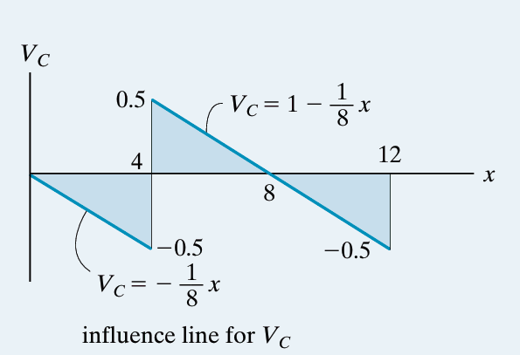
Fig 16

Example 05
Construct the influence line for the moment at point C of the beam in Fig. 17.
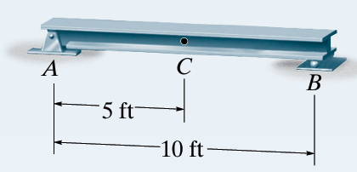
Fig 17
Solution
Tabulate values
At each selected position of the unit load, the value of MC is calculated using the method of sections. For example, see Fig. 18 for x=2.5 ft. A plot of the values in Table 04 yields the influence line for the moment at C figure 19. This diagram gives the moment at C as the unit load moves from one position to the next along the beam.

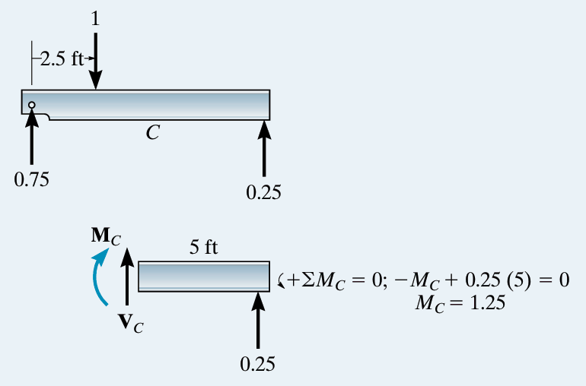
Fig 18
Direct Point-by-Point Calculations (Calculs directs point par point)
- $x=0\text{ ft}$ (Load at support $A$ / Charge en $A$) :
  - $\sum{M_{B}}=0⟹R_{A}⋅10-1⋅10=0⟹R_{A}=1.00$
  - $\sum{F_{y}}=0⟹R_{B}=1-1.00=0.00$
  - Bending moment / Moment fléchissant : $M_{C}=R_{B}⋅5=0.00⋅5=0.00\text{ ft}$
- $x=2.5\text{ ft}$ (Load between $A$ and $C$ / Charge entre $A$ et $C$) :
  - $\sum{M_{B}}=0⟹R_{A}⋅10-1⋅7.5=0⟹R_{A}=0.75$
  - $\sum{F_{y}}=0⟹R_{B}=1-0.75=0.25$
  - Bending moment / Moment fléchissant : $M_{C}=R_{B}⋅5=0.25⋅5=1.25\text{ ft}$
- $x=5\text{ ft}$ (Load at point $C$ / Charge en $C$) :
  - $\sum{M_{B}}=0⟹R_{A}⋅10-1⋅5=0⟹R_{A}=0.50$
  - $\sum{F_{y}}=0⟹R_{B}=1-0.50=0.50$
  - Bending moment / Moment fléchissant : $M_{C}=R_{A}⋅5=0.50⋅5=2.50\text{ ft}$
- $x=7.5\text{ ft}$ (Load between $C$ and $B$ / Charge entre $C$ et $B$) :
  - $\sum{M_{B}}=0⟹R_{A}⋅10-1⋅2.5=0⟹R_{A}=0.25$
  - $\sum{F_{y}}=0⟹R_{B}=1-0.25=0.75$
  - Bending moment / Moment fléchissant : $M_{C}=R_{A}⋅5=0.25⋅5=1.25\text{ ft}$
- $x=10\text{ ft}$ (Load at support $B$ / Charge en $B$) :
  - $\sum{M_{B}}=0⟹R_{A}⋅10-1⋅0=0⟹R_{A}=0.00$
  - $\sum{F_{y}}=0⟹R_{B}=1-0.00=1.00$
  - Bending moment / Moment fléchissant : $M_{C}=R_{A}⋅5=0.00⋅5=0.00\text{ ft}$
Summary Table 04 (Tableau Récapitulatif)
Position x (ft) | Reaction RA​ | Reaction RB​ | Bending Moment MC​ (ft)
0 | $$1.00$$ | $$0.00$$ | $$0.00$$
2.5 | $$0.75$$ | $$0.25$$ | $$1.25$$
5 | $$0.50$$ | $$0.50$$ | $$2.50$$
7.5 | $$0.25$$ | $$0.75$$ | $$1.25$$
10 | $$0.00$$ | $$1.00$$ | $$0.00$$
Fig 19
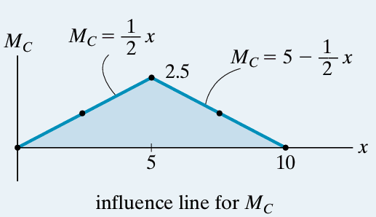

Influence-Line Equations.
The two line segments for the influence line can be determined using $\sum{M_{c}}$ = 0 along with the method of sections shown in Fig. 19.
Support Reactions Equations
- Moment equilibrium about support $B$ ($\sum{M_{B}}=0$) :
$$R_{A}\left(x\right)⋅10-1⋅\left(10-x\right)=0⟹R_{A}\left(x\right)=1-\frac{x}{10}$$
- Vertical force equilibrium ($\sum{F_{y}}=0$) :
$$R_{A}\left(x\right)+R_{B}\left(x\right)-1=0⟹R_{B}\left(x\right)=\frac{x}{10}$$
Bending Moment Equations for $M_{C}$ (Équations du moment fléchissant en $C$)
- Segment 1 ($0≤x≤5\text{ ft}$) — Unit load to the left of $C$ (figure 20.a):
$$M_{C}\left(x\right)=R_{B}\left(x\right)⋅5=\left(\frac{x}{10}\right)⋅5=0.5x$$
- Segment 2 ($5≤x≤10\text{ ft}$) — Unit load to the right of $C (figure 20.b)$ :
$$M_{C}\left(x\right)=R_{A}\left(x\right)⋅5=\left(1-\frac{x}{10}\right)⋅5=5-0.5x$$

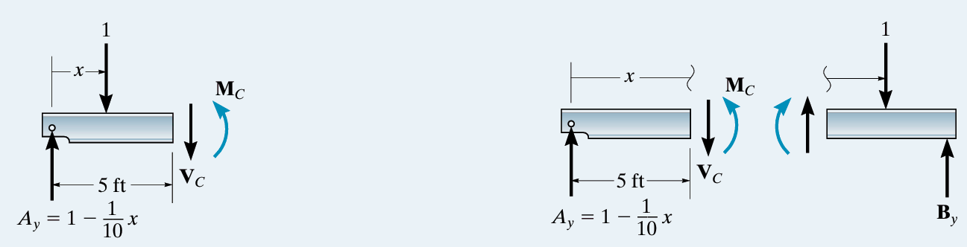
Fig 20.a
Fig 20.b

Summary Table (Tableau récapitulatif par équations)
Position x (ft) | Segment / Condition | Equation for MC​ | Calculation | Reaction RA​ | Reaction RB​ | Bending Moment MC​ (ft)
0 | $$0≤x≤5$$ | $$M_{C}=0.5x$$ | $$0.5⋅0$$ | $$1.00$$ | $$0.00$$ | 0.00
2.5 | $$0≤x≤5$$ | $$M_{C}=0.5x$$ | $$0.5⋅2.5$$ | $$0.75$$ | $$0.25$$ | 1.25
5 | Point $C$ | $$M_{C}=0.5x$$ | $$0.5⋅5$$ | $$0.50$$ | $$0.50$$ | 2.50
7.5 | $$5≤x≤10$$ | $$M_{C}=5-0.5x$$ | $$5-0.5⋅7.5$$ | $$0.25$$ | $$0.75$$ | 1.25
10 | $$5≤x≤10$$ | $$M_{C}=5-0.5x$$ | $$5-0.5⋅10$$ | $$0.00$$ | $$1.00$$ | 0.00

Example 06
Construct the influence line for the moment at point C of the beam in Fig. 21
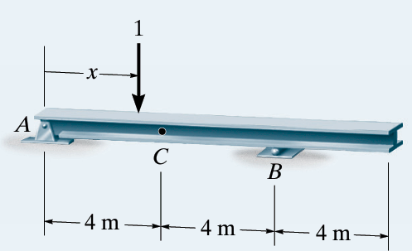
Fig 21

SOLUTION
Tabulate Values. Using statics and the method of sections, verify that the values of the moment MC at point C in Fig. 21 correspond to each position x of the unit load. A plot of the values in Fig. 22.b yields the influence line in Fig. 22.c.
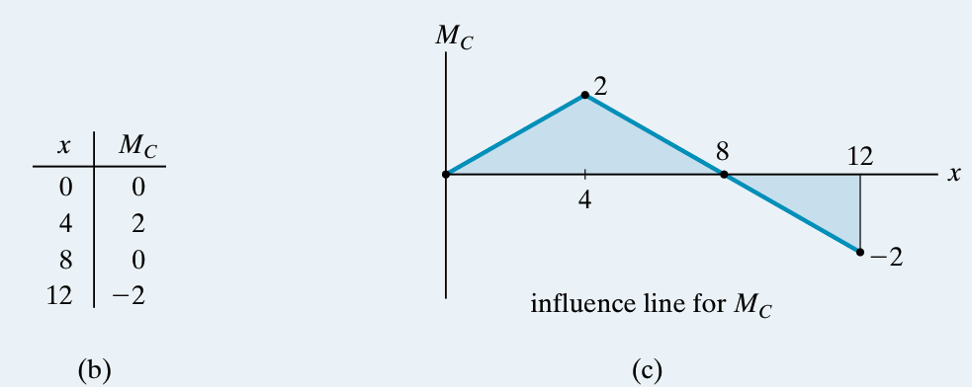
Fig 22

Influence-Line Equations.
Support Reactions Equations (Équations des réactions d'appui)
- Moment equilibrium about $B$ ($\sum{M_{B}}=0$) [Équilibre des moments en $B$] :
$$R_{A}\left(x\right)⋅8-1⋅\left(8-x\right)=0⟹R_{A}\left(x\right)=1-\frac{x}{8}$$
- Vertical force equilibrium ($\sum{F_{y}}=0$) [Équilibre des forces verticales] :
$$R_{A}\left(x\right)+R_{B}\left(x\right)-1=0⟹R_{B}\left(x\right)=\frac{x}{8}$$
Influence Line Equations for Bending Moment $M_{C}$ (Équations du moment fléchissant)
- Segment 1 ($0≤x≤4\text{ m}$) — Unit load to the left of $C$ (Charge à gauche de $C$) :
$$M_{C}\left(x\right)=R_{B}\left(x\right)⋅4=\left(\frac{x}{8}\right)⋅4=0.5x$$
- Segment 2 ($4≤x≤12\text{ m}$) — Unit load to the right of $C$ (Charge à droite de $C$) :
$$M_{C}\left(x\right)=R_{A}\left(x\right)⋅4=\left(1-\frac{x}{8}\right)⋅4=4-0.5x$$
Summary Table (Tableau Récapitulatif)
Position x (m) | Segment / Condition | Equation for MC​ | Reaction RA​ | Reaction RB​ | Bending Moment MC​ (m)
0 | $$0≤x≤4$$ | $$M_{C}=0.5⋅0$$ | $$1.00$$ | $$0.00$$ | 0.00
2 | $$0≤x≤4$$ | $$M_{C}=0.5⋅2$$ | $$0.75$$ | $$0.25$$ | 1.00
4 | Point $C$ | $$M_{C}=0.5⋅4$$ | $$0.50$$ | $$0.50$$ | 2.00
6 | $$4≤x≤12$$ | $$M_{C}=4-0.5⋅6$$ | $$0.25$$ | $$0.75$$ | 1.00
8 | Support $B$ | $$M_{C}=4-0.5⋅8$$ | $$0.00$$ | $$1.00$$ | 0.00
10 | Overhang (Console) | $$M_{C}=4-0.5⋅10$$ | $$-0.25$$ | $$1.25$$ | -1.00
12 | Free End (Extrémité libre) | $$M_{C}=4-0.5⋅12$$ | $$-0.50$$ | $$1.50$$ | -2.00

I.3 MÜLLER-BRESLAU PRINCIPLE : QUALITATIVE KINEMATIC APPROACH
In 1886, Heinrich Müller-Breslau developed a technique for quickly determining the shape of an influence line.
The Müller-Breslau principle is based on the principle of virtual work and provides a simple way to construct the qualitative shape of influence lines.
Principle
The qualitative shape of the influence line for a given function, such as:
- Support reaction (R)
- Shear force (T) or (V)
- Bending moment (M)
can be obtained by:
- Releasing the restraint corresponding to the function being studied at the section where the influence line is required.
- Applying a unit action corresponding to this function in its positive direction.
- Allowing the modified structure to deform.
The deflected shape of the modified structure represents the qualitative shape of the influence line.
Easy rule to remember
RELEASE → APPLY → DEFORM → INFLUENCE LINE
Example 1: Influence Line for the Vertical Reaction (Ay)
Consider the beam shown in Fig. 23.a.
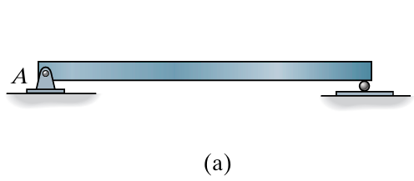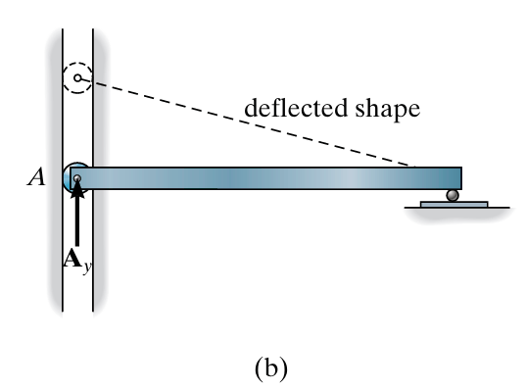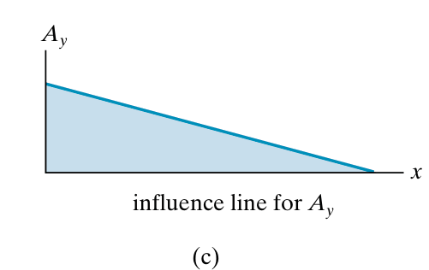
Fig 23
We want to determine the qualitative shape of the influence line for the vertical reaction (Ay) at A.
Step 1 – Release the reaction
Replace the pin at A with a roller guide, as shown in Fig. 23.b.
The roller guide still allows the beam to resist the horizontal force, but it cannot resist the vertical reaction (Ay).
Step 2 – Apply the positive action
Apply a positive upward force (Ay) at A.
Step 3 – Observe the deformation
The beam deflects into the dashed position shown in Fig. 23.c.
Conclusion
The dashed deflected shape in Fig. 23.c represents the qualitative shape of the influence line for (Ay).
Remember:
Release (Ay) → Apply (+Ay) → Observe the deflected shape → Influence line for (Ay).
Example 2: Influence Line for the Shear Force at C
Let us determine the qualitative shape of the influence line for the shear force (VC) at section (C), as shown in Fig. 24.a.
Step 1 – Release the shear
The section at (C) is replaced by a roller guide, as shown in Fig. 24.b.
This support can resist moment and axial force, but it cannot resist shear force.
Step 2 – Apply the positive shear
Apply a positive shear force (VC) at point (C).
Step 3 – Observe the deformation
The beam deforms into the dotted shape shown in Fig. 24.b.
Step 4 – Obtain the influence line
This deformed shape gives the qualitative shape of the influence line for (VC), as shown in Fig. 24.c.
Conclusion
Release the shear → Apply (+VC) → Observe the deformation → Obtain the influence line for (VC).
Fig 24
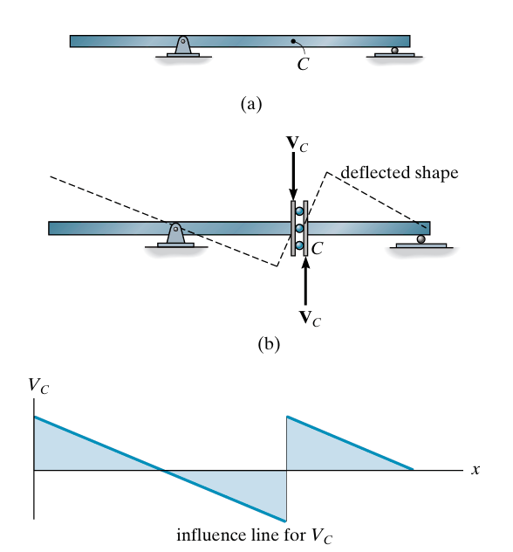

Example 3: Influence Line for the Bending Moment at C
Let us determine the qualitative shape of the influence line for the bending moment $M_{C}$at section $C$, as shown in Fig. 25.a.
Step 1 – Release the moment
Introduce an internal hinge (articulation) at $C$, as shown in Fig. 25.b.
The internal hinge can resist axial and shear forces, but it cannot resist a bending moment.
Step 2 – Apply the positive moment
Apply a positive bending moment $M_{C}$at $C$.
Step 3 – Observe the deformation
The beam deforms into the dotted position shown in Fig. 25.b.
Step 4 – Obtain the influence line
The resulting deformed shape represents the qualitative shape of the influence line for $M_{C}$, as shown in Fig. 25.c.
Conclusion
Release the moment → Apply $+M_{C}$→ Observe the deformation → Obtain the influence line for $M_{C}$.
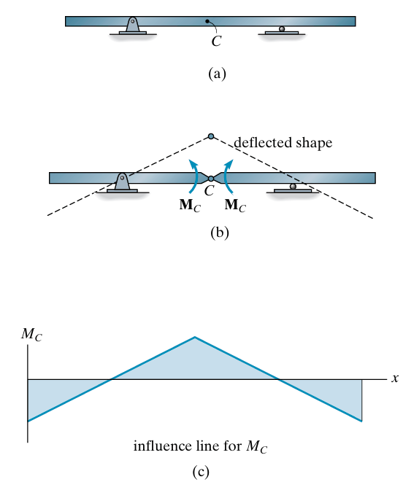
Fig 25

Exmaple 4
For each beam in Fig. 26.a through 26.c, sketch the influence line for the vertical reaction at A

SOLUTION
The support is replaced by a roller guide at A since it will resist Ax, but not Ay. The force Ay is then applied.
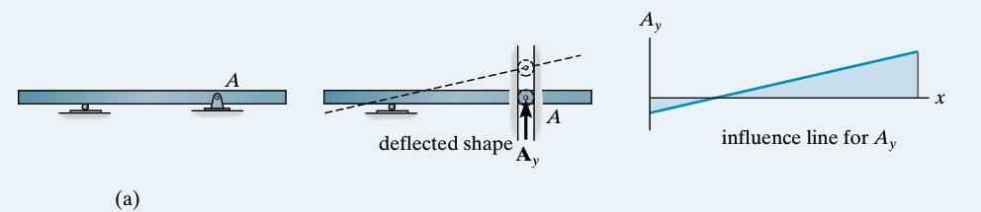
Fig 26
Again, a roller guide is placed at A and the force Ay is applied
Fig 26
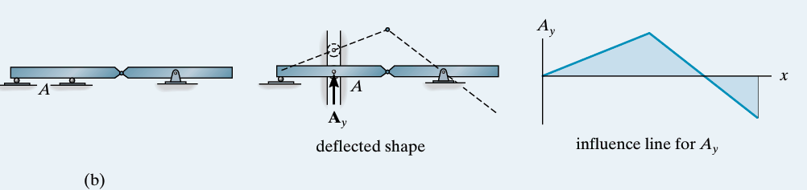

A double-roller guide must be used at A in this case, since this type of support will resist both a moment MA at the fixed support and axial load Ax, but will not resist Ay.
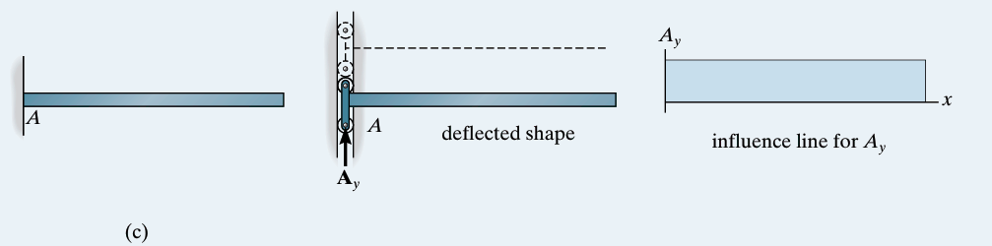
Fig 26
Example 05
For each beam in Figs. 27.a through 27.c, sketch the influence line for the shear at B.
SOLUTION
The roller guide is introduced at B and the positive shear VB is applied. Notice that the right segment of the beam will not deflect since the roller at A actually constrains the beam from moving vertically, either up or down
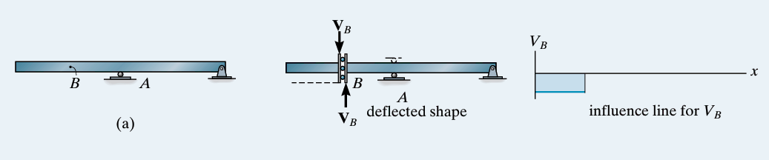
Fig 27
Placing the roller guide at B and applying the positive shear at B yields the deflected shape and corresponding influence line.
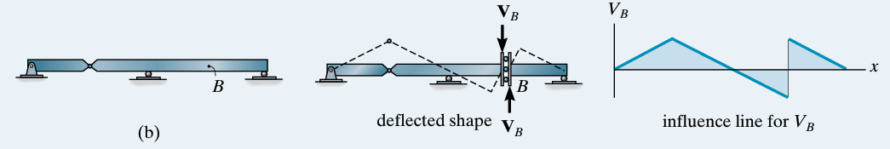
Fig 27

Again, the roller guide is placed at B, the positive shear is applied, and the deflected shape and corresponding influence line are shown. Note that the left segment of the beam does not deflect, due to the fixed support.
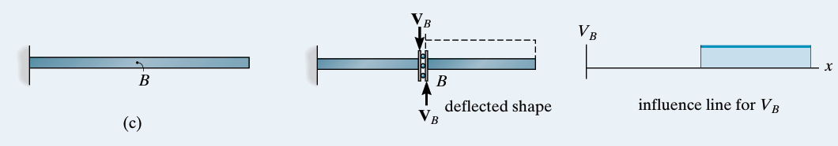
Fig 27
Example 06
For each beam in Figs. 28.a through Fig. 28.c, sketch the influence line for the moment at B.
SOLUTION
A hinge is introduced at B and positive moments MB are applied to the beam. The deflected shape and corresponding influence line are shown.
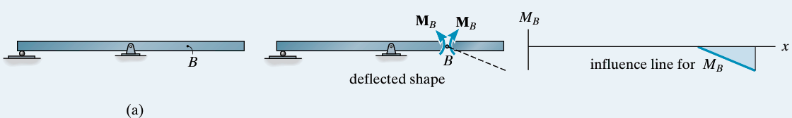
Fig 28
Placing a hinge at B and applying positive moments MB to the beam yields the deflected shape and influence line.
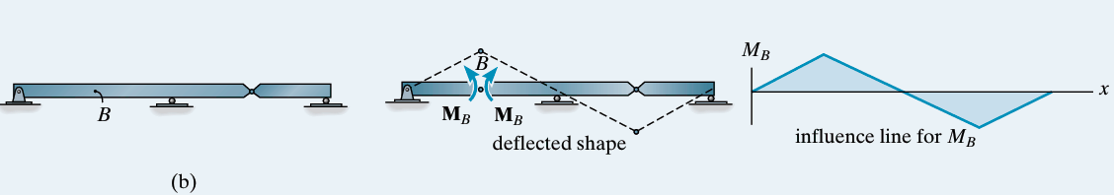
With the hinge and positive moment at B the deflected shape and influence line are shown. The left segment of the beam is constrained from moving due to the fixed wall at A
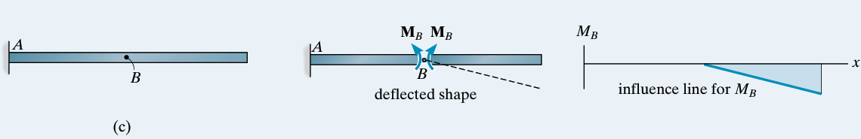

I.4. Influence Lines for Floor Girders
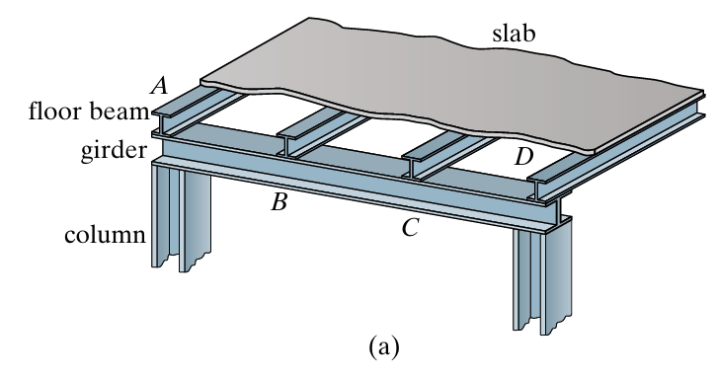
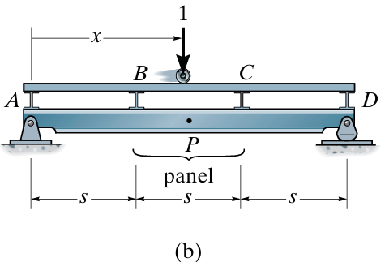
In a floor system, loads are transferred from the slab to the floor beams, then to the girder, and finally to the columns. The girder is simply supported by the columns. As shown in Fig. 29.a, the load is transferred to the girder at specific points A, B, C, and D, called panel points. The part between two panel points, such as B–C in Fig. 29.b, is called a panel. These points are important for drawing the influence lines of the girder.
$$R_{A}$$
$$R_{D}$$
$$F_{B}$$
$$F_{C}$$
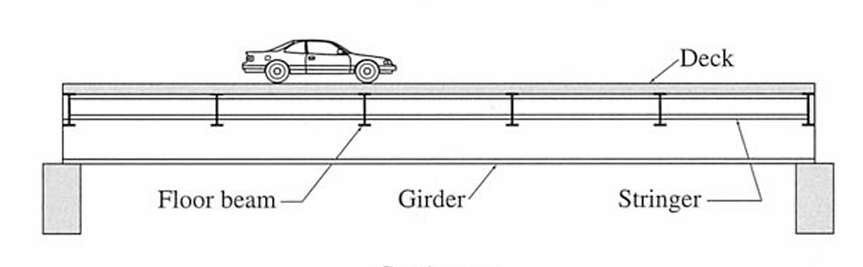

The influence line for a specified point on the girder can be determined using the same statics procedure, place the unit load at various points x on the floor slab and always compute the function (shear or moment) at the specified point P in the girder, Fig. 29.b. Plotting these values versus x yields the influence line for the function at P.
For example, when the unit load is placed on the floor slab, as shown in Fig. 29.b:
- Determine the slab reactions $F_{B}$and $F_{C}$.
- Use these reactions to calculate the girder support reactions $F_{A }$and $F_{D}$.
- Cut the girder at point $P$and use the method of sections to determine the internal shear $V_{P }$and internal moment${ M}_{P }$.
$$V_{P }=R_{A }-F_{B}$$
${ M}_{P }$​=$R_{A }$x−$F_{B}$​(x−s)
where:
- $V_{P}$= internal shear at point $P$
- $M_{P}$= internal moment at point $P$
- $R_{A}$= girder reaction at $A$
- $F_{B}$= reaction from the floor slab at $B$
- $x$= distance from $A$to $P$
- $s$= distance from $A$to $B$
Important : $V_{P}$is constant within the panel $BC$, whereas $M_{P}$depends on the exact position of $P$.
Step-by-Step Analysis
1. Slab Reactions ($F_{B}$ and $F_{C}$)
For a unit load acting on slab panel $BC$ at distance $x$ from $A$:
- Span of the panel segment = $s$
- Position of unit load relative to point $B$ = $x-s$
Applying static equilibrium to the slab span $BC$:
- $\sum{M_{C}}=0⟹F_{B}⋅s=1⋅\left(2s-x\right)$
$$F_{B}=\frac{2s-x}{s}=2-\frac{x}{s}$$
- $\sum{M_{B}}=0⟹F_{C}⋅s=1⋅\left(x-s\right)$
$$F_{C}=\frac{x-s}{s}=\frac{x}{s}-1$$
Girder Support Reactions ($R_{A}$ and $R_{D}$)
The total length of the girder is $L=3s$. The loads transmitted from the slab through the floor beams onto the girder are $F_{B}$ at point $B$ ($x=s$) and $F_{C}$ at point $C$ ($x=2s$).
Applying equilibrium to the entire girder:
- Taking moments about $D$ ($x=3s$):
$$\sum{M_{D}}=0⟹R_{A}\left(3s\right)=F_{B}\left(2s\right)+F_{C}\left(s\right)$$
$$R_{A}\left(3s\right)=\left(2-\frac{x}{s}\right)\left(2s\right)+\left(\frac{x}{s}-1\right)\left(s\right)=3s-x$$
$$R_{A}=\frac{3s-x}{3s}=1-\frac{x}{3s}$$
- Taking moments about $A$ ($x=0$):
$$\sum{M_{A}}=0⟹R_{D}\left(3s\right)=F_{B}\left(s\right)+F_{C}\left(2s\right)$$
$$R_{D}\left(3s\right)=\left(2-\frac{x}{s}\right)\left(s\right)+\left(\frac{x}{s}-1\right)\left(2s\right)=x$$
$$R_{D}=\frac{x}{3s}$$
- Internal Forces at Point $P$ ($V_{P}$ and $M_{P}$)
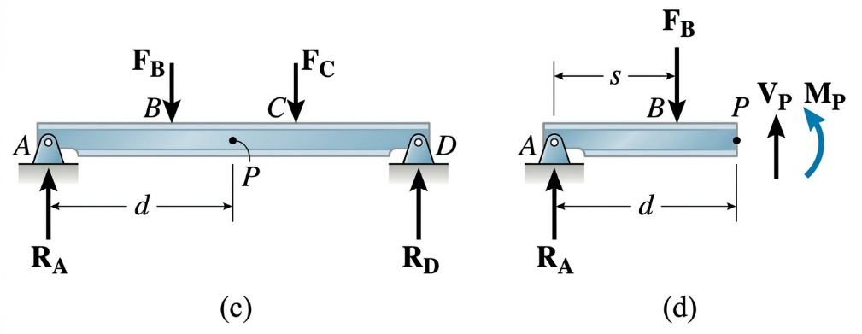
Consider a section cut at point $P$ located at distance $d$ from support $A$ (where $s<d<2s$). Isolate the left segment of the girder ($A$ to $P$) Fig29.c and Fig 29.d:

- Internal Shear ($V_{P}$):
$$\sum{F_{y}}=0⟹R_{A}-F_{B}-V_{P}=0$$
$$V_{P}=R_{A}-F_{B}=\left(1-\frac{x}{3s}\right)-\left(2-\frac{x}{s}\right)=-1+\frac{2x}{3s}$$
(Note: $V_{P}$ depends only on the unit load position $x$, remaining uniform for any point $P$ within panel $BC$.)
- Internal Moment ($M_{P}$):
$$\sum{M_{P}}=0⟹M_{P}=R_{A}⋅d-F_{B}⋅\left(d-s\right)$$
$$M_{P}=\left(1-\frac{x}{3s}\right)d-\left(2-\frac{x}{s}\right)\left(d-s\right)$$
$$M_{P}=2s-d-x+\frac{2xd}{3s}$$
Here is the calculation summary for the three unit load positions (measuring distance $x$ from support $A$):
Case 1: Unit Load at Point $B$ ($x=s$)
- Slab Reactions:
  - $F_{B}=2-\frac{s}{s}=1$
  - $F_{C}=\frac{s}{s}-1=0$
- Girder Support Reactions:
  - $R_{A}=1-\frac{s}{3s}=\frac{2}{3}$
  - $R_{D}=\frac{s}{3s}=\frac{1}{3}$
- Internal Forces at Point $P$:
  - Shear force: $V_{P}=-1+\frac{2\left(s\right)}{3s}=-\frac{1}{3}$
  - Bending moment: $M_{P}=\left(\frac{2}{3}\right)d-1\left(d-s\right)=s-\frac{1}{3}d$
Intermediate Case: Unit Load Between $B$ and $C$ (Midpoint of Panel, $x=1.5s=\frac{3}{2}s$)
The midpoint of panel $BC$ is located at distance $x=s+0.5s=1.5s$ from support $A$.
- Slab Reactions:
  - $F_{B}=2-\frac{1.5s}{s}=\frac{1}{2}$
  - $F_{C}=\frac{1.5s}{s}-1=\frac{1}{2}$
- Girder Support Reactions:
  - $R_{A}=1-\frac{1.5s}{3s}=\frac{1}{2}$
  - $R_{D}=\frac{1.5s}{3s}=\frac{1}{2}$
- Internal Forces at Point $P$:
  - Shear force: $V_{P}=R_{A}-F_{B}=\frac{1}{2}-\frac{1}{2}=0$
  - Bending moment: $M_{P}=\left(\frac{1}{2}\right)d-\frac{1}{2}\left(d-s\right)=\frac{1}{2}s$
Case 2: Unit Load at Point $C$ ($x=2s$)
- Slab Reactions:
  - $F_{B}=2-\frac{2s}{s}=0$
  - $F_{C}=\frac{2s}{s}-1=1$
- Girder Support Reactions:
  - $R_{A}=1-\frac{2s}{3s}=\frac{1}{3}$
  - $R_{D}=\frac{2s}{3s}=\frac{2}{3}$
- Internal Forces at Point $P$:
  - Shear force: $V_{P}=-1+\frac{2\left(2s\right)}{3s}=\frac{1}{3}$
  - Bending moment: $M_{P}=\left(\frac{1}{3}\right)d-0\left(d-s\right)=\frac{1}{3}d$
What this means for the Influence Line (IL)Because the transmitted panel loads $F_{B}$and $F_{c }$vary linearly (as straight lines) between B and C, any structural effect in the main girder (support reactions, shear force $V_{P}$, or bending moment $M_{P}$) must also vary linearly as a straight line across panel BC
💡The Golden Rule in Practice
- Thanks to this fundamental property, you never need to set up equations for load positions in the middle of a panel!To draw a complete Influence Line for an indirectly loaded floor system:Calculate the effect only when the unit load is placed at each panel point (A, B, C, D, etc.).Plot these specific values on your diagram.Connect adjacent points using straight line segments.
- As long as the load remains in panel $CD$, panel $BC$ receives no direct transferred load. The internal shear passing through this entire panel remains completely constant from $B$ to $C$, equal to the support reaction $R_{A}$.
Example 01
Draw the influence line for the shear in panel CD of the floor girder in Fig. 30.a.
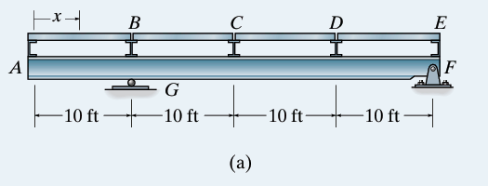
Derivation of Support Reactions $R_{G}$ and $R_{F}$
The main girder rests on a roller support at $G$ ($x=10\text{ ft}$) and a pin support at $F$ ($x=40\text{ ft}$). The distance between supports is $L_{GF}=40-10=30\text{ ft}$.
To derive the support reaction formulas for any unit load position $x$ measured from point $A$:
- Sum of moments about support $F$ ($x=40\text{ ft}$):
$$\sum{M_{F}}=0⟹R_{G}⋅\left(40-10\right)-1⋅\left(40-x\right)=0$$
$$30R_{G}=40-x⟹R_{G}=\frac{40-x}{30}$$
- Sum of moments about support $G$ ($x=10\text{ ft}$):
$$\sum{M_{G}}=0⟹R_{F}⋅\left(40-10\right)-1⋅\left(x-10\right)=0$$
$$30R_{F}=x-10⟹R_{F}=\frac{x-10}{30}$$
- Vertical Equilibrium Check:
$$R_{G}+R_{F}=\frac{40-x}{30}+\frac{x-10}{30}=\frac{30}{30}=1 \text{(Satisfied)}$$
2. General Expression for Panel Shear $V_{CD}$
To find the internal shear force $V_{CD}$, make a section cut anywhere inside panel $CD$ ($20\text{ ft}<x_{\text{cut}}<30\text{ ft}$) and sum the vertical forces acting to the left of the cut:
$$\sum{F_{y}}=0⟹R_{G}-F_{A}-F_{B}-F_{C}-V_{CD}=0$$
$$V_{CD}=R_{G}-\left(F_{A}+F_{B}+F_{C}\right)$$
3. Detailed Step-by-Step Calculations
Case 1: Load at Node $A$ ($x=0\text{ ft}$)
- Reactions:
$$R_{G}=\frac{40-0}{30}=\frac{40}{30}=\frac{4}{3}$$
$$R_{F}=\frac{0-10}{30}=-\frac{10}{30}=-\frac{1}{3}$$
- Transmitted Floor Loads: $F_{A}=1$, $F_{B}=0$, $F_{C}=0$
- Panel Shear:
$$V_{CD}=R_{G}-F_{A}=\frac{4}{3}-1=+\frac{1}{3}$$
Case 2: Load at Node $B$ ($x=10\text{ ft}$)
- Reactions:
$$R_{G}=\frac{40-10}{30}=\frac{30}{30}=1$$
$$R_{F}=\frac{10-10}{30}=0$$
- Transmitted Floor Loads: $F_{A}=0$, $F_{B}=1$, $F_{C}=0$
- Panel Shear:
$$V_{CD}=R_{G}-F_{B}=1-1=0$$
Case 3: Load at Node $C$ ($x=20\text{ ft}$)
- Reactions:
$$R_{G}=\frac{40-20}{30}=\frac{20}{30}=\frac{2}{3}$$
$$R_{F}=\frac{20-10}{30}=\frac{10}{30}=\frac{1}{3}$$
- Transmitted Floor Loads: $F_{A}=0$, $F_{B}=0$, $F_{C}=1$
- Panel Shear:
$$V_{CD}=R_{G}-F_{C}=\frac{2}{3}-1=-\frac{1}{3}$$
Case 4: Load at Midpoint of Panel $CD$ ($x=25\text{ ft}$)
- Reactions:
$$R_{G}=\frac{40-25}{30}=\frac{15}{30}=\frac{1}{2}$$
$$R_{F}=\frac{25-10}{30}=\frac{15}{30}=\frac{1}{2}$$
- Transmitted Floor Loads (Distributed across Panel $CD$):
$$F_{C}=\frac{30-25}{10}=\frac{5}{10}=\frac{1}{2}$$
$$F_{D}=\frac{25-20}{10}=\frac{5}{10}=\frac{1}{2}$$
$$F_{A}=0, F_{B}=0$$
- Panel Shear:
$$V_{CD}=R_{G}-F_{C}=\frac{1}{2}-\frac{1}{2}=0$$
Case 5: Load at Node $D$ ($x=30\text{ ft}$)
- Reactions:
$$R_{G}=\frac{40-30}{30}=\frac{10}{30}=\frac{1}{3}$$
$$R_{F}=\frac{30-10}{30}=\frac{20}{30}=\frac{2}{3}$$
- Transmitted Floor Loads:
$$F_{A}=0, F_{B}=0, F_{C}=0, F_{D}=1$$
- Panel Shear:
(Since $F_{D}$ acts to the right of the section cut, it does not enter the left-hand section equilibrium)
$$V_{CD}=R_{G}-0=+\frac{1}{3}$$
Case 6: Load at Node $E$ ($x=40\text{ ft}$)
- Reactions:
$$R_{G}=\frac{40-40}{30}=0$$
$$R_{F}=\frac{40-10}{30}=\frac{30}{30}=1$$
- Transmitted Floor Loads:
$$F_{A}=0, F_{B}=0, F_{C}=0, F_{E}=1$$
- Panel Shear:
$$V_{CD}=R_{G}-0=0$$
4. Summary Table
Load Position x | Panel Point | $R_{G}$​ | $$R_{F}$$ | F$F_{C}$ | Panel Shear $V_{CD}$​
$$0\text{ ft}$$ | A | $$+4/3$$ | $$-1/3$$ | $$0$$ | $$+1/3$$
$$10\text{ ft}$$ | B (G) | $$1$$ | $$0$$ | $$0$$ | $$0$$
$$20\text{ ft}$$ | C | $$+2/3$$ | $$+1/3$$ | $$1$$ | $$-1/3$$
$$25\text{ ft}$$ | Midpoint CD | $$+1/2$$ | $$+1/2$$ | $$1/2$$ | $$0$$
$$30\text{ ft}$$ | D | $$+1/3$$ | $$+2/3$$ | $$0$$ | $$+1/3$$
$$40\text{ ft}$$ | E (F) | $$0$$ | $$1$$ | $$0$$ | $$0$$
Influence Line. When the tabular values are plotted and the points connected with straight line segments, the resulting influence line for $V_{CD}$ is as shown in Fig. 30.e.
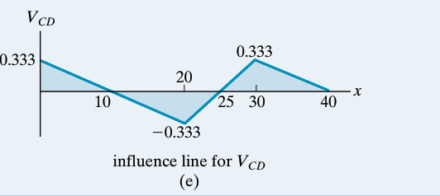
Example 2
Draw the influence line for the moment at point F for the floor girder in Fig. 31.
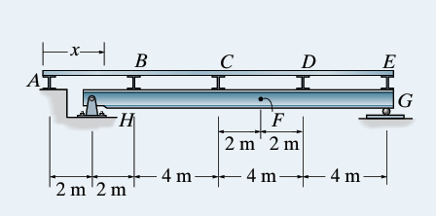
Solution
Static Model and System Geometry
From the structural diagram:
- Origin ($x=0$): Set at the leftmost end at node $A$.
- Panel Points (Floor Beams / Load Transfer Nodes):
  - Node $A$: $x_{A}=0\text{ m}$ (rests directly on the abutment/wall)
  - Node $B$: $x_{B}=4\text{ m}$
  - Node $C$: $x_{C}=8\text{ m}$
  - Node $D$: $x_{D}=12\text{ m}$
  - Node $E$: $x_{E}=16\text{ m}$
- Main Girder Supports:
  - Pin support $H$: $x_{H}=2\text{ m}$
  - Roller support $G$: $x_{G}=16\text{ m}$
  - Main girder span: $L=x_{G}-x_{H}=16-2=14\text{ m}$
- Section of Interest $F$: $x_{F}=10\text{ m}$ (located $8\text{ m}$ from $H$ and $6\text{ m}$ from $G$).
2. General Support Reaction Equations
For a concentrated force $P$ acting on the main girder at position $x_{\text{girder}}$ (measured from $A$):
- Sum of moments about support $H$ ($x=2\text{ m}$):
$$\sum{M_{H}}=0⟹R_{G}⋅\left(14\right)-P⋅\left(x_{\text{girder}}-2\right)=0⟹R_{G}=P⋅\frac{x_{\text{girder}}-2}{14}$$
- Sum of moments about support $G$ ($x=16\text{ m}$):
$$\sum{M_{G}}=0⟹R_{H}⋅\left(14\right)-P⋅\left(16-x_{\text{girder}}\right)=0⟹R_{H}=P⋅\frac{16-x_{\text{girder}}}{14}$$
3. Principle of Indirect Loading
In an indirectly loaded floor system, the unit moving load ($1\text{ kN}$) travels across the slab, which transfers concentrated loads exclusively to the panel points ($A,B,C,D,E$).
Between adjacent panel points, any internal structural effect varies strictly linearly (straight line segments). Therefore, we only need to calculate $M_{F}$ by placing the $1\text{ kN}$ unit load successively at each panel point.
4. Node-by-Node Detailed Calculations
Case 1: Unit Load at Node $A$ ($x=0\text{ m}$)
- The load is applied directly above the abutment wall.
- No force is transmitted to the main girder ($F_{B}=F_{C}=F_{D}=F_{E}=0$).
- Support reactions: $R_{H}=0$, $R_{G}=0$.
- Moment at $F$:
$$M_{F}=0\text{ kN}⋅\text{m}$$
Case 2: Unit Load at Node $B$ ($x=4\text{ m}$)
- The floor slab transfers the entire load to node $B$: $F_{B}=1\text{ kN}$ at $x=4\text{ m}$.
- Support reaction at $G$:
$$R_{G}=1⋅\frac{4-2}{14}=\frac{2}{14}=\frac{1}{7}\text{ kN}$$
- Cut section at point $F$ ($x_{F}=10\text{ m}$) and consider the right segment ($F→G$):
$$M_{F}=R_{G}⋅\left(16-10\right)=\left(\frac{1}{7}\right)⋅6=+\frac{6}{7}\text{ kN}⋅\text{m}≈+0.857\text{ kN}⋅\text{m}$$
Case 3: Unit Load at Node $C$ ($x=8\text{ m}$)
- The floor slab transfers the entire load to node $C$: $F_{C}=1\text{ kN}$ at $x=8\text{ m}$.
- Support reaction at $G$:
$$R_{G}=1⋅\frac{8-2}{14}=\frac{6}{14}=\frac{3}{7}\text{ kN}$$
- Cut section at point $F$ ($x_{F}=10\text{ m}$) and consider the right segment ($F→G$):
$$M_{F}=R_{G}⋅\left(16-10\right)=\left(\frac{3}{7}\right)⋅6=+\frac{18}{7}\text{ kN}⋅\text{m}≈+2.571\text{ kN}⋅\text{m}$$
Case 4: Unit Load at Node $D$ ($x=12\text{ m}$)
- The floor slab transfers the entire load to node $D$: $F_{D}=1\text{ kN}$ at $x=12\text{ m}$.
- Support reaction at $H$:
$$R_{H}=1⋅\frac{16-12}{14}=\frac{4}{14}=\frac{2}{7}\text{ kN}$$
- Cut section at point $F$ ($x_{F}=10\text{ m}$) and consider the left segment ($H→F$):
$$M_{F}=R_{H}⋅\left(10-2\right)=\left(\frac{2}{7}\right)⋅8=+\frac{16}{7}\text{ kN}⋅\text{m}≈+2.286\text{ kN}⋅\text{m}$$
Case 5: Unit Load at Node $E$ ($x=16\text{ m}$)
- The load acts directly over support $G$ ($R_{G}=1\text{ kN}$, $R_{H}=0$).
- Cut section at point $F$ and consider the left segment:
$$M_{F}=R_{H}⋅\left(10-2\right)=0⋅8=0\text{ kN}⋅\text{m}$$
5. Verification at Intermediate Position ($x=10\text{ m}$)
When the unit load is directly over point $F$ ($x=10\text{ m}$, midpoint of panel $CD$):
- Load distribution to nodes $C$ and $D$:
$$F_{C}=\frac{12-10}{4}=\frac{1}{2}\text{ kN}, F_{D}=\frac{10-8}{4}=\frac{1}{2}\text{ kN}$$
- Support reaction at $G$:
$$R_{G}=\left(\frac{1}{2}\right)⋅\frac{8-2}{14}+\left(\frac{1}{2}\right)⋅\frac{12-2}{14}=\frac{3}{14}+\frac{5}{14}=\frac{8}{14}=\frac{4}{7}\text{ kN}$$
- Moment at $F$ (right segment $F→G$):
$$M_{F}=R_{G}⋅\left(16-10\right)-F_{D}⋅\left(12-10\right)=\left(\frac{4}{7}\right)⋅6-\left(\frac{1}{2}\right)⋅2=\frac{24}{7}-1=+\frac{17}{7}\text{ kN}⋅\text{m}≈+2.429\text{ kN}⋅\text{m}$$
(Note: This matches the arithmetic mean between $M_{F}\left(C\right)=\frac{18}{7}$ and $M_{F}\left(D\right)=\frac{16}{7}$, confirming linear continuity across the panel).
6. Summary Table
Load Position (x) | Panel Point | Reaction RH​ | Reaction RG​ | Moment MF​ (kN⋅m)
$$x=0\text{ m}$$ | A | $$0$$ | $$0$$ | $$0$$
$$x=4\text{ m}$$ | B | $$+6/7$$ | $$+1/7$$ | $$+\frac{6}{7}≈+0.857$$
$$x=8\text{ m}$$ | C | $$+4/7$$ | $$+3/7$$ | $+\frac{18}{7}≈+2.571$ (Maximum)
$$x=10\text{ m}$$ | Midpoint $CD$ ($F$) | $$+3/7$$ | $$+4/7$$ | $$+\frac{17}{7}≈+2.429$$
$$x=12\text{ m}$$ | D | $$+2/7$$ | $$+5/7$$ | $$+\frac{16}{7}≈+2.286$$
$$x=16\text{ m}$$ | E | $$0$$ | $$1$$ | $$0$$
7. Plotting Instructions
- Horizontal Baseline: Draw a reference axis from $x=0$ to $x=16\text{ m}$ marking nodes $A,B,C,D,E$.
- Plot Key Ordinates:
  - At $A$ ($x=0$): $0$
  - At $B$ ($x=4\text{ m}$): $+6/7$
  - At $C$ ($x=8\text{ m}$): $+18/7$
  - At $D$ ($x=12\text{ m}$): $+16/7$
  - At $E$ ($x=16\text{ m}$): $0$
- Connect Segments: Join adjacent points sequentially ($A→B→C→D→E$) using straight line segments:
  - $A→B$: Increasing line from $0$ to $+6/7$.
  - $B→C$: Increasing line from $+6/7$ to the maximum peak at $+18/7$.
  - $C→D$: Continuous decreasing line from $+18/7$ to $+16/7$ (passing through $+17/7$ at $x=10\text{ m}$).
  - $D→E$: Decreasing line from $+16/7$ back to $0$.
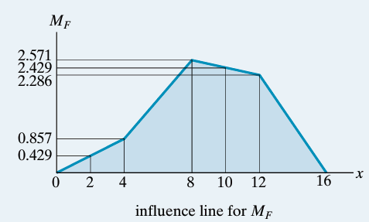

I.5 Influence Lines for Trusses
Trusses are often used as primary load-carrying elements for bridges. Hence, for design it is important to be able to construct the influence lines for each of its members. As shown in Fig. 33, the loading on the bridge deck is transmitted to stringers, which in turn transmit the loading to floor beams and then to the joints along the bottom cord of the truss.
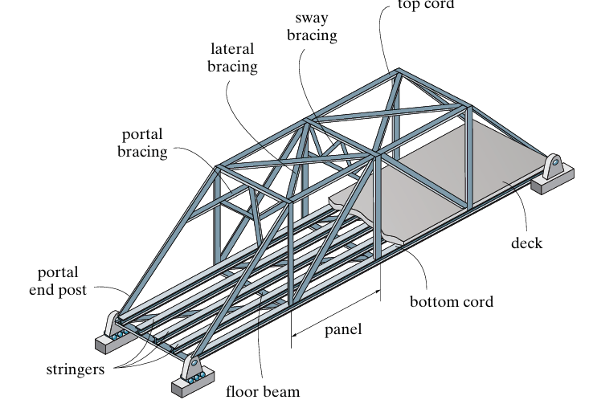
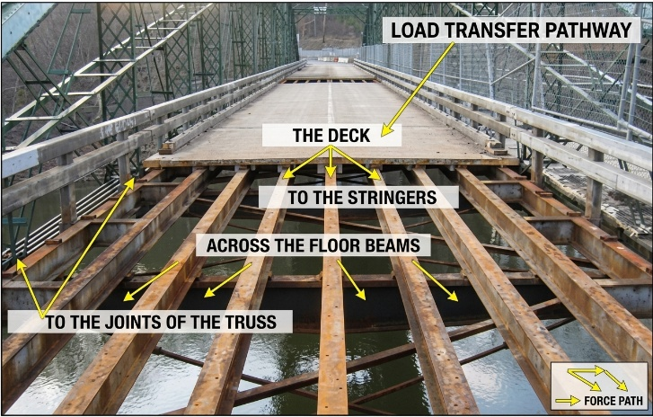
Trusses are commonly used to support bridge loads. To draw the influence line of a truss member, a unit load is placed successively at each joint along the bottom chord. The force in the member is then calculated using the method of joints or method of sections. The calculated forces are plotted against the load positions. Tension is taken as positive (+) and compression as negative (−). Finally, the points are connected with straight lines to obtain the influence line.

Exercice 01
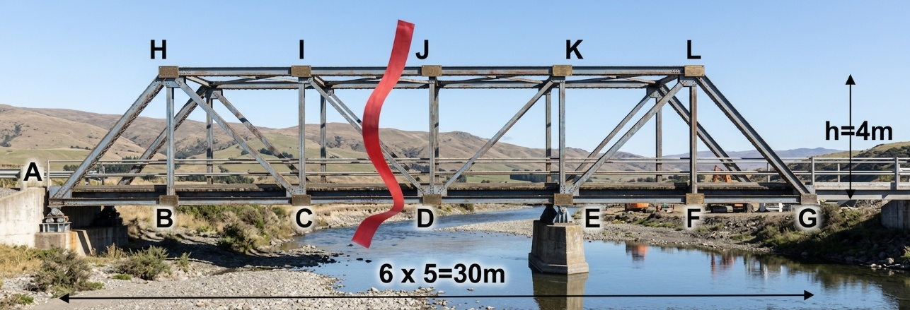
Draw the influence line diagrams for the axial forces in members IJ, CD, and ID of the bridge truss shown in Fig. 6–24a.
To plot the influence lines for the axial forces in members $IJ$, $CD$, and $ID$, we use Method of Sections (Ritter's method).
1. Geometry and Support Reactions
- Dimensions:
  - $6$ panels of $5\text{ m}$ each $⟹$ Total length $=30\text{ m}$.
  - Truss height $h=4\text{ m}$.
  - Node coordinates along the bottom chord:
    - $A=0\text{ m}$ (Support A)
    - $B=5\text{ m}$
    - $C=10\text{ m}$
    - $D=15\text{ m}$
    - $E=20\text{ m}$ (Support E)
    - $F=25\text{ m}$
    - $G=30\text{ m}$ (Cantilever end from $E$ to $G$)
- Support Reactions for a moving downward unit load $P=1$ at position $x∈\left[0,30\text{ m}\right]$:
$$\sum{M_{E}}=0⟹R_{A}\left(x\right)=\frac{20-x}{20}$$
$$\sum{M_{A}}=0⟹R_{E}\left(x\right)=\frac{x}{20}$$

2. Influence Line for Axial Force $N_{IJ}$ (Top Chord)
Pass a section cutting through members $IJ$, $ID$, and $CD$. Taking moments about node $D$ ($x_{D}=15\text{ m},y_{D}=0$):
- Load to the right of $D$ ($15\text{ m}≤x≤30\text{ m}$):
Isolating the left section:
$$\sum{M_{D}}=0⟹R_{A}⋅15+N_{IJ}⋅4=0⟹N_{IJ}\left(x\right)=-\frac{15}{4}R_{A}\left(x\right)=\frac{3\left(x-20\right)}{16}$$
- Load to the left of $D$ ($0≤x≤15\text{ m}$):
Isolating the right section:
$$\sum{M_{D}}=0⟹R_{E}⋅5+N_{IJ}⋅4=0⟹N_{IJ}\left(x\right)=-\frac{5}{4}R_{E}\left(x\right)=-\frac{x}{16}$$
Key Values for $N_{IJ}$:
Position x (m) | 0 (A) | 5 (B) | 10 (C) | 15 (D) | 20 (E) | 25 (F) | 30 (G)
$$N_{IJ}$$ | $$0$$ | $$-0.3125$$ | $$-0.625$$ | $$-0.9375$$ | $$0$$ | $$+0.9375$$ | $$+1.875$$
- Diagram Shape: A negative triangular shape from $A\left(0\right)$ to $E\left(20\right)$ peaking at $D\left(15\right)$ with $-0.9375$, followed by a straight upward line reaching $+1.875$ at $G\left(30\right)$.
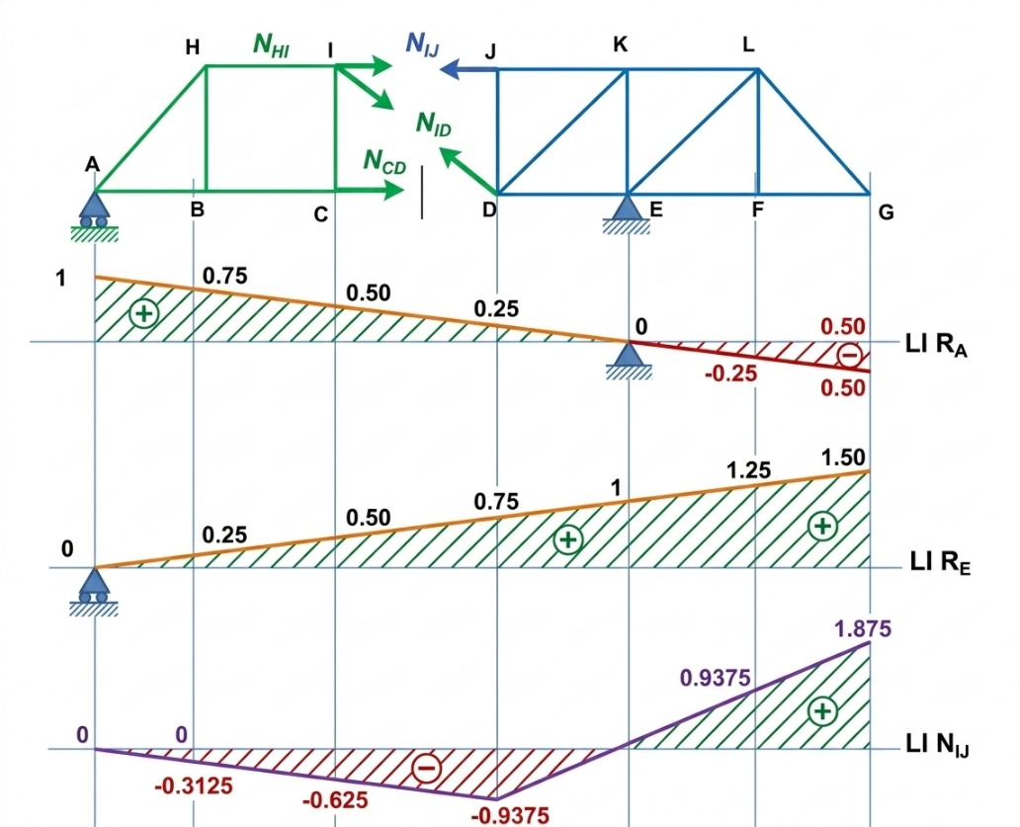
3. Influence Line for Axial Force $N_{CD}$ (Bottom Chord)
Taking moments about node $I$ ($x_{I}=10\text{ m},y_{I}=4\text{ m}$):
- Load to the left of $C$ ($0≤x≤10\text{ m}$):
Isolating the right section:
$$\sum{M_{I}}=0⟹R_{E}⋅10-N_{CD}⋅4=0⟹N_{CD}\left(x\right)=\frac{10}{4}R_{E}\left(x\right)=\frac{x}{8}$$
- Load to the right of $C$ ($10\text{ m}≤x≤30\text{ m}$):
Isolating the left section:
$$\sum{M_{I}}=0⟹R_{A}⋅10-N_{CD}⋅4=0⟹N_{CD}\left(x\right)=\frac{10}{4}R_{A}\left(x\right)=\frac{20-x}{8}$$
Key Values for $N_{CD}$:
Position x (m) | 0 (A) | 5 (B) | 10 (C) | 15 (D) | 20 (E) | 25 (F) | 30 (G)
$$N_{CD}$$ | $$0$$ | $$+0.625$$ | $$+1.25$$ | $$+0.625$$ | $$0$$ | $$-0.625$$ | $$-1.25$$
- Diagram Shape: A positive triangle from $A\left(0\right)$ to $E\left(20\right)$ peaking at $C\left(10\right)$ with $+1.25$, then sloping downward to $-1.25$ at $G\left(30\right)$.
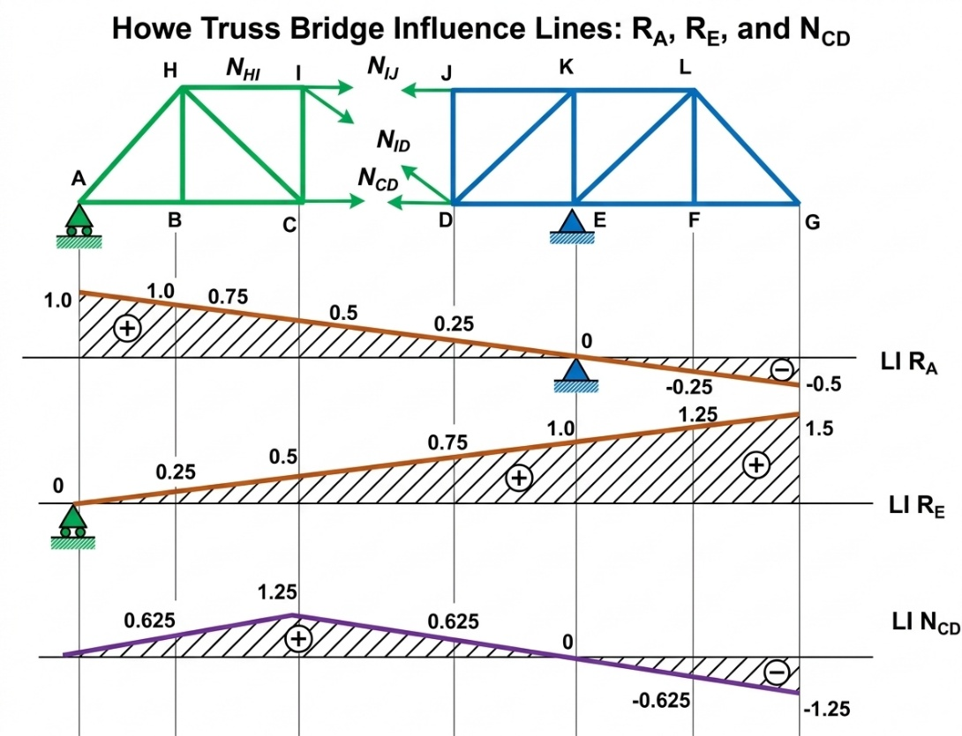

4. Influence Line for Axial Force $N_{ID}$ (Diagonal)
Diagonal $ID$ connects node $I\left(10,4\right)$ to $D\left(15,0\right)$.
- Inclination: $\sin{α}=\frac{h}{L_{ID}}=\frac{4}{\sqrt{5^{2}+4^{2}}}=\frac{4}{\sqrt{41}}≈0.6247$.
Applying vertical force equilibrium $\sum{F_{y}}=0$ across the section:
- Load to the left of panel $CD$ ($0≤x≤10\text{ m}$):
Isolating the right section:
$$\sum{F_{y}}=0⟹R_{E}+N_{ID}\sin{α}=0⟹N_{ID}\left(x\right)=-\frac{R_{E}\left(x\right)}{\sin{α}}=-\frac{\sqrt{41}}{80}x≈-0.08004 x$$
- Load to the right of panel $CD$ ($15\text{ m}≤x≤30\text{ m}$):
Isolating the left section:
$$\sum{F_{y}}=0⟹R_{A}-N_{ID}\sin{α}=0⟹N_{ID}\left(x\right)=\frac{R_{A}\left(x\right)}{\sin{α}}=\frac{\sqrt{41}}{80}\left(20-x\right)≈0.08004 \left(20-x\right)$$
- Inside panel $CD$ ($10\text{ m}≤x≤15\text{ m}$):
Linear transition between $x=10\text{ m}$ and $x=15\text{ m}$, crossing zero ($N_{ID}=0$) at $x_{0}=13.33\text{ m}$ (i.e., $x=\frac{40}{3}\text{ m}$).
Key Values for $N_{ID}$:
Position x (m) | 0 (A) | 10 (C) | 13.33 | 15 (D) | 20 (E) | 30 (G)
$N_{ID}$ (Exact) | $$0$$ | $$-\frac{\sqrt{41}}{8}$$ | $$0$$ | $$+\frac{\sqrt{41}}{16}$$ | $$0$$ | $$-\frac{\sqrt{41}}{8}$$
$N_{ID}$ (Decimal) | $$0$$ | $$-0.800$$ | $$0$$ | $$+0.400$$ | $$0$$ | $$-0.800$$
- Diagram Shape:
  - From $A\left(0\right)$ to $C\left(10\right)$: linearly decreases from $0$ to $-0.800$.
  - From $C\left(10\right)$ to $D\left(15\right)$: linear transition line passing through $0$ at $x=13.33\text{ m}$ up to $+0.400$ at $D\left(15\right)$.
  - From $D\left(15\right)$ to $G\left(30\right)$: straight line going through $0$ at $E\left(20\right)$ and down to $-0.800$ at $G\left(30\right)$.

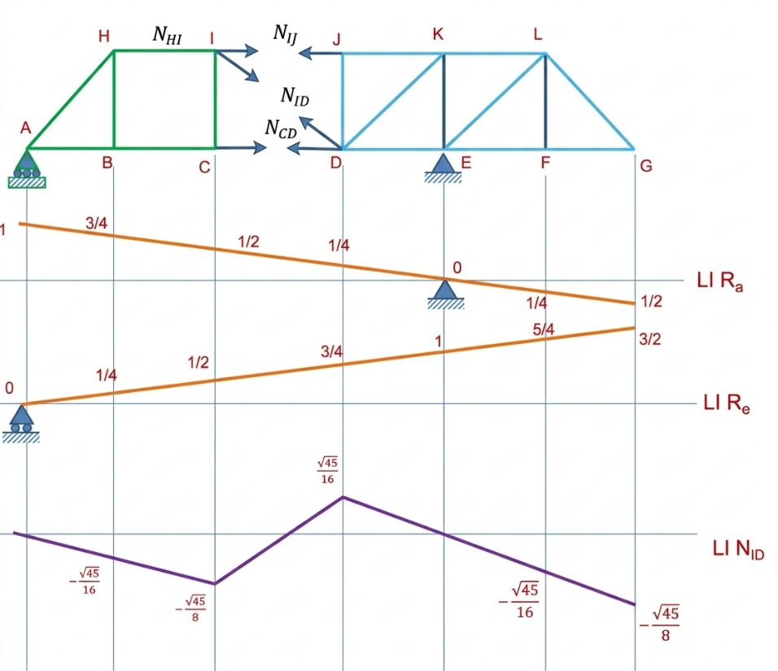
Plotting Summary
Node / Position x | A (0 m) | C (10 m) | D (15 m) | E (20 m) | G (30 m)
$$N_{IJ}$$ | $$0$$ | $$-0.625$$ | $$-0.938$$ | $$0$$ | $$+1.875$$
$$N_{CD}$$ | $$0$$ | $$+1.250$$ | $$+0.625$$ | $$0$$ | $$-1.250$$
$$N_{ID}$$ | $$0$$ | $$-0.800$$ | $$+0.400$$ | $$0$$ | $$-0.800$$

Example 02
Draw the influence line for the force in member CG of the bridge truss shown in Fig. 34.
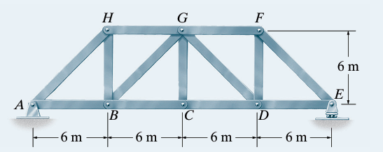
Solution
. Static Analysis of Joint $C$ (Method of Joints)
To determine the force $F_{CG}$ in the vertical member $CG$, isolate joint $C$:
- Members meeting at joint $C$:
  - Two collinear horizontal bottom-chord members: $CB$ and $CD$.
  - One vertical member: $CG$.
- External loading:
  - As the unit moving load $P=1$ moves across the bridge deck, a fraction $P_{C}$ is transferred to joint $C$ via the floor beams.
Summing forces vertically ($\sum{F_{y}}=0$) at joint $C$:
$$\sum{F_{y}}=0⟹F_{CG}-P_{C}=0⟹F_{CG}=P_{C}$$
Thus, the axial force in member $CG$ is directly equal to the fraction of the unit load transmitted to joint $C$.
2. Calculation of Force $F_{CG}$ for Various Load Positions ($x$)
Consider a unit load $P=1$ moving along the bottom chord from $x=0\text{ m}$ (joint $A$) to $x=24\text{ m}$ (joint $E$):
- Load between $x=0\text{ m}$ and $x=6\text{ m}$ (Panel $AB$):
  - The load is carried entirely by joints $A$ and $B$.
  - No load is transmitted to joint $C$ ($P_{C}=0$).
  - $F_{CG}=0$
- Load between $x=6\text{ m}$ and $x=12\text{ m}$ (Panel $BC$):
  - By the lever rule, the fraction transmitted to joint $C$ increases linearly:
$$P_{C}=\frac{x-6}{12-6}=\frac{x-6}{6}$$
  - At $x=6\text{ m}$ (Joint $B$): $F_{CG}=0$
  - At $x=12\text{ m}$ (Joint $C$): $F_{CG}=+1\text{ (Tension)}$
- Load between $x=12\text{ m}$ and $x=18\text{ m}$ (Panel $CD$):
  - The fraction transmitted to joint $C$ decreases linearly:
$$P_{C}=\frac{18-x}{18-12}=\frac{18-x}{6}$$
  - At $x=12\text{ m}$ (Joint $C$): $F_{CG}=+1\text{ (Tension)}$
  - At $x=18\text{ m}$ (Joint $D$): $F_{CG}=0$
- Load between $x=18\text{ m}$ and $x=24\text{ m}$ (Panel $DE$):
  - The load is carried entirely by joints $D$ and $E$.
  - No load is transmitted to joint $C$ ($P_{C}=0$).
  - $F_{CG}=0$
3. Summary Table of Ordinates
Load Position x (m) | Node | Force FCG​ | Stress State
$$0$$ | A | $$0$$ | Zero force
$$6$$ | B | $$0$$ | Zero force
$$12$$ | C | $$+1$$ | Maximum Tension
$$18$$ | D | $$0$$ | Zero force
$$24$$ | E | $$0$$ | Zero force
4. Instructions for Plotting the Influence Line
- Horizontal Baseline: Draw a horizontal axis representing the total span from $x=0\text{ m}$ to $x=24\text{ m}$, marking nodes $A,B,C,D,E$.
- Plot Segments:
  - From $x=0\text{ m}$ to $x=6\text{ m}$ ($A→B$): Draw a horizontal line lying on the axis ($F_{CG}=0$).
  - From $x=6\text{ m}$ to $x=12\text{ m}$ ($B→C$): Draw a line sloping upward from $0$ to a maximum value of $+1$ above the axis.
  - From $x=12\text{ m}$ to $x=18\text{ m}$ ($C→D$): Draw a line sloping downward from $+1$ to $0$.
  - From $x=18\text{ m}$ to $x=24\text{ m}$ ($D→E$): Draw a horizontal line lying on the axis ($F_{CG}=0$).

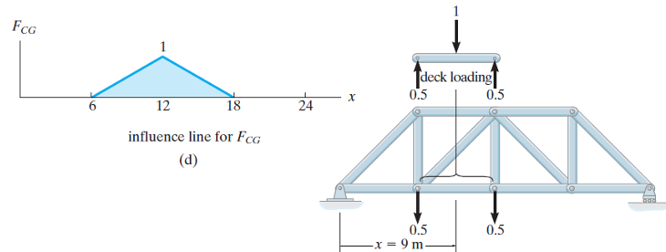
I.6 Influence Lines for frame
For a structural frame, influence lines can be used to determine the support reactions, shear force, and bending moment at a specific point. A unit load ($W=1$) is moved along the frame, and the corresponding value of the required function is calculated for each load position. These values are then plotted against the load position to obtain the influence line.
Key Points:
- Move a unit load ($W=1$) along the frame.
- Calculate the desired function (reaction, shear force, or bending moment) at the specified point.
- Plot the calculated values versus the load position ($x$).
- Connect the key points with straight lines.
Example 01
Consider the frame shown in Fig. 36. The goal is to draw the influence lines for:
a) The vertical reaction at support $A$ ($R_{A}$)
b) The shear force at point $C$ ($V_{C}$)
c) The bending moment at point $C$ ($M_{C}$)
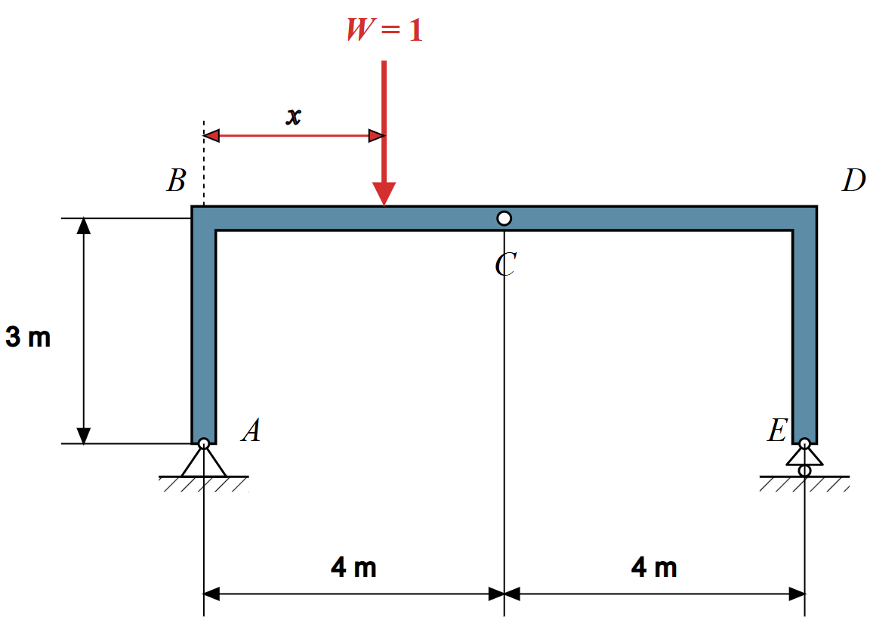
Solution
Global Static Analysis & Reaction Equations
- Frame geometry and supports :
  - The frame consists of a horizontal beam $BD$ with a total span of $L=8\text{ m}$ ($4\text{ m}+4\text{ m}$) and two vertical columns of height $h=3\text{ m}$.
  - Support $A$ is a pin support (restraining vertical reaction $R_{A}$ and horizontal reaction $H_{A}$).
  - Support $E$ is a roller support (restraining vertical reaction $R_{E}$ only, $H_{E}=0$).
  - A downward unit vertical load $W=1$ moves along the horizontal member $BD$, with its position defined by distance $x$ measured from joint $B$ ($0≤x≤8\text{ m}$).
- Static equilibrium equations:
  - Horizontal Equilibrium ($\sum{F_{x}}=0$):
$$H_{A}=0$$
Since no horizontal external force acts on the frame, the columns carry no horizontal shear, and the frame behaves like a simply supported beam of $8\text{ m}$ span.
  - Moment Equilibrium about Support $E$ ($\sum{M_{E}}=0$):
$$R_{A}⋅8-1⋅\left(8-x\right)=0⟹R_{A}\left(x\right)=1-\frac{x}{8}$$
  - Vertical Equilibrium ($\sum{F_{y}}=0$):
$$R_{A}+R_{E}=1⟹R_{E}\left(x\right)=\frac{x}{8}$$
2. Influence Line Equations & Calculations
a) Influence Line for $R_{A}$ (Vertical Reaction at Support A)
- Equation:
$$R_{A}\left(x\right)=1-\frac{x}{8} \text{for }0≤x≤8\text{ m}$$
- Key Coordinates:
  - At load position $B$ ($x=0\text{ m}$): $R_{A}=1-\frac{0}{8}=+1.0$
  - At load position $C$ ($x=4\text{ m}$): $R_{A}=1-\frac{4}{8}=+0.5$
  - At load position $D$ ($x=8\text{ m}$): $R_{A}=1-\frac{8}{8}=0.0$
b) Influence Line for $V_{C}$ (Shear Force at Point C)
- Method of Sections at Point $C$ ($x_{C}=4\text{ m}$):
  - Case 1: Load on segment $BC$ ($0≤x<4\text{ m}$):
$$V_{C}\left(x\right)=R_{A}-1=\left(1-\frac{x}{8}\right)-1=-\frac{x}{8}$$
    - At $x=0\text{ m}$ (Joint $B$): $V_{C}=0.0$
    - At $x→4^{-}\text{ m}$ (Just left of $C$): $V_{C}=-\frac{4}{8}=-0.5$
  - Case 2: Load on segment $CD$ ($4\text{ m}<x≤8\text{ m}$):
$$V_{C}\left(x\right)=R_{A}=1-\frac{x}{8}$$
    - At $x→4^{+}\text{ m}$ (Just right of $C$): $V_{C}=1-\frac{4}{8}=+0.5$
    - At $x=8\text{ m}$ (Joint $D$): $V_{C}=1-\frac{8}{8}=0.0$
- Unit Jump at Point $C$:
$$ΔV_{C}=V_{C}\left(4^{+}\right)-V_{C}\left(4^{-}\right)=+0.5-\left(-0.5\right)=1.0$$
c) Influence Line for $M_{C}$ (Bending Moment at Point C)
- Sign Convention: Positive bending moment causes sagging (tension at the bottom fibers).
- Equations by Segment:
  - Case 1: Load on segment $BC$ ($0≤x≤4\text{ m}$):
$$M_{C}\left(x\right)=R_{E}⋅4=\left(\frac{x}{8}\right)⋅4=\frac{x}{2}$$
    - At $x=0\text{ m}$ (Joint $B$): $M_{C}=0.0\text{ kN}⋅\text{m}$
    - At $x=4\text{ m}$ (Point $C$): $M_{C}=\frac{4}{2}=+2.0\text{ kN}⋅\text{m}$
  - Case 2: Load on segment $CD$ ($4\text{ m}≤x≤8\text{ m}$):
$$M_{C}\left(x\right)=R_{A}⋅4=\left(1-\frac{x}{8}\right)⋅4=4-\frac{x}{2}$$
    - At $x=4\text{ m}$ (Point $C$): $M_{C}=4-\frac{4}{2}=+2.0\text{ kN}⋅\text{m}$
    - At $x=8\text{ m}$ (Joint $D$): $M_{C}=4-\frac{8}{2}=0.0\text{ kN}⋅\text{m}$
3. Summary Table of Coordinates (Influence Line Values)

Load Position (x) | Joint B (0 m) | Point C− (4− m) | Point C+ (4+ m) | Joint D (8 m)
$R_{A}$ (Vertical Reaction at A) | $$+1.0$$ | $$+0.5$$ | $$+0.5$$ | $$0.0$$
$V_{C}$ (Shear Force at C) | $$0.0$$ | $$-0.5$$ | $$+0.5$$ | $$0.0$$
$M_{C}$ (Bending Moment at C) | $$0.0\text{ kN}⋅\text{m}$$ | $$+2.0\text{ kN}⋅\text{m}$$ | $$+2.0\text{ kN}⋅\text{m}$$ | $$0.0\text{ kN}⋅\text{m}$$

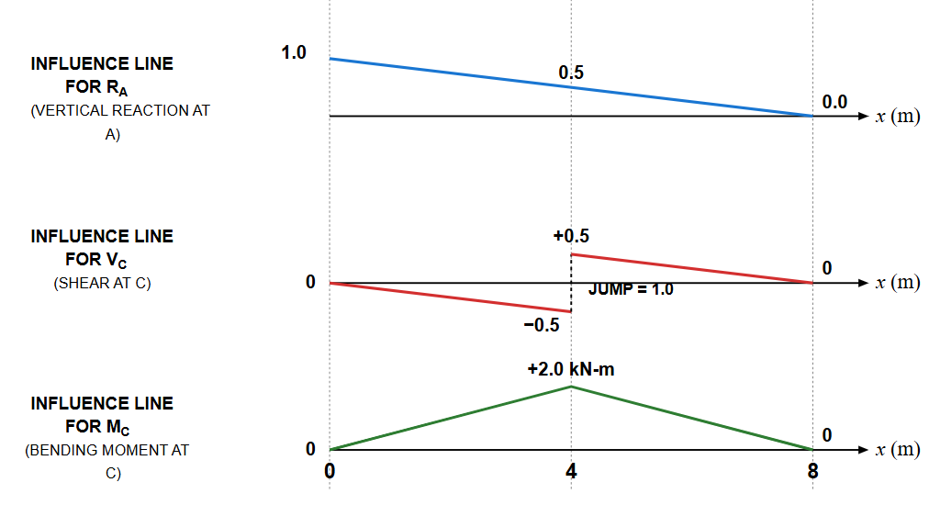

Example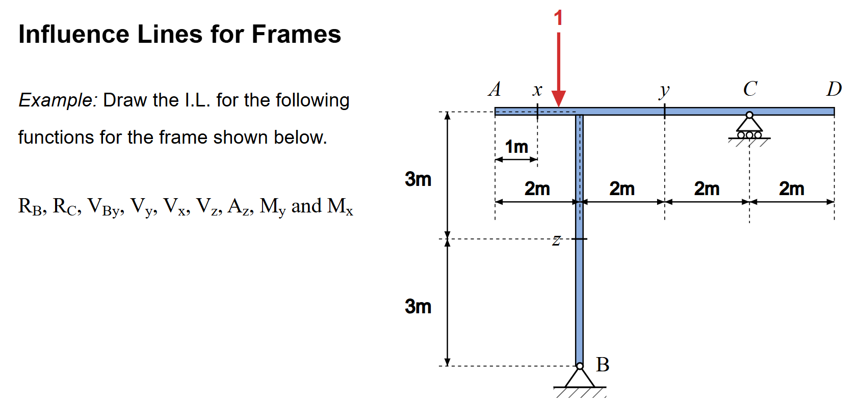
Solution
Support Reactions ($R_{B}$ and $R_{C}$)
To determine the influence lines for the support reactions, a unit vertical load $P=1$ moves along the top beam $AD$ ($0≤x_{p}≤8\text{ m}$).
- Moment equilibrium about Support $B$ ($\sum{M_{B}}=0$):
$$R_{C}⋅4-1⋅\left(x_{p}-2\right)=0⟹R_{C}=\frac{x_{p}-2}{4}$$
- Vertical force equilibrium ($\sum{F_{y}}=0$):
$$R_{B}+R_{C}-1=0⟹R_{B}=\frac{6-x_{p}}{4}$$
- Horizontal reaction at Support $B$ ($H_{B}$):
$$H_{B}=0 \left(\text{for all }x_{p}\right)$$
Since no external horizontal forces act on the frame, the horizontal reaction remains zero.
2. Internal Forces at Section $x$ ($x_{p}=1\text{ m}$)
- Shear Force ($V_{x}$):
  - For $0≤x_{p}<1\text{ m}$ (load to the left of section $x$): $V_{x}=-1$
  - For $1\text{ m}<x_{p}≤8\text{ m}$ (load to the right of section $x$): $V_{x}=0$
- Bending Moment ($M_{x}$):
  - For $0≤x_{p}≤1 \text{m}$: $M_{x}=x_{p}-1$
  - For $1\text{ m}≤x_{p}≤8 \text{m}$: $M_{x}=0$
3. Shear Force Just Right of Column Joint ($V_{By}$)
This corresponds to the shear force in the horizontal beam segment immediately to the right of the joint above column $B$ ($x_{p}=2^{+}$) :
- For $0≤x_{p}<2 \text{m}$: $V_{By}=R_{C}=\frac{x_{p}-2}{4}$
- For $2\text{ m}<x_{p}≤8 \text{m}$: $V_{By}=R_{C}-1=\frac{x_{p}-6}{4}$
4. Internal Forces at Section $y$ ($x_{p}=4\text{ m}$)
- Shear Force ($V_{y}$):
  - For $0≤x_{p}<4 \text{m}$: $V_{y}=R_{C}=\frac{x_{p}-2}{4}$
  - For $4\text{ m}<x_{p}≤8 \text{m}$: $V_{y}=R_{C}-1=\frac{x_{p}-6}{4}$
- Bending Moment ($M_{y}$):
  - For $0≤x_{p}≤4 \text{m}$: $M_{y}=-2R_{C}=-\frac{x_{p}-2}{2}$
  - For $4\text{ m}≤x_{p}≤8 \text{m}$: $M_{y}=\frac{x_{p}-6}{2}$
5. Internal Forces at Section $z$ (Vertical Column $JB$)
- Axial Force ($A_{z}$ / Normal Force):
The vertical column transmits the reaction $R_{B}$ (compression when negative) :
$$A_{z}=-R_{B}=\frac{x_{p}-6}{4}$$
- Column Shear Force ($V_{z}$):
$$V_{z}=0 \left(\text{for all }x_{p}\right)$$
Function / Load Position | Point A (xp​=0 m) | Section x (xp​=1 m) | Joint B (xp​=2 m) | Section y (xp​=4 m) | Support C (xp​=6 m) | Point D (xp​=8 m)
$R_{C}$ (Reaction at C) | $$-0.5$$ | $$-0.25$$ | $$0.0$$ | $$+0.5$$ | $$+1.0$$ | $$+1.5$$
$R_{B}$ (Reaction at B) | $$+1.5$$ | $$+1.25$$ | $$+1.0$$ | $$+0.5$$ | $$0.0$$ | $$-0.5$$
$V_{x}$ (Shear at x) | $$-1.0$$ | $$-1.0∣0.0$$ | $$0.0$$ | $$0.0$$ | $$0.0$$ | $$0.0$$
$M_{x}$ (Moment at x) | $$-1.0$$ | $$0.0$$ | $$0.0$$ | $$0.0$$ | $$0.0$$ | $$0.0$$
$V_{By}$ (Shear right of B) | $$-0.5$$ | $$-0.25$$ | $$0.0/-1.0$$ | $$-0.5$$ | $$0.0$$ | $$+0.5$$
$V_{y}$ (Shear at y) | $$-0.5$$ | $$-0.25$$ | $$0.0$$ | $$+0.5/-0.5$$ | $$0.0$$ | $$+0.5$$
$M_{y}$ (Moment at y) | $$+1.0$$ | $$+0.5$$ | $$0.0$$ | $$-1.0$$ | $$0.0$$ | $$+1.0$$
$A_{z}$ (Axial Force in Column) | $$-1.5$$ | $$-1.25$$ | $$-1.0$$ | $$-0.5$$ | $$0.0$$ | $$+0.5$$
$V_{z}$ (Shear in Column) | $$0.0$$ | $$0.0$$ | $$0.0$$ | $$0.0$$ | $$0.0$$ | $$0.0$$
6. Summary Table of Influence Line Ordinates
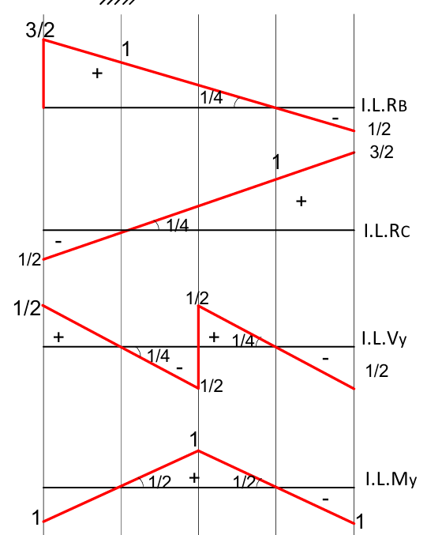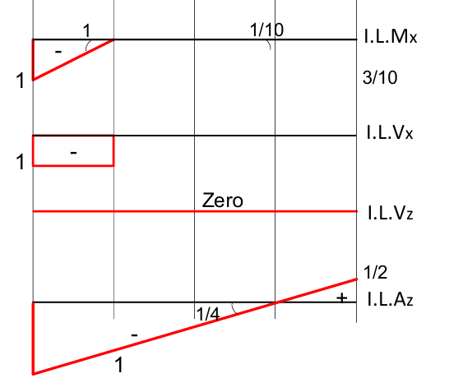
Example 03
Draw the I.L. for the following functions for the frame shown below. RB RC, RAY, Vc, VH, VJ, MH and MJ.
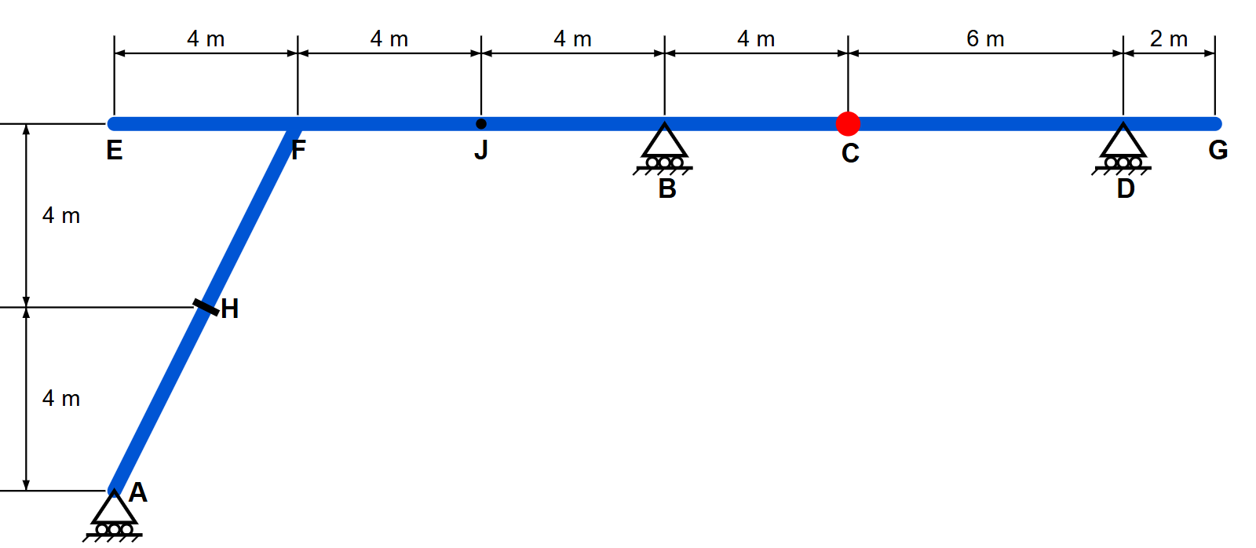
Solution
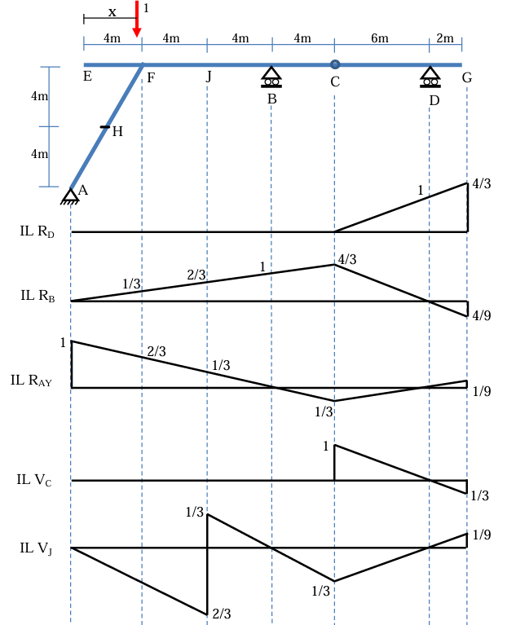
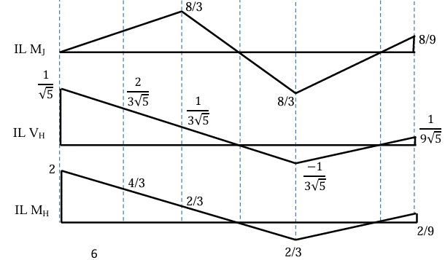

I.7 Application of Influence Lines :
Once the influence line for a function (reaction, shear, or moment) has been constructed, it will then be possible to position the live loads on the beam which will produce the maximum value of the function. Two types of loadings will now be considered.

I.7.1. Response at a particular location due to a single moving concentrated load

The numerical values of an influence line are determined using a dimensionless unit load. Therefore, for any concentrated force $F$acting on a beam at a position $x$, the value of the quantity being studied can be obtained by multiplying the ordinate of the influence line at that position by the magnitude of the force $F$.

For example, consider the influence line for the reaction at A for beam $AB$(Fig).

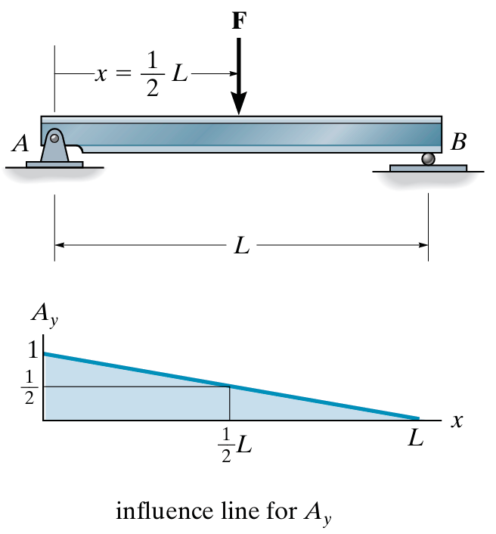

If the unit load is placed at:

$$x=\frac{1}{2}L$$

The influence line indicates that the reaction at A is:

$$A_{y}=\frac{1}{2}$$

Therefore, if a concentrated force $F$is applied at the same location, the reaction at A is:

$$A_{y}=\frac{1}{2}F$$

The same result can, of course, also be obtained directly using the equations of statics.

In general:

$$\boxed{\text{Effect}\text{ of }F=F×\text{ordinate of the influence line}}$$

The maximum effect produced by a concentrated force $F$occurs when the force is placed at the location where the ordinate of the influence line is maximum.

In this example, the maximum occurs at $x=0$, at point A. The corresponding reaction is therefore:

$$\boxed{A_{y}=\left(1\right)F=F}$$

Key point: For a concentrated force, simply read the ordinate of the influence line at the force location and multiply it by the magnitude of $F$.

I.7.2. Response at a particular location due to a uniformly distributed live load

Consider a portion of a beam subjected to a uniformly distributed load $w_{0}$, as shown in Fig.

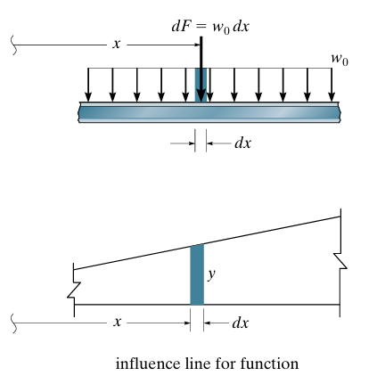

Each small segment $dx$of the load can be considered as a concentrated force:

$$dF=w_{0} dx$$

If $dF$is applied at a position $x$, where the ordinate of the influence line for a particular function (reaction, shear, or moment) is $y$, then the corresponding effect is:

$$dF\left(y\right)=\left(w_{0} dx\right)y$$

The total effect of all the concentrated forces $dF$is obtained by integrating over the entire loaded length:

$$\int{w_{0}}y dx=w_{0}\int{y} dx$$

Since

$$\int{y} dx$$

represents the area under the influence line, the general rule is:

$$\boxed{\text{Effect}\text{ of a }\text{uniform} \text{load}=\left(\text{area under the influence line}\right)×w_{0}}$$

Example

For the uniformly loaded beam shown in Fig., the reaction at $A$can be determined directly from the influence line.

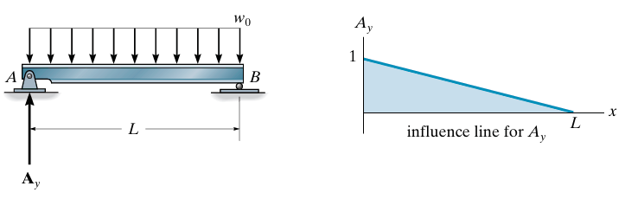

The area under the influence line is a triangle with:
- Base $=L$
- Height $=1$

Therefore:

$$A_{y}=\left(\text{Area}\right)\left(w_{0}\right) \\ A_{y}=\left(\frac{1}{2}L×1\right)w_{0}$$

Hence:

$$\boxed{A_{y}=\frac{1}{2}w_{0}L}$$

This result can, of course, also be obtained directly using the equations of statics.

Key point: For a uniformly distributed load, the effect is obtained by multiplying the area under the influence line by the load intensity $w_{0}$

Example :

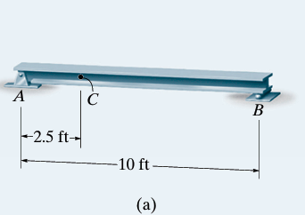
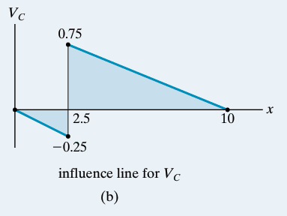
Determine the maximum positive shear that can be developed at point C in the beam shown in Fig.a due to a concentrated moving load of 4000 lb and a uniform moving load of 2000 lb/ft.

SOLUTION The influence line for the shear at C has been established in Example 4 Fig.14 and is shown in Fig. b.
- Concentrated Force.

The maximum positive shear at C will occur when the 4000-lb force is located at x = 2.5+ ft, since this is the positive peak of the influence line. The ordinate of this peak is +0.75 ; so that VC = 0.75(4000 lb) = 3000 lb
- Uniform Load.

The uniform moving load creates the maximum positive influence for VC when the load acts on the beam between x = 2.5+ ft and x = 10 ft, since within this region the influence line has a positive area.

The magnitude of VC due to this loading is

VC = [1/2(10 - 2.5)*(0.75)]*2000 = 5625 lb

Total Maximum Shear at C :

(VC)max = 3000 lb + 5625 lb = 8625 lb
- Notice that once the positions of the loads have been established using the influence line, Fig.c, this value of (VC) max can also be determined using statics and the method of sections. Show that this is the case

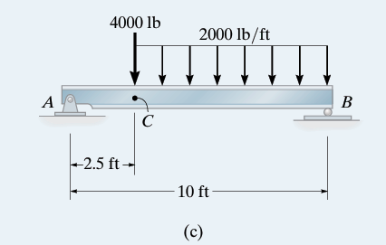

Verification Using Statics

Once the critical positions of the loads have been determined from the influence line :
- The $4000$-lb concentrated force is placed at $x={2.5}^{+}$ft.
- The $2000$-lb/ft uniform load acts from $x=2.5$ft to $x=10$ft.

1. Replace the uniform load by its resultant

The length over which the uniform load acts is

$$L=10-2.5=7.5\text{ ft}$$

Therefore, its equivalent concentrated force is

$$W=wL \\ W=\left(2000\right)\left(7.5\right)=15,000\text{ lb}$$

This resultant acts at the center of the loaded length:

$$x_{R}=2.5+\frac{7.5}{2}=6.25\text{ ft}$$

2. Determine the reaction at $A$

Taking moments about support $B$:

$$\sum{M_{B}}=0 \\ A_{y}\left(10\right)=4000\left(10-2.5\right)+15000\left(10-6.25\right)$$

Thus,

$$A_{y}=\frac{4000\left(7.5\right)+15000\left(3.75\right)}{10} \\ A_{y}=\frac{30,000+56,250}{10} \\ \boxed{A_{y}=8625\text{ lb}}$$

3. Determine the shear at $C$

Now make a section immediately to the right of $C$, at $C^{+}$.

Since both the $4000$-lb force and the distributed load are located to the right of $C$, they do not act on the left segment.

For the left segment:

$$\sum{F_{y}}=0 \\ A_{y}-V_{C}=0$$

Therefore,

$$V_{C}=A_{y} \\ \boxed{V_{C}=8625\text{ lb}}$$

Final Answer

Hence, using statics and the method of sections,

$$\boxed{{\left(V_{C}\right)}_{max}=8625\text{ lb}}$$

which agrees exactly with the result obtained from the influence-line method:

$$\boxed{{\left(V_{C}\right)}_{max}=3000+5625=8625\text{ lb}}$$

Thus, the influence line determines the critical load positions, while statics verifies the resulting maximum shear at $C$.

I.7.3. Response at a particular location due to a series of moving concentrated loads
When a train or truck moves across a bridge, several concentrated wheel loads act on the girder. To determine the maximum reaction, shear, or moment at a particular point, the influence line can be used.
For a single concentrated load, the maximum effect is simply:
$$\text{Maximum }\text{effect}=P×\left(\text{maximum influence-line ordinate}\right)$$
However, when several concentrated loads move together, the loads have different positions relative to the influence line. Therefore, the maximum effect must be determined by considering the possible critical positions of the load system.
Two approaches can be used:
- Trial-and-error method
- A method based on the change in the reaction, shear, or moment as the loads move.

Example: Maximum Shear at $C$
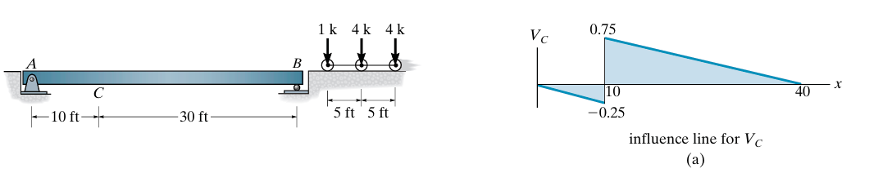
Consider the simply supported beam shown in Fig., with the influence line for the shear at $C$.

We want to determine the maximum positive shear at $C$caused by three moving concentrated loads:$1\text{ k}, 4\text{ k}, 4\text{ k}$
The loads move from right to left.
The positive peak of the influence line occurs immediately to the right of $C$, where the ordinate is:
$$y=+0.75$$Therefore, the critical position will occur when one of the loads is located just to the right of $C$.
Because there are three loads, three possible cases can be investigated.

Case 1
The $1$-k load is positioned at the positive peak:
$${\left(V_{C}\right)}_{1}=1\left(0.75\right)+4\left(0.625\right)+4\left(0.50\right) \\ {\left(V_{C}\right)}_{1}=0.75+2.50+2.00 \\ \boxed{{\left(V_{C}\right)}_{1}=5.25\text{ k}}$$

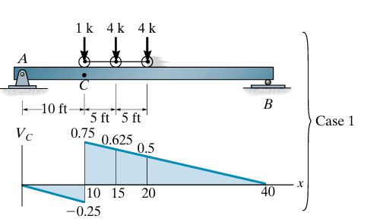

Case 2
The second $4$-k load is positioned at the positive peak:

$${\left(V_{C}\right)}_{2}=1\left(-0.125\right)+4\left(0.75\right)+4\left(0.625\right) \\ {\left(V_{C}\right)}_{2}=-0.125+3.00+2.50 \\ \boxed{{\left(V_{C}\right)}_{2}=5.375\text{ k}}$$

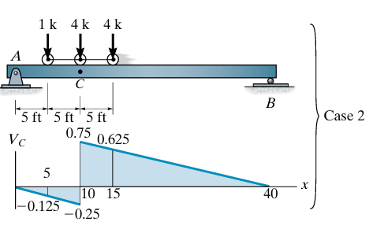

Case 3
The third $4$-k load is positioned at the positive peak:
$${\left(V_{C}\right)}_{3}=1\left(0\right)+4\left(-0.125\right)+4\left(0.75\right) \\ {\left(V_{C}\right)}_{3}=0-0.50+3.00 \\ \boxed{{\left(V_{C}\right)}_{3}=2.50\text{ k}}$$
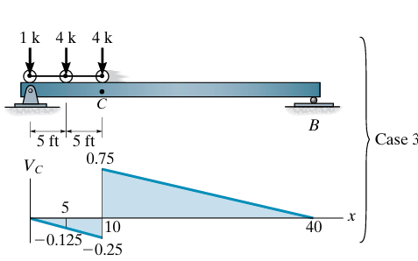

Comparison
The three possible values are:
$$\begin{aligned}{\left(V_{C}\right)}_{1}&=5.25\text{ k} \\ {\left(V_{C}\right)}_{2}&=5.375\text{ k} \\ {\left(V_{C}\right)}_{3}&=2.50\text{ k}\end{aligned}$$
Therefore,
$$\boxed{{\left(V_{C}\right)}_{max}=5.375\text{ k}}$$
The critical loading is Case 2, where the $1$-k load is located 5+ ft from the left support, and the second $4$-k load is immediately to the right of $C$.

Important idea
The key principle is:
For a series of concentrated moving loads, the maximum effect occurs when one of the loads is positioned at a critical point of the influence line.
We therefore place each possible load at the critical position, calculate the resulting effect, and compare the values.
Here:
$$\boxed{\text{Case 2 }\text{gives}\text{ the maximum positive }\text{shear}}$$
because
$$5.375>5.25>2.50$$
- A method based on the change in the reaction, shear, or moment as the loads move

Moving from one position to the next

The idea is to calculate the change in shear as the loads move from one position to the next:

$$\boxed{ΔV=\text{effect of the jumps}+\text{effect of moving along the slope}}$$

In this example:

$$\boxed{ΔV=P_{\text{jump}}\left(Δy_{\text{jump}}\right)+\left(\sum{P}\right)s d}$$

where:
- $P_{\text{jump}}$= the load that crosses the point where there is a jump;
- $Δy_{\text{jump}}$= the magnitude of the jump, including its sign;
- $\sum{P}$= the sum of all the loads;
- $s$= the slope of the influence line;
- $d$= the distance the loads move.

The most important rule

$$\boxed{\begin{matrix}ΔV>0 & ⇒\text{continue moving the loads} \\ ΔV<0 & ⇒\text{stop: the previous position is critical}\end{matrix}}$$

This is precisely what the textbook means by “finding the change in shear as the loads move.

First Step: Calculate the Slope of the Influence Line

The slope of the influence line is:

$$s=\frac{0.75}{40-10}$$

Therefore,

$$s=\frac{0.75}{30} \\ \boxed{s=0.025}$$

This means that when the loads move 1 ft along this inclined portion of the influence line, the ordinate increases by:

$$0.025$$

For a displacement of $5$ft:

$$Δy=\left(0.025\right)\left(5\right)=0.125$$

4. What Happens Between Case 1 and Case 2?

The loads move:

$$5\text{ ft}$$

to the left.

During this movement:

Effect 1: Movement Along the Slope

All three loads move upward along the inclined portion of the influence line.

The sum of the loads is:

$$1+4+4=9 k$$

The increase in the ordinate is:

$$\left(0.025\right)\left(5\right)=0.125$$

Therefore, the contribution due to the slope is:

$$9\left(0.125\right)=1.125 k$$

Effect 2: Jump at Point $C$

The $1 k$load crosses point $C$.

At $C$, the influence line has a jump of:

$$+0.75-\left(-0.25\right)=1$$

However, during the movement considered, the load makes a downward jump on the influence-line diagram.

Therefore, its contribution is:

$$1\left(-1\right)=-1 k$$

5. Total Change

We add the two effects:

$$V_{1-2}=1\left(-1\right)+\left(1+4+4\right)\left(0.025\right)\left(5\right) \\ V_{1-2}=-1+9\left(0.125\right) \\ V_{1-2}=-1+1.125 \\ \boxed{V_{1-2}=+0.125 k}$$The result is positive.

Therefore:

$$\boxed{V_{2}>V_{1}}$$

In other words, Case 2 gives a larger shear than Case 1.

We can also verify this directly:

$$5.375-5.25=0.125 k$$

which gives exactly the same result.

6. Now Consider Case 2 → Case 3

The loads move another:

$$5\text{ ft}$$

This time, the $4 k$load crosses point $C$.

Therefore, it experiences the negative jump:

$$4\left(-1\right)=-4 k$$

At the same time, all three loads continue to move upward along the inclined portion of the influence line.

The contribution from the slope remains:

$$\left(1+4+4\right)\left(0.025\right)\left(5\right) \\ =9\left(0.125\right) \\ =1.125 k$$

Therefore:

$$V_{2-3}=4\left(-1\right)+\left(1+4+4\right)\left(0.025\right)\left(5\right) \\ V_{2-3}=-4+1.125 \\ \boxed{V_{2-3}=-2.875 k}$$

This time, the change is negative.

7. What Does the Negative Result Mean?

We found:

$$V_{1-2}=+0.125 k$$

Therefore:

$$V_{2}>V_{1}$$

But:

$$V_{2-3}=-2.875 k$$

Therefore:

$$V_{3}<V_{2}$$

So the shear increases from Case 1 to Case 2, but then decreases from Case 2 to Case 3.

Hence, the critical position is:

$$\boxed{\text{Case 2}}$$

This illustrates the key idea: as soon as $ΔV$changes from positive to negative, the preceding position is the critical position for maximum shear.

The Difference in One Mental Picture

Shear $V_{C}$

There is: a jump + a slope

$$\boxed{ΔV=P_{\text{jump}}Δy_{\text{jump}}+\sum{P} s d}$$

Moment $M_{C}$

There is: no jump, but there may be two different slopes.

$$\boxed{ΔM=\sum{P_{i}} s_{i} d}$$

In short
- Shear: jump + slope
- Moment: slopes only
- For moment, if different loads are on different slopes, calculate each group separately.

Example Moment.

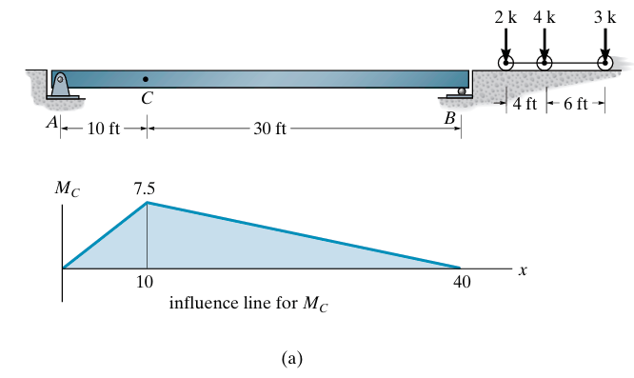
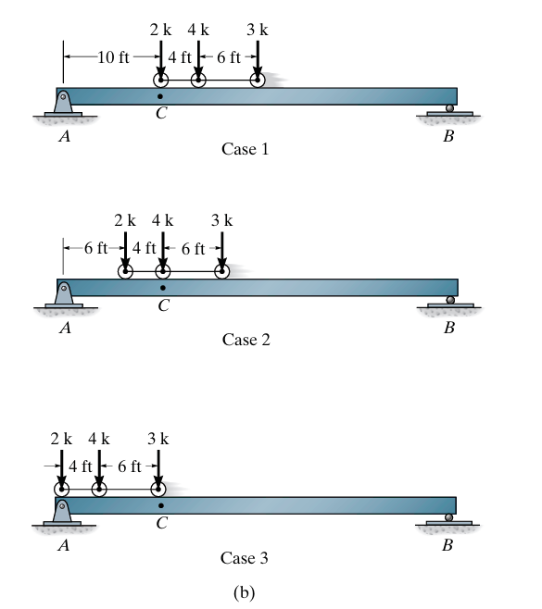
We can also use the foregoing methods to determine the critical position of a series of concentrated forces so that they create the largest internal moment at a specific point in a structure. Of course, it is first necessary to draw the influence line for the moment at the point. As an example, consider the beam, loading, and influence line for the moment at point C shown in Fig. If each of the three concentrated forces is placed on the beam, coincident with the peak of the influence line, we will obtain the greatest influence from each force.

This is the same change in-effect method, but now it is used to find the maximum moment at $C$instead of shear.

The loads are moved from one case to the next, and we calculate only the change in moment.

1. From Case 1 to Case 2

The change in moment is:

$$M_{1-2}=-2\left(\frac{7.5}{10}\right)\left(4\right)+\left(4+3\right)\left(\frac{7.5}{40-10}\right)\left(4\right) \\ M_{1-2}=1.0\text{ k}⋅\text{ft}$$

Since:

$$\boxed{M_{1-2}>0}$$

the moment increases when the loads move from Case 1 to Case 2.

Therefore, we must continue moving the loads.

2. From Case 2 to Case 3

The loads are moved another $6$ft.

$$M_{2-3}=-\left(2+4\right)\left(\frac{7.5}{10}\right)\left(6\right)+3\left(\frac{7.5}{40-10}\right)\left(6\right) \\ \boxed{M_{2-3}=-22.5\text{ k}⋅\text{ft}}$$

Now the change is negative:

$$\boxed{M_{2-3}<0}$$

Therefore, the moment decreases when we move from Case 2 to Case 3.

So the previous position, Case 2, is the critical loading position.

3. Calculate the maximum moment

Once Case 2 has been identified as the critical position, calculate the actual moment at $C$:

$${\left(M_{C}\right)}_{max}=2\left(4.5\right)+4\left(7.5\right)+3\left(6.0\right) \\ =9+30+18 \\ \boxed{{\left(M_{C}\right)}_{max}=57.0\text{ k}⋅\text{ft}}$$

II. Influence Lines of Indeterminate Structures

The procedures used to determine influence lines for statically indeterminate structures are similar to those described for statically determinate structures.
- The main distinguishing characteristic between influence lines in the two cases is that, for statically determinate structures, the diagrams consist of straight-line segments, whereas for statically indeterminate structures, they are generally composed of curves.
- The Müller-Breslau principle makes it possible to directly obtain the qualitative shape of the influence-line diagrams.
- To determine the numerical values of the ordinates of the deformed curve representing the required influence line, the Müller-Breslau method must be complemented by another method, such as the force method or another appropriate structural analysis method.

II.1 Influence Lines for a Two-Span Continuous Beam Using the Müller-Breslau Principle

Consider the two-span continuous beam $ABC$shown in Fig. We will construct the influence lines for the reaction $R_{B}$, the shear force $V_{D}$, and the bending moment $M_{F }$using the Müller-Breslau principle.

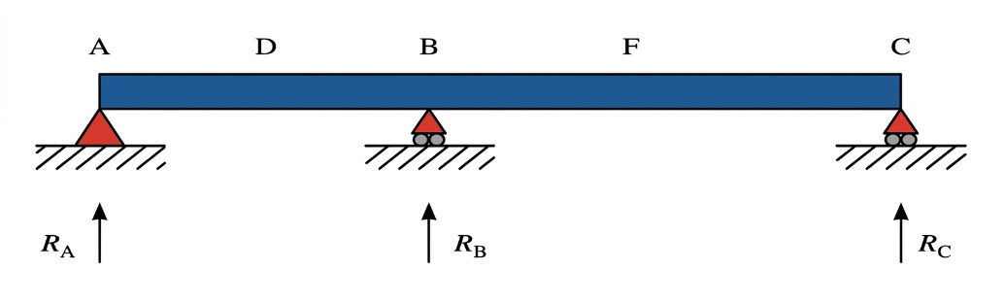
Fig.a

1. Influence Line for $R_{B}$

As shown in Fig.b:
- Remove the support (constraint) at $B$.
- Apply a unit displacement at $B$in the direction of the reaction $R_{B}$.
- The beam deforms while remaining supported at $A$and $C$.

The resulting deformed shape of the beam represents the qualitative influence line for $R_{B}$.

Because the beam is statically indeterminate, the influence line is curved, rather than consisting of straight-line segments.

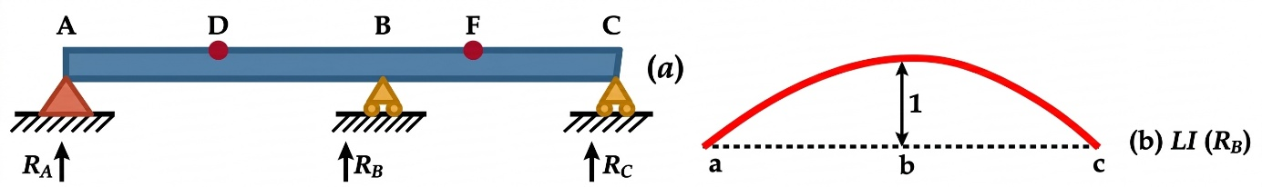

2. Influence Line for the Shear Force $V_{D}$

To obtain the influence line for the shear at $D$:
- Make a cut in the beam at $D$.
- Apply a unit relative vertical displacement between the two sides of the cut, as shown in Fig (c).
- The beam remains connected to the support at $C$, so its deformation is a curve.

The slope of the influence line must be the same on both sides of $D$. Otherwise, a residual moment would produce a relative rotation, which is not allowed because only a displacement corresponding to the shear force has been imposed.

Therefore, the influence line for $V_{D}$between $A$and $D$is curved.
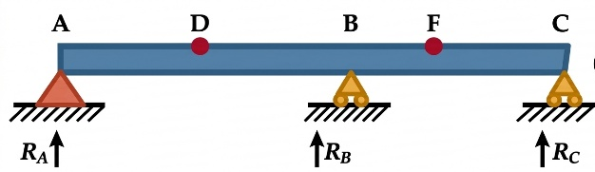

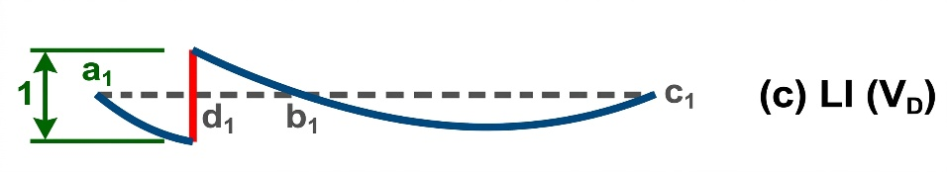

3. Influence Line for the Bending Moment $M_{F}$

To obtain the influence line for the bending moment at $F$:
- Insert a hinge (internal pin) at $F$.
- Apply a unit relative rotation between the two sides of the hinge, as shown in Fig.d.

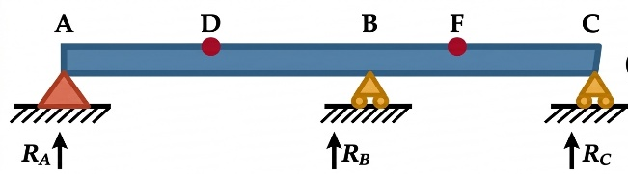
According to the Müller-Breslau principle, the resulting deformed shape gives the qualitative influence line for $M_{F}$.

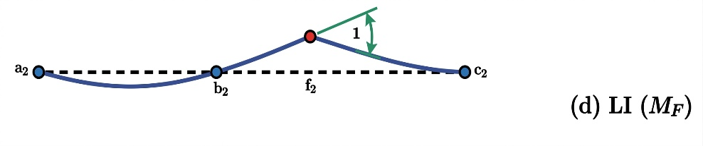

The influence line is therefore curved along both portions:$ABF$ and $FC$

Key idea

For a statically indeterminate continuous beam, the Müller-Breslau principle gives the qualitative shape of the influence line by releasing the corresponding restraint and imposing the associated unit displacement:
Quantity | Release / Modification | Unit action
$$R_{B}$$ | Remove support at $B$ | Unit vertical displacement
$$V_{D}$$ | Cut beam at $D$ | Unit relative vertical displacement
$$M_{F}$$ | Insert hinge at $F$ | Unit relative rotation

The important difference from a statically determinate beam is that the resulting influence lines are generally curved, because the continuous beam is statically indeterminate.
Example 01
Using the Müller-Breslau principle, sketch qualitatively the following influence lines:
- Influence line for : IL(RA)
- Influence line for : IL(RB)
- Influence line for : IL(VC)
Solution

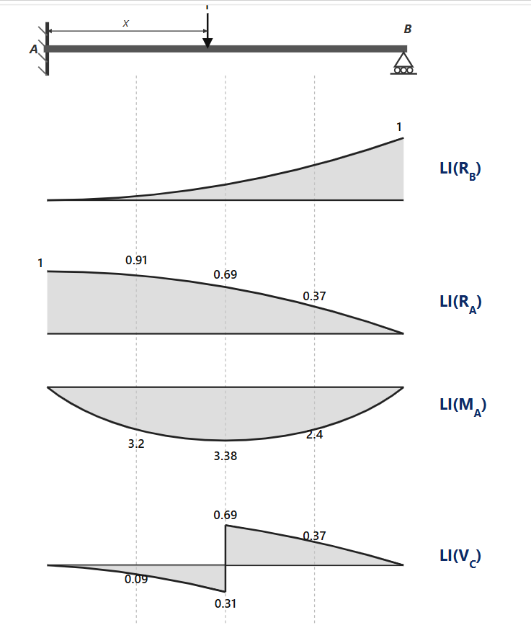

To obtain the numerical values shown on the influence lines, you need to determine the analytical equation for each internal force or reaction as a function of the unit load's position $x$ ($P=1$). (Cliquer sur lien pour bien comprendre https://www.youtube.com/watch?v=BEGfz0qrKzY)

Let $a=\frac{x}{L}$ be the relative position of the unit load along the beam ($0≤a≤1$).

Step 1: Derivation of $R_{B}\left(a\right)$ using the Force Method

For a propped cantilever beam (fixed at $A$, simply supported at $B$ — statically indeterminate of degree 1):
- Primary System : Remove the support at $B$ (converting the structure into a cantilever beam fixed at $A$).
- Deflection due to unit load: The downward deflection at point $B$ caused by a unit load $P=1$ at position $x=aL$ is:

$$δ_{BP}=\frac{L^{3}}{6EI}⋅a^{2}\left(3-a\right)$$
- Flexibility coefficient: The upward deflection at $B$ due to a unit reaction $R_{B}=1$ is:

$$δ_{BB}=\frac{L^{3}}{3EI}$$
- Compatibility Condition ($Δ_{B}=0$):

$$δ_{BP}-R_{B}⋅δ_{BB}=0⟹R_{B}\left(a\right)=\frac{δ_{BP}}{δ_{BB}}=\frac{3a^{2}-a^{3}}{2}$$

Step 2: Numerical Values for Each Influence Line

The values on the diagrams are evaluated at quarter points of the span ($a=0.25$, $a=0.50$, $a=0.75$):

1. Influence Line for $R_{A}$: $IL\left(R_{A}\right)$

From vertical equilibrium ($\sum{F_{y}}=0⟹R_{A}+R_{B}=1$):

$$R_{A}\left(a\right)=1-R_{B}\left(a\right)=1-\frac{3a^{2}-a^{3}}{2}=\frac{{\left(1-a\right)}^{2}\left(2+a\right)}{2}$$
- At $a=0$ ($x=0$): $R_{A}=1$
- At $a=0.25$ ($x=0.25L$): $R_{A}=\frac{{\left(0.75\right)}^{2}×2.25}{2}≈0.91$
- At $a=0.50$ ($x=0.50L$): $R_{A}=\frac{{\left(0.50\right)}^{2}×2.50}{2}=0.69$
- At $a=0.75$ ($x=0.75L$): $R_{A}=\frac{{\left(0.25\right)}^{2}×2.75}{2}≈0.37$
- At $a=1.00$ ($x=L$): $R_{A}=0$

2. Influence Line for Shear Force at C: $IL\left(V_{C}\right)$ (where C is at mid-span, $a_{C}=0.5$)

By equilibrium of the section to the left or right of $C$:
- When the load is to the left of $C$ ($a≤0.5$): $V_{C}\left(a\right)=-R_{B}\left(a\right)$
  - At $a=0.25$: $V_{C}=-\frac{3{\left(0.25\right)}^{2}-{\left(0.25\right)}^{3}}{2}≈-0.09$
  - At $a={0.50}^{-}$: $V_{C}=-\frac{3{\left(0.5\right)}^{2}-{\left(0.5\right)}^{3}}{2}=-0.31$
- When the load is to the right of $C$ ($a>0.5$): $V_{C}\left(a\right)=+R_{A}\left(a\right)$
  - At $a={0.50}^{+}$: $V_{C}=+0.69$
  - At $a=0.75$: $V_{C}=+0.37$

The jump at section $C$ is exactly $ΔV_{C}=0.69-\left(-0.31\right)=1.00$.

3. Influence Line for Bending Moment at A: $IL\left(M_{A}\right)$

From moment equilibrium about $A$:

$$M_{A}\left(a\right)=R_{B}\left(a\right)⋅L-a⋅L=-\frac{L⋅a\left(1-a\right)\left(2-a\right)}{2}$$

For a given span length (for instance $L=18\text{ m}$) :
- At $a=0.25$: $|M_{A}|≈3.2$
- At $a=0.50$: $|M_{A}|=\frac{18×0.5×0.5×1.5}{2}=3.38$
- At $a=0.75$: $|M_{A}|≈2.4$

Example 02

Draw qualitative influence lines for the vertical reactions at supports A and B, the bending moment at point B, and the shear and bending moment at point C of the four-span continuous beam shown in Fig (a). Also, show the arrangements of a uniformly distributed downward live load wl to cause the maximum positive reactions at supports A and B, the maximum negative bending moment at B, the maximum negative shear at C, and the maximum positive bending moment at C.

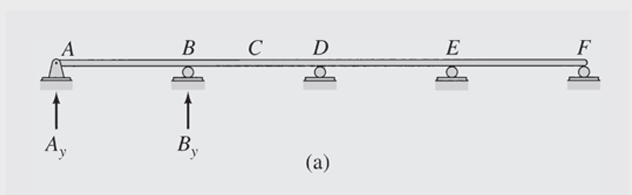

Solution

For the four-span continuous beam, the Müller-Breslau principle is used.

1. Influence line for $A_{y}$
- Remove the vertical support at A.
- Give A a small displacement in the positive direction of $A_{y}$.
- The deflected shape gives the qualitative influence line for $A_{y}$.
- The maximum positive $A_{y}$occurs when the load $w_{l}$covers the spans where the influence line is positive:

$$\boxed{AB\text{ and }DE}$$

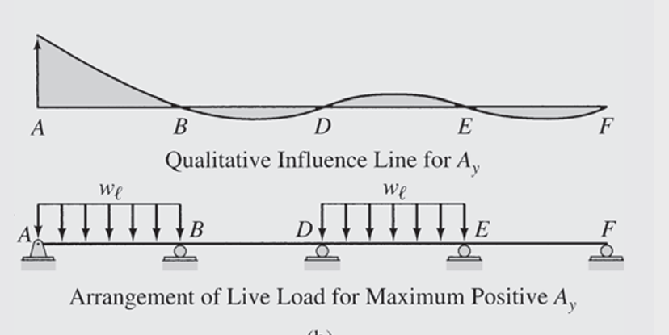

2. Influence line for $B_{y}$
- Remove the vertical restraint at B.
- Give B a small displacement in the positive direction of $B_{y}$.
- The resulting deflected shape gives the influence line for $B_{y}$.

To obtain maximum positive $B_{y}$, place $w_{l }$on the spans where the influence line is positive.
$$\boxed{AD\text{ and }EF}$$

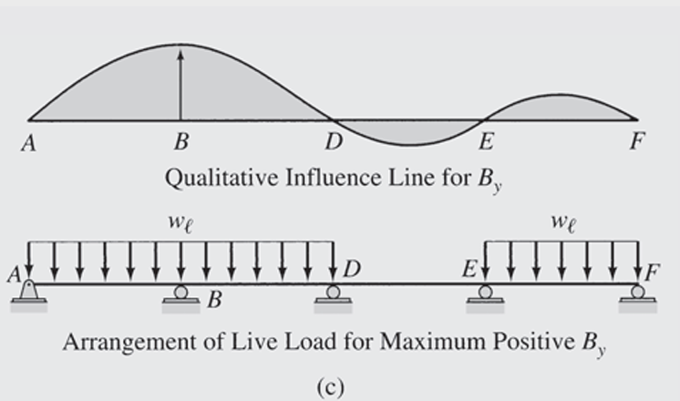

3. Influence line for $M_{B}$
- Insert a hinge at B.
- Rotate the left part counterclockwise and the right part clockwise.
- The resulting deflected shape gives the influence line for $M_{B}$.
- For the maximum negative moment at B, place $w_{l}$where the influence line is negative:

$$\boxed{AB, BD, EF}$$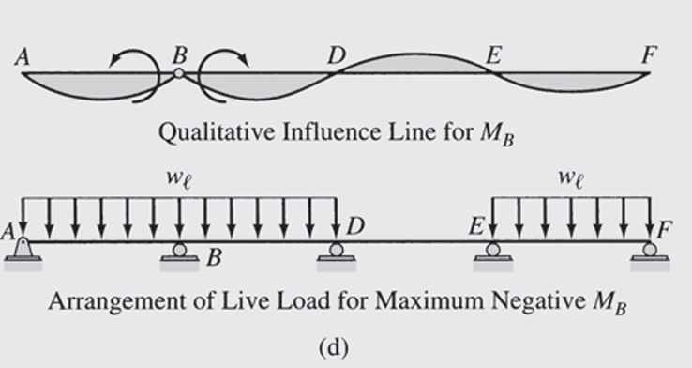

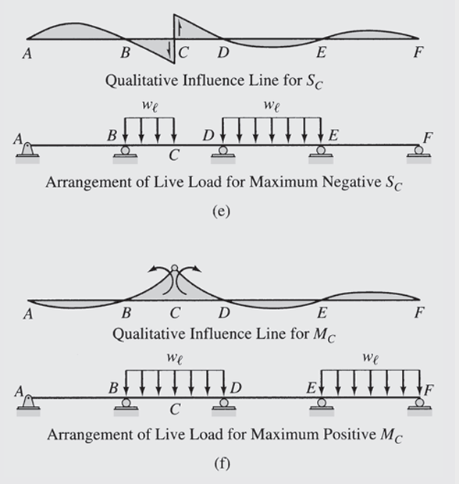

Key rule

$$\boxed{\text{Maximum positive }\text{effect}→\text{load positive ordinates}} \\ \boxed{\text{Maximum }\text{negative} \text{effect}→\text{load negative ordinates}}$$

I.8. Problems

