Notes on Voloridge Project Assessment
Initial Thoughts
$$β_{coeff}=\frac{Covar\left(Index,Entity\right)}{Var\left(Index\right)}$$
Corr *Var(entity) Var(index)

Tradeoffs – approaches
Predict Var with VIX.
Predict Covar with var of entity and already made of entity
https://osquant.com/papers/a-quants-guide-to-covariance-matrix-estimation/
VXX DOES NOT ACCOUNT FOR STOCK SPLITS
Macro thoughts

Small cap stocks will generally perform during rate cuts
High oil prices 2010-2014 from opec, 2014 drop from US shale
When Real yield goes down and break evens go up (aggressive fed easing) best for precious metals and commodities, Cyclical and EM and vol falls for rates.* lower vol for AUD, NZD, NOK, least for JPY.

Features
Yield curve proxy between SHY, IEF, TLT
Equity risk premium

Machine learning and things
Autogluon
XG-Boost

Spy Variance n_estimators=300,learning_rate=0.05,max_depth=4,subsample=0.8,colsample_bytree=0.8,random_state=42,n_jobs=-1
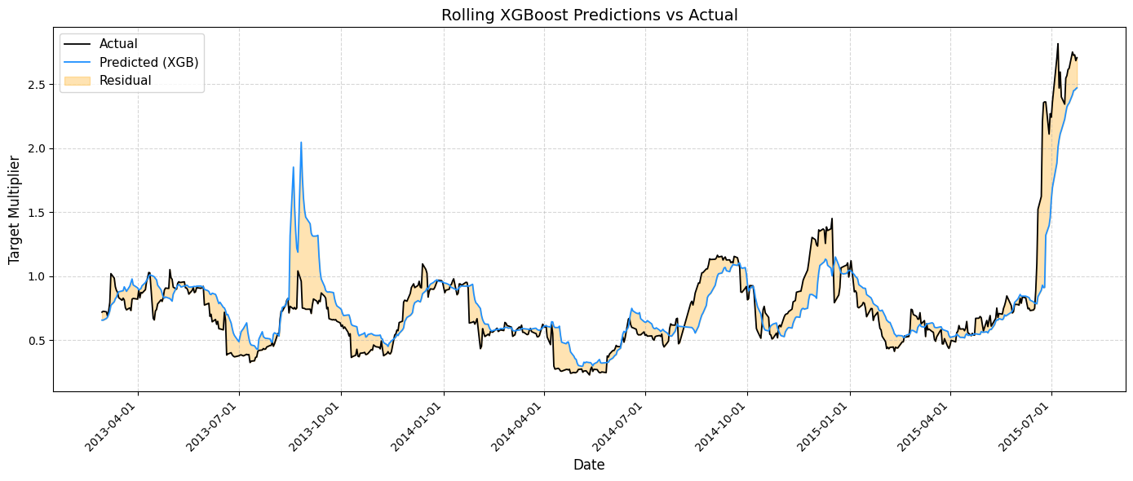
Spy Covariance with GM n_estimators=150,learning_rate=0.1,max_depth=4,subsample=0.8,colsample_bytree=0.8,random_state=42,n_jobs=-1
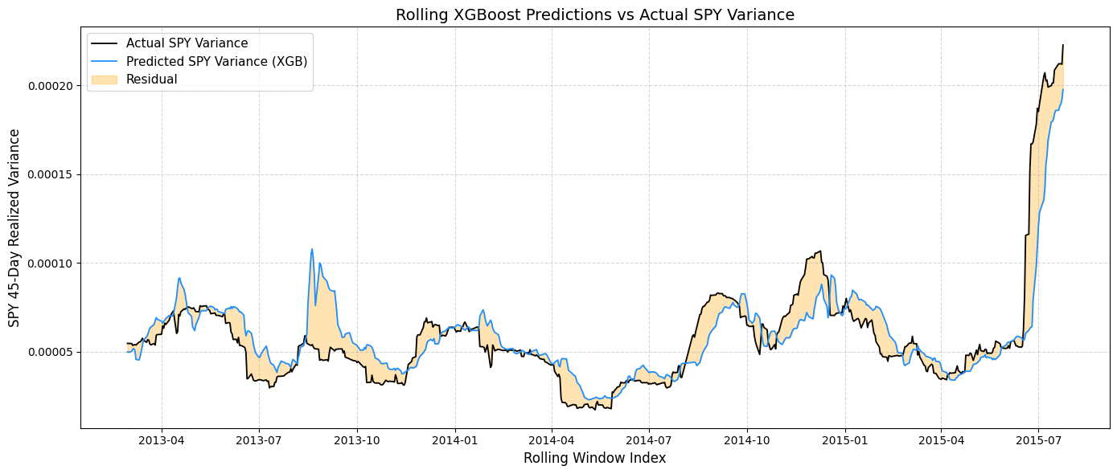
==================================================
Cross-Group Performance Summary
==================================================
Group HAR_R2 Hybrid_R2 HAR_RMSE Hybrid_RMSE
Volatility_ETFs -0.189455 0.206843 0.000056 0.000046
Major_Banks -0.358898 0.387544 0.000047 0.000031
Sector_ETFs -0.356365 -0.040324 0.000047 0.000041
All_Features -0.189455 0.128345 0.000056 0.000048

Direct SPY GM Beta Coefficient Prediction
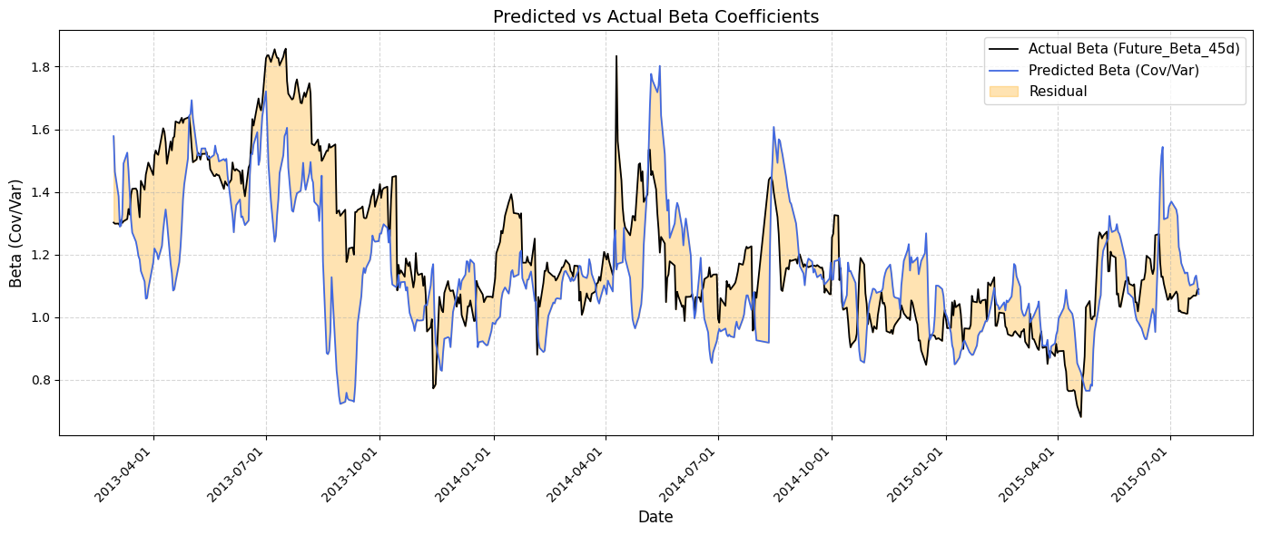
========= ERROR SUMMARY ==========
Mean Error (Bias): -0.052241  Mean Absolute Error: 0.166700  RMSE: 0.213758 | Std of Residuals: 0.207448  Max Over-prediction: 0.596806  Max Under-prediction: -0.682506

Separate Term SPY GM Beta Coefficient Prediction
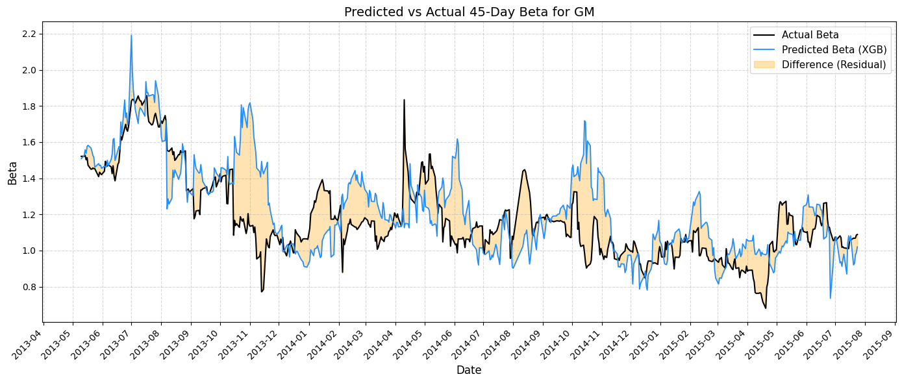
========= 45-day Beta GM With separate terms==========
Beta MSE: 0.046320 | R²: 0.1213

Index
Entities with different IPO dates
- ABBV, AbbVie Inc.
- BABA, Alibaba Group Holding Ltd.
- DBEF, Xtrackers MSCI EAFE Hedged Equity ETF
- DWTI.F, VelocityShares 3x Inverse Crude Oil ETN
- FB, Meta Platforms Inc. (formerly Facebook Inc.)
- GOOG, Alphabet Inc. Class C
- IEFA, iShares Core MSCI EAFE ETF
- IEMG, iShares Core MSCI Emerging Markets ETF
- KMI, Kinder Morgan Inc.
- PANW, Palo Alto Networks Inc.
- PSX, Phillips 66
- TWTR, Twitter Inc.
ETFs
- AGG, iShares Core U.S. Aggregate Bond ETF
- AMLP, Alerian MLP ETF
- BND, Vanguard Total Bond Market ETF
- DBEF, Xtrackers MSCI EAFE Hedged Equity ETF
- DIA,SPDR Dow Jones Industrial Average ETF
- EEM, iShares MSCI Emerging Markets ETF
- EFA, iShares MSCI EAFE ETF
- EWG, iShares MSCI Germany ETF
- EWJ, iShares MSCI Japan ETF
- EWZ, iShares MSCI Brazil ETF
- EZU, iShares MSCI Eurozone ETF
- FXI, iShares China Large-Cap ETF
- GDX, VanEck Gold Miners ETF
- GLD, SPDR Gold Shares ETF
- IEF, iShares 7-10 Year Treasury Bond ETF
- IEFA, iShares Core MSCI EAFE ETF
- IEMG, iShares Core MSCI Emerging Markets ETF
- IJH, iShares Core S&P Mid-Cap ETF
- HYG, iShares iBoxx $ High Yield Corporate Bond ETF
- IBB, iShares Nasdaq Biotechnology ETF
- IVV, iShares Core S&P 500 ETF
- IWB, iShares Russell 1000 ETF
- IWD, iShares Russell 1000 Value ETF
- IWF, iShares Russell 1000 Growth ETF
- IWM, iShares Russell 2000 ETF
- IWN, iShares Russell 2000 Value ETF
- IWR, iShares Russell Mid-Cap ETF
- IYR, iShares U.S. Real Estate ETF
- MDY, SPDR S&P MidCap 400 ETF
- NFLX, Netflix Inc.
- QQQ, Invesco QQQ Trust (NASDAQ-100 ETF)
- SHY, iShares 1-3 Year Treasury Bond ETF
- SPY, SPDR S&P 500 ETF Trust
- TLT, iShares 20+ Year Treasury Bond ETF
- UVXY, ProShares Ultra VIX Short-Term Futures ETF
- V, Visa Inc.
- VEA, Vanguard FTSE Developed Markets ETF
- VEU, Vanguard FTSE All-World ex-US ETF
- VGK, Vanguard FTSE Europe ETF
- VLO, Valero Energy Corporation
- VNQ, Vanguard Real Estate ETF
- VOO, Vanguard S&P 500 ETF
- VTI, Vanguard Total Stock Market ETF
- VTV, Vanguard Value ETF
- VWO, Vanguard FTSE Emerging Markets ETF
- XOP, SPDR S&P Oil & Gas Exploration & Production ETF

