HALAL POLICY
We, AMINRA Company, are committed to ensuring that all products manufactured comply with applicable halal requirements and regulatory standards TCVN 12944:2020, MS 1500:2019.
We shall ensure that:
- Only approved halal raw materials, ingredients, and suppliers are used.
- Halal integrity is maintained throughout receiving, storage, processing, packaging, and distribution.
- Cross-contamination with non-halal materials is prevented through effective controls and procedures.
- A Halal Assurance System (HAS) is established, implemented, and maintained.
- Adequate resources, training, and authority are provided to the Internal Halal Committee (IHC) and relevant personnel.
- The effectiveness of halal controls is reviewed and continuously improved.
- This Halal Policy is communicated to all employees and made available to relevant stakeholders.
Signed by:
Name: Khaled Dinh
Designation: Chief Executive Officer
Signature: 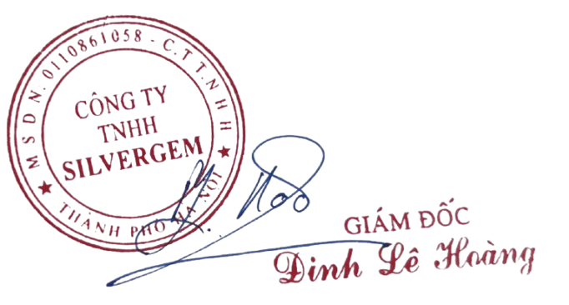
Date: 3/4/2026

