

Dhaka International University

Lab Report details:

Lab Report Topic : Verification of Basic Logic Gates (AND, OR, NOT)  
Lab Report No : 01  
Course Title : Digital Logic Design Lab  
Course Code :

|  |  |
| --- | --- |
| Submitted By: | Submitted To: |
| S M Nabil Ausaf  Roll: 01  Reg No : CS-D-91-23-124492 | Sumaiya Tabassum, Lecturer of CSE Department |

Date of Submission:11.4.25

Lab Report

# Experiment No: 01

Experiment Name: Verification of Basic Logic Gates (AND, OR, NOT)

Date: 4.10.25

# Theory:

Logic gates are the basic building blocks of digital circuits. Each gate implements a Boolean function. The three fundamental gates are:  
  
1. AND Gate – Outputs HIGH (1) only if both inputs are HIGH.  
 Boolean Expression: X = A · B  
  
2. OR Gate – Outputs HIGH if at least one input is HIGH.  
 Boolean Expression: X = A + B  
  
3. NOT Gate – Outputs the inverse of the input.  
 Boolean Expression: X = A'  
  
These gates are implemented using ICs in digital electronics:

* IC 7408 contains four AND gates.
* IC 7432 contains four OR gates.
* IC 7404 contains six NOT gates.

**Procedure:**

1. Place the required IC (7408 for AND, 7432 for OR, 7404 for NOT) on the breadboard.
2. Connect **Pin 14** to **Vcc (5V)** and **Pin 7** to **Ground (GND)**.
3. Connect input wires or switches to the input pins of the logic gate IC.
4. Attach LEDs (with current-limiting resistors) or a logic probe to the output pins.
5. Provide all combinations of input signals (e.g., 0 and 1) using switches or jumper wires.
6. Observe the output for each input combination and record it.
7. Compare the observed outputs with the standard **truth table** for each gate.

# Diagram:

**AND Gate Connection Using IC 7408:**  
  
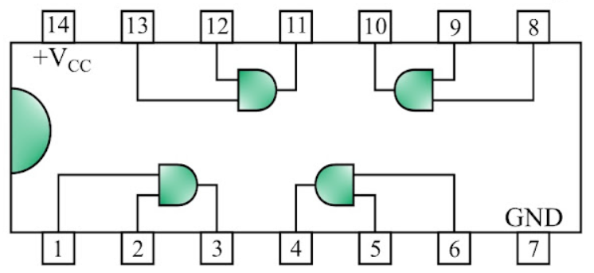

Pin 14: Vcc (Power Supply)

Pin 7 : GND (Ground)

Output: For pin 1 & 2 the output pin is 3

**OR Gate Connection Using IC 7432:**

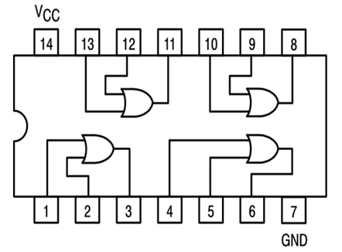

* + Input A: Pin 1
  + Input B: Pin 2
  + Output Y: Pin 3
* **NOT Gate Connection Using IC 7404:** 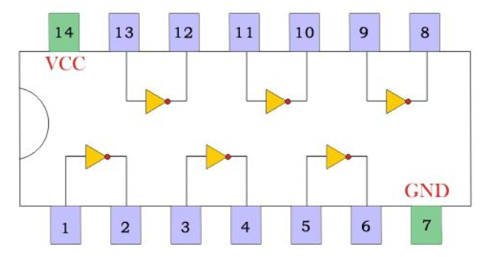
  + Input A: Pin 1
  + Output Y: Pin 2

**Note:** Connect LED + resistor at output for indication.

# Truth Table (AND Gate):

|  |  |  |
| --- | --- | --- |
| **A** | **B** | **X = A·B** |
| **0** | **0** | **0** |
| **0** | **1** | **0** |
| **1** | **0** | **0** |
| **1** | **1** | **1** |

🔹 **Explanation:**  
The **AND gate** gives an output of **1** only when **both inputs are 1**.  
If **either** or **both** inputs are **0**, the output is **0**.  
It follows the Boolean expression: **X = A · B**

# 🔷 OR Gate Truth Table (IC 7432)

| A | B | X = A + B |
| --- | --- | --- |
| 0 | 0 | 0 |
| 0 | 1 | 1 |
| 1 | 0 | 1 |
| 1 | 1 | 1 |

🔹 Explanation: The output of the OR gate is 1 if any one or both inputs are 1.  
(Only 0 + 0 gives 0)

# 🔶 NOT Gate Truth Table (IC 7404)

| A | X = A' |
| --- | --- |
| 0 | 1 |
| 1 | 0 |

🔹 Explanation: The NOT gate is an inverter. It simply outputs the opposite of the input.

# Discussion:

In this experiment, we verified the functionality of basic logic gates using ICs. The connections were made as per the pin configuration of each IC. The output was tested using a logic probe or LED. The truth tables were verified to match the theoretical values for all three gates. The experiment confirmed the behavior of AND, OR, and NOT gates using ICs 7408, 7432, and 7404 respectively.

**Conclusion:**

In this experiment, we verified the behavior of basic logic gates: **AND**, **OR**, and **NOT**, using their respective ICs (**7408**, **7432**, and **7404**). We tested all possible input combinations and confirmed that the outputs matched the expected truth tables. This practical exercise enhanced our understanding of how digital logic gates work, which is essential for designing and analyzing digital circuits.