Equipment Number: EQ-81
Serial Number: Scion 8500 GC
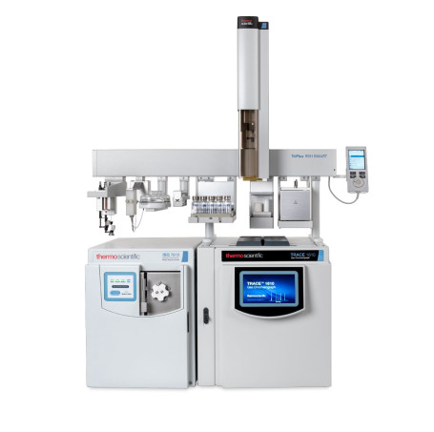

- PURPOSE

This standard test method procedure is intended to provide chemist / analyst / technician the general guide on performing the test analysis appropriately.

- SCOPE

This test method covers the determination of different Polychlorinated Biphenyls (PCBs) in used and unused insulating liquids.

- PRINCIPLE OF ANALYSIS

  - General Principle

The use of Thermo Fischer Scientific Gas Chromatography is fully automatic with software / hardware, injector, detector, column, and flow controller are integrated in one operating unit system. The operator simply must familiarize with the software, prepare the test samples, place it in test chamber, select the appropriate specification or test method for the test, download the program method and then start the test sequence. Results are evaluated after each run is completed.

- DISTRIBUTION

This operational procedure is distributed to the following:
Copy No. Copyholder
Original General Manager
- Laboratory-In-Charge/Technical Manager, Chemistry Laboratory

- TERMS AND DEFINITIONS

PCBs are man-made organic chemicals consisting of carbon, hydrogen and chlorine atoms1. They are polychlorinated biphenyls, mixtures of up to 209 individuals chlorinated compounds2. PCBs were once widely used in the manufacture of carbonless copy paper, as heat transfer fluids, and as dielectric and coolant fluids for electrical equipment3. PCBs have no known taste or smell, and range in consistency from oil to waxy solid. These compounds are of concern to health and environment.

Electron Capture Detector (ECD) is 100-1000x sensitive to Cl,Br,F than FID. In GC-ECD it separates the 200+ PCB compounds by boiling point on a long capillary column, and detects them by how much chlorin they have
More chlorine = bigger peak.

- APPARATUS / REAGENTS

6.1 Gas Chromatography (GC-ECD)

6.2 Analytical Balance

6.3 Helium and Air Cylinder

6.4 PCB- AROCLOR 1242, 1254, 1260 200ppm ampules

6.5 Lindane (Internal Standard)- 100 PPM (Working standard)

6.6 Iso Propyl Alcohol analytical grade

6.7 2ml Vial with TFE-fluorocarbon Faced Butyl Septa cap

6.8 1ml Micropipettes with pipette tip

- PROCEDURE

  - Preparation of Standards / Internal Standard
    - Preparation of PCB from the CRM 1000ppm

    - Take 1ml of the PCB standard (Ampule- 1000 ppm) and dilute with 10ml PCB free insulating oil yielding 100 ppm. This will be our stock for further dilutions.

    - Prepare the following standard concentration of PCB from each mixture (1242, 1254, 1260) (20ppm, 10ppm and 5ppm).
 | Concentration | Volume (ml)  (Stock Sol’n.) | Final Weight with Isooctane  (g)
1 | 5 ppm | 2.5 g from the 100ppm stock | 50
2 | 2 ppm | 1 g from the 100 ppm standard | 50

    - Preparation of Stock Internal Standard Solution (In IPA).

Weigh 0.1 (±0.10mg) of Lindane in 100ml flask and dissolve it with toluene then add IPA up to 100 g yielding 1000ppm.
Dilute the stock to 100ppm for use in the samples - Working standard

  - Preparation of Std Calibration
7.2.1 Take 1 ml of each standard and add 2.0 ml of internal standard using calibrated pipette to the test tube.
7.2.2 Close the tube and shake. Shake well and take it to 2ml GC vials

7.2.3 Inject the standards in GC-ECD on already set up method “PCB METHOD IEC 61619”.
7.2.4 Change type to “Calibration Standard” and level for each standard.
7.2.5 Evaluate the chromatograph and calibrate the method.

  - Preparation of Sample
7.3.1 Take 1 ml of each sample and add 2.0 ml of internal standard using calibrated pipette into 2ml test tubes.
Shake well and take it to 2ml GC vials,inject to GC-ECD

7.3.2 Set up method “PCB METHOD IEC 61619” on GC system.
7.3.3 Prepare a sequence, 1st vial Solvent Blank.
    - After analysis is completed, integrate the peaks and record the results up to three decimals.
    - Run “Blank- IPA” after each 2 samples.
- Calibration, Verification and Cleanup

  - A yearly commissioning service preventive maintenance is provided by Naizak Engineer for highly technical checkup.
  - Column Check Up
    - Condition the column monthly using “Column condition” method.
    - Run wash between the sample sequence to prevent any sample accumulation.
  - Verification is done by using standard prepared in-house or a sample of known concentration and recording in the quality control chart.
  - Column conditioning is performed every week.

- REFERENCES

  - IEC 61619-2015 Contamination by Polychlorinated Biphenyls (PCBs) - Method Of Determination By Capillary Column Gas Chromatography.

  - Scion 8500 GC-ECD manual.

- ATTACHMENTS

  - EQ “Equipment Operation Record”

  - QF “Equipment Maintenance Record”

