It helps to establish the enterprise architecture blueprint for business and technology alignment to

- reduce costs

- minimize risk

- increase value

Enterprise Architect role is increasing who can translate a company's business strategy into concrete solutions, design and execute an IT systems architecture blueprint to support that strategy

The process by which organizations standardize and organize IT infrastructure to aligns with business goals. These strategies support digital transformation, IT growth and the modernization of IT as a department

Enterprise Architecture (EA) is an organizational model; an abstract representation of an Enterprise that aligns strategy, operations and technology to create a roadmap for success

EA began in the 1960s, born from “various architectural manuscripts on Business Systems Planning (BSP) by Professor Dewey Walker,” according to the Enterprise Architecture Book of Knowledge (EABOK)

It’s also useful for bringing more discipline into the organization by standardizing and consolidating processes for more consistency

According to CompTIA, these are the four leading Enterprise Architect Planning (EAP) methodologies:

* The Open Group Architecture Framework (TOGAF) (provides principles for designing, planning, implementing and governing enterprise IT architecture)
* The Zachman Framework for Enterprise Architecture (It’s better understood as a “taxonomy,” according to CompTIA, and it spans six architectural focal points and six primary stakeholders to help standardize and define the IT architecture components and outputs)
* Federal Enterprise Architecture Framework (FEAF)( It’s designed for the U.S. government, but it can also be applied to private companies that want to use the framework)
* Gartner (While it’s not an individual framework, CompTIA recognizes it as a “practical” methodology that focuses on business outcomes with “few explicit steps or components.”)

TOGAF:

is a proven Enterprise Architecture methodology and framework used by the world’s leading organizations to improve business efficiency, the most prominent and reliable Enterprise Architecture standard, ensuring consistent standards, methods, and communication among Enterprise Architecture professionals

The Enterprise Continuum is partitioned into three distinct continua as follows:

* The Enterprise Continuum (It enables the organization of re-usable architecture artifacts and solution assets to maximize the enterprise architecture investment opportunities)
* The Architecture Continuum (The Architecture Continuum illustrates how architectures are developed and evolved across a continuum ranging from Foundation Architectures,)
* The Solutions Continuum (The Solutions Continuum represents the detailed specification and construction of the architectures at the corresponding levels of the Architecture Continuum)

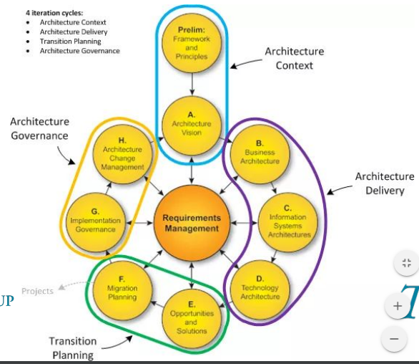

Developing common language in organizational architecture is not easy

* Different interest
* Different approach
* One thing, but many definitions

Establishing a Common Language | Establishing a Common Language Enterprise Architecture should find correct arguments to “argue” to give consistent language by adding

* Proper business value
* Focusing on capabilities, actor, event, process etc.

Biggest challenge in big & complex organization is

* too much information
* organize architectural knowledge more effectively
* manage it effectively

