UX Research

**QuickSafe** – это браслеты с QR кодом и номерами телефонов самых близких. QR код позволит узнать самую необходимую помощь, которую нужно оказать этому человеку, номера телефонов, адрес и т.д.

Our health is the main thing in the life of every person! Many of us cannot say for sure that we are completely healthy. And we found a problem with that.

In order to verify this, we conducted an online survey and a live interview. For a survey, we used web-site, called “SurveyMonkey”, and collected more than 60 responses. Here is the QR-code and link to this survey:

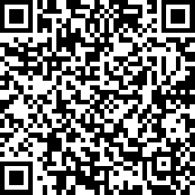 <https://ru.surveymonkey.com/r/32QKTHF>

On the first question, you can understand that most people are faced with situations where a person needed to provide emergency assistance.

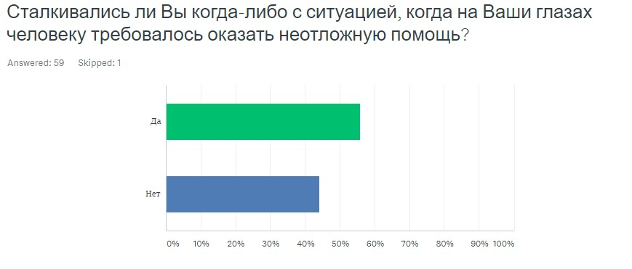

Further, it can be inferred that in such cases they would act independently, which means many will begin to wonder how to help a person.

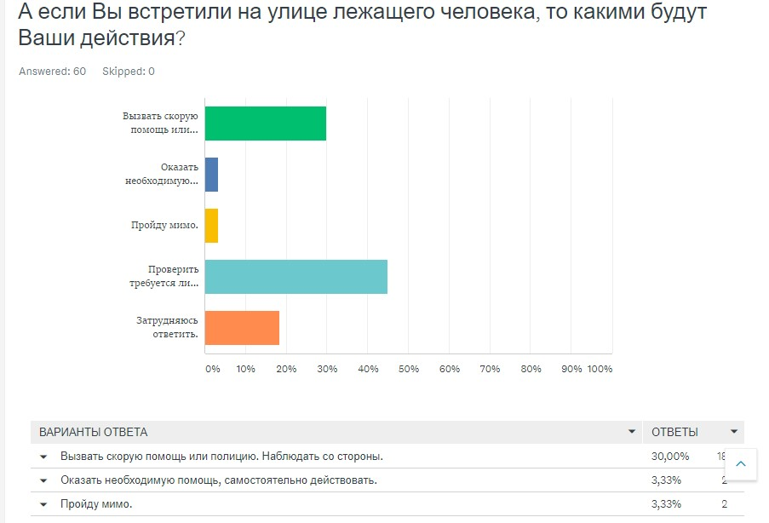

In the next question, they even consider the fact, that most of them may not properly help a person.

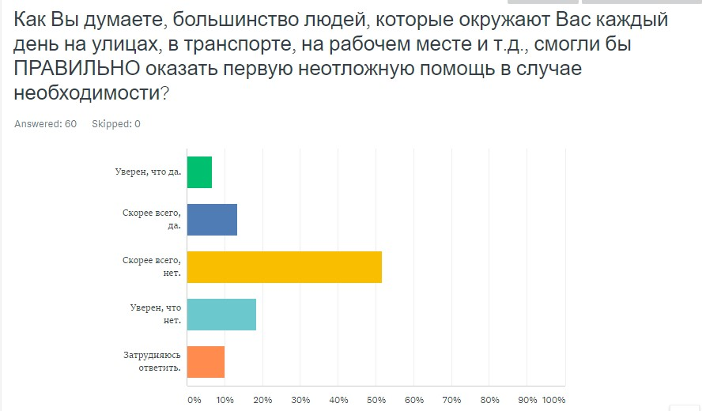

This also tells us how our product can become a very helpful guide to helping sick people. Then, here we have the answer to the main question, which defines our consumers:

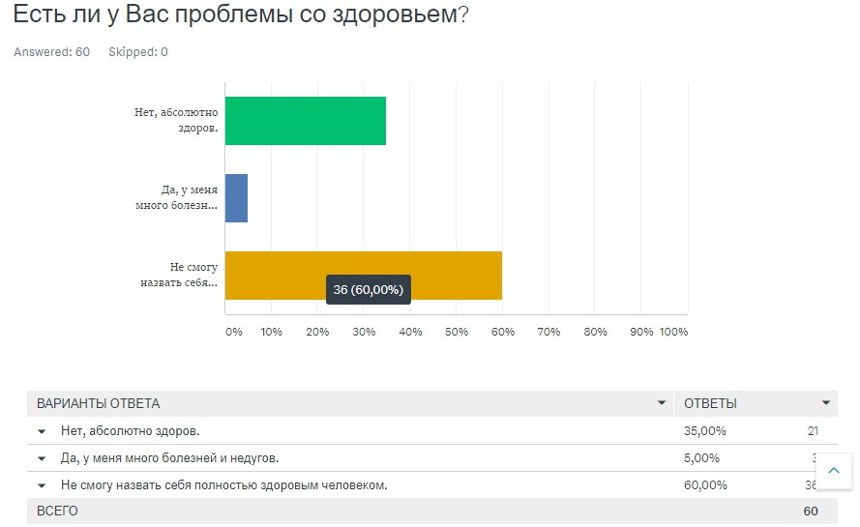

Now, we can conclude that our product will be a bracelet that will point to the phone numbers of acquaintances, and most importantly, the QR-code that, when scanned, will transfer to the home page of the sick person.

There you can find out detailed information on how you can help this person, what medicines he forgot to take, what he is allergic to, and what drugs are harmful to him.

Therefore, the source of this information is also important for customers, our task is to provide an effective website/app that will give this opportunity.

Firstly, we made a sketch of our web-site on *moqups*:

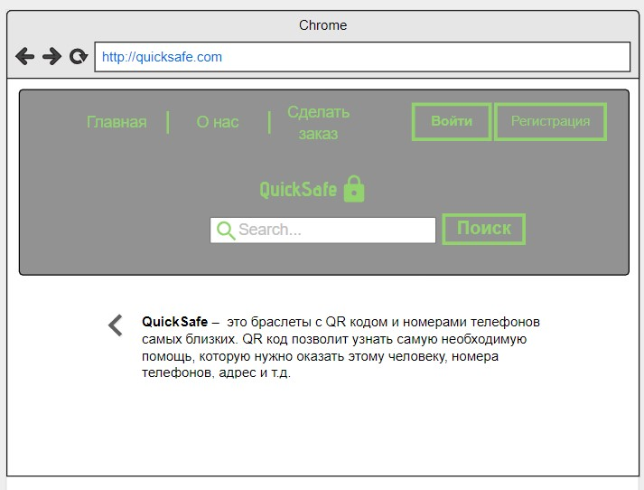

After, we created a prototype:

