Cofe District Comments Dated 23rd July 2017

1. Gift cards:- While adding a gift card, it should open the pop up same as it doing for Coffee items to manage the quantity, so the customer should have the ability of purchasing more than 1 gift card at the same time. (not done )
2. My Cart pop up: The thumbnail and the delete icons should be smaller. (not done)
3. Updation of Cart icon in the header while adding any item:-

The value is not adding by clicking Add to cart, but it updates while refreshing the page, and it should count each item as 1 in the cart,

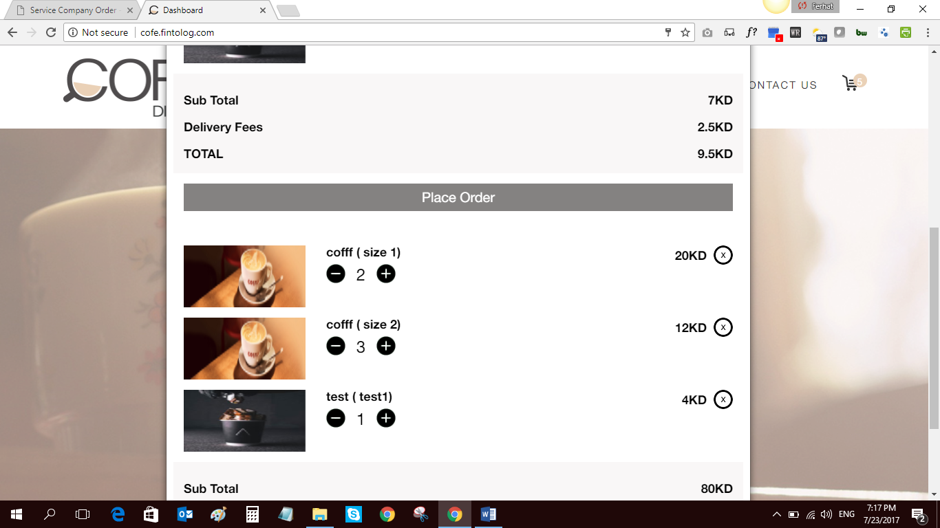

For e.g, see the qty in the cart, it is showing only 5, but it should also count each quantity of the item as well as gift card.

1. Voucher code management, there should be option in the Admin panel to generate the voucher code as value or percentedge.
2. Sometimes when clicked on My cart, it gives the below screenshot:-

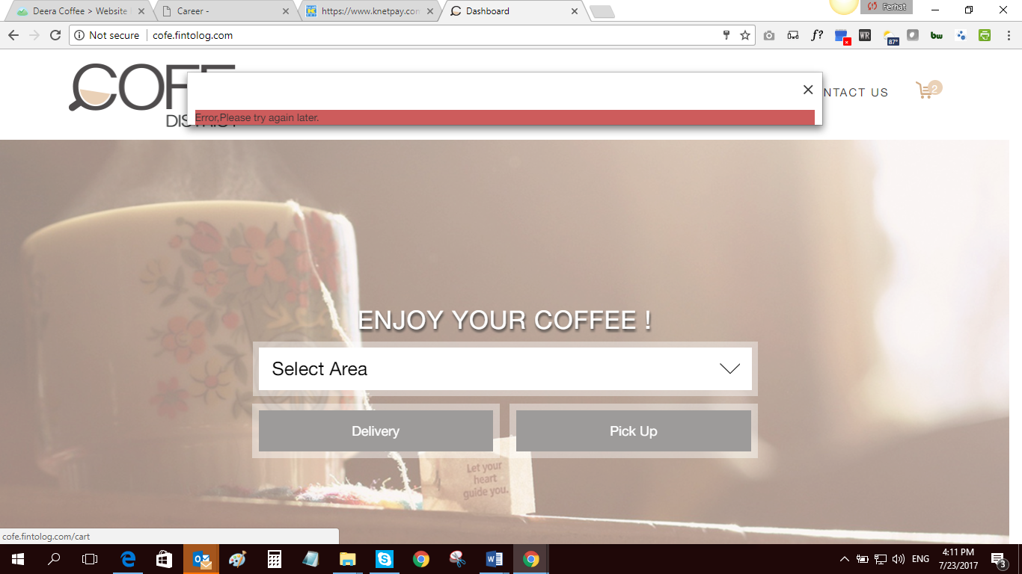

My order :

-oreder sammay must be order receive on click cash on delevary

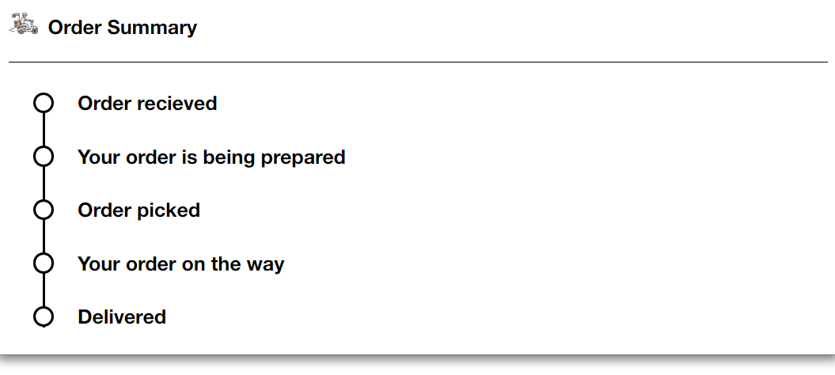

2- delevary :

-whene order status delevaring thire is track button redirect to admin area

catering :

after fill the form no sucess massege

career:

after submit a form no sucess massege

contact_us:

http://localhost:8000/contact_us/create

after submit a form no sucess massege

* Check out page :   
  on select cash on delevary the order in admin side   
  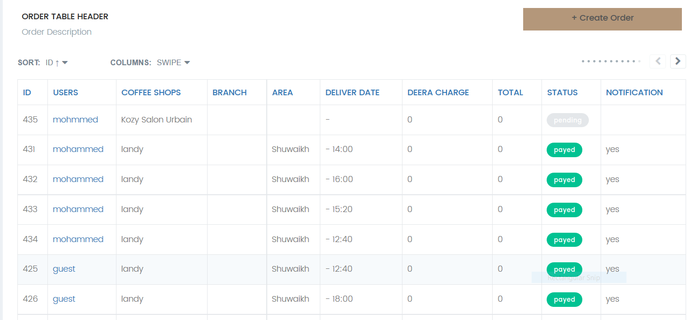

My Profile :

Update button not work

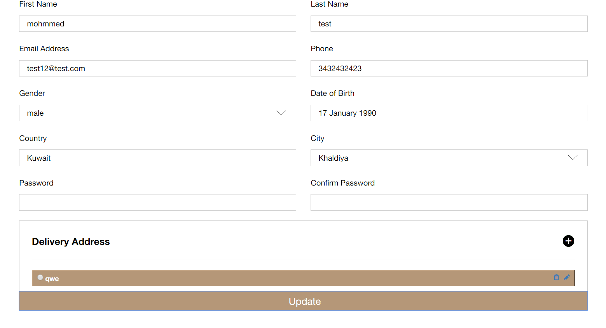

Pick Up :

When select landy and select a branch No time

