Artificial Intelligence

Homework 1

Vanessa White

1642721

University of Birmingham

February 22nd, 2016

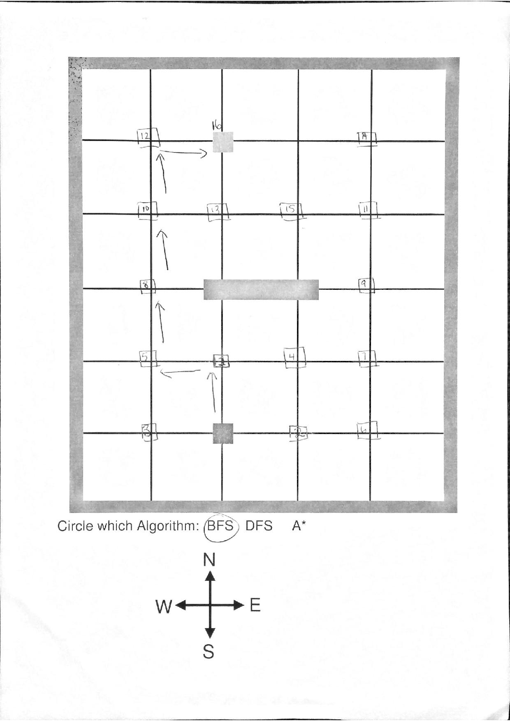

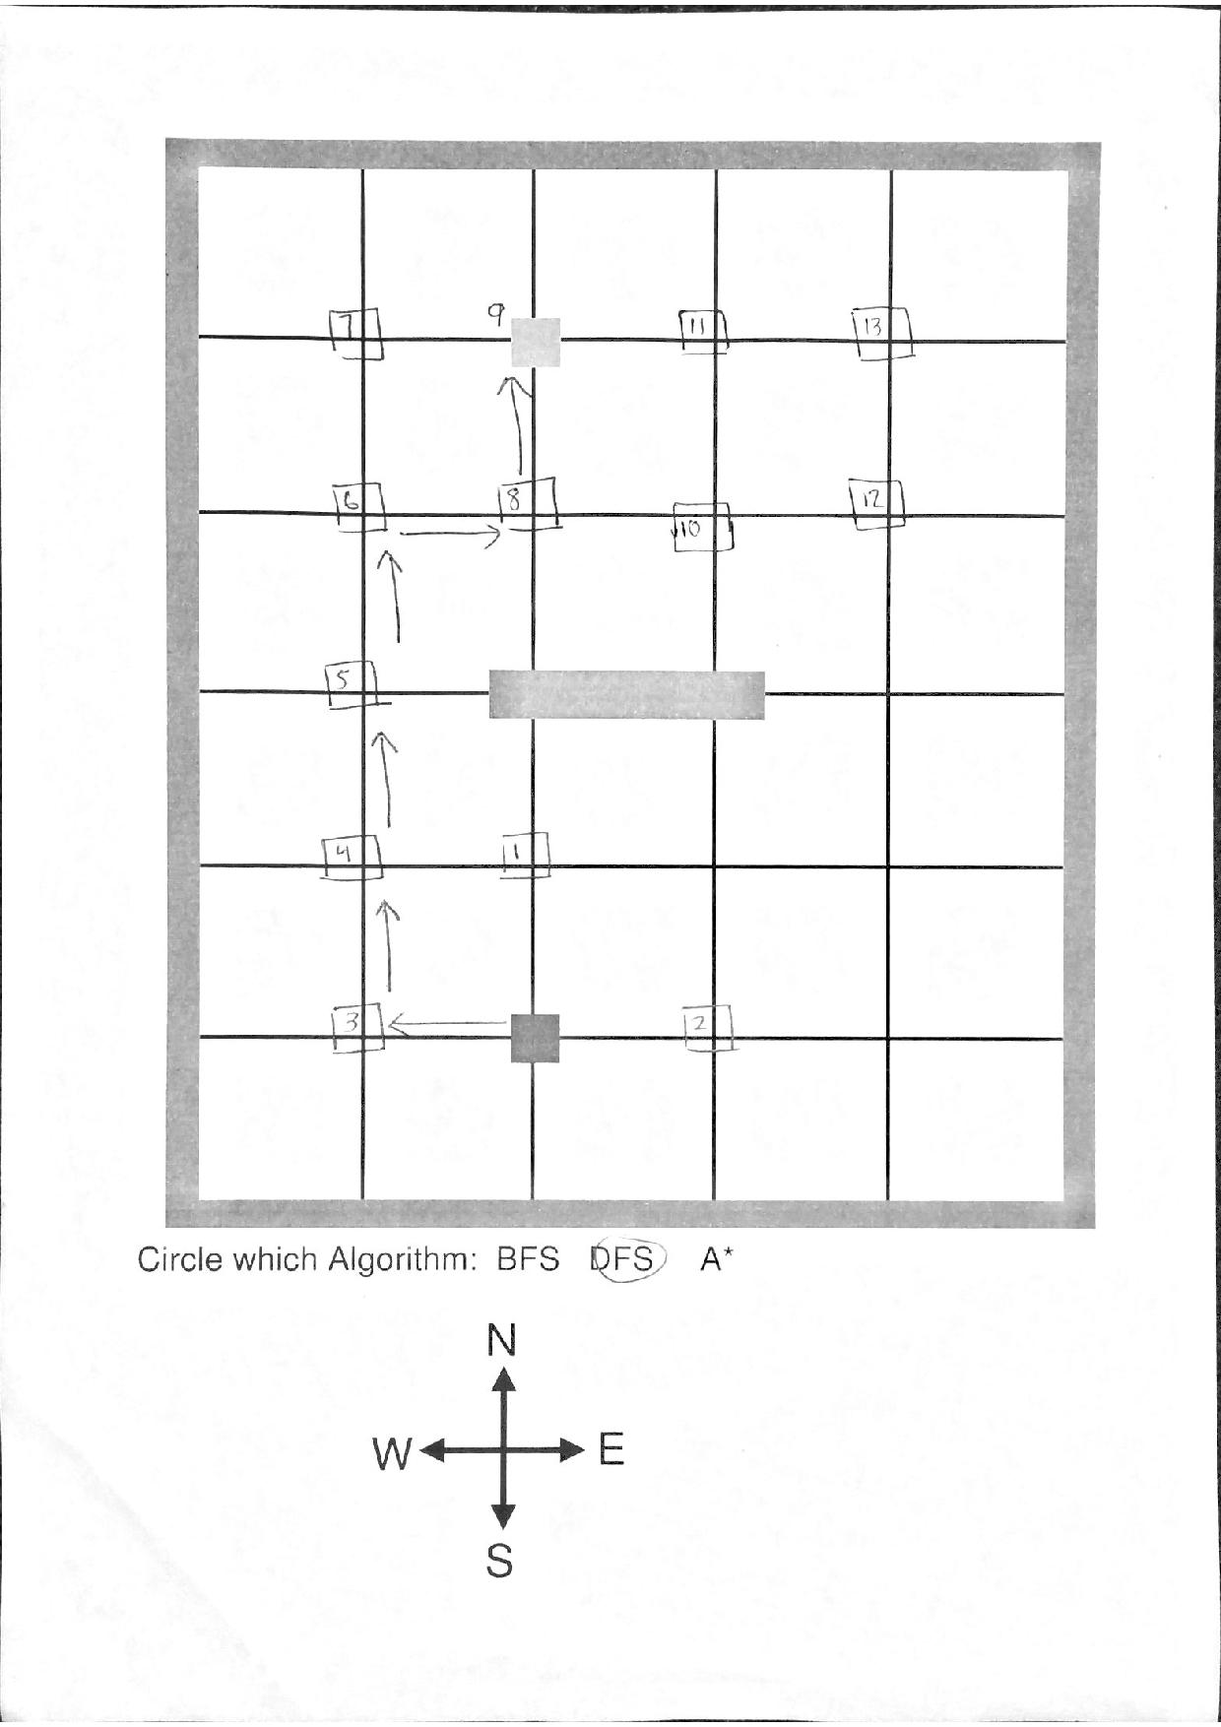

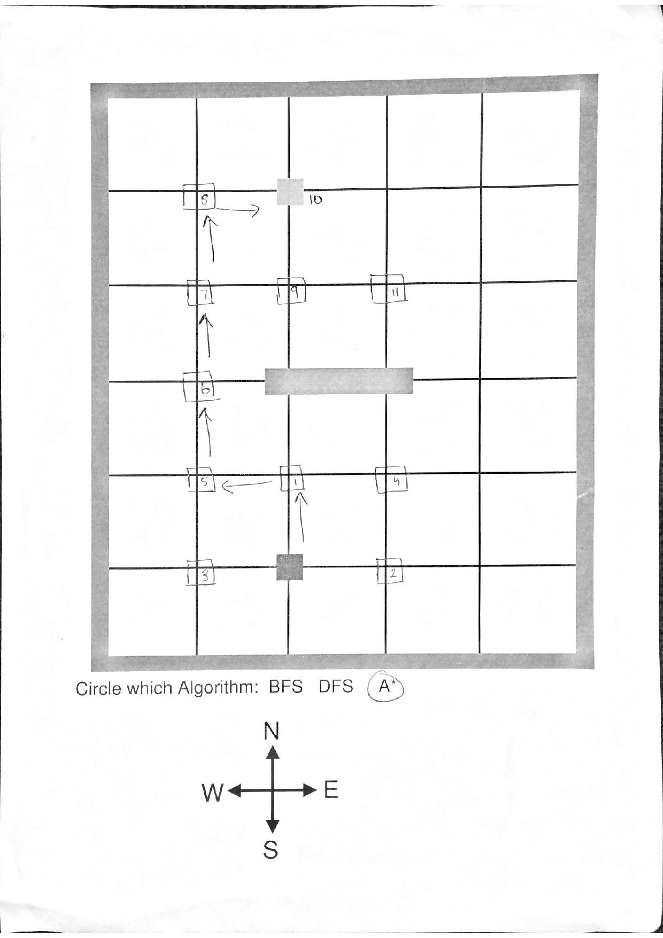

4.

5.

6. Notation used:

* **(m,c,b)**
  + Where m is the amount of missionaries located on the left bank.
  + Where c is the amount of cannibals located on the left bank.
  + Where b is the location of the boat. It can either be (L)eft or (R)ight.

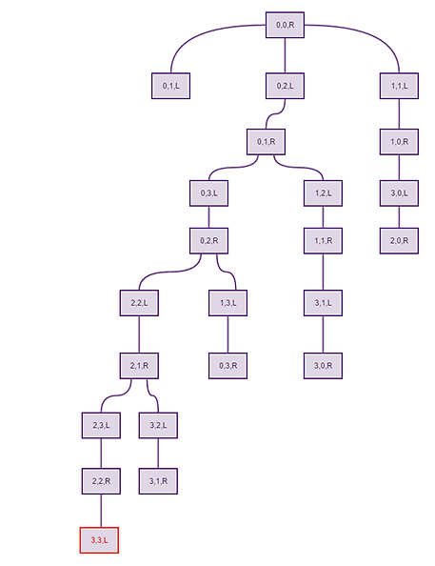

7. a) True. Since the goal is unknown, a heuristic of h(n)=0 would make the search algorithm perform as uniform cost search which is similar to breadth first search. The contours of the search would be circles which would allow searching on a bigger scale. This is necessary since the goal is unknown, so overestimation of the distance remaining to reach the goal is not present.

b) True. Even with zero steps, uniform cost search will be complete. Completeness refers to a goal that exists and can be reached where the graph is finite. Thus, the search will be complete even if no steps are taken because a goal is present within a finite graph.

c) False. A rook is able to move over multiple squares at a time as long as the path is clear. So, the Manhattan distance heuristic may overestimate the number of moves available instead of looking at the multiple squares as one move.

8.