### Destination Recommendation System (Web)

Nowadays, travelling has become more and more popular among Hong Kong citizens. However, it is sometimes difficult to figure out a favourite destination even though you have some criteria in mind. In light of the case, we hope to implement a destination recommendation system which serves as a facilitator to help travellers come up with places which are the most suitable for them and match with their preference. After choosing desired criteria, a list of suggested destination and flight offered by Cathay Pacific will be shown to users.

For our website, we expect the user to answer a list of questions by selecting options offered by the system. For example, the system would like if user interested in a list of activities, such as scuba diving, skydiving, foot-hunting, shopping, etc. From user’s responses, we retrieve preference information of user’s will on destination. We then summarize a list of destinations that fit user’s criteria, sorted by the number of matches. With sufficient time, we would also return a list of articles from travel bloggers or KOL, and flight offered by Cathay Pacific.

**Technologies used**

HTML, CSS, Bootstrap (for front-end layout)

JS and JQuery (for core logic)

Database

**Use case diagram**

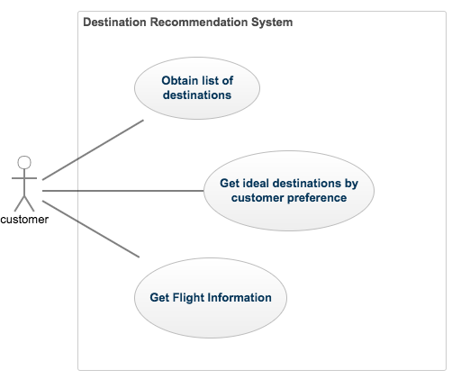

**Flow Chart**

