

VFE Capacity Management Tool - BI
Design Document
Version 1.3
Table 1: Document Change Control

Document Version | Action | Author | Date | Changes
1.0 | Created | Karim Wadie | 25-Feb-2013
1.1 | Updated | Noura Salem | 25-Feb-2013 | Queries and General sections
1.2 | Updated | Gihan Mahmoud | 26-Feb-2013 | Queries and Tractability Matrix
1.3 | Updated | Karim Wadie | 26-Fen-2013 | General Write up and consolidation
Table of Contents
1. Introduction 6
1.1 Design Scope 6
1.2 Abbreviations & Definitions 6
1.3 References 6
2. System Overview 7
2 7
2.1 System Architecture 7
2.1.1 High-Level Logical Architecture 7
2.1.2 Data Diagram 8
2.1.3 Predefined Reports Structure 9
2.1.4 Semantic Layer Structure 10
3. Design Unit Description 12
3 12
3.1 [SRV-01] Service 1: Voice Calls 12
3.1.1 Dashboards & Reports Wireframes 12
3.1.2 Excel Models 12
3.1.3 Queries and Views 12
4. Traceability Matrix 28

List of Figures
Figure 1 Logical Architecture 7
Figure 2 Data Diagram 8
Figure 3 Predefined Reports Structure 9
Figure 4 Semantic Layer Structure 11

List of Tables
Table 1: Document Change Control 2
Table 2: Abbreviations and definitions 6
Table 3: References 6

Introduction

Design Scope
This document is concerned with the BI module of the project only. It covers the high-level components and technologies used dashboards wireframes of the dashboards, queries used for each report and excel models used for what-if-analysis.

Abbreviations & Definitions
Table 2: Abbreviations and definitions
Abbreviation | Definition
<INSERT abbreviation HERE> | <INSERT definition of abbreviation HERE>

References
Table 3: References
Reference | Location
<INSERT the name of any other documents referenced to in this document HERE> | <INSERT the physical location of any other documents referenced to in this document HERE>

System Overview

System Architecture

High-Level Logical Architecture
This section details the BI solution logical architecture and components.
On top of the oracle data source there will be a Semantic layer that separates the data base complexity from the business user to allow him\her to create ad-hoc reports in an easy manner (using drag & drop actions) from a user friendly interface.
Later on different BusinessObjects report authoring tools can used to create reports and dashboards directly from semantic layer without the need to write complex SQL statements on the data base.
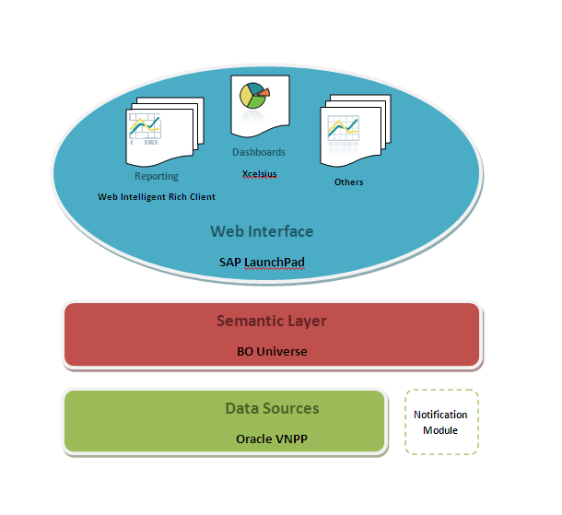
Figure 1 Logical Architecture

Data Diagram

The below ERD illustrate the tables used to store the nodes master data, KPI notification module and actual traffic and utilization table for each system. The rest of data source tables are not part of the project implementation, they are only used in read-only mode to generate reports
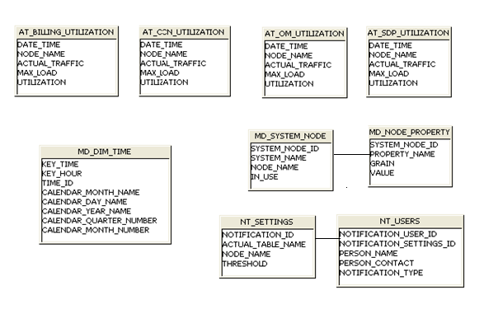
Figure 2 Data Diagram

Predefined Reports Structure
Each service will have one main dashboard (Service-Level Dashboard) which has links to multiple detailed reports for each sub-system (System-Level Dashboards) as well as a What-if-Analysis module.
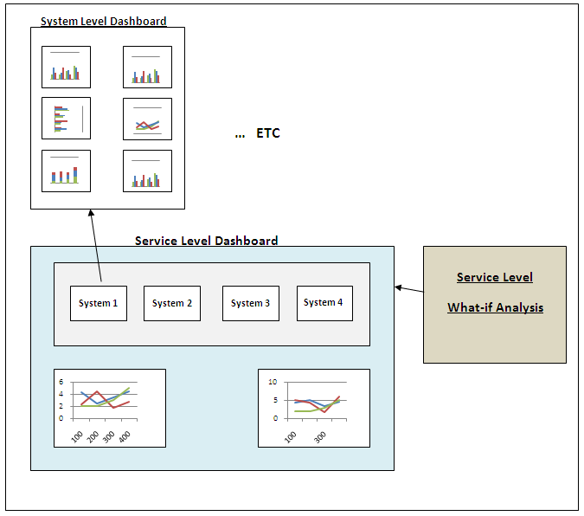
Figure 3 Predefined Reports Structure

Semantic Layer Structure
This section illustrates the Semantic Layer (BO Universe) Structure for implementing the solution.
Each System will have a separate folder, under which all original data base tables covering this system will be grouped under one folder ‘SystemName Original Tables’ as well as all other derived tables (views) that are used by the predefined reports\dashboards.
For each table -original or derived- (Class in Universe terminology) a list of attributes can be found (Objects) that maps to either a data base column, derived column or measure. These objects can be used then by reporting tools to create predefined and ad-hoc reports.

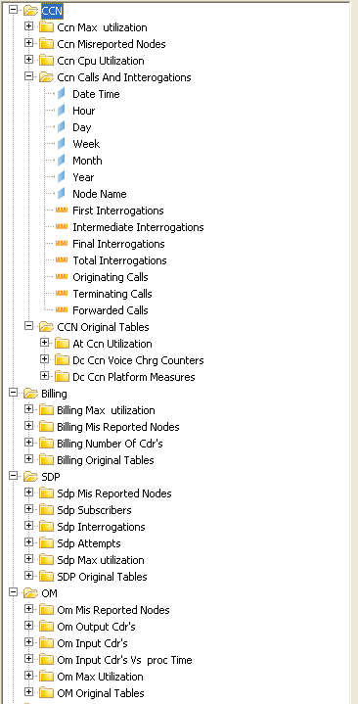
Figure 4 Semantic Layer Structure

Design Unit Description

[SRV-01] Service 1: Voice Calls

Dashboards & Reports Wireframes

Main Dashboard

What-If-Analysis

System Dashboard Template

Excel Models
All Dashboards that are implemented using Excelsuis needs an excel model that can be either static or populated from a data source using a web service. Below Are the Excel models used in the solution.

Main Dashboard
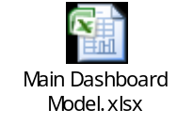

What If Analysis
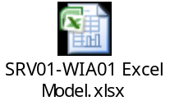

Queries and Views

Main Dashboard
SRV01-D1-C1
Chart - Daily Calls & CDRs Chart
----- Calls
select SUM(Originating) As Originating ,
TO_CHAR(Date_Time,'DD/MM/YYYY') As DayDate,
CAST(TO_CHAR(Date_Time,'DD') AS NUMBER) As Day,
CAST(TO_CHAR(Date_Time,'WW') AS NUMBER) AS Week,
CAST(TO_CHAR(Date_Time,'MM') AS NUMBER) As Month,
CAST(TO_CHAR(Date_Time,'YYYY') AS NUMBER) As Year
from DC_SDP_ALL_ATTEMPT
group by
TO_CHAR(Date_Time,'DD/MM/YYYY') ,
CAST(TO_CHAR(Date_Time,'DD') AS NUMBER) ,
CAST(TO_CHAR(Date_Time,'WW') AS NUMBER) ,
CAST(TO_CHAR(Date_Time,'MM') AS NUMBER) ,
CAST(TO_CHAR(Date_Time,'YYYY') AS NUMBER)

----- CDRs
select SUM(TOTAL_STREAM_RECORDS_IN) AS TotalStream,
TO_CHAR(Date_Time,'DD/MM/YYYY') As DayDate,
CAST(TO_CHAR(Date_Time,'DD') AS NUMBER) As Day,
CAST(TO_CHAR(Date_Time,'WW') AS NUMBER) AS Week,
CAST(TO_CHAR(Date_Time,'MM') AS NUMBER) As Month,
CAST(TO_CHAR(Date_Time,'YYYY') AS NUMBER) As Year
from DC_OFFLINE_NO_CDRS_INPUT
group by
TO_CHAR(Date_Time,'DD/MM/YYYY') ,
CAST(TO_CHAR(Date_Time,'DD') AS NUMBER) ,
CAST(TO_CHAR(Date_Time,'WW') AS NUMBER) ,
CAST(TO_CHAR(Date_Time,'MM') AS NUMBER) ,
CAST(TO_CHAR(Date_Time,'YYYY') AS NUMBER)

SRV01-D1-C2
Chart - Last Week Calls Comparison
select SUM(Originating) AS Originating,
TO_CHAR(Date_Time,'DD/MM/YYYY') As DayDate,
CAST(TO_CHAR(Date_Time,'HH') AS NUMBER) As Hour,
CAST(TO_CHAR(Date_Time,'DD') AS NUMBER) As Day,
CAST(TO_CHAR(Date_Time,'WW') AS NUMBER) AS Week,
CAST(TO_CHAR(Date_Time,'MM') AS NUMBER) As Month,
CAST(TO_CHAR(Date_Time,'YYYY') AS NUMBER) As Year
from DC_SDP_ALL_ATTEMPT
group by
TO_CHAR(Date_Time,'DD/MM/YYYY') ,
CAST(TO_CHAR(Date_Time,'HH') AS NUMBER) ,
CAST(TO_CHAR(Date_Time,'DD') AS NUMBER) ,
CAST(TO_CHAR(Date_Time,'WW') AS NUMBER) ,
CAST(TO_CHAR(Date_Time,'MM') AS NUMBER) ,
CAST(TO_CHAR(Date_Time,'YYYY') AS NUMBER)

SRV01-D1-C3
Chart - Last Week CDRs Comparison
select SUM(TOTAL_STREAM_RECORDS_IN) AS TotalStream,
TO_CHAR(Date_Time,'DD/MM/YYYY') As DayDate,
CAST(TO_CHAR(Date_Time,'HH') AS NUMBER) As Hour,
CAST(TO_CHAR(Date_Time,'DD') AS NUMBER) As Day,
CAST(TO_CHAR(Date_Time,'WW') AS NUMBER) AS Week,
CAST(TO_CHAR(Date_Time,'MM') AS NUMBER) As Month,
CAST(TO_CHAR(Date_Time,'YYYY') AS NUMBER) As Year
from DC_OFFLINE_NO_CDRS_INPUT
group by
TO_CHAR(Date_Time,'DD/MM/YYYY') ,
CAST(TO_CHAR(Date_Time,'DD') AS NUMBER) ,
CAST(TO_CHAR(Date_Time,'HH') AS NUMBER) ,
CAST(TO_CHAR(Date_Time,'WW') AS NUMBER) ,
CAST(TO_CHAR(Date_Time,'MM') AS NUMBER) ,
CAST(TO_CHAR(Date_Time,'YYYY') AS NUMBER)

SDP-CCN-Ratio
SDP-CCN-Ratio
select sum(actual_traffic) as ccn_sum from AT_CCN_UTILIZATION
select sum (actual_traffic) as sdp_sum from AT_SDP_UTILIZATION

Busy Hour Time and Percentage
Busy Hour Time and Percentage
select maxcalls,spd2.date_time,
(
select sum(ORIGINATING) FROM DC_SDP_ALL_ATTEMPT
where TO_CHAR(DATE_TIME, 'DD-MM-YY')= TO_CHAR(to_date(spd2.DATE_TIME), 'DD-MM-YY')
) totalcalls
from
(
select max(totalcalls) maxcalls from
(
SELECT TO_CHAR(DATE_TIME, 'DD-MM-YY HH') Date_Time, SUM(ORIGINATING) TotalCALLS
FROM DC_SDP_ALL_ATTEMPT sdp1
GROUP BY TO_CHAR(DATE_TIME, 'DD-MM-YY HH')
order by DATE_TIME
) spd1 ) sdp1
inner join
(
SELECT TO_CHAR(DATE_TIME, 'DD-MM-YY HH') Date_Time, SUM(ORIGINATING) TotalCALLS
FROM DC_SDP_ALL_ATTEMPT sdp1
GROUP BY TO_CHAR(DATE_TIME, 'DD-MM-YY HH')
order by DATE_TIME
) spd2
on spd2.totalcalls= sdp1.maxcalls

SDP

SRV01-D2-C1
SDP Max. Utilization
SELECT DATE_TIME AS "Date Time",NODE_NAME AS "Node Name" ,CAST(TO_CHAR(DATE_TIME,'HH24') AS NUMBER) AS "Hour",CAST(TO_CHAR(DATE_TIME,'DD') AS NUMBER) AS "Day" ,CAST(TO_CHAR(DATE_TIME,'W') AS NUMBER) AS "Week"
,CAST(TO_CHAR(DATE_TIME,'MM') AS NUMBER) AS "Month",CAST(TO_CHAR(DATE_TIME,'YYYY') AS NUMBER) AS "Year", MAX(UTILIZATION) AS "Max Utilization" FROM AT_SDP_UTILIZATION
GROUP BY DATE_TIME,NODE_NAME

SRV01-D2-C2
Attempts
SELECT ID,date_time as "Date Time",NODE_NAME as "Node Name",CAST(TO_CHAR(DATE_TIME,'HH24') AS NUMBER) AS "Hour",CAST(TO_CHAR(DATE_TIME,'DD') AS NUMBER) AS "Day" ,CAST(TO_CHAR(DATE_TIME,'W') AS NUMBER) AS "Week",CAST(TO_CHAR(DATE_TIME,'MM') AS NUMBER) AS "Month",CAST(TO_CHAR(DATE_TIME,'YYYY') AS NUMBER) AS "Year",SUM(Voice) AS "Number Of Calls"
,SUM(SMS) AS "Number SMS's",SUM(SUCC_RE_BYEXT_NW) AS "Successful Attempts"
,SUM(UNSUCC_NORM_TERM_EXT) AS "Unsuccessful Attempts"
FROM DC_SDP_ALL_ATTEMPT
GROUP BY ID,date_time,CAST(TO_CHAR(DATE_TIME,'HH24') AS NUMBER),CAST(TO_CHAR(DATE_TIME,'DD') AS NUMBER),CAST(TO_CHAR(DATE_TIME,'WW') AS NUMBER),CAST(TO_CHAR(DATE_TIME,'MM') AS NUMBER),CAST(TO_CHAR(DATE_TIME,'YYYY') AS NUMBER),NODE_NAME

SRV01-D2-C3
Interrogations
SELECT ID,NODE_NAME AS "Node Name",DATE_TIME as "Date Time",CAST(TO_CHAR(DATE_TIME,'HH24') AS NUMBER) AS "Hour",CAST(TO_CHAR(DATE_TIME,'DD') AS NUMBER) AS "Day" ,CAST(TO_CHAR(DATE_TIME,'W') AS NUMBER) AS "Week",CAST(TO_CHAR(DATE_TIME,'MM') AS NUMBER)AS "Month",CAST(TO_CHAR(DATE_TIME,'YYYY') AS NUMBER) AS "Year",SUM(TOTAL_INTERR_SUCC) AS "Interrogations Success", SUM(TOTAL_INTERR_FAIL) AS "Interrogations Failed",SUM(FIRST_INTERR_SUCC + FIRST_INTERR_FAIL) AS "First Interrogations",
SUM (INTER_INTERR_SUCC + INTER_INTERR_FAIL)AS "Intermediate Interrogations",SUM (FINAL_INTERR_SUCC + FINAL_INTERR_FAIL) AS "Final Interrogations"
FROM DC_SDP_NEW_LREG
GROUP BY ID,NODE_NAME,DATE_TIME

SRV01-D2-C4
Subscribers
SELECT X.ID, X.DATE_TIME AS "Date Time",X.NODE AS "Node Name" ,
CAST(TO_CHAR(X.DATE_TIME,'DD') AS NUMBER) AS "Day"
,SUM(X.COUNT_ALL) as "Total Subscribers" ,
SUM(X.VALIDITY) as "Active Subscribers", SUM(X.GRACE) as "Grace Subscribers", SUM(X.AFTERGRACE) as "After Grace Subscribers" ,(MAX(Y.MAX_CONCURRENT)*10) AS "Licenses"
FROM DC_SDP_SNAPSHOT X,DC_PREPAID_LICENSES Y
WHERE X.DATE_TIME=Y.ENTRY_DAY
GROUP BY X.ID, X.DATE_TIME,X.NODE

SRV01-D2-C5 / SRV01-D2-C6
Mis-Reported Nodes / Mis-Reported Nodes Details
Select RefTable.Key_Time as "Date Time" ,TO_DATE(TO_CHAR(RefTable.Key_Time,'DD/MM/YYYY'),'DD/MM/YYYY') as "Date", CAST(TO_CHAR(RefTable.Key_Time,'HH24') AS NUMBER) AS "Hour",CAST(TO_CHAR(RefTable.Key_Time,'DD') AS NUMBER) AS "Day" ,CAST(TO_CHAR(RefTable.Key_Time,'W') AS NUMBER) AS "Week",CAST(TO_CHAR(RefTable.Key_Time,'MM') AS NUMBER) AS "Month",CAST(TO_CHAR(RefTable.Key_Time,'YYYY') AS NUMBER) AS "Year", RefTable.Node_name as "Node Name" from
(select y.key_Time, x.Node_name from MD_SYSTEM_NODE X, MD_DIM_TIME Y where
TO_DATE(TO_CHAR(y.key_TIME,'DD/MM/YYYY HH24'),'DD/MM/YYYY HH24') <= TO_DATE(TO_CHAR(sysdate,'DD/MM/YYYY HH24'),'DD/MM/YYYY HH24') and X.In_Use= 'Y' and X.SYSTEM_NAME='SDP') RefTable left join @DerivedTable("SDP Interrogations") on RefTable.key_time="SDP Interrogations"."Date Time"
where "SDP Interrogations"."Node Name" is null

CCN

SRV01-D3-C1
CCN Max. Utilization
SELECT DATE_TIME AS "Date Time",NODE_NAME AS "Node Name" ,CAST(TO_CHAR(DATE_TIME,'HH24') AS NUMBER) AS "Hour",CAST(TO_CHAR(DATE_TIME,'DD') AS NUMBER) AS "Day" ,CAST(TO_CHAR(DATE_TIME,'W') AS NUMBER) AS "Week"
,CAST(TO_CHAR(DATE_TIME,'MM') AS NUMBER) AS "Month",CAST(TO_CHAR(DATE_TIME,'YYYY') AS NUMBER) AS "Year", MAX(UTILIZATION) AS "Max Utilization" FROM AT_CCN_UTILIZATION
GROUP BY DATE_TIME,NODE_NAME

SRV01-D3-C2 / SRV01-D3-C3
Calls / Interrogations
Select X."Date Time" , X."Hour" , X."Day" , X."Week" , X."Month" , X."Year" , X."Node Name" , X."First Interrogations" ,X."Intermediate Interrogations", X."Final Interrogations" , (X."First Interrogations" + X."Intermediate Interrogations" + X."Final Interrogations") as "Total Interrogations" , X."Originating Calls" , X."Terminating Calls" , X."Forwarded Calls"
from
(Select
Date_Time as "Date Time",
CAST(TO_CHAR(DATE_TIME,'HH24') AS NUMBER) AS "Hour",
CAST(TO_CHAR(DATE_TIME,'DD') AS NUMBER) As "Day",
CAST(TO_CHAR(DATE_TIME,'W') AS NUMBER) AS "Week",
CAST(TO_CHAR(DATE_TIME,'MM') AS NUMBER) As "Month",
CAST(TO_CHAR(DATE_TIME,'YYYY') AS NUMBER) As "Year",
NODE_NAME as "Node Name",

SUM (CASE WHEN COUNTER_NAME like'Voice-Charging-FirstInterrogation%' THEN ROUTING_VALUE ELSE 0 end) as "First Interrogations" ,
SUM (CASE WHEN COUNTER_NAME like'Voice-Charging-IntermediateInterrogation%' THEN ROUTING_VALUE ELSE 0 end) as "Intermediate Interrogations",
SUM (CASE WHEN COUNTER_NAME like'Voice-Charging-FinalReport%' THEN ROUTING_VALUE ELSE 0 end ) as "Final Interrogations",

SUM (CASE WHEN COUNTER_NAME='Voice-Charging-Originating-Call' THEN ROUTING_VALUE ELSE 0 end) as "Originating Calls" ,
SUM (CASE WHEN COUNTER_NAME='Voice-Charging-Terminating-Call' THEN ROUTING_VALUE ELSE 0 end) as "Terminating Calls" ,
SUM (CASE WHEN COUNTER_NAME='Voice-Charging-Forwarding-Call' THEN ROUTING_VALUE ELSE 0 end) as "Forwarded Calls"

from DC_CCN_VOICE_CHRG_COUNTERS
group by

date_time,
NODE_NAME
having
SUM (CASE WHEN COUNTER_NAME='Voice-Charging-Originating-Call' THEN ROUTING_VALUE ELSE 0 end) +
SUM (CASE WHEN COUNTER_NAME='Voice-Charging-Terminating-Call' THEN ROUTING_VALUE ELSE 0 end) +
SUM (CASE WHEN COUNTER_NAME='Voice-Charging-Forwarding-Call' THEN ROUTING_VALUE ELSE 0 end ) <>0
or
SUM (CASE WHEN COUNTER_NAME like'Voice-Charging-FirstInterrogation%' THEN ROUTING_VALUE ELSE 0 end) +
SUM (CASE WHEN COUNTER_NAME like'Voice-Charging-IntermediateInterrogation%' THEN ROUTING_VALUE ELSE 0 end) +
SUM (CASE WHEN COUNTER_NAME like'Voice-Charging-FinalReport%' THEN ROUTING_VALUE ELSE 0 end ) <>0
) X

SRV01-D3-C4
CPU Utilization
Select
MAX(MAX_CPU_LOAD) AS "CPU Utilization",
Date_Time as "Date Time",
CAST(TO_CHAR(DATE_TIME,'HH24') AS NUMBER) AS "Hour",
CAST(TO_CHAR(DATE_TIME,'DD') AS NUMBER) As "Day",
CAST(TO_CHAR(DATE_TIME,'W') AS NUMBER) AS "Week",
CAST(TO_CHAR(DATE_TIME,'MM') AS NUMBER) As "Month",
CAST(TO_CHAR(DATE_TIME,'YYYY') AS NUMBER) As "Year",
NODE_NAME as "Node Name"
From DC_CCN_PLATFORM_MEASURES
Where PROCESSOR_NAME = '_SYSTEM'
group by
date_time,
NODE_NAME

SRV01-D5-C5 / SRV01-D3-C6
Mis-Reported Nodes / Mis-Reported Nodes Details
select RefTable.Key_Time as "Date Time" ,TO_DATE(TO_CHAR(RefTable.Key_Time,'DD/MM/YYYY'),'DD/MM/YYYY') as "Date", CAST(TO_CHAR(RefTable.Key_Time,'HH24') AS NUMBER) AS "Hour",CAST(TO_CHAR(RefTable.Key_Time,'DD') AS NUMBER) AS "Day" ,CAST(TO_CHAR(RefTable.Key_Time,'W') AS NUMBER) AS "Week",CAST(TO_CHAR(RefTable.Key_Time,'MM') AS NUMBER) AS "Month",CAST(TO_CHAR(RefTable.Key_Time,'YYYY') AS NUMBER) AS "Year", RefTable.Node_name as "Node Name" from
(select y.key_Time, x.Node_name from MD_SYSTEM_NODE x, MD_DIM_TIME y where
TO_DATE(TO_CHAR(y.key_TIME,'DD/MM/YYYY HH24'),'DD/MM/YYYY HH24') <= TO_DATE(TO_CHAR(sysdate,'DD/MM/YYYY HH24'),'DD/MM/YYYY HH24') and X.In_Use= 'Y' and X.SYSTEM_NAME='CCN' ) RefTable left join @DerivedTable("CCN Calls and Intterogations") on RefTable.key_time="CCN Calls and Intterogations"."Date Time"
where "CCN Calls and Intterogations"."Node Name" is null

Offline Mediation
SRV01-D4-C1
Offline Mediation Max. Utilization
SELECT DATE_TIME AS "Date Time",NODE_NAME AS "Node Name" ,CAST(TO_CHAR(DATE_TIME,'HH24') AS NUMBER) AS "Hour",CAST(TO_CHAR(DATE_TIME,'DD') AS NUMBER) AS "Day" ,CAST(TO_CHAR(DATE_TIME,'W') AS NUMBER) AS "Week"
,CAST(TO_CHAR(DATE_TIME,'MM') AS NUMBER) AS "Month",CAST(TO_CHAR(DATE_TIME,'YYYY') AS NUMBER) AS "Year", MAX(UTILIZATION) AS "Max Utilization" FROM AT_OM_UTILIZATION
GROUP BY DATE_TIME,NODE_NAME

SRV01-D4-C2
Input CDR's
SELECT ID, DATE_TIME as "Date Time" ,STREAM_ID AS "Stream", NODE_NAME AS "Node Name" ,CAST(TO_CHAR(DATE_TIME,'HH24') AS NUMBER) AS "Hour",CAST(TO_CHAR(DATE_TIME,'DD') AS NUMBER) AS "Day" ,CAST(TO_CHAR(DATE_TIME,'W') AS NUMBER) AS "Week",CAST(TO_CHAR(DATE_TIME,'MM') AS NUMBER) AS "Month",CAST(TO_CHAR(DATE_TIME,'YYYY') AS NUMBER) AS "Year", SUM(TOTAL_STREAM_RECORDS_IN) AS "Input CDR's"
FROM DC_OFFLINE_NO_CDRS_INPUT
WHERE NODE_NAME = 'offline_RMD'
OR NODE_NAME = 'offline_HQ'
GROUP BY ID, DATE_TIME ,STREAM_ID , NODE_NAME

SRV01-D4-C3
Input CDR's Vs. Processing Time
SELECT Y.DATE_TIME as "Date Time" ,Y.STREAM_ID AS "Stream", Y.NODE_NAME AS "Node Name" ,CAST(TO_CHAR(Y.DATE_TIME,'HH24') AS NUMBER) AS "Hour",
CAST(TO_CHAR(Y.DATE_TIME,'DD') AS NUMBER) AS "Day" ,CAST(TO_CHAR(Y.DATE_TIME,'W') AS NUMBER) AS "Week"
,CAST(TO_CHAR(Y.DATE_TIME,'MM') AS NUMBER) AS "Month",CAST(TO_CHAR(Y.DATE_TIME,'YYYY') AS NUMBER) AS "Year",
SUM(Y.TOTAL_STREAM_RECORDS_IN) AS "Input CDR's", SUM(X.TOTAL_DURATION)/SUM(X.TOTAL_COUNT) AS "Processing Time"
FROM DC_OFFLINE_DURATION_TIME X,DC_OFFLINE_NO_CDRS_INPUT Y
WHERE X.STREAM_ID IN (11,30)
AND X.DATE_TIME=Y.DATE_TIME
AND X.STREAM_ID= Y.STREAM_ID
AND X.DESTINATION_ID = 'BD_DWH_Dist'
GROUP BY Y.DATE_TIME ,Y.STREAM_ID , Y.NODE_NAME

SRV01-D4-C4
Output CDR's
SELECT ID, DATE_TIME as "Date Time" ,STREAM_ID AS "Stream", NODE_NAME AS "Node Name" ,CAST(TO_CHAR(DATE_TIME,'HH24') AS NUMBER) AS "Hour",CAST(TO_CHAR(DATE_TIME,'DD') AS NUMBER) AS "Day" ,CAST(TO_CHAR(DATE_TIME,'W') AS NUMBER) AS "Week",CAST(TO_CHAR(DATE_TIME,'MM') AS NUMBER) AS "Month",CAST(TO_CHAR(DATE_TIME,'YYYY') AS NUMBER) AS "Year", SUM(TOTAL_STREAMS_RECORDS_OUT) AS "Output CDR's"
FROM DC_OFFLINE_NO_CDRS_OUTPUT
WHERE NODE_NAME = 'offline_RMD'
OR NODE_NAME = 'offline_HQ'
GROUP BY ID, DATE_TIME ,STREAM_ID , NODE_NAME

SRV01-D4-C5 / SRV01-D4-C6
Mis-Reported Nodes / Mis-Reported Nodes Details
select RefTable.Key_Time as "Date Time" ,TO_DATE(TO_CHAR(RefTable.Key_Time,'DD/MM/YYYY'),'DD/MM/YYYY') as "Date", CAST(TO_CHAR(RefTable.Key_Time,'HH24') AS NUMBER) AS "Hour",CAST(TO_CHAR(RefTable.Key_Time,'DD') AS NUMBER) AS "Day" ,CAST(TO_CHAR(RefTable.Key_Time,'W') AS NUMBER) AS "Week",CAST(TO_CHAR(RefTable.Key_Time,'MM') AS NUMBER) AS "Month",CAST(TO_CHAR(RefTable.Key_Time,'YYYY') AS NUMBER) AS "Year", RefTable.Node_name as "Node Name" from
(select y.key_Time, x.Node_name from MD_SYSTEM_NODE x, MD_DIM_TIME y where
TO_DATE(TO_CHAR(y.key_TIME,'DD/MM/YYYY HH24'),'DD/MM/YYYY HH24') <= TO_DATE(TO_CHAR(sysdate,'DD/MM/YYYY HH24'),'DD/MM/YYYY HH24') and X.In_Use= 'Y' and X.SYSTEM_NAME='OM' ) RefTable left join @DerivedTable("OM Input CDR's") on RefTable.key_time="OM Input CDR's"."Date Time"
where "OM Input CDR's"."Node Name" is null

Billing

SRV01-D5-C1
Billing Max. Utilization
SELECT DATE_TIME AS "Date Time",NODE_NAME AS "Node Name" ,CAST(TO_CHAR(DATE_TIME,'HH24') AS NUMBER) AS "Hour",CAST(TO_CHAR(DATE_TIME,'DD') AS NUMBER) AS "Day" ,CAST(TO_CHAR(DATE_TIME,'W') AS NUMBER) AS "Week"
,CAST(TO_CHAR(DATE_TIME,'MM') AS NUMBER) AS "Month",CAST(TO_CHAR(DATE_TIME,'YYYY') AS NUMBER) AS "Year", MAX(UTILIZATION) AS "Max Utilization" FROM AT_BILLING_UTILIZATION
GROUP BY DATE_TIME,NODE_NAME

SRV01-D5-C2
Number Of CDR's
Select w."Date Time", w."Hour" , w."Day", w."Week", w."Month" , w."Year", w."Node Name" , w.FIH , w."Processed" , w."PRIH",R."RIH", R."Postpaid RLH" , R."Prepaid RLH"
from
(select s."Date Time", s."Hour" , s."Day", s."Week", S."Month" , s."Year", s."Node Name" , s.FIH , s.Processed as "Processed" , v."PRIH"
from
(select Date_Time as "Date Time",
CAST(TO_CHAR(DATE_TIME,'HH24') AS NUMBER) AS "Hour",
CAST(TO_CHAR(DATE_TIME,'DD') AS NUMBER) As "Day",
CAST(TO_CHAR(DATE_TIME,'W') AS NUMBER) AS "Week",
CAST(TO_CHAR(DATE_TIME,'MM') AS NUMBER) As "Month",
CAST(TO_CHAR(DATE_TIME,'YYYY') AS NUMBER) As "Year",
NODE_NAME as "Node Name",
SUM (CASE WHEN COUNTER_NAME='Numbers of processed Records' THEN COUNTER_VALUE ELSE 0 END) FIH,
SUM (CASE WHEN COUNTER_NAME='Records filtered by System Scenario' THEN COUNTER_VALUE ELSE 0 END) Processed
From
DC_Billing_Rating_FIH
Where Counter_name in ('Numbers of processed Records','Records filtered by System Scenario')
group by
date_time,
NODE_NAME) S inner join ( select Date_Time as "Date Time",
CAST(TO_CHAR(DATE_TIME,'HH24') AS NUMBER) AS "Hour",
CAST(TO_CHAR(DATE_TIME,'DD') AS NUMBER) As "Day",
CAST(TO_CHAR(DATE_TIME,'W') AS NUMBER) AS "Week",
CAST(TO_CHAR(DATE_TIME,'MM') AS NUMBER) As "Month",
CAST(TO_CHAR(DATE_TIME,'YYYY') AS NUMBER) As "Year",
NODE_NAME as "Node Name",
SUM(NUMBER_OF_RECORDS) as "PRIH"
from
DC_billing_rating_PRIH
group by
date_time,
NODE_NAME) V
on S."Date Time" =V."Date Time" and V."Node Name" = V."Node Name") W inner join (
select s.Date_Time as "Date Time",s."Hour" , s."Day", s."Week", S."Month" , s."Year", s.NODE_NAME AS "Node Name" ,
s.Input_Records as "RIH", Y.Loaded_LT as "Postpaid RLH" , Y.Loaded_ST as "Prepaid RLH"
from
( select Date_Time,
CAST(TO_CHAR(DATE_TIME,'HH24') AS NUMBER) AS "Hour",
CAST(TO_CHAR(DATE_TIME,'DD') AS NUMBER) As "Day",
CAST(TO_CHAR(DATE_TIME,'W') AS NUMBER) AS "Week",
CAST(TO_CHAR(DATE_TIME,'MM') AS NUMBER) As "Month",
CAST(TO_CHAR(DATE_TIME,'YYYY') AS NUMBER) As "Year",
NODE_NAME ,
SUM(INPUT_RECORDS) Input_Records
from
DC_billing_rating_RIH
group by
date_time,
NODE_NAME) S inner join
(select Date_Time,
CAST(TO_CHAR(DATE_TIME,'HH24') AS NUMBER) AS Hr,
CAST(TO_CHAR(DATE_TIME,'DD') AS NUMBER) As Dy,
CAST(TO_CHAR(DATE_TIME,'W') AS NUMBER) AS Week,
CAST(TO_CHAR(DATE_TIME,'MM') AS NUMBER) As Mnth,
CAST(TO_CHAR(DATE_TIME,'YYYY') AS NUMBER) As Yr,
NODE_NAME,
SUM(NUMBER_REC_LOADED_RTX_LT) Loaded_LT,
SUM(NUMBER_REC_LOADED_RTX_ST) Loaded_ST
from
DC_billing_rating_RLH
group by
date_time,
NODE_NAME) Y
on Y.Date_time=S.Date_time
and Y.NODE_NAME=S.NODE_NAME
) R
on R."Date Time"= W."Date Time"
and R."Node Name"=W."Node Name"

SRV01-D5-C3 / SRV01-D4-C4
Mis-Reported Nodes / Mis-Reported Nodes Details
select RefTable.Key_Time as "Date Time" ,TO_DATE(TO_CHAR(RefTable.Key_Time,'DD/MM/YYYY'),'DD/MM/YYYY') as "Date", CAST(TO_CHAR(RefTable.Key_Time,'HH24') AS NUMBER) AS "Hour",CAST(TO_CHAR(RefTable.Key_Time,'DD') AS NUMBER) AS "Day" ,CAST(TO_CHAR(RefTable.Key_Time,'W') AS NUMBER) AS "Week",CAST(TO_CHAR(RefTable.Key_Time,'MM') AS NUMBER) AS "Month",CAST(TO_CHAR(RefTable.Key_Time,'YYYY') AS NUMBER) AS "Year", RefTable.Node_name as "Node Name" from
(select y.key_Time, x.Node_name from MD_SYSTEM_NODE x, MD_DIM_TIME y where
TO_DATE(TO_CHAR(y.key_TIME,'DD/MM/YYYY HH24'),'DD/MM/YYYY HH24') <= TO_DATE(TO_CHAR(sysdate,'DD/MM/YYYY HH24'),'DD/MM/YYYY HH24') and X.In_Use= 'Y' and X.SYSTEM_NAME='Billing' ) RefTable left join DC_BILLING_RATING_FIH on RefTable.key_time=DC_BILLING_RATING_FIH.DATE_TIME
where DC_BILLING_RATING_FIH.NODE_NAME is null

Traceability Matrix
The tractability matrix is used to track any KPI or Chart in the system and its source table in the semantic layer. In case any of these source tables is changed, all the affected charts and KPIs can be detected and updated accordingly


