
Gannan Normal University

《Documentation》

Project Title: SmartCampusCompass
Team Name: HyperNova Studios
Submission Date: [April 12, 2025]

Team Introduction
Member |  | Role | Responsibilities | Contact
[Afser Seddek Tasfe Dhali (贾威医)] |  | Team Lead & Developer | Full-Stack Development, Plan and Software Management., Frontend Development | [tasfeafseramv@gmail.com]
[S M SHAFI (邵飞)] |  | Secqurity and Quality Assurancer & Developer | Project Management, Budget Management, planing and developing | [asshafi15@gmail.com]
[ROQUNUZZAMAN  (罗昆)] | UI/UX Designer & Developer |  | Back end Development, Prototyping |  | [Khanrokon571@gmail.com]

ABSTRACT

This document presents the comprehensive design, development, and deployment process of the "Smart Campus Compass" mobile application. The application is tailored to support university students by offering an all-in-one solution for navigating campus infrastructure, tracking academic events, accessing schedules, and improving student engagement with the university environment. It emphasizes real-time campus navigation, notification of academic and social events, user account management, and class reminders. This report systematically outlines the feasibility analysis, system requirements, design architecture, module-wise implementation, user interface development, testing strategies, and final observations. The project aims to address real-life campus challenges, optimize student productivity, and provide a scale-able digital solution for future academic institutions.

Keywords: Smart campus system, Mobile application, Student performance tracking, Real-time class navigation, Firebase backend, Flutter framework, Campus schedule optimization, Location-based services, Cross-platform app development, Student engagement system

Catalog
Team Introduction 2
ABSTRACT 3
1. Foreword 5
2. Feasibility Analysis 5
2. Feasibility Analysis 5
2.1 Technical Feasibility 6
2.2 Economic Feasibility 7
2.3 Operational Feasibility 8
3. Requirement Analysis 9
3. Requirement Analysis 9
3.1 Functional Requirements 10
3.2 Non-Functional Requirements 12
4. System Design 15
4. System Design 15
4.1 Design Philosophy and Architecture 15
4.1.1 Architectural Pattern: MVVM in Flutter 16
Layers: 16
Future Scalability: 17
4.2 Technology Stack Rationale 17
4.2.1 AI API Integration (Planned & Proposed Implementation) 18
4.2.2 Context Model 19
4.2.3 Sequence diagram 20
4.2.2 An Activity model of This system 20
4.3 Database Schema (Firestore) 22
4.4 Module Design and Responsibilities 24
4.5 UI/UX Design Principles 26
5. Code Implementation 27
5.1 Backend Technical Details 29
Firebase Authentication: 29
Firestore Database: 29
Firebase Cloud Functions: 29
API Caching: 29
Security & Rules: 30
Scalability: 30
6. UI Design 30
6.1 UI Implementation and Interaction Details 30
Widgets and Components: 30
Theming: 31
6.2 Frontend API Integrations 31
Map API Integration: 31
Weather API: 31
AI Roadmap API: 31
6.3 UI Designs: 32
1.Lsign up and Create Account Page 32
2.Categories Page 33
2. Campus Map Page with Search 33
Description :The Campus Map page helps users visualize and explore the layout of the campus 34
4.Lost & Found 34
5.Career Path 34
6.Weather 35
1. Profile page 35
8.Reset Password 36
2. Privacy and Policies 37
7. System Testing 38
8: How to Use Smart Campus Compass 42
Step 1: Launch the Application 42
Step 2: Sign Up or Log In 42
If you are a new user, click on Sign Up. 42
Step 3: Explore the Home Menu 43
Step 4: Use the Campus Map 43
Step 5: Check Weather Forecast 43
Step 6: Report or Search Lost & Found Items 43
Step 7: Generate Career Roadmap 44
Step 8: Messaging System (Campus Connect) 44
Step 9: Manage Notifications 44
9. Conclusion 45

Foreword
In modern academic institutions, student satisfaction and success heavily depend on access to real-time information, efficient time management, and well-connected digital services. Recognizing these needs, our team undertook the development of "Smart Campus Compass," a mobile application that seeks to improve the day-to-day experiences of students within a university setting. The idea was inspired by daily campus challenges: navigating large campuses, missing important notices, and struggling to remember class or event timings. By leveraging modern cross-platform development tools and cloud-based technologies, we aimed to develop an application that not only solves these problems but also offers a user-friendly and scalable solution that could be extended across institutions. This documentation chronicles the complete development cycle, from early brainstorming to implementation and final testing, and highlights the real-world impact such a tool can create in academic life.

2. Feasibility Analysis

2. Feasibility Analysis
Before committing significant resources to the development of the Smart Campus Compass application, a thorough feasibility analysis was conducted to assess the viability of the project across technical, economic, and operational dimensions. This analysis ensured that the project's goals were achievable within the given constraints and that the chosen approach was practical and sustainable.

2.1 Technical Feasibility
The technical feasibility assessment focused on the availability of suitable technology, the required technical expertise within the team, and the potential risks associated with the chosen tech stack.
- Technology Availability and Maturity:
  - Flutter Framework: Flutter was selected as the primary development framework. Its maturity, extensive widget library (Material Design), strong community support, and comprehensive documentation provided confidence in its ability to deliver the required features (complex UI layouts, navigation, API integration). Its cross-platform nature (targeting iOS and Android initially, with potential for web/desktop) was a major advantage, allowing for efficient development using a single codebase (Dart).
  - Firebase BaaS: Firebase offered a suite of essential backend services (Authentication, Firestore Database, Cloud Storage for future image uploads, Cloud Messaging for future notifications) under one platform. Its seamless integration with Flutter via the FlutterFire plugins significantly simplified backend development. The platform's proven scalability and reliability further supported its selection.
  - Mapping APIs: Google Maps Platform, accessed via the google_maps_flutter plugin, was chosen for campus navigation. It's a mature, well-documented, and feature-rich solution. While AMap was considered for potentially higher detail within China, Google Maps offered easier integration, global familiarity, and sufficient functionality for the project's scope. OpenWeatherMap was selected for weather data due to its straightforward API and accessible free tier.
  - Development Environment: Visual Studio Code, coupled with Flutter and Dart extensions, provided a robust, free, and efficient IDE suitable for the team's needs across different operating systems.
- Team Expertise: The development team possessed foundational knowledge in mobile app development concepts and programming (primarily Dart through Flutter). While specific expertise in every Firebase service or advanced mapping features might have required learning during the project, the extensive documentation and community resources available for Flutter and Firebase mitigated this risk. The team's collaborative structure allowed members to specialize and support each other (e.g., UI design, backend logic, API integration).
- Technical Risks:
  - API Key Management: Secure handling and configuration of API keys (Google Maps, OpenWeatherMap) across different platforms (Android, iOS) were identified as crucial steps requiring careful attention.
  - Platform-Specific Integration: While Flutter aims for cross-platform consistency, native configuration for Firebase and Google Maps (e.g., AndroidManifest.xml, Info.plist, AppDelegate.swift) required platform-specific knowledge.
  - Performance Optimization: Ensuring smooth map rendering and efficient data fetching (especially with real-time listeners for future features like chat) would require ongoing performance monitoring and optimization.
  - AI Integration Complexity (Future): Implementing the planned AI features (Lost & Found matching, Career Path roadmap) would introduce significant technical complexity, requiring expertise in API integration, data processing, and potentially machine learning concepts.
Conclusion: The chosen technology stack was deemed technically feasible. The core technologies (Flutter, Firebase, Google Maps) are mature, well-supported, and aligned with the project's requirements. The team's existing skills, combined with available learning resources, were sufficient to implement the core functionalities, with future AI features identified as requiring further research and development.

2.2 Economic Feasibility
This aspect evaluated the costs associated with developing and potentially deploying the application.
- Development Costs:
  - Software: Flutter, Dart, and VS Code are all free and open-source, incurring no licensing costs.
  - Backend Services: Firebase operates on a generous free tier ("Spark Plan") which includes sufficient quotas for Authentication, Firestore reads/writes/storage, Cloud Storage, and Cloud Messaging for typical development and moderate initial usage scenarios. This eliminated immediate backend infrastructure costs.
  - Mapping & Weather APIs: Both Google Maps Platform and OpenWeatherMap offer substantial free usage tiers. For Google Maps, this typically covers thousands of map loads and API calls per month. OpenWeatherMap's free tier provides ample calls for basic weather data integration. Careful monitoring of API usage would be necessary if the app gained widespread adoption to avoid exceeding free limits, but for development and initial deployment, costs were negligible.
  - Hardware: Development was performed on existing team member laptops. Testing primarily utilized free Android emulators and potentially personal iOS/Android devices, avoiding the need for dedicated hardware purchases.
- Operational Costs (Post-Deployment):
  - Hosting/Backend: If usage significantly exceeds Firebase's free tier limits, subscription costs would apply ("Blaze Plan" - pay-as-you-go). However, these costs scale with usage and are generally considered cost-effective compared to self-hosting.
  - API Usage: Similarly, exceeding the free tiers for Google Maps or OpenWeatherMap would incur costs.
  - Maintenance: Ongoing maintenance (bug fixes, updates for new OS versions, dependency updates) would primarily require developer time rather than direct financial outlay.
Conclusion: The project demonstrated high economic feasibility. By leveraging free and open-source tools and BaaS/API platforms with generous free tiers, the direct financial cost of development and initial deployment was essentially zero. The primary investment was the team's time and effort. The pay-as-you-go nature of the chosen services ensures that future operational costs would scale predictably with user adoption.

2.3 Operational Feasibility
This assessment considered how well the application would function within the target environment (Gannan Normal University) and how easily users (students) could adopt and utilize it.
- User Acceptance: Initial feedback gathering (as mentioned in the original document) indicated a clear need and desire among students for an integrated campus application. Features like simplified navigation, event reminders, and a centralized information hub directly address common student challenges. The intuitive design, based on familiar mobile UI patterns, aimed to minimize the learning curve.
- Workflow Integration: The app is designed to complement, not disrupt, existing student workflows. It provides quick access to information (maps, weather, notifications) needed for daily planning and campus navigation. Features like Career Path aim to support academic and professional planning.
- Data Availability & Accuracy: The usefulness of features like mapping and weather depends on the accuracy and availability of the underlying data from Google Maps and OpenWeatherMap. While generally reliable, potential inaccuracies in campus map data or weather forecasts were acknowledged as minor operational risks. Future integration with official university event feeds or systems would enhance data reliability further.
- Support & Maintenance: As a student project, long-term operational support relies on the continued involvement of the team or a successful handover to a university department or future student teams. The choice of mainstream, well-documented technologies (Flutter, Firebase) facilitates easier maintenance and knowledge transfer compared to more obscure or custom solutions.
- Deployment: Flutter allows building installable packages for both Android (.apk/.aab) and iOS (.ipa). Deployment could initially be done via direct distribution for testing, or eventually through official app stores (Google Play Store, Apple App Store), which would involve developer account fees and adherence to store guidelines.
Conclusion: The application was deemed operationally feasible. It addresses identified student needs with an intuitive interface. While dependent on external data sources, the core functionalities align well with typical student activities. The chosen technology stack supports straightforward deployment and maintenance, making it viable for real-world use within the university environment, assuming a plan for ongoing support is considered.

3. Requirement Analysis

3. Requirement Analysis
The requirement analysis phase is critical for defining the specific capabilities and characteristics of the Smart Campus Compass application. This involved identifying the core needs of the target users (university students, potentially staff later), translating these needs into specific functional requirements (what the system must do), and defining the essential quality attributes or non-functional requirements (how the system must be). This process ensures the final product aligns with user expectations and technical constraints.
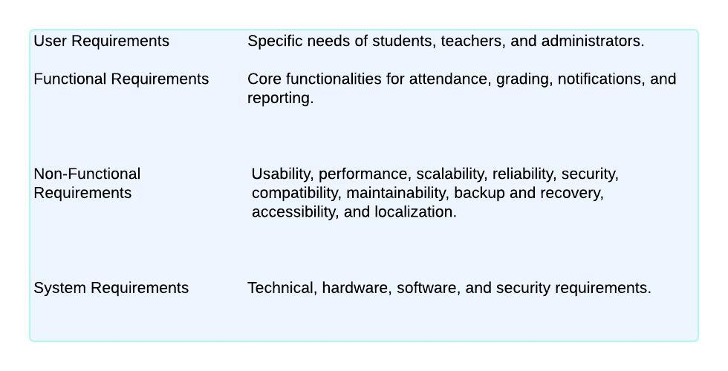

3.1 Functional Requirements
Functional requirements specify the concrete features and actions the application must perform. These were derived from analyzing common student challenges on campus and identifying opportunities for digital solutions.
- User Authentication and Profile Management:
  - Requirement: The system must provide secure user registration using email and password, a robust login mechanism, and a password reset functionality for account recovery. Users must be able to log out securely.
  - Details: This involves integrating with Firebase Authentication. The system needs distinct screens for Sign Up, Login, and Password Reset. Upon successful authentication, the user's session must be managed, granting access to the main application features. A dedicated Profile section is required where users can view their basic information (email, display name - fetched from Auth) and university-specific details (like Student ID - fetched from Firestore). Placeholder functionality for editing profile details should be included, linking to a future editing screen or the settings module.
  - Rationale: Secure authentication is fundamental for personalization, data privacy, and accessing user-specific features like career path data or potentially saved locations/preferences.
- Campus Navigation:
  - Requirement: The application must display an interactive map of the university campus, allowing users to pan, zoom, and potentially view their current location. A core feature is the ability to search for specific buildings, departments, or points of interest within the campus.
  - Details: This leverages the google_maps_flutter plugin and the Google Maps Platform API. The UI includes input fields for selecting start and destination points (initially placeholders, future implementation could involve search suggestions or map tapping). Placeholder controls for different transport modes (cycling, running, driving) and route actions (Preview, Stops, Steps) are included in the UI design, anticipating future integration with routing services (like Google Directions API).
  - Rationale: Navigating large campuses can be challenging, especially for new students. Providing an interactive map with search and routing capabilities directly addresses this need, saving time and reducing confusion.
- Weather Information:
  - Requirement: The app must display current weather conditions and a short-term forecast relevant to the campus location (or a user-defined location).
  - Details: This involves fetching data from an external weather API (OpenWeatherMap). The UI displays current temperature, "feels like" temperature, conditions (description and icon), humidity, wind speed, and an hourly forecast preview. Error handling for failed API calls and loading indicators are necessary.
  - Rationale: Weather affects daily commutes, clothing choices, and outdoor activities. Providing this information within the app adds convenience and helps students plan their day.
- Lost & Found System:
  - Requirement: The application must facilitate the reporting of lost items and the submission of found items. Users should be able to view lists of currently reported lost and found items. A mechanism for claiming found items (placeholder) and accessing help desk information is required.
  - Details: This module includes a main screen with distinct options (Report Items, Claim Found, Lost Item list, Found list, Help Desk). A dedicated form screen (ReportItemScreen) allows users to input descriptions, locations, optional contact info, and potentially upload photos (requires image picker and storage integration). Separate screens (ViewLostItemsScreen, ViewFoundItemsScreen) display lists fetched from a database (Firestore). Navigation to a help desk info screen and a placeholder claim process screen are included. Future enhancements include AI-powered matching between lost and found reports.
  - Rationale: Losing or finding items is a common campus occurrence. A centralized digital system streamlines the reporting and recovery process, increasing the chances of reuniting owners with their belongings compared to traditional physical lost-and-found offices or scattered notices.
- Career Path Guidance:
  - Requirement: The application must provide a module for students to input information related to their academic progress and career aspirations. This includes semester, major, favourite subjects, considered career options, dream job description, and future plans. Placeholder functionality for submitting this data (for future AI roadmap generation) and accessing related resources (alumni blogs, writing prompts) is needed.
  - Details: The main CareerPathScreen presents a list of information categories. Tapping each item navigates to a dedicated form screen (CommonFormStructure based) for input. The entered data is temporarily stored in the main screen's state (future implementation would save to Firestore). Buttons for "Submit" (for roadmap generation - placeholder), "Watch alumni blogs" (placeholder navigation), and "Write Somethings" (placeholder navigation) are included.
  - Rationale: Assisting students with career planning is a valuable university function. This module aims to centralize relevant information gathering, paving the way for future personalized guidance features (like AI roadmaps) and connecting students with relevant resources like alumni experiences.
- Campus Connect (Messaging - Basic UI):
  - Requirement: Provide the basic UI structure for an intra-campus messaging feature, including a list of chats and a screen for viewing/sending messages within a specific chat.
  - Details: Includes a CampusConnectListScreen displaying placeholder chat conversations (avatar, name, last message, time, unread count) and a CampusConnectChatScreen showing placeholder messages aligned left/right, with a text input field and send button.
  - Rationale: Facilitating communication between students, groups, or potentially faculty enhances campus community and collaboration. While the full backend is complex, providing the UI structure lays the groundwork for future implementation.
- Notifications:
  - Requirement: The application must display relevant notifications to the user in a dedicated section. Users should be able to view, potentially mark as read, and dismiss notifications.
  - Details: A NotificationsScreen displays a list of received notifications (placeholder data for now), showing title, body, and timestamp. Functionality for dismissing (deleting) notifications via swiping and placeholders for marking as read are included. A "Clear All" button is provided. Actual notification delivery requires backend integration (FCM).
  - Rationale: Timely notifications are essential for informing students about critical events, deadlines, lost item updates, or messages. A dedicated section keeps these organized.
- Settings:
  - Requirement: Provide a settings area for users to manage application preferences and access related information.
  - Details: The SettingsScreen includes options to navigate to Edit Profile (placeholder), Notification Settings (placeholder/link), view Privacy Policy and Terms of Service (via external links - requires url_launcher), and a secure Sign Out option with confirmation.
  - Rationale: Allows users to customize their experience, understand legal terms, and securely manage their session.

3.2 Non-Functional Requirements
Non-functional requirements define the quality attributes and constraints of the system, describing how it should operate.
- Performance:
  - Requirement: The application must be responsive and performant. UI transitions should be smooth, data loading times minimized, and map interactions (panning, zooming) fluid.
  - Rationale: Poor performance leads to user frustration and abandonment. Efficient code, optimized data fetching (e.g., pagination for long lists in the future), and appropriate use of asynchronous operations are necessary.
- Usability:
  - Requirement: The application must be intuitive and easy to use for the target student audience, requiring minimal learning effort. Navigation should be clear and consistent.
  - Rationale: A complex or confusing interface hinders adoption. Adhering to platform conventions (Material Design) and user-centric design principles is key.
- Reliability:
  - Requirement: The application should function reliably with minimal crashes or errors. Data fetched from APIs (Weather, Maps) should handle potential network issues or API errors gracefully, providing informative feedback to the user.
  - Rationale: Users expect applications to be stable. Robust error handling (try-catch), state management, and feedback mechanisms (loading indicators, error messages) are essential.
- Security:
  - Requirement: User authentication must be secure, and sensitive user data (credentials, profile information, potentially chat messages) must be protected during storage and transmission.
  - Rationale: Protecting user data and preventing unauthorized access is paramount. Leveraging Firebase Authentication's security features and implementing proper Firestore Security Rules are critical. Input validation should prevent common vulnerabilities. API keys must be stored securely (not hardcoded directly in easily accessible source code for production builds - consider environment variables or secure storage).
- Scalability:
  - Requirement: The application architecture and backend infrastructure should be capable of handling a growing number of users and increasing amounts of data without significant performance degradation.
  - Rationale: As the user base grows (potentially expanding to more students or even other universities), the system must scale efficiently. Firebase services (Auth, Firestore, Storage) are designed for scalability. A modular Flutter codebase also supports adding new features without rewriting existing ones.
- Maintainability:
  - Requirement: The codebase should be well-organized, documented (via comments), and follow consistent coding standards (like those enforced by flutter_lints) to facilitate future updates, bug fixes, and feature additions by the current or future development teams.
  - Rationale: A maintainable codebase reduces the long-term cost and effort of ownership. Using clear naming conventions, separating concerns (UI vs. logic vs. data), and employing a modular structure are crucial.
- Cross-Platform Compatibility:
  - Requirement: The application must function correctly and provide a reasonably consistent user experience on both target mobile platforms (Android and iOS).
  - Rationale: Flutter's core promise is cross-platform development. While minor platform-specific adjustments might be needed, the goal is a single codebase serving both major mobile OSs efficiently.
- Cost-Effectiveness:
  - Requirement: Development and operational costs should be minimized, leveraging free tiers of services where possible, aligning with the typical budget constraints of a student project.
  - Rationale: Ensures the project's financial viability, as detailed in the Economic Feasibility section.
By clearly defining these functional and non-functional requirements, the development process is guided towards building an application that is not only feature-rich but also robust, secure, user-friendly, and sustainable.
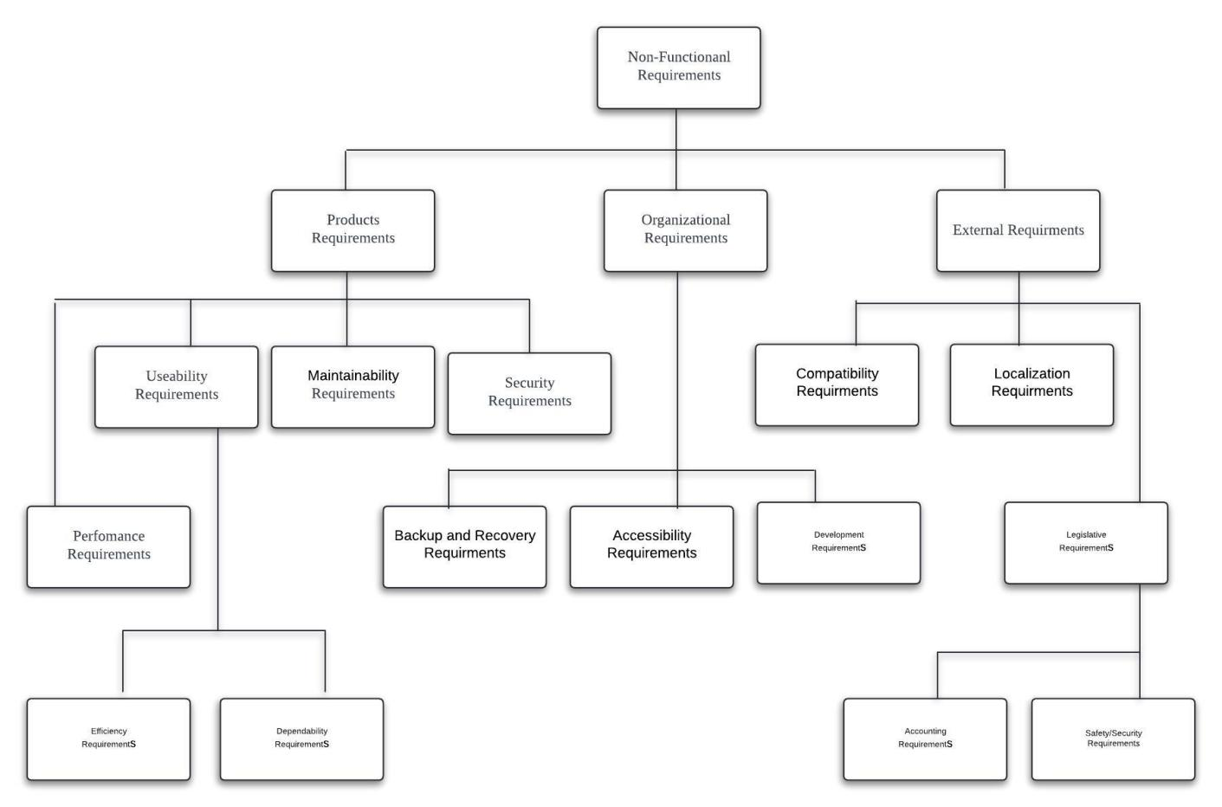
Figure: Non-Functional Requirements

System Design

4. System Design
This section details the architectural and technical design of the Smart Campus Compass application. It outlines the overall design philosophy, the chosen technology stack, the database structure, the modular breakdown of functionalities, and the key UI/UX principles guiding the development. The design prioritizes scalability, maintainability, user experience, and cost-effectiveness.

4.1 Design Philosophy and Architecture
The design of Smart Campus Compass is fundamentally user-centric, aiming to address the common pain points and needs of university students (specifically at Gannan Normal University initially) in their daily campus life. The core philosophy revolves around creating an intuitive, reliable, and integrated mobile experience that simplifies navigation, information access, and campus engagement.
Key Philosophical Pillars:
- Simplicity and Intuitiveness: The application is designed to be immediately understandable and usable by students without requiring extensive tutorials or technical knowledge. Navigation patterns (like the main menu grid and the bottom navigation bar) are chosen for familiarity and ease of access.
- Integration: Instead of requiring multiple separate apps for maps, events, lost & found, etc., Smart Campus Compass aims to be an all-in-one platform, reducing clutter and streamlining information flow.
- Real-time Information: Where applicable (maps, notifications, potentially chat), the system is designed to provide up-to-date information to the user, enhancing its practical value.
- Scalability and Maintainability: The application employs a modular design approach. Functionalities are separated into distinct modules (e.g., Authentication, Navigation, Lost & Found), making the codebase easier to understand, maintain, test, and extend with new features in the future.
Architectural Pattern:
While the original documentation mentions MVC (Model-View-Controller), Flutter's declarative UI paradigm lends itself to slightly different interpretations. We can adapt the MVC concept as follows:
- Model: Represents the application's data and business logic. This includes:
  - Data structures (like WeatherData, LostItem, ChatMessage, AppNotification, user profile data).
  - Services responsible for fetching/manipulating data (like WeatherService, AuthService implicitly handled by Firebase Auth, and future services for interacting with Firestore for Lost & Found, Career Path, etc.).
  - Interaction with the backend (Firebase Firestore, Firebase Storage).
- View: Represents the UI elements the user interacts with. In Flutter, this is primarily the Widget tree. Each screen (MenuScreen, LoginScreen, LostFoundScreen, etc.) and component (_buildGridItem, _buildListItem, etc.) constitutes the View layer. Widgets reactively display the current application state.
- Controller (or ViewModel/State Management): Acts as the intermediary between the Model and the View. It handles user input, fetches data from the Model (Services), processes it, manages the application's state, and updates the View accordingly. In our current implementation, this role is primarily fulfilled by:
  - StatefulWidgets and their associated State objects (e.g., _CareerPathScreenState, _LostFoundScreenState managing local UI state and triggering data fetches).
  - Direct interaction with services (like WeatherService) within the State objects.
  - Implicit state management via StreamBuilder listening to Firebase Auth state changes in main.dart.
  - Future Consideration: For more complex state interactions, especially across multiple screens (like user profile updates reflecting everywhere, or real-time chat updates), adopting a dedicated state management solution like Provider, Riverpod, or BLoC would be beneficial for better separation of concerns and scalability.
This architecture promotes a separation of concerns, making the application more robust and easier to manage as complexity grows.

4.1.1 Architectural Pattern: MVVM in Flutter
Though Flutter doesn't strictly follow MVC, the Smart Campus Compass project adopts a hybrid MVVM (Model-View-ViewModel) architecture for maintainability and testability.

Layers:
Model: Data classes (UserModel, LostItem, WeatherData) and service handlers (AuthService, FirestoreService, WeatherService).
View: UI elements built with Flutter Widgets (e.g., WeatherScreen, LoginScreen).
ViewModel/Controller: Each StatefulWidget's State class acts as a controller. It fetches data from models and updates views using setState(), FutureBuilder, or StreamBuilder.

Future Scalability:
Use of Provider or Riverpod is recommended for global state management.
Chat module and roadmap should implement ChangeNotifier or StateNotifier pattern.

4.2 Technology Stack Rationale
The selection of technologies was driven by requirements for cross-platform compatibility, rapid development, performance, scalability, and cost-effectiveness, particularly relevant for a student-focused project.
- Frontend Framework: Flutter (SDK Version >=3.0.0)
- Why: Flutter was chosen as the primary framework for its ability to build natively compiled applications for mobile (iOS, Android), web, and desktop from a single codebase. This significantly reduces development time and effort compared to maintaining separate native codebases. Its declarative UI model, extensive widget library (Material Design), hot reload feature for rapid iteration, and excellent performance (compiling to native ARM code) make it ideal for creating a smooth and responsive user experience. The strong backing by Google and a large, active community ensure ample resources, packages, and long-term support.
- Programming Language: Dart (SDK Version >=3.0.0)
  - Why: Dart is the language used by Flutter. It is optimized for UI development, featuring an object-oriented structure, type safety (reducing runtime errors), asynchronous programming support (essential for handling network requests and Firebase interactions without blocking the UI), and AOT (Ahead-Of-Time) compilation for fast startup and runtime performance on mobile. Its syntax is relatively easy to learn for developers familiar with languages like Java, C#, or JavaScript.
- Backend as a Service (BaaS): Firebase
  - Why: Firebase (a Google platform) was selected as the backend solution due to its comprehensive suite of integrated services, generous free tier, excellent integration with Flutter (via FlutterFire plugins), scalability, and real-time capabilities. It eliminates the need to build and manage custom server infrastructure, allowing the team to focus on application features.
  - Firebase Authentication: Used for secure user registration, login (Email/Password), password reset, and managing user sessions. It provides pre-built UI elements (though we built custom ones) and robust security features.
  - Cloud Firestore: A NoSQL, document-based database used for storing application data like user profiles (beyond basic auth info), lost & found item details, career path information, notification history, and potentially chat messages. Its real-time listeners are crucial for features like live chat updates or instant notifications. Firestore Security Rules are essential for controlling data access.
  - Firebase Storage (Planned): Intended for storing user-uploaded files, primarily images for Lost & Found items and potentially user profile pictures.
  - Firebase Cloud Messaging (FCM) (Planned): Intended for implementing push notifications for alerts (e.g., lost item matches, campus events, class reminders).
- Mapping API: Google Maps Platform (via google_maps_flutter)
  - Why: Google Maps is the industry standard for mapping and navigation, offering rich map data, satellite imagery, traffic information, and robust APIs for directions and place searching. The google_maps_flutter plugin provides seamless integration within Flutter apps. While AMap might offer more granular detail within specific Chinese locations, Google Maps provides broader familiarity, easier setup (especially with Firebase integration), and sufficient detail for general campus navigation. An API key is required, and billing must be enabled on the associated Google Cloud project.
- Weather API: OpenWeatherMap
  - Why: Chosen for its accessibility and free tier that provides current weather and basic forecast data suitable for the app's needs. It offers simple REST APIs that can be easily consumed using Dart's http package. An API key is required.
- AI APIs (Planned):
  - Rationale: The vision includes AI-powered features for Lost & Found item matching and personalized Career Path roadmap generation.
  - Potential Choices: Services like Google's Gemini API or OpenAI's GPT models could be integrated via their respective APIs. This would involve sending relevant data (e.g., item descriptions, user's career inputs) to the AI service and processing the generated response (matched items, roadmap steps) for display in the app. This requires careful API integration, cost management, and handling of potentially complex responses.
- Integrated Development Environment (IDE): Visual Studio Code (VS Code)
  - Why: VS Code is a lightweight, free, and highly extensible code editor with excellent Flutter and Dart support through official extensions. It provides features like code completion, debugging, Git integration, and a built-in terminal, offering a productive development environment across different operating systems.

4.2.1 AI API Integration (Planned & Proposed Implementation)
To bring intelligent, personalized guidance to students, we plan to integrate Artificial Intelligence through advanced third-party APIs. The primary goal is to generate customized academic and career roadmaps for students based on their inputs such as current semester, favorite subjects, career interests, and long-term goals.
API Selection and Use Case:
Preferred APIs: OpenAI GPT-4 or Google Gemini.

Use Case Flow:
User inputs academic data via the Career Path form.
Data is sent to a Firebase Cloud Function.
Cloud Function sends a structured request (JSON) to the selected AI API.
The AI API returns a detailed academic roadmap.
Response is formatted and stored in Firestore.
Roadmap is displayed on the frontend with visual widgets.

Technical Details:
Input: JSON with fields like semester, major, favSubjects, careerOptions, dreamJob, futureGoals.
Processing: AI API uses NLP to return a career path (text + timeline).
Error Handling: Cloud Function retries on failure, logs errors in Firebase Crashlytics.

4.2.2 Context Model
The context model illustrates how the Smart Campus Compass system interacts with external entities such as users and services. It provides a high-level view of the environment in which the system operates and defines the boundaries and primary data flows between the app and external actors.
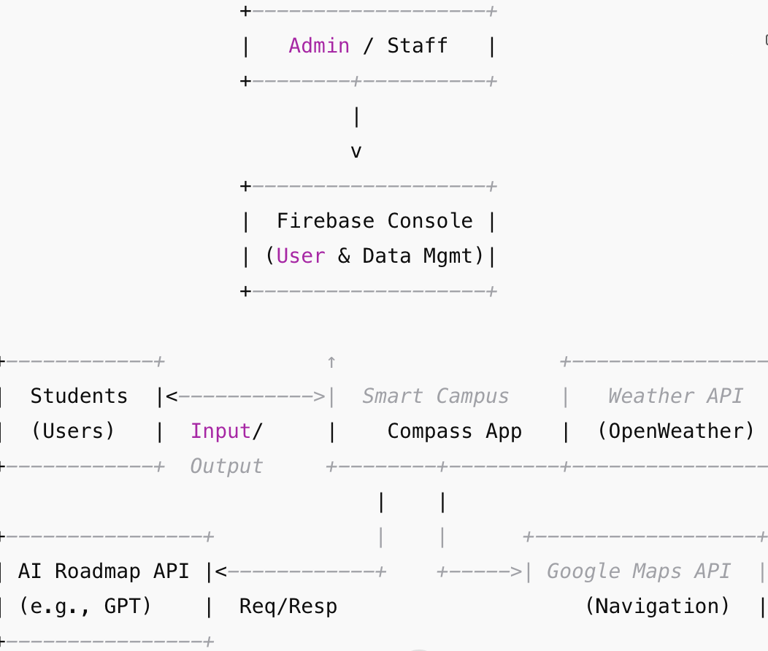

4.2.3 Sequence diagram
This sequence diagram explains the step-by-step interaction between the user, frontend, backend (Firebase & Cloud Functions), AI API, and Firestore when a student logs in and generates a personalized career roadmap.
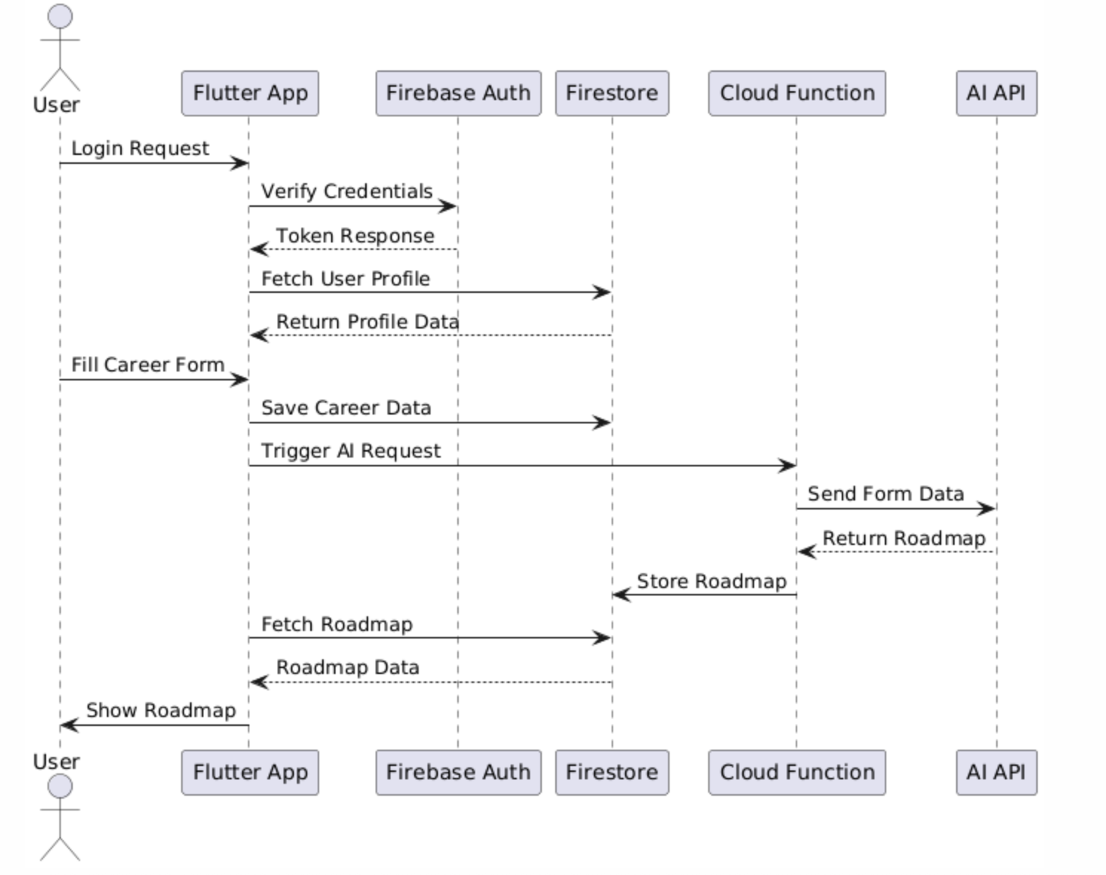

4.2.2 An Activity model of This system
This activity diagram illustrates the user flow and system actions from login to AI roadmap generation and display.
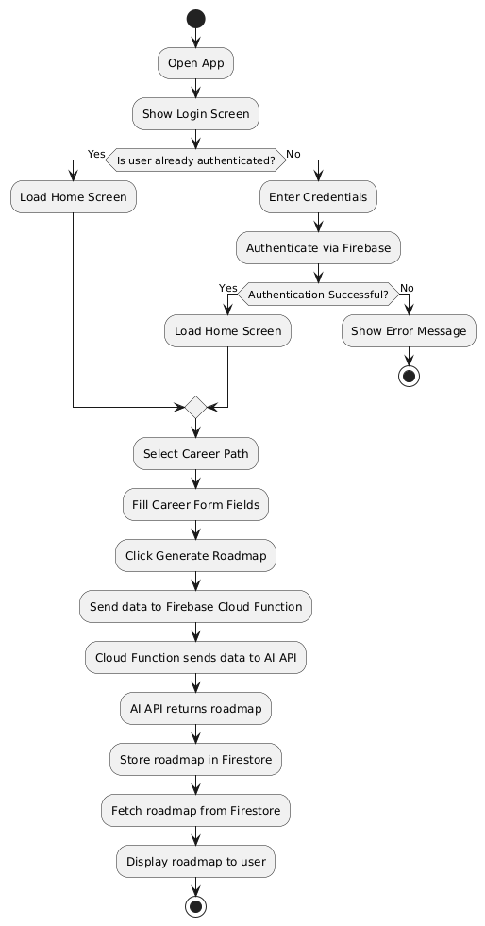

4.3 Database Schema (Firestore)
A NoSQL database like Cloud Firestore offers flexibility. The proposed structure involves several top-level collections:
- users:
  - Document ID: User's Firebase Authentication UID.
  - Fields:
    - email: (String) User's email (can be retrieved from Auth but often stored for querying).
    - displayName: (String) User's chosen display name (optional).
    - studentId: (String) University-specific student ID (crucial for campus context).
    - photoUrl: (String) URL to profile picture in Firebase Storage (optional).
    - createdAt: (Timestamp) Account creation time.
    - careerData: (Map) Nested map containing fields like semester, major, favSubject, careerOptions, dreamJob, otherInfo, futurePlan (populated from Career Path screen).
    - notificationPreferences: (Map) Settings like pushEnabled, emailEnabled (optional).
    - fcmTokens: (Array) Device tokens for push notifications (optional).
- lost_items:
  - Document ID: Auto-generated ID.
  - Fields:
    - userId: (String) UID of the user reporting the item.
    - description: (String) Detailed description of the lost item.
    - lastSeenLocation: (String) Optional location where the item was last seen.
    - contactInfo: (String) Optional contact info provided by the reporter.
    - imageUrl: (String) Optional URL to the item's photo in Firebase Storage.
    - reportedAt: (Timestamp) Time the report was submitted.
    - status: (String) e.g., "reported", "found", "claimed".
    - keywords: (Array) Auto-generated or user-provided keywords for searching/matching (Planned AI feature).
- found_items:
  - Document ID: Auto-generated ID.
  - Fields:
    - reporterUserId: (String) UID of the user submitting the found item report (optional, could be anonymous or admin).
    - description: (String) Detailed description.
    - locationFound: (String) Where the item was found.
    - imageUrl: (String) Optional URL to photo.
    - reportedAt: (Timestamp) Time the item was reported/submitted.
    - status: (String) e.g., "in_inventory", "claimed".
    - claimedByUserId: (String) UID of the user who claimed it (optional).
    - claimedAt: (Timestamp) (optional).
    - keywords: (Array) For searching/matching (Planned AI feature).
- campus_events (Example for future):
  - Document ID: Auto-generated ID or specific event ID.
  - Fields: title, description, startTime, endTime, location, category, imageUrl.
- chats (For Campus Connect - Planned):
  - Document ID: Auto-generated ID representing a chat room (could be 1-on-1 or group).
  - Fields:
    - participants: (Array) List of user UIDs in the chat.
    - lastMessage: (Map) Containing text, senderId, timestamp of the most recent message.
    - groupName: (String) Optional, if it's a group chat.
    - groupAvatarUrl: (String) Optional.
- messages (For Campus Connect - Planned):
  - Subcollection under each chats document.
  - Document ID: Auto-generated ID for each message.
  - Fields: senderId, text, timestamp, imageUrl (optional).
- notifications (For user-specific notifications):
  - Subcollection under each users document.
  - Document ID: Auto-generated ID.
  - Fields: title, body, timestamp, isRead, type (e.g., 'lost_item_match', 'event_reminder'), relatedItemId (optional).
Firestore Security Rules: Crucial for protecting data. Rules would need to be defined to ensure:
- Users can only read/write their own users document (except perhaps specific public fields).
- Users can create lost_items but maybe only modify/delete their own.
- Admins or specific roles might be needed to manage found_items.
- Chat participants can read/write messages in their respective chats.
- Notifications can only be read/updated by the target user.

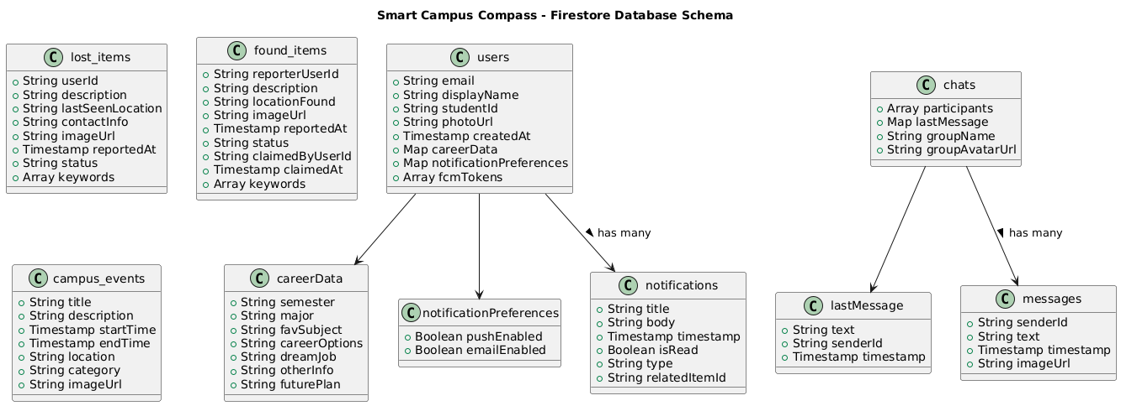
Figure: Database Schema

4.4 Module Design and Responsibilities
The application is logically divided into functional modules:
- Authentication Module:
  - Responsibilities: Handles user sign-up, sign-in (email/password), password reset, sign-out. Manages the user's authentication state.
  - Core Technologies: Firebase Authentication, Flutter Widgets (SignUpScreen, LoginScreen, ResetPasswordScreen).
  - Interaction: Provides the current user state (User?) to the rest of the app (via FirebaseAuth.instance.authStateChanges() stream in main.dart), enabling conditional navigation to login or main app content (AppShell).
- Core Navigation & Shell Module:
  - Responsibilities: Provides the main application structure (AppShell) including the bottom navigation bar. Manages the display of the primary screens (Menu, Notifications, Settings, Profile) associated with the bottom tabs.
  - Core Technologies: Flutter (Scaffold, BottomNavigationBar, StatefulWidget for AppShell), Dart (List<Widget> for screen options).
  - Interaction: Acts as the main container after login. Displays the selected screen based on bottom navigation interaction.
- Menu & Feature Navigation Module:
  - Responsibilities: Displays the main feature grid (MenuScreen). Handles navigation from the menu grid to specific feature screens (AR Navigation, Canteen, Weather, Lost & Found, Career Path, Campus Connect).
  - Core Technologies: Flutter (GridView, GestureDetector/InkWell, Navigator.push).
  - Interaction: Serves as the primary "Home" view within the AppShell. Launches other feature modules.
- Campus Navigation Module (AR Navigation):
  - Responsibilities: Displays an interactive map of the campus. Allows users to select start/destination points (planned). Displays routes based on selected transport mode (planned). Provides map interaction controls.
  - Core Technologies: google_maps_flutter plugin, Google Maps API, Flutter Widgets (ARNavigationScreen, Stack, Positioned).
  - Interaction: Launched from the Menu. Requires API key setup and potentially device location permissions. (Actual AR overlay is a future enhancement requiring separate AR plugins).
- Weather Module:
  - Responsibilities: Fetches and displays current weather conditions and forecasts for a predefined location (e.g., Ganzhou).
  - Core Technologies: Dart http package, OpenWeatherMap API, Flutter Widgets (WeatherScreen, FutureBuilder, ListView). WeatherData model, WeatherService.
  - Interaction: Launched from the Menu. Requires an OpenWeatherMap API key.
- Lost & Found Module:
  - Responsibilities: Allows users to report lost or found items (with description, location, optional photo). Displays lists of reported lost and found items. Facilitates claiming found items (placeholder). Provides help desk contact information. (AI matching is a planned feature).
  - Core Technologies: Flutter Widgets (LostFoundScreen, ReportItemScreen, ViewLostItemsScreen, ViewFoundItemsScreen, HelpDeskScreen, ClaimFoundScreen), Forms, potentially image_picker and Firebase Storage for uploads, Firestore for data storage.
  - Interaction: Launched from Menu. Requires database interaction for reporting and viewing. Claiming and AI matching require significant backend logic.
- Career Path Module:
  - Responsibilities: Collects user information about their academic progress, interests, and goals (Semester, Major, Subjects, Options, Dream Job, Plans). Submits this data (placeholder for AI processing). Provides access to related resources like alumni blogs (placeholder).
  - Core Technologies: Flutter Widgets (CareerPathScreen, CommonFormStructure, specific form screens), Forms, Navigator.push with result passing.
  - Interaction: Launched from Menu. Collects user input via multiple form screens. Placeholder for submitting data to an AI service for roadmap generation. Placeholder navigation for blogs/writing.
- Campus Connect Module (Messaging):
  - Responsibilities: Displays a list of ongoing chats (CampusConnectListScreen). Displays messages within a selected chat (CampusConnectChatScreen). Allows users to send new messages (UI only for now).
  - Core Technologies: Flutter Widgets (ListView, ListTile, TextField, IconButton).
  - Interaction: Launched from Menu. Requires significant backend (Firestore for messages/chats, real-time listeners) for full functionality.
- Notifications Module:
  - Responsibilities: Displays a list of notifications received by the user (NotificationsScreen). Allows marking as read (UI only) and deleting.
  - Core Technologies: Flutter Widgets (ListView, ListTile, Dismissible), potentially Firestore for storing/fetching notifications.
  - Interaction: Accessed via AppShell bottom navigation. Requires backend integration (e.g., FCM, Firestore triggers) to receive actual notifications.
- Settings & Profile Module:
  - Responsibilities: Displays user profile information (ProfileScreen - enhanced view). Provides options in SettingsScreen to navigate to edit profile (placeholder), notification settings, legal info (via URL), and sign out.
  - Core Technologies: Flutter Widgets (SettingsScreen, ProfileScreen, ListTile, Card), Firebase Auth (for basic user info and sign out), potentially Firestore (for extended profile data), url_launcher.
  - Interaction: Accessed via AppShell bottom navigation. Profile screen fetches user data. Settings screen links to other sections or performs actions like sign out.
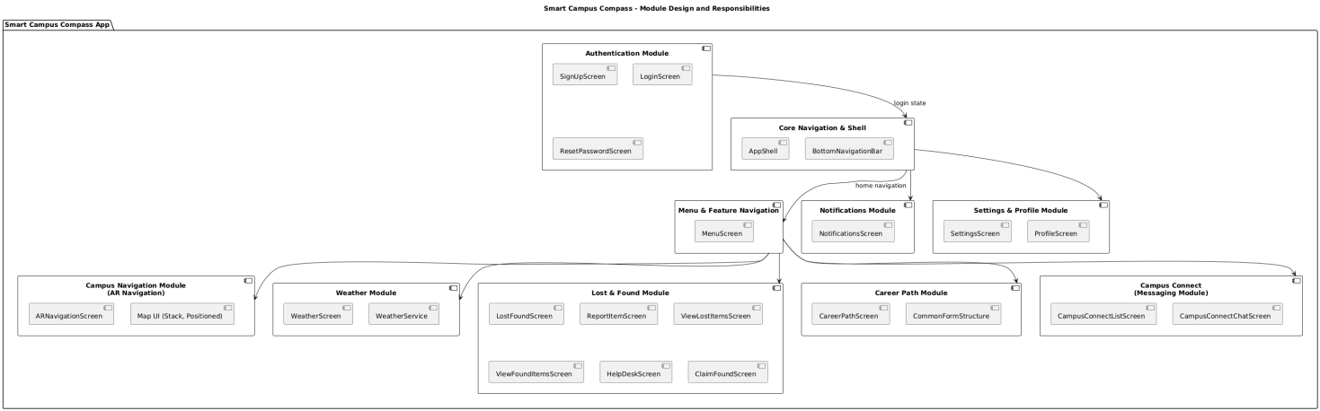
Figure: Module Design and Responsibilities

4.5 UI/UX Design Principles
The user interface and experience design adhere to the following principles:
- Consistency: A consistent visual language is maintained throughout the app using a centralized theme (AppTheme defining colors and text styles), common navigation patterns, and standardized components (like list items, cards, buttons). This ensures users feel familiar and comfortable across different features.
- Clarity: Information is presented clearly and concisely. Important actions are prominent. Standard icons (Material Icons, Font Awesome) are used for quick recognition. White space is used effectively to avoid clutter.
- Efficiency: Common tasks are accessible with minimal taps. The AppShell with the BottomNavigationBar provides quick access to core sections (Home/Menu, Notifications, Settings, Profile). The MenuScreen grid offers direct entry into specific features.
- Responsiveness: Although initially developed for mobile, Flutter's nature allows for adaptation to different screen sizes. Layouts use flexible widgets (Expanded, ListView, GridView) where appropriate. (Further testing and refinement would be needed for tablet or web optimization).
- Feedback: The application provides visual feedback for user actions, such as button press effects (via ElevatedButton, InkWell), loading indicators (CircularProgressIndicator) during data fetching or processing, and confirmation messages (SnackBar) for actions like reporting items or saving data.
- Aesthetics: While functionality is key, a clean and modern aesthetic is employed, using gradients, cards with rounded corners and subtle shadows, and a defined color palette (AppTheme) to create a visually appealing experience.
This comprehensive design approach ensures that Smart Campus Compass is not only functional but also user-friendly, maintainable, and prepared for future enhancements.

5. Code Implementation
The application codebase is organized into multiple Dart files, grouped by feature. The primary tools and packages used include:

firebase_core, firebase_auth, cloud_firestore, firebase_messaging, provider, google_maps_flutter

main.dart: Initializes Firebase, routing, and global providers

app_localization.dart: File manages localization in a Flutter app by providing translated strings and handling locale-specific content for multiple languages.
weather_data.dart: file in a Flutter app typically handles fetching, storing, and processing weather-related data, such as temperature, humidity, and forecast information, from an API or local source for display in the app.
ar_navigation_screen.dart: Initializes the AR navigation screen by setting up necessary resources. Builds the UI for the AR navigation screen with real-time location data.

canteen_screen.dart: Builds the UI for the Canteen screen with search functionality, grid items, and button interactions. Creates individual grid items for the canteen categories with icons, labels, and taps.
career_path_screen.dart :Displays the career path options and information for the user. Renders various career options available in the career path.
claim_found_screen.dart :Displays the form to claim a found item with necessary fields for user input Handles the submission of the claim for a found item.
help_desk_screen.dart : Builds the UI for the help desk page with buttons and support options Submits a request to the help desk system for assistance.
history_screen.dart : Renders the user's history of actions or activities within the app. Loads historical data related to the user's activity.
login_screen.dart : Builds the UI for the login screen with fields for username, password, and login button. Handles the user login process by authenticating credentials.
lost_found_screen.dart : Displays options for lost and found items with respective UI components. Navigates to the screen to claim a lost item.
menu_screen.dart : Builds the main menu UI with navigational options for various app features. Handles navigation based on the selected menu item.
notifications_screen.dart : Displays the notifications screen with a list of notifications. Marks a notification as read when selected by the user.
placeholder_form_screen.dart : Displays a placeholder form with input fields and a submit button. Handles form submission by collecting input data and processing it.
profile_screen.dart : Builds the UI for the profile screen with the user's details.Updates the user profile data after changes are made.

report_item_screen.dart :Displays the screen for reporting a lost or found item with necessary input fields.Handles the item report submission with appropriate validation.
setting_screen.dart : Renders the settings screen with options to change app preferences.Saves the changes made to the app settings.
signup_screen.dart : Builds the UI for the signup screen with fields for registration Handles user registration process by saving the new account details.
view_found_items_screen.dart : Displays a list of found items with relevant details for the user to view. Filters the found items based on selected criteria or search parameters.
view_lost_items_screen.dart : Displays a list of lost items with relevant information for the user to view. Filters the lost items based on selected criteria or search parameters.
weather_screen.dart :Displays the current weather and forecast details. Fetches weather data from an external API and updates the UI.
weather_service.dart : Retrieves weather data from a weather API based on location or city.Parses the weather data and extracts useful information for display.
app_theme.dart : Retrieves the current app theme, including colors and text styles.Sets the theme for the application based on user preferences or default settings.
app_shell.dart : Constructs the basic app layout with app bar, body, and navigation options.Configures the app bar for the screen, including title and actions.
firebase_option.dart : Initializes Firebase services for the app (authentication, Firestore, etc.). Configures Firebase authentication options like login and signup.

We used Git for version control and hosted the code repository on GitHub for collaboration among the team. Code was tested on real Android devices and emulators during each development stage.

5.1 Backend Technical Details

Firebase Authentication:
Email/password login implemented.
Session management done using FirebaseAuth.instance.authStateChanges().
Reset password feature sends email link through Firebase.

Firestore Database:
Structure:
/users/{uid}: Profile and career data.
/lost_items/{id} and /found_items/{id}: Lost & Found system.
/notifications/{id}: User-specific notifications.
/career_data/{uid}: Academic & roadmap inputs.
Indexed queries used to optimize search and retrieval.

Firebase Cloud Functions:
Functions planned to handle:
Roadmap API requests.
Notification triggers (e.g., item matched or event reminder).
Input validation.
Deployed to Asia-East region.

API Caching:
Weather data cached using shared preferences or local Hive DB.
TTL set to 15 minutes to reduce external calls.

Security & Rules:
Firestore security rules ensure:
Only user can read/write their data.
Admins can edit found items.
Chat messages accessible only by participants.
Environment variables used to store sensitive API keys.

Scalability:
Firebase's automatic scaling supports user growth.
App supports pagination and lazy loading.
Future plan: Redis-style caching for roadmap data.

6. UI Design

6.1 UI Implementation and Interaction Details

Widgets and Components:
ListView/GridView: Used for canteen menu and lost & found listings.
Stack & Positioned: Used in Campus Map for overlaying markers on maps.
Custom Widgets: Reusable widgets for items, cards, buttons enhance modularity.
Responsive Design:
MediaQuery: Detects device size to adapt layout.
LayoutBuilder: Adjusts font sizes and padding dynamically.
afeArea + Expanded + Flexible: Prevents overflow and ensures cross-device compatibility.

Theming:
Defined in app_theme.dart.
Primary Color: Royal Blue.
Accent Color: Lime Green.
Fonts: Poppins or Roboto with scalable typography.
All buttons and cards follow Material Design with shadow and elevation.

6.2 Frontend API Integrations

Map API Integration:
Uses google_maps_flutter.
Initializes map with a custom camera position focused on Gannan Normal University.
Custom markers added for canteen and buildings.
Map interaction includes zoom, pan, and tap for info window.

Weather API:
API: OpenWeatherMap.
Weather data fetched in weather_service.dart and displayed on WeatherScreen.
UI displays icon, temperature, humidity, wind, and 5-hour forecast.
Refresh button allows manual data fetch.

AI Roadmap API:
User selects data through dropdowns and text inputs.
Form data is converted to JSON and sent to the backend.
Backend integrates with AI model and sends back a structured roadmap.
Roadmap is shown with a Stepper widget or Timeline cards.

6.3 UI Designs:

1.Lsign up and Create Account Page
Description : The Sign Up page enables new users to create an account and access the platform by providing basic personal information and selecting login credentials (e.g., username and password). The page also often includes an email or phone verification process to ensure the user's identity and protect against spam or fraudulent accounts.
UI:

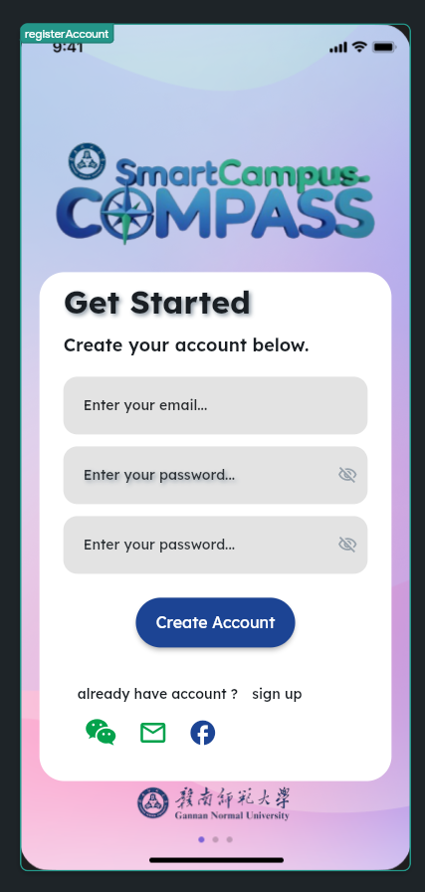

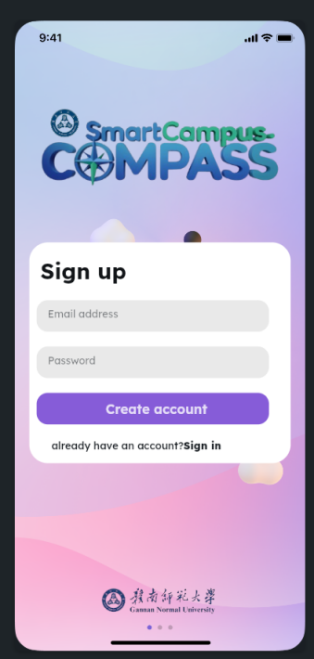

2.Categories Page

Description :This page displays a grid of categorized options (e.g., North Canteen, South Canteen, Stores, Others) that the user can tap to view more specific content under each category.

UI:

: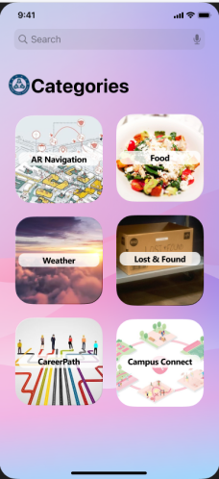

Campus Map Page with Search

Description :The Campus Map page helps users visualize and explore the layout of the campus
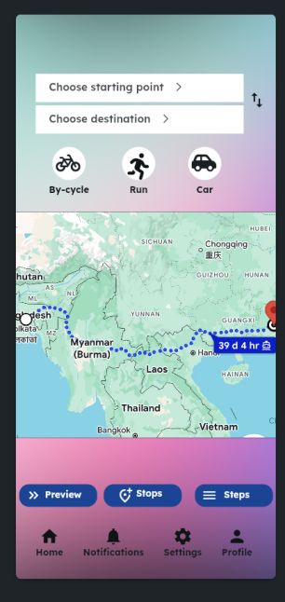

4.Lost & Found
Description :The Lost and Found page allows students, staff, and visitors to report lost or found items within the campus.

UI:
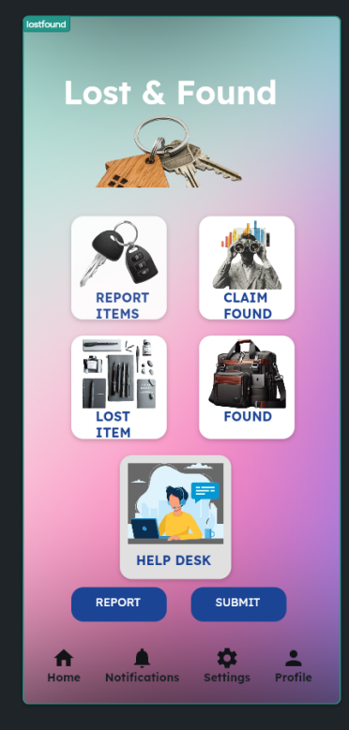

5.Career Path
Description :The Career Path page is designed to help students explore, understand, and choose different career options based on their interests, academic background, and future goals

UI:
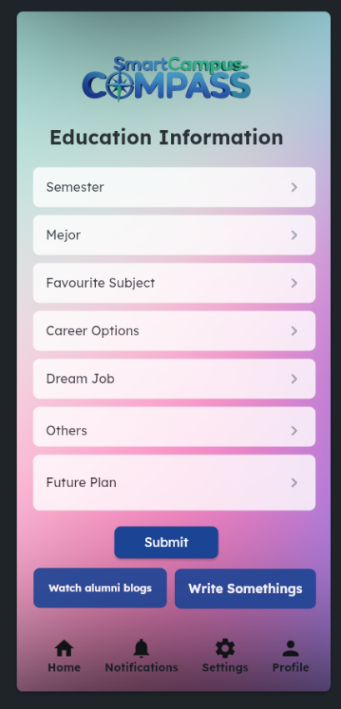

6.Weather
Description :The Weather page provides users with up-to-date information about the current weather and forecasts for a specific location. This page helps users plan their day by providing insights into temperature, humidity, wind speed, air quality, and more. It could be tied to their current location or allow users to search for different cities.

UI:
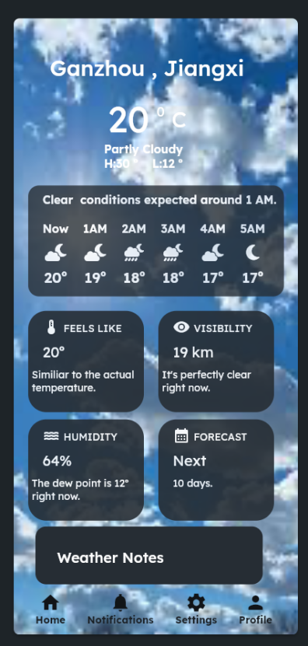

Profile page

Description:The Profile page serves as a centralized hub for users to view and update their personal information, preferences, and account settings. It helps users customize their experience, manage privacy settings, and view key details about their account (such as username, profile picture, and activity). This page enhances user interaction by providing personalization options.

UI:
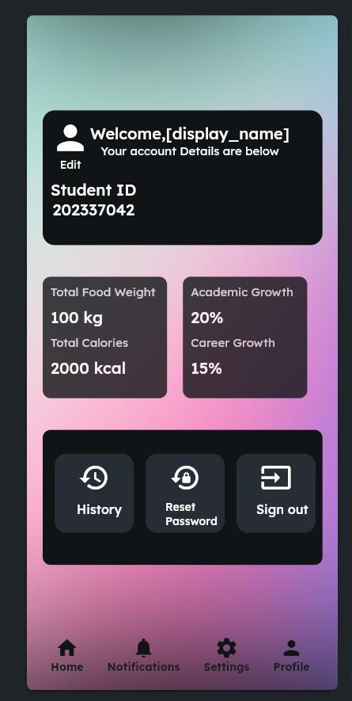

8.Reset Password

Description:The Reset Password page allows users to recover or change their password securely if they have forgotten it or need to update it for security reasons

UI:
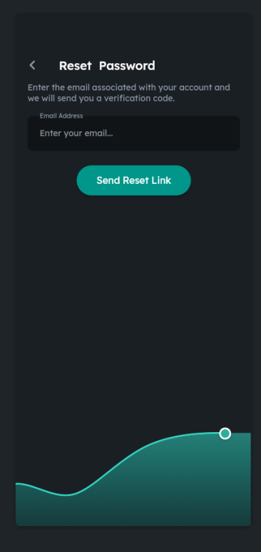

Privacy and Policies

Description:The Privacy and Policies page ensures transparency by outlining the practices, rights, and responsibilities related to user data, and sets the legal terms users must agree to when using a service or platform. This page is crucial for complying with data protection laws and building trust with users

UI:
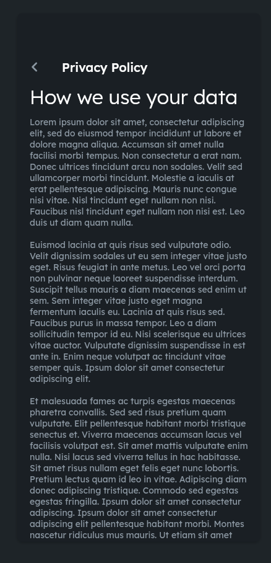

7. System Testing

We conducted rigorous testing to ensure a high-quality, bug-free user experience. Both functional and non-functional tests were planned and executed. Key testing activities included:

Unit Testing: Verifying each function such as login, map loading, and data fetch from Firebase

Integration Testing: Ensuring different modules (e.g., authentication + navigation) worked together smoothly

UI Testing: Validating visual consistency across devices with different screen sizes
UI Testing for Iphone:
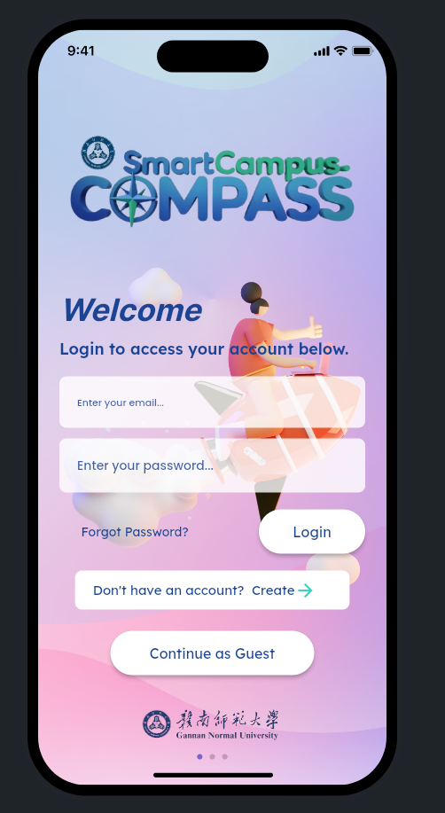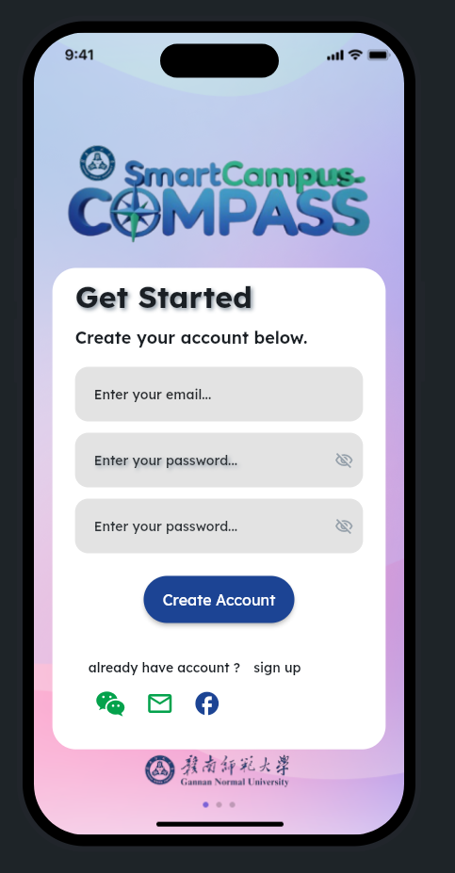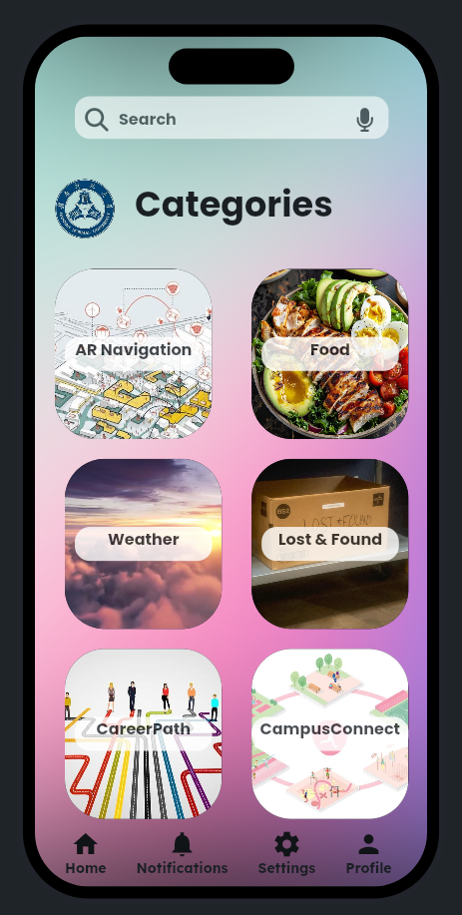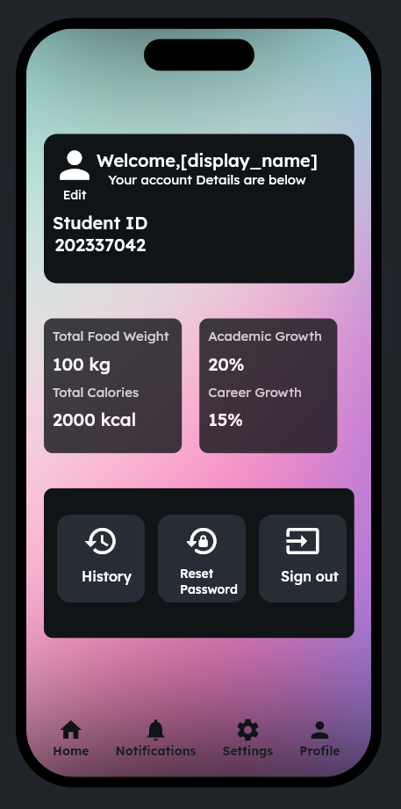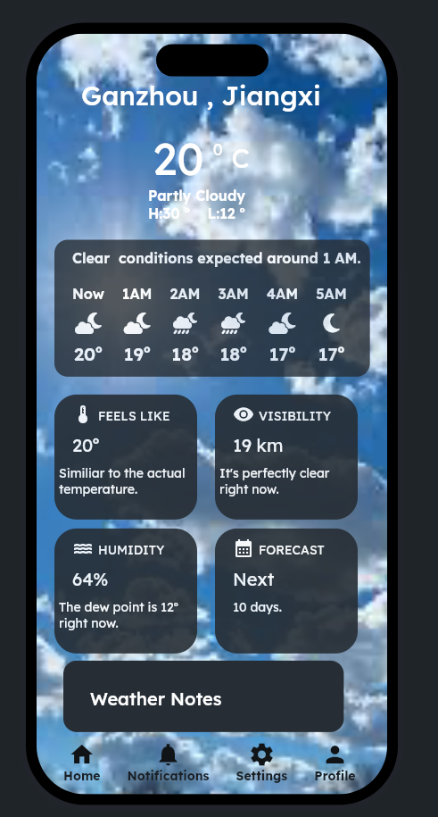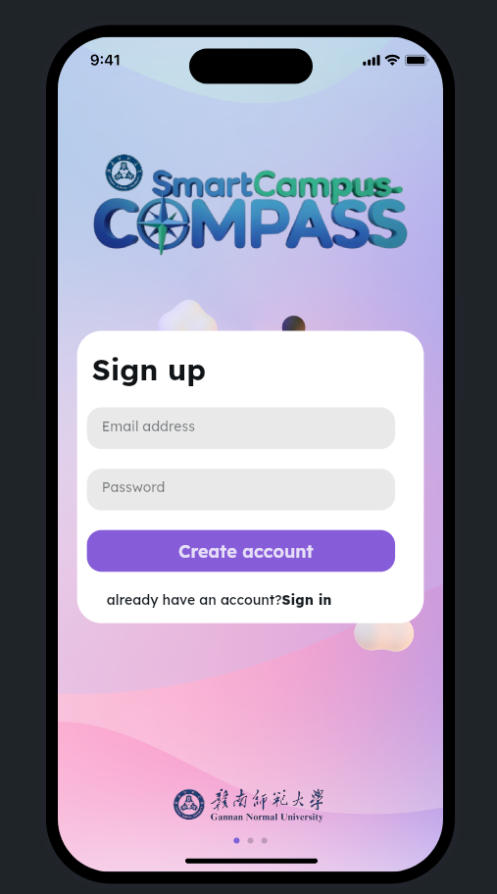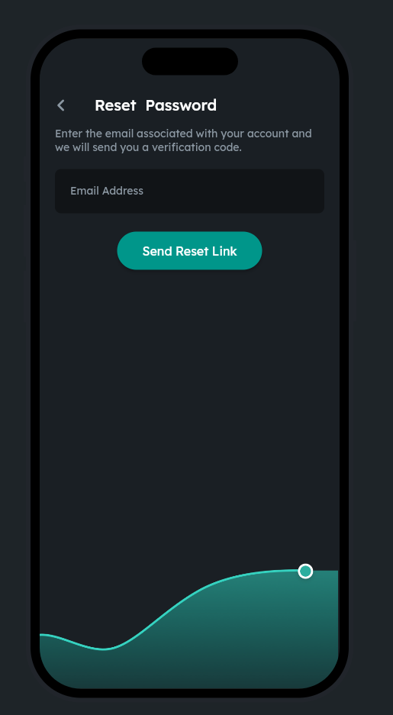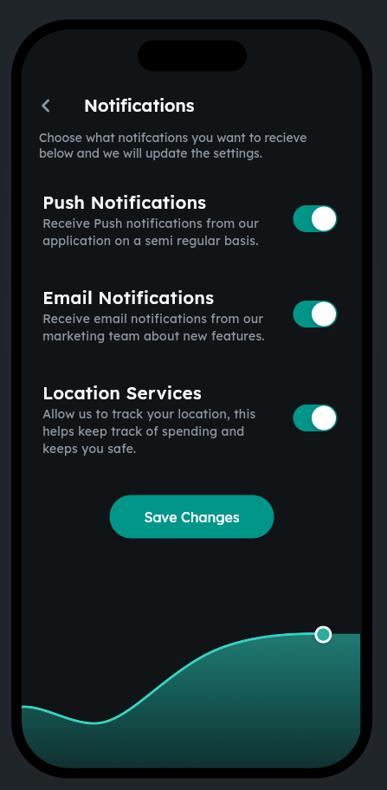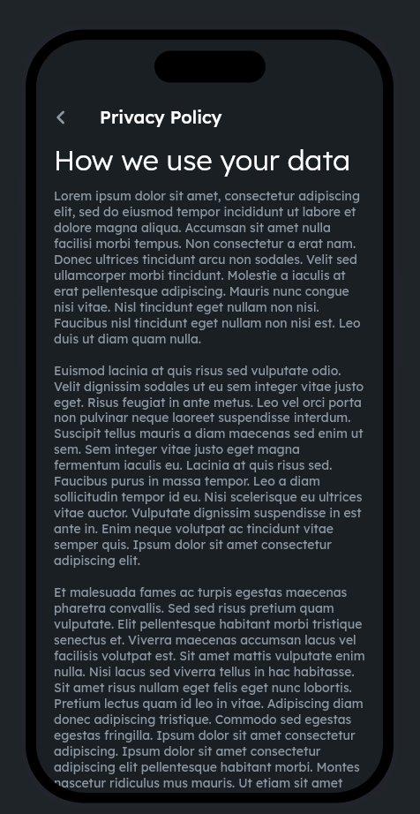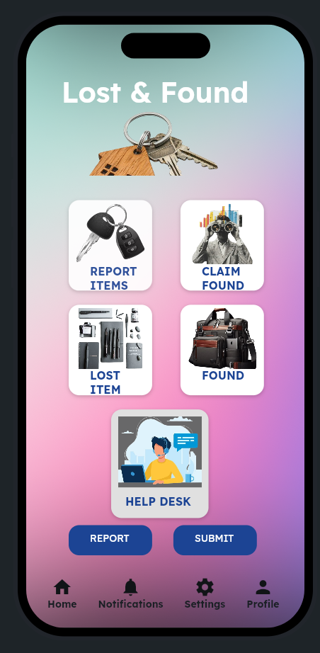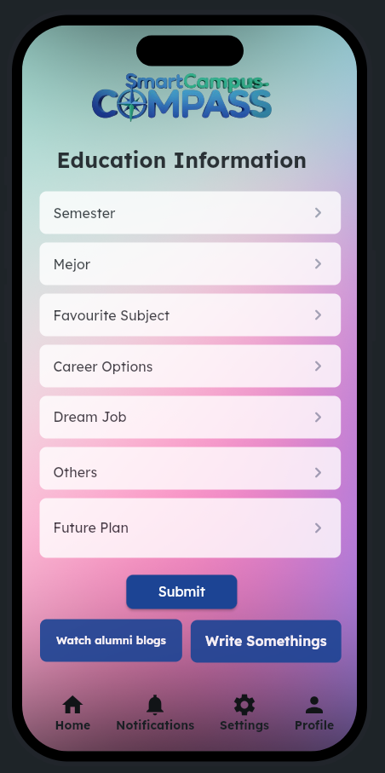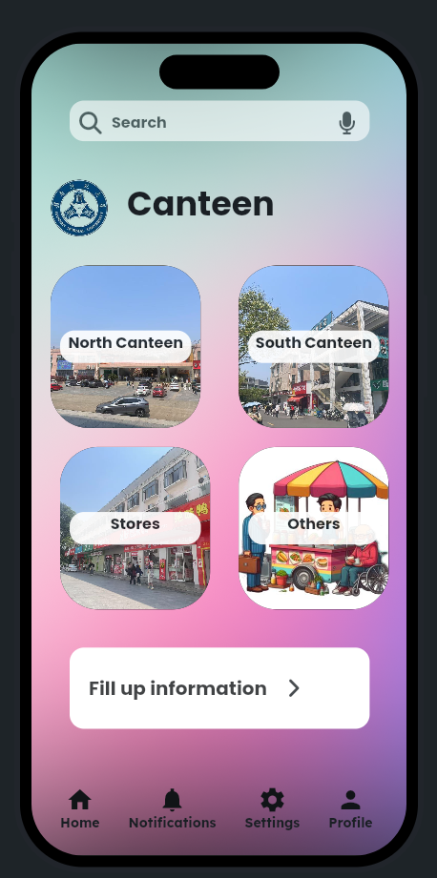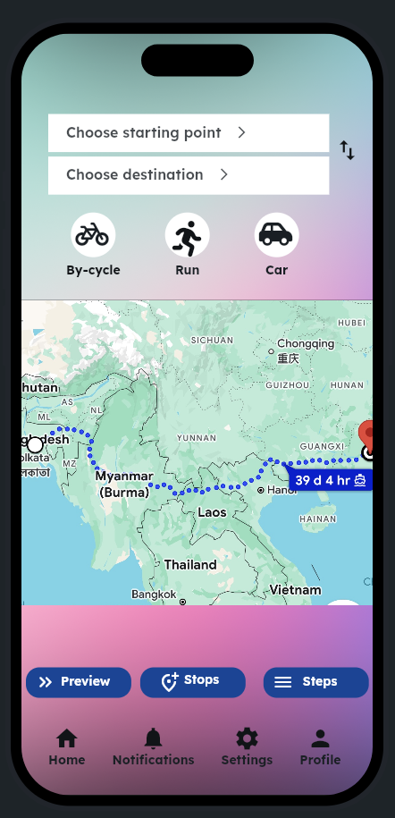

Usability Testing: Gathering student feedback on ease-of-use and design clarity

Performance Testing: Measuring map rendering speed, notification delivery time, and app responsiveness under load

Security Testing: Basic validation of user input and safe storage of credentials using Firebase rules

Test Environment:

Devices: Xiaomi, OnePlus, Huawei smartphones, iOS emulator

Tools: Android Studio Emulator, Flutter DevTools

Bug reports were tracked, prioritized, and resolved using GitHub Issues.

8: How to Use Smart Campus Compass

This section provides a practical guide on how users can interact with the Smart Campus Compass application. It is intended to help new users quickly understand the core features and navigate the system effectively.

Step 1: Launch the Application
Download the app (APK or via App Store in the future).
Open it on your Android or iOS device.The splash screen will briefly show the logo before navigating to the login screen.

Step 2: Sign Up or Log In

If you are a new user, click on Sign Up.
Enter your email, password, and student ID.
You may be asked to verify your email (optional).
If you already have an account, choose Login.
Enter your email and password.
Upon successful login, you will be redirected to the home dashboard.

Step 3: Explore the Home Menu
The Home Menu (MenuScreen) contains icons for all the major features:
Campus Map
Canteen Menu
Weather Info
Lost & Found
Career Path
Campus Connect (Messaging)
Notifications
Settings & Profile

Step 4: Use the Campus Map
Tap on the Campus Map icon.
Explore buildings and locations on the interactive map.
You can zoom, pan, and tap on markers to view canteen or building info.
Use the search bar to find specific places (e.g., library, cafeteria).

Step 5: Check Weather Forecast
Select the Weather icon.
The screen will show current temperature, humidity, and weather conditions.
A forecast preview is available for the next few hours.
Press refresh to update the weather.

Step 6: Report or Search Lost & Found Items
Go to Lost & Found.
You can:
Report a Lost or Found item using a form.
View Lost and Found item lists.
Upload images and give contact info.
In future updates, AI-based matching will suggest similar items.

Step 7: Generate Career Roadmap
Tap on Career Path.
Enter academic details like:
Your current semester
Favorite subjects
Dream job and career options
Submit the form.
(In future updates) an AI-generated roadmap will appear for your academic and career journey.

Step 8: Messaging System (Campus Connect)
Open Campus Connect.
You will see a list of chat rooms or users.
Tap a chat to view messages.
Type and send new messages (coming soon).

Step 9: Manage Notifications
Click on Notifications to view important alerts.
Swipe to delete or mark as read.
Notifications may include lost item updates, campus event reminders, or messages.
Step 10: Profile and Settings
Click on your Profile to view your information.
Go to Settings to:
Change notification preferences
View Privacy Policy and Terms
Sign out securely

9. Conclusion
The “Smart Campus Compass” mobile application has been meticulously developed from initial research and feasibility analysis through system design, coding, and testing phases. Leveraging the combined strengths of Flutter and Firebase, the app empowers students with intuitive campus navigation, streamlined class schedule management, real-time event notifications, and quick access to essential contacts. Each module is secured with role-based access control and robust data validation, ensuring both reliability and user privacy.
Through iterative testing and feedback cycles, stability and user experience have been continuously refined. Looking ahead, plans include automated updates for Android and iOS, AI-driven schedule suggestions tailored to individual study patterns, and enhanced campus mapping features such as indoor navigation and augmented reality overlays. By making university life more organized, timely, and secure, “Smart Campus Compass” truly fulfills its goal of guiding students to success on every corner of campus.

