

SmartCampusCompass Operation Manual (V1.0)



Catalog
SmartCampusCompass Operation Manual (V1.0) 3
1. Project Foreword 3
2. System Introduction 3
2.1 Version Number 3
3. System Functions 4
3.1 Login & Signup System 4
Operations: 5
3.2 Main Dashboard 6
Interface: 6
Operations: 6
7
3.3 Campus Navigator (AR Navigation) 7
Interface Information: 7
Operational Functions: 8
3.4 Lost & Found Hub 8
Interface Information: 8
➢ A [Report a Found Item] button. 9
9
3.5 EcoGuardian (Food Waste Alerts) 11
3.6 CareerPath 12
3.7 SkyGuard (Weather) 14
3.8 Campus Connect 14
3.9 Profile & Settings 15

SmartCampusCompass Operation Manual (V1.0)

1. Project Foreword
Navigating large university campuses is a common challenge for new students, faculty, and visitors. Finding specific buildings, accessing resources, and staying informed about campus life can be fragmented and difficult. Traditional methods like paper maps or static websites lack real-time updates and integration.
To solve this, the SmartCampusCompass system was developed. This software provides an all-in-one mobile platform specifically for the Gannan Normal University community.

System Core Objectives
The core objective of SmartCampusCompass is to provide an all-in-one platform to streamline campus navigation, resource management, and student support. The system integrates advanced navigation, real-time alerts, and community hubs to simplify the campus experience. By leveraging technologies like AR, AI, and real-time database-backed features, the system aims to help users navigate, learn, and thrive, making their campus life simplified and more connected.

2. System Introduction

2.1 Version Number
Version Number: V1.0
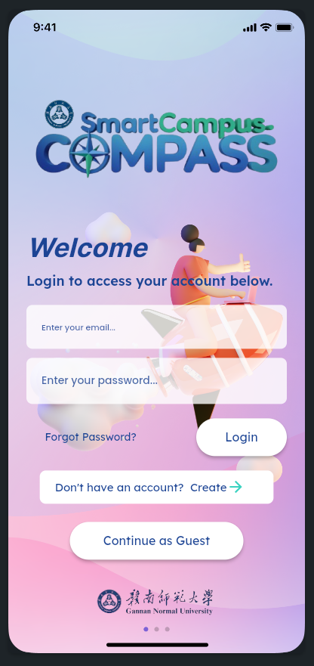

This is our welcome page look like. Here you can find several option to log into our app.

3. System Functions

3.1 Login & Signup System
This is the entry point for the application. Users must authenticate to access the system's features.

Interface:
User Email: Field to enter the user's registered email.
Password: Field to enter the user's password.
[Login] Button: Tapped to authenticate and enter the system.
[Create an account] Button: Tapped to switch to the sign up form.
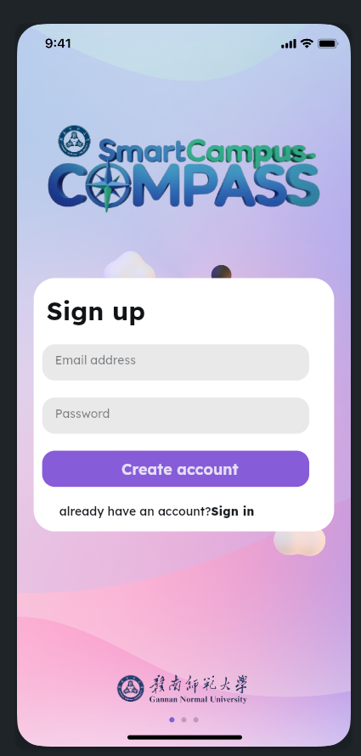

Operations:
Login: Enter your existing email and password and tap [Login].
Sign-up: Tap [Create an account], fill in your details (email, password), and tap [Sign-up] to create a new account.
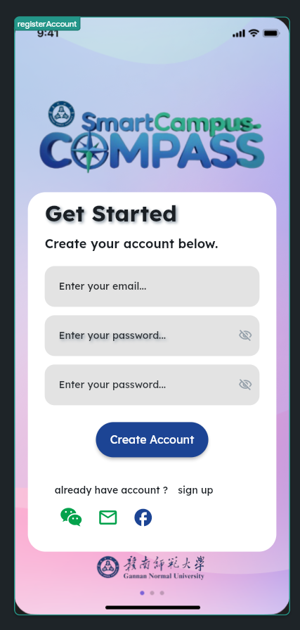

3.2 Main Dashboard
Access: This screen appears automatically after a successful login. It is the central hub for all app features.

Interface:
App Title: Displays "SmartCampusCompass" at the top of the screen.
Bottom Navigation Bar: Contains icons for [Home], [Notifications], [Profile], and [Settings].

Operations:

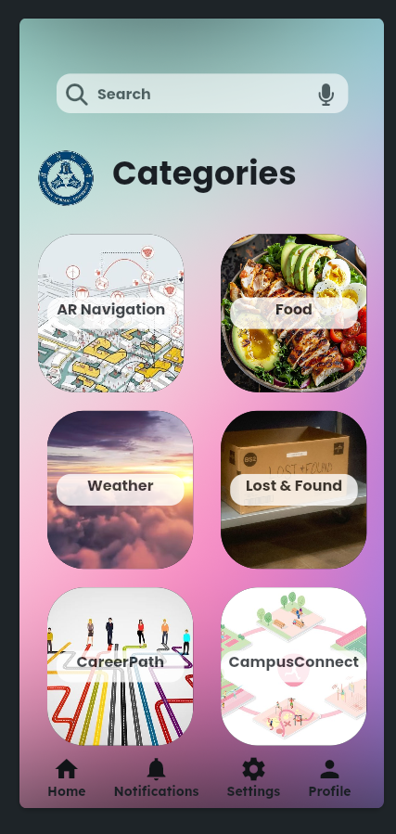
Tap any card (e.g., [Campus Navigator], [Lost & Found]) to enter that specific module.

Tap the [Home] icon on the bottom bar to return to this dashboard from any other screen.

3.3 Campus Navigator (AR Navigation)
Access: Tap the [Campus Navigator] card on the Main Dashboard.

Interface Information:
- An interactive map (Google Maps/Baidu Map API) showing the campus layout and key buildings.
- A search bar at the top to find destinations.
- A voice command icon (microphone) within the search bar.
- Buttons to select transport mode (e.g., Walking, Biking).
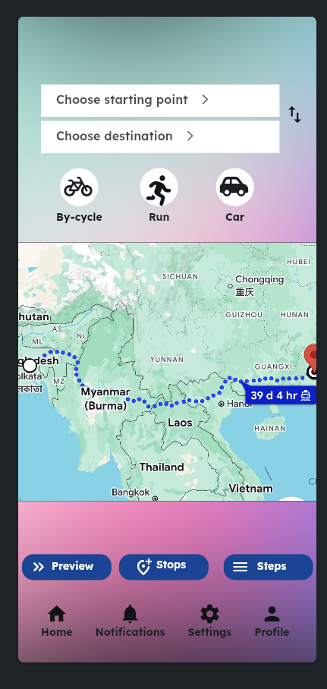

Operational Functions:
Search: Type a location (e.g., "Library") into the search bar and press enter.
Voice Command: Tap the microphone icon and speak your destination, (e.g., "Navigate to the library").
Get Directions: After selecting a location, the system will calculate and display the route, distance, and estimated time of arrival (ETA).
AR Navigation: (Optional) Tap the [AR View] button to overlay navigation arrows and directions onto your phone's live camera feed for real-time guidance.

3.4 Lost & Found Hub
Access: Tap the [Lost & Found] card on the Main Dashboard.

Interface Information:
- A grid view of items recently reported as "found," displaying a photo and location.

- A search bar to filter items by name.
- A [Report a Lost Item] button.
- A [Report a Found Item] button.

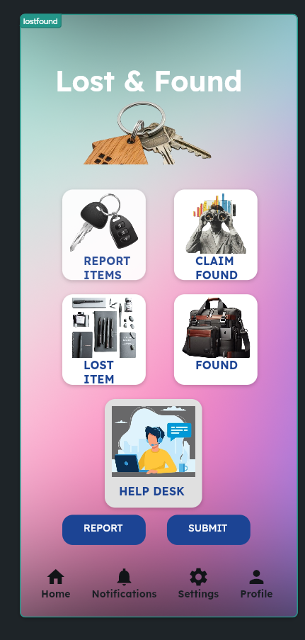
Operational Functions:
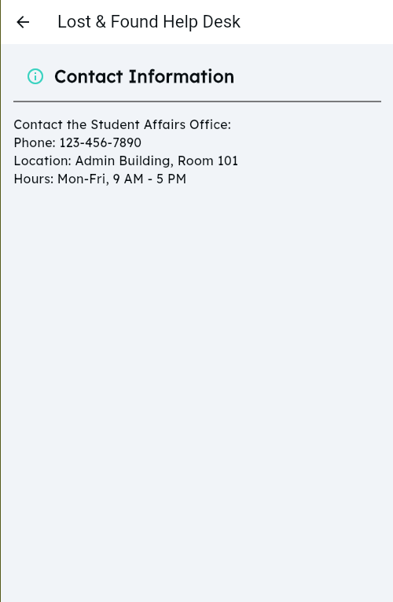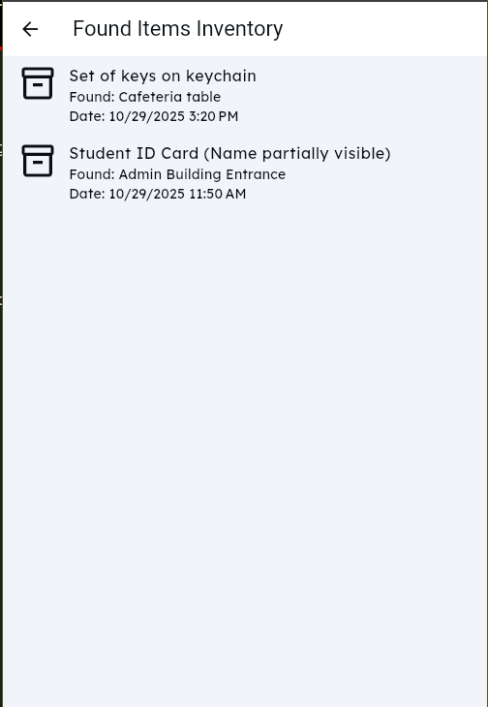
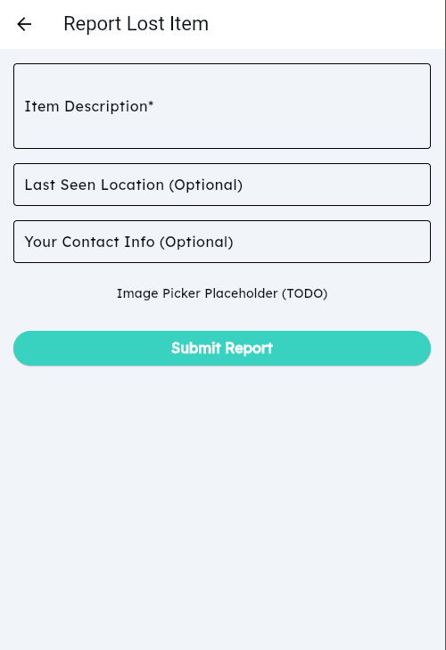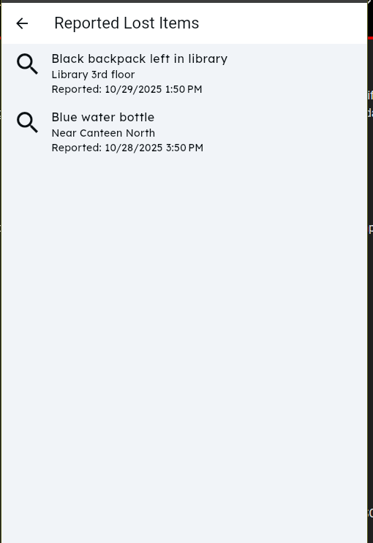

- Report Item: Tap [Report a Found Item]. Fill out the form, including item name, location found, and upload a photo. The system will use AI (TensorFlow Lite) to help categorize the item. Click [Submit].

- Search for Item: Tap [Report a Lost Item] and describe your item. The system's AI will search for potential matches in the "Found" database.

- Browse: Scroll through the grid to see all recently found items.

3.5 EcoGuardian (Food Waste Alerts)

Access: Tap the [EcoGuardian] card on the Main Dashboard.
Interface Information:
- A list of all campus canteens (e.g., "North Canteen," "South Canteen").
- For each canteen, a list of available food items, prices, and special discounts.
- Alerts for near-closing-time discounts are highlighted (e.g., "50% off pizzas!").
Operational Functions:
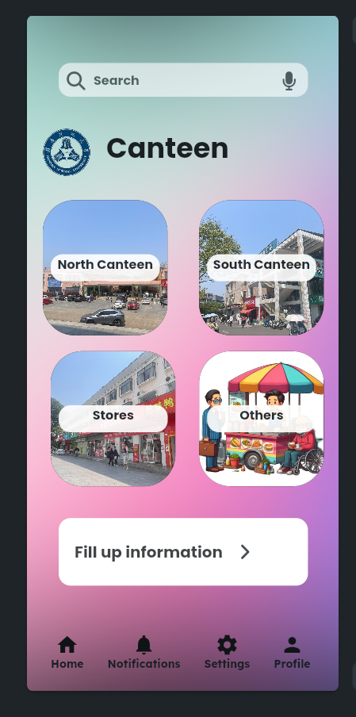
- Browse Deals: Tap on a canteen to view its menu and current discounts.
- Receive Alerts: Users will receive push notifications (via FCM) for major, time-sensitive discounts from their favorite canteens, helping reduce food waste.

3.6 CareerPath
Access: Tap the [CareerPath] card on the Main Dashboard.
Interface Information:
- A [My Profile] section to input your major, skills, and career interests.
- A [Skill Gap Analysis] module that compares your profile to job market demands.
- A [Course Recommendations] feed pulling data from the university catalog.
- A [Mock Interview] module with a chatbot interface.
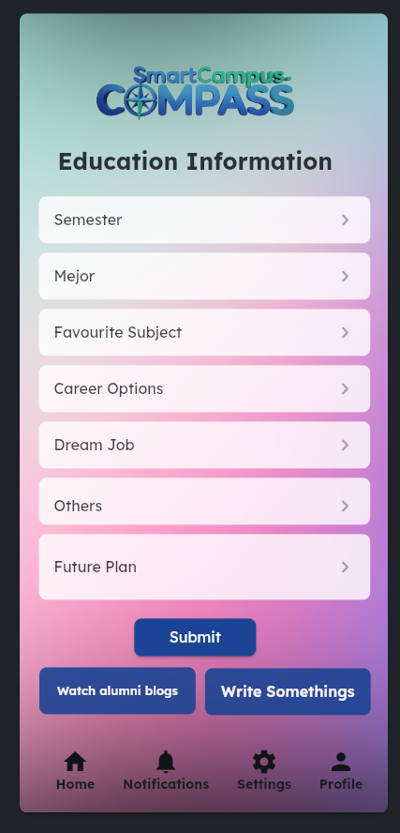
Operational Functions:
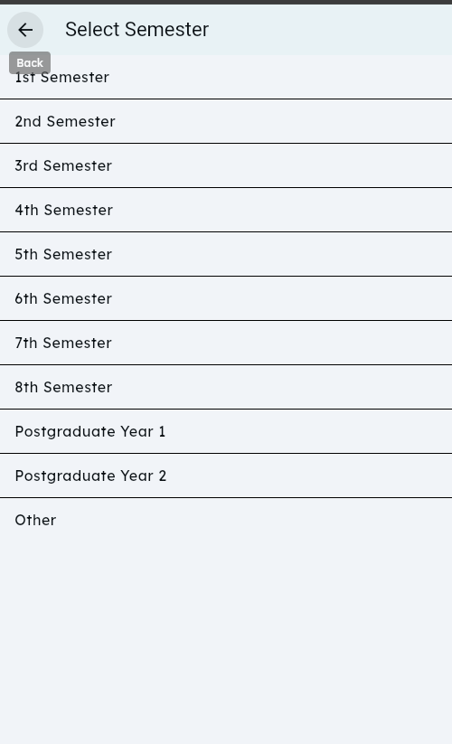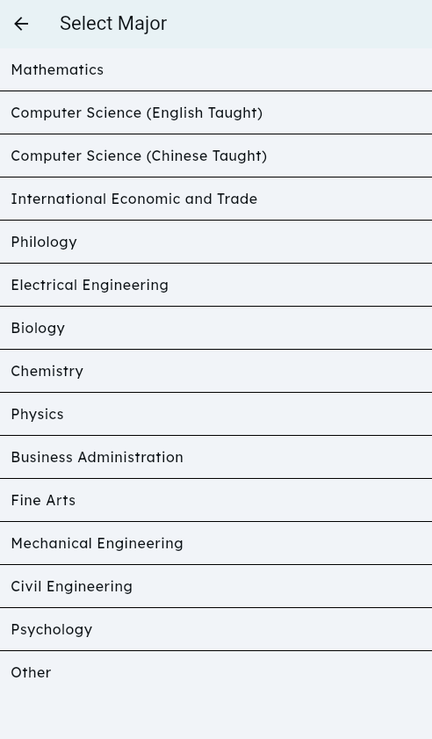
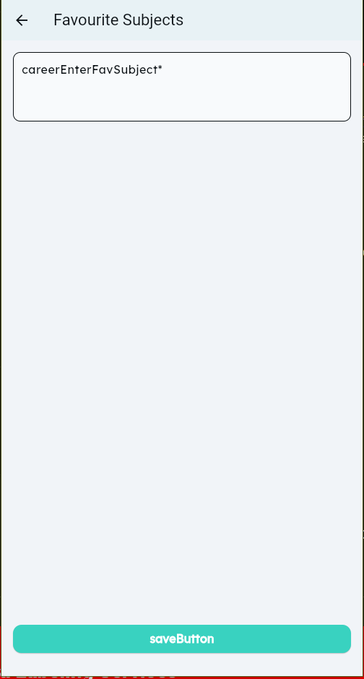
- Analyze Skills: Complete your profile to see a visual analysis of skills you have versus skills required for your target job.
- Find Courses: Browse the recommended university courses to help close any skill gaps.
- Practice: Tap [Mock Interview] to start a practice Q&A session with an AI chatbot.

3.7 SkyGuard (Weather)
Access: Tap the [SkyGuard] card on the Main Dashboard.
Interface Information:
- A full-screen, Apple-style weather interface.
- Animated backgrounds that match the current weather (e.g., raindrops, sun rays).
- Current temperature, "feels like" temperature, and humidity for the campus.
- Hourly and 5-day forecast details.

Operational Functions:
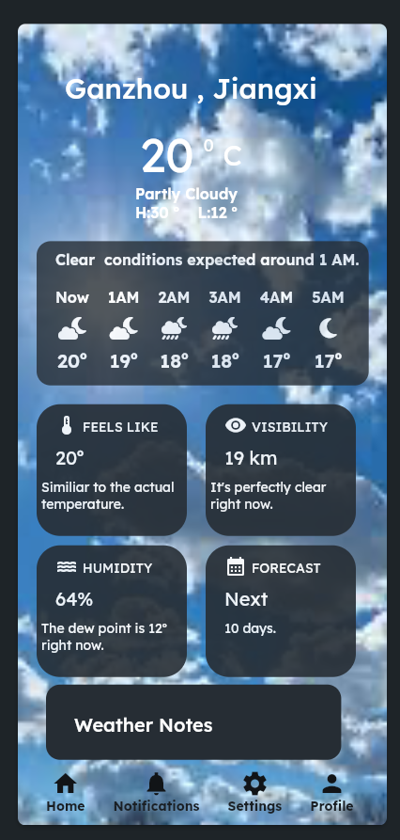
Users can view the page to get real-time, localized weather updates for the campus, helping them plan their day.

3.8 Campus Connect
Access: Tap the [Campus Connect] card on the Main Dashboard.
Interface Information:
- An Event Calendar feed showing upcoming university events, workshops, and deadlines.
- A Study Group Finder module with a list of available groups by course.
- A Campus News feed aggregating news and social media trends.

Operational Functions:
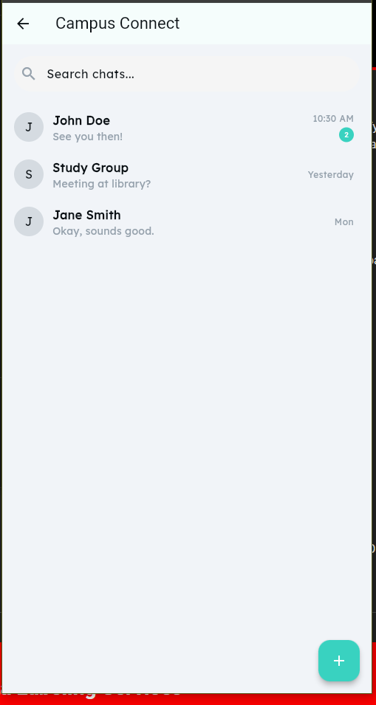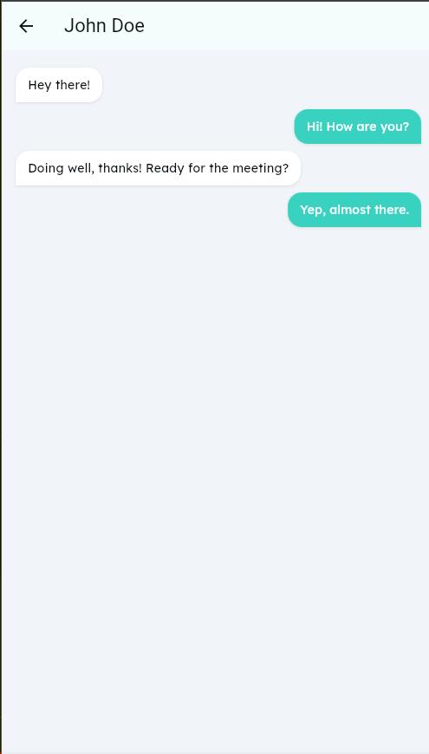
- Find Events: Scroll the calendar to see what's happening on campus.
- Join Group: Browse study groups for your class, or tap [Create Group] to start your own. Use the built-in chat to coordinate.
- Stay Updated: Read the latest news from official campus sources.

3.9 Profile & Settings

Access: Tap the [Profile] or [Settings] icon in the bottom navigation bar.
Interface Information:
- Profile Settings: Options to change your display name, profile picture, and major.
- Notification Settings: Toggles to enable or disable specific alerts (e.g., EcoGuardian alerts, Event reminders).
- Accessibility: Options for high-contrast mode or font size.
- Logout: A button to sign out of the application.

Operational Functions:
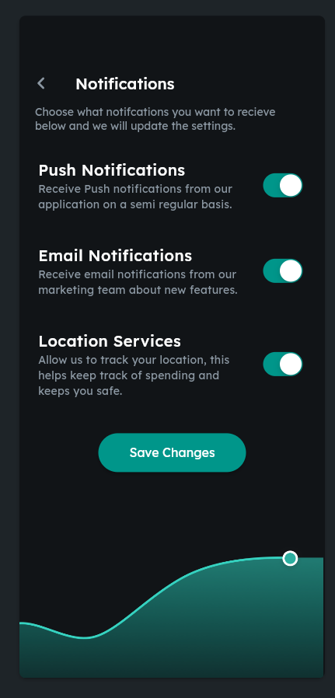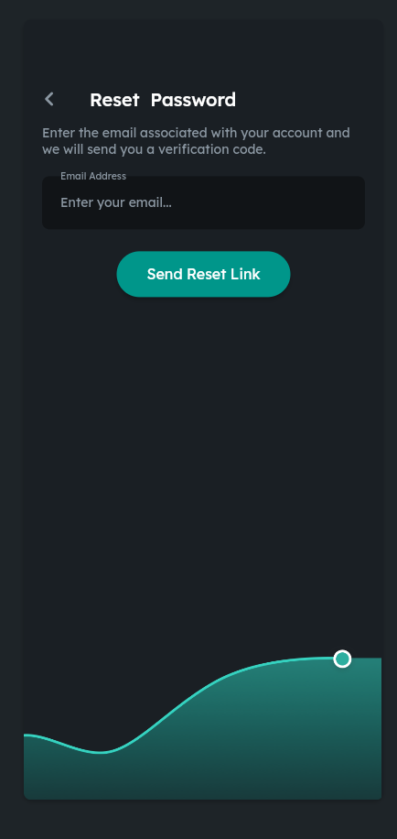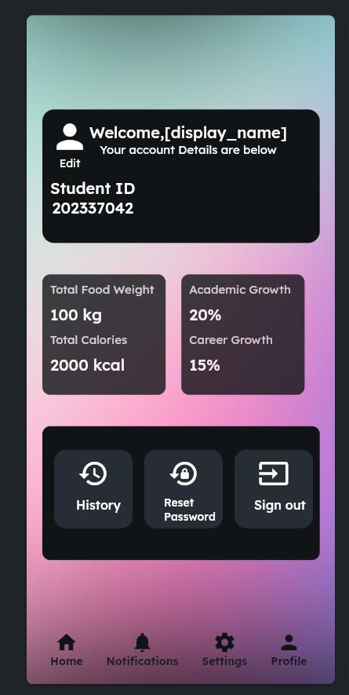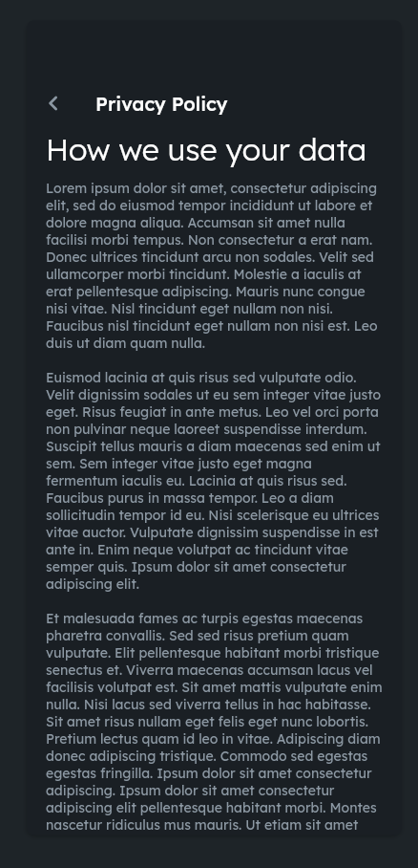
- Tap on any field to edit your profile information.
- Toggle the switches to manage which notifications you wish to receive.
- Tap [Logout] to securely sign out and return to the Login screen.

