Brain-Heart Interactions in Stress and Anxiety Related Disorders: Implications for Increased Cardiovascular Disease Risk

# Physiological basis of brain-heart interactions

## Neurocardiology

1. Historical studies of brain affecting the heart
   1. Increased nervous activity can lead to sudden death through ventricular fibrillation.(Lown, Verrier, & Rabinowitz, 1977)
      1. Animal models show that brain stimulation can lead to ventricular fibrillation, including through chemical means.(Goodman Levy, 1914)
      2. In susceptible myocardium, such as after myocardial ischemia, central nervous stimulation can trigger ventricular fibrillation more readily.(Kolman, Verrier, & Lown, 1975)
      3. Increased psychological stress reduces threshold for ventricular response, suggesting electrical instability in canine model.(Lown, Verrier, & Corbalan, 1973)
2. Relevant cardiac anatomy
   1. Pathways between heart and brain are complex.(Davis & Natelson, 1993)
   2. Important anatomy includes: medullary (parasympathetic) and spinal cord (sympathetic efferent neurons, afferent inputs to CNS from arterial and cardiac wall mechanosensors.(Williamson, Fadel, & Mitchell, 2006)
   3. **Potential Figure** showing complexity of cardiac anatomy 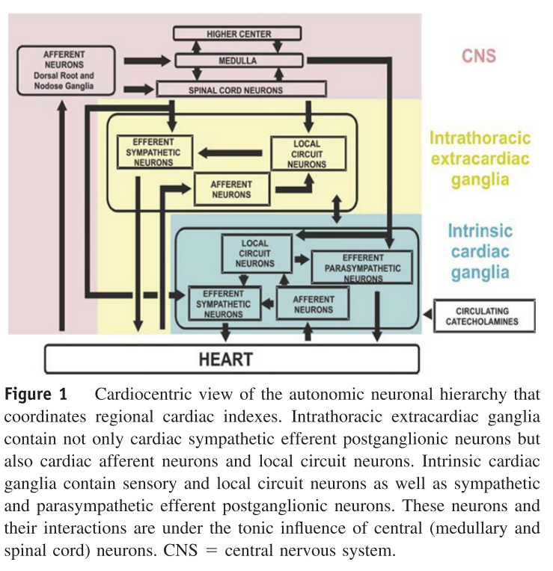
   4. Highlighting difference between intrinsic cardiac ganglia, intrathoracic extracardiac ganglia, and CNS, such that there is limited/unknown sympathetic afferent neurons from heart to higher levels.(Armour, 2010; Coote, 2013)
   5. Combination of abnormal cardiac myocyte and cardiac nervous system effect overall cardiac function.(Armour, 2008)
   6. Supramedullary effects are also present, such that the left and right insular stimulation creates different effects in bradycardia with the left, and tachycardia with the right.(Oppenheimer, Gelb, Girvin, & Hachinski, 1992)

## Autonomic nervous system affect on cardiovascular system

1. Sympathetic nervous system
   1. Stimulation of the stellate ganglion in canine models had increased chance of causing ventricular fibrillation particularly after coronary occlusion.(Harris, Otero, & Bocage, 1971)
   2. Stellate ganglion thought to be carrying efferent sympathetic fibers. After stellate ganglionectomy, the VF threshold increased to 11% from 31% (compared to control VF rate).(Kliks, Burgess, & Abildskov, 1975)
   3. Affect is complicated however, as unilateral stellectomy may have compensatory contralateral activation, and then are agonized by vagal activity.(Schwartz, Verrier, & Lown, 1977) 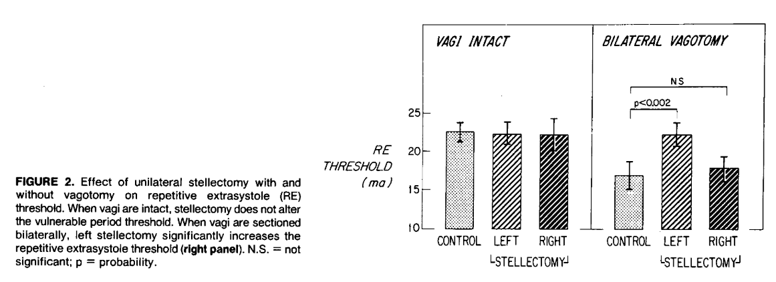
2. Parasympathetic nervous system
   1. Vagal influence was not thought to be salutary independently, it only provided protection to VF threshold with concurrent increased sympathetic tone.(Kolman et al., 1975)
   2. Vagal nerve asks through muscarinic, nicotinic, and adrenergic signals, such as methachole could raise ventricular vulnerable threshold, which could reduced with atropine.(Rabinowitz, Verrier, & Lown, 1976)
   3. Vagal activity is controversial, as sympathetic-independent nitrergic parasympathetic postganglionic nerves can independently provide ventricular protection and decrease SA-AV conduction.(Brack, Coote, & Ng, 2011; Brack, Patel, Coote, & Ng, 2007; Coote, 2013; Ng, Brack, & Coote, 2001) 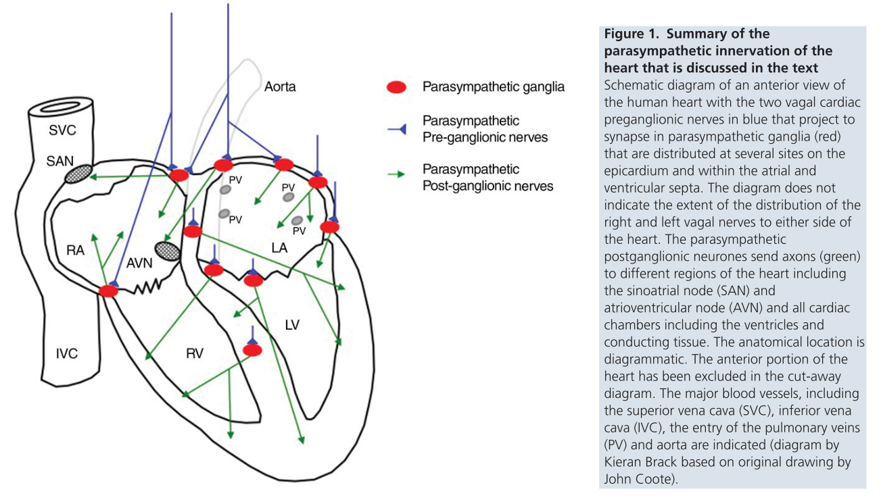
   4. Multiple types of cardiac vagal preganglionic neurons exist in the medulla in feline models, one affected by respiration and one that was not.(Daly & Kirkman, 1989)

# Measurement of brain-heart interactions

## Invasive measurements

1. Electrical measurements
   1. Microneurography
      1. Multiunit postganglionic sympathetic nerve activity (MSNA) can be recorded from the peroneal nerve using microneurography. A tungsten microelectrode is inserted into the nerve, and signals are rectified and integrated over time to obtain a mean voltage of sympathetic nerve activity. This is usually expressed burst frequency.(Mano, Iwase, & Toma, 2006; Park et al., 2017; Wallin & Fagius, 1988)
2. Chemical measurements
   1. Baroreceptor reflex
      1. Gold standard method is through the Modified Oxford technique. MSNA and RR interval are measured during arterial BP changes induced through nitroprusside and phenylephrine.(Rudas et al., 1999)
   2. Catecholamines

## Heart rate variability measurements

1. Relevance of HRV
   1. Heart rate variability is the measurement of overall autonomic outflow after modulation. Historically, the largest prospective study, ATRAMI, showed reduced BRS and HRV led to worse outcomes after MI.(La Rovere, Bigger, Marcus, Mortara, & Schwartz, 1998) The varied changes in RR intervals, measured through HRV through different methods, suggest that factors that influence HRV and thus the sinus node, are autonomic in etiology.(Saul, 1990)
   2. As the autonomic system has supramedullary inputs, HRV may index emotional landscape and psychosocial stress.(Thayer & Lane, 2000) And as HRV associates with overall cardiovascular mortality, it may be related to the effect on autonomic imbalance on mortality.(Thayer, Yamamoto, & Brosschot, 2010)
   3. Reflects cardiac autonomic regulation although the contributions of parasympathetic and sympathetic nervous systems are unknown.(Billman, 2011; Task Force of the ESC and NAS, 1996)
   4. Improvement in HRV occurs after cardiac rehabilitation, in line with improvement in functional status.(Jelinek, Huang, Khandoker, Chang, & Kiat, 2013)
2. Measurement techniques
   1. Geometric domain
      1. SDNN over 24 hour hours, when decreased after MI, had increased mortality.(Kleiger, Miller, Bigger, & Moss, 1987)
   2. Frequency domain
      1. Power spectral analysis can be broken down into 4 categories, ULF, VLF, LF, HF, and correspond to different cardiac sympathovagal balance (HF = RSA/vagal, LF = SNS, VLF = RAAS).(Akselrod et al., 1981)
      2. After MI, LF was higher and HF was lower than in controls. HF “vagal tone” is reduced after MI but normalizes over the following year.(Lombardi et al., 1987)
      3. Unclear the role of each frequency band, as LF may not be an adequate measure of sympathetic activity.(Houle & Billman, 1999) The LF/HF ratio may also not represent sympathovagal balance.(Billman, 2013)
   3. Non-linear domain
      1. Non-linear HRV uses the relationship between RR(n) and RR(n+1) to analyze heart rate dynamics. The multipole/Poincaré method results in *Dyx*, which is shown to be a prognostic marker in patients s/p myocardial infarction.(Jørgensen et al., 2016, 2015; Olesen et al., 2005)
3. Considerations
   1. Heart rate and HRV are not independent, but the relationship can be adjusted for mathematically.(J. Sacha, 2014)
   2. Gender plays a significant role in HRV, and men and women cannot be compared easily.(J. Sacha et al., 2014)

# Impact of stress-related disorders on autonomic function and cardiovascular disease

## Physiological influence of stress-related disorders

1. Relationship of psychological stress with cardiovascular events
   1. Early study looked at sudden death in factory workers - interview based data noted that a majority had been depressed prior to the event, and were acutely precipitated by arousal (anxiety, anger, increased work stress), suggesting that abrupt psychological changes leads to disharmonious responses.(Greene, Goldstein, & Moss, 1972)
   2. Finland study with life stress and CHD (MI n=279, SCD n=226), showed both populations had recent life stress in prior 6 months, but even more strongly in those with SCD.(Rahe, Bennett, Romo, Siltanen, & Arthur, 1973)
   3. Anecdotally stress and anger events precede MI. Interviewing n=1623 patients right after MI showed that anger occurred 2 hours prior had a RR=2.3, which was reduced in those taking aspirin but mechanism unknown.(Mittleman et al., 1995)
2. Pathophysiological changes
   1. In normal hearts, in the setting of monkeys on high-cholesterol diet, psychosocial stress led to endothelial damage, which was limited by the administration of B1-blockers.(Strawn et al., 1991)
   2. Type A behavior traits compared to type B behavior traits had significantly more coronary calcification.(Sparagon et al., 2001)
   3. In mice model, chronic social stress leads to increased sympathetic tone (based on geometric HRV), decreased circadian rhythm, and myocardial fibrosis.(Costoli, 2004) This compares with the concept of chronic psychosocial stress through human development, as the increased allostatic load leads to worse cardiovascular outcomes.(Danese & McEwen, 2012)
   4. Insular cortex may mediate the sympathetic tone that leads to myocardial injury, such as seen in Takotsubo cardiomyopathy.(Nagai et al., 2017)

## Post-traumatic stress disorder

1. Clinical
   1. PTSD can be diagnosed by SCID.(First, Michael B., Spitzer, Robert L, Gibbon Miriam, and Williams, 1996)
   2. Characterized by emotional/mental stress after trauma, sx include hyperarousal, flashbacks/nightmares, intrusive thoughts
   3. Health consequences are multi-organ, including cardiovascular risk even after adjustment for other factors.(Boscarino, 1997, 2008)
2. Autonomic mechanism
   1. Angiotensin II may mediate some of the sympathetic activity, and thus some of the increased CVD risk.(Reid, 1992) 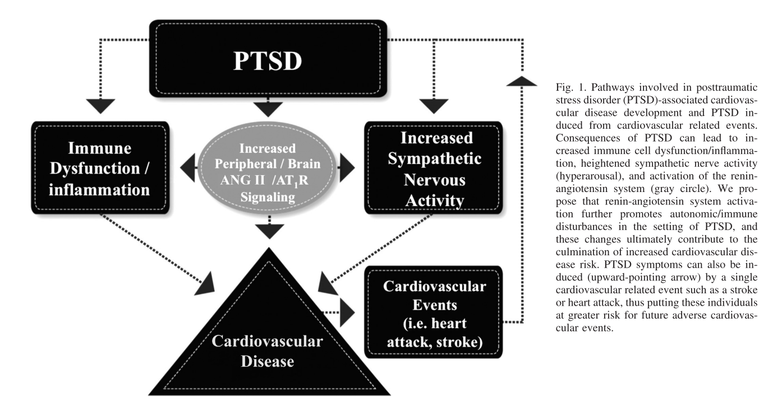
   2. PTSD leads to higher resting HR and BP, and was dependent on chronicity of PTSD.(Buckley & Kaloupek, 2001) Increased nocturnal SNS dominance has been seen, changing diurnal sleeping ANS function.(Muraoka, Carlson, & Chemtob, 1998)
   3. Baroreflexes are also reduced in patients with PTSD, included blunted changes in HR and greater orthostasis.(Hughes, Dennis, & Beckham, 2007; Peckerman et al., 2003)
   4. Reduced/blunted BRS and increased MSNA occur during mental stress in PTSD than controls.(Park et al., 2017)
   5. PTSD had inversely related with VLF and LF, even after adjustment for other risk factors.(Shah et al., 2013)
3. Cardiovascular risk
   1. Double the CHD in veteran twin pairs discordant for PTSD.(Vaccarino et al., 2013) Increased CAC scores independent of risk factors in PTSD veterans.(Ahmadi et al., 2011) PTSD particularly in women have a significantly higher incidence of CHD.(Vaccarino & Bremner, 2017)

## Depressive disorders

1. Clinical
   1. Depression is prevalent in the US, affecting roughly 1/6 adults.(Kessler, Chiu, Demler, & Walters, 2005) It also is associated with cardiovascular events.(Carney & Freedland, 2017)
   2. Can be measured in severity through Beck Depression Inventory.(Beck, Steer, & Carbin, 1988)
   3. Relationship may be bidirectional, as mental disorders including depressive episodes and dysthymia can develop after CAD.(Schaich et al., 2018)
2. Autonomic mechanism
   1. Depression coexsits with coronary heart disease, increases poor prognosis. Physiologically represents chronic, severe stress.(Carney & Freedland, 2017)
   2. When depression is studied by HRV, the relationship appears bidirectional, but more heavily that autonomic dysfunction affects depression risk more than the converse.(Huang et al., 2018)
   3. After ACS, HRV is decreased over 24-hour ECG monitoring in patients with depression than those without.(Carney et al., 2001)
   4. Depression is related to decreased HRV in both clinical and non-clinical populations.(Paniccia, Paniccia, Thomas, Taha, & Reed, 2017) Thought to be partially due to prefrontal cortex hypoactivity, which possibly contributes to vagal withdrawal.(Sgoifo, Carnevali, Pico Alfonso, & Amore, 2015)
   5. Decreases in HF HRV in depression is associated with suicidal ideation, even after adjustment of depression, anxiety, and stress.(Adolph, Teismann, Forkmann, Wannemüller, & Margraf, 2018)
   6. Mechanism of lower HRV and depression is partially influenced by underlying biological pathway
3. Cardiovascular risk
   1. Increased cardiovascular risk occurs independently with onset of depression for decades after diagnosis.(Ford et al., 1998)
   2. First ever depressive episode after ACS led to a OR of 2.6 for recurrent cardiac event.(Ossola, Gerra, Panfilis, Tonna, & Marchesi, 2018)

## Anxiety disorder

1. Clinical
2. Autonomic mechanism
   1. Anxiety is related to decreased HRV in both clinical and non-clinical populations.(Paniccia et al., 2017)
   2. In anxious depression, higher pretreatment HRV had better outcomes, while in non-anxious depression lower pretreatment HRV had better outcomes.
   3. Reduced HRV seen in all major psychiatric disorders.(Alvares, Quintana, Hickie, & Guastella, 2016)
3. Cardiovascular risk
   1. Anxiety may have an opposing effect to depression after ACS, being weakly protective in those who did not develop incidental depression.(Ossola et al., 2018)

# Cardiovascular risk

## Mental stress

1. Vasomotor response
   1. In patients with CAD, increased vasomotor tone during mental-stress associates with increased activation in the insula and parietal cortex.(Shah et al., 2018)
   2. Women have higher peripheral arterial tone during mental stress, but lower reactive hyperemia index after mental stress which suggests microvascular dysfunction, with doubled the rate of MSIMI than in men..[Vaccarino2018]
2. Brain correlates
   1. Stress-induced vasoreactivity leads to changes in brain responses during mental stress in patients with CAD.(Shah et al., 2018)
   2. MSIMI associated with activation in brain areas involving autonomic regulation (left insula activation, and right precentral, postcentral, and temporal gyrus).(Bremner et al., 2018)

## Gender differences

1. Differences in myocardial ischemia
   1. Unclear etiology of differences in ischemia, with older studies finding anginal stories and ischemic changes, but without consistent catherization data for plaque.(Glancy et al., 1971)
   2. Depressive disorders after CAD are predicted by female gender and younger age.(Schaich et al., 2018)
   3. Women have higher peripheral arterial tone during mental stress, but lower reactive hyperemia index after mental stress which suggests microvascular dysfunction, with doubled the rate of MSIMI than in men..[Vaccarino2018]
   4. For those with suspected or established CAD, depression increases the risk of death, particularly in women.(Shah et al., 2014)
2. Stress-related mental disorders
   1. Increased risk of PTSD and depression in women than in men, which may lead to more vulnerability to cardiovascular disease than in men.(Vaccarino & Bremner, 2017)
   2. Women and men have differences in cardiovascular responses to MSIMI, such that women have more peripheral vasoconstriction, while men have increased hemodynamic workload.(Sullivan et al., 2018)
   3. Women with CAD are also more susceptible to MSIMI.(Vaccarino et al., 2016)

## Treatment and behavioral modification

1. Biofeedback
   1. HRV biofeedback is a self-regulation of a “dysregulated” vagal nerve, thought to help with management of mental-health disease.(Blase, Dijke, Cluitmans, & Vermetten, 2010)
   2. Mindfulness training reduces subjective feelings of depression after ACS.(Lundgren, Garvin, Kristenson, Jonasson, & Thylén, 2018)
   3. Meditation also increases HRV and has brain correlates with changes in the anterior cingulate gyrus and hippocampus.(Tang et al., 2009)
2. Medications
   1. Antidepressants
      1. T wave amplitude and QTc length did not change in patients with depression or anxiety on TCA, SSRI, SNRI.
      2. Initial studies with SSRI showed it is safe in MI, but also showed trend of better overall functioning.(Glassman et al., 2002)
      3. After ACS, SSRI shows decreased MACE in long-term followup (median 8 years).(Kim et al., 2018)
      4. TCA however show a further decrease in HRV in patients with anxiety or mood disorders, while the data on SSRI and SNRI is much more mixed.(Alvares et al., 2016) SSRI seem to increase HRV in patients with depression.(Kidwell & Ellenbroek, 2018)
3. Other
   1. Vagal nerve stimulation reduces depression symptoms, but unknown effects on cardiovascular risk.(Kidwell & Ellenbroek, 2018)

# References

Adolph, D., Teismann, T., Forkmann, T., Wannemüller, A., & Margraf, J. (2018). High frequency heart rate variability: Evidence for a transdiagnostic association with suicide ideation. *Biological Psychology*, *138*, 165–171. <https://doi.org/10.1016/j.biopsycho.2018.09.006>

Ahmadi, N., Hajsadeghi, F., Mirshkarlo, H. B., Budoff, M., Yehuda, R., & Ebrahimi, R. (2011). Post-traumatic stress disorder, coronary atherosclerosis, and mortality. *American Journal of Cardiology*, *108*(1), 29–33. <https://doi.org/10.1016/j.amjcard.2011.02.340>

Akselrod, S., Gordon, D., Ubel, F. A., Shannon, D. C., Berger, A. C., & Cohen, R. J. (1981). Power Spectrum Analysis of Heart Rate Fluctuation: A Quantitative. *Science (New York, N.Y.)*, *213*(July), 220–222. <https://doi.org/10.1126/science.6166045>

Alvares, G. A., Quintana, D. S., Hickie, I. B., & Guastella, A. J. (2016). Autonomic nervous system dysfunction in psychiatric disorders and the impact of psychotropic medications: A systematic review and meta-analysis. <https://doi.org/10.1503/jpn.140217>

Armour, J. A. (2008). Potential clinical relevance of the ’little brain’ on the mammalian heart. Wiley/Blackwell (10.1111). <https://doi.org/10.1113/expphysiol.2007.041178>

Armour, J. A. (2010). Functional anatomy of intrathoracic neurons innervating the atria and ventricles. *Heart Rhythm*, *7*(7), 994–996. <https://doi.org/10.1016/j.hrthm.2010.02.014>

Beck, A. T., Steer, R. A., & Carbin, M. G. (1988). Psychometric properties of the Beck Depression Inventory: Twenty-five years of evaluation. *Clinical Psychology Review*, *8*(1), 77–100. <https://doi.org/10.1016/0272-7358(88)90050-5>

Billman, G. E. (2011). Heart rate variability - A historical perspective. *Frontiers in Physiology*, *2 NOV*. <https://doi.org/10.3389/fphys.2011.00086>

Billman, G. E. (2013). The LF/HF ratio does not accurately measure cardiac sympatho-vagal balance. *Frontiers in Physiology*, *4*, 26. <https://doi.org/10.3389/fphys.2013.00026>

Blase, K. L., Dijke, A. van, Cluitmans, P. J. M., & Vermetten, E. (2010). Efficacy of HRV-biofeedback as additional treatment of depression and PTSD. *The American Journal of Psychiatriy*, *58*(4), 292–300. Retrieved from <http://www.ncbi.nlm.nih.gov/pubmed/27075221>

Boscarino, J. A. (1997). Diseases among men 20 years after exposure to severe stress: Implications for clinical research and medical care. *Psychosomatic Medicine*, *59*(6), 605–614. <https://doi.org/10.1097/00006842-199711000-00008>

Boscarino, J. A. (2008). A prospective study of ptsd and early-age heart disease mortality among vietnam veterans: Implications for surveillance and prevention. *Psychosomatic Medicine*, *70*(6), 668–676. <https://doi.org/10.1097/PSY.0b013e31817bccaf>

Brack, K. E., Coote, J. H., & Ng, G. A. (2011). Vagus nerve stimulation protects against ventricular fibrillation independent of muscarinic receptor activation. *Cardiovascular Research*, *91*(3), 437–446. <https://doi.org/10.1093/cvr/cvr105>

Brack, K. E., Patel, V. H., Coote, J. H., & Ng, G. A. (2007). Nitric oxide mediates the vagal protective effect on ventricular fibrillation via effects on action potential duration restitution in the rabbit heart. *Journal of Physiology*, *583*(2), 695–704. <https://doi.org/10.1113/jphysiol.2007.138461>

Bremner, J. D., Campanella, C., Khan, Z., Shah, M., Hammadah, M., Wilmot, K., … Vaccarino, V. (2018). Brain Correlates of Mental Stress-Induced Myocardial Ischemia. *Psychosomatic Medicine*, *80*(6), 515–525. <https://doi.org/10.1097/PSY.0000000000000597>

Buckley, T. C., & Kaloupek, D. G. (2001). A meta-analytic examination of basal cardiovascular activity in posttraumatic stress disorder. *Psychosomatic Medicine*, *63*(4), 585–594. <https://doi.org/10.1097/00006842-200107000-00011>

Carney, R. M., Blumenthal, J. A., Stein, P. K., Watkins, L., Catellier, D., Berkman, L. F., … Freedland, K. E. (2001). Depression, heart rate variability, and acute myocardial infarction. *Circulation*, *104*(17), 2024–2028. <https://doi.org/10.1161/hc4201.097834>

Carney, R. M., & Freedland, K. E. (2017). Depression and coronary heart disease. <https://doi.org/10.1038/nrcardio.2016.181>

Coote, J. H. (2013). Myths and realities of the cardiac vagus. <https://doi.org/10.1113/jphysiol.2013.257758>

Costoli, T. (2004). Effects of chronic psychosocial stress on cardiac autonomic responsiveness and myocardial structure in mice. *AJP: Heart and Circulatory Physiology*, *286*(6), H2133–H2140. <https://doi.org/10.1152/ajpheart.00869.2003>

Daly, M. B., & Kirkman, E. (1989). Differential modulation by pulmonary stretch afferents of some reflex cardioinhibitory responses in the cat. *The Journal of Physiology*, *417*, 323–341. Retrieved from [http://www.ncbi.nlm.nih.gov/pubmed/2621597 http://www.pubmedcentral.nih.gov/articlerender.fcgi?artid=PMC1189269](http://www.ncbi.nlm.nih.gov/pubmed/2621597%20http://www.pubmedcentral.nih.gov/articlerender.fcgi?artid=PMC1189269)

Danese, A., & McEwen, B. S. (2012). Adverse childhood experiences, allostasis, allostatic load, and age-related disease. <https://doi.org/10.1016/j.physbeh.2011.08.019>

Davis, A. M., & Natelson, B. H. (1993). Brain-heart interactions. The neurocardiology of arrhythmia and sudden cardiac death. *Texas Heart Institute Journal*, *20*(3), 158–169. Retrieved from [http://www.ncbi.nlm.nih.gov/pubmed/8219819 http://www.pubmedcentral.nih.gov/articlerender.fcgi?artid=PMC325088](http://www.ncbi.nlm.nih.gov/pubmed/8219819%20http://www.pubmedcentral.nih.gov/articlerender.fcgi?artid=PMC325088)

First, Michael B., Spitzer, Robert L, Gibbon Miriam, and Williams, J. B. (1996). *Structured Clinical Interview for DSM-IV Axis I Disorders, Clinician Version (SCID-CV)*.

Ford, D. E., Mead, L. A., Chang, P. P., Cooper-Patrick, L., Wang, N. Y., & Klag, M. J. (1998). Depression is a risk factor for coronary artery disease in men: The precursors study. *Archives of Internal Medicine*, *158*(13), 1422–1426. <https://doi.org/10.1001/archinte.158.13.1422>

Glancy, D. L., Marcus, M. L., Epstein, S. E., Luk, D., Marcus, M. L., Epstein, S. E., & Glancy, L. (1971). Myocardial infarction in young women with normal coronary arteriograms. <https://doi.org/10.1161/01.CIR.44.4.495>

Glassman, A. H., O’Connor, C. M., Califf, R. M., Swedberg, K., Schwartz, P., Bigger, J. T., … Harrison, W. M. (2002). Sertraline treatment of major depression in patients with acute MI or unstable angina. *Journal of the American Medical Association*, *288*(6), 701–709. <https://doi.org/10.1001/jama.288.6.701>

Goodman Levy, A. (1914). Sudden Death under Light Chloroform Anaesthesia. *Heart*, (4), 319–378. Retrieved from <http://journals.sagepub.com/doi/pdf/10.1177/003591571400701421>

Greene, W. A., Goldstein, S., & Moss, A. J. (1972). Psychosocial Aspects of Sudden Death: A Preliminary Report. *Archives of Internal Medicine*, *129*(5), 725–731. <https://doi.org/10.1001/archinte.1972.00320050049005>

Harris, A. S., Otero, H., & Bocage, A. J. (1971). The induction of arrhythmias by sympathetic activity before and after occlusion of a coronary artery in the canine heart. *Journal of Electrocardiology*, *4*(1), 34–43. <https://doi.org/10.1016/S0022-0736(71)80048-1>

Houle, M. S., & Billman, G. E. (1999). Low-frequency component of the heart rate variability spectrum: a poor marker of sympathetic activity. *American Journal of Physiology-Heart and Circulatory Physiology*, *276*(1), H215–H223. <https://doi.org/10.1152/ajpheart.1999.276.1.H215>

Huang, M., Shah, A., Su, S., Goldberg, J., Lampert, R. J., Levantsevych, O. M., … Vaccarino, V. (2018). Association of Depressive Symptoms and Heart Rate Variability in Vietnam War–Era Twins. *JAMA Psychiatry*, *75*(7), 705. <https://doi.org/10.1001/jamapsychiatry.2018.0747>

Hughes, J. W., Dennis, M. F., & Beckham, J. C. (2007). Baroreceptor sensitivity at rest and during stress in women with posttraumatic stress disorder or major depressive disorder. *Journal of Traumatic Stress*, *20*(5), 667–676. <https://doi.org/10.1002/jts.20285>

Jelinek, H. F., Huang, Z. Q., Khandoker, A. H., Chang, D., & Kiat, H. (2013). Cardiac rehabilitation outcomes following a 6-week program of PCI and CABG Patients. *Frontiers in Physiology*, *4*(OCT). <https://doi.org/10.3389/fphys.2013.00302>

Jørgensen, R. M., Abildstrøm, S. Z., Levitan, J., Kobo, R., Puzanov, N., Lewkowicz, M., … Group, N. I. C. D. pilot study. (2016). Heart Rate Variability Density Analysis (Dyx) and Prediction of Long-Term Mortality after Acute Myocardial Infarction. *Annals of Noninvasive Electrocardiology : The Official Journal of the International Society for Holter and Noninvasive Electrocardiology, Inc*, *21*(1), 60–68. <https://doi.org/10.1111/anec.12297>

Jørgensen, R. M., Levitan, J., Halevi, Z., Puzanov, N., Abildstrøm, S. Z., Messier, M. D., … Jons, C. (2015). Heart rate variability density analysis (Dyx) for identification of appropriate implantable cardioverter defibrillator recipients among elderly patients with acute myocardial infarction and left ventricular systolic dysfunction. *Europace*, *17*(12), 1848–1854. <https://doi.org/10.1093/europace/euu394>

Kessler, R. C., Chiu, W. T., Demler, O., & Walters, E. E. (2005). Prevalence, Severity, and Comorbidity of 12-Month DSM-IV Disorders in the National Comorbidity Survey Replication. *Archives of General Psychiatry*, *62*(6), 617. <https://doi.org/10.1001/archpsyc.62.6.617>

Kidwell, M., & Ellenbroek, B. A. (2018). Heart and soul: Heart rate variability and major depression. *Behavioural Pharmacology*, *29*(1998), 152–164. <https://doi.org/10.1097/FBP.0000000000000387>

Kim, J.-M., Stewart, R., Lee, Y.-S., Lee, H.-J., Kim, M. C., Kim, J.-W., … Yoon, J.-S. (2018). Effect of Escitalopram vs Placebo Treatment for Depression on Long-term Cardiac Outcomes in Patients With Acute Coronary Syndrome. *JAMA*, *320*(4), 350. <https://doi.org/10.1001/jama.2018.9422>

Kleiger, R. E., Miller, J. P., Bigger, J. T., & Moss, A. J. (1987). Decreased Heart Rate Variability and Its Association with Increased Mortality After Acute Myocardial Infarction. *Am J Cardiol*, *59*(4), 258–282. <https://doi.org/10.1016/0002-9149(87)90795-8>

Kliks, B. R., Burgess, M. J., & Abildskov, J. A. (1975). Influence of sympathetic tone on ventricular fibrillation threshold during experimental coronary occlusion. *The American Journal of Cardiology*, *36*(1), 45–49. <https://doi.org/10.1016/0002-9149(75)90866-8>

Kolman, B. S., Verrier, R. L., & Lown, B. (1975). The effect of vagus nerve stimulation upon vulnerability of the canine ventricle. *Circulation*, *52*(4), 578–585. <https://doi.org/10.1161/01.CIR.52.4.578>

La Rovere, M. T., Bigger, J. T., Marcus, F. I., Mortara, A., & Schwartz, P. J. (1998). Baroreflex sensitivity and heart-rate variability in prediction of total cardiac mortality after myocardial infarction. *Lancet*, *351*(9101), 478–484. <https://doi.org/10.1016/S0140-6736(97)11144-8>

Lombardi, F., Sandrone, G., Pernpruner, S., Sala, R., Garimoldi, M., Cerutti, S., … Malliani, A. (1987). Heart rate variability as an index of sympathovagal interaction after acute myocardial infarction. *The American Journal of Cardiology*, *60*(16), 1239–1245. <https://doi.org/10.1016/0002-9149(87)90601-1>

Lown, B., Verrier, R., & Corbalan, R. (1973). Psychologic stress and threshold for repetitive ventricular response. *Science*, *182*(4114), 834–836. <https://doi.org/10.1126/science.182.4114.834>

Lown, B., Verrier, R. L., & Rabinowitz, S. H. (1977). Neural and psychologic mechanisms and the problem of sudden cardiac death. *The American Journal of Cardiology*, *39*(6), 890–902. <https://doi.org/10.1016/S0002-9149(77)80044-1>

Lundgren, O., Garvin, P., Kristenson, M., Jonasson, L., & Thylén, I. (2018). A journey through chaos and calmness: Experiences of mindfulness training in patients with depressive symptoms after a recent coronary event - a qualitative diary content analysis. *BMC Psychology*, *6*(1), 46. <https://doi.org/10.1186/s40359-018-0252-1>

Mano, T., Iwase, S., & Toma, S. (2006). Microneurography as a tool in clinical neurophysiology to investigate peripheral neural traffic in humans. <https://doi.org/10.1016/j.clinph.2006.06.002>

Mittleman, M. A., Maclure, M., Sherwood, J. B., Mulry, R. P., Tofler, G. H., Jacobs, S. C., … Muller, J. E. (1995). Triggering of acute myocardial infarction onset by episodes of anger. *Circulation*, *92*(7), 1720–1725. <https://doi.org/10.1161/01.CIR.92.7.1720>

Muraoka, M. Y., Carlson, J. G., & Chemtob, C. M. (1998). Twenty-four-hour ambulatory blood pressure and heart rate monitoring in combat-related posttraumatic stress disorder. *Journal of Traumatic Stress*, *11*(3), 473–484. <https://doi.org/10.1023/A:1024400628342>

Nagai, M., Dote, K., Kato, M., Sasaki, S., Oda, N., Kagawa, E., … Kario, K. (2017). The Insular Cortex and Takotsubo Cardiomyopathy. *Current Pharmaceutical Design*, *23*(6), 879–888. <https://doi.org/10.2174/1381612822666161006123530>

Ng, G. A., Brack, K. E., & Coote, J. H. (2001). Effects of direct sympathetic and vagus nerve stimulation on the physiology of the whole heart - A novel model of isolated Langendorff perfused rabbit heart with intact dual autonomic innervation. *Experimental Physiology*, *86*(3), 319–329. <https://doi.org/10.1113/eph8602146>

Olesen, R. M., Thomsen, P. E. B., Saermark, K., Glikson, M., Feldman, S., Lewkowicz, M., & Levitan, J. (2005). Statistical analysis of the DIAMOND MI study by the multipole method. *Physiological Measurement*, *26*(5), 591–598. <https://doi.org/10.1088/0967-3334/26/5/002>

Oppenheimer, S. M., Gelb, A., Girvin, J. P., & Hachinski, V. C. (1992). Cardiovascular effects of human insular cortex stimulation. *Neurology*, *42*(9), 1727–1727. <https://doi.org/10.1212/WNL.42.9.1727>

Ossola, P., Gerra, M. L., Panfilis, C. D., Tonna, M., & Marchesi, C. (2018). Anxiety, Depression, and Cardiac Outcomes after a first Acute Coronary Syndrome. *Health Psychology*. <https://doi.org/10.1037/hea0000658>

Paniccia, M., Paniccia, D., Thomas, S., Taha, T., & Reed, N. (2017). Clinical and non-clinical depression and anxiety in young people: A scoping review on heart rate variability. <https://doi.org/10.1016/j.autneu.2017.08.008>

Park, J., Marvar, P. J., Liao, P., Kankam, M. L., Norrholm, S. D., Downey, R. M., … Rothbaum, B. O. (2017). Baroreflex dysfunction and augmented sympathetic nerve responses during mental stress in veterans with post-traumatic stress disorder. *Journal of Physiology*, *595*(14), 4893–4908. <https://doi.org/10.1113/JP274269>

Peckerman, A., Dahl, K., Chemitiganti, R., LaManca, J. J., Ottenweller, J. E., & Natelson, B. H. (2003). Effects of posttraumatic stress disorder on cardiovascular stress responses in Gulf War veterans with fatiguing illness. *Autonomic Neuroscience: Basic and Clinical*, *108*(1-2), 63–72. <https://doi.org/10.1016/S1566-0702(03)00155-3>

Rabinowitz, S. H., Verrier, R. L., & Lown, B. (1976). Muscarinic effects of vagosympathetic trunk stimulation on the repetitive extrasystole (RE) threshold. Retrieved from <http://www.ncbi.nlm.nih.gov/pubmed/56242>

Rahe, R. H., Bennett, L., Romo, M., Siltanen, P., & Arthur, R. J. (1973). Subjects’ recent life changes and coronary heart disease in Finland. *American Journal of Psychiatry*, *130*(11), 1222–1226. <https://doi.org/10.1176/ajp.130.11.1222>

Reid, I. A. (1992). Interactions between ANG II, sympathetic nervous system, and baroreceptor reflexes in regulation of blood pressure. *American Journal of Physiology-Endocrinology and Metabolism*, *262*(6), E763–E778. <https://doi.org/10.1152/ajpendo.1992.262.6.E763>

Rudas, L., Crossman, A. A., Morillo, C. A., Halliwill, J. R., Tahvanainen, K. U., Kuusela, T. A., & Eckberg, D. L. (1999). Human sympathetic and vagal baroreflex responses to sequential nitroprusside and phenylephrine. *American Journal of Physiology*, *276*(5 Pt 2), H1691–H1698. <https://doi.org/10.1152/ajpheart.1999.276.5.H1691>

Sacha, J. (2014). Interaction between heart rate and heart rate variability. Wiley/Blackwell (10.1111). <https://doi.org/10.1111/anec.12148>

Sacha, J., Barabach, S., Statkiewicz-Barabach, G., Sacha, K., Müller, A., Piskorski, J., … Schmidt, G. (2014). Gender differences in the interaction between heart rate and its variability - How to use it to improve the prognostic power of heart rate variability. <https://doi.org/10.1016/j.ijcard.2013.11.116>

Saul, J. (1990). Beat-To-Beat Variations of Heart Rate Reflect Modulation of Cardiac Autonomic Outflow. *Physiology*, *5*(1), 32–37. <https://doi.org/10.1152/physiologyonline.1990.5.1.32>

Schaich, A., Westermair, A. L., Munz, M., Nitsche, S., Willenborg, B., Willenborg, C., … Schweiger, U. (2018). Mental health and psychosocial functioning over the lifespan of German patients undergoing cardiac catheterization for coronary artery disease. *Frontiers in Psychiatry*, *9*(JUL), 338. <https://doi.org/10.3389/fpsyt.2018.00338>

Schwartz, P. J., Verrier, R. L., & Lown, B. (1977). Effect of stellectomy and vagotomy on ventricular refractoriness in dogs. *Circulation Research*, *40*(6), 536–540. <https://doi.org/10.1161/01.RES.40.6.536>

Sgoifo, A., Carnevali, L., Pico Alfonso, M. de los A., & Amore, M. (2015). Autonomic dysfunction and heart rate variability in depression. <https://doi.org/10.3109/10253890.2015.1045868>

Shah, A., Chen, C., Campanella, C., Kasher, N., Evans, S., Reiff, C., … Bremner, J. D. (2018). Brain correlates of stress-induced peripheral vasoconstriction in patients with cardiovascular disease. Wiley/Blackwell (10.1111). <https://doi.org/10.1111/psyp.13291>

Shah, A. J., Ghasemzadeh, N., Zaragoza-Macias, E., Patel, R., Eapen, D. J., Neeland, I. J., … Vaccarino, V. (2014). Sex and age differences in the association of depression with obstructive coronary artery disease and adverse cardiovascular events. *Journal of the American Heart Association*, *3*(3), e000741. <https://doi.org/10.1161/JAHA.113.000741>

Shah, A. J., Lampert, R., Goldberg, J., Veledar, E., Bremner, J. D., & Vaccarino, V. (2013). Posttraumatic stress disorder and impaired autonomic modulation in male twins. *Biological Psychiatry*, *73*(11), 1103–1110. <https://doi.org/10.1016/j.biopsych.2013.01.019>

Sparagon, B., Friedman, M., Breall, W. S., Lou Goodwin, M., Fleischmann, N., & Ghandour, G. (2001). Type A behavior and coronary atherosclerosis. *Atherosclerosis*, *156*(1), 145–149. <https://doi.org/10.1016/S0021-9150(00)00604-3>

Strawn, W. B., Bondjers, G., Kaplan, J. R., Manuck, S. B., Schwenke, D. C., Hansson, G. K., … Clarkson, T. B. (1991). Endothelial dysfunction in response to psychosocial stress in monkeys. *Circulation Research*, *68*(5), 1270–1279. <https://doi.org/10.1161/01.RES.68.5.1270>

Sullivan, S., Hammadah, M., Al Mheid, I., Wilmot, K., Ramadan, R., Alkhoder, A., … Vaccarino, V. (2018). Sex Differences in Hemodynamic and Microvascular Mechanisms of Myocardial Ischemia Induced by Mental Stress. *Arteriosclerosis, Thrombosis, and Vascular Biology*, *38*(2), 473–480. <https://doi.org/10.1161/ATVBAHA.117.309535>

Tang, Y.-Y., Ma, Y., Fan, Y., Feng, H., Wang, J., Feng, S., … Fan, M. (2009). Central and autonomic nervous system interaction is altered by short-term meditation. *Proceedings of the National Academy of Sciences*, *106*(22), 8865–8870. <https://doi.org/10.1073/pnas.0904031106>

Task Force of the ESC and NAS. (1996). Heart Rate Variability. *European Heart Journal*, *17*(5), 354–381. <https://doi.org/10.1161/01.CIR.93.5.1043>

Thayer, J. F., & Lane, R. D. (2000). A model of neurovisceral integration in emotion regulation and dysregulation. *Journal of Affective Disorders*, *61*(3), 201–216. <https://doi.org/10.1016/S0165-0327(00)00338-4>

Thayer, J. F., Yamamoto, S. S., & Brosschot, J. F. (2010). The relationship of autonomic imbalance, heart rate variability and cardiovascular disease risk factors. <https://doi.org/10.1016/j.ijcard.2009.09.543>

Vaccarino, V., & Bremner, J. D. (2017). Behavioral, emotional and neurobiological determinants of coronary heart disease risk in women. <https://doi.org/10.1016/j.neubiorev.2016.04.023>

Vaccarino, V., Goldberg, J., Rooks, C., Shah, A. J., Veledar, E., Faber, T. L., … Bremner, J. D. (2013). Post-traumatic stress disorder and incidence of coronary heart disease: A twin study. *Journal of the American College of Cardiology*, *62*(11), 970–978. <https://doi.org/10.1016/j.jacc.2013.04.085>

Vaccarino, V., Wilmot, K., Mheid, I. A., Ramadan, R., Pimple, P., Shah, A. J., … Quyyumi, A. A. (2016). Sex differences in mental stress-induced myocardial ischemia in patients with coronary heart disease. *Journal of the American Heart Association*, *5*(9). <https://doi.org/10.1161/JAHA.116.003630>

Wallin, B. G., & Fagius, J. (1988). Peripheral Sympathetic Neural Activity in Conscious Humans. *Annual Review of Physiology*, *50*(1), 565–576. <https://doi.org/10.1146/annurev.ph.50.030188.003025>

Williamson, J. W., Fadel, P. J., & Mitchell, J. H. (2006). New insights into central cardiovascular control during exercise in humans: A central command update. Wiley/Blackwell (10.1111). <https://doi.org/10.1113/expphysiol.2005.032037>