# D. RESEARCH STRATEGY

## D1. SIGNIFICANCE

### Burden of Depression in Coronary Artery Disease: An Untreated Epidemic

Depression is the leading cause of disability in the world,2 and CAD is the leading cause of death.3 Depression is estimated to occur in over 300 million people, which accounts for roughly 4% of the global population.2 The estimated yearly economic burden of depression in US is $210 billion dollars and the estimated direct and indirect costs of CAD is $204 billion, with the cost of both continuing to climb.34,35 In individuals with CAD, the prevalence of depression is up to 20%.4 In comorbid depression and CAD, there is a 3-fold increase in the incidence of secondary cardiovascular disease (CVD) outcomes;6 however only in the last several years has depression been recognized as an additional prognostic marker of mortality.5 The rate of increased mortality in CAD with depression has remained unchanged over the past 35 years.6

**Critical Gap in the Evidence Linking Depression Treatment with CVD Risk Reduction**

Although interventions such as cognitive behavioral therapy and antidepressants are well-proven in reducing depressive symptoms, their impacts are only modest in CAD patients, and they do not impact event-free survival.7 Although the American College of Cardiology recommends depression should be routinely screened for in patients with cardiovascular disease,4 there is limited evidence that this leads to an improvement in overall mortality.8 More research is needed to understand the potential therapeutic mechanisms underlying depression and CAD1 in order to develop more effective therapies for the high-risk individuals in which both occur together. Our key premise for this investigation is that autonomic mechanisms can help fill this critical gap and provide insight into future novel, more effective therapies for both depression and CAD.

### Autonomic Nervous System Plays an Important Mechanistic Role in both Depression and CAD

Dysfunction of the autonomic nervous system (ANS) has been found to occur in diseases of both the brain and heart, and may also underly somatic symptoms and vasomotor abnormalities observed in depression.36 Autonomic dysfunction occurs at multiple levels, from central neurological processes to peripheral cardiovascular reflexes.37 This includes vagal withdrawal in depression and heightened sympathetic tone in cardiovascular disease, for example. Depression has been linked to dysregulation of the ANS though increased levels of catecholamines,38 increased cardiovascular reactivity to stress,39 and decreased baroreflex sensitivity.40 The heart itself harbors an intrinsic cardiac nervous system that responds to changes in autonomic tone, such as in myocardial ischemia and infarction (MI), by changing heart rate, strength contraction, or the speed of nerve conduction.32,41

Study of ANS-related mechanisms may inform future therapies. Interventions targeting ANS dysfunction show improved symptom burden in both depression and CAD and warrant additional research.10 For example, the vagal nerve activity may protect against ventricular fibrillation,42 and vagal nerve stimulation has been shown to relieve angina pectoris and cardiac arrhythmias.12,13 Vagal nerve stimulation (VNS) is also effective in treatment-resistant depression.11 Dr. Shah has studied non-invasive VNS in PTSD and found that it blunts the sympathetic response to stress.43 In summary, ANS dysfunction occurs in both depression and CAD, and research in this area is important as neuromodulation therapies such as non-invasive VNS are studied and become increasingly available.

### Advances in Electrocardiography can Assess Autonomic Dysfunction

A novel ECG-based biomarker for ANS dysfunction, *Dyx*, has surfaced in the last several years, and is actively being investigated by the company HeartTrends, LLC for its clinical application in CAD risk stratification. *Dyx* is an advanced heart rate variability (HRV) metric that strongly associates with myocardial ischemia and future adverse outcomes.19,20 HRV is an accepted measure of cardiac autonomic activity, which is the integration of the multiple levels of sympathetic and parasympathetic efferent input at the level of the sinoatrial node. 15,16 *Dyx* is derived from heart rate time series analysis and measures the variability and randomness of the heart rhythm. *Dyx* is generated through the multipole method analysis of Poincaré plot, in which beat-to-beat (RR) interval lengths are plotted as a function of prior RR intervals to form an ellipse, as seen in our prior work (**Figure D1**).44 *Dyx* is calculated as the ratio of the kurtosis along the y-axis and the x-axis of the ellipse, better capturing the density of heart beats and thus including non-linear features of heart rate dynamics.17,18 Low *Dyx* predicts ventricular dysrhythmia and cardiovascular mortality after myocardial infarction, with a hazard ratio of 2.4 (95% CI 1.5 – 3.8).18,19 In addition, individuals with chest pain and low *Dyx* had an odds ratio of 8 (95% CI 3.1 – 23.9) for having abnormal exercise stress test results.20,21 This makes *Dyx* a strong candidate for assessing ANS dysfunction in our proposal.

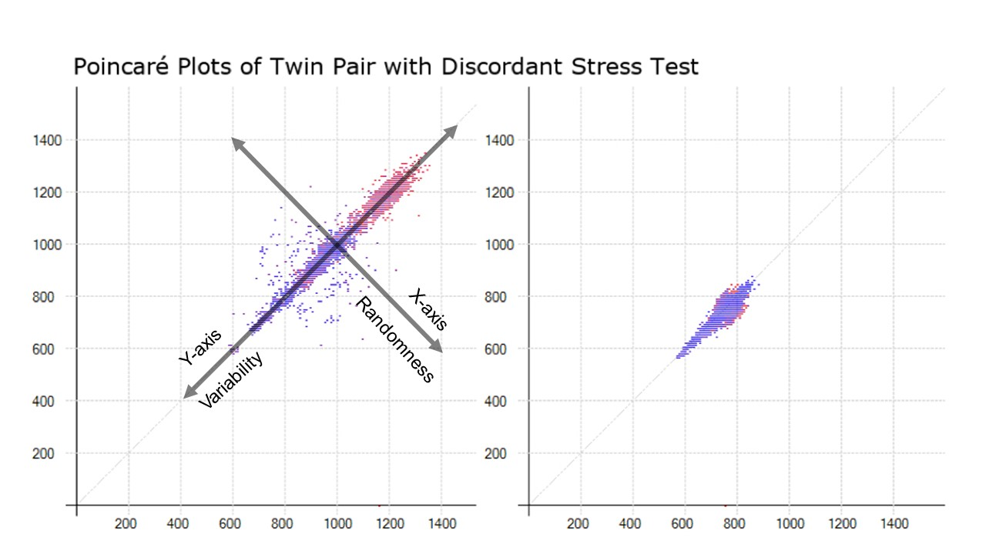

Figure 1. The two Poincaré plots represent ECG data at 7 AM for a twin pair that are discordant for stress test results. Both axes are RR interval lengths in milliseconds. The x-axis coordinate represents the RR interval for an initial beat, while the y-axis coordinate represents the RR interval for the following beat, such that the (x, y) coordinate represents (RRn, RRn+1). Each subsequent coordinate is plotted in this way. The red points are beats that were slower than the previous beat, while the blue points were faster than the previous beat. The shape of the resulting plot is abstracted into a single descriptive index called *Dyx*. The first twin (left) had no myocardial perfusion deficits on stress testing with a *Dyx* = 3.7. The second twin (right) had an abnormal stress test with a *Dyx* = 1.7.

RR interval (ms)

RR interval (ms)

RR interval (ms)

RR interval (ms)

## Preliminary Data Supporting HRV as a Marker of CAD and Depression

We recently found that in a cohort of 276 twins without known CAD, low *Dyx* in the morning hours associated with a 12-fold increase in the odds of abnormal MPI (95% CI, 1.2 – 111.4) and a 13% decreased coronary flow reserve (**Table D1**).45 This relationship was not explained by traditional risk factors. We have also investigated HRV with stress metrics. Preliminary analysis from our twins cohort found *Dyx* associated with depressive symptoms. In a separate analysis in the Atherosclerotic Risk In Communities (ARIC) study, we found somatic depressive symptoms (specifically vital fatigue) were associated with persistent and robust decreases in related HRV metrics, supporting the biological derangements that occur in depression.

Table D1. Regression models for both regional and global CFR with *Dyx*. Adjusted models accounted for twin pairs, and multivariate models also included traditional covariates. The regional territories are defined as LAD = left anterior descending artery, LCX = left circumflex artery, RCA = right coronary artery.



Over the course of this year, we have developed the methodologies to collect additional data as part of the Emory Biobank Study (PI Quyyumi). Through these efforts, we have studied the relationship between HRV, depression, and CAD in 30 participants. The mean age was 63 ± 13, 3 were women, and 5 were black; 25% (n=7) had moderate to severe depressive symptoms (PHQ-9 ≥ 10), and 75% (n=21) had moderate or less depressive symptoms (PHQ-9 < 10). Coronary angiography revealed that 73% (n=22) had stenosis of the coronary arteries with at least one vessel > 70% stenosed, while 27% (n=8) had mild to no angiographic disease. Ambulatory ECG was collected on all patients via VivaLNK patch for 4 to 25 hours, and 74% were of sufficient quality to analyze.

In addition to *Dyx*, which is provided to us by the company HeartTrends in a blinded manner, we are also able to generate other HRV measures that assess both variability and/or randomness of the heart rate. The key additional measures are high/low frequency HRV, multiscale entropy, and deceleration capacity.46 They are relevant particularly because they predict adverse outcomes and also associate with stress-factors. Nonetheless, our preliminary analysis shows that Dyx has a stronger relationship with myocardial ischemia than these other measures.

HRV was compared by the first hour of ECG after recording began, which occurred before anesthesia, sedation, or cardiac catherization occurred. When comparing HRV recordings in patients with and without depression (PHQ-9), there was a significant difference in population means (mean (SD)) by two-sample t-test (p < 0.05) with Dyx (2.16 (0.15) vs. 1.84 (0.17)), high frequency (6.03 (1.44) vs 4.44 (1.11)), and deceleration capacity (-10.74 (8.45) vs. -4.17 (2.11)). When comparing long-term HRV recordings in patients with >70% stenosis of any major coronary artery (CASS-70 ≥ 1), the mean in obstructive CAD versus non-obstructive CAD was significantly different with sample entropy (1.49 (0.17) vs. 1.20 (0.16)) and with Dyx (2.59 (1.19) vs. 1.69 (0.63)). Although additional data analysis is needed in a large sample size, it supports the proof of concept that depression and CAD are both associated with low HRV. The proposed research plan will allow us to improve the power of our study to analyze hourly effects, measure *Dyx*, and adjust for multiple covariates (such as clinical indications for catherization).

## Sex and Age are Potentially Important Effect Modifiers of the Brain-Heart Relationship

The potential mechanisms behind HRV, depression, and CAD are complex and may be dependent on age, sex, and genetics. HRV for example has a strong association with both age and sex.33 The prognostic power of HRV Is also different for cardiac and noncardiac mortality in women versus men. Dr. Vaccarino and Dr. Shah have shown that depressive symptoms are associated with CAD, with the finding being most prevalent in younger women (age < 55 years) as compared to older women or men.23 Depression also leads to an increased propensity to develop myocardial ischemia due to mental stress,37 which in turn is more likely to develop in young women but not men.28 In addition, we have previously presented data showing a greater stress-related HRV response in young post-MI women vs. post-MI men.47

## D2. INNOVATION

Innovation of new translational diagnostic modalities is central to this proposal. Specifically, we seek to evaluate a new paradigm of measuring the heart-brain connection with a low-cost ECG-based measure, *Dyx,* that is likely central to both depression and ischemic heart disease. This may help evaluate depressive symptoms objectively and in a way that focuses on its cardiovascular impact. If found to be valid and accurate as a marker of increased risk, it may facilitate tracking of the neurocardiac axis while patients undergo various interventions such as stress management, exercise therapy, and biofeedback.48 Although many studies of HRV, depression, and CAD have been performed before, our preliminary data suggests *Dyx* may be incrementally more associated with each. We are also using a new disruptive technology for our future data collection efforts, the VivaLNK patch (**Figure D2**), which has a much lower patient burden than traditional Holter monitoring (smaller than a credit card). This enables us to measure HRV in a busy clinical setting and for the first time, prospectively evaluate *Dyx*20 and its relationship with coronary angiography findings. Depending on the negative predictive value of high Dyx, it may have the potential to reduce unnecessary catheterizations. In future studies (that I may include in a future K23 application) we may also evaluate the relationship of *Dyx* with secondary clinical outcomes. Additional evaluation of *Dyx* with depression in high-risk individuals will be the first study of their kind. It will lead to better a mechanistic understanding of the neurocardiac axis, and future work may help to evaluate how interventions can target autonomic dysfunction. Overall, our rigorous, holistic evaluation of HRV will help provide critical assessment of its value in measuring autonomic dysfunction in the evaluation of depression and CAD.

Figure D2. The VivaLNK ECG patch is a small, wireless device, roughly 2” by 0.5” that will be placed in the mid-axillary line at the level of the heart. It has been approved for use for heart rate monitoring and recording of raw ECG signal.

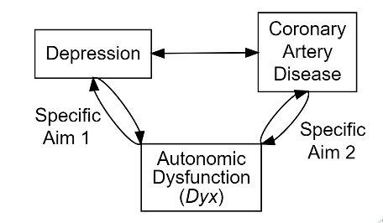

Figure D3. This theoretical model emphasizes the relationship between depression and CAD, including the relationship to autonomic dysfunction

## D3. APPROACH

### Study Overview

This training grant proposes an ancillary study on an ongoing prospective registry of patients undergoing cardiac catherization, the Emory Cardiovascular Biobank (Biobank, PI Quyyumi) which was established to identify novel biomarkers and mechanisms associated with the pathobiological process underlying cardiovascular disease.22 This includes cases of acute myocardial infarction and angina, among others.49 The Biobank is enriched for individuals with high suspicion for obstructive CAD, of which approximately 75% are found to have at least one vessel with >70% stenosis. The registry has over 7,000 unique patients from three Atlanta-based sites in the Emory University Hospital system. Enrollment is ongoing with 10-20 participants per week, and Dr. Quyyumi has long-term resources in place to support the project. IRB approval for an amendment to study ECG data is in place. **Figure D3** shows an overview of the scientific basis of the proposed aims. The ECG patch has been purchased/provided by Dr. Shah, and I have trained the current staff to apply it and collect data from participants that meet eligibility criteria. The F32 will support continued data collection and analysis for an additional 2 years.

### Study Population

The Biobank not only studies major cardiovascular events, but also evaluates additional biomarkers for inflammation, cardiac injury, and genetics, with the goal of predicting CVD outcomes.22 All patients aged 18 years and older undergoing cardiac catherization are recruited to participate by a full-time study coordinator prior to the start of the procedure. After informed consent, they are interviewed for health behaviors and neuropsychological functioning the same day, prior to cardiac catherization. They are excluded if they have congenital heart disease, severe valvular heart disease, severe anemia, a recent blood transfusion, myocarditis, history of active inflammatory disease, cancer or are unable or not willing to provide consent (approximately 5%). We will exclude patients that are found to have atrial fibrillation or have >20% ectopic beat burden or noise, as well as those that are pacer dependent. We will exclude patients with known CAD, and oversample for patients with angina in which CAD status is not known.

### Study Design

General Protocol: The enrollment, consent, and detailed phenotyping of the patients has been described in prior studies of the Biobank.22 Additional measures, including lifestyle factors, medical comorbidities, revascularization during the index cardiac catheterization, and previous revascularization procedures are ascertained via patient interview and chart review. The study will enroll participants daily from October 2019 until December 2020. The Biobank enrolls on average 10-20 patients per week, and we estimate from our pilot study that up to half will meet inclusion criteria for the sub-study and agree to ECG analysis.

Heart Rate Variability: As described above, we will collect ambulatory ECG with the VivaLNK patch. I will continue to supervise and assist the study staff with data collection efforts. The consent will occur in the evening before, or morning of the catherization. The patch will be applied to the left mid-axillary line immediately after informed consent and will continue collecting data for up to 24 hours. We will use a commercial from HeartTrends (Lev-El Diagnostics Ltd., Israel) to generate the *Dyx* measure. We will also use an open source, internally developed HRV toolbox to provide frequency and time domain HRV metrics.25 A materials transfer agreement with the company is already in place with HeartTrends for unrestricted evaluation of ECG data. We are using HRV from the first hour of monitoring within the 7 AM to 10 AM time block as our primary time of measurement.

Psychological Measures: The enrollment protocol includes patient interviews by study staff. Depressive symptoms will be assessed via the 9-question Primary Care Evaluation of Mental Disorders Brief Patient Health Questionnaire (PHQ-9).50 Moderate-severe depression is considered when the PHQ-9 score is 10 points or higher (out of 27). This cutpoint has a sensitivity and specificity of 88% for major depression.24

Cardiac Measures: The primary cardiac outcome is obstructive CAD, measured by >70% stenosis or hemodynamic significance by fractional flow reserve. Coronary angiography will also be evaluated by the Gensini score, which is a visual estimation of luminal narrowing in multiple segments based on a modified form of the American Heart Association classification of the coronary tree by trained cardiologists.29 Coronary angiography will also be evaluated using the Coronary Artery Surgery Study (CASS), which evaluates the number of major epicardial vessels that have a certain percent stenosis, e.g. the CASS-50 score determines the number of vessels with > 50% stenosis. During catherization additional values of end-diastolic pressure and ejection fraction are collected as important covariates and potential confounders that may influence HRV.

**Specific Aim #1: Quantify the relationship between depressive symptoms and ANS dysfunction.**

Rationale: Depression is not only common is patients with CAD, but is also prognostic after myocardial infarction, independent of traditional risk factors.51–54 Our preliminary analyses from the Emory Twin Study found *Dyx* to be a significant determinant of depressive symptoms (r= 0.14, p<0.001 in 276 individuals). We seek to reproduce this analysis in a group that is high risk for CAD, in whom depressive symptoms may arise from neurocardiac dysfunction and detected by low *Dyx*.

Data Collection and Analysis: Consecutive participants undergoing evaluation for ischemic heart disease are approached for participation in the biobank from Emory University Hospital (for this analysis). After informed consent, we will apply the VivaLNK patch, which will transmit raw ECG signal to a study smartphone via Bluetooth at 128 Hz. The data are uploaded Emory Box, which is approved for sensitive information. We have prepared additional programs that allow for extraction of the raw ECG signal. Data will be pre-processed for noise and arrhythmia detection and only analyzed for HRV when 80% of the signal is identified as sufficient quality and without arrhythmia. De-identified raw data will also be transmitted to HeartTrends for blinded analysis of *Dyx* in hourly intervals.18,44 The primary outcome will be depressive symptoms (PHQ-9). The primary exposure will be autonomic function, measured by *Dyx* and other HRV indices. We will measure HRV indices in the morning before catherization. The effect of time-of-day on the relationship between HRV and depression has not been studied, thus we will limit analysis to morning hours (6 AM to 7 PM). We will create individual regressions models for the continuous *Dyx* measure, and logistic regressions for *Dyx* using the clinical cutoff of <2 units.55 Secondary outcomes will include adjustment for age and sex to study the potential interaction effect that may be present.

Power calculations: In this exploratory study, the expected cohort size is 200 participants collected over 10-12 months. We anticipate a maximum of 20% data loss due to poor ECG quality (>20% artifact) or missing psychological data. We do not expect attrition as this is a cross-sectional study. After these reductions we expect a sample size of 160 participants. We expect 25% of participants to have major depression, as our pilot study suggests. With α = 0.05, and 1 – β = 0.80, for n = 160 we would be adequately powered to detect an effect size of Cohen’s d = 0.59 (for n = 120, d = 0.59; for n = 200, d = 0.45).56 With α = 0.05 and 1 – β = 0.90, for n = 160 we would be adequately powered to detect an effect size of Cohen’s d = 0.59 (for n = 120, d = 0.68; for n = 200, d = 0.51).

Potential Problems and Solutions: Unmeasured confounders will exist, and we will attempt to identify and measure them through clinical chart review, patient questionnaires, and through careful study design and patient selection. For example, the PHQ-9 is not validated in the setting of acute stress, which certain patients may present for in the setting of acute coronary syndromes. We will attempt to assess participants that are clinically stable by excluding those admitted to the intensive care unit. Treatment of depression may lead to favorable changes in HRV. We will control for antidepressant use through additional subgroup analysis. We will perform additional cosinor analysis to explore if time of day is an important factor in this measurement. The generalizability of this data is difficult, as depression leads to changes in health behaviors. There are additional socioeconomic and health literacy data that may help control for health behavior changes. Data collection may also be limited, as depression has a lower prevalence as compared to CAD. If needed, we will open up recruitment at the other Emory University affiliated hospital sites, including Emory University Hospital Midtown and the Veterans Affairs Medical Center. To ensure data safety and prevent data loss, we have implemented a protocol for storage through a cloud-based, HIPAA-compliant syncing service (Box), which archives data immediately and prevents data loss. ECG data when retrieved is immediately uploaded to this service.

Anticipated Results: We expect to find an independent association between increased depressive symptoms and autonomic dysfunction, measured by low *Dyx* (primary outcome), as well as time/frequency domain HRV metrics (secondary outcome). We expect that this finding of depression and low HRV will be most strongly associated in women and in younger participants (age < 65 years).

Training Integration: For both aims of this proposal, ECG analysis plays an important role. Under the guidance of Dr. Shah, I will continue to learn proficiency with the HRV toolbox to generate hourly frequency and geometric domain indices of HRV for additional assessments.25 This will increase my experience with signal processing and the MATLAB software. In addition, the training through additional biostatistical and epidemiology courses will provide me the necessary tools to conduct these analyses, with support from Dr. Vaccarino and Dr. Shah in evaluation and interpretation of the data. Familiarizing myself with the mathematical principles and technical skills underlying signal processing and time-series analysis will be critical for my training, allowing me to translate our findings into clinically meaningful assessments.

**Specific Aim #2: Examine the relationship of obstructive CAD with ANS dysfunction and its potential dose-response relationship.**

Figure 4. The non-linear HRV metric, *Dyx*, was found to be significantly lower in the early morning hours in patients with abnormal myocardial perfusion deficits.

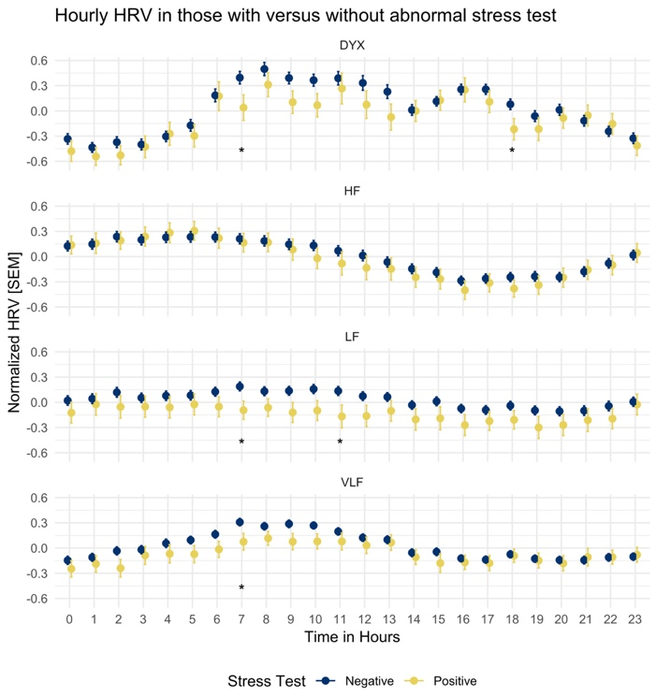

Rationale: Abnormal HRV indicates autonomic dysfunction and increases the risk of cardiovascular mortality. *Dyx* has been shown to predict myocardial perfusion defects during pharmacological stress test. Our previous work suggests this finding is most robust during morning hours, as in **Figure 4**.45 We are looking to evaluate *Dyx* during morning hours and the relationship with obstructive CAD and overall plaque burden. We look to provide further validation that plaque burden lowers HRV in a dose-response manner. Our prior work was conducted in middle-aged, male veterans and can be expanded by including women.

Data Collection and Analysis: I will compare the exposure of HRV to the primary outcome of obstructive CAD > 70%, as well as the secondary outcomes of coronary artery plaque burden measured by the Gensini and CASS scores, from cardiac catherization using regression models. Regression models will be fit using a clinical cutoff point of *Dyx* (< 2.0 units)against obstructive CAD (stenosis > 70%).55 Additional models will be fit using continuous HRV measures and continuous coronary artery plaque burden. Analysis will also be performed to test the interaction of age and sex on HRV and CAD. Adjusted models will evaluate the performance of HRV against traditional risk factors.

Power calculations: As above, we expect an initial cohort size of 200 patients, with 160 patients with non-missing data. We expect that 75% of patients will have obstructive CAD, similar to the rate seen in our pilot study. With α = 0.05, and 1 – β = 0.80, for n = 160 we would be adequately powered to detect an effect size of Cohen’s d = 0.59 (for n = 120, d = 0.59; for n = 200, d = 0.45).56 With α = 0.05 and 1 – β = 0.90, for n = 160 we would be adequately powered to detect an effect size of Cohen’s d = 0.59 (for n = 120, d = 0.68; for n = 200, d = 0.51).

Potential Problems and Solutions: This patient population is likely to have a high proportion of patients on beta-blockers, which has a known effect on heart rate and spectral HRV.57 For patients on beta-blocker therapy we will adjust for confounding effects in multivariable models, and perform an additional subgroup analysis to evaluate for effect modification. Continuous ECG data are susceptible to artifact, which may lead to erroneous data. Such data can be edited to remove noise and ectopy and interpolated to fill gaps. Existing software techniques allow for the easy cleaning of raw RR interval data. As our prior work suggests a circadian variability to autonomic dysfunction, continuous time-series analysis is an important component of analysis but can lead to issues of repeat measures and adjustments for circadian rhythm. We have developed experience with cosinor analysis to overcome this challenge.58,59 We will build a mixed model with a fixed effect for time of day (e.g. hourly) to determine the interaction with HRV.

Anticipated Results: We expect to find an independent association with autonomic dysfunction, measured by low Dyx, with progressive coronary artery plaque burden. We expect that the relationship of low Dyx and CAD will be stronger in women and in younger participants (age < 65 years).

Training Integration: The importance of missing data and confounding factors such as time-of-day will be important for future analysis. In addition, the effects of revascularization will require repeated measure analysis. I will perform the statistical analyses independently to help apply the biostatistical skills already gained from the MSCR and expand upon them by formal coursework in advanced biostatistics (e.g. cosinor analysis, fixed effect models, repeat measure analysis). This is particularly crucial to future training as time-series analyses require familiarity with repeat measure analysis and imputation. Dr. Shah will help supervise me in these analyses, along with support from the Biostatistics, Epidemiology, & Research Design program that provides services to Emory clinical investigators. Dr. Vaccarino will help in the interpretation of this work due to her expertise and prior work in coronary vasoreactivity.60

## D4. Future Directions

The long-term goal for this research direction is to identify ANS dysfunction as a potential mediator for the excess cardiovascular mortality in depression and discover interventions that can ameliorate ANS dysfunction. The data initially collected from this proposal are important for future analyses. As the Biobank maintains follow-up data on patients, future studies can include cardiovascular outcomes or events as part of a longitudinal analysis. Future return visits may also occur, to allow repeat measure analysis. With outcome data, we can also assess the mediation effect of ANS dysfunction on the relationship between depression and CAD. As Within this data set, we may also achieve enough power to assess the effect of the circadian rhythm when measuring HRV.61–63 This type of analysis in relation to either depression or CAD would be the first of its kind, as most previous studies do not evaluate time-of-day at all (e.g. average all of the HRV metrics over and entire 24 hour period instead).20,21 As seen in our prior work, we expect this finding to be most prominent during the morning hours. Another potentially powerful direction of this data will be the assessment of ECG morphology changes (e.g. QRS complexes or T-wave area), as the raw ECG signal is available and the tools are currently being built to analyze these data continuously.