# BRIEF OUTLINE

1. Title - A History of Sudden Cardiac Death
2. Important concepts - role of ANS and dysrhythmias, measurement of tone
3. Objectives - mechanism behind SCD triggers, ANS instability may be a risk factor for SCD
4. Outline - current model of SCD, relevant anatomy and physiology, ventricular substrate, triggers
5. History of SCD – MacWilliams to Lown
6. Advent of the CCU (Lown)
7. Susceptibility to VF – Lown/Rabinowitz hypotheses on neural activity changing VF threshold
8. Anatomy of the neurocardiac axis – Armour, Natelson
9. Sympathetic tone leads to increase risk of VF
10. Vagal tone can be protective
11. Heart rate variability as an integrated measurement of ANS on the sinoatrial node
12. Measurement of HRV – frequency domain as an insight into sympathovagal balance, Akselrod paper
13. Sympathovagal interaction – example using Schwartz accentuated antagonism
14. Review HRV/ANS topics thus far
15. Ventricular substrate – innervation of the heart, ventricular mass, effect of ischemia (Zipes)
16. Triggers – epidemiology studies (Leor, Rahe, Greene, Muller)
17. Autonomic risk – ATRAMI, Dyx papers, canine model of VF susceptibility (Billman)
18. Summary

# DETAILED NOTES ON THE HISTORY OF SUDDEN CARDIAC DEATH

## Introduction

1. Title
   1. A History of Sudden Cardiac Death
   2. “Why did he die on Monday instead of Tuesday?” ~ Zipes
2. Important concepts
   1. Role of the autonomic nervous system in the development of dysrhythmias
   2. Measurement of autonomic tone, e.g. sympathovagal balance
   3. Objectives
      1. Mechanisms behind “triggers” that cause SCD
      2. Autonomic instability may independently be a risk factor for SCD
3. Outline
   1. Current model of sudden death
   2. Relevant anatomy and physiology of the ANS
   3. Ventricular substrate
   4. Modifiers and triggers that lead to sudden death

# History

1. VF first proposed as mechanism of sudden cardiac death
   1. 1889 first time that ventricular fibrillation proposed as mechanism for SCD (de Silva, 1989)
      1. prior to advent of ECG
      2. historically called *fatal syncope*, although still cardiac syncope still has significant independent mortality (Koene, Adkisson, & Benditt, 2017)
   2. occurred historically under Carl Ludwig in Leipzig, the home of the Ludwig Institute of physiology (training site of Fick, Pavlov, Kronecker)
      1. inventor of kymograph, the first method to record blood pressure
      2. applied electricity to the hearts of mammals inducing *cardiac tetany*
   3. previous names of ventricular fibrillation - delirium cordis, circus contraction, intervermiform movement
   4. First successful defibrillation of the human heart was in 1947 (Meyer, 1988)
   5. Ventricular tachycardia, as a pre-fibrillatory rhythm, requires low-energy for cardioversion, thus, can be reverted by the precordial thump.(Pennington, Taylor, & Lown, 1970)
      1. 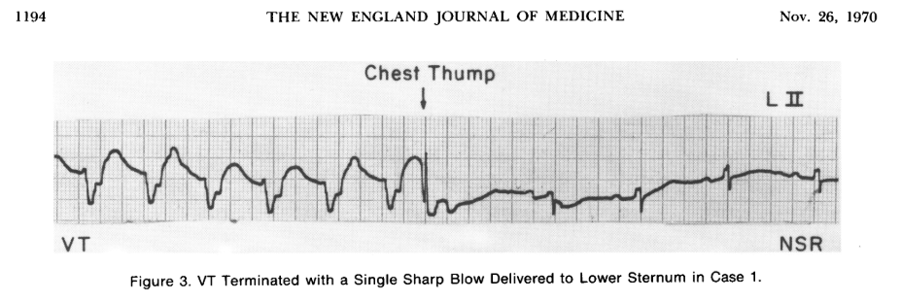

## Model of sudden cardiac death

1. Coronary care unit (Lown & Selzer, 1968)
   1. Bernie Lown proposed that a specialized unit will reduce mortality after myocardial ischemia
      1. 70-90% of post-MI have ventricular extrasystole
      2. Built on the premise of 1) quiet/restful rooms, 2) continuous cardiac monitoring, 3) cardiac nurses, 4) oriented around prophylaxis of arrhythmias
      3. Reduction in rate of mortality from >30% to <20%
2. Concept of susceptibility to ventricular fibrillation
   1. Sudden death is an electrical accident that is based on 4 premises (Lown, Verrier, & Rabinowitz, 1977)
      1. Mechanism of sudden death is ventricular fibrillation
      2. Electrical instability of the myocardium may long precede onset of catastrophic arrhythmia
      3. Ventricular premature beats may reflect electrical instability, which in turn may predispose the unstable heart to develop repetitive ventricular activity and subsequent fibrillation
      4. Transient risk factors induce electrical instability and increase cardiac susceptibility to ventricular fibrillation (thought from nervous activity)
   2. The autonomic nervous system, for example, affects/modulates risk for ventricular activity. (Lown et al., 1977) Vagal nerve activity is protective and increased threshold against developing VF.(Kolman, Verrier, & Lown, 1975)
      1. 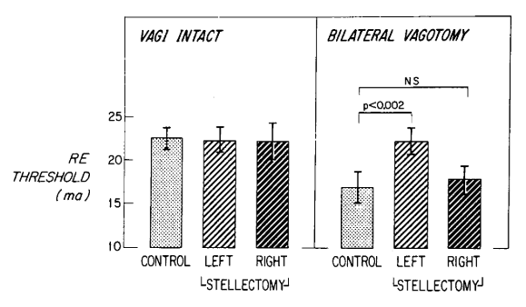
3. Substrate model (draw out model)
   1. Ventricular substrate is modified by factors such as ischemia
   2. Triggers, such as autonomic stimuli, then precipitate VT/VF

## Autonomic nervous system

1. Anatomy and neurocardiac axis
   1. Neurocardiac axis as described by Armour.(Armour, 2010) The anatomy is complex, but simplifies down to local ganglion plexus in cardiac fat pads (see echo).
      1. 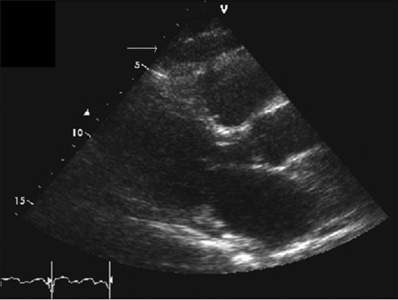
      2. 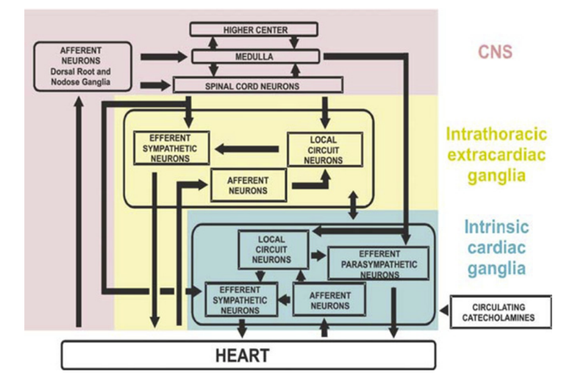
   2. Complex model suggesting directionality of afferent and efferent sympathetic markers.(Davis & Natelson, 1993)
      1. 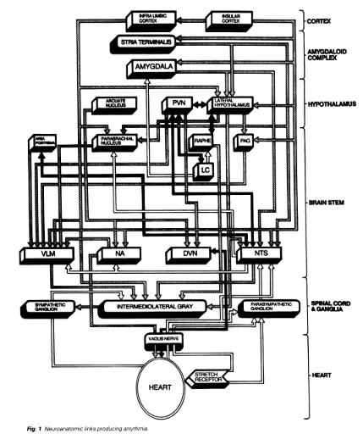
2. Sympathetic tone can lead to increased risk of VF.
   1. Stimulation of the stellate ganglion in canine models had increased chance of causing ventricular fibrillation particularly after coronary occlusion.(Harris, Otero, & Bocage, 1971)
   2. Stellate ganglion thought to be carrying efferent sympathetic fibers. After stellate ganglionectomy, the VF threshold increased to 11% from 31% (compared to control VF rate).(Kliks, Burgess, & Abildskov, 1975)
   3. Effect is complicated however, as unilateral stellectomy may have compensatory contralateral activation, and then are agonized by vagal activity.(Schwartz, Verrier, & Lown, 1977)
3. Vagal tone can be protective.
   1. Vagal influence was not thought to be salutary independently, it only provided protection to VF threshold with concurrent increased sympathetic tone.(Kolman et al., 1975)
   2. Vagal nerve asks through muscarinic, nicotinic, and adrenergic signals, such as methacholine could raise ventricular vulnerable threshold, which could reduced with atropine.(Rabinowitz, Verrier, & Lown, 1976)
   3. Vagal activity is controversial, as sympathetic-independent nitrergic parasympathetic postganglionic nerves can independently provide ventricular protection and decrease SA-AV conduction.(Brack, Coote, & Ng, 2011; Brack, Patel, Coote, & Ng, 2007; Ng, Brack, & Coote, 2001)
      1. 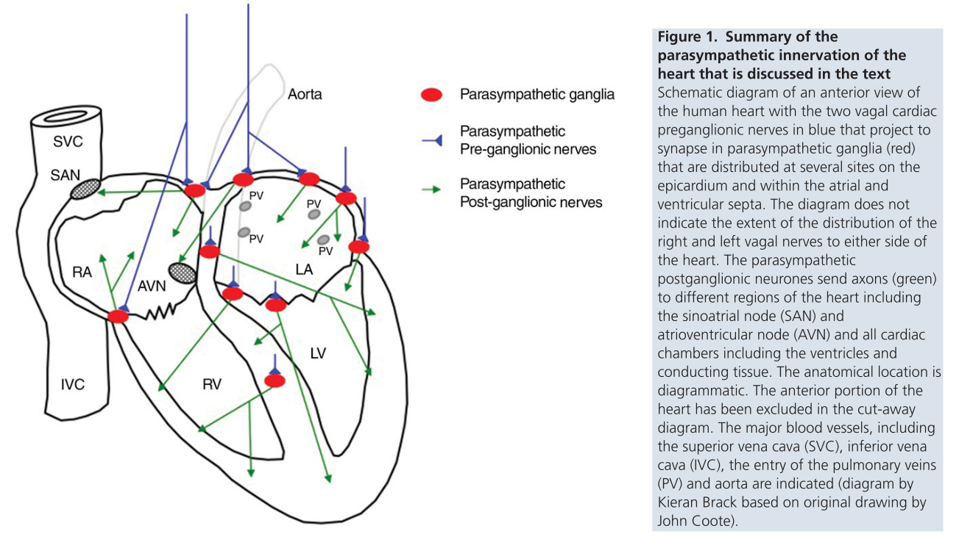
      2. Multiple types of cardiac vagal preganglionic neurons exist in the medulla in feline models, one affected by respiration and one that was not.(Daly & Kirkman, 1989)

# Heart rate variability

1. Purpose of HRV
   1. The multiple factors that influence the cardiovascular system include many levels of reflex arches and firing within the autonomic nervous system.
   2. A final integration of dynamic autonomic tone is on the sinoatrial node, measured by HRV. This is a summation point for multiple levels of control, from environmental, positional, contextual elements to volume status, respiration, etc.
      1. 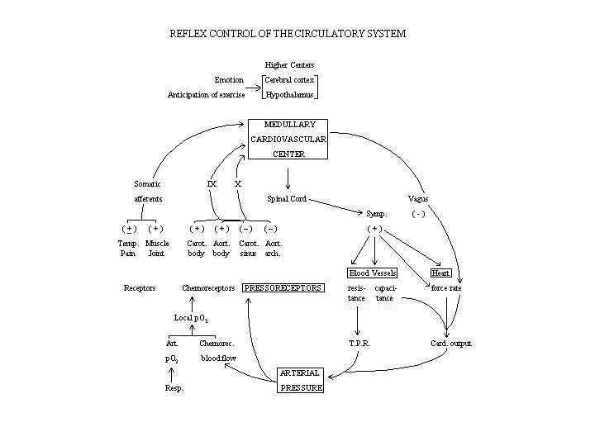
      2. 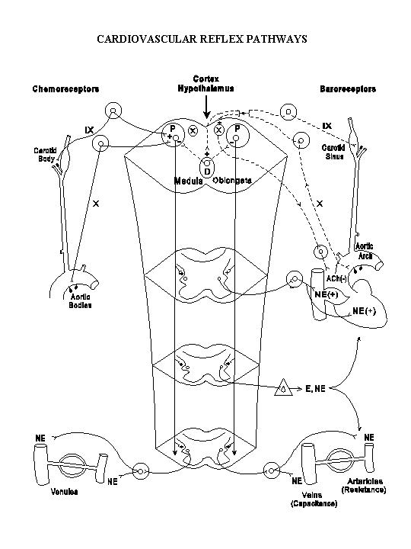
2. Measurement
   1. The measurement of HRV is mathematically complex and interesting. There are standard, geometric domains, but also non-linear and frequency. It is measured in RR or NN intervals (beat-to-beat), usually designated as sinus beats. Traditionally decreases in time measures, such as the SD of the NN interval, suggested worse prognosis.(Kleiger, Miller, Bigger, & Moss, 1987; Lombardi et al., 1987)
   2. Non-linear domain is novel, developed over last several years.(Tayel & AlSaba, 2015)
      1. Two Poincaré plots that represent one hour of ECG data at 7 AM between a twin pair discordant for myocardial stress perfusion abnormalities. Each point represents an RR interval (ms) on the x-axis plotted against the following RR interval (ms) on the y-axis over the course of the recording. The first twin (left) was negative for myocardial stress perfusion deficits (Dyx = 3.7), and the second twin (right) was positive for myocardial perfusion deficits (Dyx = 1.7).
      2. 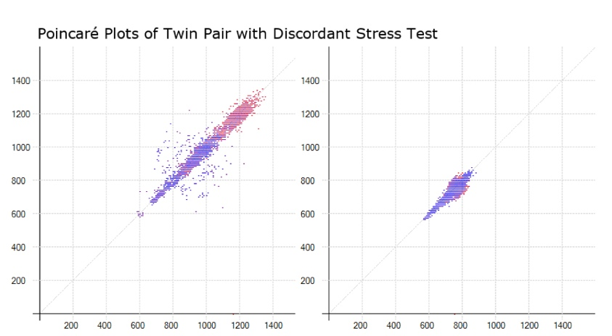
   3. Frequency domain measures are an attempt to study HRV in terms of physiological correlates, through power spectral analysis.(Akselrod et al., 1981) By using a Fourier transform, the series of RR intervals are decomposed and broken into bands, each corresponding to a physiological measure. HF occurs at ~0.4 Hz, which corresponds to respiratory rate.
      1. 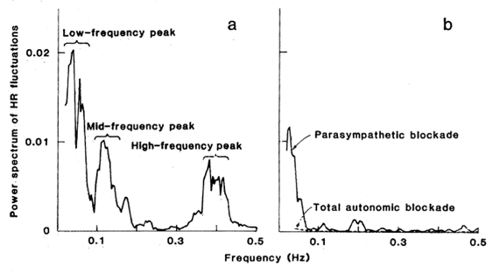
      2. 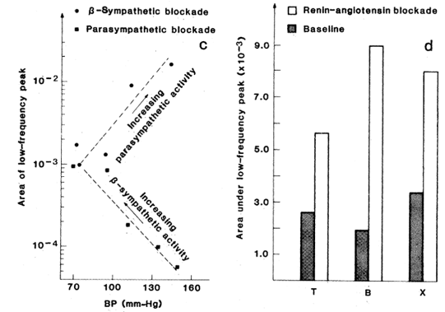
      3. Very low frequency (VLF) is between 0.0033 and < 0.04 Hz; low frequency (LF) is between 0.04 and < 0.15 Hz; and high frequency (HF) is between 0.15 and < 0.40 Hz. These frequency bands integrate heart rate in response to physiologic stimuli, including influences of the renin-angiotensin-aldosterone system (VLF), baroreceptor activity (LF), and respiration (HF).
3. Responsiveness of vagal and sympathetic tone
   1. Measure the different components is quite useful, particularly in teasing apart the effects. This study uses a conscious canine model to demonstrate an important, summative concept of *accentuated antagonism*.(Stramba-Badiale et al., 1991) Each dog has had a vagal nerve stimulator implanted in the cervical region, and subsequently had this activated during exercise versus at rest. 1) Immediately there is a change in heart rate with stimulation, suggesting that vagal activity is very rapid in its effect, almost instantaneous. 2) The effect was over-proportional to the amount of sympathetic tone (e.g. at higher heart rates, a larger bradycardic response occurred).
      1. 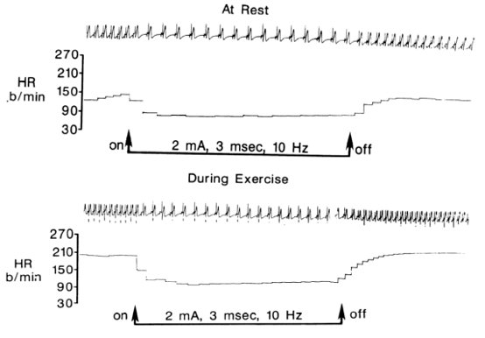
   2. The vagus and sympathetic system thus must communicate and interact, potentially at multiple levels.
4. Review of HRV and ANS
   1. HRV is final integration of ANS on the heart
   2. Vagal tone is sudden, sympathetic is slow
   3. Altered or low HRV tends to suggest poor prognosis, and may even be predictive.

## Ventricular substrate

1. Differential innervation of the heart
   1. The inferior wall of the left ventricle has a higher proportion of vagal afferent neurons, such that inferior ischemia, usually from the RCA system, leads to a cardioinhibitory pattern and subsequent sinus bradycardia.(Walker, Thames, Abboud, Mark, & Kloppenstein, 1978)
   2. In humans, imaging shows a consistent pattern of increased vagal innervation of the inferior wall, based on MIBG uptake in the myocardium.(Morozumi et al., 1997)
2. Ventricular size
   1. Historically, >4 cm of ventricle was needed to sustain VF.(de Silva, 1989) This is consistent with current research that shows a higher left ventricular volume/mass increases susceptibility to VF.(Aras, Faye, Cathey, & Efimov, 2018; Shenasa & Shenasa, 2017)
   2. LVIDD increases the risk of SCD independently of reduced EF.(Narayanan et al., 2014)
      1. 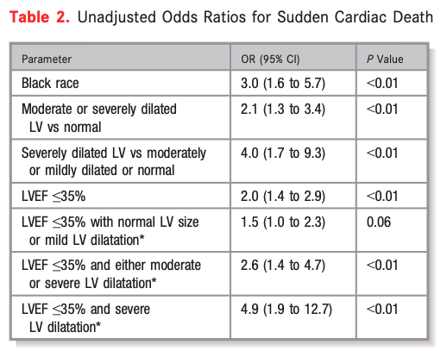
3. Ischemia
   1. The depth of ischemia is important. Transmural infraction leads to sympathetic denervation, unlike subendocardial ischemia, which may only damage vagal efferent nerves (as seen in figure).(Herre et al., 1988; Zipes, 1990)
      1. 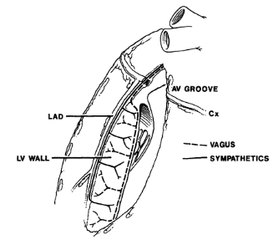
   2. Response to ischemia can be both denervation as well as hyperinnervation, which leads to tissue that has heterogenous sympathetic fibers, leading to arrhythmogenesis.(Huang, Boyle, & Vaseghi, 2017) The location of ischemia is also important, as measuring postganglionic activity shows differences in activity depending on whether it serves ischemic versus nonischemic territory.(Neely & Hageman, 1990)
4. Review substrate model
   1. Simplified model suggesting how ANS affects cardiac refractoriness and repolarization.(P Taggart, Critchley, & Lambiase, 2011)
      1. 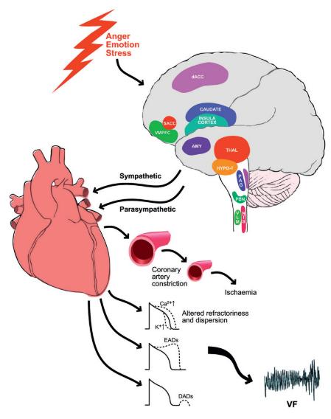

## Triggering sudden death

1. Precipitating events
   1. Anecdotes of events of threat, grief, arousal, mourning, personal danger, reunion precede sudden death.(Engel, 1971)
      1. After the Northridge earthquake in 1994, there was an increase in number of SCD, even after accounting for trauma or physical exertion.(Leor, Poole, & Kloner, 1996)
         1. 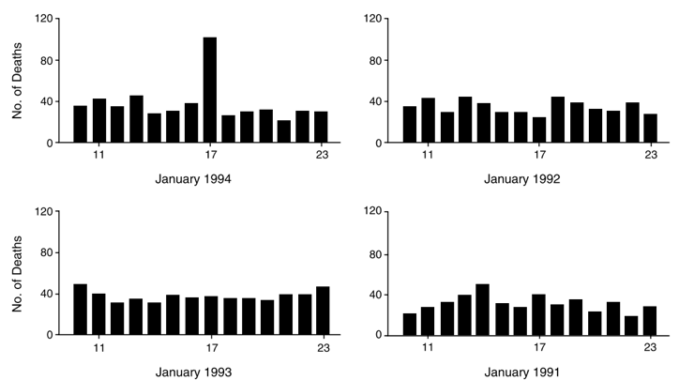
      2. In an industrial plant in Rochester, NY, there were 26 reported cases of sudden death. Interviews with family noted that these individuals had been depressed over the past several weeks, and the events happened in the setting of acute arousal, either through increased work, anxiety, or anger.(Greene, Goldstein, & Moss, 1972)
      3. Increasing stress has been shown to precede SCD,(Rahe, Bennett, Romo, Siltanen, & Arthur, 1973) and when measured in patients with ICD, VT and VF showed a similar pattern.(Lampert et al., 2002; Peter Taggart, Boyett, Logantha, & Lambiase, 2011)
   2. The events also follow a circadian rhythm. Peak events of MACE occur from 6 AM to 10 AM, followed by a secondary peak of events from 6 PM to 8 PM.(Boudreau, Dumont, Kin, Walker, & Boivin, 2011; Muller, 1999; Portaluppi et al., 2012)
   3. Increasing the frequency of VT and VF after induction of stressful situations.(Lown, Verrier, & Corbalan, 1973; Lown et al., 1977; Verrier, Calvert, & Lown, 1975)
      1. 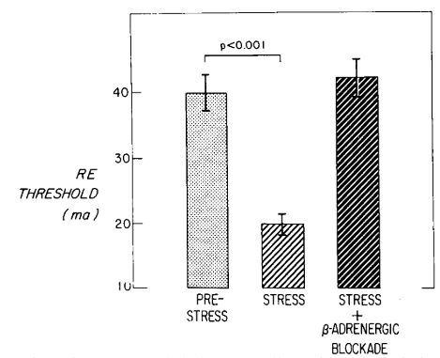
      2. 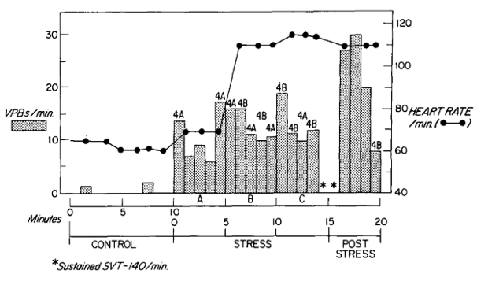
      3. 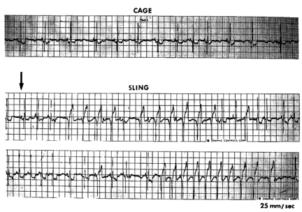
2. Autonomic risk
   1. In canine model, those at risk for VF after stress/coronary occlusion had decreased HRV during testing, suggesting an independent/additional risk factor.(Houle & Billman, 1999)
      1. 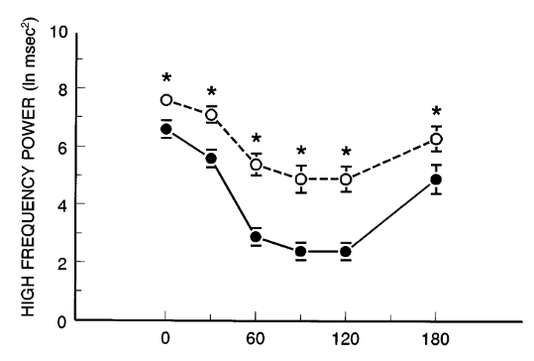
   2. Increased mortality with autonomic dysfunction seen in multiple studies.(Bauer, 2017; De Ferrari et al., 2007; Jørgensen et al., 2016; La Rovere, Bigger, Marcus, Mortara, & Schwartz, 1998)
      1. 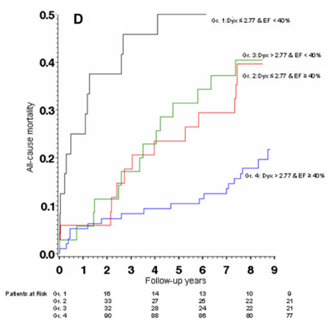
   3. Potential explanation of autonomic risk is microvascular ischemia, changes in resistance vessels, although its not certain if epicardial vessels could be obstructed either.
      1. 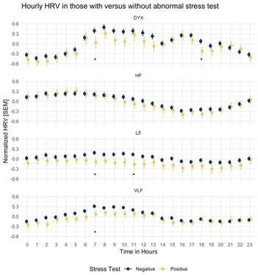

# References

Akselrod, S., Gordon, D., Ubel, F. A., Shannon, D. C., Barger, A. C., & Cohen, R. J. (1981). Power spectrum analysis of heart rate fluctuation: A quantitative probe of beat-to-beat cardiovascular control. *Science*, *213*(4504), 220–222. https://doi.org/10.1126/science.6166045

Aras, K. K., Faye, N. R., Cathey, B., & Efimov, I. R. (2018). Critical Volume of Human Myocardium Necessary to Maintain Ventricular Fibrillation. *Circulation. Arrhythmia and Electrophysiology*, *11*(11), e006692. https://doi.org/10.1161/CIRCEP.118.006692

Armour, J. A. (2010). Functional anatomy of intrathoracic neurons innervating the atria and ventricles. *Heart Rhythm*, *7*(7), 994–996. https://doi.org/10.1016/j.hrthm.2010.02.014

Bauer, A. (2017). Identifying high-risk post-infarction patients by autonomic testing — Below the tip of the iceberg. *International Journal of Cardiology*, *237*, 19–21. https://doi.org/10.1016/j.ijcard.2017.03.087

Boudreau, P., Dumont, G., Kin, N. M. K. N. Y., Walker, C.-D. D., & Boivin, D. B. (2011). Correlation of heart rate variability and circadian markers in humans. In *2011 Annual International Conference of the IEEE Engineering in Medicine and Biology Society* (pp. 681–682). IEEE. https://doi.org/10.1109/IEMBS.2011.6090153

Brack, K. E., Coote, J. H., & Ng, G. A. (2011). Vagus nerve stimulation protects against ventricular fibrillation independent of muscarinic receptor activation. *Cardiovascular Research*, *91*(3), 437–446. https://doi.org/10.1093/cvr/cvr105

Brack, K. E., Patel, V. H., Coote, J. H., & Ng, G. A. (2007). Nitric oxide mediates the vagal protective effect on ventricular fibrillation via effects on action potential duration restitution in the rabbit heart. *Journal of Physiology*, *583*(2), 695–704. https://doi.org/10.1113/jphysiol.2007.138461

Daly, M. B., & Kirkman, E. (1989). Differential modulation by pulmonary stretch afferents of some reflex cardioinhibitory responses in the cat. *The Journal of Physiology*, *417*, 323–341.

Davis, A. M., & Natelson, B. H. (1993). Brain-heart interactions. The neurocardiology of arrhythmia and sudden cardiac death. *Texas Heart Institute Journal*, *20*(3), 158–169.

De Ferrari, G. M., Sanzo, A., Bertoletti, A., Specchia, G., Vanoli, E., & Schwartz, P. J. (2007). Baroreflex Sensitivity Predicts Long-Term Cardiovascular Mortality After Myocardial Infarction Even in Patients With Preserved Left Ventricular Function. *Journal of the American College of Cardiology*, *50*(24), 2285–2290. https://doi.org/10.1016/j.jacc.2007.08.043

de Silva, R. A. (1989). John MacWilliam, evolutionary biology and sudden cardiac death. *Journal of the American College of Cardiology*, *14*(7), 1843–1849. https://doi.org/10.1016/0735-1097(89)90041-7

Engel, G. L. (1971). Sudden and rapid death during psychological stress. Folklore or folk wisdom? *Annals of Internal Medicine*, *74*(5), 771–782. https://doi.org/10.7326/0003-4819-74-5-771

Greene, W. A., Goldstein, S., & Moss, A. J. (1972). Psychosocial Aspects of Sudden Death: A Preliminary Report. *Archives of Internal Medicine*, *129*(5), 725–731. https://doi.org/10.1001/archinte.1972.00320050049005

Harris, A. S., Otero, H., & Bocage, A. J. (1971). The induction of arrhythmias by sympathetic activity before and after occlusion of a coronary artery in the canine heart. *Journal of Electrocardiology*, *4*(1), 34–43. https://doi.org/10.1016/S0022-0736(71)80048-1

Herre, J. M., Wetstein, L., Lin, Y. L., Mills, A. S., Dae, M., & Thames, M. D. (1988). Effect of transmural versus nontransmural myocardial infarction on inducibility of ventricular arrhythmias during sympathetic stimulation in dogs. *Journal of the American College of Cardiology*, *11*(2), 414–421. https://doi.org/10.1016/0735-1097(88)90110-6

Houle, M. S., & Billman, G. E. (1999). Low-frequency component of the heart rate variability spectrum: a poor marker of sympathetic activity. *American Journal of Physiology-Heart and Circulatory Physiology*, *276*(1), H215–H223. https://doi.org/10.1152/ajpheart.1999.276.1.H215

Huang, W. A., Boyle, N. G., & Vaseghi, M. (2017). Cardiac Innervation and the Autonomic Nervous System in Sudden Cardiac Death. *Cardiac Electrophysiology Clinics*. https://doi.org/10.1016/j.ccep.2017.08.002

Jørgensen, R. M., Abildstrøm, S. Z., Levitan, J., Kobo, R., Puzanov, N., Lewkowicz, M., … Group, N. I. C. D. pilot study. (2016). Heart Rate Variability Density Analysis (Dyx) and Prediction of Long-Term Mortality after Acute Myocardial Infarction. *Annals of Noninvasive Electrocardiology : The Official Journal of the International Society for Holter and Noninvasive Electrocardiology, Inc*, *21*(1), 60–68. https://doi.org/10.1111/anec.12297

Kleiger, R. E., Miller, J. P., Bigger, J. T., & Moss, A. J. (1987). Decreased heart rate variability and its association with increased mortality after acute myocardial infarction. *The American Journal of Cardiology*, *59*(4), 256–262. https://doi.org/10.1016/0002-9149(87)90795-8

Kliks, B. R., Burgess, M. J., & Abildskov, J. A. (1975). Influence of sympathetic tone on ventricular fibrillation threshold during experimental coronary occlusion. *The American Journal of Cardiology*, *36*(1), 45–49. https://doi.org/10.1016/0002-9149(75)90866-8

Koene, R. J., Adkisson, W. O., & Benditt, D. G. (2017, December). Syncope and the risk of sudden cardiac death: Evaluation, management, and prevention. *Journal of Arrhythmia*. https://doi.org/10.1016/j.joa.2017.07.005

Kolman, B. S., Verrier, R. L., & Lown, B. (1975). The effect of vagus nerve stimulation upon vulnerability of the canine ventricle. *Circulation*, *52*(4), 578–585. https://doi.org/10.1161/01.CIR.52.4.578

La Rovere, M. T., Bigger, J. T., Marcus, F. I., Mortara, A., & Schwartz, P. J. (1998). Baroreflex sensitivity and heart-rate variability in prediction of total cardiac mortality after myocardial infarction. *Lancet*, *351*(9101), 478–484. https://doi.org/10.1016/S0140-6736(97)11144-8

Lampert, R., Joska, T., Burg, M. M., Batsford, W. P., McPherson, C. A., & Jain, D. (2002). Emotional and physical precipitants of ventricular arrhythmia. *Circulation*, *106*(14), 1800–1805. https://doi.org/10.1161/01.CIR.0000031733.51374.C1

Leor, J., Poole, W. K., & Kloner, R. A. (1996). Sudden Cardiac Death Triggered by an Earthquake. *New England Journal of Medicine*, *334*(7), 413–419. https://doi.org/10.1056/NEJM199602153340701

Lombardi, F., Sandrone, G., Pernpruner, S., Sala, R., Garimoldi, M., Cerutti, S., … Malliani, A. (1987). Heart rate variability as an index of sympathovagal interaction after acute myocardial infarction. *The American Journal of Cardiology*, *60*(16), 1239–1245. https://doi.org/10.1016/0002-9149(87)90601-1

Lown, B., & Selzer, A. (1968). The coronary care unit. *The American Journal of Cardiology*, *22*(4), 597–602. https://doi.org/10.1016/0002-9149(68)90167-7

Lown, B., Verrier, R., & Corbalan, R. (1973). Psychologic stress and threshold for repetitive ventricular response. *Science*, *182*(4114), 834–836. https://doi.org/10.1126/science.182.4114.834

Lown, B., Verrier, R. L., & Rabinowitz, S. H. (1977). Neural and psychologic mechanisms and the problem of sudden cardiac death. *The American Journal of Cardiology*, *39*(6), 890–902. https://doi.org/10.1016/S0002-9149(77)80044-1

Meyer, J. A. (1988). Claude Beck and Cardiac Resuscitation. *Annals of Thoracic Surgery*, *45*(1), 103–105. https://doi.org/10.1016/S0003-4975(10)62412-5

Morozumi, T., Kusuoka, H., Fukuchi, K., Tani, A., Uehara, T., Matsuda, S., … Nishimura, T. (1997). Myocardial iodine-123-metaiodobenzylguanidine images and autonomic nerve activity in normal subjects. *Journal of Nuclear Medicine : Official Publication, Society of Nuclear Medicine*, *38*(1), 49–52.

Muller, J. E. (1999). Circadian variation in cardiovascular events. *American Journal of Hypertension*, *12*(2 Pt 2), 35S–42S. https://doi.org/10.1016/S0895-7061(98)00278-7

Narayanan, K., Reinier, K., Teodorescu, C., Uy-Evanado, A., Aleong, R., Chugh, H., … Chugh, S. S. (2014). Left ventricular diameter and risk stratification for sudden cardiac death. *Journal of the American Heart Association*, *3*(5). https://doi.org/10.1161/JAHA.114.001193

Neely, B. H., & Hageman, G. R. (1990). Differential cardiac sympathetic activity during acute myocardial ischemia. *The American Journal of Physiology*, *258*(5 Pt 2), H1534-41. https://doi.org/10.1152/ajpheart.1990.258.5.H1534

Ng, G. A., Brack, K. E., & Coote, J. H. (2001). Effects of direct sympathetic and vagus nerve stimulation on the physiology of the whole heart - A novel model of isolated Langendorff perfused rabbit heart with intact dual autonomic innervation. *Experimental Physiology*, *86*(3), 319–329. https://doi.org/10.1113/eph8602146

Pennington, J. E., Taylor, J., & Lown, B. (1970). Chest Thump for Reverting Ventricular Tachycardia. *New England Journal of Medicine*, *283*(22), 1192–1195. https://doi.org/10.1056/NEJM197011262832204

Portaluppi, F., Tiseo, R., Smolensky, M. H., Hermida, R. C., Ayala, D. E., & Fabbian, F. (2012). Circadian rhythms and cardiovascular health. *Sleep Medicine Reviews*. https://doi.org/10.1016/j.smrv.2011.04.003

Rabinowitz, S. H., Verrier, R. L., & Lown, B. Muscarinic effects of vagosympathetic trunk stimulation on the repetitive extrasystole (RE) threshold., 53 Circulation § (1976).

Rahe, R. H., Bennett, L., Romo, M., Siltanen, P., & Arthur, R. J. (1973). Subjects’ recent life changes and coronary heart disease in Finland. *American Journal of Psychiatry*, *130*(11), 1222–1226. https://doi.org/10.1176/ajp.130.11.1222

Schwartz, P. J., Verrier, R. L., & Lown, B. (1977). Effect of stellectomy and vagotomy on ventricular refractoriness in dogs. *Circulation Research*, *40*(6), 536–540. https://doi.org/10.1161/01.RES.40.6.536

Shenasa, M., & Shenasa, H. (2017). Hypertension, left ventricular hypertrophy, and sudden cardiac death. *International Journal of Cardiology*, *237*, 60–63. https://doi.org/10.1016/j.ijcard.2017.03.002

Stramba-Badiale, M., Vanoli, E., De Ferrari, G. M., Cerati, D., Foreman, R. D., & Schwartz, P. J. (1991). Sympathetic-parasympathetic interaction and accentuated antagonism in conscious dogs. *American Journal of Physiology-Heart and Circulatory Physiology*, *260*(2), H335–H340. https://doi.org/10.1152/ajpheart.1991.260.2.H335

Taggart, P., Boyett, M. R., Logantha, S. J. R. J., & Lambiase, P. D. (2011). Anger, emotion, and arrhythmias: From brain to heart. *Frontiers in Physiology*, *2 OCT*. https://doi.org/10.3389/fphys.2011.00067

Taggart, P., Critchley, H., & Lambiase, P. D. (2011). Heart-brain interactions in cardiac arrhythmia. *Heart*, *97*(9), 698–708. https://doi.org/10.1136/hrt.2010.209304

Tayel, M., & AlSaba, E. (2015). Poincaré Plot for Heart Rate Variability. *International Journal of Medical, Health, Biomedical, Bioengineering and Pharmaceutical Engineering*, *9*(9), 708–711.

Verrier, R. L., Calvert, A., & Lown, B. (1975). Effect of posterior hypothalamic stimulation on ventricular fibrillation threshold. *American Journal of Physiology*, *228*(3), 923–927.

Walker, J. L., Thames, M. D., Abboud, F. M., Mark, A. L., & Kloppenstein, H. S. (1978). Preferential distribution of inhibitory cardiac receptors in the left ventricle of the dog. *American Journal of Physiology*, *235*(2), H188–H192. https://doi.org/10.1152/ajpheart.1978.235.2.H188

Zipes, D. P. (1990). Influence of myocardial ischemia and infarction on autonomic innervation of heart. *Circulation*, *82*(4), 1095–1105. https://doi.org/10.1161/01.CIR.82.4.1095