**Disturbances of the Neurocardiac Axis: Using Heart Rate Variability to Measure Disease in the Brain and Heart**

**Principal Investigator:**

Anish Shah, MD

Resident

J. Willis Hurst Internal Medicine Residency

Department of Medicine

Phone: 469-835-7606

Email: [anish.shah@emory.edu](mailto:anish.shah@emory.edu)

**Lead Mentor:**

Amit Shah, MD, MSCR

Assistant Professor of Epidemiology

Assistant Professor of Medicine (Cardiology)

1518 Clifton Rd. NE, Rm 3053  
Atlanta, GA 30322  
Phone: 404-727-8712

Email: [ajshah3@emory.edu](mailto:ajshah3@emory.edu)

**Co-Lead Mentor:**

Alvaro Alonso, MD, PhD

Associate Professor

Department of Epidemiology

Rollins School of Public Health

Emory University

Phone: 404-727-8714

Email: [alvaro.alonso@emory.edu](mailto:alvaro.alonso@emory.edu)

**ABSTRACT**

Ischemic heart disease (IHD) is a highly prevalent and one of the leading causes of mortality, yet in the majority of affected individuals, their diagnosis is not detected by clinical exam. As such, the majority of sudden cardiac deaths occurs in those not previously diagnosed with IHD. This suggests the need for better IHD screening mechanisms, and a growing body of literature suggests autonomic dysfunction may be a novel risk factor. Ambulatory electrocardiography can be used to study autonomic dysfunction through heart rate variability. Recently, a novel marker of heart rate variability (*Dyx*) was found to be predictive of myocardial ischemia based on abnormal nuclear stress test. Our group also found that low *Dyx,* when measured in the early morning, was predictive of abnormal myocardial perfusion imaging as well. It is not known, however, how *Dyx* correlates with coronary angiography findings and the need for coronary intervention. Additionally, *Dyx* is influenced by central neuropsychological mechanisms, such as depression. Neurologic pathways may influence coronary microvascular function and lead to ischemia even in the absence of obstructive coronary artery disease. Assessment of depression and cognitive impairment and their relationship with *Dyx* may help to elucidate additional neurocardiac mechanisms on how autonomic function may lead to adverse outcomes, even in the absence of coronary artery disease. We will examine the relationship of neuropsychological metrics (mood, cognitive function) and ischemic heart disease with *Dyx* to better understand these effects in a high-risk cohort of patients with stable angina who are undergoing cardiac catherization. Aim 1 will evaluate the relationship of low *Dyx* with obstructive coronary artery disease, based on cardiac catherization. Aim 2 will determine the effect of neuropsychological pathology, as determined by depression and cognitive impairment, on autonomic dysfunction as measured by low *Dyx*. The goal of this study is to further evaluate the utility of *Dyx* as a measure of autonomic dysfunction that can help risk-stratify patients for obstructive coronary artery disease, and also determine the influence of brain-related factors on it as well. This research will improve our understanding of the clinical importance of disturbances of the neurocardiac axis through a quantified measurement of autonomic dysfunction as it relates to clinically actionable coronary artery disease. As such, it may help to yield very important, low-cost assessments of risk with widespread public health implications.

**A. SPECIFIC AIMS**

Four out of five patients with ischemic heart disease (IHD) are unrecognized by clinical exam.1 The majority of sudden cardiac death (SCD) still occurs in those without diagnosed IHD.2 Although the overall rate of cardiovascular mortality is declining, the rate of community events has not declined proportionally, suggesting the need for more public health interventions.3 A growing body of literature suggests that autonomic dysfunction is not only of prognostic value in cardiovascular mortality,4 but may serve as a novel risk factor for IHD. Recently, a new ECG-based biomarker of autonomic dysfunction based on heart rate variability (HRV), named *Dyx*, was found to be an important predictor of myocardial ischemia.5 *Dyx* is calculated from an hour-long recording of ambulatory ECG, and low values (< 2.0 units) are associated with an 8-fold increased odds of abnormal nuclear stress test findings (suggesting altered regulation of coronary blood flow and possibly IHD).5 While promising, the study was limited by a small sample size, it did not assess for relationship with angiographic findings; the outcome used, single photon emission tomography (SPECT), is only 80% sensitive and specific for obstructive coronary artery disease (CAD).6 In an analysis I independently conducted that was highlighted at the 2018 American Heart Association Scientific Sessions, we found that that low *Dyx* in the early morning was predictive of myocardial perfusion imaging (MPI) deficits in a cohort of 276 veteran twins without known CAD.7 We found for the first time that the time of day in which HRV is measured is a critical step in measuring heart disease risk. Nonetheless, we were unable to differentiate whether this relationship is due to obstructive CAD (requiring revascularization) and/or abnormal vascular reactivity (likely microvascular).8 This is important when considering the clinical implications of low *Dyx*.

Low *Dyx*, as with other HRV metrics, is influenced by central neurologic mechanisms, and in an unpublished analysis in our twins dataset, we found a robust association between depressive symptoms and reduced *Dyx*. This suggests neurologic pathways that may influence coronary microvascular function and lead to ischemia (even in absence of obstructive CAD).9 Neurovisceral integration theory describes a network of brain regions that influence cognitive function, mood, and autonomic regulation that help understand the anatomy of these connections.10 Neurovisceral dysfunction occurs in the setting of neuropsychological pathology, such as in depression and cognitive impairment, which have well-known effects on autonomic regulation,11,12 confer a worse prognosis in coronary artery disease (CAD),13,14 and increase the risk of SCD.15,16 Low *Dyx* values may be due to brain-related factors, rather than (or in addition to) obstructive CAD.10,17 By studying the relationship of brain-based metrics (mood, cognitive function) and CAD with *Dyx*, we can better evaluate these effects.

I hypothesize that disturbances of the neurocardiac axis, assessed by both heart and brain metrics, associate with autonomic dysfunction, which can be measured by *Dyx*. As such, Dyx is a useful metric in both efforts to risk stratify for CAD, as well as detect neurovisceral dysfunction. We propose to study *Dyx* by measuring HRV through ambulatory ECG patches (BioStamp®, MC10 Inc.) in subjects with chronic stable angina undergoing evaluation in the Emory Cardiovascular Biobank. The Biobank is a prospective cohort study of individuals undergoing clinically indicated cardiac catherizationin which conducts validated neuropsychological assessments are also made.18 The data we collect from this proposal will allow the assessment of autonomic and neuropsychiatric function prior to the heart catheterization. Our aims are:

1. **To evaluate the relationship of autonomic dysfunction, measured by abnormal HRV, to the spectrum of progressive CAD.** *Hypothesis:* *Low Dyx (<2.0 units) in the morning hours will be associated with an increased odds of finding obstructive CAD (stenosis > 70%). When evaluated as a continuous exposure, Dyx will be negatively associated with CAD plaque burden (Gensini score) in a dose-response relationship.*19
2. **To determine the effect of neurovisceral dysfunction, as determined by depressed mood and cognitive impairment, on autonomic dysfunction.***Hypothesis: Depressive symptoms (Patient Health Questionnaire-9, PHQ-9) ad cognitive impairment (Montreal Cognitive Assessment, MoCA) will be independently associated with lower Dyx.*

The mentored research and structured didactics of the MSCR will prepare me for my goal of becoming a physician-scientist. My future goals include the pursuit of a K grant focusing on translational studies in neurocardiology, risk stratification, and prevention. Under the guidance of my mentorship team (Amit Shah, MD, MSCR (co-lead); Alvaro Alonso, MD, PhD (co-lead); Marc Thames, MD; Viola Vaccarino, MD, PhD; Arshed Quyyumi, MD) I will gain invaluable training in study design, primary data collection, data analysis, manuscript preparation, and grant-writing. This will help prepare me for my long-term goals in a career as a clinical investigator in cardiovascular epidemiology and translational research.

# SIGNIFICANCE

## B1. The Burden of Ischemic Heart Disease: a Hidden Epidemic with Unrecognized Risk Factors

Ischemic heart disease (IHD) accounts for in 1 in every 7 deaths in the United States, with a prevalence of 3% or 7.9 million US adults.20 Over 700,000 new heart attacks occur annually, with annual costs of heart attacks ($12.1 billion). The estimated direct and indirect costs of IHD were $204 billion, and these medical costs are projected to double by the year 2030.20 However up to 20% of MIs are silent and up to 80% of IHD is unrecognized by standard ECG and clinical parameters.1 Although there has been a decline in cardiovascular mortality overall, the rate of out-of-hospital events has not decreased in proportion to the rate of in-hospital events.3 Mental stress plays a role in the complications of IHD, and is an under-recognized and important risk factor. More research on the brian-heart connection may help unlock some of the difficult roadblocks in reducing IHD in the community.21 New integrative and/or holistic strategies to approach IHD and prevent its associated complications may help lead to a downward frameshift in event rates.

## B2. Autonomic Nervous System Metrics Can Help Examine CVD Risk from Neuropsychiatric Factors

Heart rate variability (HRV) is an inexpensive biomarker derived from ambulatory electrocardiographic monitoring.22 It allows for continuous, non-invasive assessment of autonomic function, which is influenced by neuropsychological factors, such as mental stress, and heart disease.23,24 The neurovisceral integration theory provides the anatomical basis for this relationship. This theory links cognitive and affective networks to autonomic regulation by identifying the differential activation of important brain structures (prefrontal cortex, cingulate cortex, and insula).10,25 Psychological stress, including depression, leads to changes in autonomic function that are historically known to increase to the risk of ventricular ectopy, SCD, and cardiovascular disease.13,26–30 Cognitive impairment, particularly as it relates to executive function, also is related to abnormal HRV, and leads to an increased odds of IHD independent of other cardiovascular risk factors.31,32 These interesting findings suggest that neurovisceral dysfunction may contribute greatly to autonomic dysfunction as measured by HRV. Exploring this relationship may provide important insight into why those with dysautonomia have worse psychological, neurological, and cardiovascular outcomes.

## B3. Advances in Electrocardiography are Independently Prognostic of Cardiovascular Disease Risk

Advanced ECG analysis conveys information about autonomic function that is an independent marker for cardiovascular mortality.22,33,34 Traditional methods including exercise stress testing have limited sensitivity,6 but HRV analysis has led to novel risk markers for IHD that need further investigation.5,35 Information within traditional HRV indices was thought to be explained by heart rate itself,36 but newer indices capture additional information.37 A novel method for HRV analysis is througha non-linear method named *Dyx*, which uses the multipole method in Poincaré plots where RR intervals are plotted as a function of prior RR intervals (**Figure 1)**.38–40 *Dyx* measures overall variability in heart rate, but also indicates how erratic and non-linear the heart rate trends are as well. After MI, low *Dyx* has an independent hazard ratio of 2.4 (CI 1.5 to 3.8) for mortality in a recent study.41 Very few studies however have studied the prospective value of autonomic dysfunction in predicting obstructive CAD as measured by coronary angiography. A single, recent study examined *Dyx* with no known IHD and found that low *Dyx* predicted abnormal MPI with an improved sensitivity and specificity to exercise stress test.5 We demonstrated in a cohort of 276 individuals with no known IHD from the Emory Twin Study, low *Dyx* in morning hours had a 12-fold increase in the odds of abnormal MPI. 7 These findings validate the prior work on *Dyx* but also contextualize autonomic balance within the circadian rhythm.42,43 These important findings have helped to place measures of autonomic dysfunction in a potentially clinically useful role. Given the low costs and risks associated with this measure (requires only ambulatory ECG), there is a pressing need for more translational research in the area. Such technologies may ultimately reduce the need for invasive testing with coronary angiography as well as identify asymptomatic, high-risk individuals.

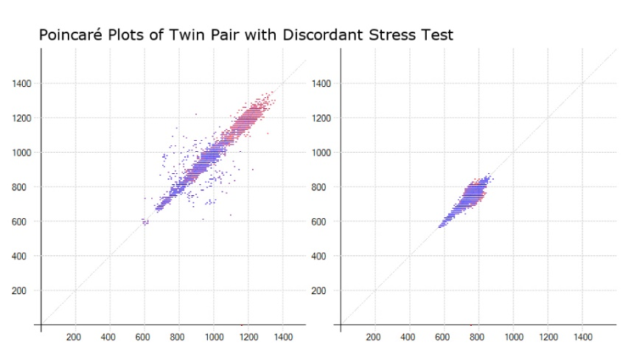

**Figure 1. Poincaré Plot for *Dyx***

## B4. Clinical Implications and Utility of Measuring Autonomic Dysfunction

Our research program will pursue clinical relevance for an HRV-based biomarker, and potentially help to fill an important gap that has prevented HRV from becoming a mainstream clinical test for cardiovascular disease diagnosis.22 This potential is gaining momentum. Based on recent research findings,5 HeartTrends was recently established as a company to offer *Dyx* as a clinical tool to risk-stratify individuals for CAD. Their work is only supported by small, industry-sponsored studies of non-invasive cardiac imaging however, and therefore not currently being utilized in most clinics. Our project will provide an independent evaluation of their metrix, *Dyx*, as a potentially measure of *obstructive CAD* as measured by *coronary angiography*. This additional test of its clinical relevance may help evaluate its clinical potential; if we find that it is predictive, this may have widespread clinical implications when deciding who to send for coronary angiography. *Dyx* is not solely a metric of obstructive CAD risk, however. It may also help measure the complex relationship between the heart and the brain, and explain stress-related microvascular disease dysfunction as well.9 This is important because studies showing low *Dyx* as predictive of abnormal myocardial perfusion imaging (MPI), including our own, are inherently limited: abnormal MPI findings cannot distinguish between the larger epicardial coronary arteries and smaller myocardial resistance vessels.7,35 *Dyx*, as a marker for neurovisceral dysfunction, may also shed light into the mechanism of increased non-cardiac risk. As such, it may have potential in predicting psychiatric outcomes such as future depression,44 as well as future cognitive decline.45

**C. INNOVATION**

Innovation is central to this proposal, which seeks to validate a new, low-cost ECG-based measure (*Dyx*) as an alternative diagnostic test for obstructive CAD. It may also provide a robust measure of autonomic regulation in disturbances of the neurocardiac axis that has additional relevance to psychiatric and neurologic diseases. This is a paradigm shift towards metrics that have a focus on the brain-heart connection, as opposed to focused tests on anatomy or self-reported symptoms. This new way of seeing IHD as connected to the neurocardiac axis may lead to clinical practice changes in disease management as well. For example, it may promote stress management and exercise therapy in management of IHD.46 *Dyx* is relatively new and unexplored compared to other HRV indices. For the first time, we are also taking into close consideration the time of day when measuring HRV. 42,47 Most previous studies, on the other hand, do not evaluate this at all, or average all of the HRV metrics over and entire 24 hour period.35,48,49



**Figure 3. BioStamp**

The technology utilized for this study is also cutting edge and more easily collected in clinical settings than previous methods. We will utilize the BioStamp patch (**Figure 3**), which has a much lower patient burden than traditional Holter monitoring (smaller than a credit card).

Our study design also allows us to achive breakthrough in the assessment of Dyx; as opposed to previous studies, we can now evaluate its predictive potential with with coronary angiography findings. Future studies (may be included in K23) may also evaluate the relationship of *Dyx* with secondary clinical outcomes. Additional evaluation of *Dyx* with depression and cognitive function will be the first studies of their kind. It will lead to better a mechanistic understanding of the neurocardiac axis, and future work may help to evaluate non-cardiac outcomes such as depression. Overall, our rigorous, holistic evaluation of *Dyx* will help provide critical assessment of its value in IHD risk prediction and evaluation of neuropsychological pathology.

# D. APPROACH

## D1. Study Overview

This training grant proposes an ancillary study on an ongoing prospective registry of patients undergoing cardiac catherization, the Emory Cardiovascular Biobank (EmCAB, PI Quyyumi) ﻿which was established to identify novel factors associated with the pathobiological process and treatment of cardiovascular disease.18 The EmCAB is enriched for patients with high suspicion for obstructive CAD, which provides ample statistical power for studies of risk prediction. The registry has over 7,000 unique patients from three Atlanta-based sites in the Emory University Hospital system. The EmCAB has ongoing enrollment (10-20 patients per week), with established facilities, staff, and data collection mechanisms in place, and has IRB approval for future research that includes analysis of de-identified data. **Figure 2** shows an overview of the scientific basis of the proposed aims. One of the applicant’s roles will be to lead efforts in acquiring and analyzing ECG data needed to calculate *Dyx*, as well as collaborate with the existing study team that is already collecting self-reported data on depression and administering a cognitive assessment. He will then work closely with the database management, cleaning, analysis, and reporting.

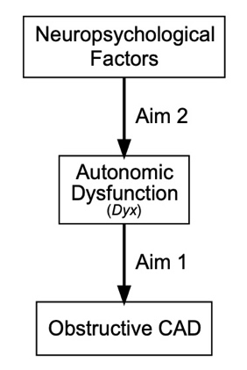

**Figure 2. Specific Aims**

# D2. Study Population

The EmCAB has assessed approximately 3,000 major cardiovascular events thus far.14 It also evaluates additional biomarkers for inflammation, cardiac injury, and genetics, with the goal of predicting CVD outcomes.18 All patients aged 18 years and older undergoing cardiac catherization are recruited to participate by a full-time study coordinator. After informed consent, they are interviewed for health behaviors and neuropsychological functioning the same day, prior to cardiac catherization. ﻿Detailed chart extraction is also performed. They are excluded if they have congenital heart disease, severe valvular heart disease, severe anemia, a recent blood transfusion, myocarditis, history of active inflammatory disease, cancer or are unable or not willing to provide consent (approximately 5%). We will specifically evaluate subjects who have chronic stable angina and exclude acute coronary syndrome.

## D3. Research Design

General Protocol: The enrollment, consent, and detailed phenotyping of the patients has been described in multiple prior studies using the EmCAB.18 ﻿Additional measures, including lifestyle factors, medical comorbidities, revascularization during the index cardiac catheterization, and previous revascularization procedures are ascertained via patient interview and chart review. The sample for study will be collected daily over the course of the first several months of this study, with an estimated 20 patients enrolled per week. Coronary angiographies will be evaluated by the Gensini score, which is a visual estimation of luminal narrowing in multiple segments based on a modified form of the American Heart Association classification of the coronary tree by trained cardiologists.19

Heart Rate Variability: This study will add HRV to the data collected by the EmCAB. We will use non-invasive, continuous, ambulatory ECG patches (Biostamp®, MC10 Inc), which we have acquired through my mentor Dr. Shah. I will assist with the consent and incorporation of ECG data collection into the larger study protocol. The consent will occur in the early morning (7 AM — 9 AM), after which the patch will be applied until their angiogram. This follows from our recent findings demonstrating that the most important time for detecting autonomic dysfunction is between 7 AM and 10 AM.7 If possible, the ECG duration will be extended. We will use the commercial HeartTrends algorithm (Lev-El Diagnostics Ltd., Israel) to generate the *Dyx* measure, as well as an internally developed HRV toolbox to generate additional indices for comparison.50 A materials transfer agreement with the company is already in place with HeartTrends.

Neuropsychological Measures: The enrollment protocol includes patient interviews by study staff. Depressive symptoms will be assessed via the 9-question Primary Care Evaluation of Mental Disorders Brief Patient Health Questionnaire (PHQ-9).51 Moderate depression is seen at a cutoff of 10 points or higher (out of 27), with a sensitivity and specificity of 88% for major depression.52 Questionnaires are included on perceived life stress and chronic burden as well. Cognitive impairment will be measured by the Montreal cognitive assessment (MoCA), which is a measure of global cognitive function and is comprised of the sub-domains: memory, visuospatial function, executive function, sustained attention, language, and orientation. The MoCA has a sensitivity of 90% and specificity of 87% for detecting mild cognitive impairment using a cutoff score of 26 (out of 30).53

Power Calculation: The expected cohort size for this ancillary study is 150 patients, which we should be able to collect over the course of 6 months. We anticipate a maximum of 20% loss of data due to poor ECG quality (>20% artifact), missing data, or other exclusion criteria as above. After these reductions we estimate a sample size of 120 patients. Out of this sample, we expect to find 80-90 patients with CAD, 10-20 patients with depression, and 15-25 patients with cognitive impairment. Using α=0.05, and 1-β=0.80, we would have the power to detect an effect size as small as Cohen’s f2=0.07—0.13 for both specific aims (including covariates).54

**D4. Specific Aim #1: To evaluate the relationship of autonomic dysfunction, measured by abnormal HRV, on the spectrum of progressive CAD.**

Rationale: Abnormal HRV indicates autonomic dysfunction and increases the risk of cardiovascular mortality. *Dyx* has been shown to predict myocardial perfusion defects during stress test. Our previous work suggests this finding is most robust during morning hours, as in **Figure 4**.7 We are looking to, for the first time, evaluate *Dyx* during morning hours and the relationship with obstructive CAD and overall plaque burden.

**Figure 4. Low Morning HRV and Abnormal MPI**

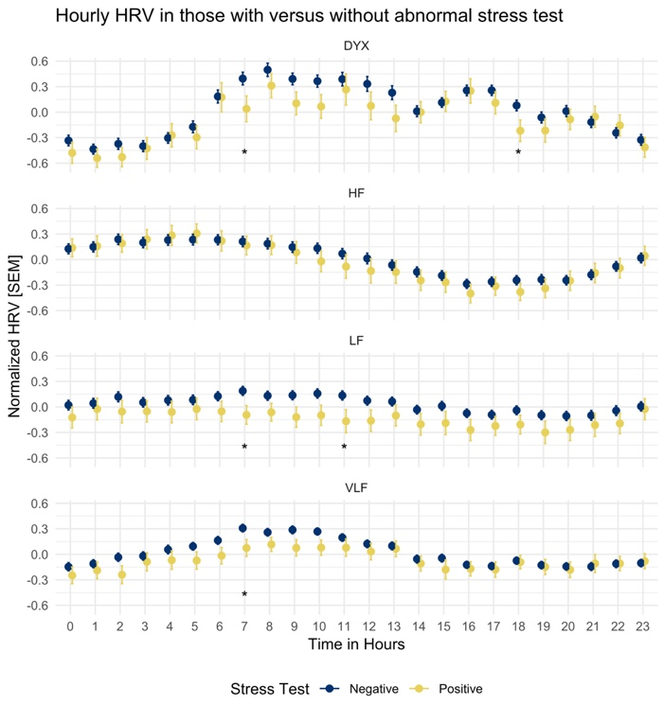

Data Collection and Analysis: I will be directly involved with the study coordinators to enroll and consent patients for ambulatory ECG. I will be responsible for working with the BioStamp company to retrieve raw ECG data, and converting it into usable RR intervals and evaluation for arrhythmia (which would be excluded from analysis). I will communicate with the HeartTrends company to assist with the appropriate and timely generation of the *Dyx* index through Poincaré plot analysis.38,39 I will learn to use the HRV toolbox under the guidance of Dr. Shah to generate hourly frequency and geometric domain indices of HRV for additional HRV assessments.50 Familiarizing myself with the mathematical principles and technical skills underlying signal processing will be critical for my training. I will compare the exposure of HRV to the outcome of coronary artery plaque burden, measured by the Gensini score, from cardiac catherization using linear regression models, with multivariate analysis to evaluate the performance of HRV against traditional risk factors. Logistic regression models will be fit using a clinical cutoff point of *Dyx* (< 2.0 units)against obstructive CAD (stenosis > 70%).22 I will perform these analyses independently, under the guidance of Dr. Alonso and Dr. Shah, to help apply the biostatistics skills strengthened by formal coursework during the MSCR.

Potential Problems and Solutions: This patient population is likely to have a higher proportion of patients on beta-blockers, which has a known effect on heart rate and spectral HRV.55 For patients on beta-blocker therapy we will perform an additional subgroup analysis to prevent confounding. Continuous ECG data are susceptible to artifact, which may lead to erroneous data. Such data can be edited to remove noise and ectopy, and interpolated to fill gaps, which existing software techniques allow for the easy cleaning of raw RR interval data.

Anticipated Results: We expect to find an independent association with autonomic dysfunction in the morning hours, measured by low *Dyx*, with progressive coronary artery plaque burden.

**D5. Specific Aim #2: To determine the effect of neurovisceral dysfunction on autonomic dysfunction.**

Rationale: Both cognitive impairment and depression are not only common in patients with CAD, but are prognostic after MI, independent of traditional risk factors.31,56,57 Our preliminary analyses from the Emory Twin Study found *Dyx* to be a significant determinant of depressive symptoms (r= 0.14, p<0.001 in 276 individuals). Also, in a preliminary analysis from the Atherosclerotic Risk In Communities (ARIC) study, psychological life stressors like exhaustion are associated with abnormal HRV. Cognitive impairment also associates with decreases in HRV.58 We will look to elucidate the relationship of depression and stress and cognitive impairment with *Dyx* as a marker for neurovisceral dysfunction.

Data Collection and Analysis: The primary exposures will be depressive symptoms (PHQ-9), stress (questionnaire), and cognitive impairment (MoCA score). The primary outcome will be autonomic function, measured by *Dyx* and other HRV indices. I will create linear regression models for the continuous *Dyx* measure, and logistic regressions for *Dyx* using the clinical cutoff of <2 units.22 As in **Aim #1**, I will create models that adjust for cardiovascular risk factors to assess for confounding due to sociodemographic and traditional risk factors. My training through the MSCR will provide me the necessary tools to conduct these analyses. Dr. Alonso is an expert in cognitive decline and heart disease, and will help in the analysis and interpretation of these data. Dr. Shah will help in the evaluation of depression and HRV as well.

Potential Problems and Solutions: The PHQ-9 is not validated in the setting of acute stress, for which we will exclude patients diagnosed with acute coronary syndrome. Treatment of depression may lead to favorable changes in HRV. We will control for antidepressant use through additional subgroup analysis. The generalizability of this data is difficult, as patients with severe cognitive impairment may not be referred for catherization, and thus excluded from the study.

## D6. Mentorship and Training Integration

The combination of direct human research experience (including patient enrollment and study design), data management and analysis, dedicated course work through the MSCR, and the clinical training from my residency are integral to building my foundation as a physician-scientist. Dr. Shah has an expertise in ECG signal processing and psychosocial stress and has been a dedicated mentor for the past three years. We will have frequent in-person and phone meetings, and he will provide guidance on data measurement, analysis, and interpretation of HRV data. Dr. Alonso studies the effect of neurocognitive factors on arrhythmia risk, and is an investigator in a large clinical cohort, the Atherosclerotic Risk In Communities study (ARIC). We will meet in-person every other week, where he will provide guidance on study design and data interpretation as it relates to neurocognitive impairment, as well as direction on statistical analysis. Dr. Thames is a senior cardiologist with extensive research into the cardiac autonomic nervous system. He has provided expert insight into mechanisms and pathways in prior manuscripts and will continue to teach me the interpretation of translational research in cardiac autonomic function. Dr. Vaccarino, as the head of the Emory Program in Cardiovascular Outcomes Research and Epidemiology (EPICORE) and T32 program, conducts biweekly meetings that I will participate in, allowing me to share my work, meet with other trainees, and attend seminars by invited speakers on cardiovascular disease epidemiology and health disparities. I will also participate in dedicated teaching programs in vascular biology and biostatistics as a trainee in EPICORE. She will also provide feedback on manuscript drafting focused on epidemiology and biostatistics concepts. Dr. Quyyumi is the lead investigator of the EmCAB and has participated in a number of clinical trials. He will help me integrate this new HRV component into the EmCAB, giving me guidance on the practical steps needed to modify and design a clinical study, and provide manuscript feedback focusing on translational and clinical aspects. Certain skills gained through the MSCR curriculum will be foundational to my success as a researcher. Of note, the *MSCR 594 Scientific and Grant Writing* will help as I prepare to apply for my first K grant in preventive cardiology. With my background in programming, including the statistical language R, the basic and advanced biostatistics courses including *MSCR 534 Analytic Methods for Clinical and Translational Research* *and MSCR 596 Advanced Data Management in R* will enhance my ability to become an independent researcher.

## D7. Timeline

This research proposal is intended to allow for completion of several projects over the course of the upcoming academic year, from July 2019 to June 2020. I will spend 35-45% of my time completing academic coursework for the MSCR, including additional classes and seminars in advanced biostatistics and statistical programming languages. I expect to split my remaining time between implementation of the proposed study protocol, including enrollment, data collection, and study design, and primary data analysis. No clinical work will be assigned. I intend to start working with the EmCAB coordinators, the MC10 BioStamp company, and the HeartTrends group by July 2019 or earlier to facilitate a productive research year. In January of 2020, I will start with the statistical analysis and the preparation of manuscripts to be submitted. By March of 2020, I will dedicate time to completing the dissertation and start grant proposals for future studies, along with research opportunities through fellowship in academic cardiology.

## D8. Future Directions

We expect to find a clinically meaningful (risk ratio >2) association with the non-linear HRV index, *Dyx*, and obstructive CAD, highlighting the utility of autonomic dysfunction as an independent risk factor for CAD. I also expect to find an independent association of *Dyx* with depression and neurocognitive impairment, demonstrating its role in quantifying neurocardiac health, and highlighting the importance of the brain in this relationship. I hope to use this research as the basis for screening for autonomic dysfunction through ECG to identify those at risk for obstructive CAD, and future grants would further elaborate on this work with larger sample sizes, clinical outcomes, and additional mechanisms such as inflammatory biomarkers. I also plan on using HRV as a tool to research the effects of neuropsychological factors on cardiovascular disease risk, such as directionality and effect size, with the intent to eventually direct interventions that may be protective.