Lab 2 — Reflective Report
Data Pipeline with dbt & DuckDB
Data Engineering — January 2026
Ecole Centrale Casablanca

1. Final Architecture
The pipeline is built around three distinct layers — ingestion, transformation, and serving — each with a clear responsibility and clean interface to the next.

1.1 Ingestion Layer (Python)
Python scripts from Lab 1 connect to the Google Play Store API and persist raw data as JSON files in the raw_data/ folder. Two files are produced:
- apps_catalog.json — one record per app (appId, title, genre, score, ratings, developer)
- apps_reviews.json — one record per user review (appId, userName, content, score, thumbsUpCount, at)
This layer is intentionally kept separate from the transformation logic. Raw files are never modified by dbt — they are treated as immutable inputs.

1.2 Transformation Layer (dbt + DuckDB)
dbt orchestrates all transformation logic across two sub-layers:

Staging (models/staging/)
stg_playstore_apps and stg_playstore_reviews are materialized as views. They rename columns to snake_case, cast data types, generate surrogate keys using md5(), and deduplicate reviews using ROW_NUMBER() window functions. No business logic is applied here.

Marts (models/marts/)
The marts layer is materialized as tables and contains all business-meaningful models:
- dim_categories — unique Play Store genres, keyed by md5(category)
- dim_developers — unique publishers, keyed by md5(developer)
- dim_apps — current app state with surrogate key app_sk = md5(app_id), linking to both dim_categories and dim_developers
- dim_apps_scd — historical app versions built from the apps_snapshot, with valid_from, valid_to, and is_current columns
- dim_date — calendar dimension dynamically anchored to the min/max review dates in stg_playstore_reviews
- fact_reviews — incremental fact table at grain: one row per review event per app, joined to dim_apps_scd using temporal validity

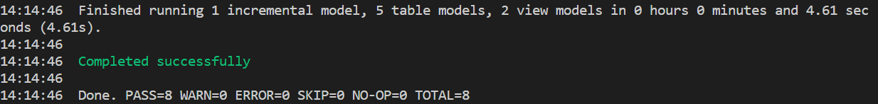

1.3 Storage & Serving Layer (DuckDB)
DuckDB acts as both the execution engine and the persistent analytical store. All dbt models are materialized into a single playstore.duckdb file. This file can be directly connected to BI tools such as Power BI or Metabase without any additional infrastructure.
Architecture diagram:
Python (raw_data/) → dbt staging (views) → dbt marts (tables) → playstore.duckdb → BI tool

2. Key Implementations

2.1 Incremental Loading
fact_reviews is defined as an incremental model in models/marts/facts/fact_reviews.sql. This means dbt only processes new rows on each run rather than rebuilding the entire table from scratch.
The model uses two mechanisms to achieve this:
- unique_key='review_id' — if a review_id already exists in the table, dbt updates it rather than inserting a duplicate
- Incremental filter — on subsequent runs, only reviews with a review_date greater than the current maximum are processed
The relevant SQL block in the model is:
{% if is_incremental() %}
where cast(r.review_date as timestamp) >
(select max(cast(review_date as timestamp)) from {{ this }})
{% endif %}
The first run builds the full table. Every subsequent run appends only new data. This makes the pipeline efficient for daily ingestion without reprocessing historical reviews.

2.2 SCD Type 2
Slowly Changing Dimensions (SCD2) are implemented via a dbt snapshot defined in snapshots/apps_snapshot.sql. The snapshot uses the check strategy, monitoring changes in three columns: category, developer, and rating.
strategy='check',
check_cols=['category', 'developer', 'rating']
When any of these values change for an app, dbt automatically:
- Closes the previous row by setting dbt_valid_to to the current timestamp
- Inserts a new row with the updated values and dbt_valid_to = NULL (open/current)
dim_apps_scd is then built on top of this snapshot, exposing clean columns including valid_from, valid_to, and is_current for easy querying.
We validated this by running simulate_scd2_change.py, which modified the category of Google NotebookLM from Productivity to Productivity_MODIFIED. After re-running the snapshot and models, dim_apps_scd contained two rows for that app:
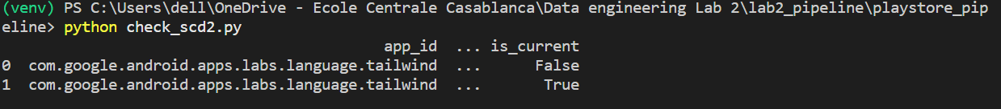
The fact table joins to dim_apps_scd using a temporal condition to ensure each review links to the version of the app that was valid at review time:
on r.app_id = a.app_id
and cast(r.review_date as timestamp) >= a.valid_from
and (a.valid_to is null or cast(r.review_date as timestamp) < a.valid_to)

2.3 Data Quality & Testing
dbt's native testing framework is used to enforce data quality across all layers. Tests are defined in schema.yml files and run automatically with dbt test. The pipeline has 34 tests in total across staging and marts.

Staging tests (models/staging/schema.yml)
- unique + not_null on stg_playstore_apps.app_id — ensures no duplicate or missing app identifiers
- unique + not_null on stg_playstore_reviews.review_id — the surrogate key md5(appId + content + timestamp) must be unique
- relationships: stg_playstore_reviews.app_id → stg_playstore_apps.app_id — no orphan reviews allowed

Marts tests (models/marts/schema.yml)
- unique + not_null on all dimension primary keys (date_key, app_sk, category_id, developer_id)
- relationships on dim_apps.category_id → dim_categories and dim_apps.developer_id → dim_developers — enforces the snowflake hierarchy
- relationships on fact_reviews.app_sk → dim_apps_scd and fact_reviews.review_date_key → dim_date — full referential integrity on the fact table

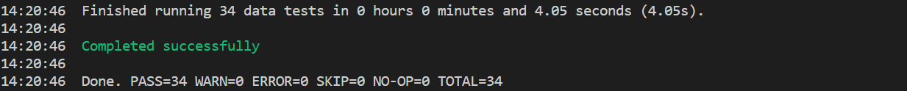

3. Python-Only vs dbt-Based Pipeline
Lab 1 used pure Python (pandas, custom scripts) for all transformation logic. Lab 2 replaced this with dbt + DuckDB. The table below summarizes the key differences:

Aspect | Python-Only (Lab 1) | dbt-Based (Lab 2)
Transformation logic | Scattered across .py scripts with manual dataframe operations | Declarative SQL models in versioned .sql files, orchestrated by dbt
Reproducibility | Fragile — re-running scripts could overwrite or duplicate data silently | Idempotent by design — dbt run always produces the same result
Data quality | Manual if-checks in Python, no systematic enforcement | 34 schema tests (unique, not_null, relationships) run automatically
Incremental loads | Required custom logic to track what was already processed | Native dbt incremental model with unique_key deduplication
Historical tracking | Not supported — each run overwrote the previous state | SCD Type 2 via dbt snapshots with dbt_valid_from/to columns
Lineage & documentation | None — no way to trace where a value came from | dbt generates a full DAG showing model dependencies
Storage | CSV/JSON files in memory or on disk | DuckDB — persistent analytical database with SQL query support

The most significant practical difference was reproducibility. In Lab 1, re-running a script could silently overwrite clean data or produce duplicates depending on execution order. In Lab 2, dbt run always produces the same output regardless of how many times it is executed, because models are either views (recomputed on query) or tables rebuilt from scratch (or incrementally merged with deduplication).

4. Reflections

4.1 Most Fragile Part of the Pipeline
The most fragile part is the temporal join in fact_reviews that links reviews to their corresponding app version in dim_apps_scd:
and cast(r.review_date as timestamp) >= a.valid_from
and (a.valid_to is null or cast(r.review_date as timestamp) < a.valid_to)
This join silently drops any review whose timestamp falls outside all known app versions — for example, reviews written before the first snapshot was taken. In a production system this would require a backfill strategy or a default 'catch-all' version row to prevent data loss. During development, we encountered this exact issue when fact_reviews referential integrity tests failed because dim_date did not cover all review dates — a symptom of the same underlying sensitivity to timestamp boundaries.

4.2 Biggest Architectural Insight
The biggest insight was understanding why separating ingestion from transformation matters in practice, not just in theory. In Lab 1, Python handled both extraction and transformation in the same script. When something broke, it was impossible to tell whether the problem was in the source data or in the transformation logic.
In Lab 2, the raw JSON files are never touched by dbt. If stg_playstore_apps produces wrong results, the issue is in the staging model — not in the ingestion. If dim_categories has missing values, the issue is in the mart — not in staging. This separation makes debugging dramatically faster and also makes it safe to re-run any layer independently without risk of corrupting another layer.

4.3 One Design Decision We Would Change
We would change the surrogate key strategy in dim_apps from md5(app_id) to md5(app_id) only — which is effectively just a hash of a single column and adds no real uniqueness beyond app_id itself.
A better approach would be to use dbt_utils.generate_surrogate_key(['app_id']) from the dbt-utils package, which handles null values and cross-database compatibility, and to apply the same pattern consistently across all dimensions. More importantly, we would have introduced surrogate keys earlier in the design process rather than adding them as a fix — having natural keys leak into the fact table before being replaced by surrogate keys created confusion when joining across models.

