Blockly案例

2017级物理三班 第五小组 邵骏 320170936311

**案例说明**：计算某种粒子是否能够穿越大气，当粒子速度小于等于0.01c时，不考虑钟慢效应，当粒子速度大于0.01c时，考虑钟慢效应，设大气层厚度为9000m。

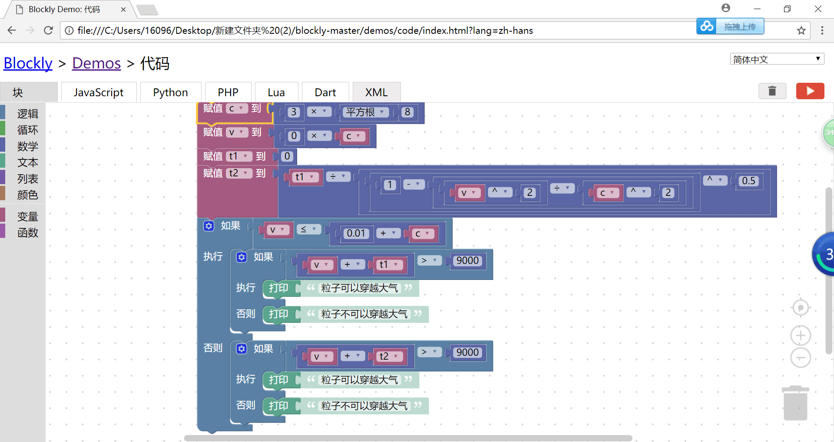

**案例运行**：1.μ子速度为0.998c，其固有寿命为0.000002s：

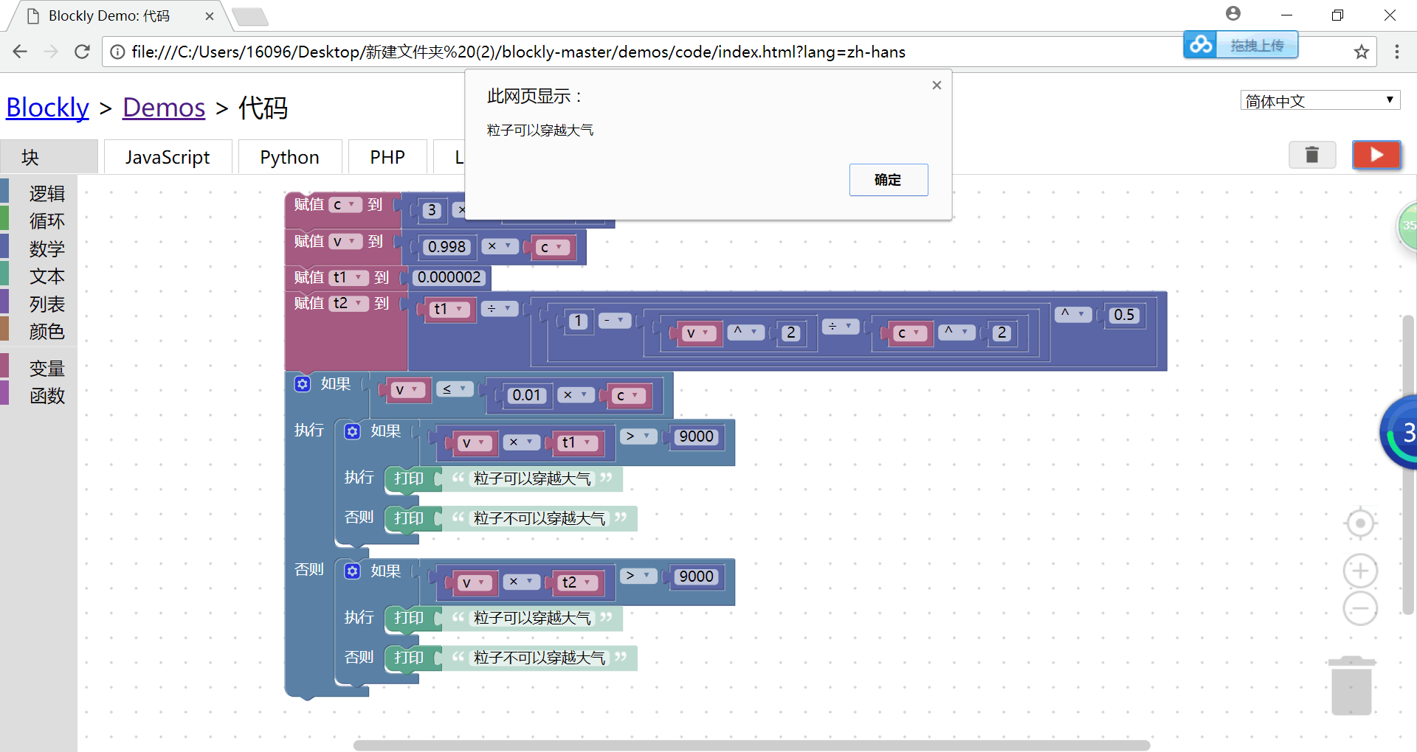

可以穿越大气。

2.假设μ子速度变为0.9c:

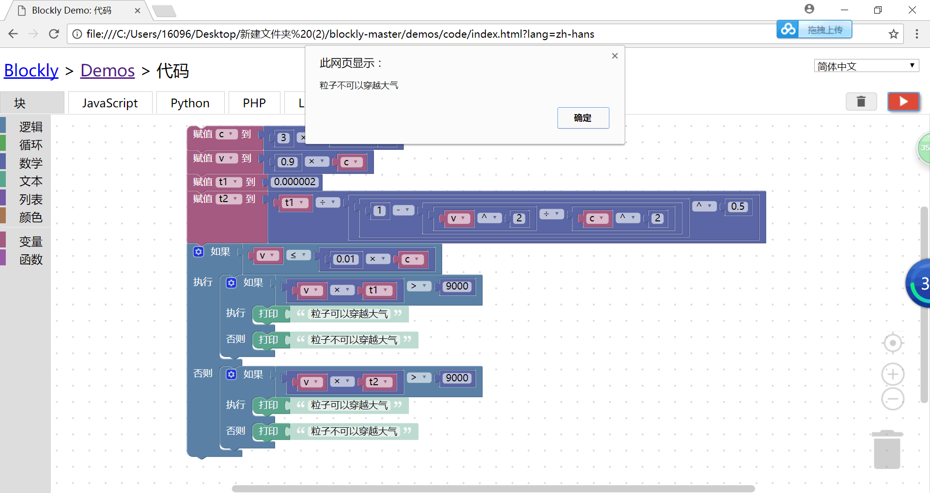

不可以穿越大气。

3.某粒子速度为0.001c，其固有寿命为0.02s：

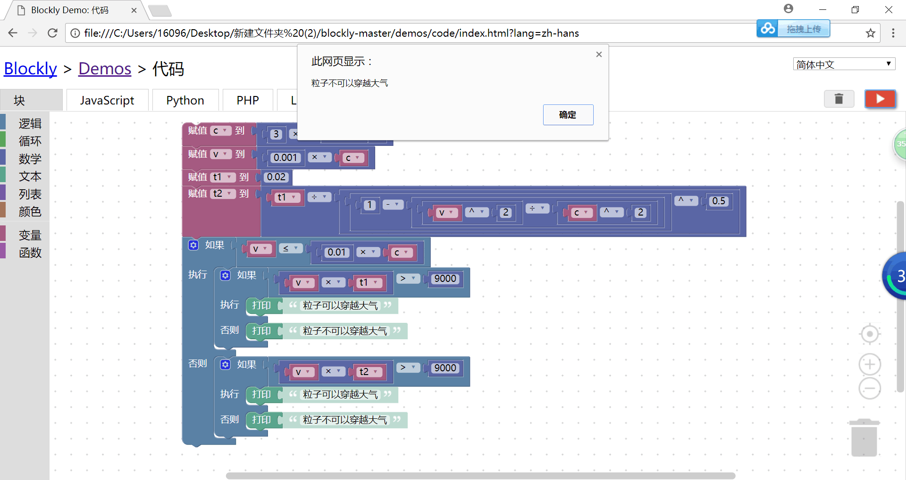

不可以穿越大气。

4.若该粒子寿命变为0.04s：

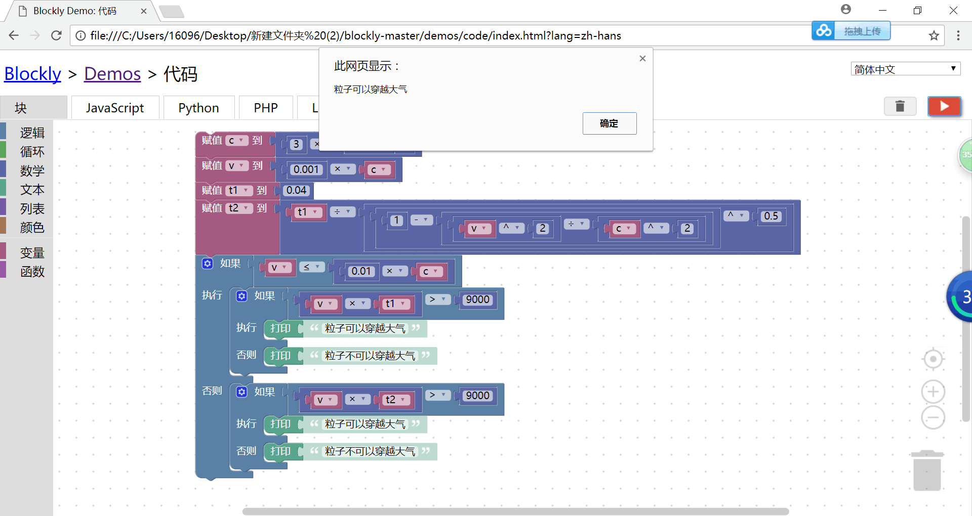

可以穿越大气。

**XML代码**：

<xml xmlns="http://www.w3.org/1999/xhtml">

<variables>

<variable type="" id="4*Lbdn~S7c|kL2T?*0_i">t1</variable>

<variable type="" id="*}BzL_gxpk4vT~By7LeS">t2</variable>

<variable type="" id="{)]P%BO|,!W~euXHg2Fx">c</variable>

<variable type="" id=")K|QWF67dgT:4TzDqH4R">v</variable>

</variables>

<block type="variables_set" id="T#xH$2ChXS~k(Gqv86LX" x="188" y="-37">

<field name="VAR" id="{)]P%BO|,!W~euXHg2Fx" variabletype="">c</field>

<value name="VALUE">

<block type="math_arithmetic" id=")j+zP!(GFY/t(ZW5!Rv9">

<field name="OP">MULTIPLY</field>

<value name="A">

<shadow type="math_number" id=":Ys0FnJ[|Bi%=}*Bjc3i">

<field name="NUM">1</field>

</shadow>

<block type="math_number" id="7mH(P~$`J6D-ALZxzU5V">

<field name="NUM">3</field>

</block>

</value>

<value name="B">

<shadow type="math_number" id="J=MOFZ!=HhVbzaM}=S3~">

<field name="NUM">1</field>

</shadow>

<block type="math_single" id=",t|6}*;W0gcRl-{ngHiW">

<field name="OP">ROOT</field>

<value name="NUM">

<shadow type="math_number" id="7[]X@P=ZDZwEY;yCQ.;C">

<field name="NUM">9</field>

</shadow>

<block type="math_number" id="sR2zfBZ`z@Ye:#y-dEY`">

<field name="NUM">8</field>

</block>

</value>

</block>

</value>

</block>

</value>

<next>

<block type="variables_set" id="*lP~,=H4]Jt(;cPiwqWw">

<field name="VAR" id=")K|QWF67dgT:4TzDqH4R" variabletype="">v</field>

<value name="VALUE">

<block type="math_arithmetic" id="MB+@qcPcJ1PRjm;A@11v">

<field name="OP">MULTIPLY</field>

<value name="A">

<shadow type="math_number" id="=IfG*R3PnmK%CiWjRG+2">

<field name="NUM">1</field>

</shadow>

<block type="math_number" id="l;-q+{1H^i^I4B9~r2hI">

<field name="NUM">0</field>

</block>

</value>

<value name="B">

<shadow type="math_number" id="byQ,|nC9.OPE@/0$8r]p">

<field name="NUM">1</field>

</shadow>

<block type="variables_get" id="L:K2kIfFL?/Uc_NGoJyH">

<field name="VAR" id="{)]P%BO|,!W~euXHg2Fx" variabletype="">c</field>

</block>

</value>

</block>

</value>

<next>

<block type="variables_set" id="-QNU3(SC]ZP*tOco$R~w">

<field name="VAR" id="4*Lbdn~S7c|kL2T?*0_i" variabletype="">t1</field>

<value name="VALUE">

<block type="math_number" id="iG*jawd.qZfK6OYvs7}M">

<field name="NUM">0</field>

</block>

</value>

<next>

<block type="variables_set" id="I$38B.wX,2Y2Fj[UQDQ~">

<field name="VAR" id="*}BzL_gxpk4vT~By7LeS" variabletype="">t2</field>

<value name="VALUE">

<block type="math_arithmetic" id="^Wb1x9K~FVr]l3B2=NPp">

<field name="OP">DIVIDE</field>

<value name="A">

<shadow type="math_number" id="GWz6yPI?XoXfhJ3t]xiZ">

<field name="NUM">1</field>

</shadow>

<block type="variables_get" id="{sV*Yvu)DOcj~(_BCm+)">

<field name="VAR" id="4*Lbdn~S7c|kL2T?*0_i" variabletype="">t1</field>

</block>

</value>

<value name="B">

<shadow type="math_number" id="^MUAkqCDr!zF.IqUu.x,">

<field name="NUM">1</field>

</shadow>

<block type="math_arithmetic" id="31mYJIu@rppr!Mn_sh]}">

<field name="OP">POWER</field>

<value name="A">

<shadow type="math_number" id="LLBGY#VpM(SGIE#lI[3b">

<field name="NUM">1</field>

</shadow>

<block type="math_arithmetic" id="C]VgCbvh|H2}8rkJ`M|x">

<field name="OP">MINUS</field>

<value name="A">

<shadow type="math_number" id="$-2TaUdZq.zA)ReipqL2">

<field name="NUM">1</field>

</shadow>

<block type="math_number" id="EyoOo*rY$lLOsx]!t-GO">

<field name="NUM">1</field>

</block>

</value>

<value name="B">

<shadow type="math_number" id="yLCU6$;cv$z;C0IgHJ2F">

<field name="NUM">1</field>

</shadow>

<block type="math_arithmetic" id="w65QdEf]H:xC.jI%xg,o">

<field name="OP">DIVIDE</field>

<value name="A">

<shadow type="math_number" id="[E1}`Y*/Yl-PYKVK^^73">

<field name="NUM">1</field>

</shadow>

<block type="math_arithmetic" id="@%1`O)rm(Zl;kHM$#;rP">

<field name="OP">POWER</field>

<value name="A">

<shadow type="math_number" id="=%e|~z,dvWv+^KG7Q!*C">

<field name="NUM">1</field>

</shadow>

<block type="variables_get" id="I6G$YNnV`Fy]xZ99|5HB">

<field name="VAR" id=")K|QWF67dgT:4TzDqH4R" variabletype="">v</field>

</block>

</value>

<value name="B">

<shadow type="math_number" id="GF.2xP,OEhsW1zp,$8T[">

<field name="NUM">1</field>

</shadow>

<block type="math_number" id="3~tz?zeC?Zg_l;[VFI?n">

<field name="NUM">2</field>

</block>

</value>

</block>

</value>

<value name="B">

<shadow type="math_number" id="Ps9,mx]9ZU6jm#?]]OOQ">

<field name="NUM">1</field>

</shadow>

<block type="math_arithmetic" id="[ylHOR=!R+JhJ9%.n!jD">

<field name="OP">POWER</field>

<value name="A">

<shadow type="math_number" id="%Qn!6}ItG+(/A3e-oUl3">

<field name="NUM">1</field>

</shadow>

<block type="variables_get" id="li[h=V:D;TTK`wjMN~25">

<field name="VAR" id="{)]P%BO|,!W~euXHg2Fx" variabletype="">c</field>

</block>

</value>

<value name="B">

<shadow type="math_number" id="GF.2xP,OEhsW1zp,$8T[">

<field name="NUM">1</field>

</shadow>

<block type="math_number" id="@DTsx;,#OnTaUctqFAni">

<field name="NUM">2</field>

</block>

</value>

</block>

</value>

</block>

</value>

</block>

</value>

<value name="B">

<shadow type="math_number" id="vJi,VltotH[~Z1dfKLlG">

<field name="NUM">1</field>

</shadow>

<block type="math_number" id="9.e^!/wc^M4Dl*LAn{kd">

<field name="NUM">0.5</field>

</block>

</value>

</block>

</value>

</block>

</value>

<next>

<block type="controls_if" id="`w(Rvdm0*NTK=C=Y65)#">

<mutation else="1"></mutation>

<value name="IF0">

<block type="logic_compare" id="=dLU?2r4RW_3v6/}ep2b">

<field name="OP">LTE</field>

<value name="A">

<block type="variables_get" id="zzn/]h}h|QF#B~^wE/FO">

<field name="VAR" id=")K|QWF67dgT:4TzDqH4R" variabletype="">v</field>

</block>

</value>

<value name="B">

<block type="math_arithmetic" id="LC(?#@F-f/UFZ6E_WDMq">

<field name="OP">ADD</field>

<value name="A">

<shadow type="math_number" id="-@wM9c@@FF@GW4lC)0RU">

<field name="NUM">1</field>

</shadow>

<block type="math_number" id="f3)T..S{@wWCV^wh[j`z">

<field name="NUM">0.01</field>

</block>

</value>

<value name="B">

<shadow type="math_number" id="OKUcz(UQa]tmTfTr//IS">

<field name="NUM">1</field>

</shadow>

<block type="variables_get" id="8XV)Po=Q*sn1N!+g}y*s">

<field name="VAR" id="{)]P%BO|,!W~euXHg2Fx" variabletype="">c</field>

</block>

</value>

</block>

</value>

</block>

</value>

<statement name="DO0">

<block type="controls_if" id="5L6g?(xA38vv(l-Y!;bi">

<mutation else="1"></mutation>

<value name="IF0">

<block type="logic_compare" id="=DxOgk.{Y##.XE#h$#uy">

<field name="OP">GT</field>

<value name="A">

<block type="math_arithmetic" id="iO#s|+u,OVIEs8Yvh`0n">

<field name="OP">ADD</field>

<value name="A">

<shadow type="math_number" id="-(Hw)C(^t?3R3!^u{?2!">

<field name="NUM">1</field>

</shadow>

<block type="variables_get" id="7[!i*7(WK+w`7;a?,}l~">

<field name="VAR" id=")K|QWF67dgT:4TzDqH4R" variabletype="">v</field>

</block>

</value>

<value name="B">

<shadow type="math_number" id="`iCu]$$Am8)dDR@7?Ky_">

<field name="NUM">1</field>

</shadow>

<block type="variables_get" id="Gp;-5Y+^[,}fRw^*j~*k">

<field name="VAR" id="4*Lbdn~S7c|kL2T?*0_i" variabletype="">t1</field>

</block>

</value>

</block>

</value>

<value name="B">

<block type="math_number" id="_2f.ih_:P#TL;)T,3]Vg">

<field name="NUM">9000</field>

</block>

</value>

</block>

</value>

<statement name="DO0">

<block type="text_print" id="-H.eT4h7?)@Hy]62fH*J">

<value name="TEXT">

<shadow type="text" id="?7X{C)Sz2MiO6v+RnEdk">

<field name="TEXT">粒子可以穿越大气</field>

</shadow>

</value>

</block>

</statement>

<statement name="ELSE">

<block type="text_print" id="U:6Zqgg,yr+Q6-)kM;#;">

<value name="TEXT">

<shadow type="text" id="ma1WaOZ^Rjo(o:#iXAu.">

<field name="TEXT">粒子不可以穿越大气</field>

</shadow>

</value>

</block>

</statement>

</block>

</statement>

<statement name="ELSE">

<block type="controls_if" id=".BK1!.+w+n?.HX$L_$Bl">

<mutation else="1"></mutation>

<value name="IF0">

<block type="logic_compare" id="M+CkFSBvkwhWq#DC%fBh">

<field name="OP">GT</field>

<value name="A">

<block type="math_arithmetic" id="LT`NGSU6LIa1ojYUpyV_">

<field name="OP">ADD</field>

<value name="A">

<shadow type="math_number" id="-(Hw)C(^t?3R3!^u{?2!">

<field name="NUM">1</field>

</shadow>

<block type="variables_get" id="5If-@H9Q)LZyIC-lgegv">

<field name="VAR" id=")K|QWF67dgT:4TzDqH4R" variabletype="">v</field>

</block>

</value>

<value name="B">

<shadow type="math_number" id="`iCu]$$Am8)dDR@7?Ky_">

<field name="NUM">1</field>

</shadow>

<block type="variables_get" id="B(l|8s_UE7B6=jI[+l-y">

<field name="VAR" id="*}BzL_gxpk4vT~By7LeS" variabletype="">t2</field>

</block>

</value>

</block>

</value>

<value name="B">

<block type="math_number" id=".nqoK}VR]bDn:Y,OR8`~">

<field name="NUM">9000</field>

</block>

</value>

</block>

</value>

<statement name="DO0">

<block type="text_print" id="kZN$V82+x?%D{j}0NY%a">

<value name="TEXT">

<shadow type="text" id="!FRTE!T1J:Ko_BSG1DX_">

<field name="TEXT">粒子可以穿越大气</field>

</shadow>

</value>

</block>

</statement>

<statement name="ELSE">

<block type="text_print" id="KA,Ln-~Wj_)TQny**RO%">

<value name="TEXT">

<shadow type="text" id="x;AxO*7RszvK)F,K}A0^">

<field name="TEXT">粒子不可以穿越大气</field>

</shadow>

</value>

</block>

</statement>

</block>

</statement>

</block>

</next>

</block>

</next>

</block>

</next>

</block>

</next>

</block>

</xml>