描述点[x,y]到直线AX+BY+C=0的距离

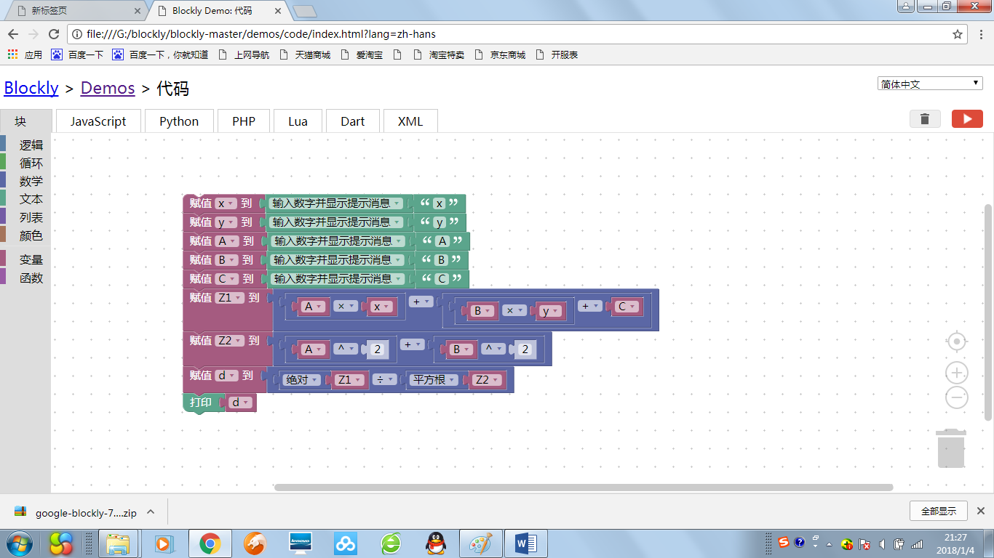

运算点{0,0}到直线X+Y+1=0的距离，输入x=0,y=0,A=1,B=1,C=1,运算结果如下

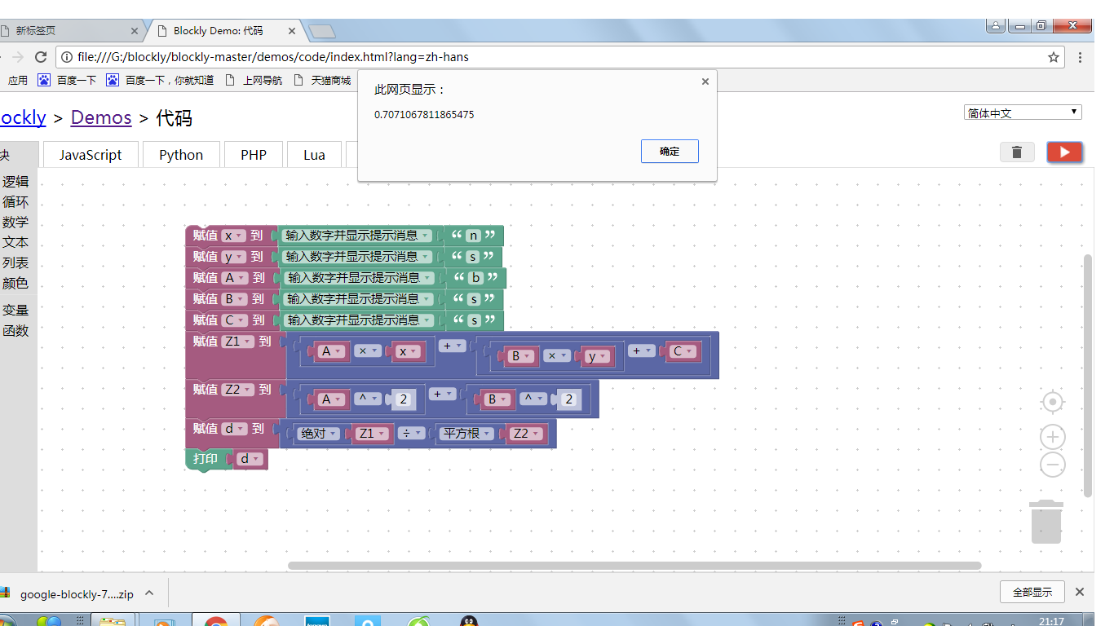

XMl代码

<xml xmlns="http://www.w3.org/1999/xhtml">

<variables>

<variable type="" id="jaeDEPh:zC|}:no%[uVU">x</variable>

<variable type="" id="RVgIwJxFa71owj_I%W|5">y</variable>

<variable type="" id="ejw^qJ-geusoEKKkZgD/">A</variable>

<variable type="" id="sQqrb_J.-@Pr*TY4V-c)">B</variable>

<variable type="" id="CkqiLc@sQ]L`S}`X3%1%">C</variable>

<variable type="" id="a+)RYEk0.*!KEPC7V-[m">Z1</variable>

<variable type="" id="5Zir,0BH`qv;^60XL-U^">Z2</variable>

<variable type="" id="m9DgXEjZFup!g[Z+:?KU">d</variable>

</variables>

<block type="variables_set" id="4uxKQjmgLv5%xz]{,vR;" x="63" y="62">

<field name="VAR" id="jaeDEPh:zC|}:no%[uVU" variabletype="">x</field>

<value name="VALUE">

<block type="text_prompt_ext" id="Y1EsDA:bAnH.G?[PjOUL">

<mutation type="TEXT"></mutation>

<field name="TYPE">TEXT</field>

<value name="TEXT">

<shadow type="text" id="yflD@chjtHj=)0l.X3S|">

<field name="TEXT">abc</field>

</shadow>

<block type="text" id="NY0wlpwLY[O!Z%xR*%H/">

<field name="TEXT">x</field>

</block>

</value>

</block>

</value>

<next>

<block type="variables_set" id="4{^[eI;]CW)h%$HW!bf7">

<field name="VAR" id="RVgIwJxFa71owj_I%W|5" variabletype="">y</field>

<value name="VALUE">

<block type="text_prompt_ext" id="#ev:i83^E)r:O$?*MPyQ">

<mutation type="TEXT"></mutation>

<field name="TYPE">TEXT</field>

<value name="TEXT">

<shadow type="text" id="N1xCV43C%l_$L.Qwl4U9">

<field name="TEXT">abc</field>

</shadow>

<block type="text" id="zGW[qh:#r4T-ZI);S$T{">

<field name="TEXT">y</field>

</block>

</value>

</block>

</value>

<next>

<block type="variables_set" id="G%AP$x(^uK.w#,owIfJ|">

<field name="VAR" id="ejw^qJ-geusoEKKkZgD/" variabletype="">A</field>

<value name="VALUE">

<block type="text_prompt_ext" id="d[CTe%+giix]3P%+oX)A">

<mutation type="TEXT"></mutation>

<field name="TYPE">TEXT</field>

<value name="TEXT">

<shadow type="text" id="/N^}OXT;oe+B=rb7mRm2">

<field name="TEXT">abc</field>

</shadow>

<block type="text" id="zurI9L[Qg3;pRKRDlRqE">

<field name="TEXT">A</field>

</block>

</value>

</block>

</value>

<next>

<block type="variables_set" id="v1FNVqaax)CuuRrKVe|?">

<field name="VAR" id="sQqrb_J.-@Pr*TY4V-c)" variabletype="">B</field>

<value name="VALUE">

<block type="text_prompt_ext" id="u8LWKRn5r-G6sf,p87T;">

<mutation type="TEXT"></mutation>

<field name="TYPE">TEXT</field>

<value name="TEXT">

<shadow type="text" id="(YZoNA4{,1g{`N~R0.*6">

<field name="TEXT">abc</field>

</shadow>

<block type="text" id="M{WRiD[[-A@;s]f]DDF8">

<field name="TEXT">B</field>

</block>

</value>

</block>

</value>

<next>

<block type="variables_set" id="Xs!%qN?j9fJkY[N~lx6m">

<field name="VAR" id="CkqiLc@sQ]L`S}`X3%1%" variabletype="">C</field>

<value name="VALUE">

<block type="text_prompt_ext" id="2jvI#sLthuA~@z@:o!25">

<mutation type="TEXT"></mutation>

<field name="TYPE">TEXT</field>

<value name="TEXT">

<shadow type="text" id="*HMeOWbwJW2vyPh$#Je9">

<field name="TEXT">abc</field>

</shadow>

<block type="text" id="_|*~K4jM?=L|uo=@-Z)E">

<field name="TEXT">C</field>

</block>

</value>

</block>

</value>

<next>

<block type="variables_set" id="^ugr*eW)tgRmL}p]#y$M">

<field name="VAR" id="a+)RYEk0.*!KEPC7V-[m" variabletype="">Z1</field>

<value name="VALUE">

<block type="math_arithmetic" id="aJE@{J,W+0yW[]vWf.SQ">

<field name="OP">ADD</field>

<value name="A">

<shadow type="math_number" id=":#M%3zP]Mvq~cA(;=}3|">

<field name="NUM">1</field>

</shadow>

<block type="math_arithmetic" id="+*,J5T,lsi+oDUgL4%9J">

<field name="OP">MULTIPLY</field>

<value name="A">

<shadow type="math_number" id="_v$JVPRjM(Pj}2oLOTCP">

<field name="NUM">1</field>

</shadow>

<block type="variables_get" id="4.Wo#$Bqh5,o6tuaw1GD">

<field name="VAR" id="ejw^qJ-geusoEKKkZgD/" variabletype="">A</field>

</block>

</value>

<value name="B">

<shadow type="math_number" id="huD._7N84wwYYgp=rK]}">

<field name="NUM">1</field>

</shadow>

<block type="variables_get" id="_kwn,arbwgS!8985Az?v">

<field name="VAR" id="jaeDEPh:zC|}:no%[uVU" variabletype="">x</field>

</block>

</value>

</block>

</value>

<value name="B">

<shadow type="math_number" id="^_mo@}_m3Au-b4;EOyTb">

<field name="NUM">1</field>

</shadow>

<block type="math_arithmetic" id="U`)XX4ErHW,NcwtJh;Lp">

<field name="OP">ADD</field>

<value name="A">

<shadow type="math_number" id=",a!CH}P8XA4DdQp1k)45">

<field name="NUM">1</field>

</shadow>

<block type="math_arithmetic" id="$nzB{?Ww;R1g1aQ#Fixg">

<field name="OP">MULTIPLY</field>

<value name="A">

<shadow type="math_number" id="0jw43+V!,+yE!l.-(%D@">

<field name="NUM">1</field>

</shadow>

<block type="variables_get" id="B)m/:a.9YuF]6JiXRFoD">

<field name="VAR" id="sQqrb_J.-@Pr*TY4V-c)" variabletype="">B</field>

</block>

</value>

<value name="B">

<shadow type="math_number" id="(ldB2(Ow[{zE5?oodiOx">

<field name="NUM">1</field>

</shadow>

<block type="variables_get" id="b`TxI0HKM`YcqxUptZ6y">

<field name="VAR" id="RVgIwJxFa71owj_I%W|5" variabletype="">y</field>

</block>

</value>

</block>

</value>

<value name="B">

<shadow type="math_number" id="D:R]MaE6iJ!Oce+R)+]e">

<field name="NUM">1</field>

</shadow>

<block type="variables_get" id="U6V#~IG@/I_`HfXS;zkU">

<field name="VAR" id="CkqiLc@sQ]L`S}`X3%1%" variabletype="">C</field>

</block>

</value>

</block>

</value>

</block>

</value>

<next>

<block type="variables_set" id="+k^q1,q=?mNJ4espG1zf">

<field name="VAR" id="5Zir,0BH`qv;^60XL-U^" variabletype="">Z2</field>

<value name="VALUE">

<block type="math_arithmetic" id="AQG[]zU3)P!Pp4v8q`r=">

<field name="OP">ADD</field>

<value name="A">

<shadow type="math_number" id="maV/,8p(#DtygL{]Dv7!">

<field name="NUM">1</field>

</shadow>

<block type="math_arithmetic" id="#IN+ZUj%yoa`En`%GnP`">

<field name="OP">POWER</field>

<value name="A">

<shadow type="math_number" id="_LAPLeZ[_]H57e9m~$vh">

<field name="NUM">1</field>

</shadow>

<block type="variables_get" id="9u%4/?y+i^rm9.n8+:Ov">

<field name="VAR" id="ejw^qJ-geusoEKKkZgD/" variabletype="">A</field>

</block>

</value>

<value name="B">

<shadow type="math_number" id="m%k2:9`{{:_o7pcf~Z?G">

<field name="NUM">2</field>

</shadow>

</value>

</block>

</value>

<value name="B">

<shadow type="math_number" id="zAh};e@eV3^(RQ5=$kP:">

<field name="NUM">1</field>

</shadow>

<block type="math_arithmetic" id="nni4[%h@DWa%zc;;@!:.">

<field name="OP">POWER</field>

<value name="A">

<shadow type="math_number" id="@w@cy27HL}7zv@xTC9)X">

<field name="NUM">1</field>

</shadow>

<block type="variables_get" id="0y_bh:IJDR3ercJ+AA%%">

<field name="VAR" id="sQqrb_J.-@Pr*TY4V-c)" variabletype="">B</field>

</block>

</value>

<value name="B">

<shadow type="math_number" id="+T9.4kO2B4(xB,9-9iT6">

<field name="NUM">2</field>

</shadow>

</value>

</block>

</value>

</block>

</value>

<next>

<block type="variables_set" id="VJV$spmSq7x*T-y)-MuW">

<field name="VAR" id="m9DgXEjZFup!g[Z+:?KU" variabletype="">d</field>

<value name="VALUE">

<block type="math_arithmetic" id="%:S#{-riEiU)mg-:Usq-">

<field name="OP">DIVIDE</field>

<value name="A">

<shadow type="math_number" id=")t+K6]X!@Uat*@R[Tl*j">

<field name="NUM">1</field>

</shadow>

<block type="math_single" id="|8dh@8bfIvw{EeY^.W6^">

<field name="OP">ABS</field>

<value name="NUM">

<shadow type="math_number" id="1pA8/WB87e~=opM/~,(*">

<field name="NUM">9</field>

</shadow>

<block type="variables_get" id="iNq.OI4,X$kA(k97kie7">

<field name="VAR" id="a+)RYEk0.*!KEPC7V-[m" variabletype="">Z1</field>

</block>

</value>

</block>

</value>

<value name="B">

<shadow type="math_number" id="a[^xuch]%=ERCd]yjXKw">

<field name="NUM">1</field>

</shadow>

<block type="math_single" id="tB!apm,5$R81gq-eXp`x">

<field name="OP">ROOT</field>

<value name="NUM">

<shadow type="math_number" id="==A0tDon^DO}$veO{Spa">

<field name="NUM">9</field>

</shadow>

<block type="variables_get" id="p[8PIt#HPiV#;~_ow2P[">

<field name="VAR" id="5Zir,0BH`qv;^60XL-U^" variabletype="">Z2</field>

</block>

</value>

</block>

</value>

</block>

</value>

<next>

<block type="text_print" id="U5?i?/:!AQ`lc]J`U]#*">

<value name="TEXT">

<shadow type="text" id="-CTEM4Nr;Q)gHt2oXM[L">

<field name="TEXT">abc</field>

</shadow>

<block type="variables_get" id="vvQ9Ntxytl~`/!.R;GFb">

<field name="VAR" id="m9DgXEjZFup!g[Z+:?KU" variabletype="">d</field>

</block>

</value>

</block>

</next>

</block>

</next>

</block>

</next>

</block>

</next>

</block>

</next>

</block>

</next>

</block>

</next>

</block>

</next>

</block>

</xml>

乔爱琳 320170936280 2017级物理科学与技术学院三班