求一元二次方程实数根

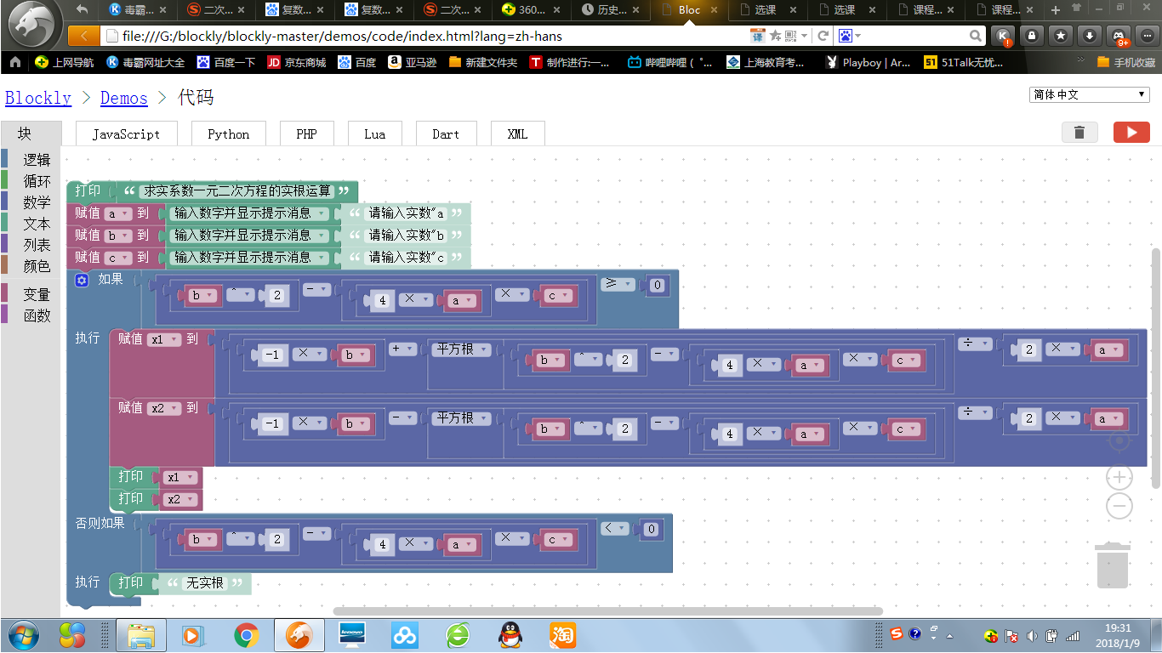

输入a=1 b=2 c=1 结果如下

X1

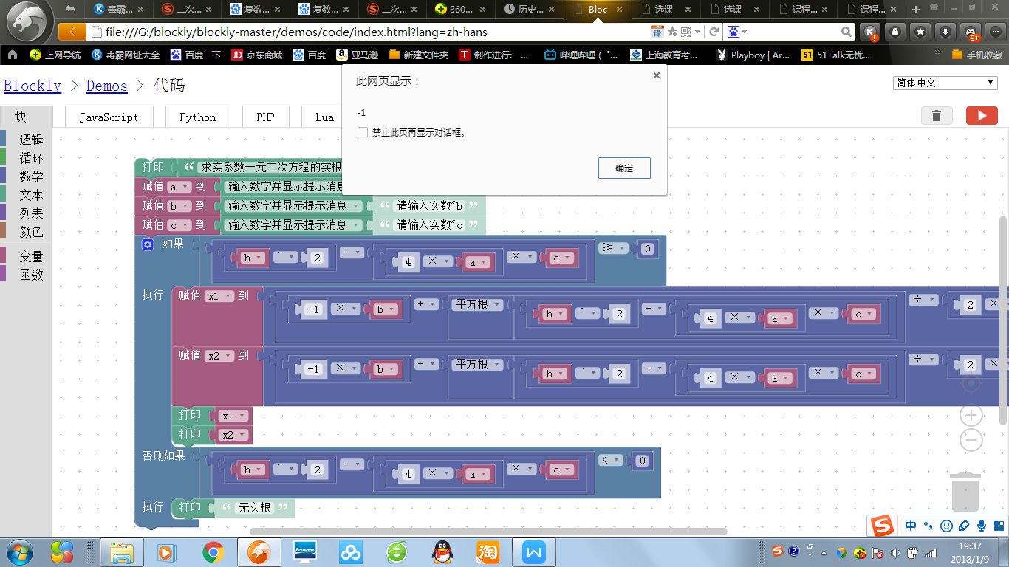

X2

输入 a=1 b=1 c=1 结果如下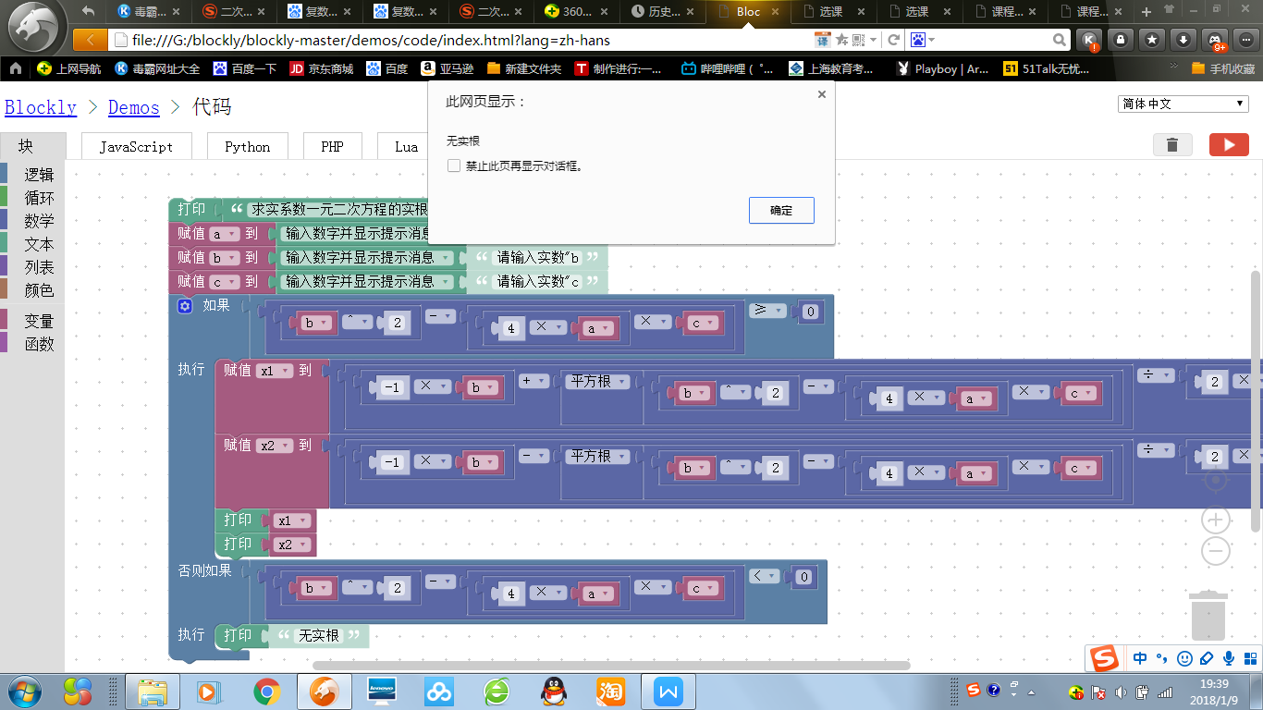

<xml xmlns="http://www.w3.org/1999/xhtml">

<variables>

<variable type="" id="j/F|p3VPuZ~arg$m[Z|y">a</variable>

<variable type="" id="ax9Elr;`dh)1SP)=3o_e">b</variable>

<variable type="" id="^8#NYIZ:v/}g)?tu$.(^">c</variable>

<variable type="" id="6j];)D$6]SubPoC6AJaZ">x1</variable>

<variable type="" id="V6R,VLi8,F3::u2uzpaH">x2</variable>

</variables>

<block type="text_print" id="Sf@K.G3%oYcn|1{{%!p?" x="112" y="-12">

<value name="TEXT">

<shadow type="text" id="nSDy4:VMYN-R*iJ6;Cs,">

<field name="TEXT">abc</field>

</shadow>

<block type="text" id="JUJFdnjSf-C5_{UQ(lud">

<field name="TEXT">求实系数一元二次方程的实根运算</field>

</block>

</value>

<next>

<block type="variables_set" id="[dCao!~@DIQ.g;Z/x2ws">

<field name="VAR" id="j/F|p3VPuZ~arg$m[Z|y" variabletype="">a</field>

<value name="VALUE">

<block type="text_prompt_ext" id="NM+g.=1b?iqy;7L44bU$">

<mutation type="TEXT"></mutation>

<field name="TYPE">TEXT</field>

<value name="TEXT">

<shadow type="text" id="~$9@d9N@}l~tFxjuIehD">

<field name="TEXT">请输入实数"a</field>

</shadow>

</value>

</block>

</value>

<next>

<block type="variables_set" id="{:N5VNVJ%s:s;-Sq:c6j">

<field name="VAR" id="ax9Elr;`dh)1SP)=3o_e" variabletype="">b</field>

<value name="VALUE">

<block type="text_prompt_ext" id="l-O1rQFG#=djHUT|nYTa">

<mutation type="TEXT"></mutation>

<field name="TYPE">TEXT</field>

<value name="TEXT">

<shadow type="text" id=",Xt@^(:jB+`o}X;MK-[t">

<field name="TEXT">请输入实数"b</field>

</shadow>

</value>

</block>

</value>

<next>

<block type="variables_set" id="QGt/gwfE_lA{UX_ejr~Y">

<field name="VAR" id="^8#NYIZ:v/}g)?tu$.(^" variabletype="">c</field>

<value name="VALUE">

<block type="text_prompt_ext" id="+)DvzW05{{e9RxX;(i.u">

<mutation type="TEXT"></mutation>

<field name="TYPE">TEXT</field>

<value name="TEXT">

<shadow type="text" id="G7tAs/SRtGFg@CV6i.c_">

<field name="TEXT">请输入实数"c</field>

</shadow>

</value>

</block>

</value>

<next>

<block type="controls_if" id="Pz!p7)s|PjkAo#89/12]">

<mutation elseif="1"></mutation>

<value name="IF0">

<block type="logic_compare" id="d{EylX^@D|.}O}4[LIYD">

<field name="OP">GTE</field>

<value name="A">

<block type="math_arithmetic" id="C=-+{E;r*2;RbPBe]ZU(">

<field name="OP">MINUS</field>

<value name="A">

<shadow type="math_number" id="qC84FhdI6~Yo0N2bKwls">

<field name="NUM">1</field>

</shadow>

<block type="math_arithmetic" id="?!GVqPm2(l5JTYd:pA5l">

<field name="OP">POWER</field>

<value name="A">

<shadow type="math_number" id="bN^LJS)VPQy!]Kg21S0C">

<field name="NUM">1</field>

</shadow>

<block type="variables_get" id="]A5t`OLlCd*QuHW,N=4x">

<field name="VAR" id="ax9Elr;`dh)1SP)=3o_e" variabletype="">b</field>

</block>

</value>

<value name="B">

<shadow type="math_number" id="(3O#[F$Vn..kR],;luNw">

<field name="NUM">2</field>

</shadow>

</value>

</block>

</value>

<value name="B">

<shadow type="math_number" id="iak+YLNP94l78qoe?Ap|">

<field name="NUM">1</field>

</shadow>

<block type="math_arithmetic" id="js:j/z2(KO3oUsx}L9gx">

<field name="OP">MULTIPLY</field>

<value name="A">

<shadow type="math_number" id="FEu*LL$V`Al1rJNIl(}/">

<field name="NUM">1</field>

</shadow>

<block type="math_arithmetic" id="vWP8#aHVSe?`Hu.AY?S%">

<field name="OP">MULTIPLY</field>

<value name="A">

<shadow type="math_number" id=";3yvjgBH{elOlc5L/+(,">

<field name="NUM">4</field>

</shadow>

</value>

<value name="B">

<shadow type="math_number" id="yH$!eC7.Q2rwDE|nLLx$">

<field name="NUM">1</field>

</shadow>

<block type="variables_get" id=")C`phxRHRnN$XQZ!nOAB">

<field name="VAR" id="j/F|p3VPuZ~arg$m[Z|y" variabletype="">a</field>

</block>

</value>

</block>

</value>

<value name="B">

<shadow type="math_number" id="U^6338S0x#=qR}eox`d/">

<field name="NUM">1</field>

</shadow>

<block type="variables_get" id=";6N[gtcWj-L+QaI3{w`n">

<field name="VAR" id="^8#NYIZ:v/}g)?tu$.(^" variabletype="">c</field>

</block>

</value>

</block>

</value>

</block>

</value>

<value name="B">

<block type="math_number" id="GRZdm^`-;j0Dw*LY[_}y">

<field name="NUM">0</field>

</block>

</value>

</block>

</value>

<statement name="DO0">

<block type="variables_set" id="P-rp:N@HlL0oq$~b!7O,">

<field name="VAR" id="6j];)D$6]SubPoC6AJaZ" variabletype="">x1</field>

<value name="VALUE">

<block type="math_arithmetic" id="gSXQBD;$JVJX*((_lQ1h">

<field name="OP">DIVIDE</field>

<value name="A">

<shadow type="math_number" id="6Tl3XYAK.TX[y-ho._mQ">

<field name="NUM">1</field>

</shadow>

<block type="math_arithmetic" id=",ePE9St@O86bjWYlb@8{">

<field name="OP">ADD</field>

<value name="A">

<shadow type="math_number" id="]~xE+xs)vMfkog0Z^7Lz">

<field name="NUM">1</field>

</shadow>

<block type="math_arithmetic" id=";%!rUyvQI;MGgIQXpKPS">

<field name="OP">MULTIPLY</field>

<value name="A">

<shadow type="math_number" id="lOpZdlbmIGx9q*dFCtT#">

<field name="NUM">-1</field>

</shadow>

</value>

<value name="B">

<shadow type="math_number" id="R.RW~Th?}R4bSlsJJ)/c">

<field name="NUM">1</field>

</shadow>

<block type="variables_get" id="!,rjW}8tYYj#Hv_I?J[N">

<field name="VAR" id="ax9Elr;`dh)1SP)=3o_e" variabletype="">b</field>

</block>

</value>

</block>

</value>

<value name="B">

<shadow type="math_number" id="!Fs!~C1#xRY4}N(k)Fh~">

<field name="NUM">1</field>

</shadow>

<block type="math_single" id="E4qXXJ4S9T3OTuA6q51$">

<field name="OP">ROOT</field>

<value name="NUM">

<shadow type="math_number" id="m%C?HeLZ+G@jw_EC~li9">

<field name="NUM">9</field>

</shadow>

<block type="math_arithmetic" id="{Kp?nn+-TT_#Ol*!Rp;D">

<field name="OP">MINUS</field>

<value name="A">

<shadow type="math_number" id="qC84FhdI6~Yo0N2bKwls">

<field name="NUM">1</field>

</shadow>

<block type="math_arithmetic" id="WVeqj/vCd#BDs+[msk_o">

<field name="OP">POWER</field>

<value name="A">

<shadow type="math_number" id="bN^LJS)VPQy!]Kg21S0C">

<field name="NUM">1</field>

</shadow>

<block type="variables_get" id=":/@w3nr%$[ci23H(^At:">

<field name="VAR" id="ax9Elr;`dh)1SP)=3o_e" variabletype="">b</field>

</block>

</value>

<value name="B">

<shadow type="math_number" id=")[p3-4aL/2NAv|`*ByI=">

<field name="NUM">2</field>

</shadow>

</value>

</block>

</value>

<value name="B">

<shadow type="math_number" id="iak+YLNP94l78qoe?Ap|">

<field name="NUM">1</field>

</shadow>

<block type="math_arithmetic" id=",E5j5(lkC+ndLu}%3#?M">

<field name="OP">MULTIPLY</field>

<value name="A">

<shadow type="math_number" id="FEu*LL$V`Al1rJNIl(}/">

<field name="NUM">1</field>

</shadow>

<block type="math_arithmetic" id="o%NEa-q!^e)Z/KmznVT6">

<field name="OP">MULTIPLY</field>

<value name="A">

<shadow type="math_number" id="cW]V|c@lnn!@pcqV/}xZ">

<field name="NUM">4</field>

</shadow>

</value>

<value name="B">

<shadow type="math_number" id="yH$!eC7.Q2rwDE|nLLx$">

<field name="NUM">1</field>

</shadow>

<block type="variables_get" id="QZ5KBCkk)R-NuGJcsX)?">

<field name="VAR" id="j/F|p3VPuZ~arg$m[Z|y" variabletype="">a</field>

</block>

</value>

</block>

</value>

<value name="B">

<shadow type="math_number" id="U^6338S0x#=qR}eox`d/">

<field name="NUM">1</field>

</shadow>

<block type="variables_get" id="b$QNK]Q23.hr;jzk^]vd">

<field name="VAR" id="^8#NYIZ:v/}g)?tu$.(^" variabletype="">c</field>

</block>

</value>

</block>

</value>

</block>

</value>

</block>

</value>

</block>

</value>

<value name="B">

<shadow type="math_number" id="H:6n!Zm{-;]1Mu[xIe[;">

<field name="NUM">1</field>

</shadow>

<block type="math_arithmetic" id="3x6C#Ii93b8EU}KB#Njx">

<field name="OP">MULTIPLY</field>

<value name="A">

<shadow type="math_number" id="T3bZ-Jv?m3^3Lw=cbnpZ">

<field name="NUM">2</field>

</shadow>

</value>

<value name="B">

<shadow type="math_number" id="7MPw_fQ/hU*d]m%?:%#}">

<field name="NUM">1</field>

</shadow>

<block type="variables_get" id="4%gD3Fzf[(XDUUpysYzU">

<field name="VAR" id="j/F|p3VPuZ~arg$m[Z|y" variabletype="">a</field>

</block>

</value>

</block>

</value>

</block>

</value>

<next>

<block type="variables_set" id="V/@3~J0v7a9QU}bIYp)A">

<field name="VAR" id="V6R,VLi8,F3::u2uzpaH" variabletype="">x2</field>

<value name="VALUE">

<block type="math_arithmetic" id="Cy}{?gHS1,5$ScsKg;-/">

<field name="OP">DIVIDE</field>

<value name="A">

<shadow type="math_number" id="6Tl3XYAK.TX[y-ho._mQ">

<field name="NUM">1</field>

</shadow>

<block type="math_arithmetic" id="6?A#C|A!7UhwF`1dcZNz">

<field name="OP">MINUS</field>

<value name="A">

<shadow type="math_number" id="]~xE+xs)vMfkog0Z^7Lz">

<field name="NUM">1</field>

</shadow>

<block type="math_arithmetic" id="gV#sAkbq/jjW+P9!o7OJ">

<field name="OP">MULTIPLY</field>

<value name="A">

<shadow type="math_number" id="QF6Mg5KDqo.]qp(nR)]x">

<field name="NUM">-1</field>

</shadow>

</value>

<value name="B">

<shadow type="math_number" id="R.RW~Th?}R4bSlsJJ)/c">

<field name="NUM">1</field>

</shadow>

<block type="variables_get" id="pxmr0:.(lAMSy916hdYs">

<field name="VAR" id="ax9Elr;`dh)1SP)=3o_e" variabletype="">b</field>

</block>

</value>

</block>

</value>

<value name="B">

<shadow type="math_number" id="!Fs!~C1#xRY4}N(k)Fh~">

<field name="NUM">1</field>

</shadow>

<block type="math_single" id="-k.Fst6ou^TdIzV(+/G2">

<field name="OP">ROOT</field>

<value name="NUM">

<shadow type="math_number" id="m%C?HeLZ+G@jw_EC~li9">

<field name="NUM">9</field>

</shadow>

<block type="math_arithmetic" id="5V;?SRMKnG%O(`Xf$T+7">

<field name="OP">MINUS</field>

<value name="A">

<shadow type="math_number" id="qC84FhdI6~Yo0N2bKwls">

<field name="NUM">1</field>

</shadow>

<block type="math_arithmetic" id="D/z#pMEylvfJy4{3]~+v">

<field name="OP">POWER</field>

<value name="A">

<shadow type="math_number" id="bN^LJS)VPQy!]Kg21S0C">

<field name="NUM">1</field>

</shadow>

<block type="variables_get" id="MkwrcD7R}ctc_t@Xaos.">

<field name="VAR" id="ax9Elr;`dh)1SP)=3o_e" variabletype="">b</field>

</block>

</value>

<value name="B">

<shadow type="math_number" id="25c).z*5GdnEw@?^9;o%">

<field name="NUM">2</field>

</shadow>

</value>

</block>

</value>

<value name="B">

<shadow type="math_number" id="iak+YLNP94l78qoe?Ap|">

<field name="NUM">1</field>

</shadow>

<block type="math_arithmetic" id="+A}lSIAE4QEgQg$s|lk`">

<field name="OP">MULTIPLY</field>

<value name="A">

<shadow type="math_number" id="FEu*LL$V`Al1rJNIl(}/">

<field name="NUM">1</field>

</shadow>

<block type="math_arithmetic" id="QJ]Z]$l`MG(VG!XdSv`@">

<field name="OP">MULTIPLY</field>

<value name="A">

<shadow type="math_number" id="5.P6|l,KZKq%S)neob7H">

<field name="NUM">4</field>

</shadow>

</value>

<value name="B">

<shadow type="math_number" id="yH$!eC7.Q2rwDE|nLLx$">

<field name="NUM">1</field>

</shadow>

<block type="variables_get" id="0p-rE`4X6|OoLHr3mn7M">

<field name="VAR" id="j/F|p3VPuZ~arg$m[Z|y" variabletype="">a</field>

</block>

</value>

</block>

</value>

<value name="B">

<shadow type="math_number" id="U^6338S0x#=qR}eox`d/">

<field name="NUM">1</field>

</shadow>

<block type="variables_get" id="!}R*|K.YNQj(xMG3Kr#L">

<field name="VAR" id="^8#NYIZ:v/}g)?tu$.(^" variabletype="">c</field>

</block>

</value>

</block>

</value>

</block>

</value>

</block>

</value>

</block>

</value>

<value name="B">

<shadow type="math_number" id="H:6n!Zm{-;]1Mu[xIe[;">

<field name="NUM">1</field>

</shadow>

<block type="math_arithmetic" id="U(tGKNmK(hGq$$;|;c8P">

<field name="OP">MULTIPLY</field>

<value name="A">

<shadow type="math_number" id="mOpen}Q,*?R7e5y.6nBD">

<field name="NUM">2</field>

</shadow>

</value>

<value name="B">

<shadow type="math_number" id="7MPw_fQ/hU*d]m%?:%#}">

<field name="NUM">1</field>

</shadow>

<block type="variables_get" id="wkuiVRle[nW^$_AAZPpv">

<field name="VAR" id="j/F|p3VPuZ~arg$m[Z|y" variabletype="">a</field>

</block>

</value>

</block>

</value>

</block>

</value>

<next>

<block type="text_print" id="i|b,FXk9BX1y6Q!J#u;n">

<value name="TEXT">

<shadow type="text" id="}yRxE{p`4%wq#bavHf6r">

<field name="TEXT">abc</field>

</shadow>

<block type="variables_get" id="qM{KLh7M{O`6Ss-v%T#}">

<field name="VAR" id="6j];)D$6]SubPoC6AJaZ" variabletype="">x1</field>

</block>

</value>

<next>

<block type="text_print" id="Hin.gEXLKW7bf]a0vF+K">

<value name="TEXT">

<shadow type="text" id="]CYZ9TrlN^RwhZ+Zc%:%">

<field name="TEXT">abc</field>

</shadow>

<block type="variables_get" id="|eG0n@QT*Fu{7pmpDnR=">

<field name="VAR" id="V6R,VLi8,F3::u2uzpaH" variabletype="">x2</field>

</block>

</value>

</block>

</next>

</block>

</next>

</block>

</next>

</block>

</statement>

<value name="IF1">

<block type="logic_compare" id="Q:).6i`Mz7.F,NkcJ$Oe">

<field name="OP">LT</field>

<value name="A">

<block type="math_arithmetic" id="[7.@4zsQtJoXBWS_Dniq">

<field name="OP">MINUS</field>

<value name="A">

<shadow type="math_number" id="qC84FhdI6~Yo0N2bKwls">

<field name="NUM">1</field>

</shadow>

<block type="math_arithmetic" id="?TfD.4o$/7JcALbLNh8{">

<field name="OP">POWER</field>

<value name="A">

<shadow type="math_number" id="bN^LJS)VPQy!]Kg21S0C">

<field name="NUM">1</field>

</shadow>

<block type="variables_get" id="rz0G[HbvwxmH)DG)Di2?">

<field name="VAR" id="ax9Elr;`dh)1SP)=3o_e" variabletype="">b</field>

</block>

</value>

<value name="B">

<shadow type="math_number" id="j5Ppb4_-`.q1bAePbkks">

<field name="NUM">2</field>

</shadow>

</value>

</block>

</value>

<value name="B">

<shadow type="math_number" id="iak+YLNP94l78qoe?Ap|">

<field name="NUM">1</field>

</shadow>

<block type="math_arithmetic" id="tUL-KYg`d-?1RsR}*@.z">

<field name="OP">MULTIPLY</field>

<value name="A">

<shadow type="math_number" id="FEu*LL$V`Al1rJNIl(}/">

<field name="NUM">1</field>

</shadow>

<block type="math_arithmetic" id="0yPJCTqsZjLP,O{:-,BT">

<field name="OP">MULTIPLY</field>

<value name="A">

<shadow type="math_number" id="pu1{i]hO(J*sj4SkM`FU">

<field name="NUM">4</field>

</shadow>

</value>

<value name="B">

<shadow type="math_number" id="yH$!eC7.Q2rwDE|nLLx$">

<field name="NUM">1</field>

</shadow>

<block type="variables_get" id=",$cs6bufgLg!z-Xj}}d(">

<field name="VAR" id="j/F|p3VPuZ~arg$m[Z|y" variabletype="">a</field>

</block>

</value>

</block>

</value>

<value name="B">

<shadow type="math_number" id="U^6338S0x#=qR}eox`d/">

<field name="NUM">1</field>

</shadow>

<block type="variables_get" id="JbB{GGoqfFAR:`PyH=CX">

<field name="VAR" id="^8#NYIZ:v/}g)?tu$.(^" variabletype="">c</field>

</block>

</value>

</block>

</value>

</block>

</value>

<value name="B">

<block type="math_number" id="8uZ{^ZT#t`}JTrE+x#p[">

<field name="NUM">0</field>

</block>

</value>

</block>

</value>

<statement name="DO1">

<block type="text_print" id="6J?h{9)78%Wa}CL;Ebu`">

<value name="TEXT">

<shadow type="text" id="OW(X(XV!+x2;2uGAXb)d">

<field name="TEXT">无实根</field>

</shadow>

</value>

</block>

</statement>

</block>

</next>

</block>

</next>

</block>

</next>

</block>

</next>

</block>

</xml>

孟骄阳 320170936190